

**ICP Tech Lab (ITL)**

**User Guide**

ICP Tech Lab (ITL)

Version – 1.0

© 2021 Optum, Inc. All rights reserved.

The information in this document is subject to change without notice. This documentation contains proprietary information, and is protected by U.S. and international copyright. No part of this documentation may be reproduced or transmitted in any form or by any means, electronic or mechanical, including photocopying, modifying, or recording, without the prior written permission of Optum, Inc. No part of this documentation may be translated to another program language without the prior written consent of Optum.

Optum, Inc.   
11000 Optum Circle, Eden Prairie, MN 55344  
[optum.com](http://www.optum.com)

ICP Tech Lab User Guide

Contents

Overview 5

ICP Tech Lab (ITL) Access 5

VM Services 5

Product Services 5

Status, Information & Monitoring 5

ITL Access 6

Pre-requisites 6

ITL Login 6

ITL Dashboard 6

ITL User Profile 7

ITL Help 8

ITL Logout 8

VM Services 8

Provision a VM 8

View Requests 10

Mapping a shared drive 11

Maintain a VM 12

Delete a VM 13

Product Services 15

DDR 6.0 Base Install 15

DDR 6.0 Upgrade From ICP 5.4 16

DDR 6.0 KB Install 18

ICP 5.4 Base Install 19

ICP 5.4 CU Install 21

ICP 5.4 KB Load 23

ICP 5.4 LCD Load 24

# **Overview**

The ICP Tech Lab (ITL) application contains features and capabilities to assist all ICP users with the development, testing, support and monitoring of the ICP & DDR applications.

## ICP Tech Lab (ITL) Access

The ICP Tech Lab (ITL) application requires a user to have an active OTL account. The ITL app will prompt the user to enter their OTL credentials in order to access the ITL app.

## VM Services

The ICP Tech Lab (ITL) application provides functionality to create, maintain and delete virtual environments (VMs) that can be used to develop and test the ICP applications. The capability includes:  
- Provision a new VM  
- Maintain the VM  
- Delete the VM

## Product Services

The ICP Tech Lab (ITL) application provides functionality to install ICP & DDR products. The capability includes:  
- DDR 6.0 base installation   
- DDR 6.0 upgrade from ICP 5.4   
- DDR 6.0 KB installation   
- ICP 5.4 base installation  
- ICP 5.4 CU installation  
- KB load to ICP 5.4   
- LCD load to ICP 5.4

## Status, Information & Monitoring

The ICP Tech Lab (ITL) application provides links to information on the various applications that build and test the ICP & DDR applications. The application links include:  
- ICP builds via Jenkins  
- ICP longevity testing via RBR environments  
- ICP performance testing via wiki’s with performance test results

# **ITL Access**

## Pre-requisites

The ICP Tech Lab (ITL) requires a user to have an active OTL account. This account can be obtained by sending an email request to the ICP DevOps team.

## ITL Login

A user can access the ITL application from their OTL VDI using the following URL – <http://itl:8080/ITL/login.jsp>. The ITL Login page will be displayed.

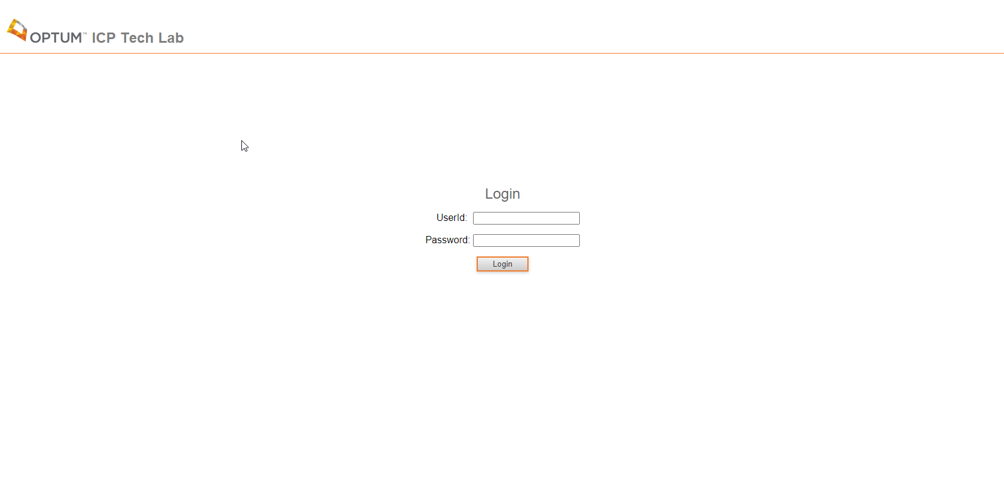

The user will then enter their OTL userid and password and click Login. If the user has an active OTL account and enters valid credentials, the ITL Dashboard page will be displayed.

## ITL Dashboard

The ITL Dashboard page has a variety of links to monitor ICP & DDR related build and performance status and various wiki news & information. The ITL Main Menu primary functions include links to VM Services for the provisioning of VMs, and Product Services for the installation of DDR & ICP products.

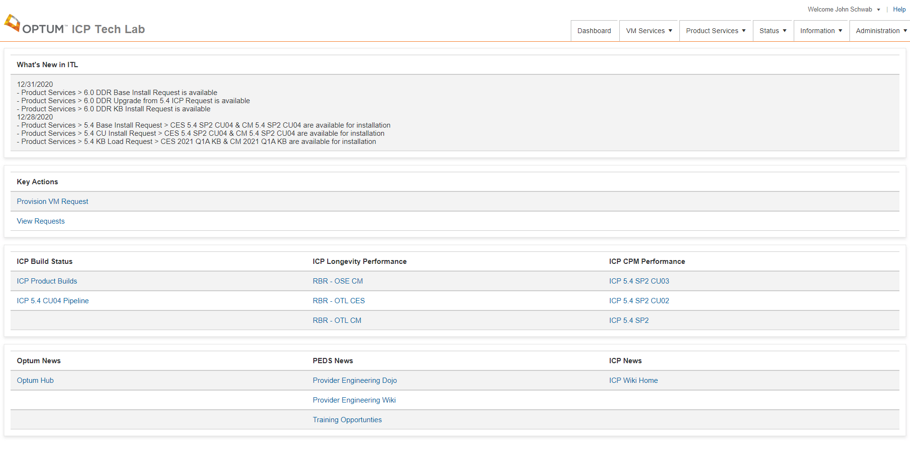

## ITL User Profile

A user profile exists in ITL for each user and can be viewed by clicking on their name in the upper right corner and clicking View User Profile.

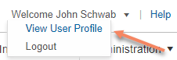

The ITL User Profile page will be displayed.

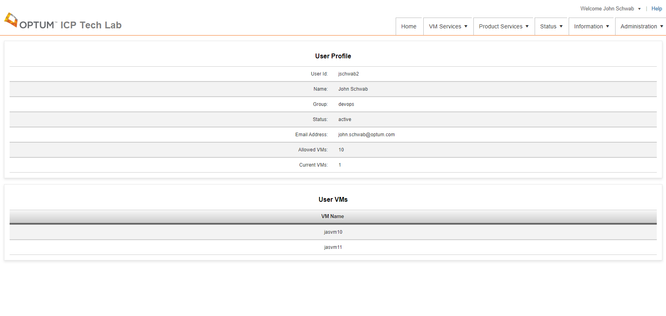

## ITL Help

A user can access the ITL User Guide by clicking the Help link in the upper right. A new browser tab will open displaying the ITL User Guide.

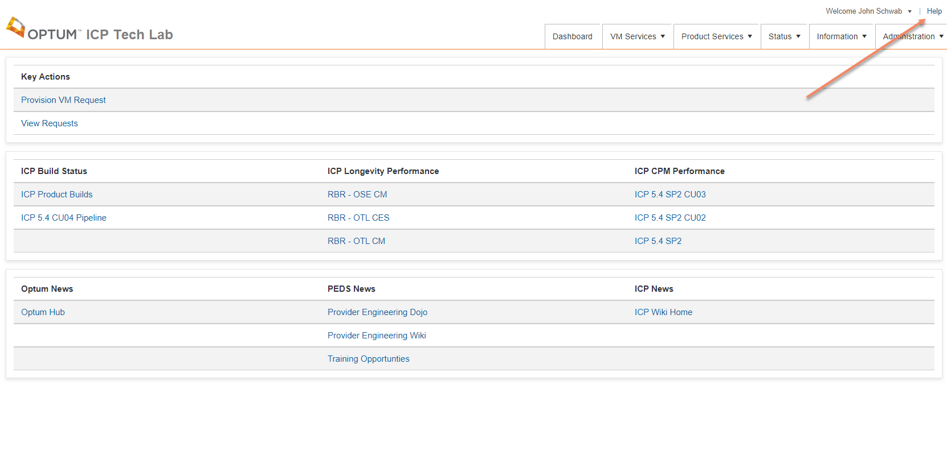

## ITL Logout

A user can logout of ITL by clicking on their name in the upper right corner and clicking Logout. This will return the user to the ITL Login page.

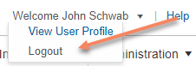

# **VM Services**

## Provision a VM

A user is able to provision a new OTL VM for their development, QA or support needs. The Provision New VM Request page can be accessed from the Main Menu by clicking VM Services and Provision VM Request.

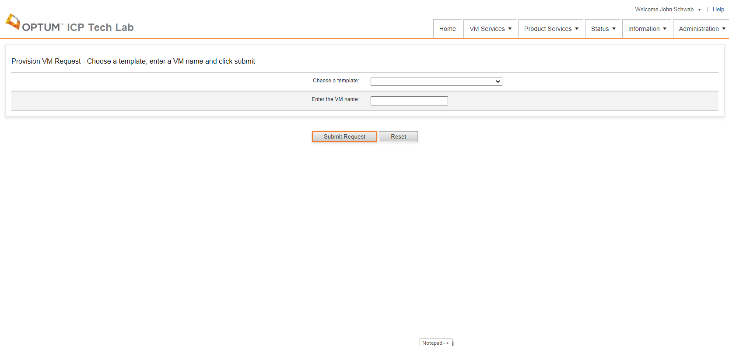

On this page a user will choose a template that the new VM will be based on.

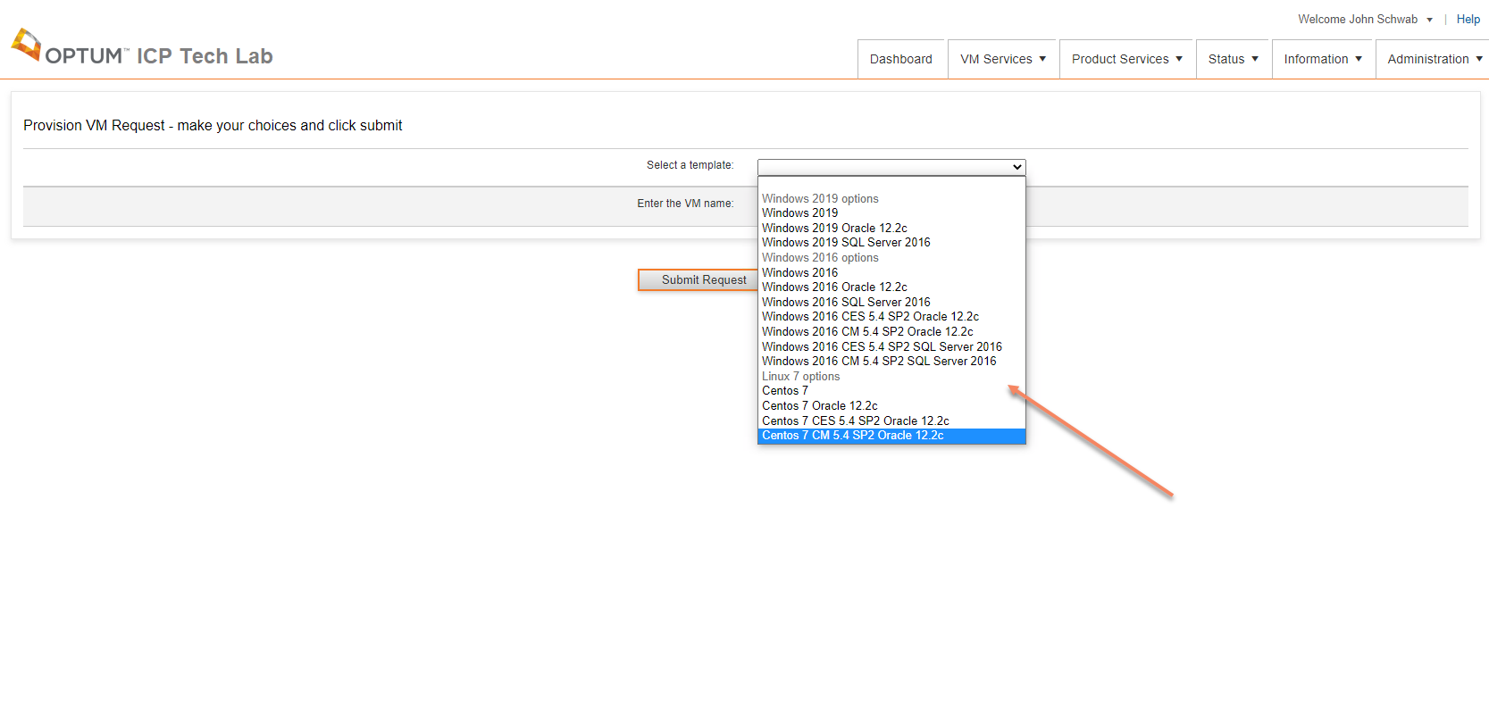

After a template is chosen a user enters the name for the new VM, which must be unique and not greater than 15 alphanumeric characters. Then the user will click Submit Request.

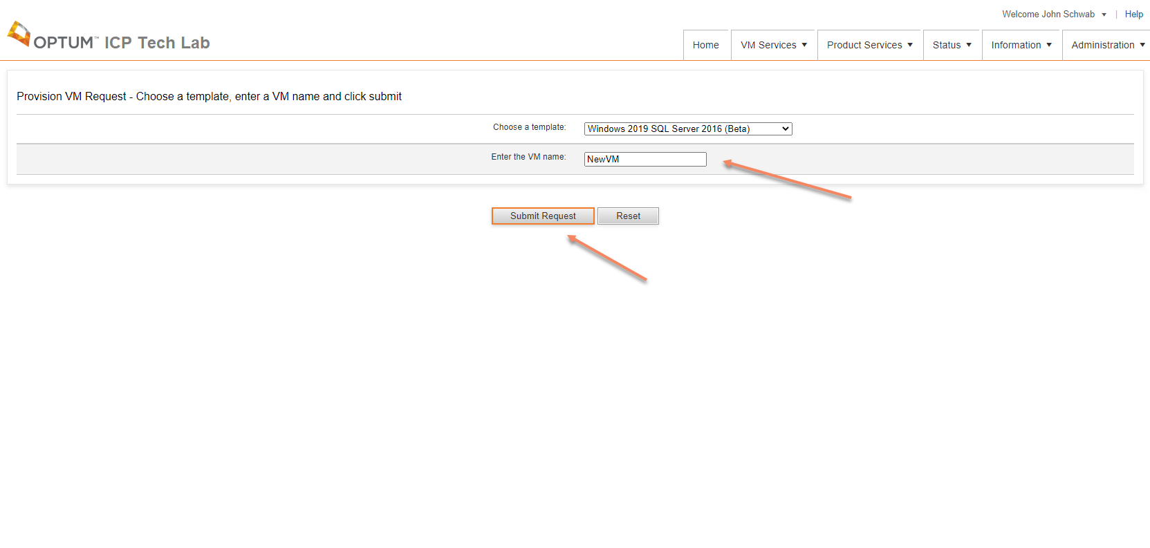

A request is submitted to the ITL application and a job is created to fulfil the users request. The user will be forwarded to the View Requests page after clicking the Submit Request button. Once the job starts the user will receive an email containing the request information. Once the job completes the user will receive another email letting them know the job is complete and the VM is ready.

## View Requests

The View Request page displays all the user’s requests that have been submitted. The most current request is first. The View Requests page can be accessed from the Main Menu by clicking VM Services or Product Services and View Requests. The user can monitor the progress of their job on this page by clicking the Refresh button in the upper middle of the page, which will refresh the request data.

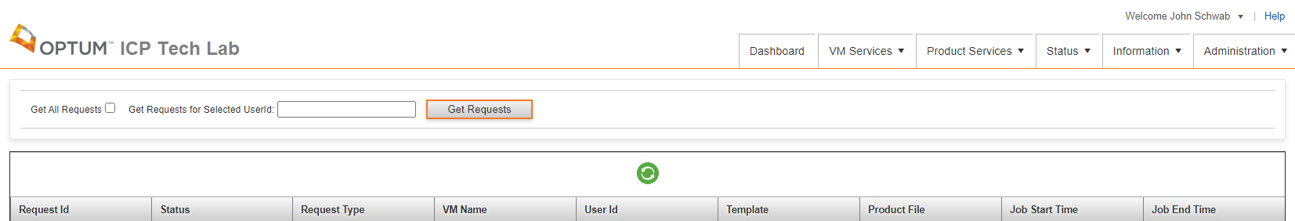 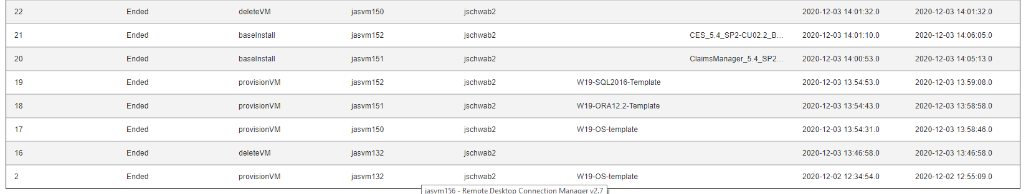

## Mapping a shared drive

OTL is a restricted environment for security purposes, but more than likely you are going to need to copy files, data, etc. from your laptop or another VM onto your OTL VM or visa-versa. There is an OTL shared drive just for this purpose.

The shared OTL drive is a limited space shared drive so limit the size of your files, such as putting them in a folder with your name, and in deleting them when you are done. This shared drive is not meant for permanent storage and will be cleaned up periodically.

Map a drive from your laptop or VM to the OTL shared drive either URL using this URL:

* + \\otl-svm0.otl.lab\ICP-WVC

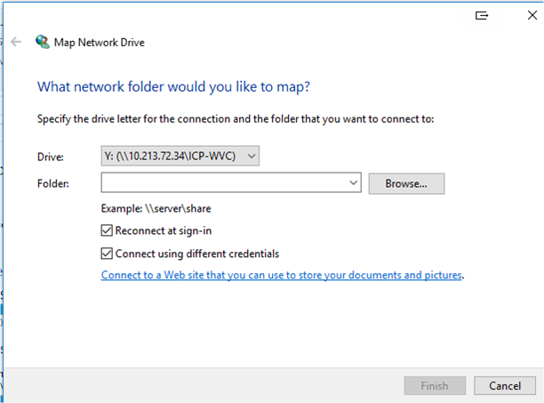

When asked for the User, enter:

* + OTL\<your OTL username>
  + Give your OTL password

You now have a shared drive you can copy files, data, etc. from your laptop or VM.

Now, log into your OTL VDI and create the same mapped drive using the steps above.

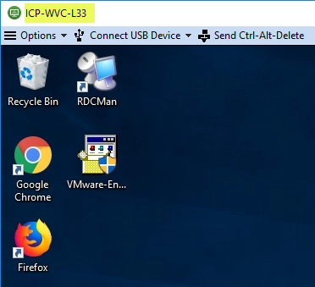

You now have a way to copy files back and forth from your laptop or other VM to your OTL VMs or visa-versa.

## Maintain a VM

A user can maintain an OTL VM for their development, QA or support needs. The Maintain VM Request page can be accessed from the Main Menu by clicking VM Services and Maintain VM Request. This page allows a user to Start, Stop, or Restart a VM.

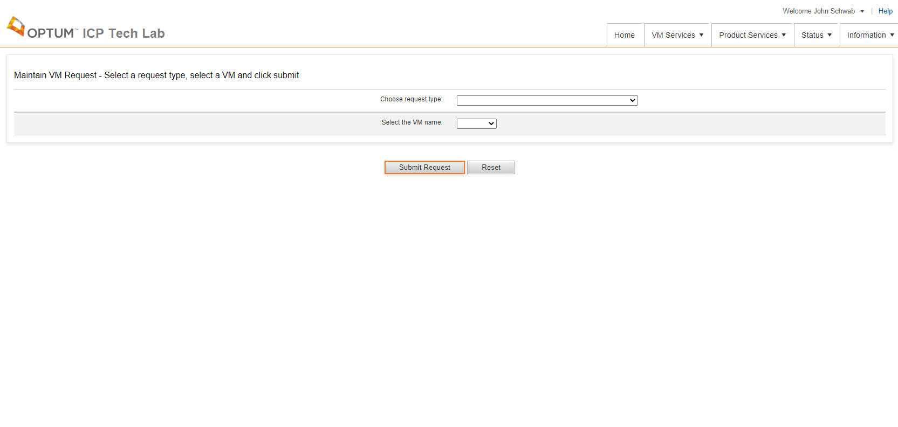

On this page a user will choose a VM.

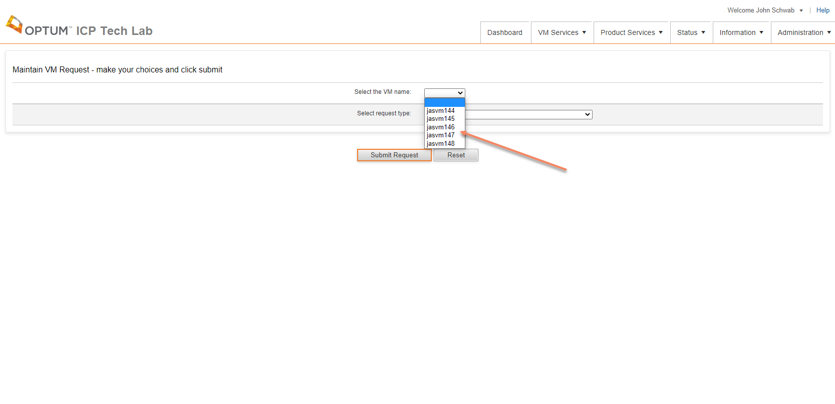

Then the user will choose a Request Type from the list and then click Submit Request.

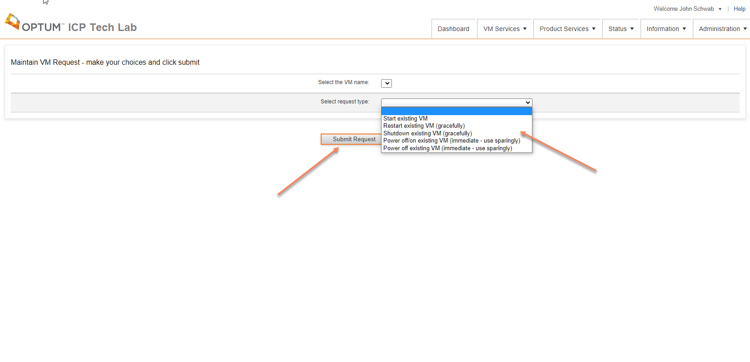

A request is submitted to the ITL application and a job is created to fulfil the users request. The user will be forwarded to the View Requests page after clicking the Submit Request button. Once the job starts the user will receive an email containing the request information. Once the job completes the user will receive another email letting them know the job is complete.

## Delete a VM

A user can delete an OTL VM which they own. Take caution with this service since the VM is permanently deleted without any recovery. The Delete VM Request page can be accessed from the Main Menu by clicking VM Services and Delete VM Request.

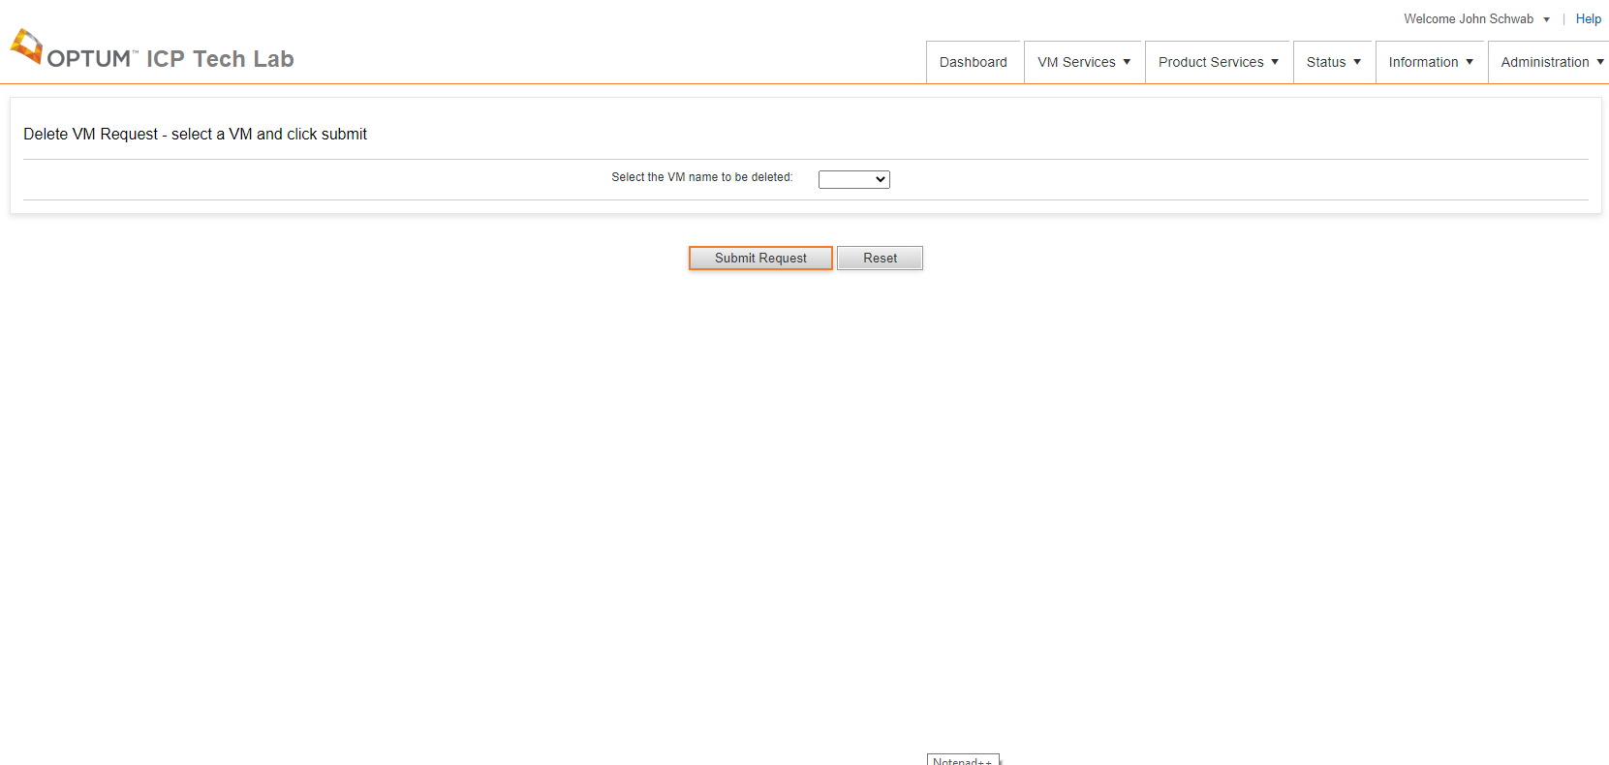

On this page the user will choose a VM from the list of VMs that the user owns and then click Submit Request.

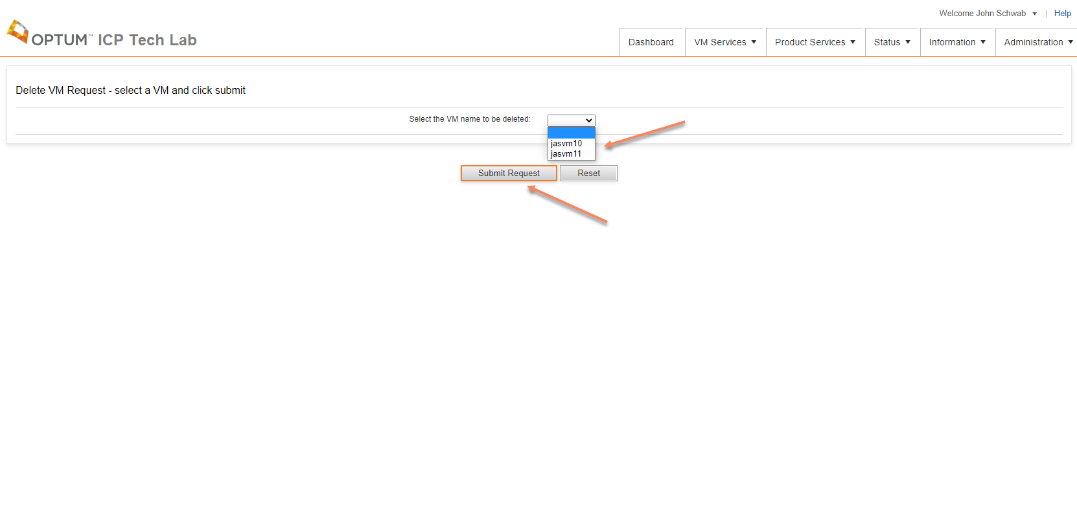

A request is submitted to the ITL application and a job is created to fulfil the users request. The user will be forwarded to the View Requests page after clicking the Submit Request button. Once the job starts the user will receive an email containing the request information. Once the job completes the user will receive another email letting them know the job is complete.

# **Product Services**

## DDR 6.0 Base Install

A user can request a DDR 6.0 base install on a VM that does not have DDR installed. The DDR 6.0 Base Install Request page can be accessed from the Main Menu by clicking Product Services and 6.0 - DDR Base Install Request.

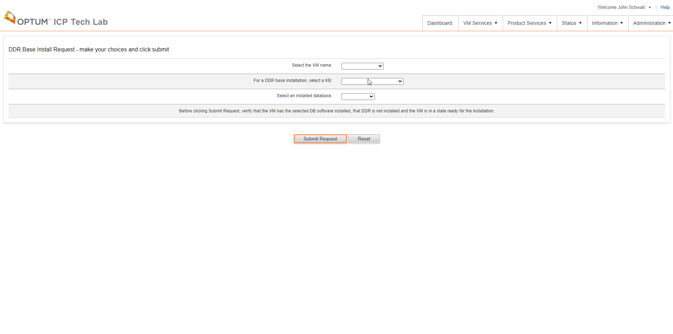

On this page the user will select the VM they want to run a DDR base install on.

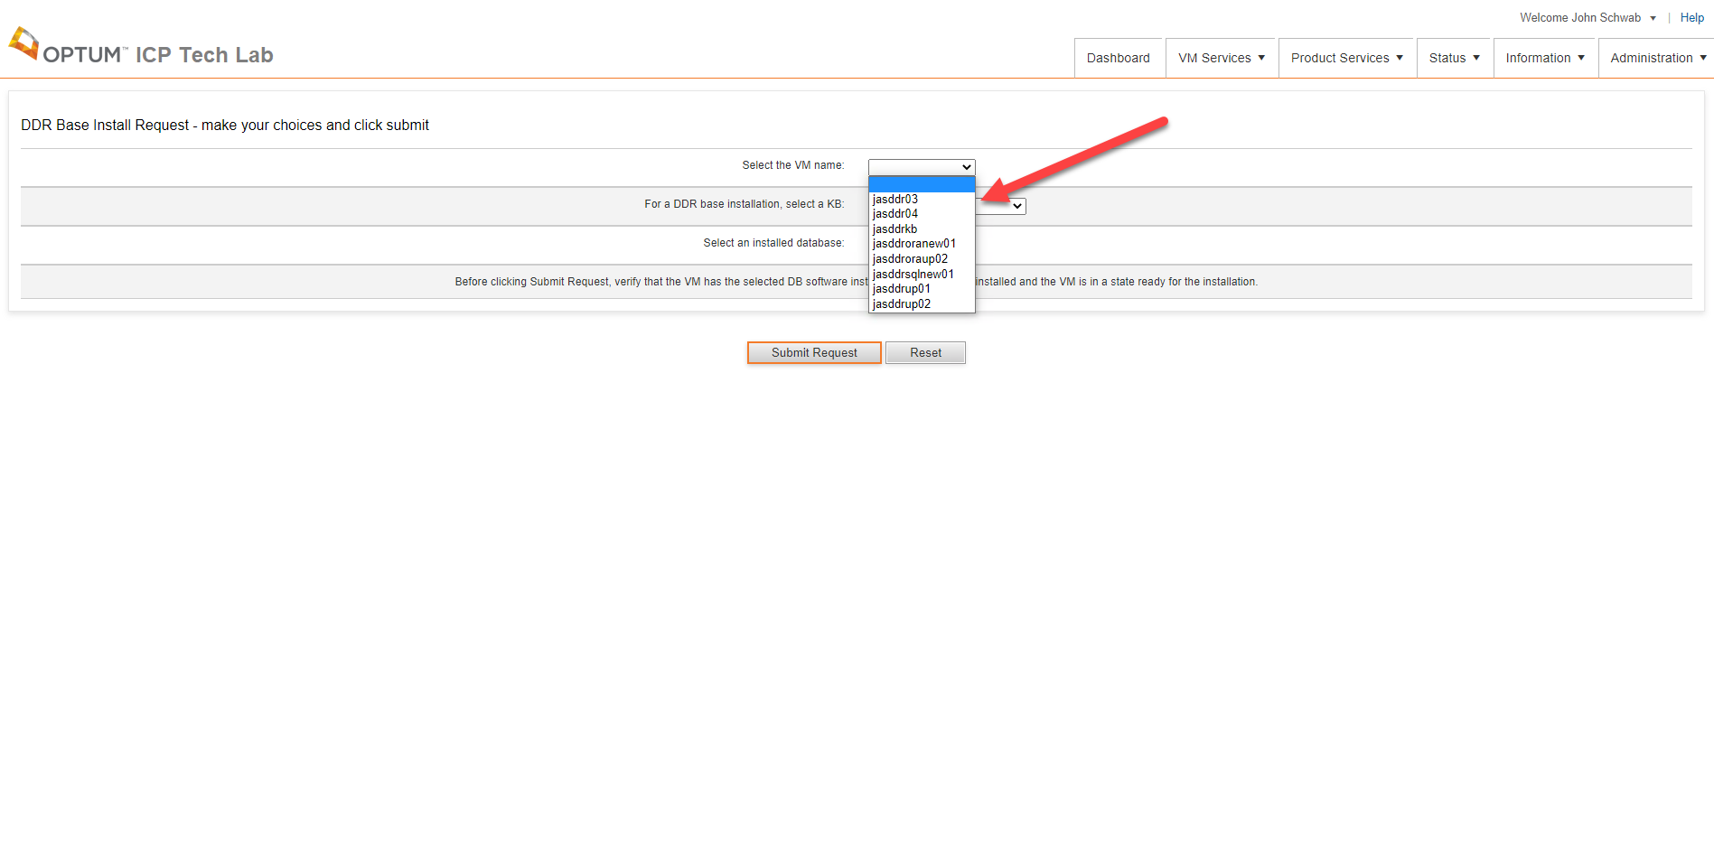

Then the user selects the KB (which includes the DDR engine) that they want installed.

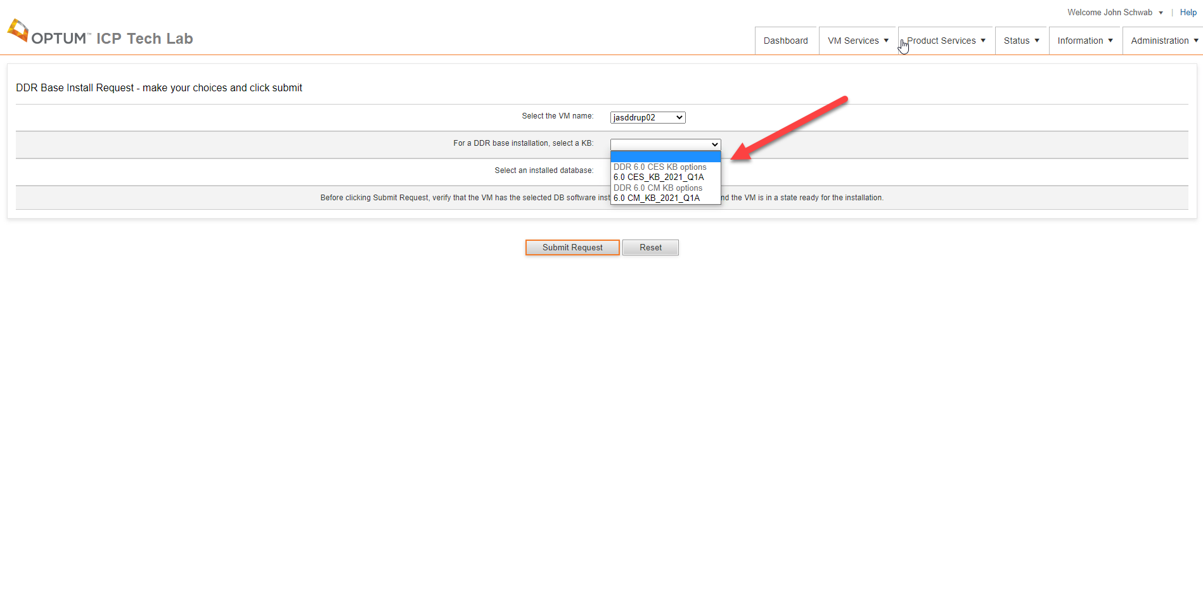

Then the user selects the database that is already installed on the VM and clicks the Submit Request button. 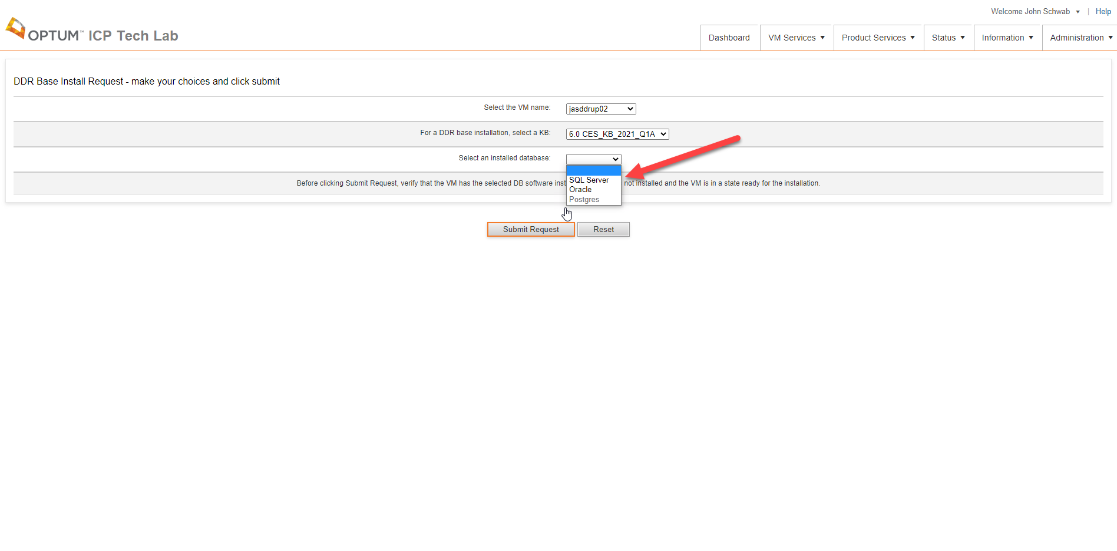A request is submitted to the ITL application and a job is created to fulfil the users request. The user will be forwarded to the View Requests page after clicking the Submit Request button. Once the job starts the user will receive an email containing the request information. Once the job completes the user will receive another email letting them know the job is complete.

## DDR 6.0 Upgrade From ICP 5.4

A user can request a DDR 6.0 Upgrade From ICP 5.4 on a VM that has ICP 5.4 CU02 or greater installed. The DDR 6.0 Upgrade From ICP 5.4 Request page can be accessed from the Main Menu by clicking Product Services and 6.0 - DDR Upgrade From ICP 5.4 Request.

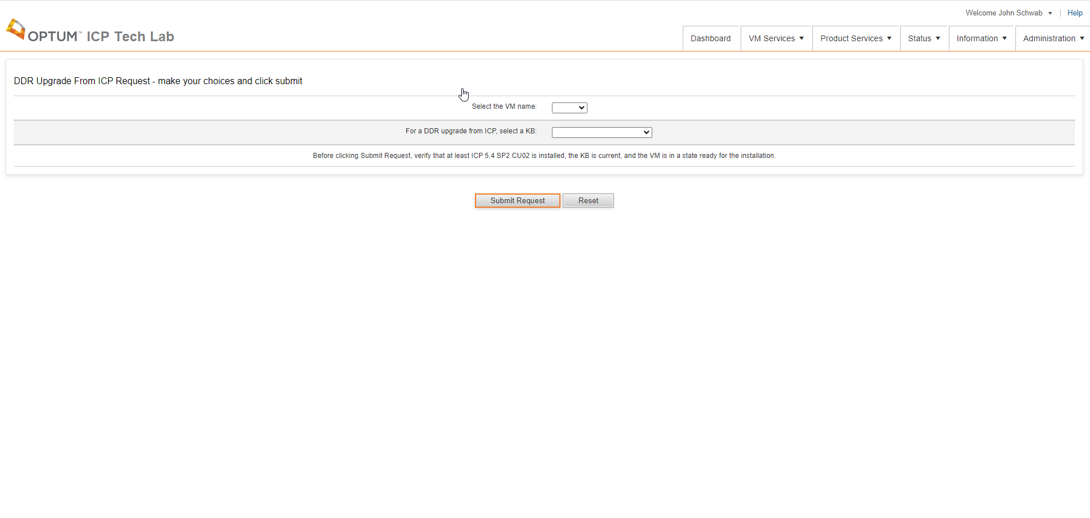

On this page the user will select the VM they want to run a DDR base install on.

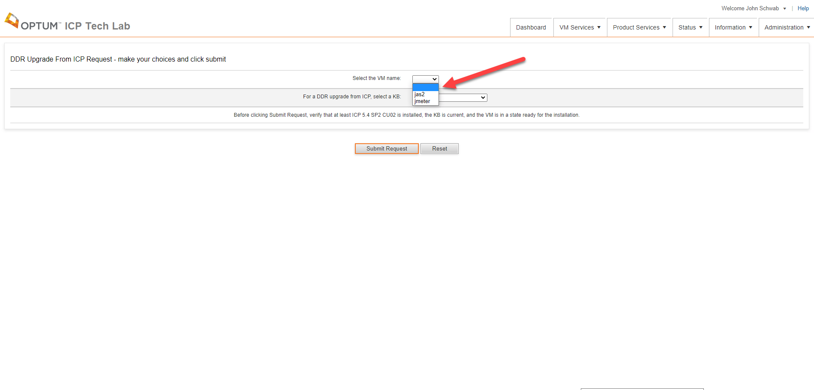

Then the user selects the KB (which includes the DDR engine) that they want installed and clicks the Submit Request button.

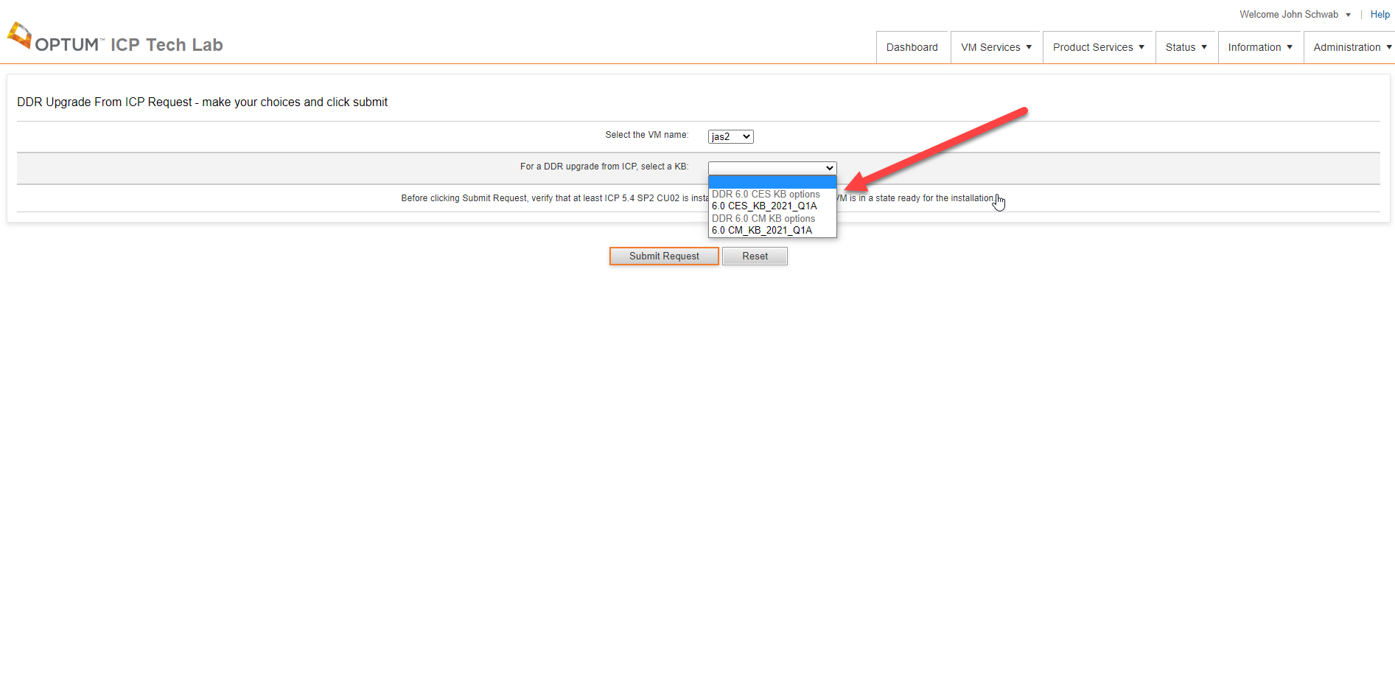

A request is submitted to the ITL application and a job is created to fulfil the users request. The user will be forwarded to the View Requests page after clicking the Submit Request button. Once the job starts the user will receive an email containing the request information. Once the job completes the user will receive another email letting them know the job is complete.

## DDR 6.0 KB Install

A user can request a DDR 6.0 KB Install on a VM that has DDR 6.0 installed. The DDR 6.0 KB Install Request page can be accessed from the Main Menu by clicking Product Services and 6.0 - DDR KB Install Request.

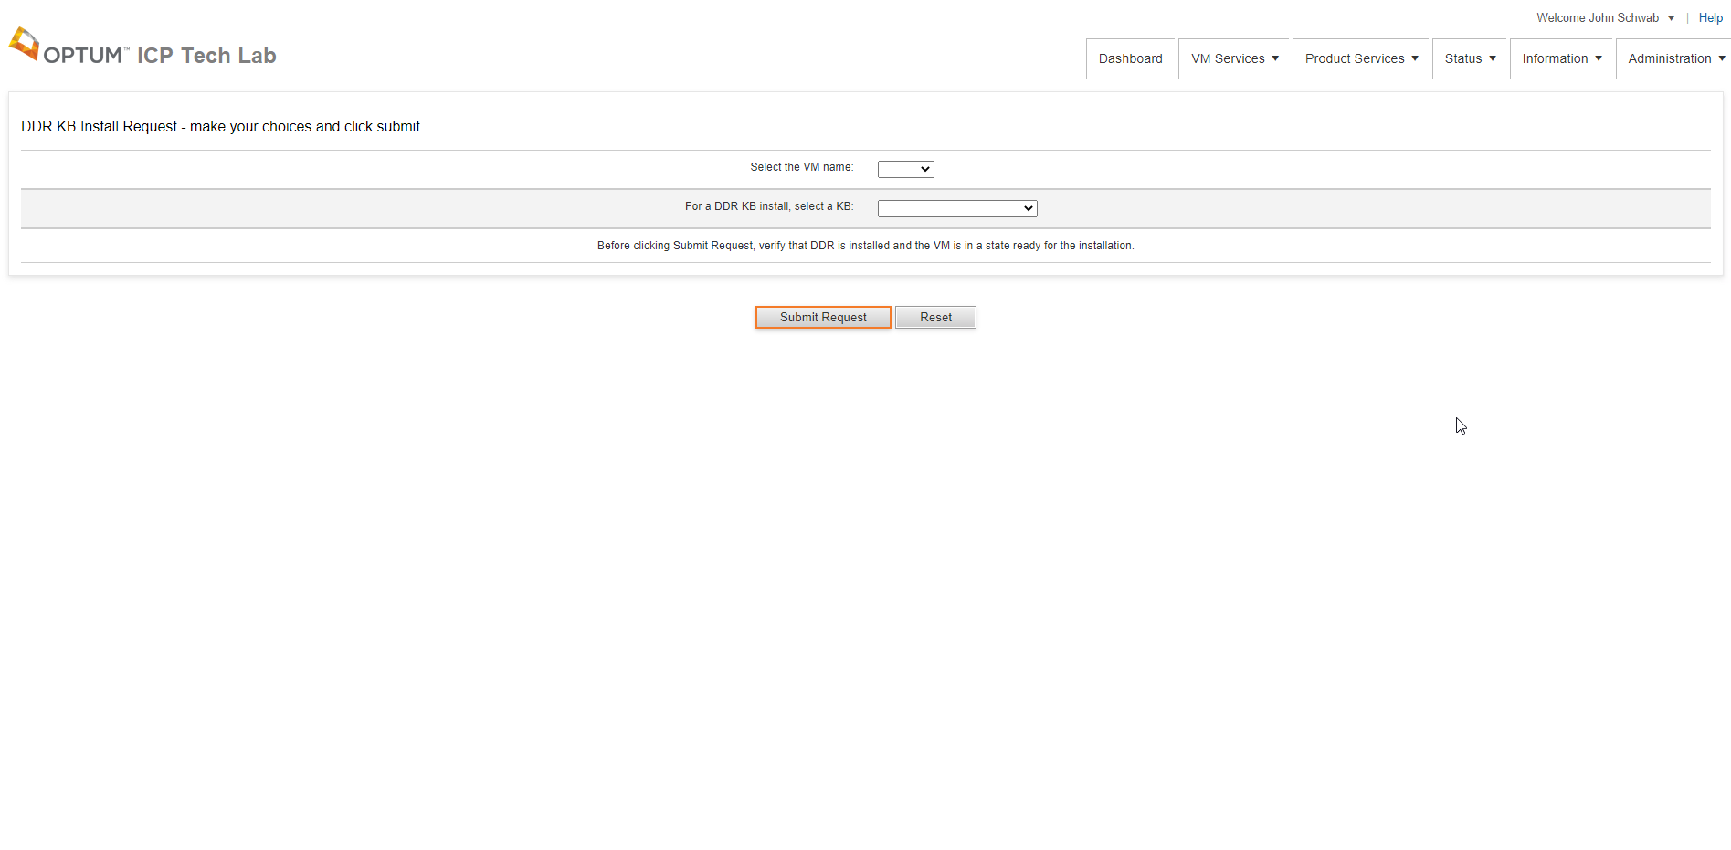

On this page the user will select the VM they want to run a DDR KB install on.

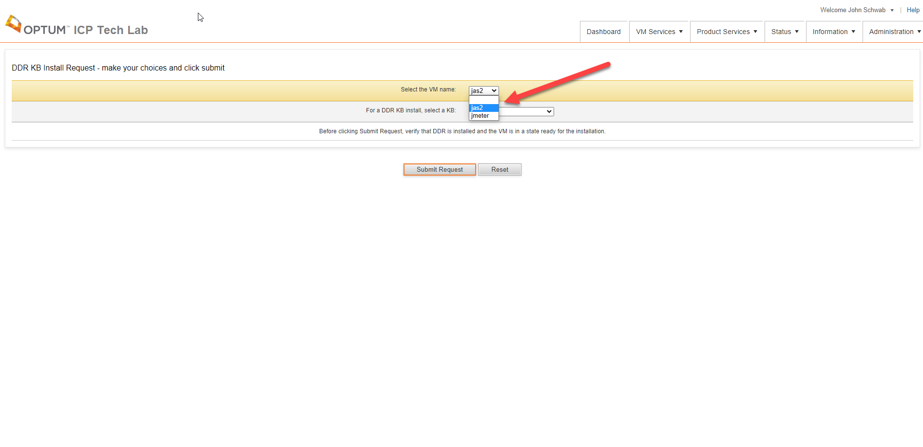

Then the user selects the KB (which includes the DDR engine) that they want installed and clicks the Submit Request button.



A request is submitted to the ITL application and a job is created to fulfil the users request. The user will be forwarded to the View Requests page after clicking the Submit Request button. Once the job starts the user will receive an email containing the request information. Once the job completes the user will receive another email letting them know the job is complete.

## ICP 5.4 Base Install

A user can request an ICP 5.4 base install on a VM that does not have ICP installed. The ICP 5.4 Base Install Request page can be accessed from the Main Menu by clicking Product Services and 5.4 ICP Base Install Request.

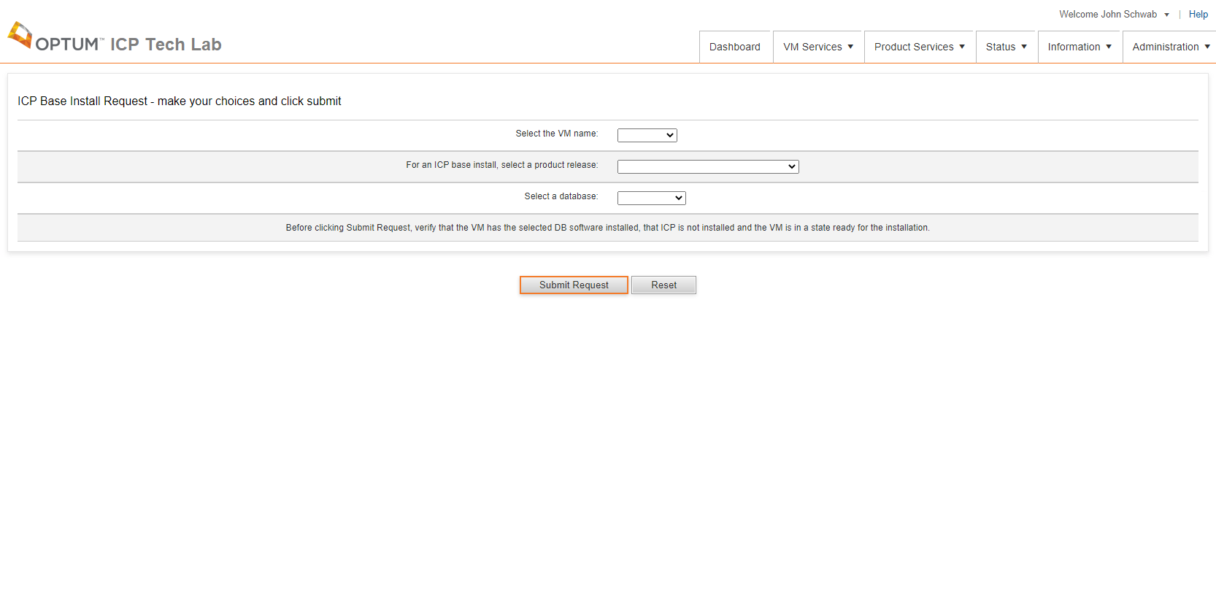

On this page the user will selects the VM they want to run an ICP base install on.

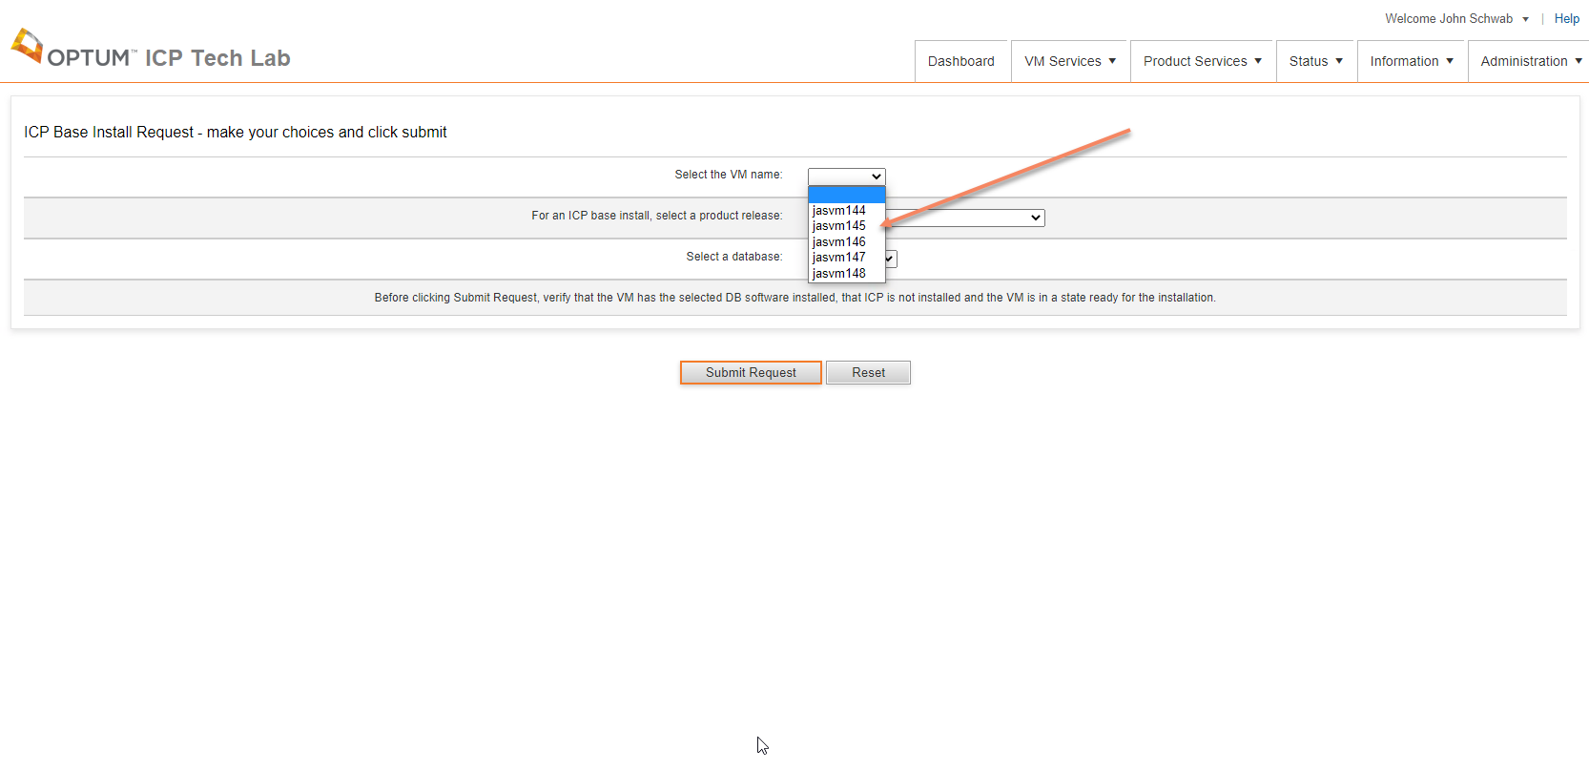

Then the user selects the base install product that they want installed.

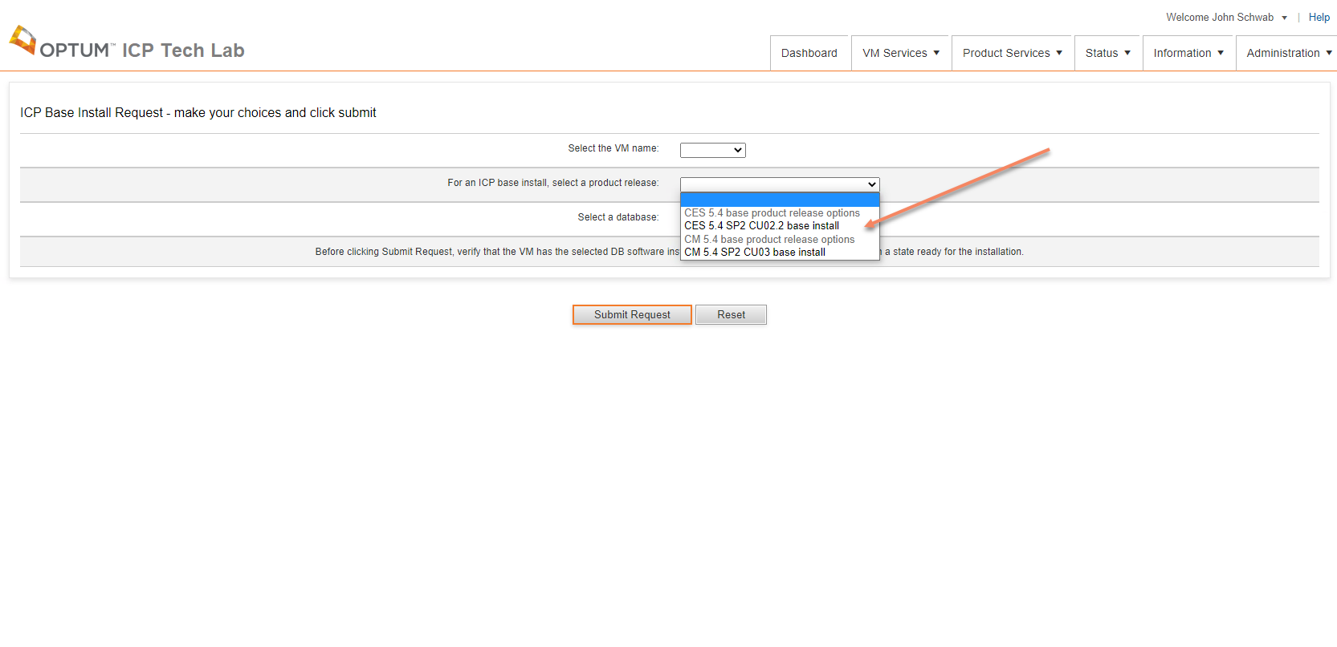

Then the user selects the database that is already installed on the VM and clicks the Submit Request button. 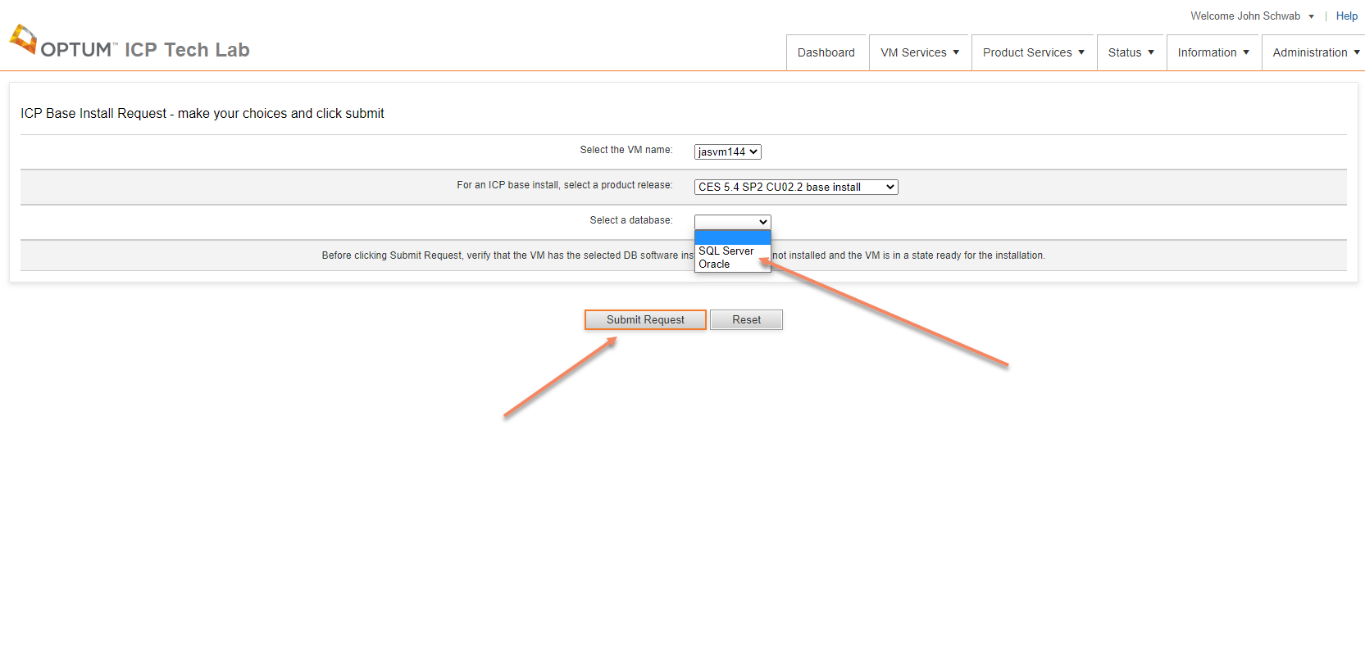A request is submitted to the ITL application and a job is created to fulfil the users request. The user will be forwarded to the View Requests page after clicking the Submit Request button. Once the job starts the user will receive an email containing the request information. Once the job completes the user will receive another email letting them know the job is complete.

## ICP 5.4 CU Install

A user can request an ICP 5.4 CU install on a VM that does have ICP installed. The 5.4 ICP CU Install Request page can be accessed from the Main Menu by clicking Product Services and 5.4 ICP CU Install Request.

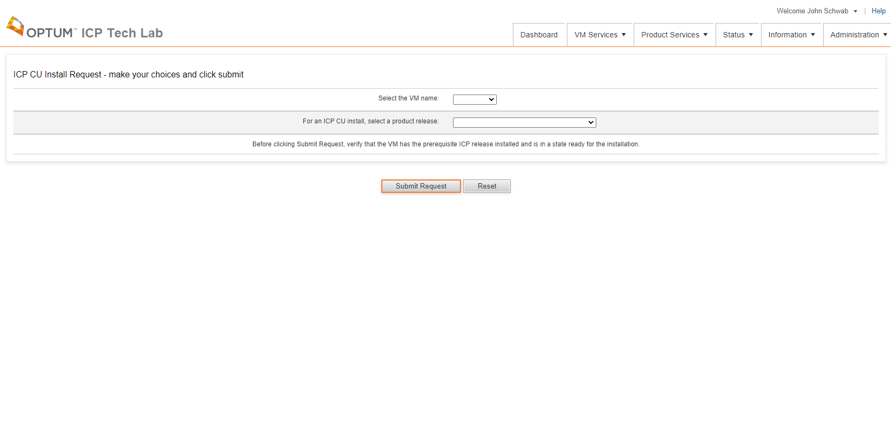

On this page the user will selects the VM they want to run a CU install on.

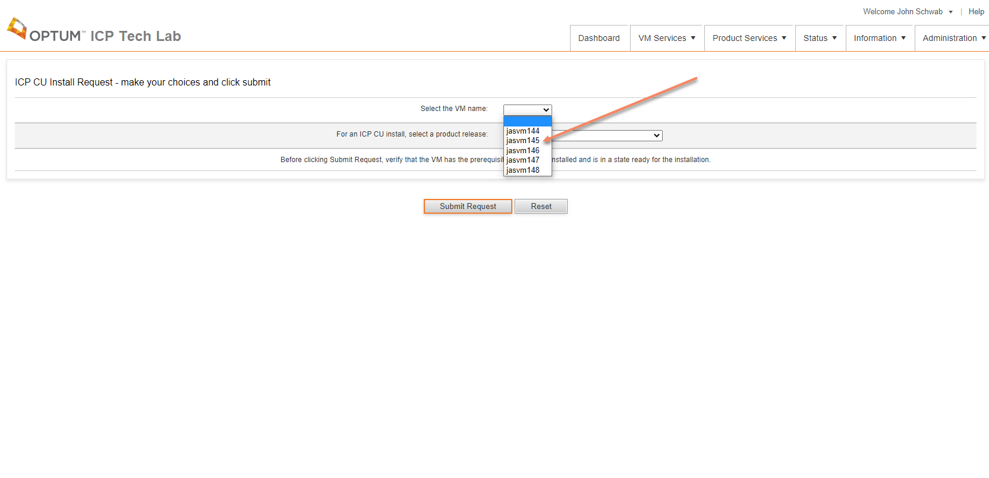

Then the user the user will select the CU product that they want installed and click the Submit Request button.

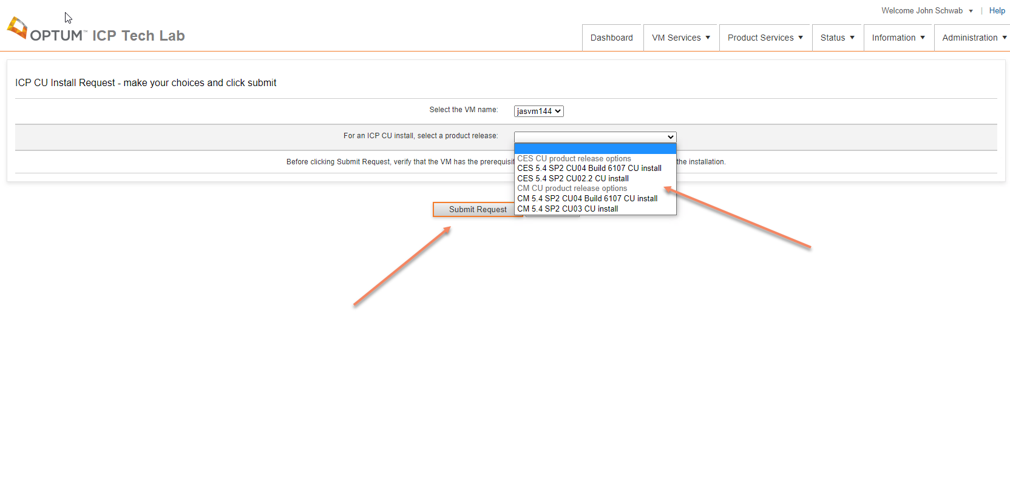A request is submitted to the ITL application and a job is created to fulfil the users request. The user will be forwarded to the View Requests page after clicking the Submit Request button. Once the job starts the user will receive an email containing the request information. Once the job completes the user will receive another email letting them know the job is complete.

## ICP 5.4 KB Load

A user can request a KB Load to a VM that does have ICP 5.4 installed. The KB Load Request page can be accessed from the Main Menu by clicking Product Services and 5.4 - KB Load Request.

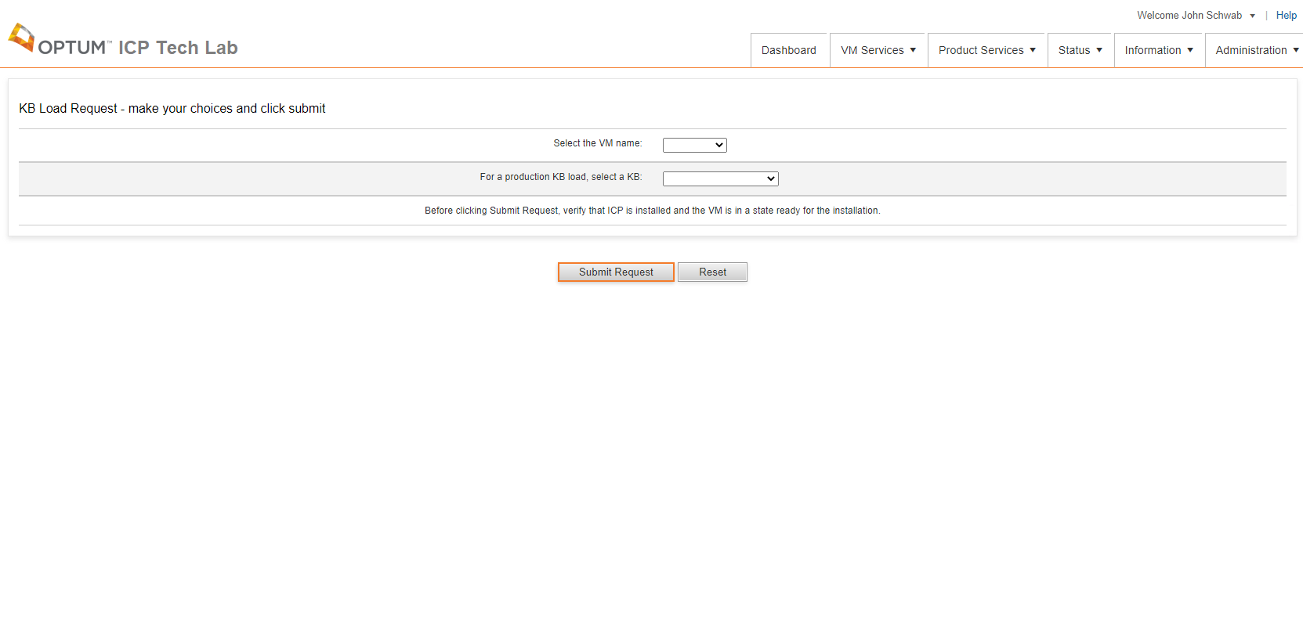

On this page the user will selects the VM they want to run a KB Load on.

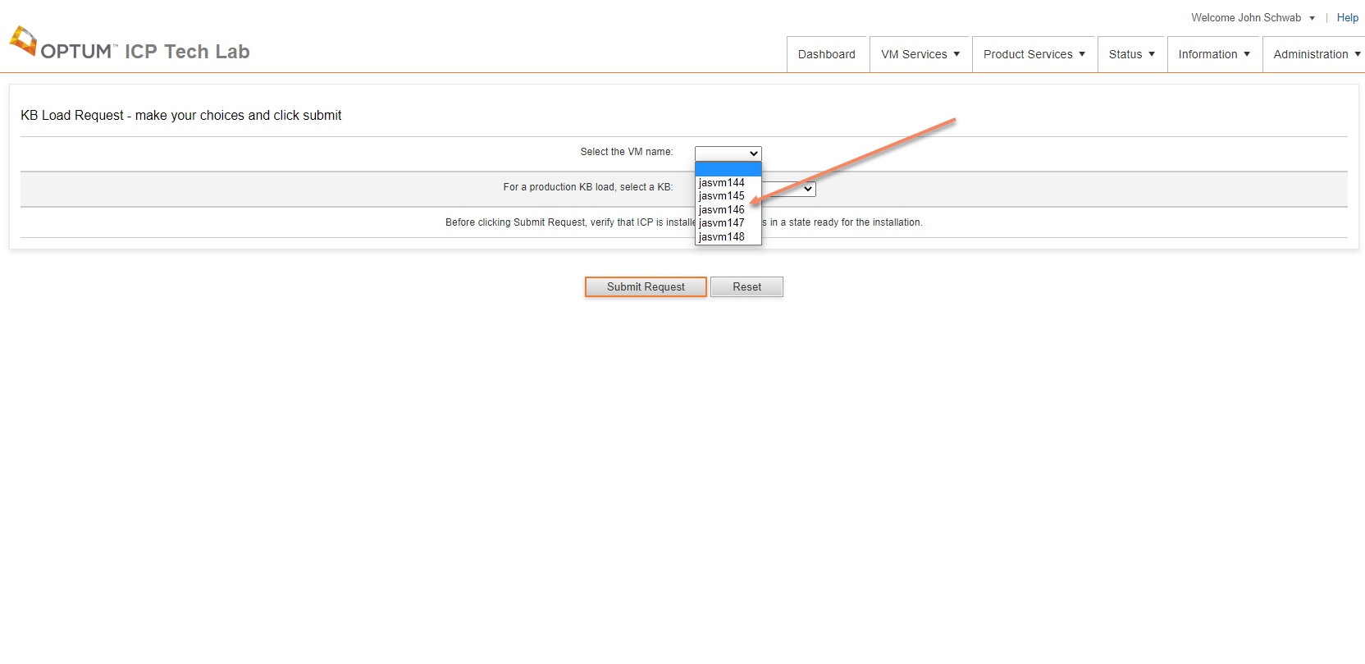

Then the user selects a KB that they want to load and clicks the Submit Request button.

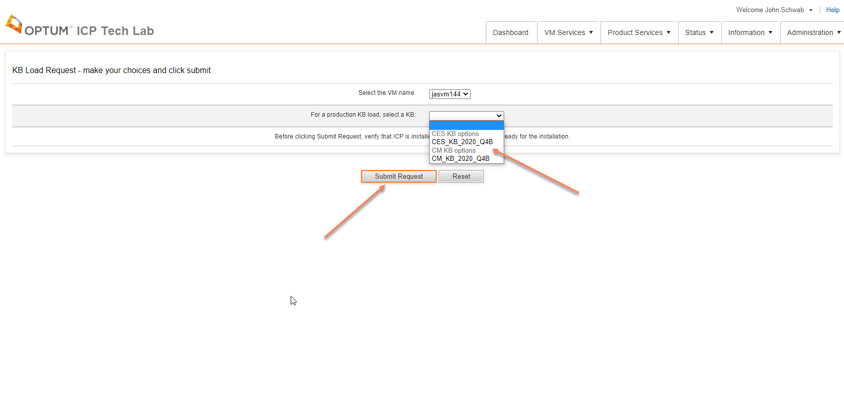

A request is submitted to the ITL application and a job is created to fulfil the users request. The user will be forwarded to the View Requests page after clicking the Submit Request button. Once the job starts the user will receive an email containing the request information. Once the job completes the user will receive another email letting them know the job is complete.

## ICP 5.4 LCD Load

A user can request a LCD Load to a VM with ICP 5.4 installed. The LCD Load Request page can be accessed from the Main Menu by clicking Product Services and 5.4 – LCD Load Request.

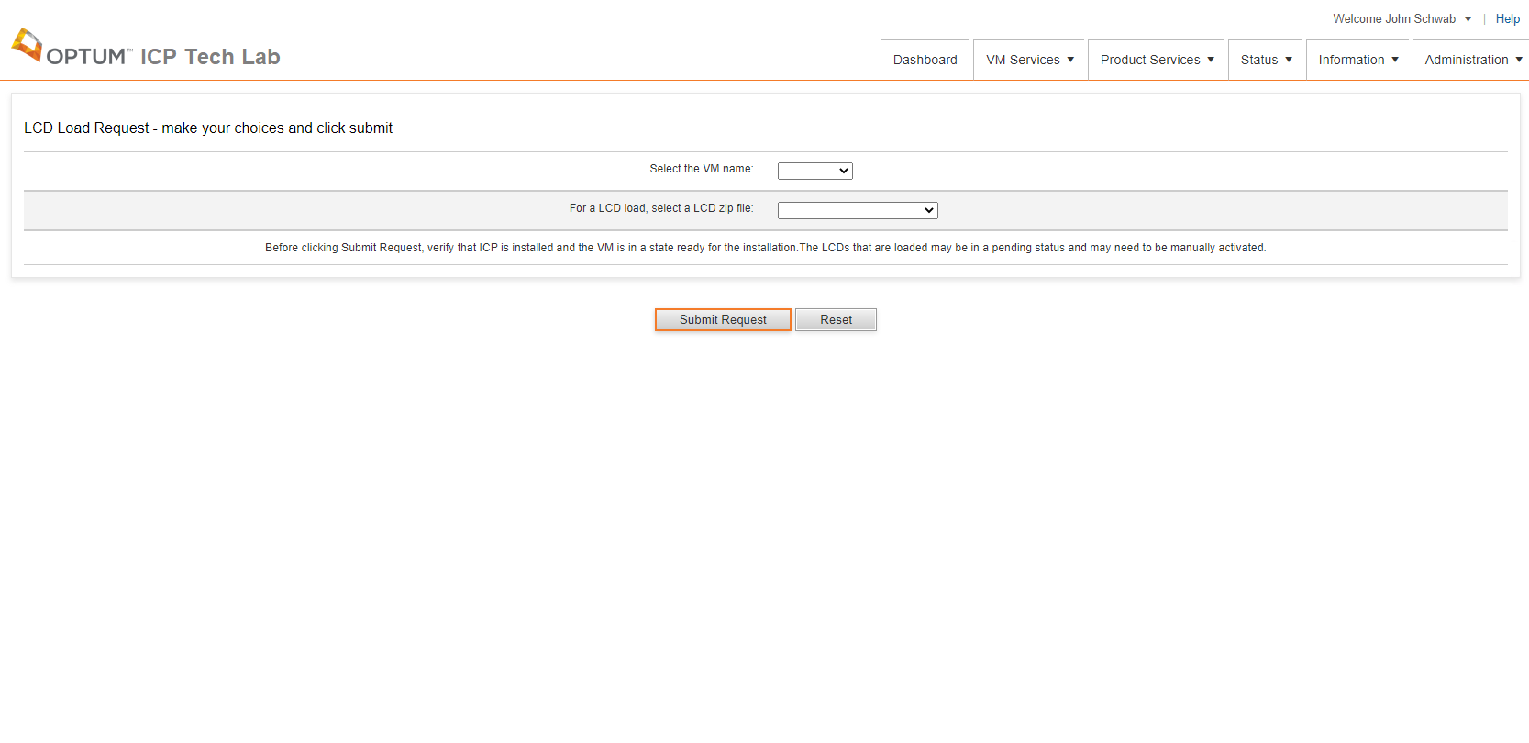

On this page the user will selects the VM they want to run a LCD Load on.

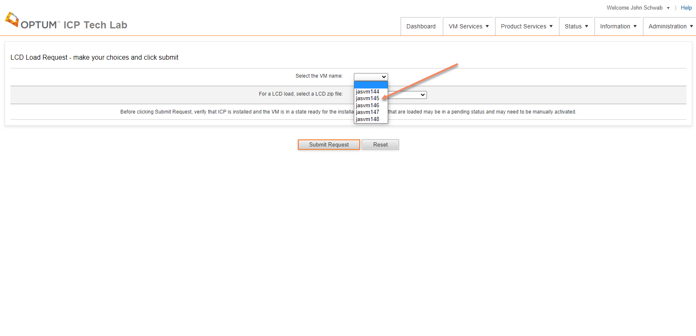

Then the user selects a LCD file that they want loaded and clicks the Submit Request button.

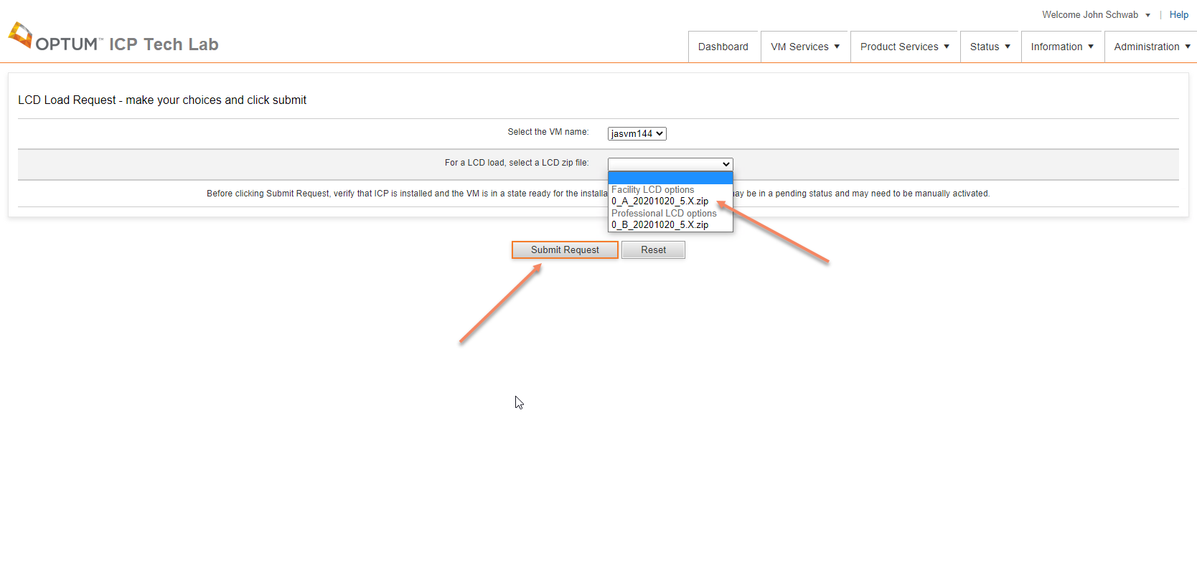

A request is submitted to the ITL application and a job is created to fulfil the users request. The user will be forwarded to the View Requests page after clicking the Submit Request button. Once the job starts the user will receive an email containing the request information. Once the job completes the user will receive another email letting them know the job is complete.