On the Improvements of Abstract-Check-Refinement Verification
Li Li^{1,2,3}, Ming Gu^{2,3}, Xiaoyu Song⁴, Jianmin Wang^{2,3}, Jiang Li^{2,3}, Kaiduo He^{1,2,3}
¹Dept. Computer Science & Technology, Tsinghua University, Beijing, China
²Key Laboratory for Information System Security, Ministry of Education China
³School of Software, Tsinghua University, Beijing, China
⁴Dept. ECE, Portland State University, Oregon, USA
Abstract - Model Checking has been introduced to verifying software successfully. Technique for abstracting software is even more critical for infinite-state systems, which makes model checking for software a reality. We present a good algorithm to integrate and optimize the three phrase of the abstract-check-refinement loop and automatically verify the safety properties of a program. We developed a prototype system named Jchecker to implement the method. In comparison with the previously work, the proposed method gets more efficiency in software model checking.
Index Terms - software, model checking, abstraction, safety.
1. Introduction
With the increased complexity of security systems, network protocols and embedded software systems, it is imperative to guarantee the functional correctness of system. Formal verification is an important technique to complement traditional test and simulation approaches. State space explosion problem imposes a major limitation in automated verification.
Predicate abstraction constitutes a promising strategy of reducing state space [1]. The counter-example-guided abstraction refinement (CEGAR) framework [2, 3, 4, 5] plays a key role in application of model checking. It has been successfully applied to checking device drivers by Microsoft’s SLAM project [4, 5]. Given a C program P and a set E of predicates, SLAM automatically creates a Boolean program BP(P;E), an abstraction of P. A Boolean program is a C program in which the only type is Boolean. The Boolean program has the same control-flow structure as P but contains only |E| Boolean variables, each representing a predicate in E. For each statement of P, SLAM automatically constructs the corresponding Boolean transfer functions that conservatively represent the effect of statement on the predicates in E. On the other hand, Berkeley’s BLAST project employed a similar idea with lazy abstraction [3, 6]. BLAST constructs partial abstract state graphs using different local predicates. A control flow automata (CFA) is the control flow graph with instructions labeling the edges. An on-the-fly abstract state graph preserves properties expressible as a temporal logic formula without existential quantification over paths. It can check safety properties. When the property is true in abstract model, it is true in the concrete one [1, 2, 3, 4, 11].
The most expensive part of the CEGAR method is: (a) the computation of an abstract successor, which frequently needs using an theorem prover exponential times, and (b) exploring the abstract state space, which is time consuming with the abstraction level. In this paper, we improved both of these two aspects and implement our method in our verification package. Also, we could not always get the right ascending chain condition predicates to terminate the verification [3], we integrate and optimize the three phrases of the abstract-check-refinement iterations in verification of safety properties of a program and insure the stop of the check. We develop a prototype systems named Jchecker to implement the algorithm [16]. In comparison with the previously work, the proposed method demonstrates its efficiency in model checking process.
The rest of the paper is organized as follows. Section 2 introduces some preliminaries about Predicate Abstraction. Section 3 describes our improved predicate abstraction and representation method. Section 4 gives our algorithm. Section 5 presents experiment results on applying the method to a variety of benchmarks. Section 6 reviews related work and concludes the paper.
2. Preliminaries
Consider a sequential program P as a control flow graph by structural operational semantics [1, 3, 4].
Definition 1. (Program)
Name: P
Declarations: x₁: A₁, …, x_{n}: A_{n ,}
Transitions: T: t₁,…,t_{p}
where P is a program, 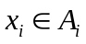 is a variable of type 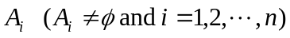. p = |P| is the length of P which is the number of transitions in P. Each transition t_{i} is an assignment or a control statement of P.
Definition 2. (State Graph) A state graph S_{P} = (Q, R_{P}, I_{P}) is defined in terms of P:
·Q = A₁ⅹ…ⅹA_{n}
·R_{p} =∪^{p}_{i=1} t_{p}
·I_{p} = {q | q∈Q and init(q) ≡ true} is the set of initial states,
where Q is the space of all the states of P.
Definition 3. (Hoare Triples) If a program P is in a state where is satisfied before transition 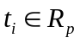, then the following state will satisfy 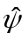.
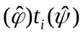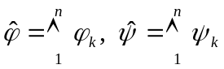
where 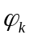 and 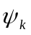 are predicates and 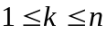, n is the number of predicates, is the pre-condition of and is the post-condition of . Both predicates characterize subsets of Q.
Definition 4. (Predicate Transformers ) [1, 10] For a fixed transition with the predicate 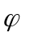 as the post-condition, the process of deriving a predicate 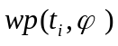, the corresponding weakest precondition, is called “a predicate transformer”. It has the property of
(1)
where 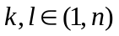. We often need a stronger condition 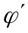 for all states, such that 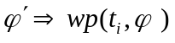.
Definition 5. (Strongest Post-condition) A predicate 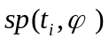 denoting the corresponding strongest post-condition where predicate denotes the pre-condition, we often need a weaker condition such that, for all states, 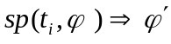.
It is shown [1, 11] that the predicate transformers 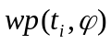 and 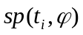 form a Galois Connection¹ with the implication of predicates as their orderings. We have :
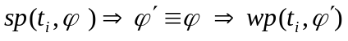 (2)
where , is the pre-condition of the transition and is the corresponding post-condition.
Definition 6. (Composition) [10] Given two successive transitions 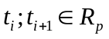, the function composition corresponding to the predicate transformer by 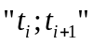 is defined as follows:
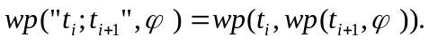
It can be generalized for a sequence of successive transitions as 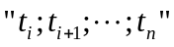, 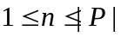.
3. Abstract Computation and Representation
Some new definitions are needed in our approach.
Definition 7. (Generalized Predicate Transformers) Let 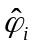 be the predicate intersection representing one of the states space of Q_{i} in a program P. Let 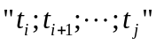 be a sequence of successive transitions from state Q_{i} to state Q_{j}. Let 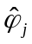 be the predicate intersection representing the state space of state Q_{j}. The pair of predicate transformer functions: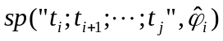 and 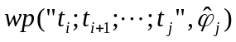 form a Galois Connection¹ with the implication of predicates as their orderings (Fig 1).
¹Galois Connection: Let 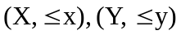be partially-ordered spaces. Functions 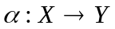and 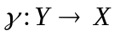form a Galois Connection 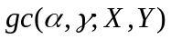 if
²Galois Embedding: A Galois Connection is Galois Embedding, if 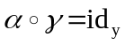, where is isotones injective and is surjective.

Fig 1: Galois Connection of state transition.
Definition 8. ( Program Abstraction) For a program P with state graph Sp = (Q, Rp, Ip), Q^{A} is an abstract state induced by a set of predicates on the variables of the concrete program P. For any concrete state space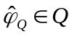 and its corresponding abstract state space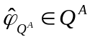, a Galois Embedding² is a function pair 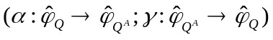 such that:
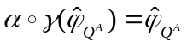 (3)
An abstract function is implied by one of the Galois Embedding properties:
(4)
This abstract function is difficult to be computed. It can be approximated by the following function [1]:
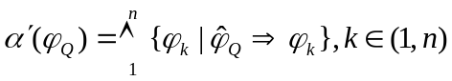 (5)
Definition 9. (Abstract Sequential Computation ) Let be a sequential block of assignments without control statements in-between. Q_{i}^{A} be the abstract state before transition t_{i}. By formulas (1-5), the abstract state Q_{j}^{A} after transition t_{j} can be expressed as follows:
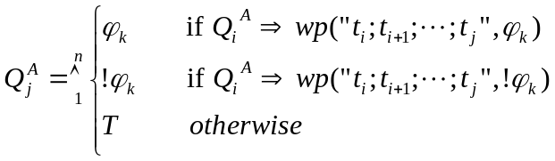 (6)
where 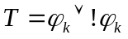 is state space of a variable [10, 14].
Theorem 1. Let 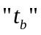 be a control statement with condition b and Q_{b}^{A} be the abstract state before it. The abstract state represented by Q_{b+1}^{A} after transition can be expressed as follows:
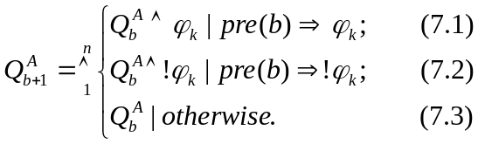 (7)
where pre(b) translates a condition statement b into a corresponding predicate.
Proof. Q_{b}^{A} be the abstract state before a control statement with b as its condition. The abstract state Q_{b+1}^{A} after Q_{b}^{A} is induced directly from formulas (1-5) as follows:
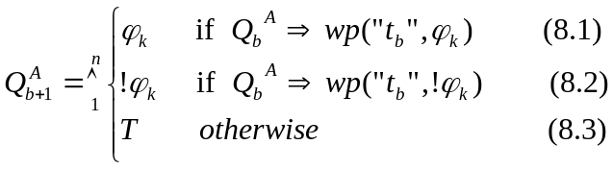 (8)
where 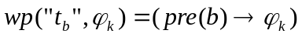 and 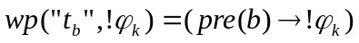 by [10, 14]. So we have
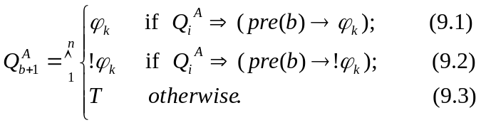 (9)
to substitute the formula (8). Using the improved formula (7) to compute the successive abstract state of the , we must prove: (a) (7)  (9) and (b) the abstract representation of (7) is more precise than (9). The proof is based on deduction.
Case 1. For the formula (7.1), assume 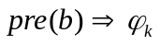;
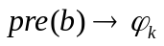is a tautology;
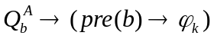 is a tautology;
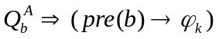 is true;
(9.1).
Case 2. From the formula (7.1) and case 1: assume
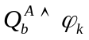; ;
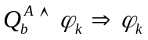,
which means the result the formula (7.1) is more precise than the (9.1). The proof of the formula (7.2) is similar to (7.1). It is clear that the formula (7.3) is true because 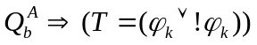 for all of states.
Example 1. For a control statement, if (x= =4), in a program (Fig 2(a)), the abstract state of the n+1 node is [T] for the predicate (x < 4) in [1, 4] (Fig 2(b)). But using the improved formula (7), we get an precise abstract state [!(x < 4)] thus reducing the traces needed to be explored in the program (Fig 2(c)).
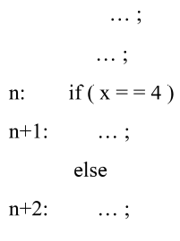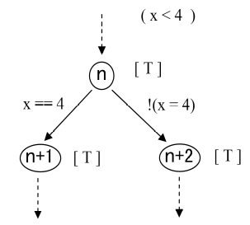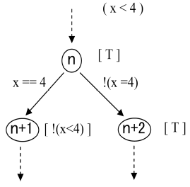
(a) a program fragment; (b) the abstract computation in [1, 4]; (c) the abstract computation by (7)
Fig 2: a program fragment and the abstract computations.
Theorem 2. (Abstract Logic Representation) Let an abstract Boolean variable B_{k} represent the concrete predicate , the value region of B_{k} is extended to {, false, true, T} like [15]. It forms a complete lattice with the logic implication as its ordering and the logic and “” and or “” as its binary operations (Fig 3(b)).
Proof. We first show the set {, false, true, T} with the logic implication is a partially ordered set. Let A be the state space of a program variable k , a predicate about k separates the A into two subsets of states: the states {} which make be true and {!} ＝ {A-{}} which make be false. Considering the set inclusion relation “” on the set {Ø, {}, {!}, A}, the relation is reflexive, anti-symmetric and transitive, where
Ø {}, Ø {!}}, {} A and {!} A. (Fig 3(a))
Intuitively, the logic type set {, false, true, T} with the logic implication “” on it is a partially ordered set. For a Boolean variable B_{k} corresponding to the predicate , T means logic unknown which represents the state space A of a variable from the program denotation semantics. represents logic empty which represented is Ø of a program variable. The implication relations on the set are
( false, true, falseT and true T).
(a) (b)
Fig 3: Abstraction representation of the lattice.
Now we show the partially ordered set <{, false, true, T };> with “” and “” is a complete lattice. Because of for all a,b∈ {, false, true, T}, the binary operation ab has a lower bound inf{a,b} and the binary operation ab has a upper bound sup{a,b}, the partially ordered set <{, false, true, T} is a lattice. where
falsetrue =, false=, falseT = false, true=, trueT = true, T =;
falsetrue = T, false= false, falseT = T, true= true, trueT = T, T = T.
Apparently, the lattice <{, false, true, T };> has a greatest element T and a least element , and it is a complete lattice. The proof is completed.
We use a n-tuple 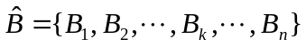 to represent an abstract state Q^{A} of the program instead of n-predicates. also means unreachable for a program variable, and so as for all of the state space from the program denotation semantic [1, 4, 7]. So the abstraction computation of a program is an invariant computation on the abstraction lattice [7].
4. The unification algorithm
To check safety properties, we add some observable variables related to safety properties in the program, thus causing the program to update the observable variables at each safety checking points [12, 13]. Thus, the safety checking can be reduced to checking an assertion (error-labeled) on the observable variables. If the new predicate is not good enough, the verification will fall into a loop. We have the following general algorithm similar to that in [3]:
Step 1 (Abstract and Search)
A finite set of global predicates are specified, and all of the abstraction reachable traces of the given program are explored and built automatically. If no abstract counter-example traces are found, the safety property holds; otherwise it goes to Step 2.
Step 2 (Check)
Abstract traces are checked automatically. When an abstract trace is found, it is checked automatically if the counter-example corresponds to a concrete counter-example in the original program. If so, then a program error has been found; otherwise the trace is a spurious counter-example and it goes to Step 3.
Step 3 (Refine)
New local predicates are found by analyzing the spurious counter-example to eliminate the spurious counter-example. If so, the exploration is resumed and the search for the program space goes on. But we may not be always getting the right predicates satisfied the ascending chain conditions to terminate the verification [3]. In that case we discard the counter-example trace and continue to search the other branching node using the new added predicates to avoid getting stuck into a loop.
We present an algorithm using the depth-first research method with Lazy abstraction [3], and using Foci theorem prover to find new preidates [8, 9]. The algorithm works on the syntax graph of the program and implements depth-first search with random branch selection. The algorithm reads a program (line 1 and compute the initial abstract states (line 2). The function forwardSearch( ) achieve the abstraction and forward exploration computation (lines 3-11). When all of the abstract state space is explored and the program is safety (line 11); otherwise, it finds a counter-example trace (line 5), the algorithm returns a trace “t” to function backTrace( ) to verify whether it is a spurious counter-example (lines 12-19). If it is true (line 17), the algorithm refines the trace expression exp(e) (lines 20-25) and gets new predicates (line 21), the system returns to forward search process to eliminating the spurious trace (line 23). If we could not find predicates where are good enough, we discard the spurious counter-example and go on searching others state space (line 22).
The improvement Algorithm
5. Validation and Experiments
We have developed a prototype system named Jchecker, to implement the advanced verification algorithm [16]. The prototype is developed in JAVA language and uses Vampyre tool [17]. It proves implication and uses Foci interpolation tool to find new predicates [8, 9]. We use a PC with Intel Celeron 2.4GHz CPU and 1024M RAM to model check safety properties of C programs partly from [3]. The results of the experimental are show in table 1.
Program | Improvement-algorithm |  |  |  | algorithm
Program | traces | predicates | TP calls | runtime | traces | predicates | TP calls | runtime
Funlock.c | 298 | 11 | 2915 | 2'4” | 894 | 15 | 3585 | 3'56”
Foo.c | 1 | 1 | 5 | 5” | 1 | 1 | 2 | 4”
Counter.c | 15 | 5 | 191 | 10” | 23 | 5 | 111 | 6”
Loop.c | 13 | 3 | 206 | 9” | 14 | 3 | 49 | 6”
Table 1: Experimental results with Jchecker
6. Conclusion
We considered a improved method in this paper to reduce the times of using the theorem prover and the state apace needed to be explored. The algorithms improves the efficient greatly in verifying safety. Although, we implemented it in C programs, it can apply to other language programs too.
Reference
- S. Graf and H. Saidi. “Construction of abstract state graphs with PVS. ” In Computer aided Verification, CAV 97. LNCS 1254, pages 72-83. Springer-Verlag, 1997.
- E.M. Clarke, O. Grumberg, S. Jha, Y. Lu and H. Veith. “Counterexample-guided abstraction refinement.” In Computer Aided Verification, CAV00. Pages 154–169. Springer-Verlag, 2000.
- T.A. Henzinger, R. Jhala, R. Majumdar, and G. Sutre. “Lazy abstraction.” In Symposium on Principles of Programming Languages, POPL2002. Pages 58–70. ACM Press, 2002.
- T. Ball, A. Podelski and S. K. Rajamani. “Boolean and Cartesian abstractions for model checking C programs.” In Tools and Algorithms for Construction and Analysis of Systems, TACAS 01. LNCS 2031. Springer-Verlag, 2001.
- T. Ball, B. Cook, S. Das and S. K. Rajamani. “Refining approximations in software predicate abstraction.” In Tools and Algorithms for the Construction and Analysis of Systems, TACAS 04. LNCS 2988, pages 388–403. Springer-Verlag, 2004.
- T. A. Henzinger and R. Majumdar. “A classification of symbolic transition systems.” In Theoretical Aspects of Computer Science, STACS 00. LNCS 1770, pages 13–34. Springer-Verlag, 2000.
- Cousot, P and Cousot, R. “Abstract interpretation: A unified lattice model for static analysis of programs by construction or approximation of fix points.” In Proceedings of the 4th POPL (Los Angeles, CA). Pages 238–252. ACM Press, 1977.
- K. L. McMillan. “Application of craig interpolants in model checking.” In Proc. of the 11th International Conference on Tools and Algorithms for the Construction and Analysis of Systems. LNCS 3440 , pages 1-12. Springer, 2005.
- K. L. McMillan. “An interpolating theorem prover.” In Proc of the 10th International Conference on Tools and Algorithms for the Construction and Analysis of Systems. LNCS 2988, pages 16-30. Springer, 2004. http://www.kenmcmil.com/foci.html.
- E. W. Dijkstra. “A Discipline of Programming.” ISBN: 013215871X. Prentice Hall 1976.
- C. Loiseaux, S. Graf, J. sifakis, A. Bouajjani and S. Bensalem. “Property preserving abstractions for the verification of concurrent systems.” In Formal Methods in System Design, Vol 6, Iss 1.Jan. 1995.
- D. Beyer, A.J. Chlipala, T.A. Henzinger, R. Jhala and R. Majumdar. “the blast query language for software verification.” In Proceedings of the 11th International Static Analysis Symposium, SAS 2004. LNCS 3148, pages 2-18, Springer-Verlag, 2004.
- D. S. Rosenblum. “a practical approach to programming with assertions.” In IEEE Transactions on Software Engineering, vol. 21, no. 1. Jan. 1995.
- M. Huth and M. Ryan. “Logic in Computer Science Modelling and Reasoning about Systems.” ISBN: 0 521 54310X. Cambridge University Press 2001.
- M. Fitting. “Kleene's Logic, Generalized.” IN Logic and Computation. Pages 797--810, 1992.
- http://code.google.com/p/jchecker/.
- http://www.cs.ucla.edu/~rupak/Vampyre/.

