2015 was a prolific year for biotech IPO’s. The year however, culminated with a dip in fourth quarter pricing, and speculation that a biotech bubble was forming. In our last issue we opposed the “bubble idea” and put forth an alternate thesis that over the last fifteen years, three essential process technologies fundamentally changed the biotech industry, resulting in faster, more effective innovation: mapping of the human genome, informatics and HTS or high throughput screening. As the cost of gene sequencing, informatics and HTS became dramatically lower, these technologies became ubiquitous resulting in increased potential for unprecedented biotech innovation. Consistent with our theses, we are seeing the full manifestation of this in today’s biotech industry.
These disruptive technologies, which are now industry standard, were foundational to the impressive drug pipeline that fed the 2015 crop of new issues, and will continue to provide an ever growing pipeline of pharmaceutical innovation for decades. We constantly encourage investors to review R&D processes as an essential component of due diligence, to understand if these methods of discovery are used to drive innovation within target investments. And we put forth the idea that investments that have relied on informatics and HTS in particular are likely to have increased probability of success. In general, biotech investors should gravitate toward companies that rely on these techniques.
Just within the last two years, a fourth disruptive technology, possibly the most profound of all, was discovered which is spreading rapidly throughout the biotech community, the use of CRISPR. There is tremendous irony in the idea that the biggest biotech innovation in the last 15 years, arguably to date, was derived from a process developed over five billion years ago by our prokaryotic ancestors. Pronouned “CRISPER”, CRISPR is an acronym: Clustered Regularly Interspaced Short Palandromic Repeats. CRISPR is essentially a component of the immune defense of prokaryotes such as bacteria.
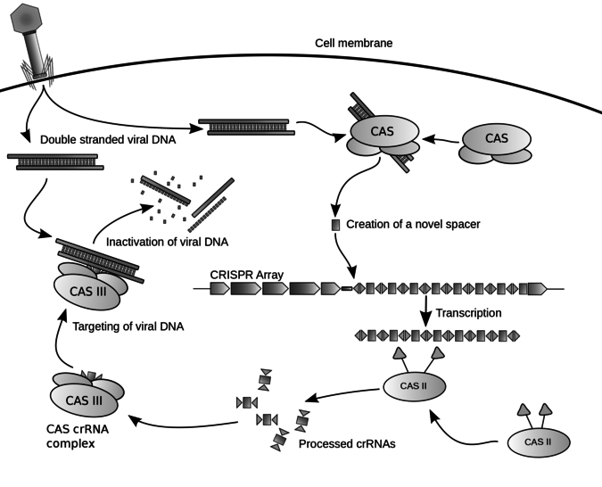
Figure 1 Diagram of the CRISPR prokaryotic viral defense mechanism. Horvath P, Barrangou R (2010). "CRISPR/Cas, the immune system of bacteria and archaea". Science 327 (5962): 167–70. Bibcode:2010Sci...327..167H. doi:10.1126/science.1179555. PMID 20056882.

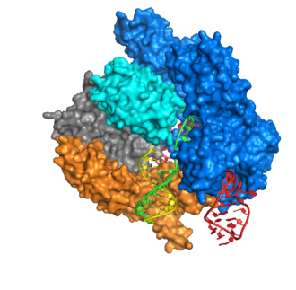
CRISPR’s work with CAS enzymes, or proteins (CRISPR Associated Proteins, such as CAS1, CAS2, CAS3 & CAS9) to intercept invading DNA, e.g. viral DNA as depicted in Figure 1. The primary mode of action is the CRISPR guide RNA, which essentially transcribes invading “enemy” DNA to determine if the DNA is compatible. If the DNA is incompatible it is bound to CAS proteins which impede replication of the DNA, a process known as protein interference. But if the DNA is compatible or beneficial, it is cleaved and added to the bacterial DNA as an enhancement.
Leveraging the ability to cleave and incorporate, scientists have adopted techniques to harness the CRISPR mechanism and modified CAS proteins for the purpose of gene editing. Gene editing is not a new field, and there are other techniques. However, CRISPR gene editing holds tremendous promise for therapeutic application. Imagine being able to cheaply and easily “knock out” undesired genes such as the dreaded p53 cancer gene or Huntington’s HTT gene.
As promising as gene editing is in the context of mammalian and human therapeutic applications, it will be many years before the complexity of this technique will see prime time application as a true gene editing tool in mammals.
Figure 2Crystal Structure of Cas9 bound to DNA, as solved by Anders et al in their 2014 Nature paper. Structural rendition was performed using UCSF's Chimera software.
But CRISPR is quickly establishing itself as the gold standard for other research techniques, the most significant of which is use of CRISPR as a screening mechanism, to quickly and easily identify potential drug targets. Before CRISPR, HTS (High Throughput Screening) was the state of the art means to screen. And state of the art HTS robotics today are able to screen at a rate of one compound every 3 – 4 days. Even today this is considered a blinding speed compared to the methods as recent as two years ago.
So the excitement about CRISPR is well deserved. Not only has this technology brought about a new level of therapeutic potential, it is currently leveraged as a much more efficient precursor to traditional robotic HTS. By leveraging CRISPR to predict protein binding, the technique can eliminate thousands of potential protein targets in a single test process, shrinking years of trial and error to a single experiment. So rather than using HTS to screen for example 1,000 compounds over a period measured in years, CRISPR can reduce that group to hypothetically, 10 and HTS can then complete more specific testing in, again hypothetically 40 days. For the biotech industry, this is a leap forward on an unfathomable order of magnitude! Imagine the time, R&D cost reduction associated pipeline impact of eliminating so many candidates so easily. No doubt CRISPR is going to have a tremendous impact on the efficiency of drug discovery.
In terms of the investment world, for investors searching for early stage blockbusters, targeting companies using CRISPR as a screening tool seems like a great way to hack the complexity of handicapping R&D success. In broader investment terms, there are two ways to look at CRISPR. The first is the profound application of true gene editing, for example to “knock out” a gene such as HTT (Huntington’s). And there are already many public and private companies involved in this aspect of CRISPR. We see gene editing triggering a number of biological and ethical issues that may take at least a decade to resolve. So exercise caution on swinging for the fences on this approach.
The second, and what we see as more immediate term is the use of CRISPR as a screening tool to dramatically accelerate the identification of drug candidates. This aspect of CRISPR is a realistic use of CRISPR today. Companies leveraging CRISPR in this way are likely to have reduced R&D costs, accelerated discovery and overall more productive pipelines. And so we believe this is an excellent way for investors looking for the next blockbuster to hack the complexity of biotech due diligence.

About the author:

Karl B Douglas is a management consultant to institutional investors in biotechnology and other sectors. He is a co-founder of Unify Biotechnologies, a NY based biotech incubator that works with early stage to pre-IPO biotech companies. Karl@unifybio.com

Title: CRISPR, Gene Editing Possibly the Biggest Biotech Advance since Mapping the Human Genome.

