Coal will be 3rd Most Popular Source of Energy in 2030

July 2016

Coal will slip behind natural gas in 2030 and become the third fuel worldwide. This will last well beyond 2040. Run a quick search on “coal and dead” and you’ll get hundreds of articles projecting the death of coal. Recent bankruptcies effecting once considered “invincible” companies such as Peabody Energy, Arch Coal and Alpha Natural Resources, has led many to conclude coal is in fact a dead sector, relegated to the buggy whip graveyard. But the Energy Information Administration (EIA), a division of the Federal Government says otherwise. How often do you get to invest in an industry responsible for supplying 33% of a $15 Trillion dollar economy’s electricity demand for pennies on the dollar?

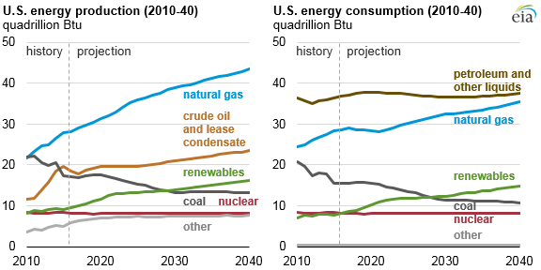
Figure 1
Source: U.S. Energy Information Administration, Annual Energy Outlook 2016 Reference case

Indeed the short term outlook is far from obvious as coal’s share of electricity generation will continue to fall. Coal was burned to generate 50% of US electricity production in 2005 and 33% in 2015. It is projected to fall to 21% by 2030 and eventually 18% by 2040. How do you make money in an industry slated to shrink by 27% over the next 14 years? Invest in strong balance sheets! It’s the un-leveraged companies that will emerge as tremendous cash flowing opportunities offering growth fueled by massive industry consolidation.

Many of the recent bankruptcies are arguably self-inflicted; the result of significant overleverage, in some cases as much as >10X EBITDA. As Figure 1 demonstrates, the onset of abundant low cost natural gas, a competing fossil fuel, directly offset a significant percentage of the coal burn through “coal-gas switching”. In fact the industry contracted 34%, with electricity from coal dropping 17 points from 50% of all electricity to 33%. The resulting commodity price drop, margin erosion, over leverage and a decade of anti-coal lobbying and media presence by environmental activist groups, produced a coal industry in a tailspin! So what makes this pariah of an industry potentially tomorrow’s darling of an investment opportunity? Things to consider:

We can’t do without it! Even under the most aggressive EPA assumptions, coal will still represent about 10% of US energy consumption by 2040, a quarter century from now. It will still be used to generate 18% of US electricity by 2040, a statistic that must be quite a disappointment to green lobbyists.

Scrubber Capex Investment – The power industry has already invested over $500B in environmental remediation equipment such as NOX/SOX scrubbers. They will need the depreciation from these investments to keep electricity prices down.

Low Gas Prices Unsustainable – Gas prices are rising steadily as environmental regulation increases and exploration activities become more costly. Rig count has fallen to a three year low and at costs above $2.50 per MMbtu, coal starts to look competitive again.

Global demand will continue: India and China will remain the largest consumers of coal through 2040. The EIA forecasts coal consumption to grow at the slowest rate of the competing fuels, at a mere .6% per annum.

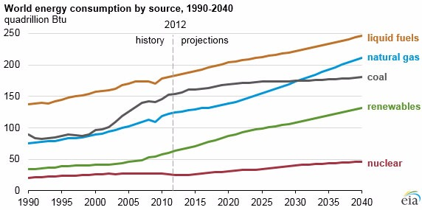
Figure 2 - World energy consumption by source 1990 - 2040. Source: EIA
No alternative for steel production: We haven’t found a steel making alternative to the use of metallurgical coal in the steel making process.

Fresh balance sheets – Previously over-leveraged companies that emerge from bankruptcy and newly formed companies managing the vestigial assets of the doomed ones will have stronger balance sheets and hopefully debt-phobic management.
Renewables benefit from coal – Newer transmission lines built to support renewable power producers would be financially unsustainable without the additional use by base load power producers that generally utilize coal for their base load generation.

Technology - Coal can be burned with zero emissions if the right technologies are used. As energy production costs continue to rise from competing sources, clean coal will reemerge as a cheap source of energy, potentially tipping the scale back in favor of the black stuff!

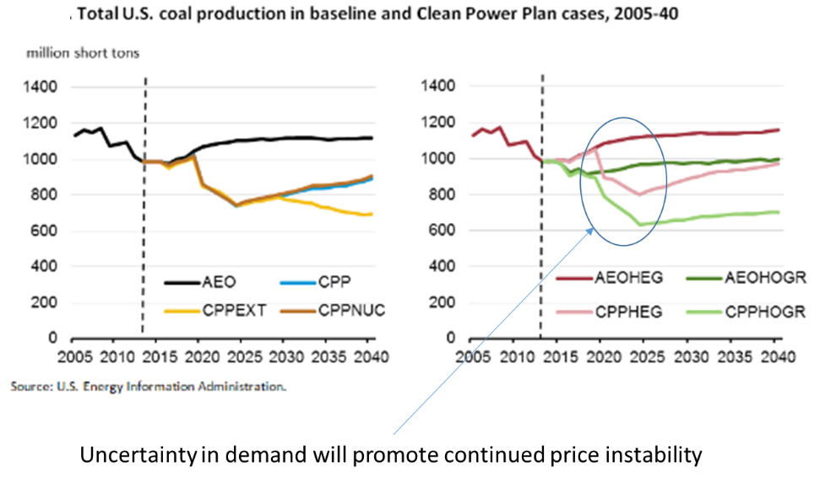
Before you open up your online trading account and start buying coal stocks, there are some very important considerations to keep in mind. In terms of coal production forecasts, the numbers vary significantly. CPP or Clean Power Plan is an EPA initiative to reduce CO2 emissions.
Figure 3

Ultimately if this plan gets fully implemented, US CO2 emissions will be reduced by 45% relative to 2005 levels by 2040. As the forecast indicates, there can still be a significant delta in demand, particularly in starting in 2019, where under the CPPHOGR scenario we see demand fall to 650M tons by 2025. But there’s a silver lining in all these numbers! According to the EIA, US utilities burned 740 million short tons in 2015. So three of the four most severe scenarios already call for more production than is currently available. And with the most recent announcement of Alpha Natural Resources, additional production will go offline. With 650M tons of thermal coal supply, well run companies should be able to achieve reasonable cash flow.

The characteristics to look for are quite simple: minimum leverage, low reclamation liability, low production cost. Production cost is usually a function of reserve quality and logistics. Forward sales price is also significant. Companies with long term off-take agreements will offer significant ability to ride out short term dips in the market which based on EIA forecasts are expected between now and 2020.

In the Microcap segment of the market, Hallador Energy Company (NasdaqCM: HNRG) is worthy of tracking. The company is in the stable Illinois Basin. It has a market cap of roughly $134M. Once again this company has demonstrated fiscal discipline, debt is roughly $250M with EBITDA of $85.38M as of 3/31/2016. Their operating margin is 13.46%, slightly lower than much larger analogs such as Alliance Resources, ARLP. We think HNRG will be interesting if they can make smart acquisitions with low to no leverage, and grow their footprint.

Foresight Energy LP (NYSE: FELP) is another Microcap with market capitalization of roughly $209M ($1.60 per share as of 7/5/2016). FELP is a significantly larger company. The company reported TTM revenues of $912.02M with EBITDA of $236.64M. Total debt is $1.6B, and operating margins are reported as of 3/31/2016 of 4.5%. We believe the leverage profile of FELP demonstrates the same type of risk profile that has brought down many of the majors. We consider over-leveraged assets (more than 5X EBITDA) an insurmountable risk in this market place. On an EV/EBITDA valuation basis, FELP is significantly overpriced relative to its peers.

The volatility in the coal sector will continue to test the mettle of coal companies through 2020. Only the companies that have minimal debt will survive. We believe many of the choice assets that will become available through the bankruptcy process will be acquired by private equity sponsored companies. Those same PE companies will seek to exit into the IPO market and a sector of hopefully deleveraged assets will join the publicly traded coal sector.

Note: This article is not an attempt to provide investment advice. The content is purely the author’s personal opinions and should not be considered advice of any kind. Investors are advised to conduct their own research or seek the advice of a registered investment professional. The author does not own shares or any equity or debt interest in any companies mentioned in this article before or at its publishing.


About the author:
Karl B. Douglas is a managing director at PPMT Capital Advisors, Ltd., a multi-family office investor. In addition to activities as a generalist, Mr. Douglas has been investing in and advising companies in the coal sector since 2006. He began a new coal investment campaign in 2015 and is currently actively investing in the coal industry.

PPMT Capital distinguishes itself by its data-driven approach to investment sourcing and its extensive global expert network capabilities for operational support and due diligence. PCAP invests in infrastructure, industrials, manufacturing, energy, healthcare, and real estate. The typical investment range is $15M to $150M in an array of debt or equity structures.

