2016 Microcaps Trends – The Indians are Coming!

According to Goldman Sachs Global Research, the top three performing economies for 2016 will be India, China and Indonesia in that order. China is obviously already well established in US capital markets, with roughly 198 ADR (American Depository Receipt) listings and a plethora of other issues listed directly on US exchanges. All sizes of Chinese companies are represented, from Large Cap to Micro Cap. Indeed there is no shortage of supply for institutions seeking China exposure. By contrast, what we find shocking, is the world’s top performing growth economy, India, is totally underrepresented in US markets.
Actually there are only 12 Indian ADRs listed in the US totaling roughly $440B of market cap. And of that, roughly $308B is contributed by one issue, HDFC Bank Ltd., NYSE-HDB. We expect institutional thirst for Indian equity exposure to increase substantially based on the China slow down and the relative decimation of commodity based BRIC economies such as Brazil and Russia. This supply demand imbalance, combined with inefficiency of capital availability in India domestically, should naturally create a flow of companies seeking the advantages of US listings.
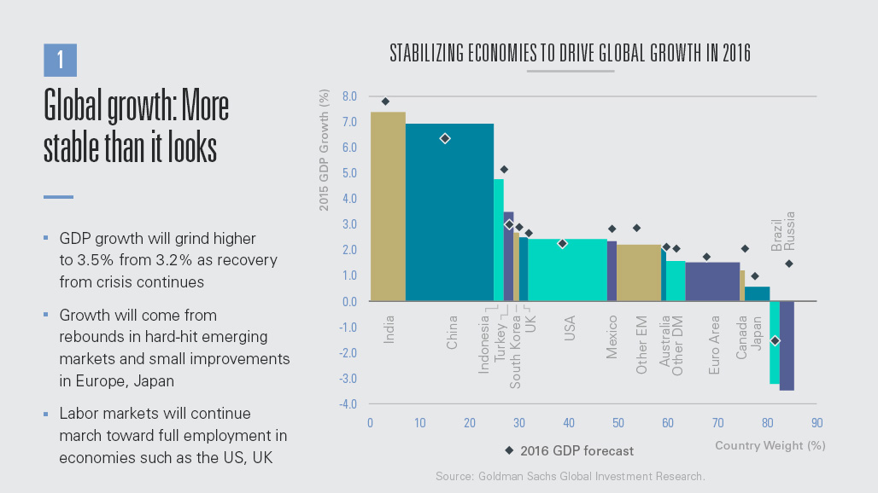
Figure 1Source:http://www.goldmansachs.com/our-thinking/pages/outlook-2016/index.html
The Bombay Stock Exchange is the major trading venue for Indian companies and their stocks. It’s the world’s 11th largest stock exchange with more than 5,000 companies listed. Aggregate BSE market capitalization exceeds $1.7 trillion. Where liquidity in the top 100 issues is quite respectable, liquidity becomes a challenge in the smaller company equities. These companies would be well served to consider level II ADR listings in the US. ADR listing of this class of security would attract US institutional investors that have resisted buying domestic Indian issues due to currency risk, added costs and in certain cases, exposure to non-US securities laws and taxes.

Although the listing standards on the BSE are quite rigorous, the vast majority of US investors prefer the governance and transparency requirements of the US exchanges. For companies already listed on the BSE, the ADR process is quite straight forward.
Figure 2Bombay Stock Exchange
The basic ADR listing process is the Level I listing process. And although there are some benefits such as providing a transition path for companies ultimately seeking national exchange listing, Level I does not provide the depth of investor access since securities under Level I are restricted to trading OTC.
However, the level II ADR listing process allows companies to trade domestic share equivalents on a US national exchange. For qualified issuers, this listing process is the quickest path to achieving improved liquidity and eventually more efficient price discovery. With Indian ADR’s in particular, quite often because of the under supply, Indian company ADR’s trade at a premium to the ordinaries.
Level III ADR process actually combines national exchange listing with a capital raise. For lesser known companies, the processes inherent in “IPO securities offering activities” for example the roadshow, serve to not only raise capital, but to educate buy side investors on the merits of owning the equity.
Overall, the ADR listing strategy is an excellent way to attract a much broader investor base into a particular security. Listing on a US national exchange will also contribute to the prestige of lesser known Indian equities and promote more efficient price discovery. Where the American Depository Receipts processes require that a company is already listed on an exchange locally, those companies that are privately listed, have the option to list domestically and pursue the ADR process, or they can consider a direct offering to the US markets. It’s this last category that quite possibly will create the best investment opportunities for US investors.

Private equity investors have enjoyed a significant pool of mature cash flowing companies from which to choose in India. High returns have been consistently generated from the significant number of competitively priced private equity deals that are available in India. There are numerous sectors where multiples are considerably lower than their US equivalents. Another factor that may contribute to a wave of Indian IPO’s is the desire to monetize growth and take money off the table. According to McKinsey Research, of the $51 B invested in private equity, only $16B has actually exited. US markets may offer an alternative to limited exit opportunities in India. With the improved liquidity for US investors and improved price discovery, PE investors may be able to exit at competitive multiple directly into the public companies.
Figure 3 McKinsey Research - EMC
Figure 4 McKinsey

All of these factors lend themselves to support for more Indian companies preparing ADR and IPO transactions for early 2016 and beyond. And for MicroCap investors and issuers, we expect to see stepped up activity in the asset class for 2016.

Wesley Ramjeet is CEO of PPMT Strategic Group, Inc., a Tax and Business Advisory Firm. PPMT is actively representing Indian companies considering the ADR listing process. Email: wramjeet@ppmtgroup.com

