Raising Capital in the Microcap Market:

7 Success Factors for Achieving Significant Capital Raise Objectives.

2016 represented a year of surprises in many areas. While we were entertained (or stressed out) by the election, many significant changes took place in the markets. We saw the coal industry go from bust to boom, and shale oil go from boom to bust and ultimately to stability all within 12 months. In addition we saw the Microcap market outperform every other market by capitalization. 2017 looks promising for the markets given some of the tax legislation being proposed. Now more than any period since 1998, Microcap CEOs should be on the trail hunting for that elusive capital. And investors will be itching to find great deals. So we’ve compiled seven of the best practices we observed in 2016 for raising capital to arm CEOs with some solid ideas as they hit the trail in 2017.
The Microcap market has existed for decades going back to the 1970’s. Once called the “Pink Sheets” referring to the 5” by 18” stack of pink quotation sheets which were collated and printed daily for market makers, and often referred to as the Penny Stock market, the Microcap market has evolved significantly. Fifteen years of SEC regulatory reforms, and tighter FINRA regulation has changed the Microcap market for the better, to a point where it is fast becoming a legitimate capital raising forum for CEO’s seeking an alternative to the perceived “limited options” of the venture capital and private equity markets.
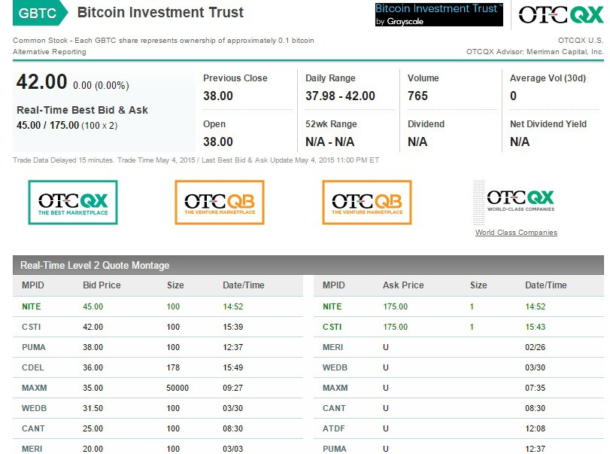
US public companies with market caps of $250M or less, so called “Microcaps” now exceed $200B, yes BILLION, in aggregate market capitalization across all US exchanges. It’s hard to argue that a $200B market is anything but legitimate. And that fact is being further echoed by value hungry institutional investors seeking returns that outperform the major markets. It’s fair to say that the Microcap market it still evolving. With the winds of opportunity filling the sails, what do CEO’s need to know to tap into this exciting alternative?

Seasoned institutional investors such as Perrit Capital, Heartland Advisors and others have developed substantive methods of due diligence that allow them to value hunt effectively. And with the presence of serious institutional funds investing in Microcap stocks, CEO’s have an unprecedented opportunity to develop a "direct to investor" audience. We examined the successes and failures of several companies that we met in 2016, during various phases of capital raises to identify the common best practices being leveraged in the Microcap market. Here are seven commonalities that we observed during 2016:

Understand the market

Just understanding that you’re competing with almost 6,000 companies for capital is a great start! The most common point among the successful CEOs and other management officers that we met during the year was that they understand the market dynamics very well. They understand that there are many institutional investors seeking out-sized returns, “seeking alpha” based on pure fundamentals of equities listed in the inefficient OTC market. Gone are the myths that “institutional investors do not invest in Microcaps.” Their conviction was bolstered by the knowledge that over 1420 of the Microcap companies currently have institutional ownership of over 10%.
US Listed Companies by Exchange
Exchange | Total Listed | Microcap
Amex | 319 | 224
Nasdaq | 2538 | 1074
NYSE | 2691 | 298
OTCBB | 74 | 67
OTC | 4586 | 4256
 | 10208 | 5919
Table 1: Microcap companies under $250M by exchange, Source: TD Ameritrade.
Most companies recognized that NASDAQ was the ideal exchange on which to be listed. But most recognized that there is value to being listed on the OTC. In general most understood that there was significant interest in various forms of PIPE (Private Investment in Public Equity) offerings. And for good reason, according the PrivateRaise.com, $82 Billion in PIPE transactions were completed during 2016.
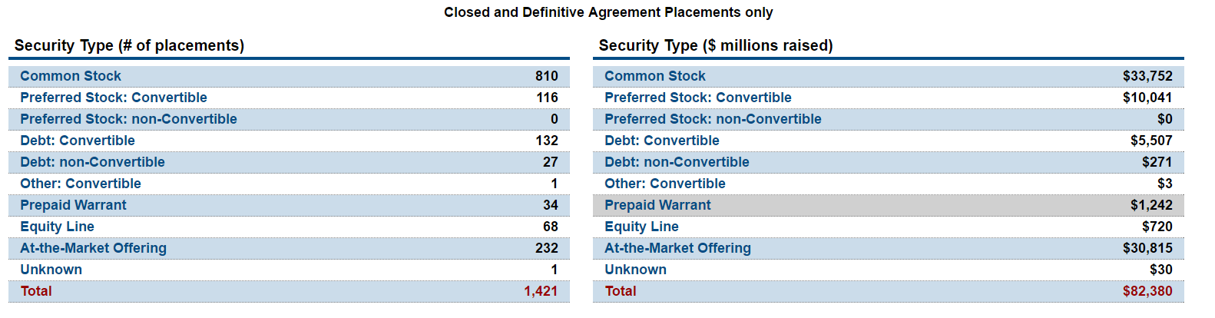
Table 2 PIPE deals completed in 2016, Source: PtivateRaise.com

Institutional investors seek value
Management for the most successful transactions we observed understood that fundamentally speaking, Microcap investors are bargain hunters. They are looking for companies that can grow at outsized return rates. If your company is growing at a compound annual growth rate that is no different to the more seasoned larger mid cap companies, it’s difficult to justify Microcap risk. Many of the more successful companies offered venture and private equity value propositions. We feel this is a critical success factor, and that both in deal structuring and marketing, it is necessary to offer venture and private equity returns with the promise of a built in “eventual” liquidity event as the market for the securities develops.

Successful capital raises typically have an institution on board well before going public.
Successful management teams generally leverage existing institutional relationships to help develop the public market for their shares. It’s important that CEO’s understand that their shares are designed to be sold. And large buyers are generally institutions that are familiar with the “story”. Who’s in the deal is often as important as the deal itself. Prestigious institutional presence often denotes that someone did significant due diligence and vetted the company and its management.
Although Microcap institutional investors are value investors, they are driven by the need for capital preservation. Capital Preservation is code for “do we trust management”. “Is there meaningful governance in place?”. By attracting a major institution in the stock, and leveraging company relationships with the “anchor institution” CEOs can generate a significant ownership base.
For early stage companies, the right institutional investor can be the difference between long term capital raising success and falling into the “OTC no man’s land”. It’s all about sponsorship: Consider that most institutions queue up to invest in venture and PE funds. They do this for the professional management that ensure proper governance and board structures are in place, as well as proper management policies and procedures are implemented. So even if it takes a deep discount to attract an influential institution, we recommend the practice. Just make sure the institution in question is committing to put their name on the deal and work with management to do the work necessary. We strongly recommend recruiting a strong institutional investor to “sponsor” a transaction as critical success factor. Not only does this create the right perception of a company and its management, but the side benefits of oversight and proper governance help to avoid many of the strategic mistakes often committed in the Microcap space.

Liquidity Building
It’s very difficult to market your stock if you don’t have a good story to tell! Needless to say, most of the successful deals we saw during 2016 had a very solid story that was easily articulated. It was the disruptors that prevailed in 2016. Combine faster and cheaper with effective management, performance and solid corporate governance and many investors paid attention.
The successful CEO’s developed a deep management bench, and allocated a significant amount of time “pitching” buy side investors on the fundamentals of their story. The successful companies went well beyond the traditional IR, and went to direct email campaigns to institutional investors, as well as a consistent presence at the major conferences.
Public relations is an area that many companies overlook. We noticed a trend toward more PR than IR. After all PR is generally more targeted at marketing the products and services of the issuer than marketing the stock. But an effective PR campaign has an added benefit that many investors will look to invest in what they see selling.

Dual listing:
Several international markets offer ways to augment liquidity development by attracting alternative investors. High net worth retail, often viewed as a necessary component of a robust liquidity strategy, is a very tough nut to crack in the US for newly listed issuers. Brokers typically cannot solicit retail orders of shares under $5 per share. And many US retail broker dealers have moved to managed money platforms as compared to stock picking. This limits retail orders to investors that hear about the company through public relations exercises.
However our neighbors to the north offer several well regulated exchange venues and retail brokers that perform more traditional investment banking roles, recommend high value opportunities to no-US investors. Although dual listing on Canadian exchanges doubles regulatory obligations, it’s well worth it if management can get the backing of a good investment banker. We have had success with firms like GMP Securities and Canaccord Genuity. Australia also offers compelling investment options through the ASX. And like Canada, offers more of a traditional investment banking option for microcap companies. In fact, Australia provides a gateway to other Asian investment markets.

Alternatives to equity.
Growing the balance sheet doesn’t always require equity offerings. In fact we saw several companies achieve significant growth during 2016 without any significant equity issuance. In many case companies were able to access debt at competitive rates in the BDC “business development company” market. BDC’s offer debt to companies with historical cash flow, where sometimes the borrowers fall short of traditional bank criteria. Many BDCs consider the full disclosure of public companies as a benefit. In addition, for early stage companies, venture lenders and receivables finance are excellent low cost alternatives to equity issuance.
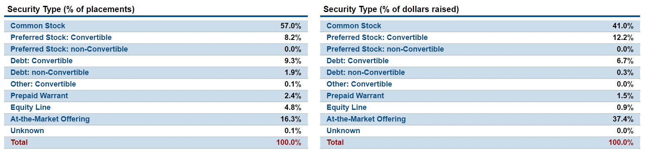
Table 3 PIPE Investments in 2016 by type. Source: PrivateRaise.com
Although basically an equity structure, ATM transactions allow companies to access capital with less equity sales. It’s sell as you go! ATM or “At-the-Market” offerings were the second most popular form of PIPE during 2016. 37.4% of 2016 PIPES were ATM deals. This relatively new structure is best suited to issuers with well developed liquidity and also ability to complete a registration statement. During 2016 many ATM transactions were completed at less than 8% discount to market, with no warrants. This new structure is often misunderstood by issuers and confused with “toxic convertible notes”. The primary difference is a note allows to owner to convert and sell without the consent of the borrower (subject to certain limitations such as price floor). However with an ATM, generally speaking the issuer is in control of issuance. For companies with strong liquidity profiles, this is a useful vehicle leveraged by many successful capital raisers in 2016.

De-Risk your deal for your audience -
In the current market there is no substitute for authenticity. The days of the basic “all upside, no competition” pitch are over. We have seen this trend develop over the last few years. Successful managers are actually helping their investors to “de-risk” a transaction by frankly and openly defining the risks and weaknesses their companies face. Speak openly about your competitive threats. It’s your strategy to outmaneuver the competition which is important. And use the competition to show what a great value you are offering. Although this may seem counterintuitive, portfolio managers are more concerned with identifying the risk in a transaction than in identifying the huge growth that most CEO’s think they are interested in. Preparation of investment materials which go beyond “basic risk factors” to an in depth analysis, often lead to a meaningful conversation, and positive results.

These critical success factors are far from comprehensive as issuers need to put significant effort into choosing service providers such as investment banks, advisors and counsel that have a proven track records. We compiled this list because selecting an simply effective IB, counsel, an audit firm and IR firm is not an automatic formula for success. As with everything success is usually a function of hard work and tireless attention to detail. The seven “extras” we identified are common among many successful Microcap CEOs. We hope list will dramatically improve your chances of a successful capital raise in 2017!

Karl Douglas is President of PPMT Capital Advisors, a private investment firm based in NY.


