Family Offices are Investing Heavily in Artificial Intelligence: Here are Five Reasons Why:


Our fourth article on family offices for Microcap Review focuses on new investment trends in the family office investor space. Recently we’ve seen increased activity in AI and 4IR, Fourth Industrial Revolution economy. In this article you’ll learn about the components of 4IR, two breakthroughs in artificial intelligence, and eight markets that will experience hyper growth over the next five years.
Figure 1 Source - UK RAS Network

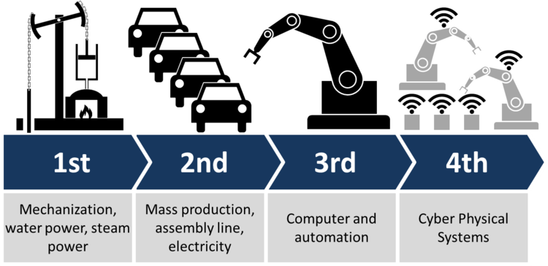
The second half of 2018, and to a greater degree, the first quarter of 2019 has been marked by a continued expansion of family office mandates from the traditional focus on real estate assets to more diverse investment strategies. Smart money is smart via its ability to identify and capitalize on mega-trends before those trends become mainstream. And the major anomaly that we’ve seen develop since last year is a spike in inquiries about investments in artificial intelligence. Of course, family office CIOs and other advisors are routinely attending World Economic Forum events. And Klaus Schwab, its Executive Chairman has been a leading advocate of the concept of The Fourth Industrial Revolution (4IR), which leverages artificial intelligence as the integrator of everything from 5G communications to biological systems, Cyber-Physical.
Figure 2 Source: World Economic Forum.

Reason 1: Biggest Economic Catalyst in 150 Years

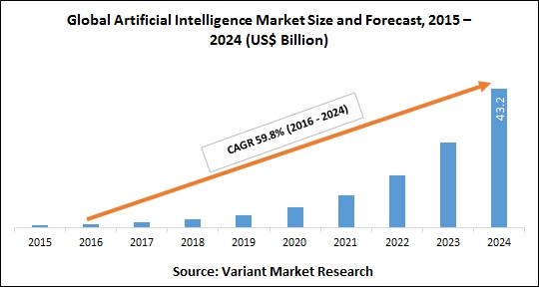
With an estimated CAGR of 59.8%, AI is too big to be ignored. The smart money realizes that sitting on the sidelines is tantamount to putting money in a mattress. Imagine knowing what you know today about the last 100+ years of economic history, and being a peer of John D. Rockefeller, Henry Ford, Alexander Graham Bell, Thomas Edison, and Charles Babbage. Your “crystal ball” would have resulted in one of the more impressive investment portfolios of all time, because you’d have gone long in the petroleum, automobile, telecommunications, power and computer sectors in their infancy before most investors understood that those industries would define the 20th-century economy i.e. shorted dying industries and investing in the emerging ones. AI, and the Fourth Industrial Revolution that it’s creating is the modern-day equivalent of that period, but with logarithmic proportions.
Figure 3. Source: Variant Market Research

Reason 2: Advances in ML and DL are Unprecedented

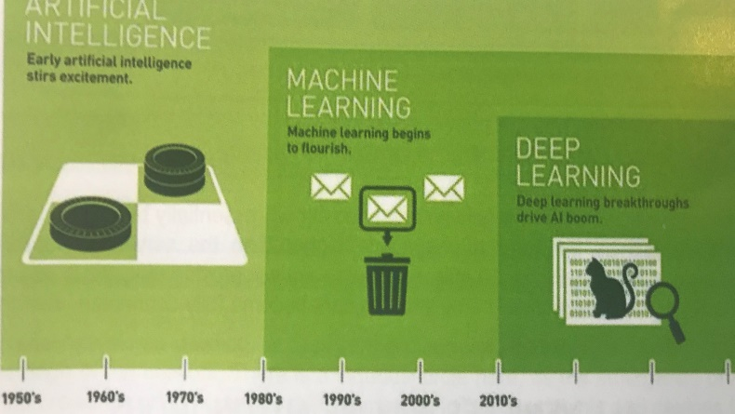
Ask anyone in the AI field to describe artificial intelligence and they’ll talk about Machine Learning (ML) and Deep Learning (DL) as the two major components. Where these two components are the basis of AI, in translation they bear little resemblance to the actual effect that AI will have on our economy, sociology and culture. That being said, it is useful to have a basic understanding of the two components.
Figure 4. There Era of Deep Learning. Source: Nvidia, JP Morgan

Machine Learning, or ML, relies on algorithms and statistical formulas run on an iterative basis to “learn” and generate an algorithmic understanding of a dataset. In effect, rather than requiring a programmer to code specific instructions based on his/her knowledge, the computer analyzes data and “learns” based on a defined data set, and refines(?) / produces a series of valuable algorithms. Take driver automation for example, the computer analyzes programmer-defined data such as maps, obstacle data, traffic rules and laws and derives a series of complex algorithms to seamlessly guide a level three (?) enabled autonomous vehicle down a major highway without incident. In ML, the dataset is largely defined. The Adoption Cycle for New Technology is Getting Progressively Shorter.

Reason 3: The Adoption Cycle is Getting Shorter

Deep learning is the next generation of ML in the sense that DL is unstructured. In DL, the program analyzes all data, determines all correlations and determines its own datasets and algorithms, not a predetermined subset, and identifies correlations, and then creates algorithms. Imagine a program that rather than figuring out how to move a car down a highway, analyzes all available data and correlations and designs the most efficient way to move people from point A to point B. That is the second generation of ML. It’s far closer to what we view as invention. So, imagine an inventor that can seamlessly access terabytes of dat - the speed and complexity of innovation is infinite and the rate of adoption is shrinking.

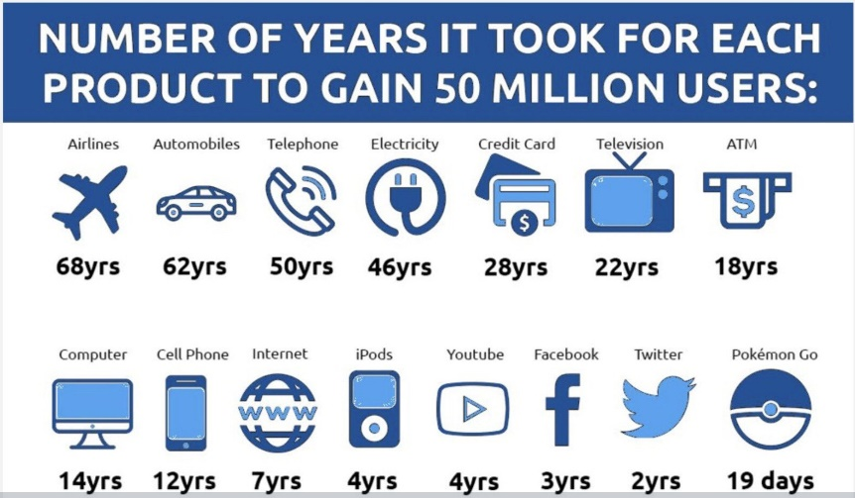

Welcome to the fourth industrial revolution. Time is being compressed and innovation is increasing at a pace beyond our comprehension. For a basic investment approach look at the requirements of AI. By its very nature, AI uses and creates a massive amount of data. This data (data storage, data processing and ability to manipulate these massive amounts) translates into the three core categories of investment opportunity. In effect, data warehousing, data mining and networks are broad categories of investment opportunities.
Figure 5. Source: Morgan Stanley

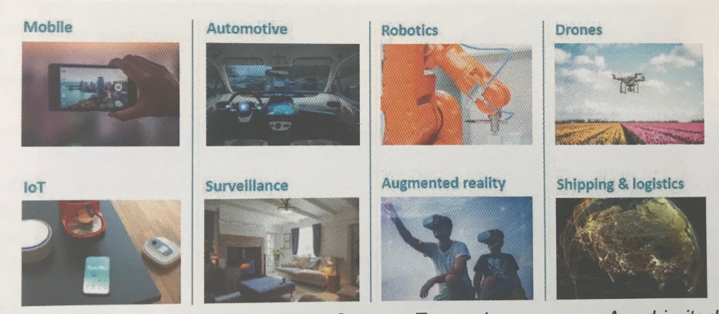
Reason 4: Many Entirely New Business Types Are Created
Figure 6. Deep Learning Will Drive Industries. Source: ARM Limited

In terms of data processing, think in terms of GPU manufacturers such as Nvidia that participate in the AI processing arena. The value associated with the ability to move the massive amounts of data that this model requires lies in the rollout of 5G. So think 5G value chain. And data storage is tantamount to the modern utility. However the fourth industrial economy, or AI economy, will reach far beyond those three areas.

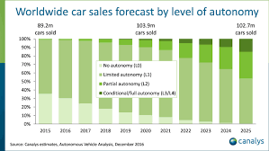
Smartphones and Smartcars (autonomous vehicles) have the most dramatic influence on the consumer. These devices will become the primary technology interface until home-based robotics are introduced. The image recognition technologies incorporated into these technologies will dramatically enhance functionality as well as create hyper growth for the camera component manufacturers. And the combination of AI chips, and additional AI programming will dramatically enhance the user experience in both examples. From the hardware perspective alone, the revenue growth could be significant. Certain technological breakthroughs which have been in the works for the last 15 years are poised to drive significant growth. Consider the improvements made in image recognition for example:
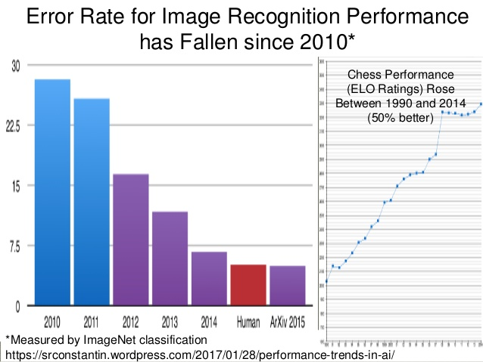
Figure 7. ImageNet
Reason 5 - Predictable Growth.

Just nine years ago, NEC was the standard with 72% accuracy vs the human benchmark of 95% accuracy. As of 2016, computers are 97% accurate in image recognition, two percent better than the human eye. From an investment perspective consider the various components of the image recognition value chain. From the lens manufacturers to the chip manufacturers, these companies will see significant growth.

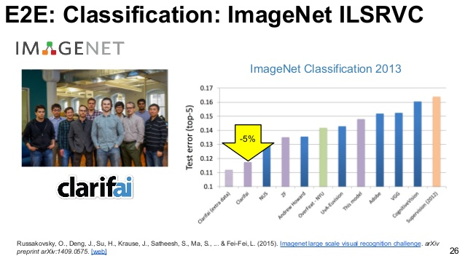

An example of this is the average smartphone currently has one or two cameras. However, by the end of 2019 the average mobile phone will have eight cameras to support the growing image recognition functionality. Smartphone camera component suppliers will see 8x growth in revenues based on current requiremen
ts. Similarly, the average L3 smart car or autonomous vehicle has upwards of twelve cameras. The graph below indicates the potential growth for suppliers of camera components to the automotive industry.

The numbers are staggering just across the smartphone and smartcar markets. Robotics and industrial automation will be another hypergrowth sector. But there are many additional areas, including drones and drone applications, IoT, or internet of things, shipping, and logistics, augmented reality, and surveillance. All are poised to be major growth areas within the Fourth Industrial Revolution. Hold on to your wireless ear buds.



About the author:
Karl B. Douglas is Chief Investment Officer at PPMT Capital Advisors, Ltd.., a multi family office advisory firm. Mr. Douglas has a career that spans over 30 years investing in private and public companies. PPMT Capital invests in private equity and debt investments of $15M to $100M in Energy, Mining, Industrials and Real Estate.
For further information contact:
kdouglas@ppmtcapital.com
800-401-9017
Note: This article is not an attempt to provide investment advice. The content is purely the author’s personal opinions and should not be considered advice of any kind. Investors are advised to conduct their own research or seek the advice of a registered investment professional. The author does not own shares or any equity or debt interest in any companies mentioned in this article before or at its publishing.

