INSURE TECH SERVICES PVT LTD
Expanded Content Suggestions
XML Services | APDF Services | Medical Billing and Coding
Related visual: Expanded Content Suggestions
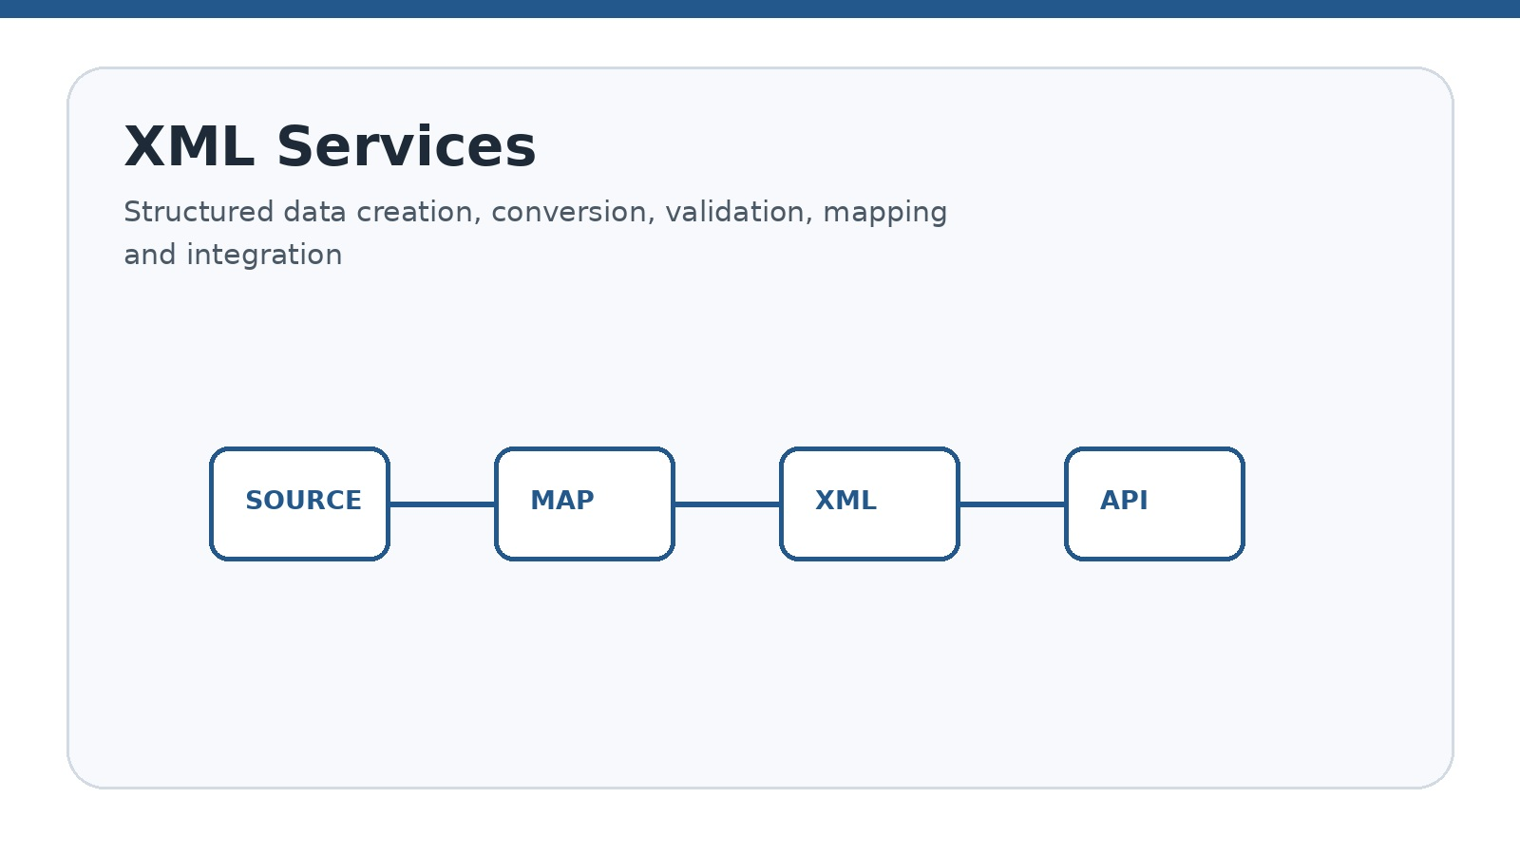

Website service-page content and SEO suggestions

1. How to Use This Content
Website teams can adapt these sections according to the final site architecture, service scope, target audience, and approved business terminology. The same core material can support service pages, landing pages, homepage sections, enquiry forms, sales presentations, and educational content.
A consistent page structure helps visitors understand what the service is, what activities are included, how the workflow operates, and what information is needed to begin a project. Headings, short paragraphs, service lists, workflow steps, FAQs, and calls to action can be reused while keeping each page focused on one service category.
For publishing, the company should review every statement against its actual capabilities. Claims about certifications, compliance, turnaround time, technology, specialties, or measurable performance should be included only after internal approval.

This document contains expanded website content suggestions for three specialized service categories: XML Services, APDF Services, and Medical Billing and Coding Services. Each section can be used as a complete website page or divided into homepage sections, service cards, landing pages, blog articles, FAQs, and marketing materials.

Recommended Page Structure
- Hero section with service title and short introduction
- Service overview
- Service categories or sub-services
- Key features and deliverables
- Business benefits
- Step-by-step workflow
- Industries served
- Quality, security, and compliance statement
- Frequently asked questions
- Call-to-action section

2. XML Services
XML projects commonly require a clear understanding of both the source information and the target structure. Before processing begins, the team can review sample files, required tags, attributes, naming conventions, data types, namespaces, schemas, and output expectations. This initial review helps establish a repeatable process.
A structured XML workflow can also make exception handling easier. Missing values, invalid structures, unexpected characters, duplicate records, or mapping differences can be identified during validation and reported for review rather than silently passing into the final output.
For organizations exchanging information with multiple systems or partners, documented mappings and transformation rules provide a useful reference for maintaining consistency. Version-controlled templates, sample outputs, validation results, and process notes can support future updates.
XML support can be organized as a standalone file-processing service or as part of a wider data workflow. The final approach depends on the source systems, file volumes, approved interfaces, security requirements, and business rules.
Related visual: 2. XML Services

Hero Section
Professional XML Services for Structured Data, Document Processing, and System Integration
Insure Tech Services PVT LTD provides XML-related support for businesses that need structured data creation, validation, transformation, processing, and integration. Our solutions help organizations exchange information accurately between applications, platforms, databases, and business partners.

Service Overview
XML, or Extensible Markup Language, is widely used to organize and exchange structured information. Our XML services are designed to help businesses manage XML files, improve data consistency, validate document structures, and connect systems through reliable data workflows.

XML Service Categories
Each XML service can be delivered as an individual activity or combined into an end-to-end workflow. For example, a project may begin with source-data conversion, continue through field mapping and schema validation, and finish with transformation, quality review, and delivery.
Where recurring processing is required, documented rules can help standardize file naming, folder structures, validation checks, exception handling, and output formats. This is particularly useful when the same type of XML document is processed repeatedly.

XML File Creation
Creation of structured XML files based on business templates, source data, schemas, or client specifications.

XML Data Conversion
Conversion of data from Excel, CSV, JSON, databases, or other approved formats into XML structures.

XML Validation
Checking XML documents against schemas, document type definitions, formatting rules, or agreed business requirements.

XML Parsing and Extraction
Extracting selected data elements from XML files for reporting, processing, migration, or system integration.

XML Transformation
Transforming XML content into another XML structure, HTML, text, JSON, or other required output formats.

XML Data Mapping
Mapping source fields to target XML tags, attributes, elements, namespaces, and required values.

XML Batch Processing
Processing multiple XML files using defined naming, validation, transformation, and output rules.

XML Integration
Connecting XML data exchange workflows with websites, applications, APIs, databases, or partner systems.

XML Cleanup and Formatting
Improving readability, consistency, indentation, encoding, field structure, and file organization.

XML Documentation
Preparing data dictionaries, field mappings, sample files, validation notes, and process documentation.

Common XML Use Cases
- Exchange of structured information between business applications
- Product, inventory, catalog, and pricing data management
- Healthcare and administrative data exchange
- Document publishing and content syndication
- Configuration and system data management
- Partner data integration and file transfer
- Migration of structured data between platforms
- Automated generation of reports and business documents

Key XML Deliverables
- XML files prepared according to approved specifications
- Source-to-target field mapping documents
- XML validation reports
- Transformation rules and output files
- Data quality and exception reports
- Batch-processing documentation
- Integration specifications and technical notes
- Sample files for testing and approval

XML Quality and Security Practices
Quality controls should be defined before production processing begins. A practical control plan can specify required fields, permitted values, encoding requirements, naming conventions, validation rules, review responsibilities, and the procedure for handling exceptions.
Security controls should reflect the sensitivity of the information being processed. Access should be limited to authorized personnel, confidential files should use approved transfer methods, and versions of schemas, mappings, templates, and processing instructions should be controlled.
- Use approved schemas and documented data rules
- Validate required fields and data types
- Check character encoding and special characters
- Maintain consistent naming and file structures
- Use secure file-transfer methods where required
- Restrict access to confidential or business-sensitive data
- Maintain version control for templates and mappings
- Review exceptions before final delivery

XML Service Workflow
Related visual: XML Service Workflow
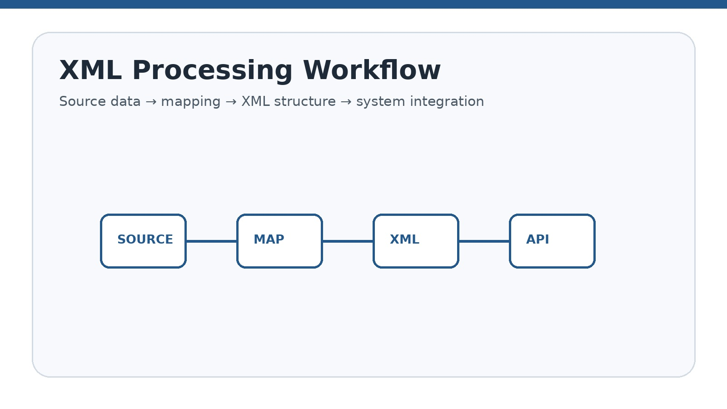

- Review the source data, target format, and business objective
- Collect XML samples, schemas, templates, and mapping requirements
- Prepare the XML structure and transformation logic
- Develop or configure the processing workflow
- Validate sample outputs and exception cases
- Perform quality checks and client review
- Deliver the final files, reports, or integration components

XML FAQ Content
Project discussions are easier when the client can provide sample source files, target examples, schemas, mapping documents, and expected outputs. These materials help define the scope and identify questions before production processing begins.
The final workflow can also distinguish between standard processing and exception cases. This makes it easier to document what happens when a file does not meet the agreed structure or when required information is missing.

What types of files can be converted into XML?
Depending on the structure and available data, XML may be generated from Excel, CSV, JSON, database exports, text files, or other supported formats.

Can you validate XML against an XSD schema?
Yes, XML validation can be performed when an XSD schema or an equivalent approved specification is provided.

Can you process large numbers of XML files?
Batch processing can be planned for large file volumes using defined validation, naming, transformation, and output rules.

Can XML data be integrated with an existing application?
Integration may be possible through APIs, file exchange, database connectivity, or other supported interfaces.

Do you provide XML documentation?
Yes, documentation can include field mappings, sample files, validation rules, process steps, and output specifications.

XML Call to Action
Need reliable XML processing, data conversion, validation, or integration support? Contact Insure Tech Services PVT LTD to discuss your structured-data requirements.

3. APDF Services
Document-processing projects often involve multiple stages rather than a single conversion task. A typical engagement may include source-file review, document preparation, conversion, extraction, validation, classification, indexing, quality review, and delivery according to agreed rules.
Because the document itself can be the operational record, consistency is important. Templates, page layouts, metadata, naming conventions, folder structures, and output standards can be documented so that recurring processing follows the same approach.
Before publishing the APDF service page, Insure Tech Services PVT LTD should confirm the official meaning of APDF and remove any service description that does not match the company's actual offering. The existing source specifically identifies this as an item requiring confirmation.
Related visual: 3. APDF Services
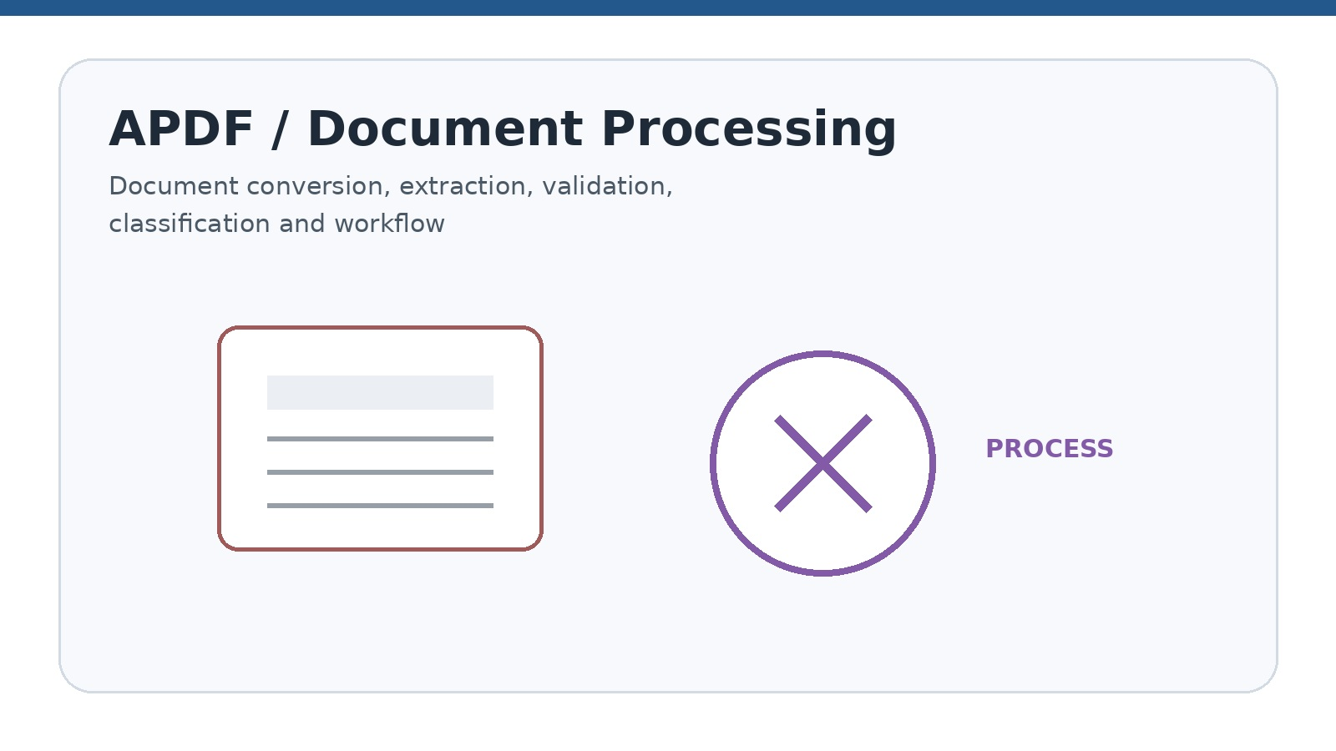

Important Naming Note
The exact full form and meaning of APDF should be confirmed before publishing the final website page. Until the official definition is approved, the following content is written as a flexible document-processing and PDF-related service concept. Remove or modify any sub-service that is not actually provided by the company.

Suggested Hero Section
APDF and Document Processing Services for Organized, Accurate, and Efficient Workflows
Insure Tech Services PVT LTD supports businesses with document preparation, conversion, processing, validation, classification, and workflow automation services related to APDF or PDF-based business requirements.

Suggested APDF Service Overview
Organizations often manage large volumes of business documents, forms, reports, invoices, records, and digital files. Our APDF-related services can help improve document consistency, reduce manual processing, organize files, and support digital workflows. The exact scope can be customized according to the required file formats, source systems, output standards, and business rules.

Possible APDF Sub-services
Document conversion can focus on producing an approved target format while preserving the required information and layout. Document generation can use structured data or templates to produce standardized outputs.
Extraction and indexing activities can help turn document contents into searchable or processable information. Classification can organize files using approved attributes such as document type, department, customer, project, date, or category.
Workflow automation can connect document movement with notifications, approvals, status changes, and delivery steps where the required systems and access are available.

Document Conversion
Conversion of approved source documents into PDF, APDF, or other required output formats.

Document Generation
Creation of standardized digital documents using templates, structured data, or application-generated content.

Document Formatting
Formatting, layout correction, page arrangement, headers, footers, tables, and document consistency support.

Document Data Extraction
Extraction of text, tables, fields, or metadata from supported documents for further processing.

Document Validation
Checking file completeness, page count, naming conventions, required fields, formatting, and output quality.

Batch Document Processing
Processing multiple files according to predefined rules for conversion, naming, classification, or delivery.

Document Classification
Organizing documents by type, department, customer, project, date, category, or other approved attributes.

Document Indexing
Adding searchable metadata and indexing information to improve document retrieval.

Document Archival Support
Preparing files and metadata for organized storage, retention, retrieval, and archival workflows.

Document Workflow Automation
Automating document movement, notifications, approvals, status updates, and output delivery.

Document Quality Review
Reviewing documents for readability, missing pages, incorrect fields, duplication, and formatting issues.

Document Integration
Connecting document workflows with business software, portals, databases, or document-management platforms.

APDF Business Benefits
The business value of document processing depends on the organization's specific workflow. A well-defined process can reduce repetitive handling, improve consistency, make documents easier to retrieve, and provide clearer visibility into processing status.
For high-volume operations, standard rules can also make exception handling more predictable. Teams can define which files require manual review, what constitutes an acceptable output, and how unresolved issues are recorded and communicated.
Related visual: APDF Business Benefits
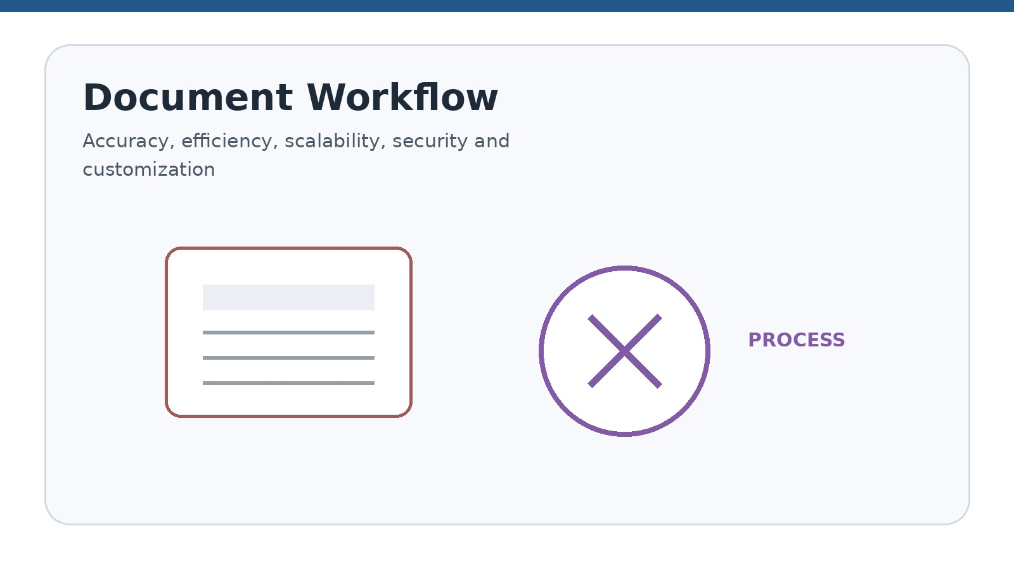

- Reduces repetitive document-handling tasks
- Improves consistency across business documents
- Supports faster document processing and delivery
- Improves document search and retrieval
- Reduces errors in file naming, classification, and formatting
- Supports centralized document workflows
- Improves audit readiness and process traceability
- Helps organizations manage high-volume document operations

APDF Workflow
A successful document workflow begins with a clear definition of source files and required outputs. The processing team can then document naming conventions, metadata fields, templates, validation rules, and delivery requirements before configuring the production process.
Sample processing should be completed before large-volume execution. Reviewing representative outputs can reveal layout issues, missing fields, classification errors, naming problems, or other exceptions that should be corrected before wider processing begins.
- Understand the document types, source files, and required output
- Confirm the official APDF definition, format, and technical specifications
- Prepare templates, naming rules, metadata, and processing instructions
- Configure or develop the document-processing workflow
- Process sample documents and review output quality
- Run validation and exception checks
- Deliver files, reports, documentation, or integrated outputs

APDF Website Content Blocks
Accuracy can be supported through documented checks for required fields, page completeness, formatting, and output quality. Efficiency can be supported through standardized or automated steps where appropriate.
Scalability should be described carefully because the practical processing capacity depends on file types, complexity, volume, systems, and agreed workflow. Security and customization should likewise be described according to the actual controls and options available.

Accuracy
Our document workflows are designed to support accurate formatting, data handling, and output verification.

Efficiency
Automated and structured processing can reduce manual effort and improve turnaround time.

Scalability
Workflows can be designed for individual documents or larger batches, depending on the project.
Access control, secure transfer, confidentiality, and appropriate data-handling procedures should be included based on the information being processed.

Customization
Document rules, templates, metadata, output formats, and delivery methods can be aligned with business requirements.

APDF FAQ Content
Clients may want to understand which document types, source formats, output standards, and volumes are supported. These details should be confirmed during project discovery because document layouts and processing requirements can vary significantly.
Where automated extraction is proposed, sample documents should be reviewed first. The accuracy of extraction can depend on document structure, layout consistency, image quality, and the required fields.

What does APDF stand for?
The official full form should be confirmed by Insure Tech Services PVT LTD before the service page is published.

What documents can be processed?
Supported documents may include forms, reports, invoices, records, applications, and other approved business files, depending on the final service scope.

Can you process documents in bulk?
Yes, bulk processing can be considered when file formats, volume, naming rules, and output requirements are defined.

Can document data be extracted automatically?
Data extraction may be possible for supported document types and layouts, subject to sample review and accuracy requirements.

Can APDF services be integrated with our software?
Integration depends on the available APIs, file-transfer methods, system access, and technical specifications.

APDF Call to Action
Discuss your document processing, conversion, validation, and workflow requirements with Insure Tech Services PVT LTD. Our team can help define the right process after reviewing your file formats and business needs.

4. Medical Billing and Coding Services
Medical billing and coding support forms part of the administrative side of healthcare operations. The service page should clearly distinguish administrative processing from clinical decision-making and should describe activities according to the approved service scope.
An organized workflow can connect patient demographic entry, insurance information review, charge entry, claim preparation, claim submission support, payment posting, accounts receivable follow-up, denial management, patient billing support, and reporting.
Because healthcare information is sensitive, service descriptions should emphasize authorized access, secure handling, confidentiality, and applicable privacy requirements without making compliance claims that have not been reviewed and approved.
Related visual: 4. Medical Billing and Coding Services
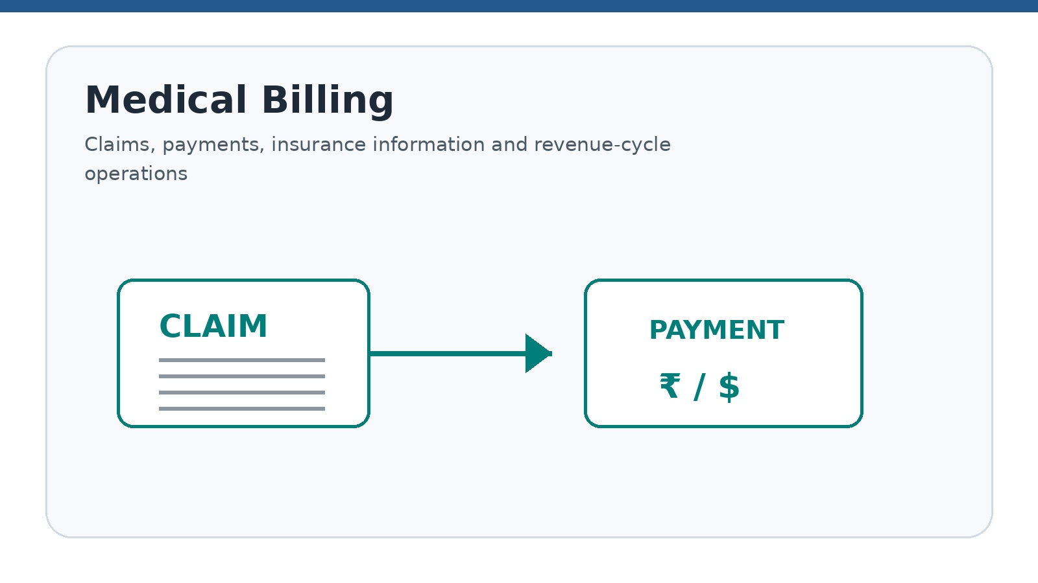

Hero Section
Medical Billing and Coding Support for Organized Healthcare Revenue-Cycle Operations
Insure Tech Services PVT LTD provides medical billing and coding support for healthcare organizations that need structured administrative workflows, accurate documentation handling, claim preparation support, payment tracking, and revenue-cycle visibility.

Service Overview
Medical billing and coding are important components of healthcare administration and revenue-cycle management. Our support services can help healthcare providers organize billing information, prepare claims, review documentation, track outstanding accounts, and improve administrative workflow efficiency. All services should be performed by qualified personnel within the approved scope and according to applicable laws, payer rules, privacy requirements, and client procedures.

Medical Billing Services
Patient demographic and insurance information should be entered or reviewed from authorized records. Accurate information at the beginning of the billing workflow can support downstream claim preparation and follow-up activities.
Claim preparation and submission support can include organizing required information, checking available documentation, and following the client's established payer and submission procedures. The exact workflow should reflect the systems and responsibilities agreed with the healthcare organization.
Payment posting and accounts receivable follow-up provide visibility into the status of financial transactions and outstanding balances. Denial management support can help categorize denial reasons and organize corrective follow-up based on available information.
Reporting can summarize agreed operational measures such as claims, payments, denials, aging, collections, productivity, and turnaround time.
Related visual: Medical Billing Services

Patient Demographic Entry
Entering and maintaining patient demographic information based on authorized records.

Insurance Information Verification
Reviewing insurance information, coverage details, eligibility data, and authorization requirements where applicable.

Charge Entry
Entering charges and service information into the approved billing system based on available documentation.

Claim Preparation
Preparing claim information for review and submission according to payer and client requirements.

Claim Submission Support
Supporting electronic or paper claim submission workflows through approved systems.

Payment Posting
Recording insurance and patient payments, adjustments, and related transaction information.

Accounts Receivable Follow-up
Tracking unpaid balances, aging accounts, claim status, and follow-up activities.

Denial Management Support
Reviewing denial reasons, categorizing issues, and supporting corrective follow-up based on available information.

Patient Billing Support
Supporting billing enquiries, statement review, account updates, and communication workflows.

Billing Reports
Preparing reports related to claims, payments, denials, aging, collections, and workflow status.

Medical Coding Services
Medical coding support should be based on authorized clinical documentation and the approved coding scope. Diagnosis and procedure coding activities should follow the applicable coding guidelines and the qualifications of the assigned personnel.
Code review can focus on completeness, consistency, and potential documentation gaps. Where documentation is unclear or incomplete, clarification should be handled through the approved channels rather than relying on unsupported assumptions.
Sample-based coding quality audits can identify recurring issues, training needs, and process-improvement opportunities. Specialty coding support should be offered only where the assigned team has the appropriate qualifications and the project scope has been defined.
Related visual: Medical Coding Services
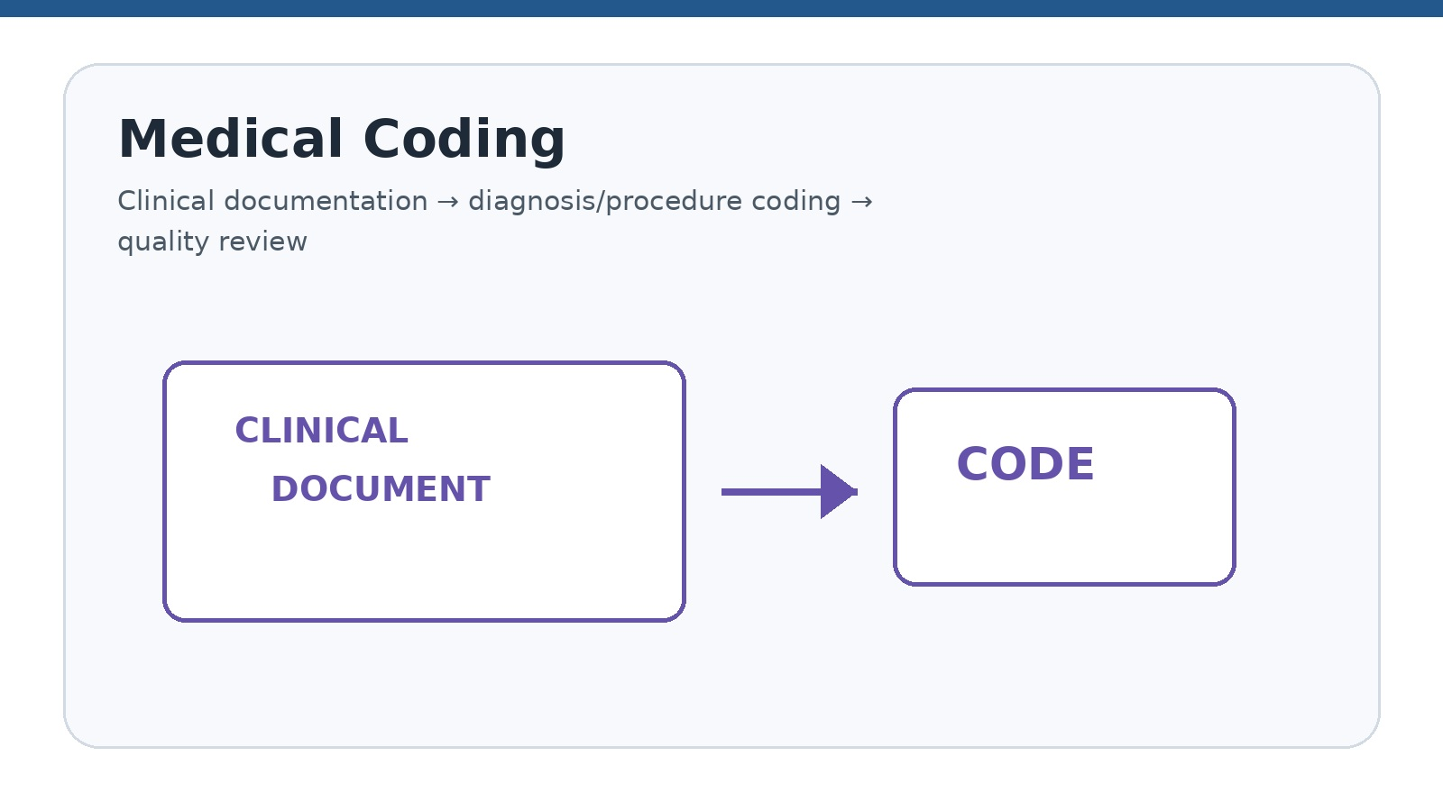

Diagnosis Coding Support
Assigning diagnosis codes based on authorized clinical documentation and applicable coding guidelines.

Procedure Coding Support
Supporting procedure and service coding based on documentation and the approved coding scope.

Code Review
Reviewing coding entries for completeness, consistency, and potential documentation gaps.

Specialty Coding Support
Providing coding support for approved specialties based on staff qualifications and project scope.

Coding Documentation Review
Identifying missing, unclear, or inconsistent documentation for appropriate clarification through approved channels.

Coding Quality Audits
Conducting sample-based reviews to identify recurring errors, training needs, and process improvements.

Coding Updates
Monitoring relevant coding changes and updating internal reference materials when included in the service scope.

Revenue-Cycle Management Support
Revenue-cycle support can be viewed as a connected sequence rather than isolated billing tasks. Information captured during registration and insurance review can affect charge capture, claim preparation, payer follow-up, payment posting, and accounts receivable activities.
Regular reporting can help healthcare organizations understand workflow status and identify areas requiring attention. Metrics should be agreed in advance so that reports remain consistent and useful for operational review.
Process documentation can also support continuity when responsibilities, systems, payer requirements, or internal procedures change. The final workflow should identify ownership of each activity and the escalation path for unresolved issues.
Related visual: Revenue-Cycle Management Support
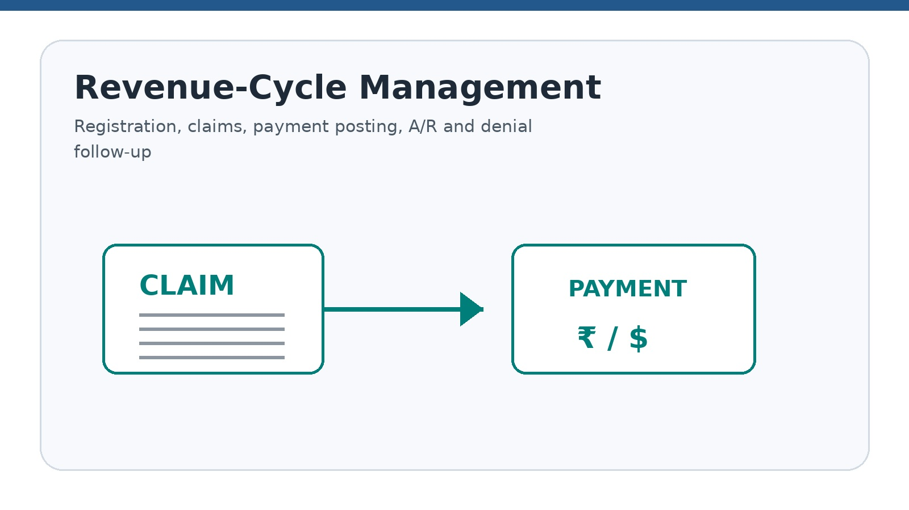

- Front-end registration and insurance information support
- Charge capture and claim preparation
- Claim tracking and payer follow-up
- Payment posting and reconciliation
- Denial categorization and resolution workflow
- Accounts receivable aging review
- Patient balance and statement support
- Revenue-cycle reports and performance tracking
- Workflow documentation and process improvement

Medical Billing and Coding Benefits
The benefits of billing and coding support are primarily operational: better organization, more consistent claim preparation, clearer visibility into outstanding work, structured follow-up, and reduced administrative workload.
Performance should be assessed using agreed measures rather than broad promises. Claim accuracy, clean claim rate, denial rate, payment posting turnaround, accounts receivable aging, coding accuracy, documentation completeness, and reporting accuracy are examples already identified in the source content.
- Improves organization of billing and coding workflows
- Supports more consistent claim preparation
- Helps reduce avoidable administrative errors
- Improves visibility into unpaid claims and outstanding balances
- Supports timely follow-up and reporting
- Reduces administrative workload for healthcare teams
- Supports better documentation and process accountability
- Helps healthcare organizations focus more on patient care

Medical Billing and Coding Workflow
Project onboarding should begin by understanding the provider's specialty, systems, workflow, documentation standards, payer requirements, privacy procedures, and access permissions. These details define how the service can be performed safely and consistently.
Once the workflow is established, authorized information can be reviewed and the agreed billing or coding activities performed. Quality checks and exception reviews should be built into the process rather than treated as an afterthought.
Unresolved issues can be documented in status reports and communicated through approved channels. Periodic performance review can then identify recurring exceptions, process gaps, and opportunities for improvement.
- Understand the healthcare provider's specialty, systems, workflow, and service scope
- Confirm documentation standards, payer requirements, privacy procedures, and access permissions
- Establish secure data-transfer and communication processes
- Review authorized patient, clinical, billing, and insurance information
- Perform billing or coding tasks according to approved procedures
- Conduct quality checks and exception reviews
- Prepare status reports and communicate unresolved issues
- Review performance and identify process improvements

Healthcare Data Security and Compliance Content
Healthcare information requires careful handling throughout the workflow. Access permissions, secure transfer methods, confidentiality procedures, staff training, audit trails, and retention practices should be aligned with the client's requirements and applicable regulations.
Security language on the website should remain accurate and specific. Any statement about certifications, regulatory compliance, security technology, or formal controls should be reviewed and approved by the company before publication.
Related visual: Healthcare Data Security and Compliance Content
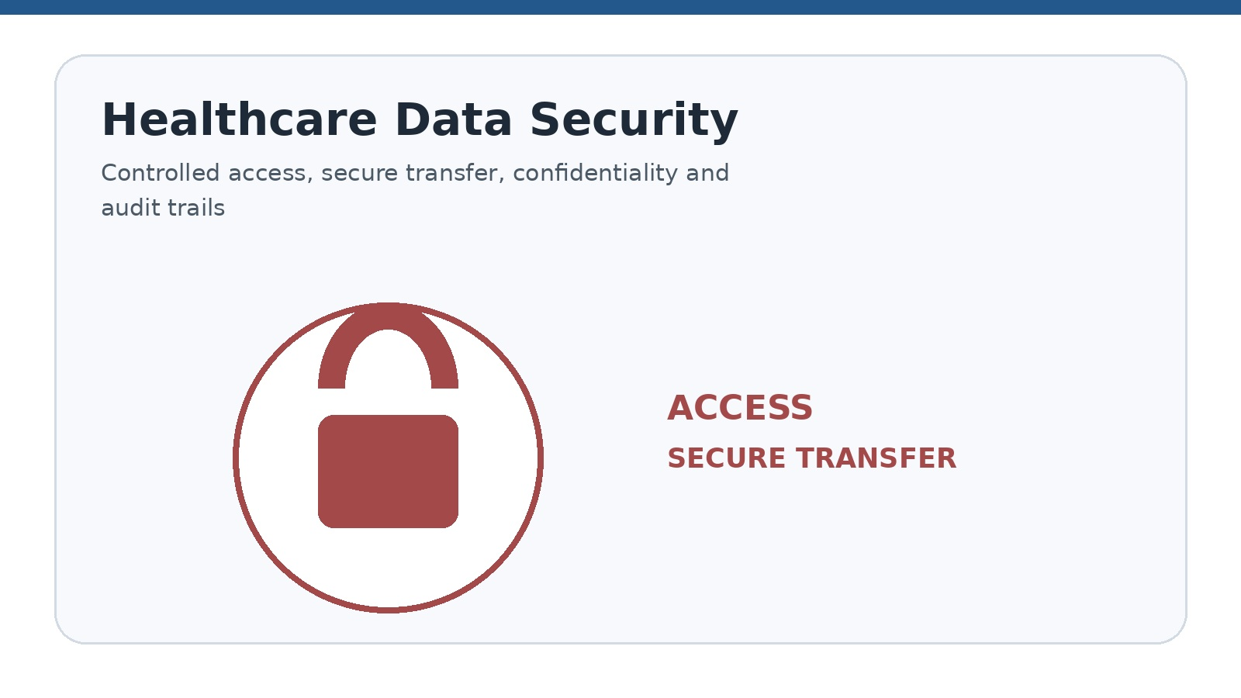

Healthcare information is sensitive and must be handled responsibly. The service workflow should include appropriate confidentiality agreements, role-based access, secure data transfer, controlled system permissions, audit trails, employee training, data-retention procedures, and compliance with applicable privacy and healthcare regulations. Specific compliance claims should be reviewed and approved before publication.

Medical Billing and Coding Quality Measures
Quality measures can be used to create a practical service dashboard. Claim-related measures can show submission quality, payment measures can show posting timeliness, and denial or aging measures can identify areas requiring follow-up.
Coding quality can be evaluated through sample audits and documentation-completeness reviews. Reporting accuracy and response or resolution turnaround can provide additional visibility into the overall support process.
- Claim accuracy rate
- Clean claim rate
- Denial rate and denial categories
- Payment posting turnaround time
- Accounts receivable aging
- Outstanding claim follow-up status
- Coding accuracy based on sample audits
- Documentation completeness
- Response and resolution turnaround time
- Client reporting accuracy

Medical Billing and Coding FAQ Content
Clients often need clarity about specialty coverage, service boundaries, data protection, denial management, coding audits, and reporting. The answers should describe what can be provided within the qualifications, systems, documentation, and agreed scope of the engagement.
The distinction between administrative support and clinical decision-making should remain clear throughout the page. Billing and coding support does not replace clinical judgment, which remains with qualified healthcare professionals.

Do you support all medical specialties?
Specialty support depends on the qualifications, experience, technology, documentation, and approved scope of the assigned team.

Do you provide both billing and coding services?
The service scope can include billing, coding, or both, depending on the healthcare organization's requirements.

How is patient data protected?
Patient information should be handled through authorized access, secure transfer, confidentiality procedures, staff training, and applicable privacy requirements.

Can you support denial management?
Denial review and follow-up support may be provided based on payer rules, documentation, authorization, and the agreed workflow.

Do you provide coding audits?
Sample-based coding quality reviews may be included when the scope, specialty, coding system, and review standards are defined.

Can reports be customized?
Reports can be designed around agreed metrics such as claims, payments, denials, aging, productivity, and turnaround time.

Are clinical decisions included?
No. Medical billing and coding support does not replace clinical judgment. Clinical decisions must remain with qualified healthcare professionals.

Medical Billing and Coding Call to Action
Looking to improve your healthcare billing, coding, claims, or revenue-cycle workflow? Contact Insure Tech Services PVT LTD to discuss your requirements, systems, specialty, and service scope.

5. Shared Website Call-to-Action Suggestions
A strong call to action should make the next step clear without overstating what happens after an enquiry. Visitors can be invited to request a service consultation, discuss project requirements, request a customized service plan, provide workflow details, talk to the service team, request a quote, or schedule a business discussion.
For service-specific pages, the CTA can reference the relevant workflow. XML visitors may be invited to discuss schemas, mappings, and file volumes; document-processing visitors may be invited to discuss source formats and output requirements; healthcare visitors may be invited to discuss specialty, systems, billing or coding scope, and reporting needs.
- Request a Service Consultation
- Discuss Your Project Requirements
- Get a Customized Service Plan
- Send Your File or Workflow Details
- Talk to Our Service Team
- Request a Quote
- Schedule a Business Discussion

6. SEO Suggestions
Each service page should use a clear SEO title, concise meta description, descriptive headings, and relevant keywords that accurately reflect the published content. The title and description should match the actual service scope rather than introducing claims that are not supported on the page.
Internal links can connect related service pages, FAQs, contact sections, and approved educational content. Images should use meaningful filenames and accessible alternative text where the website platform supports it.
SEO optimization should support readability first. Keywords can be incorporated naturally into headings and paragraphs while preserving the professional tone and accuracy of the service information.

XML Services SEO Title
XML Services | XML Data Conversion, Validation and Integration | Insure Tech Services

XML Meta Description
Explore XML creation, conversion, validation, transformation, parsing, batch processing, and integration services from Insure Tech Services PVT LTD.

XML Keywords
XML services, XML data conversion, XML validation, XML transformation, XML integration, XML processing services

APDF Services SEO Title
APDF and Document Processing Services | Insure Tech Services

APDF Meta Description
Discover APDF-related document processing, conversion, validation, formatting, extraction, classification, and workflow support services.

APDF Keywords
APDF services, document processing services, PDF processing, document conversion, document automation, document validation

Medical Billing SEO Title
Medical Billing and Coding Services | Healthcare Revenue-Cycle Support

Medical Billing Meta Description
Insure Tech Services PVT LTD provides medical billing and coding support, claim preparation, payment posting, denial follow-up, and revenue-cycle reporting.

Medical Billing Keywords
medical billing services, medical coding services, healthcare billing support, claims processing, denial management, revenue-cycle management

7. Final Publishing Checklist
Before publication, the company should complete a content approval review covering service scope, APDF terminology, contact details, claims, staff qualifications, privacy language, images, testimonials, SEO fields, internal links, and proofreading.
Images should be directly relevant to the section they accompany. For example, XML pages can use structured-data or integration visuals, document-processing pages can use document workflow visuals, and medical billing and coding pages can use healthcare administrative workflow visuals.
Final review should confirm that all calls to action lead to the intended enquiry process and that no placeholder wording remains in the published website.
Related visual: 7. Final Publishing Checklist
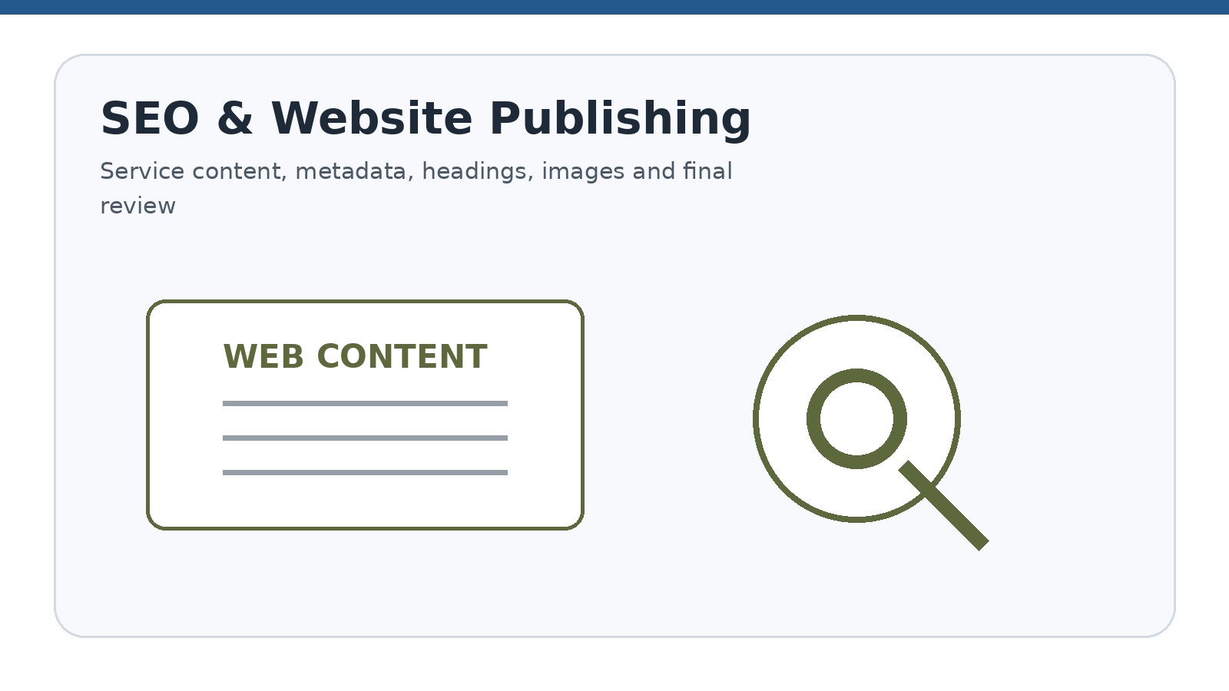

- Confirm the exact service scope offered by the company
- Confirm the official full form and meaning of APDF
- Add official contact information and enquiry details
- Use only approved claims, certifications, and compliance statements
- Confirm medical billing and coding staff qualifications
- Review healthcare privacy and data-security language
- Add service-specific images or illustrations
- Add case studies or testimonials only with permission
- Check SEO titles, meta descriptions, headings, and internal links
- Proofread all content before publishing

Request for Services – Contact Form
