Anti-competitive behavior exhibited by overlay vendors

Interference with web accessibility testing tools 1

Fake Reviews 6

Native Advertising, Paid Articles, and Paid Reviews 7

# Interference with web accessibility testing tools

Among the most notable anti-competitive behaviors exhibited by overlays is their interference with the operation of testing tools. WAVE, by WebAIM, is one of the most popular web accessibility testing tools in the market and is available via a few delivery methods including a browser extension or a web service.

Using the web service, a user needs only to enter the URL they want tested into the form on <https://wave.webaim.org/>. Upon doing so, the WAVE service will assess the code on the URL that was submitted and display the results of its automated assessment.

As shown in the image example below, overly product UserWay interferes with WAVE, displaying a brightly colored message declaring "Scan Error. The Wave online scanner is unable to accurately parse the accessibility remediations on this page". This warning message is generated by UserWay, not WAVE, and is false. The placement, appearance, and wording of this message is likely intended to erode customer's trust in the WAVE product.

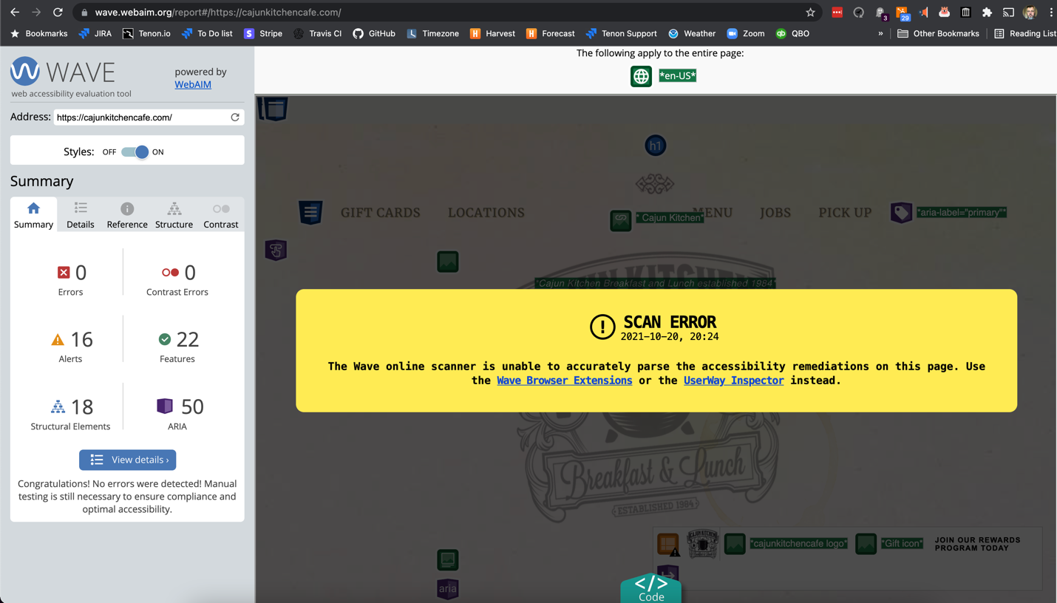

Figure : Screenshot demonstrating UserWay's interference with WAVE. Screenshot taken October 20, 2021

Although the above message makes the recommendation to "Use the Wave Browser Extension…", UserWay interferes with that tool as well. The example images below show the homepage from <https://data.unicef.org/> on November 4, 2021, at 4:09 PM US Central Time. The first picture shows the default state of the page before the WAVE testing tool has been activated. Pay particular attention to the white text on blue background on the right side of the center of the page. This color combination fails WCAG standards for color contrast requirements.

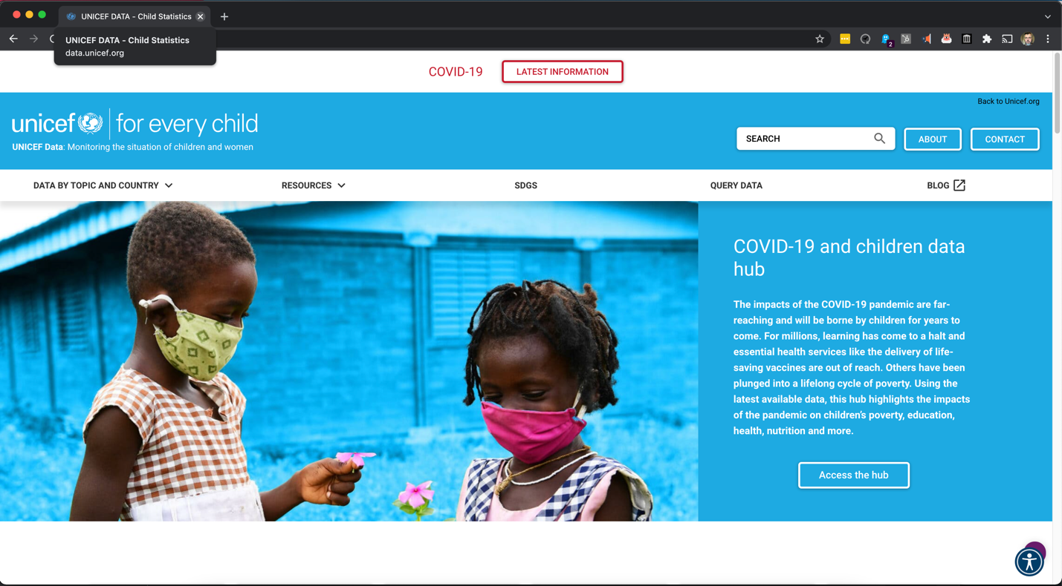

Figure : The "before" state of a web page that uses the UserWay product. Screenshot taken November 4, 2021

When the WAVE tool is activated, UserWay alters the page in a way that interferes with WAVE's ability to accurately test the page. UserWay injects code onto the page that causes the white-on-blue text to be white text on a black background, as shown in the figure below. This has the effect of:

* Tricking the UserWay customer into believing that the UserWay product is fixing things when, in its non-interfering behavior it isn't
* Interfering with the effectiveness and accuracy of another product
* (As a result of #2) convincing the UserWay customer that they do not need to take any further action on accessibility efforts.

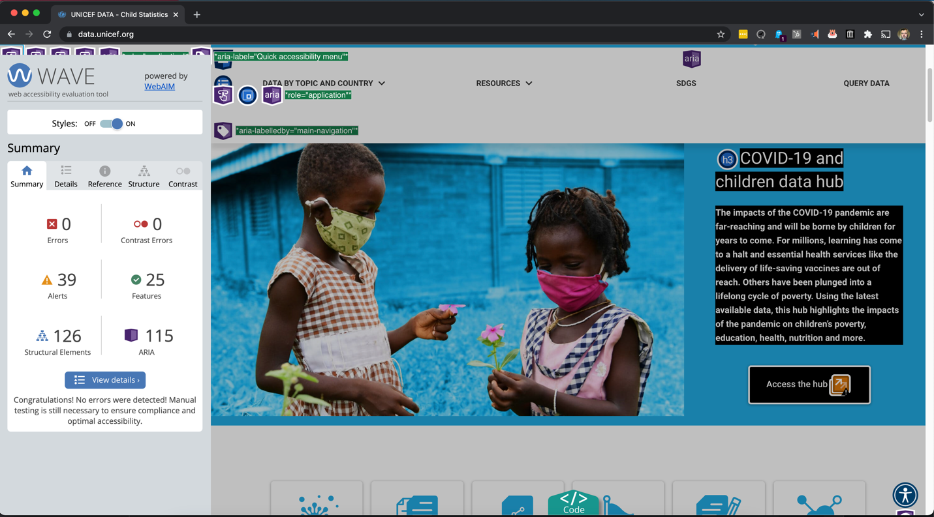

Figure : The "after" state of a page which uses the UserWay product, after activating the WAVE testing tool. Screenshot taken November 4, 2021

In 2020, Adrian Roselli documented apparent attempts by accessiBe to interfere with WAVE as well.[1] Users of the WAVE tool had reported noticing anomalous behavior on sites which use the accessiBe product including anecdotal evidence that sites containing accessiBe would report no errors when obvious errors are present. As a result, the makers of WAVE needed to add a message within their product which states "The 3rd party accessiBe integration on this page may temporarily modify content when WAVE is activated resulting in interference with WAVE's detection and of and accuracy identifying accessibility and compliance issues"

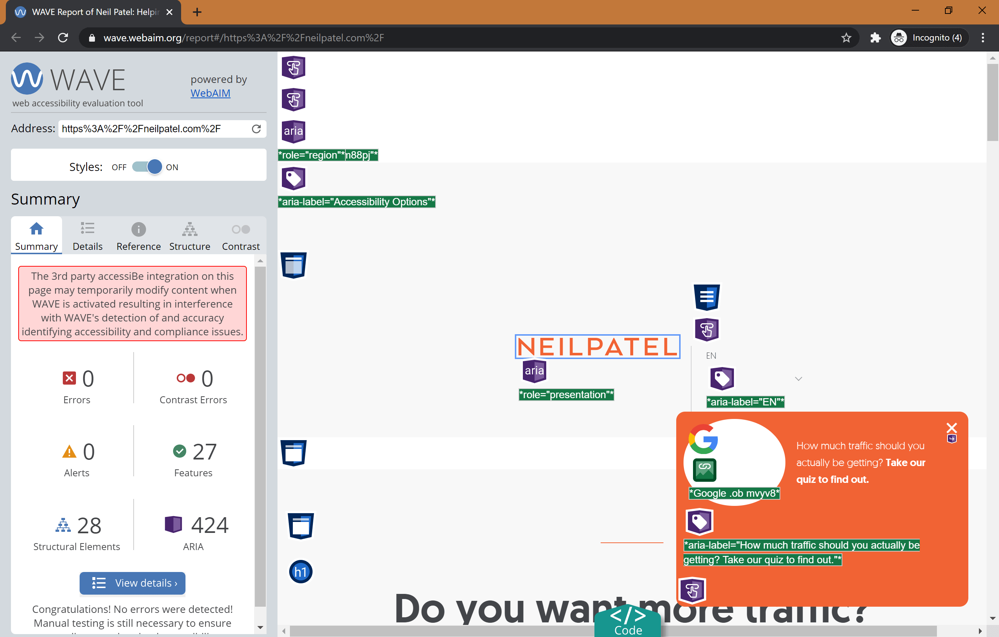

Figure : Screenshot from "accessiBe will get you sued" by Adrian Roselli, documenting accessiBe interfering with WAVE

Accessibility Consultant Adrian Roselli further documented the existence of pieces of code within the accessiBe product that appear to validate the claim of accessiBe's interference with WAVE. The code for accessiBe appears to have instances where it detects the use of WAVE, which triggers a function called runWaveProcess. The underlying code for that function has been obfuscated so its exact mechanism of operation cannot be determined but is assumed to be the code created to interfere with the WAVE tool.

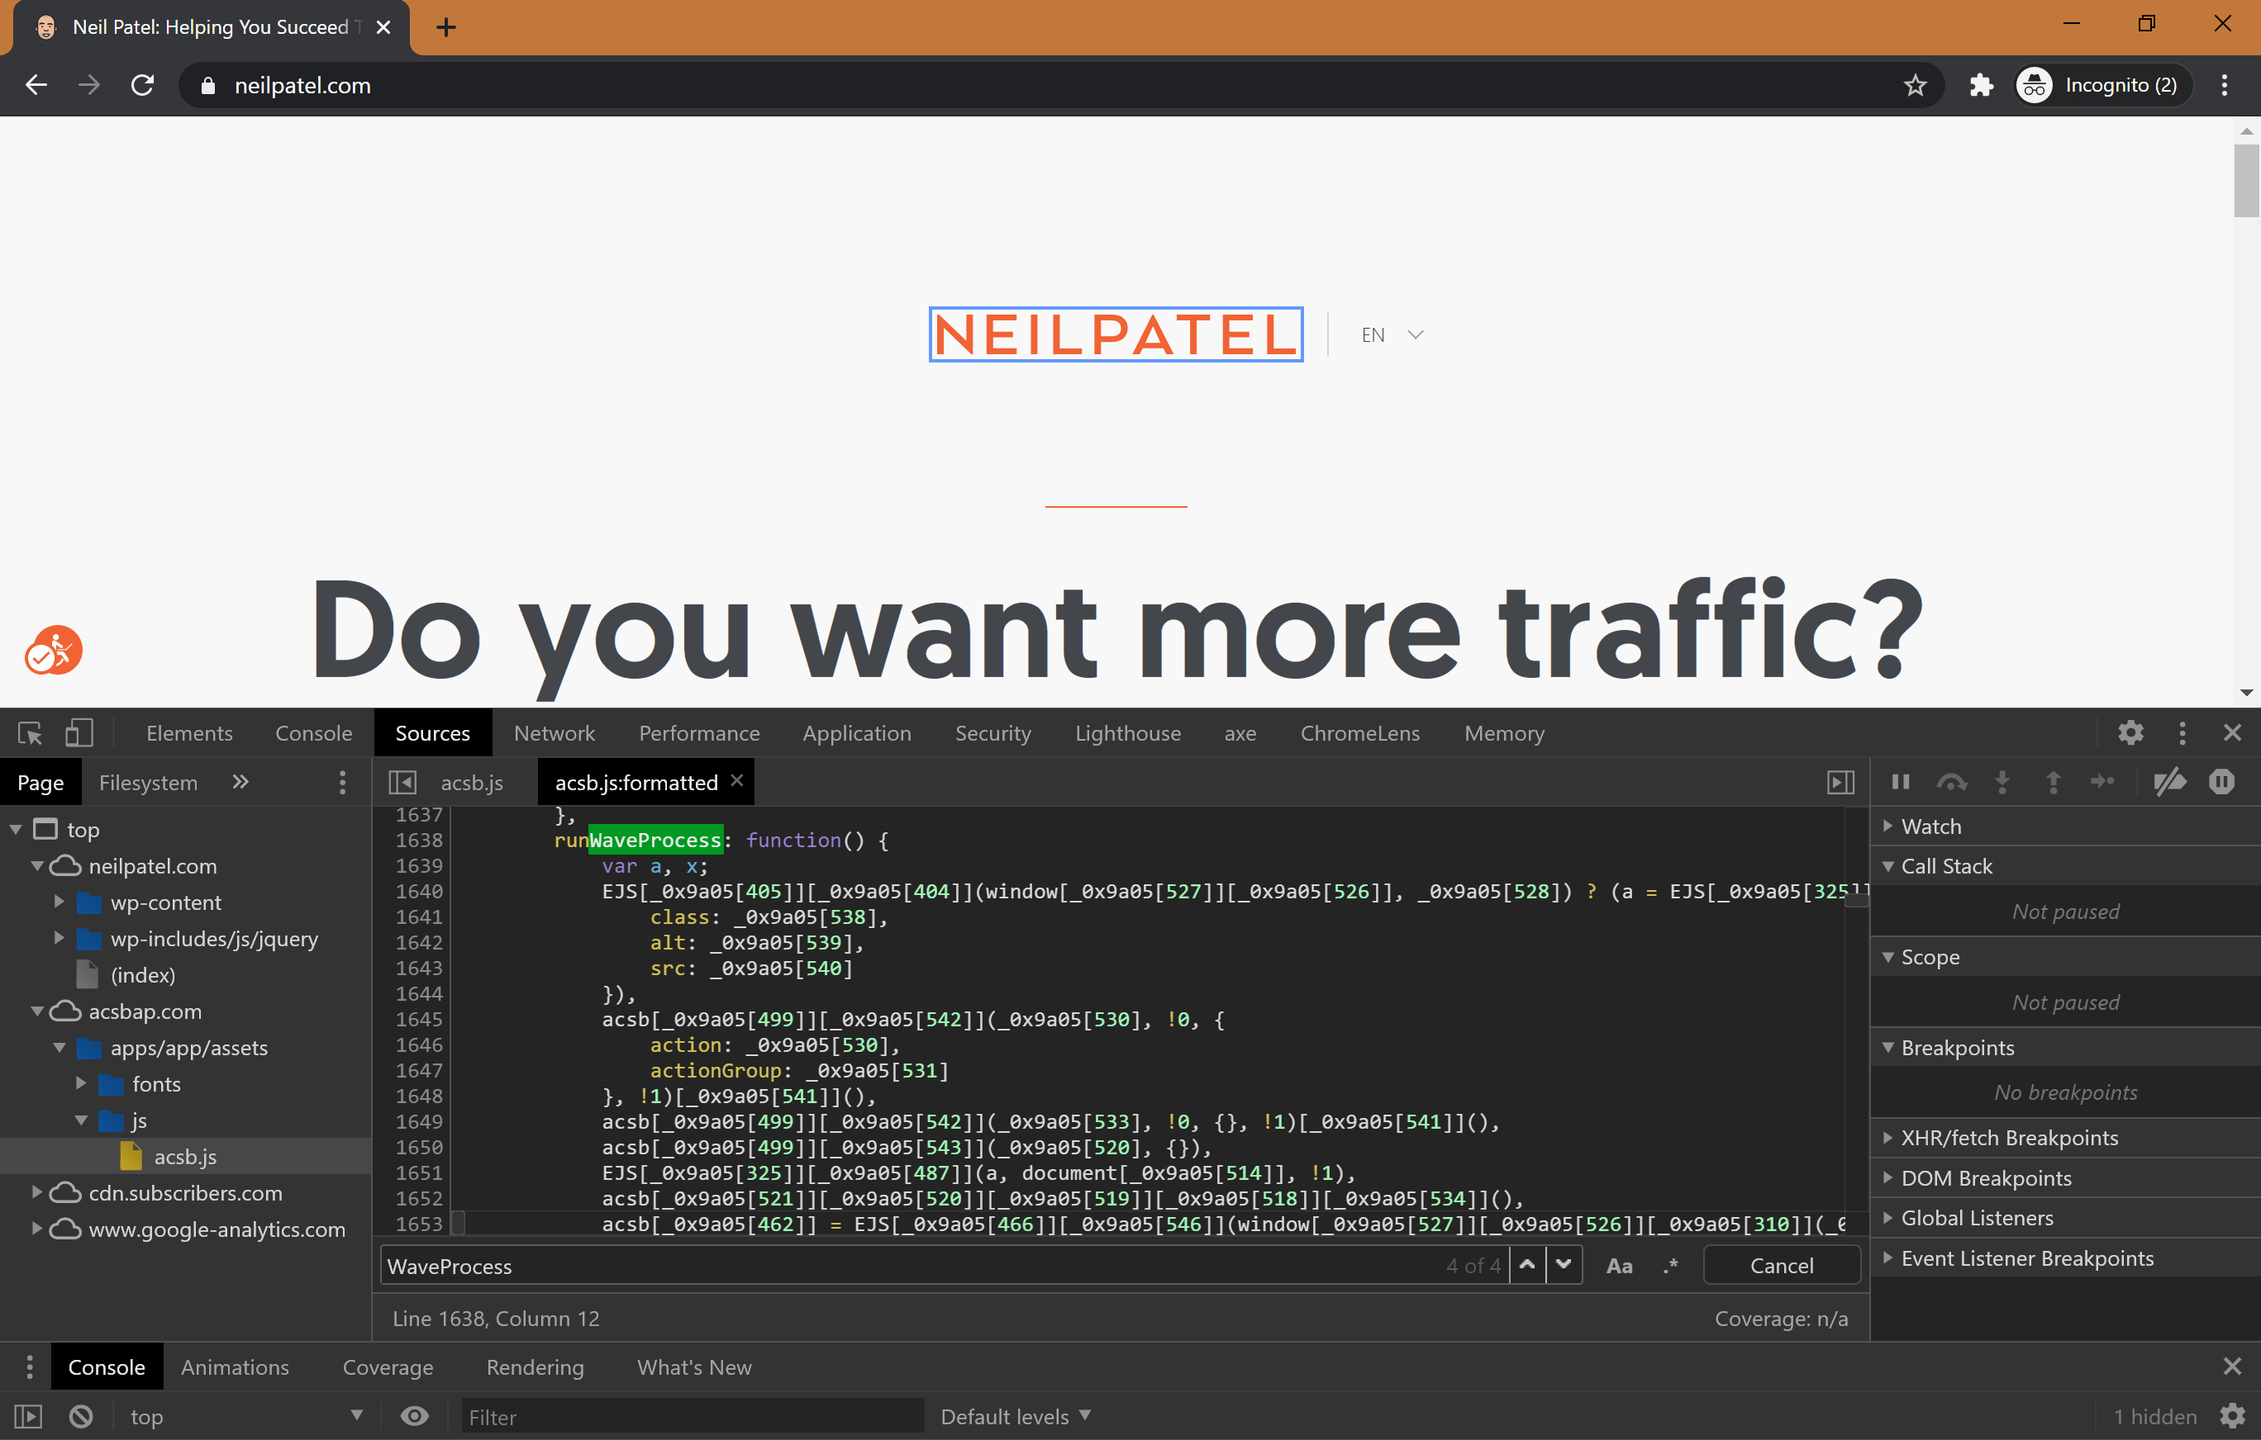

Figure : Screenshot of "accessiBe will get you sued" by Adrian Roselli showing browser console, highlighting the `runWaveProcess` function.

# Fake Reviews

In February 2021, WordPress.org removed dozens of fake reviews for accessiBe after the investigative work of Joe Dolson.[2] Dolson and members of WordPress.org's Plugin team investigated and found a pattern of suspicious behaviors indicating that the reviews were likely fake and removed them entirely.

Soliciting paid or fake reviews is not a new infraction, and it has been explicitly forbidden in the directory’s guidelines for years. This falls under guideline #9*: Developers and their plugins must not do anything illegal, dishonest, or morally offensive*, which includes “*Creating accounts to generate fake reviews or support tickets (i.e., sockpuppeting)*.”[3]

# Native Advertising, Paid Articles, and Paid Reviews

Native advertising is the practice of placing an advertisement in with normal editorial content that is paid for by the advertiser. Typically, the advertisement looks like a normal article for the publication - it is a long form, promotional, and often non-critical description of the product or service being advertised. Although the tactics used in native advertising vary, especially on the Web, they tend to share one or more of the following traits:

* The article is ghost-written by the advertiser and the author byline uses a generic name, i.e., 'Admin' or the name of the website rather than the name of an actual person.
* The article is written by frequent contributor to the site who is paid to do so.
* The article author is an employee of the company whose product is being promoted.
* The article shows unconditional positive regard for the product being discussed, citing no alternate viewpoints, other sources, or competitors.

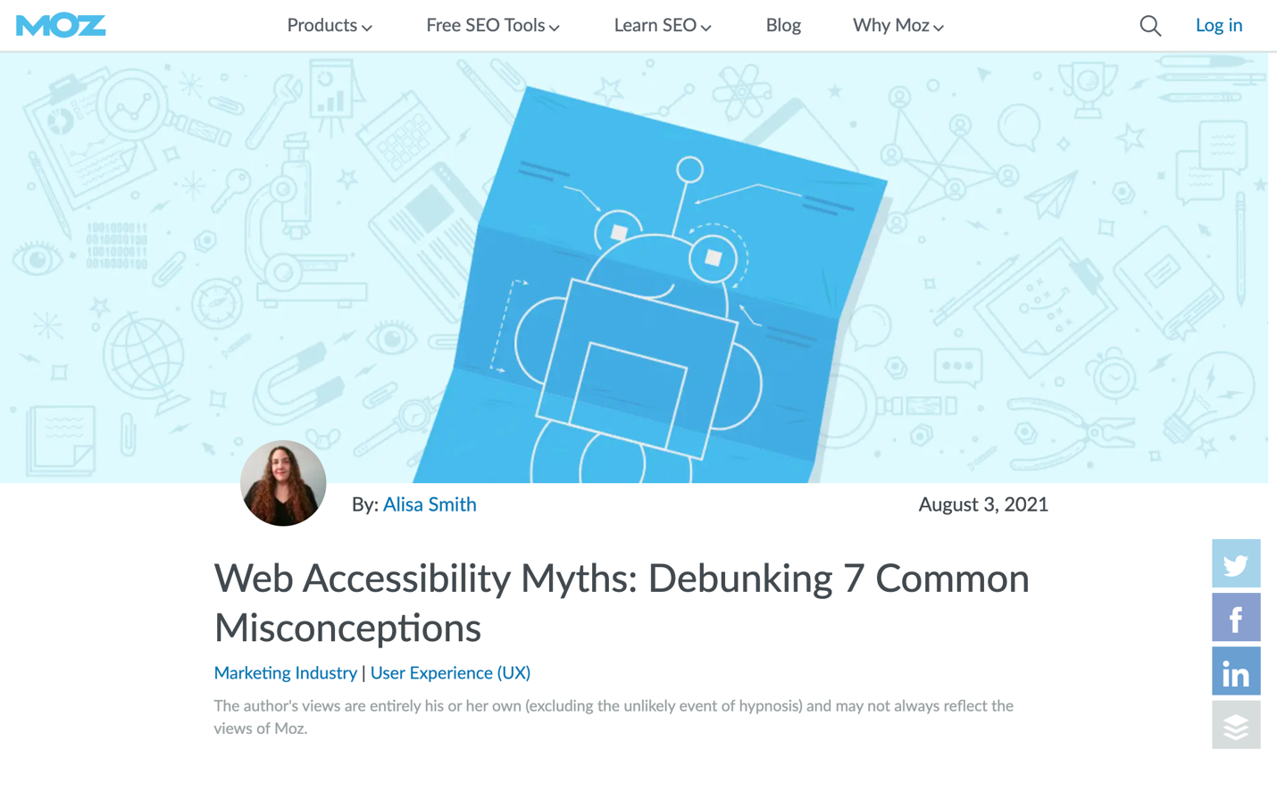

Figure : Screenshot of article on Moz.com a popular website that discusses online marketing and SEO. Author of the article is Alisa Smith, an employee of AudioEye.

Although ethical news sources will often provide disclaimers about the paid nature of such content, the provision of such disclaimers is far less common on the Web. Even when they are provided, users may still be confused by them.[4] In fact, a study by Bart Wojdynski and Nathaniel J. Evans found that only 20% of readers were aware that they were reading an advertisement even when a disclosure was present.[5] The likelihood of consumers becoming confused by such content is high enough that the FTC has issued an Enforcement Policy Statement in which they write: " Such misleadingly formatted advertisements are deceptive even if the product claims communicated are truthful and non-misleading"[6]

Overlay vendors are particularly active in their use of native advertising, especially on websites of influencers, tech news websites, and blogs. These articles continue the same common messaging themes perpetuated by the vendors themselves.

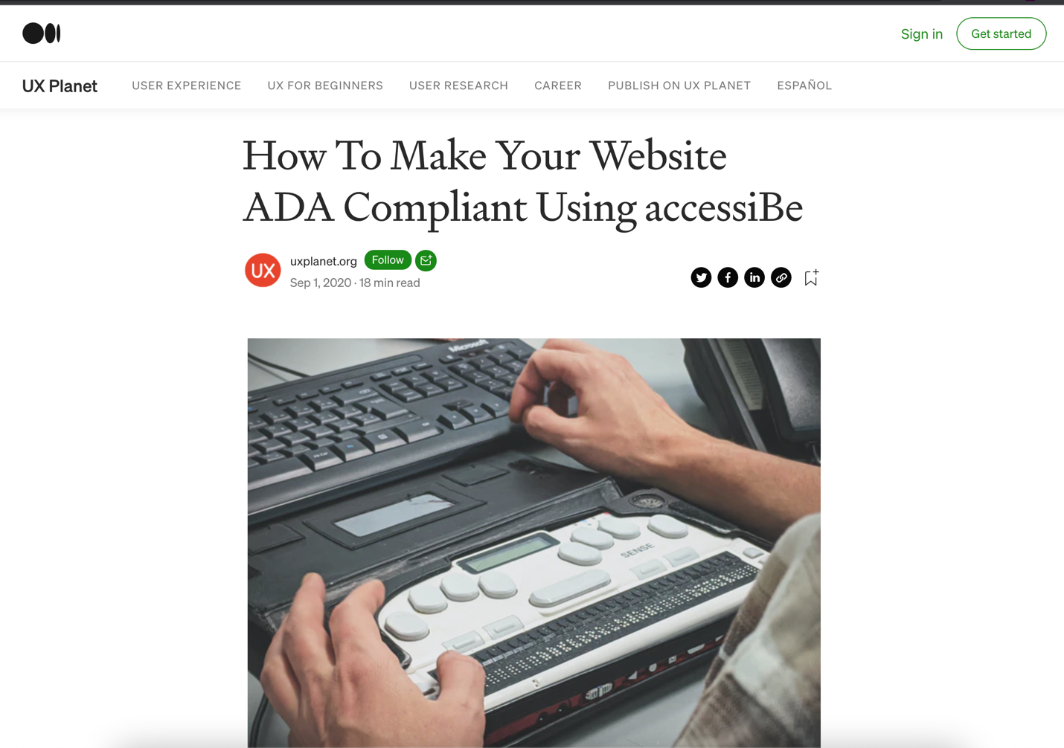

Figure : Screenshot of article titled "How to make your website ADA compliant using accessiBe" on the website UXPlanet.org

Although it is impossible to know whether an article is legitimate editorial content or an advertisement, the lack of unbiased critique or mention of competitors strongly indicates that many of the articles written about overlay products are paid for by the vendors of those products.

1. "accessiBe will get you sued - accessiBe spoofs automated checkers", Adrian Roselli, Accessed November 6, 2021, <https://adrianroselli.com/2020/06/accessibe-will-get-you-sued.html#Spoofs>
2. "AccessiBe and the fake WordPress plugin reviews", Joe Dolson, Accessed November 6, 2021, <https://www.joedolson.com/2021/02/accessibe-the-fake-wordpress-plug-in-reviews/>
3. "WordPress.org removes fake reviews for accessiBe plugin", WPTavern, Accessed November 6, 2021, <https://wptavern.com/wordpress-org-removes-fake-reviews-for-acessibe-plugin>
4. "How 'deceptive' sponsored news articles could be tricking readers — even with a disclosure message", Business Insider, Accessed November 6, 2021, <https://www.businessinsider.com/how-deceptive-sponsored-news-articles-could-be-undermining-trusted-news-brands-even-with-a-disclosure-message-2016-3>
5. Bartosz W. Wojdynski & Nathaniel J. Evans (2016) Going Native: Effects of Disclosure Position and Language on the Recognition and Evaluation of Online Native Advertising, Journal of Advertising, 45:2, 157-168, DOI: 10.1080/00913367.2015.1115380
6. "Enforcement Policy Statement on Deceptively Formatted Advertisements", US Federal Trade Commission, Accessed November 6, 2021, <https://www.ftc.gov/system/files/documents/public_statements/896923/151222deceptiveenforcement.pdf>