Truth in advertising does not exist for overlay vendors

False claims at the expense of customers and persons with disabilities.

Karl Groves, Michael Beck

Acknowledgments:

Our thanks to Chris M. Law for providing reviews and content contributions during the creation of this document.

November 12, 2021

Appendices, evidence, and resources also available at https://www.overlayfalseclaims.com

# Accessibility Notes

This document and all associated appendices make effective use of proper document structure to aid in understanding the content and the structure of that content, including mindful use of headings, lists, and tables, where necessary.

None of the images in the main document use Word's alt text feature. Each image is marked as decorative and, instead, given a caption that describes the purpose for the image. This choice was made so that all users, both visual and non-visual, can benefit from the description.

Appendix B is a full list of all evidence gathered in researching these claims. Since this mostly consists of screenshots, these images have been given text alternatives that fully replicate all text that is present in the screenshot.

# Table of Contents

Accessibility Notes 2

Table of Contents 3

Introduction 6

What is Web Accessibility? 7

False advertising among Web Accessibility Overlay vendors 8

History and description of Overlays 8

Despite the above, deceptive marketing is almost universal among overlay vendors 10

Specific examples of false claims made by Overlay vendors 11

Claim: Adding the product is the only thing the customer needs to do for accessibility 11

The Truth 12

Example 12

Claim: By using the product, the customer's site will become compliant with the ADA and other relevant regulations and standards. 13

The Truth 13

Example 14

Claim: By using the product, the customer's site will attain compliance in an extremely short period of time. 15

The Truth 15

Example 15

Claim: By using the product, the customer's website will be accessible to everyone. 16

The Truth 16

Example 17

Claim: By using the product, the customer will be shielded from litigation. 18

The Truth 19

Example 19

Claim: The product is the only one on the market that can make the customer's site compliant. 20

The Truth 20

Example 20

Claim: The product alone is sufficient in achieving compliance without any other work needed on the underlying code. 21

The Truth 22

Example 22

Claim: Increased conversion rates 22

The Truth 23

Example 23

Claim: Exaggerated number of customers 24

The Truth 24

Example 24

Claim: Specific brands as customers which are not 25

The Truth 25

Example 25

Claim: That the overlay widget is a suitable alternative to assistive technologies 26

The Truth 26

Example 27

Claim: Collaboration with 3rd parties with whom they have not done so 29

The Truth 29

Example 29

Conclusion 30

# Introduction

False advertising harms consumers and is damaging to a fair marketplace. It is also illegal.

The Federal Trade Commission Act is the primary statute of the [Federal Trade] Commission. Under this Act … the Commission is empowered, among other things, to (a) prevent unfair methods of competition and unfair or deceptive acts or practices in or affecting commerce; (b) seek monetary redress and other relief for conduct injurious to consumers; (c) prescribe rules defining with specificity acts or practices that are unfair or deceptive, and establishing requirements designed to prevent such acts or practices; (d) gather and compile information and conduct investigations relating to the organization, business, practices, and management of entities engaged in commerce…

[1],[2]

Under the Federal Trade Commission Act:

1. Advertising must be truthful and non-deceptive.
2. Advertisers must have evidence to back up their claims; and
3. Advertisements cannot be unfair.

In addition to false advertising being a violation of Federal law, all 50 states have legislation aimed at protecting consumers in their state from deceptive practices. 19 states have adopted the Uniform Deceptive Trade Practices Act[3] while the remaining states have their own, similar laws. The consumer protection laws in 49 states explicitly forbid false advertising.[4]

## What is Web Accessibility?

Web Accessibility, in simplest terms, is the extent to which people with disabilities can access websites and other web-based systems such as online retail and banking, web-based software necessary for their jobs, social media, and more. While people with disabilities may require additional hardware or software (called Assistive Technologies) to facilitate that access, websites still must be designed and programmed properly so that the assistive technologies can accurately interpret and/ or facilitate the proper experience for the users.

The criteria against which accessibility is typically measured is a standard known as the Web Content Accessibility Guidelines (WCAG). The WCAG standard is developed by the Accessibility Guidelines Working Group of the Worldwide Web Consortium (W3C), the international standards body of the Web. This working group currently has 182 participants, including 32 invited experts, representing 57 organizations across the globe. Version 2.0 of WCAG is recognized as an ISO standard (ISO/ IEC 40500:2012). It is the basis for, or referenced by, 39 laws and policies around the globe. In the United States, it is incorporated by reference in Section 508 of the Rehabilitation Act and is often referenced in lawsuit filings, settlements, and consent decrees for the Americans with Disabilities Act (ADA).

# False advertising among Web Accessibility Overlay vendors

## History and description of Overlays

The first tools for testing a website's accessibility were created not long after foundational work for the first version of WCAG (Web Content Accessibility Guidelines) - the predominant industry standard defining the requirements for accessibility on the Web - was created. Shortly after the final release of WCAG 1.0, products purporting to deliver automated compliance were created. It did not take long before companies that were promoting *automated* compliance were being heavily criticized among those in the accessibility field as being misguided and for overstating their utility for people with disabilities[5].

Those early products almost always came in the form of small user interface controls that merely read the page's content aloud. Over time, similarly, positioned products would move to adding "widgets" which intend to function as on-page assistive technologies by adding controls to modify the features of the websites on which they were deployed. These controls do things like increase font size, change the contrast of the colors on the page, and change the appearance of certain types of content on the page.

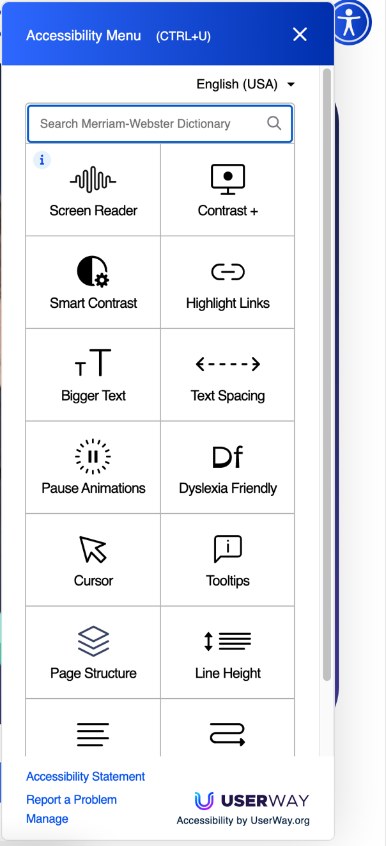

Figure 1: Screenshot of the "widget" from UserWay. Nearly all overlays have their own version of this type of control set which offer so-called "enhancements" that change the display of the site upon which they are installed. Screenshot taken November 11, 2021

More recently, vendors of these products claim that their product can repair underlying code quality problems in the sites on which they're deployed and, further still, claim that they are using artificial intelligence to render websites compliant with laws and standards having to do with accessibility.

These claims are poorly received by career professionals in the accessibility field. Over 600 people have endorsed a community-driven statement against overlay products called the Overlay Factsheet.[6] The list of signatories on the factsheet includes accessibility experts, disability rights advocates, lawyers, contributors & editors for the technical specifications that run the Web itself, and most importantly, end users with disabilities. The list of signatories come from over 16 countries around the world. In summary, the Overlay Factsheet's signers agree that:

1. Overlay widgets are unnecessary and are poorly placed in the technology stack.
2. While some automated repair is possible, customers should be discouraged from using an overlay as a long-term solution.
3. While the use of an overlay may improve compliance with a handful of provisions in major accessibility standards, full compliance cannot be achieved with an overlay.
4. Adding an overlay to your site may run counter to end users' preference for privacy and may create risk of noncompliance with applicable [privacy] regulations.
5. No overlay product on the market can cause a website to become fully compliant with any existing accessibility standard and therefore cannot eliminate legal risk.

## Despite the above, deceptive marketing is almost universal among overlay vendors

Below, we provide specific examples of false claims made by Overlay vendors. [7] In summary, the false claims made by overlay vendors fit into one of the following themes:

1. Adding the overlay product is the only thing the customer needs to do for accessibility.
2. By using the overlay product, the customer's site will automatically become compliant with the ADA (and other relevant regulations and standards).
3. By using the overlay product, the customer's site will automatically attain compliance in an extremely short period of time.
4. By using the overlay product, the customer's website will automatically be accessible to everyone.
5. By using the overlay product, the customer will automatically be shielded from litigation.
6. The overlay product is the only one on the market that can make the customer's site compliant.
7. The overlay product alone is sufficient in achieving compliance without any other work needed on the underlying code.

In addition to the above, many of the overlay vendors also claim the following which are highly dubious at best, and outright lies at worst:

1. Improved usability.
2. Increased rates of converting website visitors to purchasers.
3. Exaggerated number of customers.
4. Claiming name-brand customers who are not actually customers.
5. Collaboration with 3rd parties with whom they have not done so.
6. The product is a sufficient alternative to specialized assistive technologies

# Specific examples of false claims made by Overlay vendors

This section contains one example for each of the types of false claims made by overlay vendors. For the full list of gathered evidence and associated data, please see this document's appendixes.

## Claim: Adding the product is the only thing the customer needs to do for accessibility

The most factually incorrect claim made by overlay vendors is that adding the product to their website is the only thing the customer needs to do for accessibility.

### The Truth

In fact, no overlay product on the market can make a website fully accessible, much less conformant to major industry standards. While some overlay products can perform some behind-the-scenes repair of accessibility issues, the extent of those fixes are exceedingly small. Additionally, the "widgets" provided by overlays are most often a poorly executed attempt at replicating capabilities that already exist in the features of the user's browser and/ or operating system settings.

### Example

The image below shows the EqualWeb product's font-size increasing feature. The EqualWeb product only provides an increase of up to 150% while users of both Windows and macOS operating systems can increase system font sizes several times higher and offer additional capabilities to zoom the entire screen many times over.

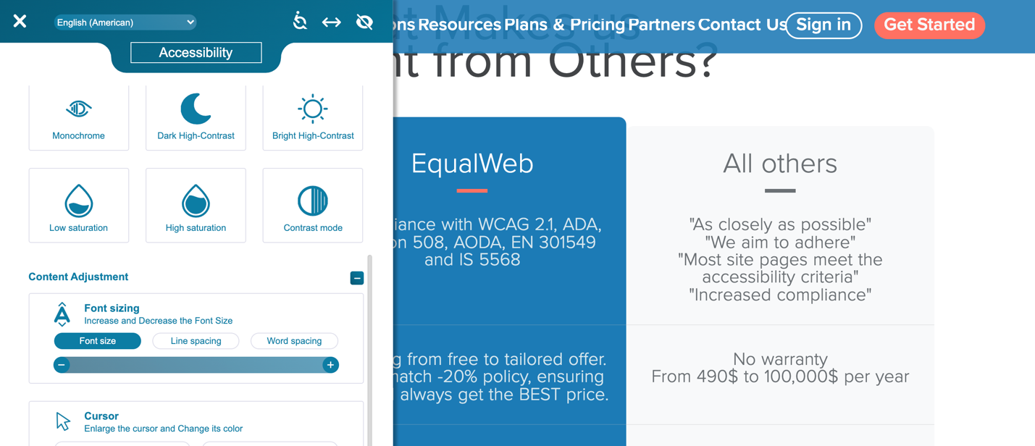

Figure 2: Screenshot of the EqualWeb product after triggering the largest font size increase the product offers. In this case it has increased the font size of text from 18px to 24px.

This does not prevent overlay vendors from making the claim - explicitly or implicitly - that adding their product to your site is the only thing you need to do. In the example below, Allyable says "… we already did all the work for you!" suggesting the site's owner doesn't need to do anything else to make their website accessible once Allyable is installed on the site.

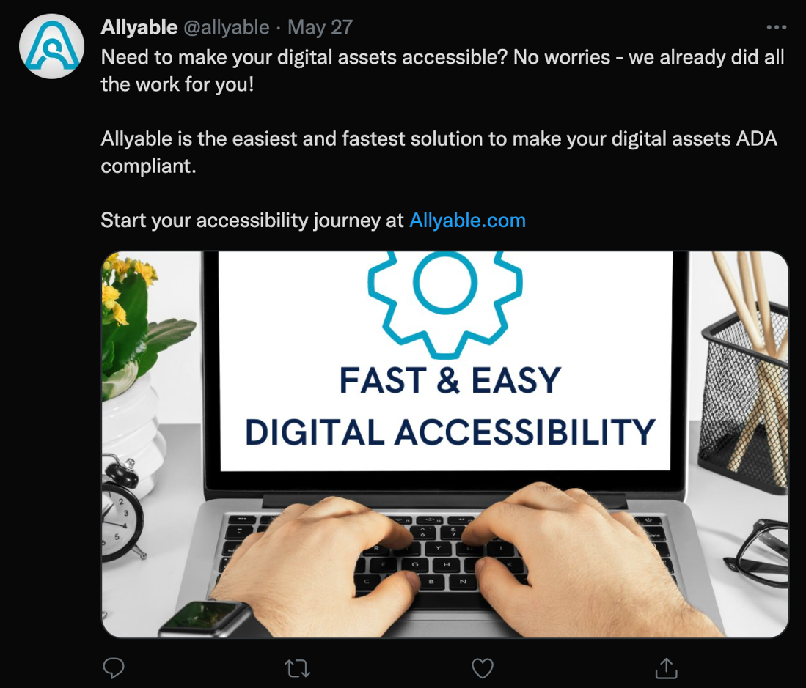

Figure 3: Screenshot from Twitter status posted by Allyable stating: "Need to make your digital assets accessible? No worries - we already did all the work for you!". Screenshot taken October 21, 2021

## Claim: By using the product, the customer's site will become compliant with the ADA and other relevant regulations and standards.

Overlay vendors frequently cite the specific regulations and standards against which the customer's site will become compliant once installing the product. This list includes the ADA, WCAG, and international regulations such as EN 301 549.

### The Truth

Because these products are incapable of repairing all accessibility issues on a website, it stands to reason that they are also incapable of delivering compliance with standards and regulations. Doing so with automated means is completely impossible for many reasons, such as:

* There are no specific technical requirements for ADA Title III. While ADA-related lawsuits and settlements tend to agree on WCAG 2.1 Level AA, this is not codified by the law itself.
* Section 508 and EAA/ EN 301 549 contain several items called "Functional Performance Criteria[8]". These criteria are typically very subjective, not clearly defined in a way that can be easily tested by machines, and heavily dependent on context.
* Some of the Success Criterion in WCAG relate to things that change on the page during user-triggered actions that cannot be detected by an overlay reliably enough to predict what action it should take to ensure compliance.

### Example

In the example below, Accessus.ai claims it is "the only automatic solution" and that it can bring sites into compliance with WCAG 2.1, ADA Title III, Section 508, EAA/EN 301 549[9].

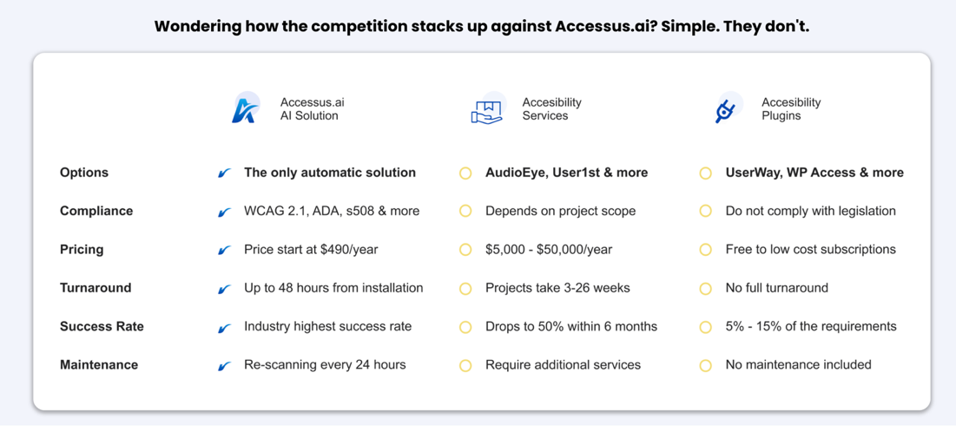

Figure 4: Screenshot from Accessus.ai website claiming it will bring a site into compliance with WCAG 2.1, ADA, Section 508 and more. Screenshot taken November 5, 2021

## Claim: By using the product, the customer's site will attain compliance in an extremely short period of time.

Overlay vendors' marketing messaging preys upon the often-urgent nature of potential customers' needs and/ or the concern that making a website accessible will be difficult and take a long time. The overlay vendors' messaging often contain such claims as:

* "Up to 48 hours from installation" - Accessus.ai
* "In up to 48 hours, your website is accessible and compliant" - AccessiBe
* "Compliant with ADA & WCAG Laws on Day 1 of implementation" - AudioEye

### The Truth

As has already been established, these products cannot cause a website to become compliant on their own in any period, much less the extraordinarily short period of time they state in their marketing claims. Effectively making an existing website compliant with WCAG can take several weeks to several months depending on the nature and size of the website and the number, nature, and severity of accessibility issues.

### Example

The screenshot below, from UserWay, claims "UserWay's solutions provide full WCAG & ADA compliance from day one, and every single day thereafter".

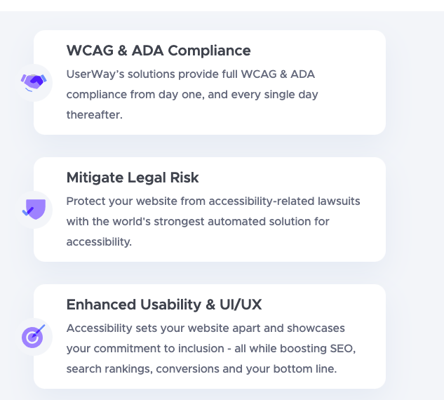

Figure 5: Screenshot from UserWay's website claiming "Full WCAG & ADA compliance from day one". Screenshot taken October 20, 2021

## Claim: By using the product, the customer's website will be accessible to everyone.

A frequent theme among overlay vendors isn't just that the customer's website will become compliant with major industry standards but that the site will become accessible to ***everyone***.

### The Truth

Unfortunately, "accessible to everyone" is not possible:

* Some cognitive disabilities are difficult or impossible to design/ develop for.
* Some accessibility changes may benefit one population while decreasing usability for others.

This is why assistive technologies exist. When deployed on the user's computer, either as hardware, software, or an alternate device altogether, the user with disabilities can choose the necessary assistive technology to assist with their specific needs.

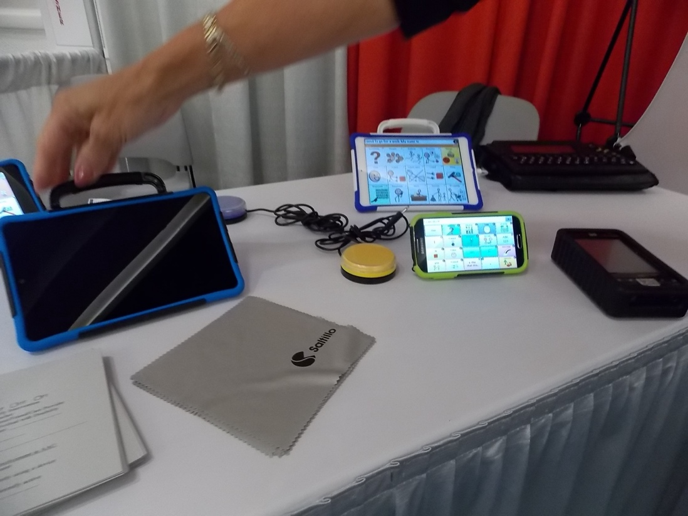

Figure 6: Alternative communication devices on display at an exhibitor's table at the annual CSUN Conference on Disabilities

Due to the extreme levels of variance in the nature, causes, and severity of disabilities - and the possibility of a person having multiple disabilities - no overlay on the market can provide a complete solution and none have ever proven to come close.

### Example

The below tweet from EqualWeb states "EqualWeb offers a 100% ADA WCAG 2.1 AA compliant solution that will make your website accessible by all".

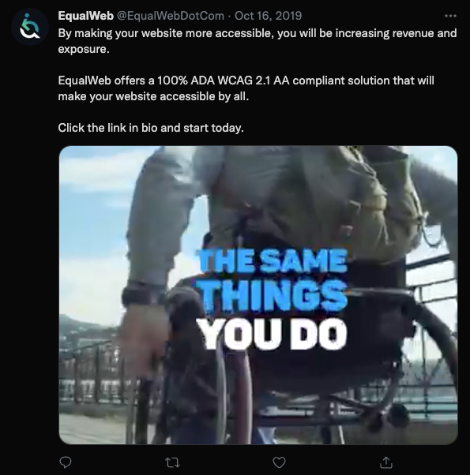

Figure 7: EqualWeb claims in this Twitter post that "EqualWeb offers a 100% ADA WCAG 2.1 AA compliant solution that will make your website accessible by all." Screenshot taken October 22, 2021

## Claim: By using the product, the customer will be shielded from litigation.

Due to the swift pace of litigation around Web Accessibility, customers who have been recently made aware of a lawsuit against them, or customers who are fearful of such a thing, are very receptive to the idea of having a product that can shield them from litigation. Therefore, claiming that they can do so is a very common theme from overlay vendors.

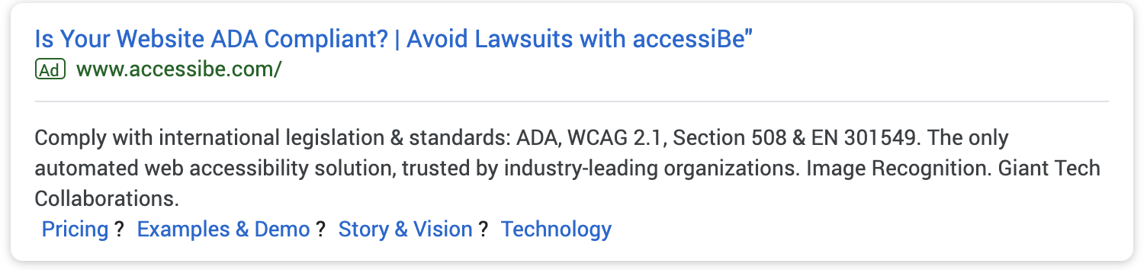

Figure 8: Screenshot of Google Ad from accessiBe which contains the headline "Is Your Website ADA Compliant? | Avoid Lawsuits with accessiBe". This ad ran in January 2020

### The Truth

Despite the marketing messages of overlay vendors, their claims of legal protection have been proven false. As shown in Appendix A, over 200 companies have been sued in 2021 despite already having purchased an overlay. Of those lawsuits, the accessiBe product was present on 95 of those sites on the day the lawsuit was filed against the defendant.

### Example

MaxAccess.io boldly proclaims "Be Compliant & Avoid Lawsuits. Make Your Website Accessible to Everyone" and "Avoid Litigation. Maintain the Highest Level of Compliance 24/7"

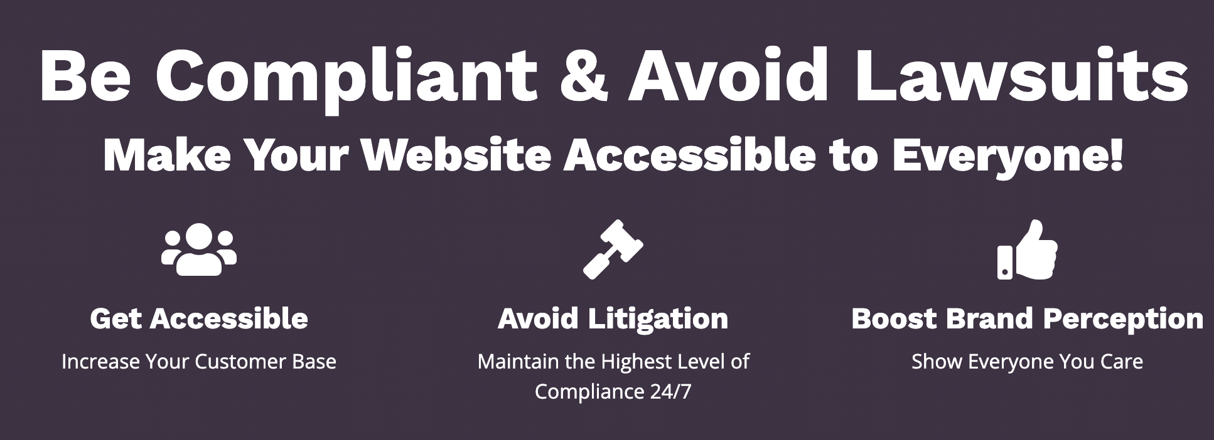

Figure 9: Screenshot from MaxAccess.io stating: "Avoid Litigation. Maintain the Highest Level of Compliance 24/7". Screenshot taken October 21, 2021

In another example, Shir Ekerling, CEO of accessiBe, proclaims in the LinkedIn comment below that "You have only seen companies that have joined accessiBe to be a solution to their already existing legal situation". This claim is demonstrably false because, as shown in Appendix A, 95 companies were sued despite using the accessiBe product on their site.

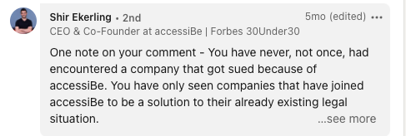

Figure 10: Screenshot of comment on LinkedIn made by Shir Ekerling, CEO of accessiBe proclaiming "You have only seen companies that have joined accessiBe to be a solution to their already existing legal situation." Screenshot taken October 27, 2021

## Claim: The product is the only one on the market that can make the customer's site compliant.

Another common theme among overlay vendors is the claim that they are the ***only*** vendor whose product can render the customer's site compliant.

### The Truth

Beyond the fact that these products don't do what they claim to, the claim that they're the only one who can do so is untrue. While the accessibility industry is quite small, there are several companies with the domain knowledge, tooling, and development capabilities necessary to make customers' sites accessible and compliant fully and completely with WCAG.

### Example

On September 30, Allyable Tweeted "Allyable is the only digital accessibility provider that gives an end-to-end solution…"

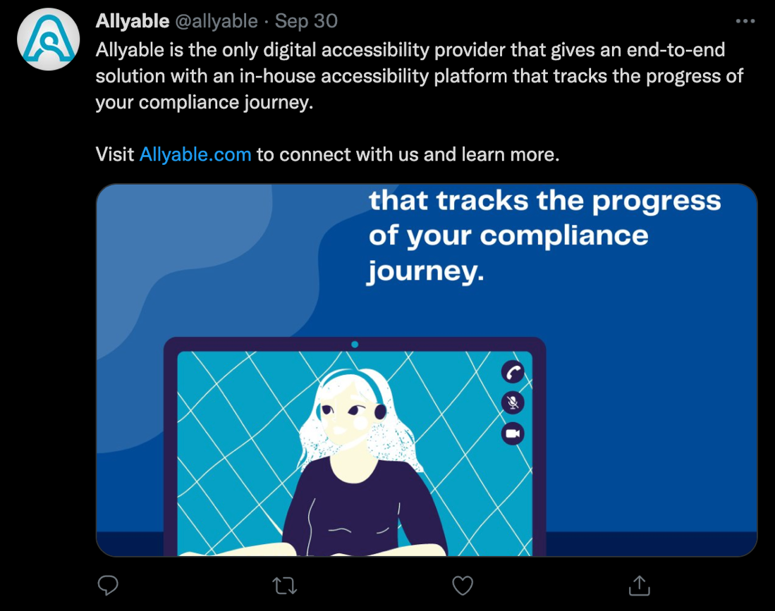

Figure 11: Screenshot from a Twitter post by Allyable claiming "Allyable is the only digital accessibility provider that gives an end-to-end solution…". Screenshot taken October 21, 2021

## Claim: The product alone is sufficient in achieving compliance without any other work needed on the underlying code.

A popular refrain within overlay vendor's marketing is that "one line of code" is all that is needed. They claim that by adding one line of (JavaScript) code, which contains the overlay product's code, the site will become accessible. The follow-on claim, as shown below, is that there is nothing else that will need to be changed on the customer's site.

### The Truth

This claim would be true if the products did what the vendors claim they do, but that is not the case. In fact, it has been proven[10] that such products are unable to correct accessibility issues in the following types of content:

* Images and other non-text-content
* Forms
* Document heading structure
* Keyboard accessibility and programmatic focus management

### Example

The below advertisement from UserWay states "No changes to your website's Code. Fully Automated."

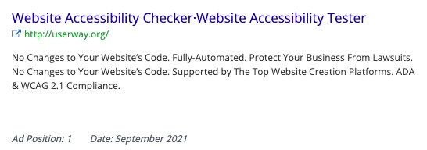

Figure 12: Screenshot of Google ad placed by UserWay which proclaims, twice, "No changes to Your Website's Code". This ad ran September 2021

## Claim: Increased conversion rates

"Conversion" is the point in time where a website's visitor performs a desired action that places them on the path toward becoming a paying customer. Marketers measure conversion rates as a metric that helps determine the effectiveness of their marketing efforts. Some overlay vendors claim that you will increase traffic and/ or increase conversions simply by installing their product.

### The Truth

Increasing a website's accessibility is often claimed to be a means to increase conversion, though most discussion on this topic is based on little more than conjecture. Nobody, overlays vendors or anyone else, has ever provided sufficient evidence to prove that accessibility improvements alone will result in increased conversion rates.

### Example

In the example provided below, ActiveIntent claims that you will increase conversions by 30% - a number that should be seen as ridiculous, in the strictest sense of the word, because a conversion rate of 30% is 4-7x more than what many marketers understand to be a good conversion rate.[11]

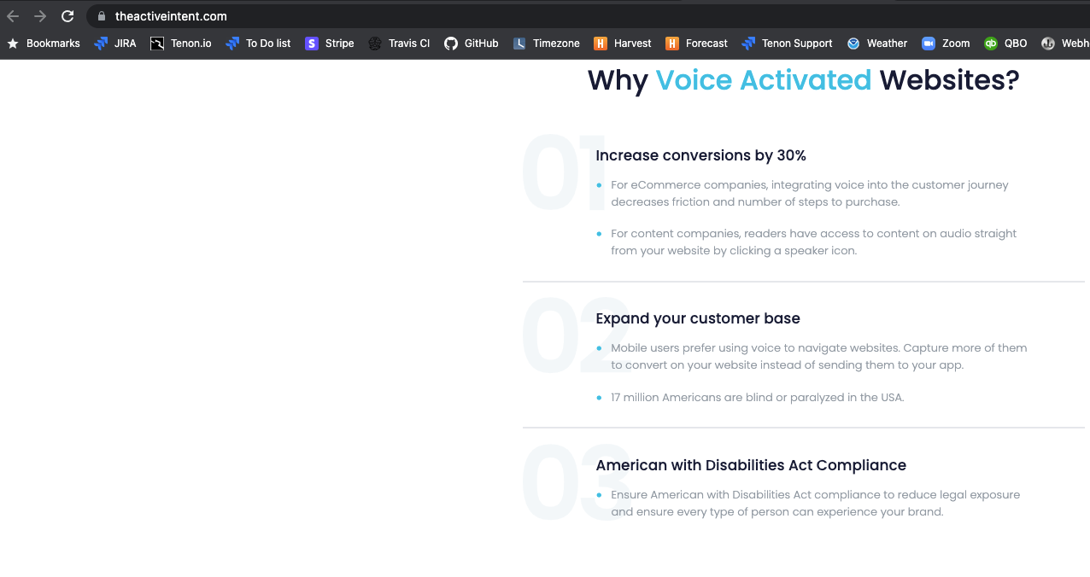

Figure 13: ActiveIntent claims that using their software will increase conversion by 30%. Screenshot taken October 20, 2021

## Claim: Exaggerated number of customers

According to Robert Cialdini,[12] Social Proof is one of the most powerful influencers. In e-commerce, the impression that a specific peer of high esteem has purchased your product can help influence a customer to buy.

### The Truth

Overlay vendors frequently exaggerate the number of customers they have. By exaggerating this number, overlay vendors make their products seem to be more popular than they really are. In fact, as shown in Appendix F, overlay vendors often overstate their market penetration 3-fold or more.

### Example

In the example below, EqualWeb claims to be installed on 100,543,679 web pages. In this case, "web pages", as a term, is a bit ambiguous. One can reasonably assume that "web pages" is not the same as "sites", which would be a collection of pages under a distinct domain. However, according to data gathered for this report, the number of sites that have installed EqualWeb is close to 6000. Even if we assume a rather generous 500 distinct pages per site, EqualWeb is still overstating their claim by over 300%. As shown in Appendix D these claims of market penetration can often be exaggerated significantly.

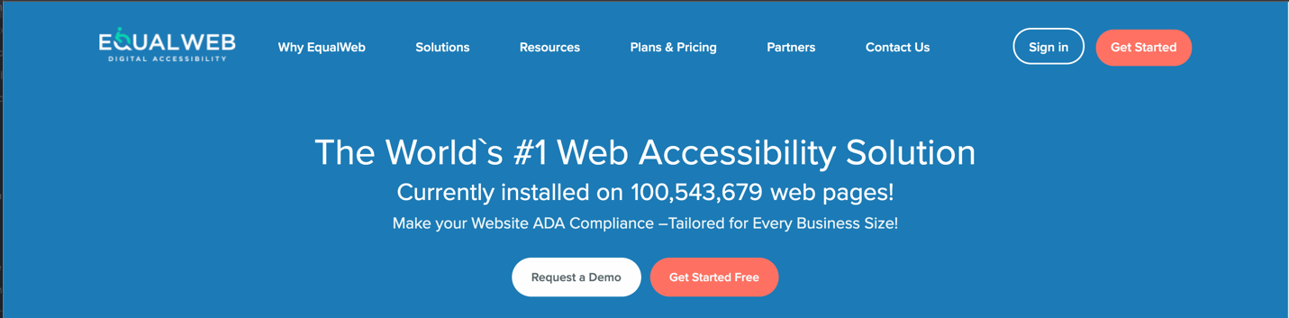

Figure 14: Screenshot from EqualWeb, claiming that their product is installed on over 100 million web pages. Screenshot taken November 5, 2021

## Claim: Specific brands as customers which are not

Like above, when it comes to Social Proof, a list of impressive customers can go a long way toward impressing those who may be similarly inclined to purchase the product.

### The Truth

When it comes to overlay vendors, there's often a disconnect between their actual customer list and their claims. They often use names, logos, and testimonials of impressive companies with which they do no actual business. Another tactic used is to add the logo of a multinational corporation on their site, lending the impression that the entire corporation is a customer, when only a small, local subsidiary is the customer.

### Example

Allyable has an impressive list of logos on their home page under the heading "Trusted By". Among the logos are companies like Diverse Ability Magazine, AudioCodes, Bank Hapoalim, and Microsoft, none of whom are Allyable customers. In fact, 10 out of the 15 companies listed are *not* Allyable customers, 1 is a reseller, and 3 are customers of a reseller. In other words, only 1 of the companies listed is a direct customer of Allyable.

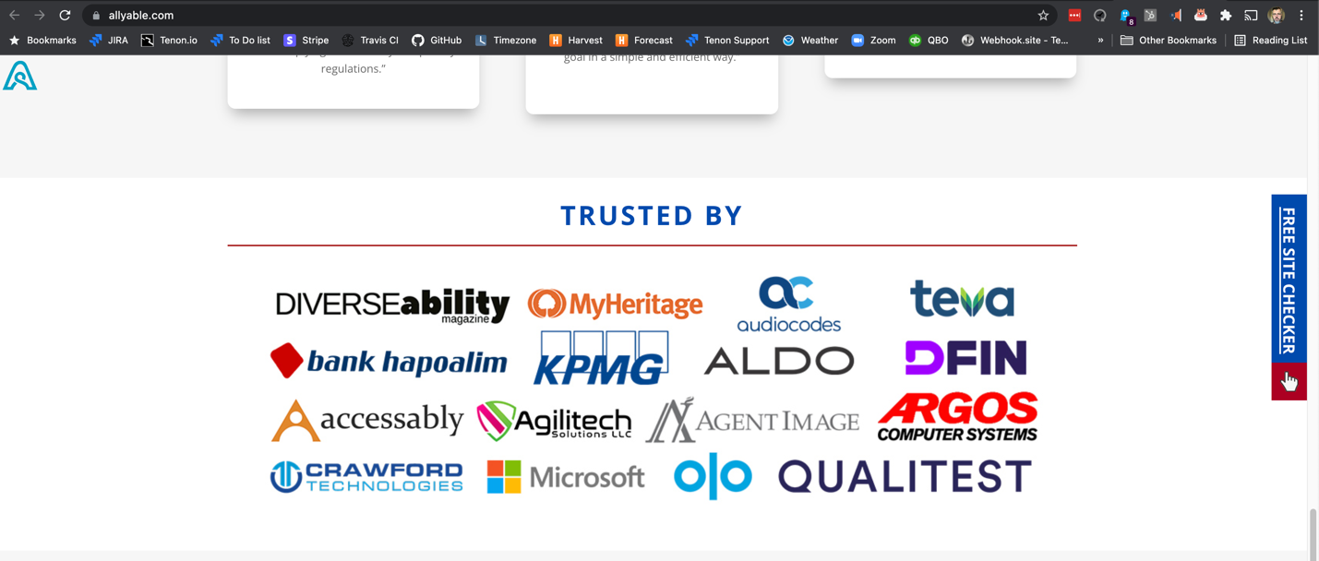

Figure 15: Screenshot from Allyable.com claiming to have several customers that they don't have. Screenshot taken October 26, 2021

## Claim: That the overlay widget is a suitable alternative to assistive technologies

The "widgets" that form the bulk of the functionality of overlay products present controls that transform the site's appearance and features in ways that they claim make the site more accessible to end users with disabilities.

### The Truth

In nearly all cases, the "enhancements" facilitated by overlay products already exist on the user's computer when purchased. In Windows, these features are located under "Ease of Access" settings[13], and in macOS they are in "Accessibility" within System Preferences[14]. Additionally, many accessibility preferences can be set within the user's browser. Users can also purchase specialized assistive technologies - both hardware and software - for their particular disability and preferences.

The fundamental absurdity of overlay vendors claiming that their product is useful as an assistive technology is that the claim fails to acknowledge that their product is poorly placed in the technology stack:

* If a user needs larger text on a website, they need larger text on all sites and applications
* If a user needs a high-contrast mode on a website, they need it on all sites and applications
* If a user needs text read aloud on a website, they need it on all sites and applications

The claim that the overlay widgets are useful in overcoming accessibility barriers strategically ignores the fact that users who *need* those features on a specific site will need those features to start the computer, open their browser, and navigate to the site in the first place.

The last reason that these products are not a suitable alternative to assistive technologies is because they often do not perform as well as the user's built-in assistive technologies.

* The font size adjustments often do not increase to the same levels. For example, Allyable, AudioEye, and UserWay only go to 200% while EqualWeb and MaxAccess only go to 150%. Built-in features for Windows and macOS go much larger.
* None of the overlay widgets' high contrast modes offer the variety, granularity, or customization capabilities of Windows or macOS

### Example

The most egregious example of this type of claim is the one below, from UserWay, who proclaims "Unlike standard screen readers, UserWay's is engineered specifically for websites. Over 40 languages. Multiple reading speeds. A seamless experience for all."

These claims are particularly deceptive because:

* As already mentioned, if a user needs a screen reader, they will need it to assist them in navigating to a website that has UserWay's product installed.
* The different languages that can be supported is dependent upon the speech synthesizer that is on the user's computer.
* Depending upon the supported speech synthesizers on a user's computer, JAWS and NVDA ("standard" screen readers implied by UserWay) can support approximately 80 languages.
* UserWay only supports 3 reading speeds ("normal", "fast", and "slow"), whereas real screenreaders can typically offer specific word-per-minute granularity and some blind screenreader users can listen to their computers at 450 words per minute[15].

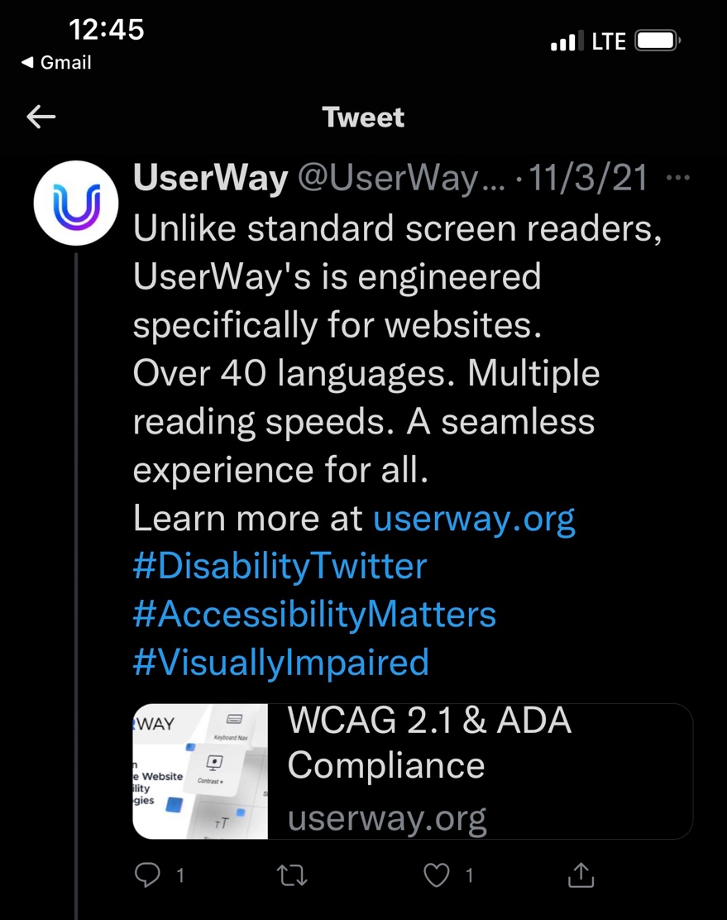

Figure : Since-deleted Tweet from UserWay, dated November 3, 2021, suggesting that their widget is a suitable alternative to major screen readers

## Claim: Collaboration with 3rd parties with whom they have not actually collaborated with

Another way an overlay vendor can use Social Proof to convince potential customers that their product is respectable is to claim that they've collaborated with others in the industry to drive innovation in their product.

### The Truth

While there may be cases where overlay vendors are in contact with the general community of users, in many cases the accessibility field shuns overlay vendors. In June 2020, for instance, the National Federation for the Blind (NFB) went so far as to say, "…the Board [of NFB] believes that accessiBe currently engages in behavior that is harmful to the advancement of blind people in society."[16]

### Example

On August 21, 2019, a representative from accessiBe, named Pamela, claimed that accessiBe had collaborated with JAWS developers on the accessiBe product, stating[17]:

For more than 18 months, our Research & Development process focused on working back to back with people with different disabilities, even prior to our first live version. The process also included leading experts in accessibility, **as well as a developer from the JAWS team whom, as you may know, is an eminence in screen-reader technology in the world today.**

According to blogger and accessibility consultant Adrian Roselli, this claim was false. He received communication from Vispero/ Freedom Scientific, the maker of JAWS, which stated:

"Neither Vispero nor any of its developers have ever worked with accessiBe relative to any products and services." Roselli also identified two other instances in which accessiBe made this false claim.[18]

# Conclusion

Although standards and technologies are available - and have been available - to make websites accessible for over 20 years, we still live in a world in which most websites are designed without accessibility in mind. Consequentially, most websites contain significant challenges for people with disabilities. Thankfully governments understand how important Accessibility is for equitable access to the digital world and, as a result, every major economic region in the world has laws mandating accessibility. In the US we have laws such as the ADA, The Rehabilitation Act, CVAA, and Air Carrier Access Act.

Federal, State, and Local government websites must comply with accessibility requirements. In recent years, lawsuits have resulted in a widespread recognition that most private companies must comply. For those who do not comply and who then receive legal complaints penalties can be painful.

Providing a solution for this problem is a very healthy business model - especially if you can do it quickly, cheaply, and with minimal disruption to the existing User Interface. This is the *false* promise made by overlay vendors.

The fact remains, however, that technology does not yet exist to cause an already existing website to become fully compliant with existing laws and standards without modifying the design, structure, and features of the site. This usually takes time, money, and disruption to the development process to insert the missing accessibility pieces. Accessibility experts provide consultation on these processes, helping companies establish new development processes such that their digital technologies become accessible each time from the beginning.

Accessibility experts, advocates, and end users with disabilities agree that overlay products are not fit for task of ‘fixing’ inaccessible websites. Nonetheless, vendors of these products continue to traffic in false claims that they possess the technology to make a website accessible and eliminate the risk of a lawsuit due to disability discrimination.

These false claims are insidious:

1. While the false claims in the diet, fitness, or male enhancement industries prey on the buyer, the false claims of overlay vendors prey on the buyer while also facilitating discrimination against people with disabilities. Based on the evidence provided in this report, overlay vendors are in the practice of convincing their customers that all the customer needs to do is install their product for near-instantaneous, around-the-clock, full compliance with industry accepted accessibility standards and that, as a result, the customer will be protected against an accessibility-related lawsuit. Naturally, this means that the customer will pursue no additional means of ensuring that they are providing an accessible experience on their website. The result is that the customer's website is not made significantly more accessible and that end users with disabilities are still unable to gain full and equal access as required by law. In short, overlay products perpetuate discrimination against persons with disabilities through their false claims and should be held accountable.
2. There is an industry of accessibility consultants and professionals who are working to help organizations to make more accessible websites through (what is widely considered to be) *legitimate* means. The costs to organizations to remediate their inaccessible content come in the form of payment for expert assistance; time for conducting a thorough job; and the provision of internal resources to adjust their previously accessibility-deficient development and testing processes. The false claims made by Overlay vendors (i.e., solutions are cheap, quick, and with minimal disruption) undermine legitimate accessibility consulting business practices. This is *unfair competition*. In addition, for the companies, their development and testing personnel who should be receiving accessibility training to enhance their own professional development are instead (unknowingly because of false advertising) receiving the false narrative that accessibility is ‘solved’ using an Overlay. This is antithetical to the underpinnings of the ADA and related laws, that accessibility should be a shared responsibility to solve a societal problem.

1. "15 USC Chapter 2, Subchapter I: Federal Trade Commission; Chapter 2 — Federal Trade Commission, Promotion of export trade and prevention of unfair methods of competition ", United States House of Representatives, Accessed November 6, 2021 <http://uscode.house.gov/view.xhtml?req=granuleid%3AUSC-prelim-title15-chapter2-subchapter1&edition=prelim>
2. "Federal Trade Commission Act, Incorporating U.S. SAFE WEB Act amendments of 2006", Federal Trade Commission, Accessed November 6, 2021, <https://www.ftc.gov/sites/default/files/documents/statutes/federal-trade-commission-act/ftc_act_incorporatingus_safe_web_act.pdf>
3. "Merchant and Consumer Protection: The Uniform Deceptive Trade Practices Act", Yale Law School, Accessed November 6, 2021, <https://digitalcommons.law.yale.edu/cgi/viewcontent.cgi?article=5831&context=ylj>
4. "Deceptive Trade Practices laws", Law Library - American Law and Legal Information, Accessed November 6, 2021, <https://law.jrank.org/pages/11799/Deceptive-Trade-Practices.html>
5. "BrowseAloud Opinions Sought; Discussion response by Paul Liversidge posted May 26, 2004", comp.infosystems.www.authoring.html, Accessed November 6, 2021, <https://groups.google.com/g/comp.infosystems.www.authoring.html/c/vU-Z_LnBX64/m/VA2ICES_MQkJ?hl=en&pli=1>
6. "Overlay Factsheet", Karl Groves et al. Accessed November 6, 2021, <https://overlayfactsheet.com/>
7. "Can assistive technologies make a website accessible?", Karl Groves, Accessed November 6, 2021, <https://karlgroves.com/2012/04/19/can-assistive-technology-make-a-website-accessible>
8. "Section 508 of the US Rehabilitation Act, Appendix C to Part 1194 - Functional Performance Criteria and Technical Requirements", National Archives, Accessed November 6, 2021

   <https://www.ecfr.gov/current/title-36/chapter-XI/part-1194#Appendix-C-to-Part-1194>
9. "EN 301 549 V 1.1.2 (2015-04) Accessibility requirements suitable for public procurement

   of ICT products and services in Europe", European Telecommunications Standards Institute, Accessed November 6, 2021 <https://www.etsi.org/deliver/etsi_en/301500_301599/301549/01.01.02_60/en_301549v010102p.pdf>
10. "Exhibit A For 21-cv-00017: Sole reliance on accessiBe will not be sufficient in ensuring full and equal access to a website", Karl Groves, Accessed November 27, 2021, https://www.scribd.com/document/490740167/Exhibit-A-for-21-cv-00017
11. "What is a good conversion rate (And how does yours compare?)", WebFX, Accessed November 6, 2021, <https://www.webfx.com/blog/marketing/what-is-a-good-conversion-rate/>
12. "Robert Cialdini", Wikipedia, Accessed November 6, 2021, <https://en.wikipedia.org/wiki/Robert_Cialdini>
13. "Make your PC easier to use", Microsoft, Accessed November 26, 2021, https://support.microsoft.com/en-us/windows/make-your-pc-easier-to-use-1c313f8f-8bc3-4e1c-c1c8-efe173a94845
14. "Set Accessibility preferences on Mac", Apple, Accessed November 26, 2021, https://support.apple.com/guide/mac-help/set-accessibility-preferences-mchlp1400/mac
15. "Software development at 450 words per minute", Vincit, Accessed November 27, 2021, https://www.vincit.fi/en/software-development-450-words-per-minute/
16. "National Convention Sponsorship Statement Regarding accessiBe", National Federation of the Blind, Accessed November 27, 2021, https://nfb.org/about-us/press-room/national-convention-sponsorship-statement-regarding-accessibe
17. "Be wary of add-on accessibility - Comment", Adrian Roselli, Accessed November 6, 2021, <https://adrianroselli.com/2015/11/be-wary-of-add-on-accessibility.html#comment-164513>
18. "accessiBe will get you sued - Update 13", Adrian Roselli, Accessed November 6, 2021, <https://adrianroselli.com/2020/06/accessibe-will-get-you-sued.html#Update13>