Resonant states for quantum ring with two infinite leads
D A Gerasimov¹, I Y Popov¹, A I Popov¹
¹Department of Higher Mathematics, ITMO University, Saint Petersburg 197101, Russia

Abstract. A scattering model of one dimensional quantum graph Γ consisting of incoming and outgoing channels with a ring scatterer is studied. Completeness of the resonant states of Γ in L₂ on the ring is proved.
1. Introduction
Quantum graph is a widely used model of nanosystem [1-4]. If the graph consists of finite number of edges and all edges have finite lengths then the Hamiltonian has purely discrete spectrum. The system of eigenfunctions is complete in 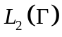. If the graph contains semi-infinite edges, one has non-empty continuous spectrum and resonances generated by the eigenvalues of the initial Hamiltonian of finite graph. For many applications, it is important to know a space in which the resonant states form a complete system. In the present paper we determine this space for a graph with two infinite leads and one loop using Sz.-Nagy model [5].
2. Scattering model
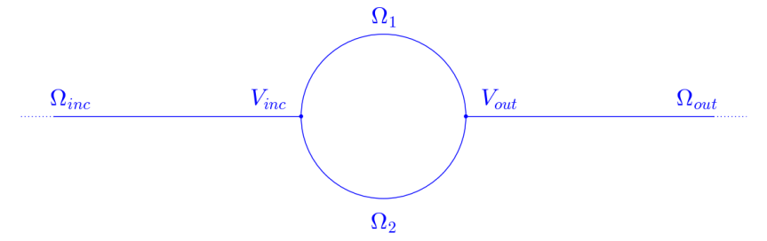
Figure 1. Quantum graph consisting of four edges 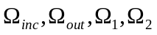. 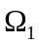and 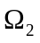represent the 1D ring connected to lead 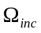 via the vertex 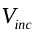 and to lead 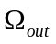 via 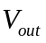.
The wavefunctions on the resonator ring arcs and take the most general form:
We are interested in the scattering of a wave coming from the left lead (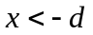) to the right one (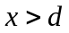):
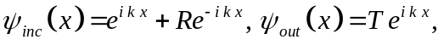
where R is the reflection coefficient, T is the transmission coefficient. Then, we impose boundary conditions at vertices , (so-called δ-coupling [1]):
where is a real valued coupling constant. With the use of boundary conditions, we obtain system of linear equations which leads to expressions for the reflection and transmission coefficients:
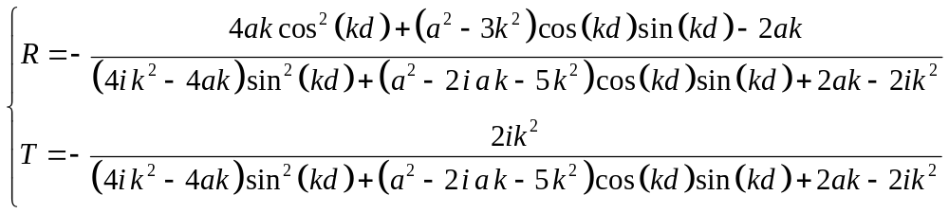
Due to the symmetry of the scattering problem w.r.t. the origin, scattering matrix has the form 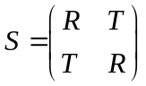, and,
.
We establish the completeness of the resonant states in the space of square integrable functions on the ring. To show this, we have to prove that S is a Blaschke-Potapov product [6], that is,
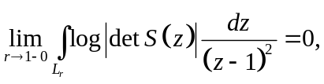
where 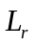 is the image of the curve 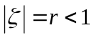 under the map 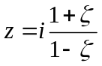. Substituting 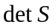, which we calculated above, and estimating the integral, one obtains the desired result.
3. Acknowledgments
This work was partially financially supported by the Government of the Russian Federation (grant 074-U01), by Ministry of Science and Education of the Russian Federation (GOSZADANIE 2014/190, Projects No 14.Z50.31.0031 and No. 1.754.2014/K), by grant MK-5001.2015.1 of the President of the Russian Federation and DFG Grant NE~1439/3-1
References
- Kuchment P. 2002 Waves in Random Media 12 (4), R1-R24.
- Lobanov I.S. Trifanov A.I. and Trifanova E.S. 2013 Nanosystems: Phys. Chem. Math. 4 (4), 512-523.
- Exner P., Keating J. P., Kuchment P., Sunada T. and Teplyaev A. (eds.). 2008. Analysis on Graphs and Its Applications. Proc. Symp. Pure Math., 77 (Providence, RI: Amer. Math. Soc.)
- Popov I. Yu., Skorynina A. N., and Blinova I. V. 2014 J. Math. Phys. 55, 033504
- Sz.-Nagy B, Foias C, Bercoviuci H, Kerchy L 2010 Harmonic Analysis of Operators on Hilbert Space. 2nd edition (Berlin: Springer)
- Nikolskii N K 1986 Tretise on the Shift Operator (Bern: Springer)

