Resonant states for quantum ring with two infinite leads

D A Gerasimov1, I Y Popov1, A I Popov1

1Department of Higher Mathematics, ITMO University, Saint Petersburg 197101, Russia

**Abstract.** A scattering model of one dimensional quantum graph  consisting of incoming and outgoing channels with a ring scatterer is studied. Completeness of the resonant states of  in L2 on the ring is proved.

**1. Introduction**

Quantum graph is a widely used model of nanosystem [1-4]. If the graph $Γ$ consists of finite number of edges and all edges have finite lengths then the Hamiltonian has purely discrete spectrum. The system of eigenfunctions is complete in $L_{2}(Γ)$. If the graph contains semi-infinite edges, one has non-empty continuous spectrum and resonances generated by the eigenvalues of the initial Hamiltonian of finite graph. For many applications, it is important to know a space in which the resonant states form a complete system. In the present paper we determine this space for a graph with two infinite leads and one loop using Sz.-Nagy model [5].

**2. Scattering model**

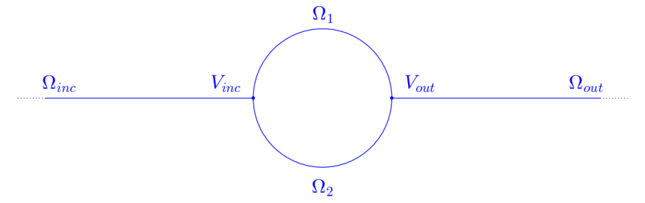

Figure 1. Quantum graph $Γ$ consisting of four edges $Ω_{inc}, Ω_{out}, Ω_{1}, Ω_{2}$. $Ω_{1}$ and $Ω_{2}$ represent the 1D ring connected to lead $Ω_{inc}$ via the vertex $V_{inc}$ and to lead $Ω_{out}$ via $V_{out}$.

The wavefunctions on the resonator ring arcs $Ω_{1}$ and $Ω_{2}$ take the most general form:

$$ψ_{1}\left(x\right)= {Q_{1}e}^{i k x}+W_{1} e^{-i k x}, ψ_{2}\left(x\right)= Q_{2}e^{i k x}+W_{2} e^{-i k x}$$

We are interested in the scattering of a wave coming from the left lead ($x<-d$) to the right one ($x>d$):

$$ψ_{inc}\left(x\right)= e^{i k x}+Re^{-i k x}, ψ_{out}\left(x\right)=T e^{i k x},$$

where R is the reflection coefficient, T is the transmission coefficient. Then, we impose boundary conditions at vertices $V_{inc}$, $V_{out}$ (so-called -coupling [1]):

$$ψ_{inc}\left(d\right)= ψ_{1}\left(-d\right)=ψ_{2}\left(-d\right), ψ_{out}\left(d\right)= ψ_{1}\left(d\right)=ψ_{2}\left(d\right)$$

$$-ψ_{inc}^{'}\left(-d\right)+ψ_{1}^{'}\left(-d\right)+ψ_{2}^{'}\left(-d\right)=aψ_{inc}\left(0\right), ψ_{out}^{'}\left(d\right)-ψ_{1}^{'}\left(d\right)-ψ_{2}^{'}\left(d\right)=aψ_{out}\left(d\right),$$

where $a$ is a real valued coupling constant. With the use of boundary conditions, we obtain system of linear equations which leads to expressions for the reflection and transmission coefficients:

$$\left\{\begin{aligned}R=-\frac{4ak\cos^{2}{(kd)}+\left(a^{2}-3k^{2}\right)\cos\left(kd\right)\sin\left(kd\right)-2ak}{\left(4i k^{2}-4ak\right)\sin^{2}\left(kd\right)+\left(a^{2}-2 i a k-5 k^{2}\right)\cos\left(kd\right)\sin\left(kd\right)+2ak-2ik^{2}} \\ T=-\frac{2ik^{2}}{\left(4i k^{2}-4ak\right)\sin^{2}\left(kd\right)+\left(a^{2}-2 i a k-5 k^{2}\right)\cos\left(kd\right)\sin\left(kd\right)+2ak-2ik^{2}}\end{aligned}\right.$$

Due to the symmetry of the scattering problem w.r.t. the origin, scattering matrix has the form $S= \left(\begin{matrix}R & T \\ T & R\end{matrix}\right)$, and,

$$\det{S}=\frac{(\left(a^{2}-5k^{2}\right)\cos{(kd)}\sin\left(kd\right)-4ak\sin^{2}\left(kd\right)+2ak)+i(2ak\cos\left(kd\right)\sin\left(kd\right)-4k^{2}\sin^{2}\left(kd\right)+2k^{2})}{(\left(a^{2}-5k^{2}\right)\cos{(kd)}\sin\left(kd\right)-4ak\sin^{2}\left(kd\right)+2ak)-i(2ak\cos\left(kd\right)\sin\left(kd\right)-4k^{2}\sin^{2}\left(kd\right)+2k^{2})}$$

We establish the completeness of the resonant states in the space of square integrable functions on the ring. To show this, we have to prove that S is a Blaschke-Potapov product [6], that is,

$$\lim_{r→1-0}{\int_{L_{r}}{\log{|\det{S(z)}|}\frac{dz}{{\left(z-1\right)}^{2}}}}=0,$$

where $L_{r}$ is the image of the curve $\left|ζ\right|=r<1$ under the map $z=i\frac{1+ζ}{1-ζ}$. Substituting $\det{S}$, which we calculated above, and estimating the integral, one obtains the desired result.

**3. Acknowledgments**

This work was partially financially supported by the Government of the Russian Federation (grant 074-U01), by Ministry of Science and Education of the Russian Federation (GOSZADANIE 2014/190, Projects No 14.Z50.31.0031 and No. 1.754.2014/K), by grant MK-5001.2015.1 of the President of the Russian Federation and DFG Grant NE~1439/3-1

**References**

1. Kuchment P. 2002 *Waves in Random Media* **12** (4), R1-R24.
2. Lobanov I.S. Trifanov A.I. and Trifanova E.S. 2013 *Nanosystems: Phys. Chem. Math*. **4** (4), 512-523.
3. Exner P., Keating J. P., Kuchment P., Sunada T. and Teplyaev A. (eds.). 2008. *Analysis on Graphs and Its Applications.* Proc. Symp. Pure Math., 77 (Providence, RI: Amer. Math. Soc.)
4. Popov I. Yu., Skorynina A. N., and Blinova I. V. 2014 *J. Math. Phys*. **55**, 033504
5. Sz.-Nagy B, Foias C, Bercoviuci H, Kerchy L 2010 *Harmonic Analysis of Operators on Hilbert Space*. 2nd edition (Berlin: Springer)
6. Nikolskii N K 1986 *Tretise on the Shift Operator* (Berlin: Springer)