Trait-based products of EMODnet benthic biology

Karline Soetaert, Olivier Beauchard, Peter Herman

9 October 2018

# Abstract

# Aim of this analysis.

Through their activity, benthic animals play an important role in marine ecosystem functioning. More specifically, they mix the sediment by their movement and feeding, a process called “bioturbation”. They also create water movements, enhancing the exchange of dissolved constituents such as oxygen, and dissolved inorganic nutrients, a process called “bio-irrigation”.

Both these activities have a large impact on the biogeochemical cycles in the environment, and they are commonly parameterised as single parameters in biogeochemical models.

Biologists have tried to categorise the bioturbation or bio-irrigation activity based on the identity of the organims. They do not derive the rate parameters as used in the biogeochemical models but rather derive a potential of the organisms to perform these tasks.

Here we use Benthic abundance data from EMODnet to estimate the bioturbation potential and the bioirrigation potential index.

To derive these potentials we need information on:

* The weights of the species and their total biomass
* The species mobility and sediment reworking mode

# Reading the data

## Species taxonomic tree

The names of all species encountered in the dataset were checked against the WORMS database, and their taxonomic tree added (this was done via , menu item *tools/Match taxa*). These data are read first. The dimensions of the data set and the first two entries are printed.

##   
## dimension and first part of the data set :

## [1] 7650 8

## id phy clas ord fam  
## 1 7500 Hemichordata Enteropneusta [unassigned] Enteropneusta   
## 2 1 Cnidaria Hydrozoa Leptothecata Sertulariidae  
## gen tx txa  
## 1 [unassigned] [unassigned] Enteropneusta [unassigned] Enteropneusta  
## 2 Abietinaria Abietinaria Abietinaria

## the MWTL data

The MWTL data is the only data set that contains both species *biomass* and *densities* (the other data sets comprise only densities or just presence/absence). This data is used to estimate mean individual weights of the various species.

Biomass is in *g AFDW/m2*, density in *number /m2*

##   
## dimension and first part of the data set :

## [1] 10369 6

## monsterpunt.id tx biomass density lon lat  
## 1 BREEVTN02 Abra 8.333333e-05 0.8111111 37.05556 95.05556  
## 2 BREEVTN02 Abra alba 7.369833e-02 58.7722222 37.05556 95.05556

## Species body mass

There are two biomass data sets. The first data set was prepared by Olivier Beauchard; it contains the body mass in ash-free dry weight.

##   
## dimension and first part of the data set :

## [1] 385 2

## tx BodyMassAFWD  
## 1 Abludomelita obtusata 0.000314  
## 2 Abra alba 0.010100

Another dataset was derived from the MWTL data series by Peter Herman; it contains both the mean weight (*mw*) and geometric mean weight (*gmw*), in ash-free dry weight, and the number of instances on which this was determined (*n*).

##   
## dimension and first part of the data set :

## [1] 605 5

## X species mw gmw n  
## 1 1 Abludomelita obtusata 0.0003007284 0.0003007279 12  
## 2 2 Abra 0.0003744496 0.0001958083 7

### Checking consistency in weight data

Both data sets contain species weights that are not present in the other data set, so they are merged. First it is checked if the data are compatible.

## number of species in first dataset absent in second: 37

## number of species in second dataset absent in first: 257

## number of species in common: 348

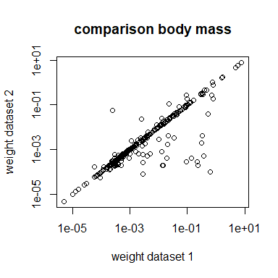

### Combining the two weight datasets.

We combine both data sets and add the taxonomic tree by merging the data with the taxon data.

### Expanding the weight dataset

Next we estimate mean weights on species level, on genus level and on the family level, and bind all in one data.frame(*mws*).

The total number of weight values thus obtained is 1136, of which 642 are estimated at species level, 318 at genus level and 176 at family level.

## FeedingTypes

Feedingtypes are known from a subset of the species. The following types are distinguished:

* “CaSc” = carnivore/scavenger
* “De” = depositfeeder
* “He” = herbivore
* “Om” = omnivore
* “Pa” = parasite
* “Su” = suspension feeder
* “SuDe” = suspension/deposit feeder

##   
## dimension and first part of the data set :

## n.acc Trophy  
## 1 Abludomelita obtusata De  
## 2 Abra alba SuDe

##   
## CaSc De He Om Pa Su SuDe   
## 78 100 20 56 3 79 37

### Feeding types on higher taxonomic levels

We now assign feeding types to the genera and families, for which we take the most commonly encountered feedingtype at the lower level.

## taxon ft level n  
## 1 Abludomelita obtusata De species 1  
## 2 Abra alba SuDe species 1

The total number of feeding types thus obtained is 810, of which 373 are known at species level, 270 at genus level and 167 at family level.

## life history traits

Life history traits are also assigned on genus and family level, where we take the most commonly encountered trait at the lower level.

##   
## dimension and first part of the data set :

## [1] 273 21

## phy cla ord fam gen  
## 1 Annelida Polychaeta Sabellida Serpulidae Spirobranchus  
## 2 Annelida Polychaeta Sabellida Sabellariidae Sabellaria  
## taxon Motility Body.size Burrowing.depth Morphology  
## 1 Spirobranchus triqueter Tubicolous 1-3cm 0cm Cylindrical  
## 2 Sabellaria spinulosa Tubicolous 3-10cm 0cm Cylindrical  
## Mobility Mixing.type Mixing.rate Mi Mi2 Ri Morphology.2  
## 1 Very low Surface mixing Very low 1 1 2 1  
## 2 Very low Surface mixing Very low 1 1 1 1  
## Morphology.2.1 Body.size.2 Burrowing.depth.2 Mixing.rate.2  
## 1 1 2 1 2  
## 2 1 3 1 3

The total number of traits thus obtained is 493, of which 273 are estimated at species level, 161 at genus level and 93 at family level.

We tabulate the number of occurrences of each trait in the resulting data.frame.

## motility:

##   
## Attached Crawler Crawler-Swimmer Tubicolous   
## 13 268 128 84

## Body size:

##   
## <1cm >20cm 1-3cm 10-20cm 3-10cm   
## 98 34 97 54 210

## Burrowing depth:

##   
## >30cm 0-5cm 0cm 10-15cm 15-30cm 5-10cm   
## 27 204 70 59 79 54

## Morphology:

##   
## Articulated Bivalved Cylindrical Flat Globular Stellar   
## 112 99 226 1 31 24

## Mobility:

##   
## High Intermediate Low Very low   
## 37 230 145 81

## Mixing type:

##   
## D/U conveying Diffusion Downward conveying   
## 33 118 20   
## Regeneration Surface mixing Upward conveying   
## 9 282 31

## Mixing rate:

##   
## High Intermediate Low Very high Very low   
## 32 57 133 41 230

## Mi:

##   
## 1 2 3 4   
## 81 145 230 37

## Ri:

##   
## 1 2 3 4 5   
## 25 257 82 120 9

## The density data

Density data are read.

##   
## dimension and first part of the data set :

## [1] 1128549 6

## data sta x y tx dens  
## 1 HELCOM HELCOM1 8.267167 56.72267 Abra alba 139.8601  
## 2 HELCOM HELCOM1 8.267167 56.72267 Abra nitida 139.8601

##   
## total number of data points per provider :

##   
## HELCOM MACROBEL MAREANO MWTL NSBS ODAM PMP PORT   
## 10399 12701 21591 8475 14622 94544 333 6796   
## REBENT RSMP SHARK SMHI   
## 24516 875244 56268 3060

Some data providers did not record density, but just presence/absence; these data are removed.

The total number of species in this data set is 5433

# A look at the data

Species densities are summed per station to give the total densities

## total number of stations per provider :

##   
## HELCOM MACROBEL MAREANO MWTL NSBS ODAM PMP REBENT   
## 914 768 370 103 235 3057 23 216   
## RSMP SHARK SMHI   
## 23915 6925 587

The total number of stations in this data set is 37113

The positions of the stations are plotted, colored according to the data provider

## Loading required package: rworldmap

## Warning: package 'rworldmap' was built under R version 3.5.1

## Loading required package: sp

## Warning: package 'sp' was built under R version 3.5.1

## ### Welcome to rworldmap ###

## For a short introduction type : vignette('rworldmap')

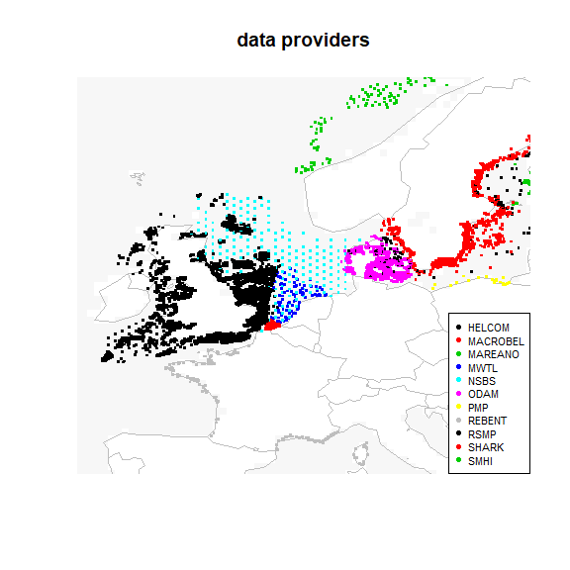

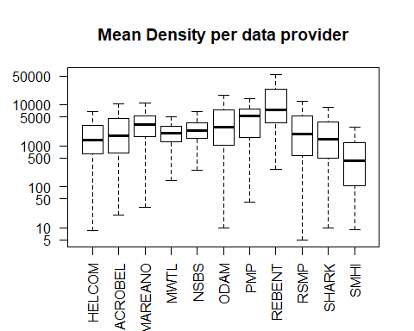

# Adding individual weights and traits to density data

Weights and trait information is not available for all species, even after determining this information on genus and familiy level. We create data sets that remove the species that do not have all information. We then calculate total density on this reduced data set and see what fraction of total density we obtain.

First the required taxonomic information is added to the density list:

## integer(0)

To merge density data with the other data sets, a function is created.

## Merging density and weights

The fraction of data for which individual weight could be estimated = 0.8002974

## Merging density and traits

The fraction of data for which traits could be estimated = 0.7339693

## Merging density and feeding types

The fraction of data for which feeding types could be estimated = 0.7111466

## Data for estimating bioturbation potential

## [1] 758588 23

## [1] 1103726 14

The fraction of data that has all information to estimate bioturbation potential = 0.6872974

## Check on the representativeness of the reduced data set

For the mwtl data we now compare the measured biomass with the biomass that we estimate, based on the mean weights.

## Min. 1st Qu. Median Mean 3rd Qu. Max.   
## -33.90963 -0.00006 0.00062 0.23759 0.01563 288.33301

## Min. 1st Qu. Median Mean 3rd Qu. Max.   
## -25.4000 -0.0002 0.0008 0.3563 0.0179 434.2944

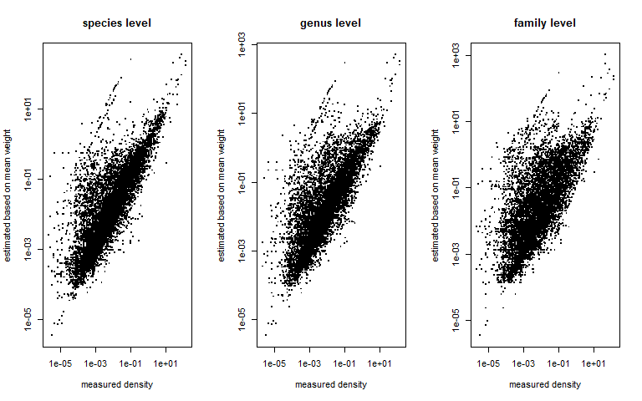

## Min. 1st Qu. Median Mean 3rd Qu. Max.   
## -18.1332 -0.0001 0.0025 0.5481 0.0427 995.4458

We also check the error we would make in the density data if we would estimate them on the merged data sets.

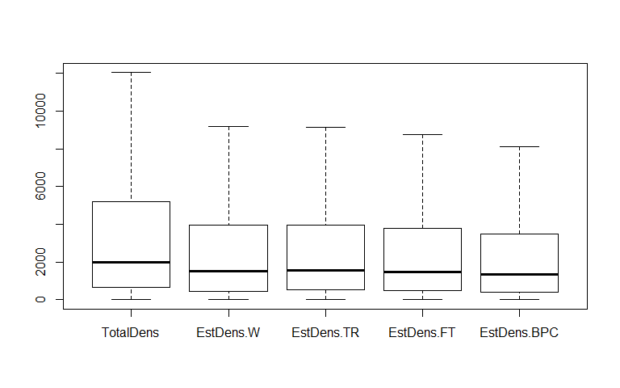

## fraction of density based on species for which weight is known:

## Min. 1st Qu. Median Mean 3rd Qu. Max.   
## 0.0003466 0.7106343 0.8709677 0.8025307 0.9811321 1.0000000

## fraction of density based on species for which traits are known:

## Min. 1st Qu. Median Mean 3rd Qu. Max.   
## 0.001121 0.699346 0.845454 0.807406 0.962963 1.000000

## fraction of density based on species for which feeding type is known:

## Min. 1st Qu. Median Mean 3rd Qu. Max.   
## 0.000999 0.654321 0.800000 0.774501 0.945946 1.000000

## fraction of density based on species for which all is known:

## Min. 1st Qu. Median Mean 3rd Qu. Max.   
## 0.0003466 0.5959077 0.7692308 0.7257031 0.9166667 1.0000000

The estimated density if we only use species for which have all data required for BPc estimation is thus on average 0.7257031 of the true value.

As we want to estimate bioturbation potential, we now split this number for the different data providers to see for which data sets we make the largest errors.

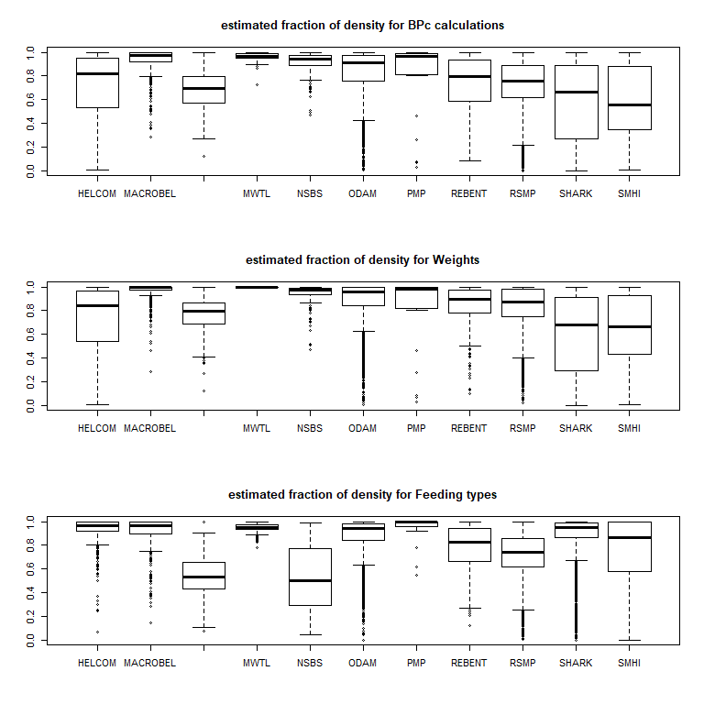

The mean recovered fraction of density for the various data providers is :

|  |  |  |  |
| --- | --- | --- | --- |
|  | BPC | W | FT |
| HELCOM | 0.6986901 | 0.7111337 | 0.9363019 |
| MACROBEL | 0.9363593 | 0.9692866 | 0.9220701 |
| MAREANO | 0.6832806 | 0.7699789 | 0.5438608 |
| MWTL | 0.9597666 | 0.9999305 | 0.9458738 |
| NSBS | 0.9121893 | 0.9454297 | 0.5267406 |
| ODAM | 0.8314929 | 0.8823917 | 0.8770125 |
| PMP | 0.7782387 | 0.7908448 | 0.9409039 |
| REBENT | 0.7400029 | 0.8250691 | 0.7712088 |
| RSMP | 0.7413248 | 0.8395028 | 0.7296203 |
| SHARK | 0.5797466 | 0.5996586 | 0.8885059 |
| SMHI | 0.5836764 | 0.6335552 | 0.7576398 |

# Estimating BPc, the bioturbation potential

The bioturbation potential is now estimated on the reduced data set. First the contribution of each species to BPc is estimated, based on the indivual weight, the abundancy, and their mobility and reworking mode.

Then the BPcs of all species per station are added.

# Characteristics per data provider

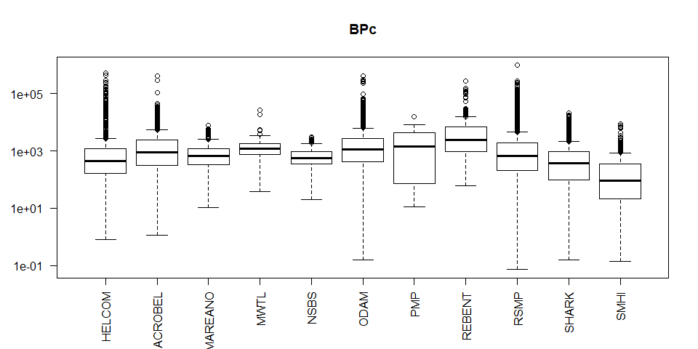

TotalDensity was already calculated

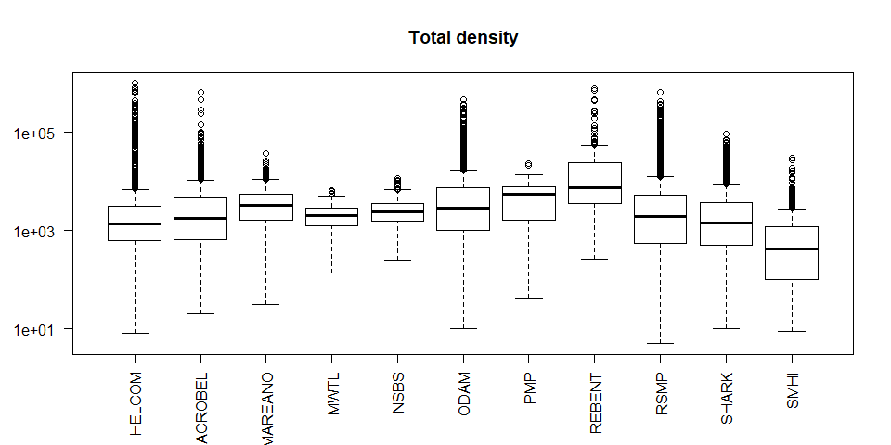

The total biomass per station:

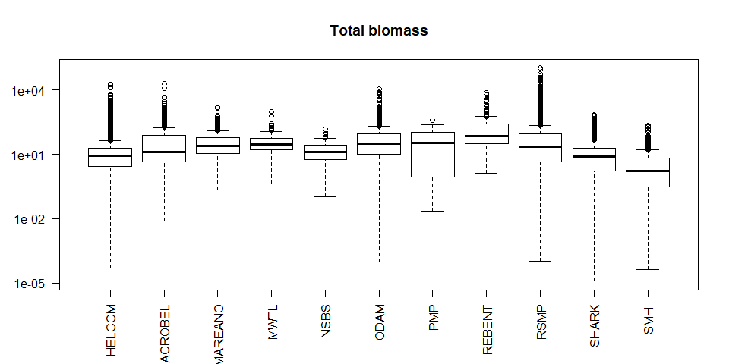

A function is created to generate image plots

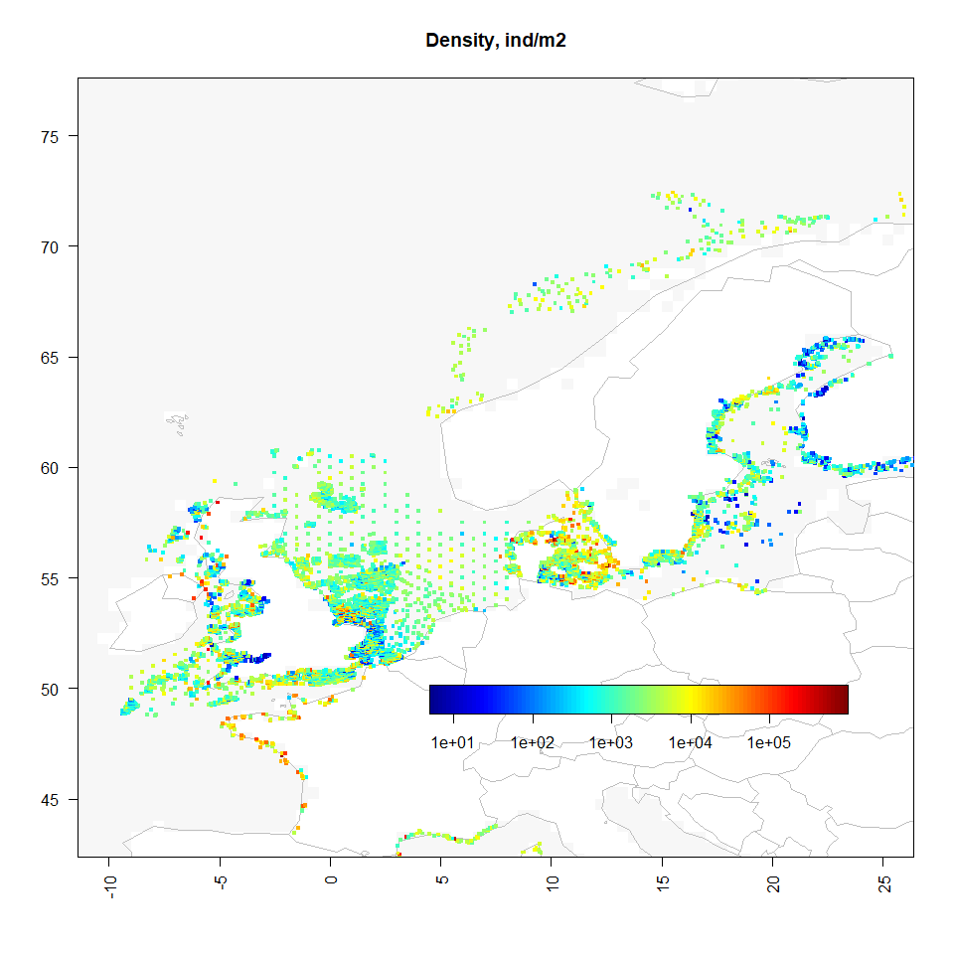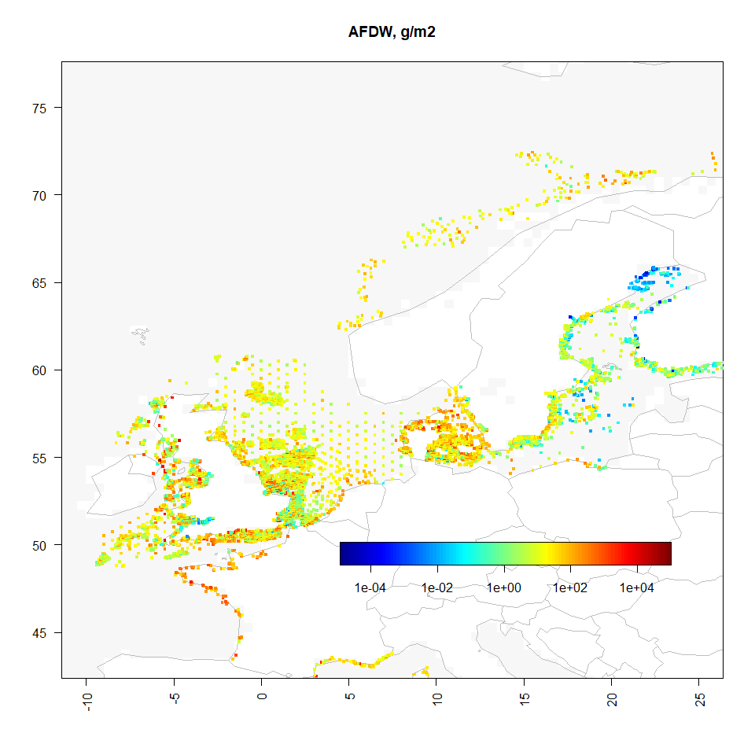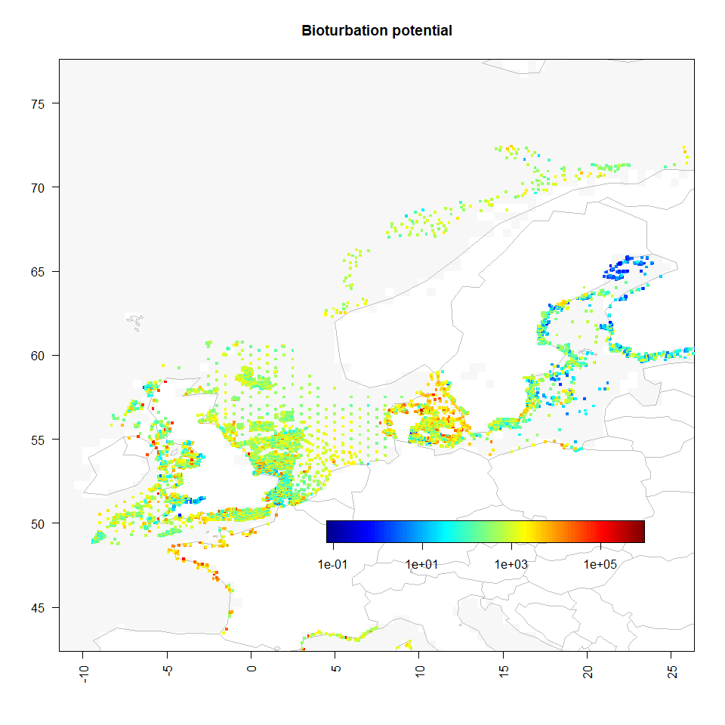

## Biomass per feeding type

## sta data x y AFDW CaSc De He  
## 1 HELCOM1 HELCOM 8.267167 56.72267 1332.03566 23.313394 60.084310 NA  
## 2 HELCOM10 HELCOM 9.238333 56.65717 2478.42383 2.219319 566.765465 NA  
## 3 HELCOM100 HELCOM 11.485833 56.20500 89.55318 23.483159 18.779218 NA  
## 4 HELCOM101 HELCOM 11.500000 57.83333 15.27973 5.225638 1.817793 NA  
## 5 HELCOM102 HELCOM 11.516667 57.75000 12.58953 3.677745 2.728795 NA  
## 6 HELCOM103 HELCOM 11.525000 57.54998 133.81228 59.643812 23.212889 NA  
## Om Pa Su SuDe AFDW_FT  
## 1 819.86727366 NA 335.6890991 80.890008 1319.84408  
## 2 124.07348421 NA 1781.3173901 4.048168 2478.42383  
## 3 NA NA 0.9817005 25.491745 68.73582  
## 4 0.06344955 NA 2.3267914 5.763861 15.19753  
## 5 0.09517433 NA 2.0635217 3.914807 12.48004  
## 6 2.04354271 NA 16.4510060 31.065997 132.41725

The stations where none of the feeding types are known are removed, and the most dominant feeding type selected.

## ISNAS  
## 1 2 3 4 5 6 7   
## 89 17198 7692 4520 3758 2272 212

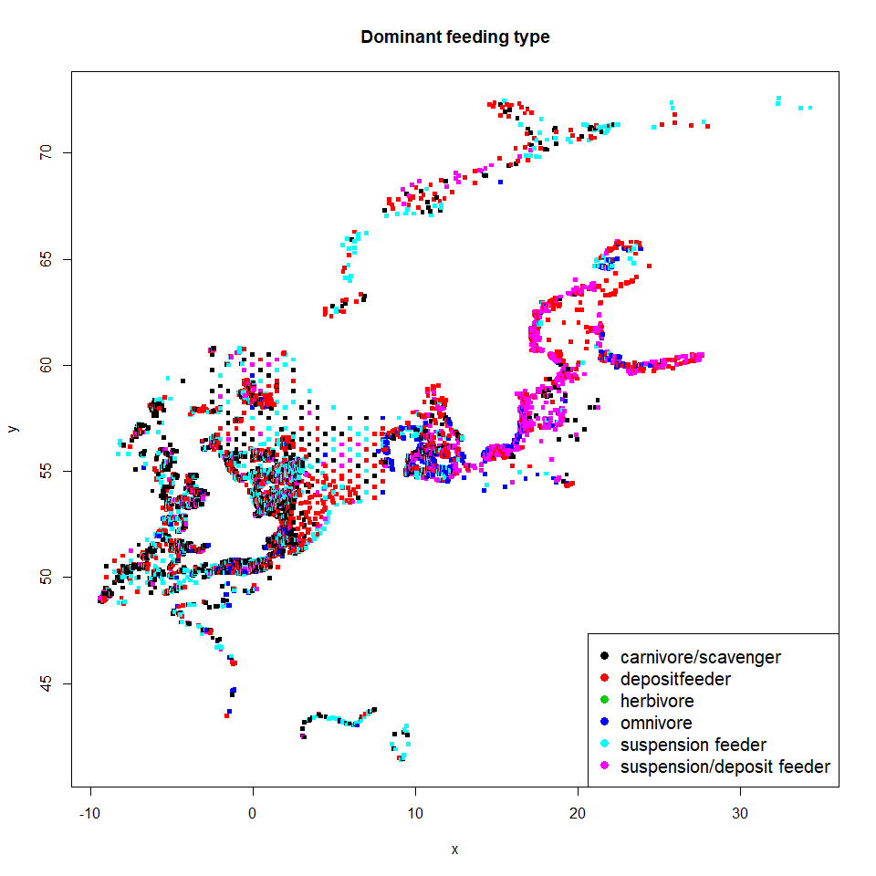

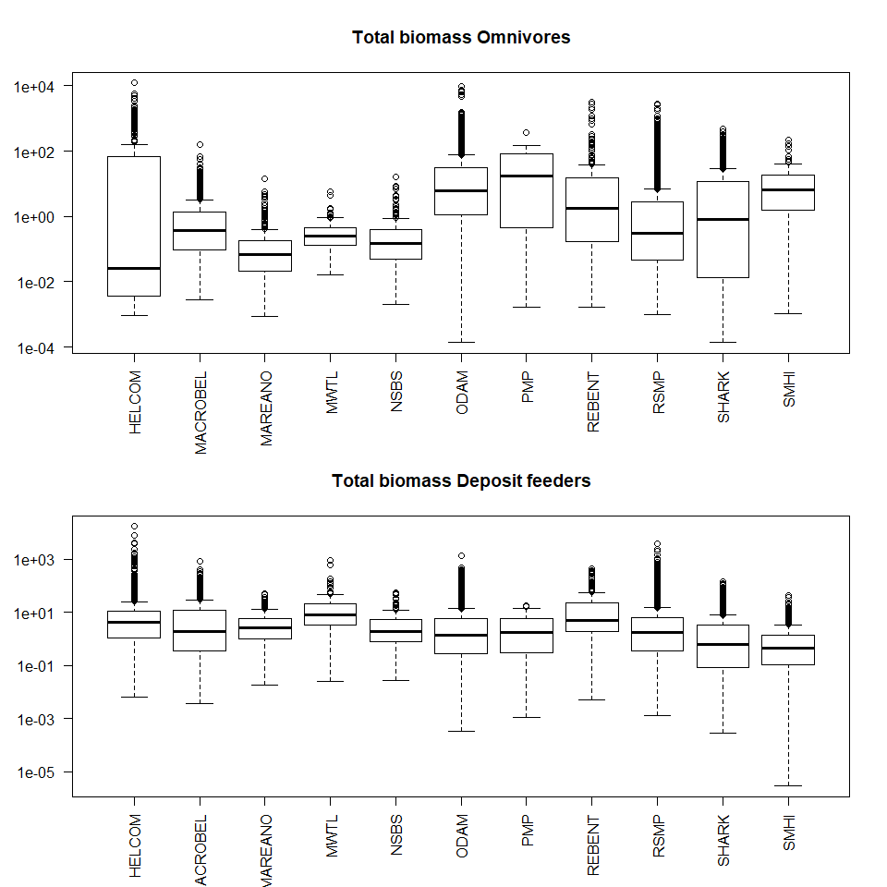

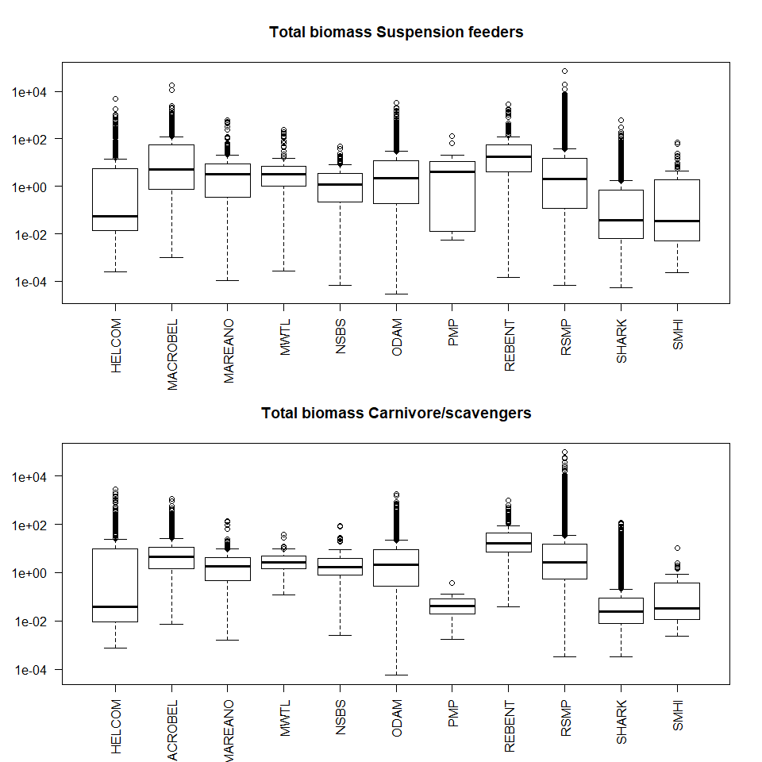

The total biomasses of feeding types

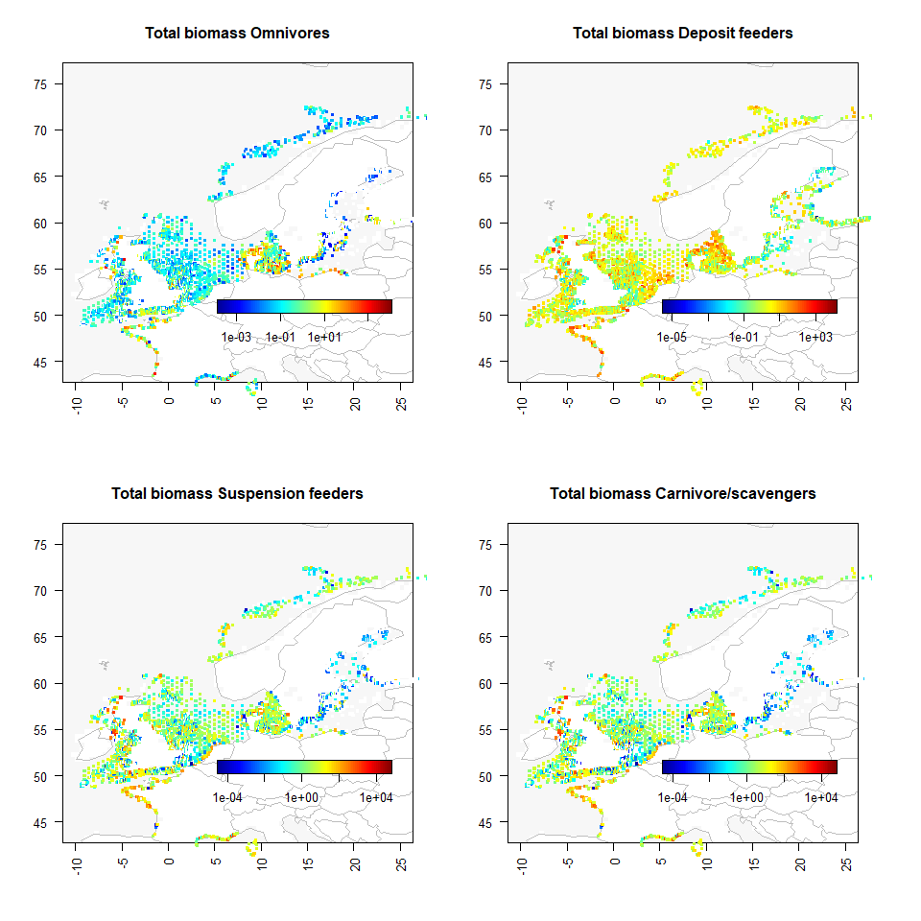

The relative biomasses of feeding types

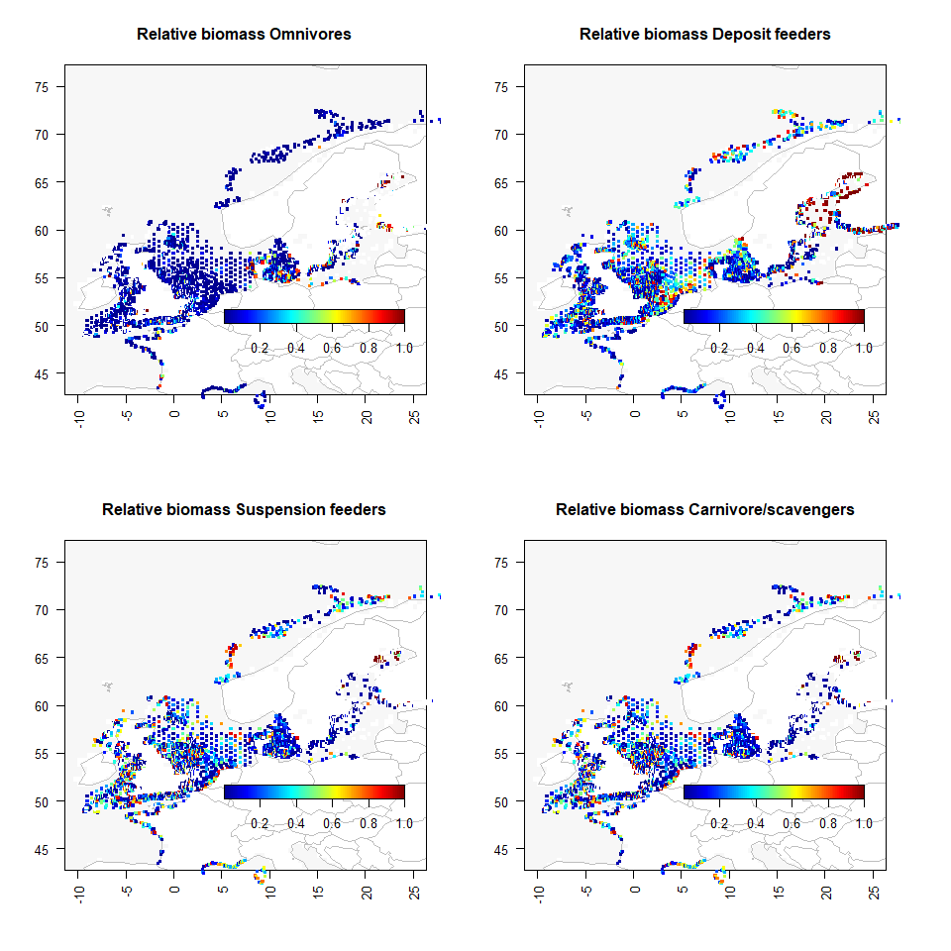

# Writing the results