**LYB**

**The BookBay Project**

**Software Requirements Specification**

**<version 1.0>**

**Revision Hidtory**

|  |  |  |  |
| --- | --- | --- | --- |
| **Date** | **Version** | **Description** | **Author** |
| **17/10/2013** | **1.0** | **Initial version** | **Jonathan Shimrony**  **Liron Shimrony**  **Brian Wu** |
|  |  |  |  |
|  |  |  |  |
|  |  |  |  |

Table of Contents

**1.** **Introduction** 4

1.1. Purpose 4

1.2. Scope 4

1.3. Definitions 4

1.4. References 4

1.5. Overview 5

**2.** **Overall Description** 6

2.1. Use-case Model Survey 6

2.2. Assumptions and Dependencies 7

**3.** **Specific Requirements** 7

3.1. Use-case Reports 7

3.2. Supplementary Requirements 16

**4.** **Supporting Information** 17

1. Introduction
   1. Purpose

The purpose of this Software Requirements Specification (SRS) document is to provide a detailed description of the functionalities of the BookBay system. This document will cover the specifics of the system such as the user interface, available functions and hardware and software requirements for the project.

* 1. Scope

The BookBay system is an online system for buying new/used books from other users. The system is composed of a user interface (the client side) and a server backend with a MySQL database to store user information as well as bidding and points information. The UI will be used by registered users and visitors. In addition there will be a super user that will have administrative permissions to manage the UI and registered user permissions.

* 1. Definitions
* MySQL-SQL Database management environment. Will be used to manage the listings and the users in the system.
* Super user - a user with administrative permissions can be noted as SU.
* Visitor user – a user of the system that haven’t yet registered to the website can be noted as VU.
* Registered User – A user that have registered to the system and has more privileges than a visitor. Can be noted as RU.
  1. References
  2. Overview

This software requirements specification document contains the detailed information for the BookBay system. In the following sections you can find the overall description section which contains of the information about use case model survey, assumptions and dependencies. The Specific requirements section includes information such as use-case report and supplementary requirements. The last section of the SRS is the supporting information which includes the table of contents, index and appendices.

1. **Overall Description**
   1. 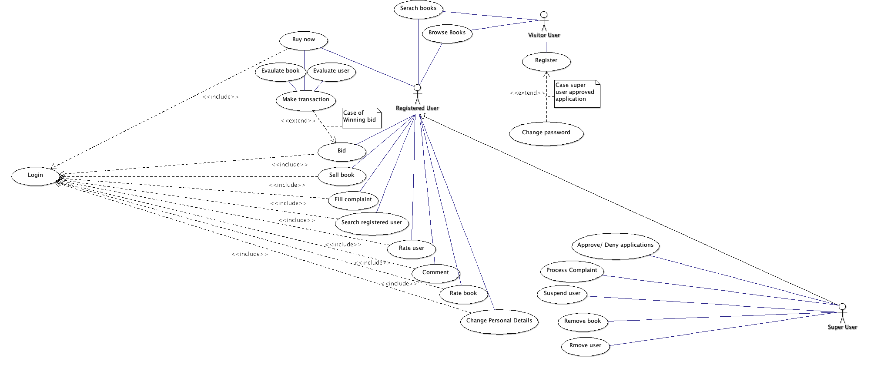Use-case Model Survey

Our system has three actors:

* Visitor user (VU)- Everyone can visit the website, browse and search books. VU has very limited functionality/
* Registered user (RU)- in order to be a register user, an application must be approved. Registered users can browse and search books, buy and sell books, rate books and other users.
* Super user (SU)- super user has administrator privileges. SU has the same privileges of a registered user and in addition he can approve RU applications, suspend users and remove book from a sale process.

* 1. Assumptions and Dependencies
* All users can connect to server.
* All users are using compatible, up to date browsers- Chrome, Firefox, Safari, IE10+.
* Data will be stored in a relation database (MySQL).
* GUI will be rendered in a web browser.
* BookBay will use a server client model for serving content

1. Specific Requirements  
   1. Use-case Reports
      1. **Browse books**
         1. Description:  
            Browse entire book selection and will be given recommendations based off their preferences.
         2. Actors**:**

Visitor

Registered User

Super User

* + - 1. Pre Condition

User is able to view our BooksBay.

* + - 1. Basic Flow of Events
* Send GET request to server asking for all books.
* Server will query database for all books
* Server returns all books to user with recommendations, if applicable.
* Client renders books  
  + - 1. Non- Functional Requirements  
         List of all books that user can view should be displayed. Display should include book name, owner, front cover, quantity, current bid price, time left, buyout price and comments.
    1. **Search books**
       1. Description:  
          Display books to user based on user specified inputs.
       2. Actors:
* Visitor
* Registered User
* Super User  
  + - 1. Pre Condition  
         User is able to view our BookBay.
      2. Basis Flow of Events
* Client defines search parameters and sends request to server.
* Server queries internal database
* Server returns books to user based on parameters
* Client renders books  
  + - 1. Non- Functional Requirements  
         List of all books that user can view should be displayed. Display should include: name of the book, owner, front cover, quantity, current bid price, time left, buyout price and comments.
    1. **Register**
       1. Description  
          Client wants to register for BookBay site.
       2. Pre ConditionClient is NOT currently a Registered User or Super User
       3. Basic Flow of Events
* Clients sends request for registration
* Super User reviews request
* Super User accept/deny application  
  + - 1. Post Condition  
         Client is now granted Registered User privileges.
      2. Non Functional Requirements  
         Client is able to set personal information -name -username -email
    1. **Login**
       1. Description  
          Client would like to login to BookBay as either Super User or Registered User.
       2. Actors
* Registered User
* Super User  
  + - 1. Pre Condition  
         Client is Registered User or Super User
      2. Basic Flow of Events
* Client enters credentials
* Server attempts to verify credentials
* Client is either granted access or denied  
  + - 1. **Post** Condition  
         Client is now logged in as Registered User or Super User
    1. **Bid**
       1. Description  
          Client would like to place a bid on a book. A bid is a monetary value placed on a book in attempt to purchase book.
       2. Actors
* Registered User
* Super User  
  + - 1. Pre Condition
* Client privileges are not revoked.
* Client has enough credits to place bid.
* Book exists to bid on.
  + - 1. Basic Flow of Events
* Client views a (one) book
* Client selects amount he would like to bid
* Bid is placed on book if funds are available.
* If bidding time is over and client is the highest bidder, deduct credits. **OR**
* If seller chooses to end bidding time and user is highest bidder, transfer ownership of book.   
  + - 1. Post Condition  
         Server attaches bid value to particular book.
      2. Non Functional Requirements

Client should only be able to bid on books that are biddable.

Client will not be charged credits if book is no longer available.

Client able to view rating of book.

Client able to view rating of user.

* + 1. **Buy book Right Away**
       1. Description  
          Client chooses 'buy out' option to purchase book immediately.
       2. Actors
* Registered User
* Super User  
  + - 1. Post Conditions
* Client has enough credits
* Client is not banned
* Book is available and has 'buy now' option.  
  + - 1. Basic Flow of events
* Client chooses to buy book now
* Credits are deducted from client
  + - 1. Post Condition
* Client now owns book.
* Clients credits reflect deduction.
* Owner of book gains credit.  
  + - 1. Non Functional Requirements
* Client able to view books.
* Client able to view seller rating.  
    
    
    
    
    
    
    
    
    
    
    
    
    
    
    
  + 1. **Make A Transaction**
       1. Description  
          Transaction is taking place when a user pays for a book.
       2. Actors
* Registered User.
* Super User   
  + - 1. Pre ConditionUser placed a bid on a book.
      2. Basic Flow of Events:
      3. Post Condition  
         User paid for the book.
    1. **Sell a book**
       1. **Description:**Client chooses to put books up for sale.
       2. **Actors**
* Registered User
* Super User   
  + - 1. Pre Condition:
* Privileges are not revoked.
* Client is able to enter all necessary information for book including book name,, price, front cover, genre (if applicable) and quantity.  
  + - 1. Basic Flow of Events
* Client sends server book parameters.
* Server verifies data
* Server inserts book to database with specified parameters  
  + - 1. Post Condition

Book is now listed and can be browsed

* + 1. **File a complaint**
       1. Description  
          Client would like to file a complaint towards Registered User. This could be to dispute bidding, product not as advertised, etc.
       2. Actors  
          1. Registered User 2. Super User
       3. Pre Condition
* Client has sufficient privileges.
* Complaints should be in the form of a comment and direct towards a (one) user.  
  + - 1. Flow of Events
* Client's complaint is registered in to the database.
* A Super User reviews complaints on a per complaint basis
* Super User chooses action based on his/her discretion.
* Increment complaint counter  
  + - 1. Post Condition
* Complaint is logged in database.
* If user has more than 3 complaints, account is automatically suspended until SU review.
* SU may deem the complaint false  
  + 1. **Search for Registered User**
       1. Description  
          Query database for Registered Users.
       2. Actors:
* Super User
* Registered User  
  + - 1. Pre Condition
* Privileges are not revoked
* Client specifies parameters for search.  
  + - 1. Flow of Events
* Client sends a search request for registered user with specific parameters.
* Server queries database with given parameters.
* Server returns results to client  
  + - 1. Post Condition  
         Client renders results from server.
      2. **Non Functional Requirements:**
* Clients should be able to see this attributes for returned users: name, rating and user type.
* Client should be able to click on user and see profile.  
  + 1. **Rate Book/User**
       1. Description  
          rank user on a scale of 1-5. 5 being highly approve, 1 being disapprove. Ratings are subjective and should reflect client experience.
       2. Actors
* Registered User
* Super User  
  + - 1. Pre Condition
* Client has sufficient privileges.
* Client may only rank books that he/she has purchased.
* Client may only rank users that he/she has interacted with. Where interaction is defined by a transaction.
  + - 1. Flow of Events
* Client selects book or user to rank.
* Client ranks (1-5) and posts to server.
* Server validates request and updates database  
  + - 1. Post Condition  
         Rankings are updated server side and can be seen immediately
    1. **Change account details**
       1. Description  
          Client updates personal information.
       2. Actors
* Registered User
* Super User  
  + - 1. Pre Condition
* Client has sufficient privileges.
* Client updates information within guidelines i.e.: cannot change username to a username that is already taken.  
  + - 1. Flow of Events
* Client enters new information in to form.
* Data is sent to server and validated
* Server then updates database if validation is successful
  + - 1. Post Condition  
         Data is updated server side and can be seen immediately.
    1. **Approve/deny applications**
       1. Description  
          When a user visits bookbay, he/she must apply and gain approval before he/she becomes registered user. Only registered users can post/buy/bid on books.
       2. Actor
* Super User  
  + - 1. Pre Condition  
         Application is validated by server
      2. Flow of Events
* Super User visits web page that has list of applications.
* Super User accepts or denies application.
  + - 1. Post Condition
* If accepted by Super User, client becomes a registered user, else, declined.  
  + 1. **Process complaints**
       1. Description  
          Super Users review complaints sent by registered users.
       2. Pre Condition  
          Complaints are validated by server i.e. cannot complain with no comment.
       3. Flow of Events  
          Super User reviews each complaint per basis and can ban the user, do nothing or remove the complaint.
       4. Related to
* Remove book from sale
* Remove suspend user  
  + 1. **Remove book from sale**
       1. Description  
          SU remove a book from database that is being sold.
       2. Actors
* Super User  
  + - 1. Pre Conditions
* Book must be for sale.
* Specify quantity and user i.e.: multiple copies of same book sold by different users  
  + - 1. Flow of Events  
         Super User chooses book and may remove at his/her discretion.
      2. Post Condition  
         specified book is removed from database and is reflected globally.
    1. **Remove/ suspend user**
       1. Description  
          SU may choose to remove or suspend a user on SU's discretion or complaints. Users that are removed are deleted from the database. Users that are suspended remain in the database but cannot log in.
       2. Pre Condition  
          User must exist in database
       3. Flow of Events  
          Super User chooses user and may remove/suspend at his/her discretion.
       4. Post Condition  
          Specified user is either suspended or removed. This should reflect immediately on the server.

* 1. Supplementary Requirements  
     User needs to have a working Internet connection.