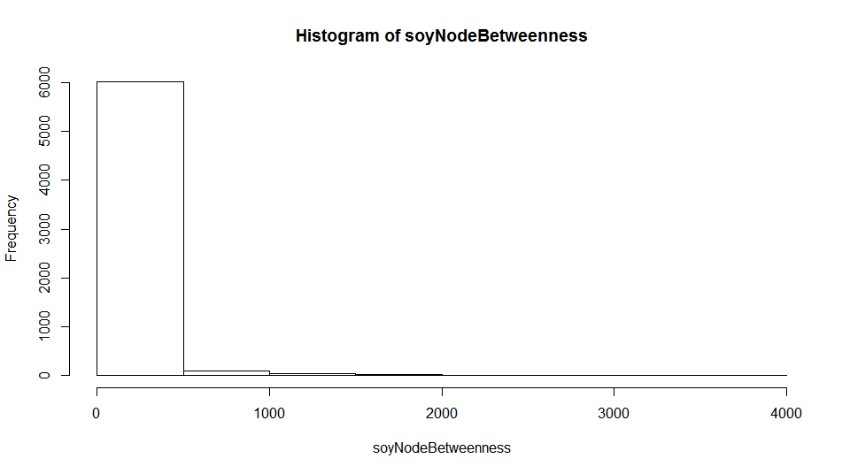

**Most nodes are not very important players.**

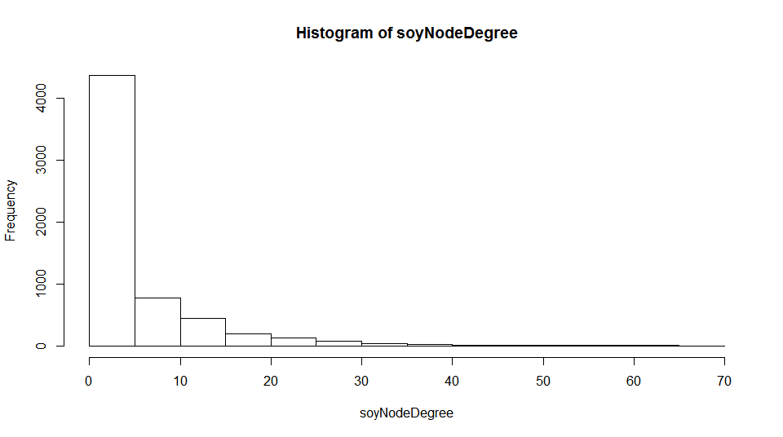

**Most nodes have very few connections across the network.**

**TEMPORAL ANALYSIS**

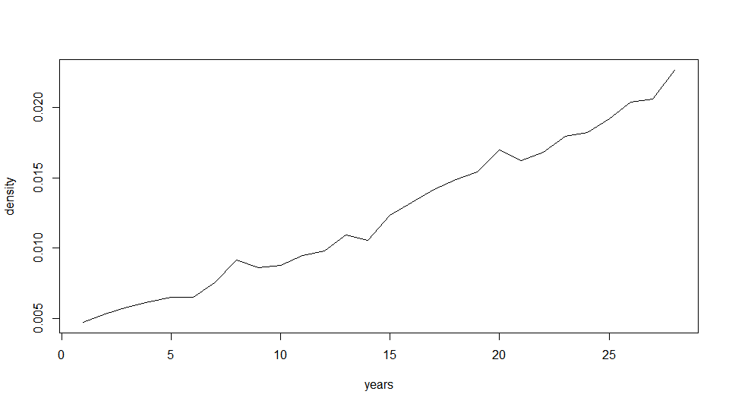

**The density of the network has increased over time (1986 – 2013)**

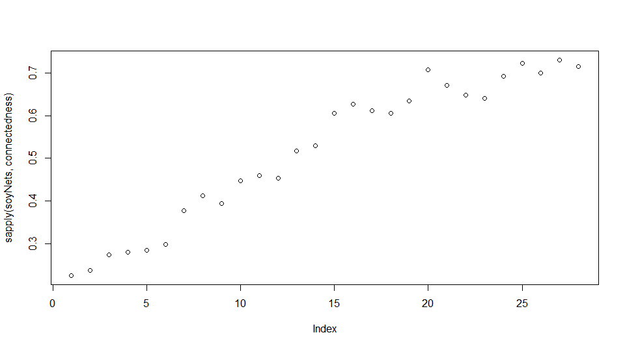

**Connectedness has also increased over time (1986 – 2013)**

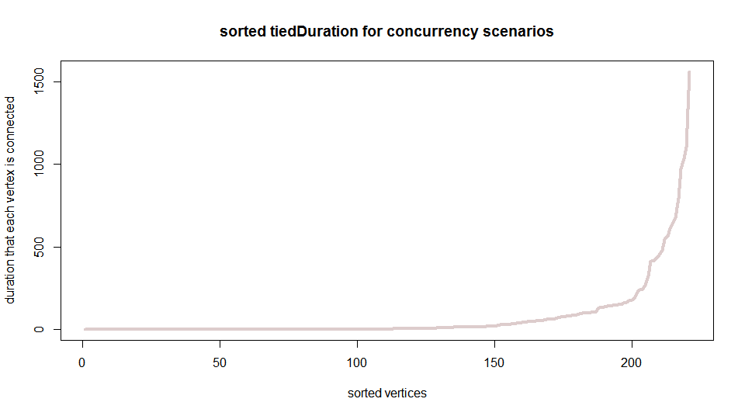

**Most nodes (vertices) are not actively participating in trade for very many timesteps in the dataset.**

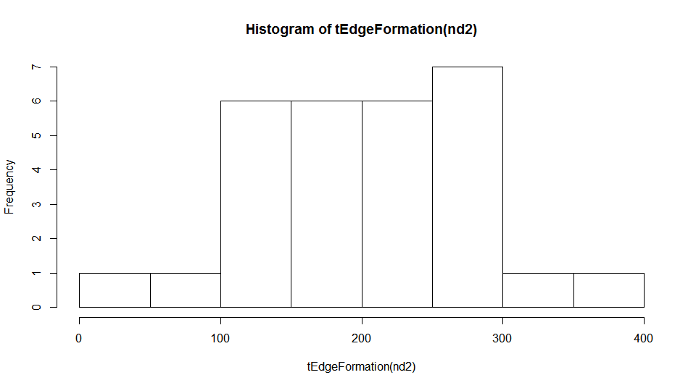

**Distribution of the number of edges (active trading partnerships) that formed per year across the time series.**

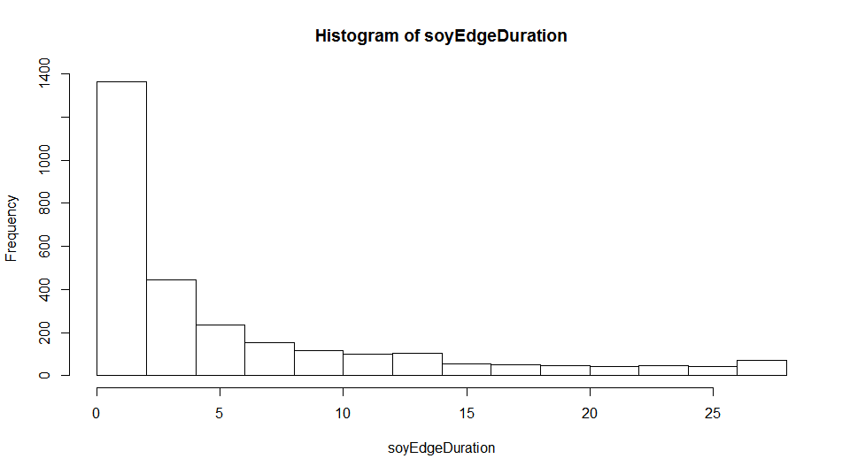

**Most relationships (edges connecting two nodes) are transient (high frequency of edges that were active only for a small number of timesteps in the dataset). This could indicate that relationships are not very strong/persistent and that there is a high degree of instability. There are a few edges that are more reliable, however!**

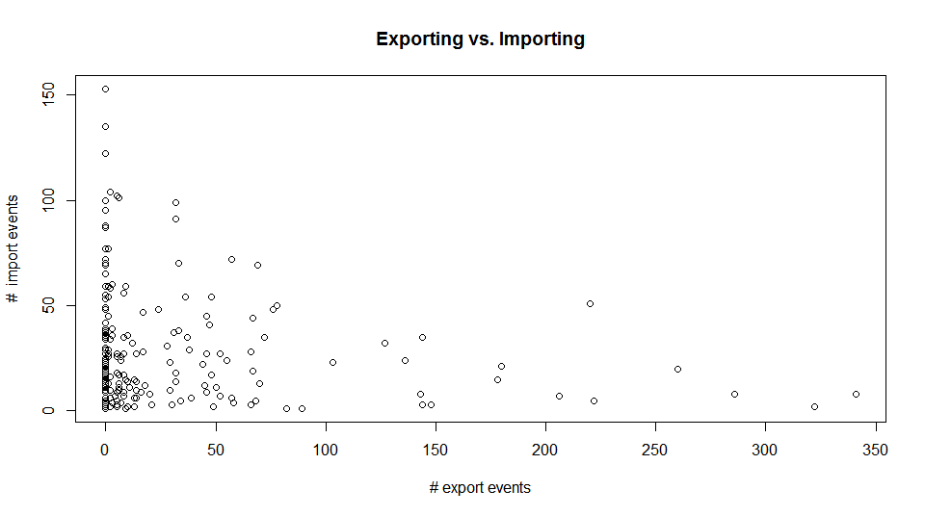

**There is a strong imbalance in export vs. import events (more consumers than producers?)**

**On average nodes were active 0.2109406 of the years**

tEdgeDensity(nd2) # [1] 0.2109406

**For all the possible dyads in the network (pairs) the likelihood they were tied in any given year was very low!**

tEdgeDensity(nd2,agg.unit = 'dyad') # [1] 0.01246033

**Not many countries are actively trading regularly in the network. Export/import events corrected for time:**

tEdgeDensity(nd2,mode='event') #[1] 0.00102279