**Problem set #1**

**1.The result of these codes are ordered as follows：**

*advanced*

*programming*

*advanced programming*

*False*

*V*

*Traceback (most recent call last):*

*File "C:\Users\MSI_NB\.spyder-py3\temp.py", line 14, in <module>*

*str [1] = "p"*

*TypeError: 'str' object does not support item assignment*

The reason why the results ‘False’ and ‘Type Error’ exist is that **‘str’** couldn’t be redefined or changed by outside.

**2. (b)**

**3. X=0 and Y=2**

*The details of the problem 4 & 5 are shown in homework1.py, including the step to do it and the logistic. Here’s just some brief conclusions of them.*

**4. Here are some outputs of these problem:(the begin date is 01-01-2018, and the end date is 01-01-2021)**

1. Here is part of these required datas.

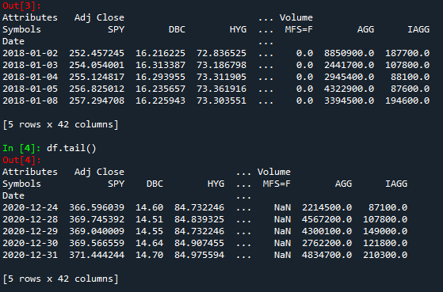

(b)

The Annualized Returns-Volatilities Table:

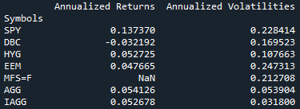

(c)

The Correlation Matrix:

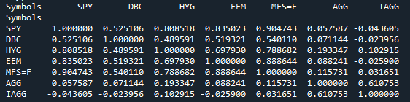

(d) Plot the cumulative returns to an investor holding each ETF, as well as an equally

weighted portfolio:

**5. Here’s one possible result of the payoffs of this portfolio:**

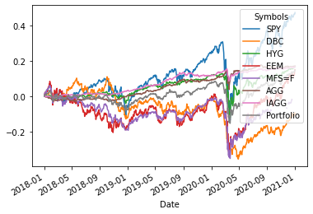

Assumed that the current price is 100, the strike price is 102 and the premium of the option is 2.

To replicate selling a put option, we can sell a call option and buy a stock.

The strategy result shows in the green line: the profit equals to the y-value of this line.

