**1.Historical Analysis of Sector ETFs:**

**(a)** I chose the dates from 2010-01-01 to 2021-09-11. After cleaning and checking the data , I got the clean data(Adj Close and the Returns) below:

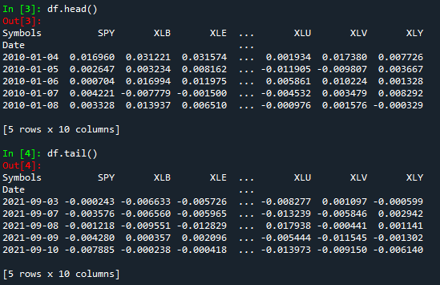 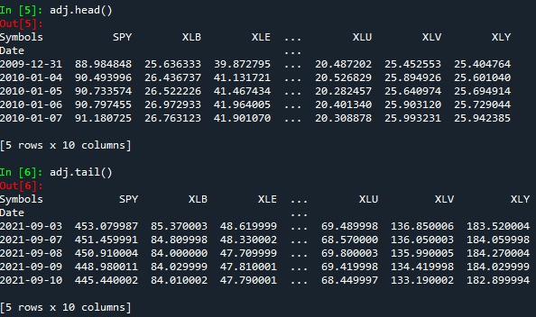

**(b)** the Annualized return and the standard deviation of each ETF are shown below:

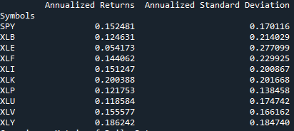

**(c)** the covariance matrix of daily and monthly returns are shown below:

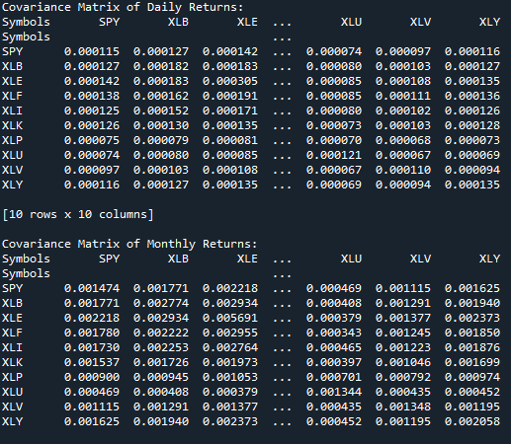

**Comments**: Obviously, the covariances are higher with monthly returns than daily ones. One possible reason is that the monthly returns is the sum of daily returns, which might be higher. It seems that daily correlation isn’t so tight as the monthly one. However, covariance might only reveal that these two objects have positive correlation or negative correlation. To explore deep about the quantitative relation, we need to focus on correlation coefficient.

**(d)** I plot the rolling 90-day correlation of each sector ETF, which is shown below:

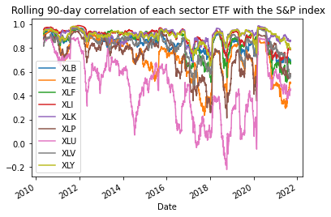

The correlations of some ETFs apparently aren’t stable over time, especially the XLU which suffers fluctuating. The possible reason for these differences might be some ETFs have more stocks in common with SPY.

Actually some ETFs were stable before 2017, the correlation then is close to 1.0 which means they have a quite positive correlation. However, all the correlations of ETFs drop down when it comes to 2017 and 2021. I guess that might be the result of Sino-US Trade War and the COVID-19 Emergency.

**(e)** the β for the entire historical period are shown below:



And the rolling 90-day β shown in the picture below:

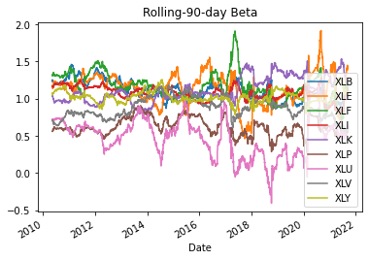

I think the betas are not so consistent with the correlation plot. But there’re some interesting things. The first is that when some ETFs’ beta quite low, others are relatively high, which means this portfolio contain different stocks in different domain and might decrease the risks. The second is when there’re some big events happen, betas and correlations move in the same direction.

**(f)** the auto-correlation of each ETF shown below:



Most of the abstract of parameter alpha is around or less than 0.01, which means they have really restricted impact on stock price. So the St wouldn’t have influence to St+1.

**2. Exotic Option Pricing via Simulation**

**(a)** the mean of the terminal value of these paths is about 100 and the deviation is around 25.

**(b)** the histogram of the payoffs for the European Option:

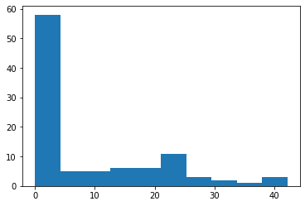

The mean of the payoffs is around **10**

The deviation of the payoffs is around **12**

**(c)** I’ve tried many times and the payoff is really close the result in question(b). And that’s reasonable since r = 0.

**(d)** the result of BS model is always about **9.947**, and the simulation results change all the times.

I’ve tried many times, changing the parameter **‘trials**’(the number of sample paths) in the first function of my codes. It seems that with generating more and more paths, the difference is becoming smaller and smaller.

Below shows the result on the condition of the number of paths is 10, 100 and 1000.

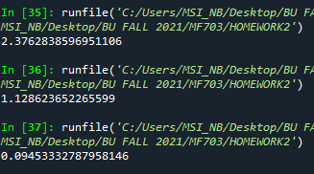

**(e)** the price of the fixed strike lookback put option with strike 100 is about **17.73**

**(f)** When the price drops first then up, the premium would be high, if the price doesn’t come back, the premium is low.

It never becomes negative because people holding lookback option are always have the priority than those don’t have, so they certainly should pay for such a right , no matter the payoff is positive or negative.

**(g)** I generate a list of sigma between 0 and 1, and simulate it for many times, here is the plot about their relations.

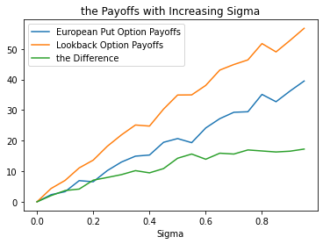

The higher the sigma is, the higher the difference would be. So does the two payoffs. The sigma rising means the simulation would have more abstract results or anomalies, which push the difference up.