**1.Sector ETF Factor Modeling**

**(a)** the data after cleaning and validating are shown below:

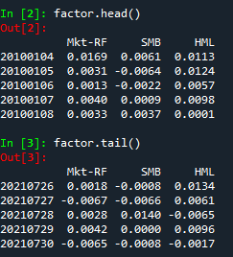

**(b)** the daily covariance matrix of the factor returns over the entire time periods are shown below:

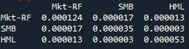

Obviously, the covariance of these is much lower than the covariance matrix in HM1, which might be a signal of none existence of correlation. But by comparing covariance between different objects, we can’t get the reliable conclusion of correlated. In fact, we can get the result by computing the correlation matrix:

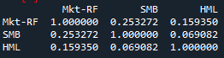

Thus, here we can finally conclude that these factors are not highly correlated.

**(c)** the table below shows the brief result of rolling-90-days correlation:

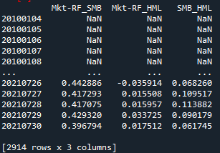

To figure out whether it’s stable, I plot these correlations on the picture below:

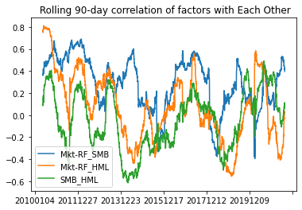

The correlations of these 3 factors are vary in a wide range. They’re not stable over time. To compare it with the ETFs in the former homework, I compute the variance of their rolling correlations separately and here is the result:

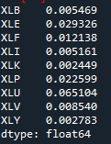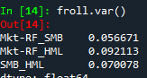

Therefore, it seem that the factors are less stable since their variances are higher.

(d) I use QQ test to test the normality, and here’s the result of three qqplots:

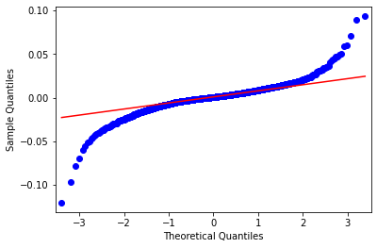 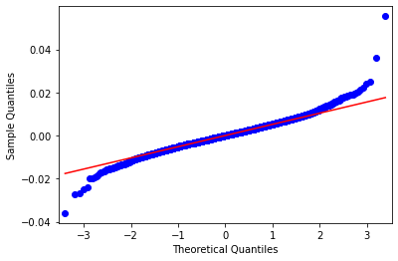 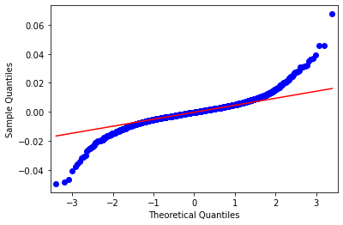

Most of the point are in a line but there’re still some endpoints deviate the line. Thus, I think they’re not totally normality.

**(e)** the betas of Fama-French model for the entire periods are below:

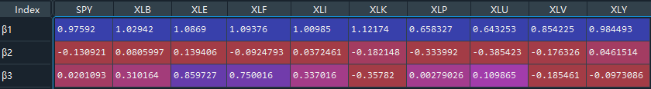

And a brief view of the Rolling-90-days beta:

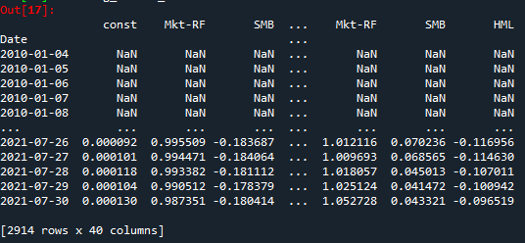

By computing the variance of these rolling betas in this homework and former one:

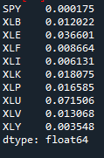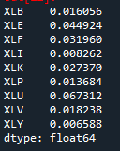

Obviously, the betas in Fama-French model are **more consistent**, since the variances here appear to be lower.

(f) Here is a brief view of the residuals as well as its mean and variances:

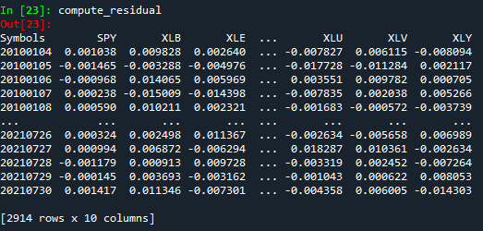

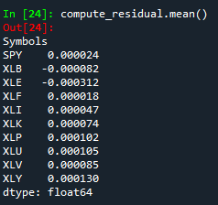 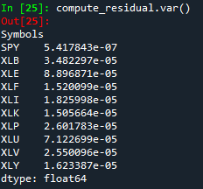

To c heck the normality, I plot the QQ plot of all the ETFs, and here’re some result:

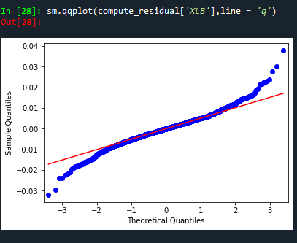 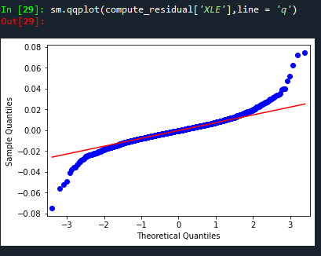

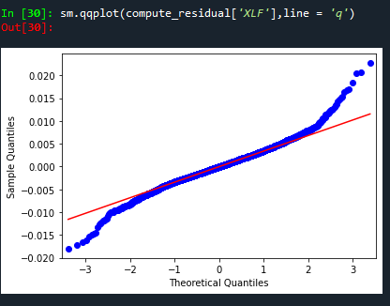 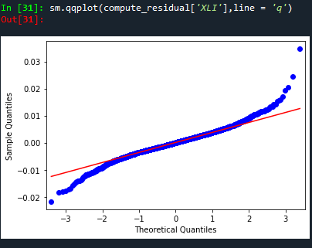

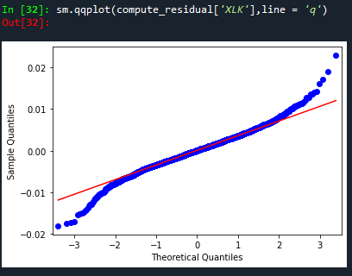 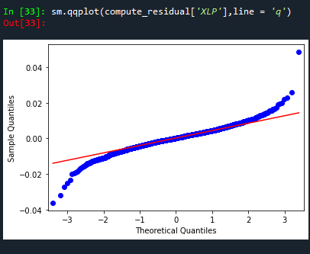

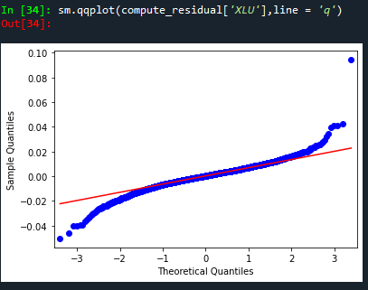 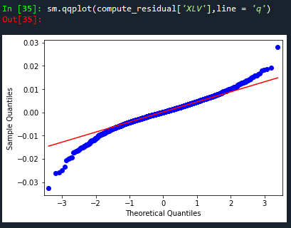

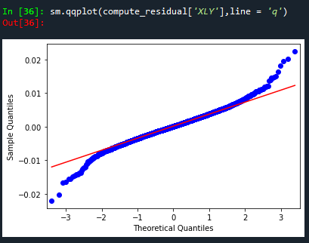

Of course, these residuals **are approximate but not serious normality.** According to the theory, the distribution of residuals should be normality, but some of residuals of these ETFs have deviations. I think this result means that Fama-French model might be a good model in most of time, since most of points are in one line. However, the model still need to be updated or advanced (such as add more factors) to fit the real market since deviations still exist. By the way, we can also use KS test to judge the model.

**2. Exotic Option Pricing via Simulation**

**(a)** I’ve generated the paths, it’s hard to describe it. But the mean of them is about 100 and the var is 10. Since the r =0 and the sigma = 10.

**(b)**the histogram of the paths and the QQ plot are shown below:

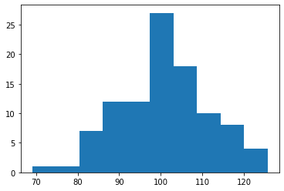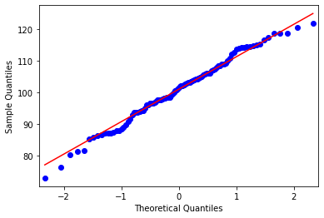

First, the histogram appears to be a curve. Second, the points in QQ plot are in one line. So my simulated paths are normality distributed.

**(c)** I got my result of lookback of payoffs around **7.5.**

If I want to compare it with the result of BS model in former homework directly, I need to change sigma into 25. At this time, I got the result around **18**.

Obviously, the result obtained by B model is higher than BS model in the same condition.

**(d)** I simulated Δ for thousands of times by changing the number of ε(between 0 and 2), and I use the results to draw the picture below:(x line is e and y line is delta)

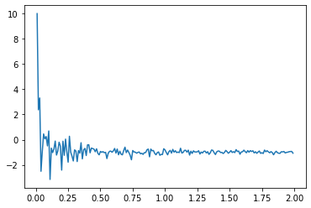

The delta is about **-1**. I think when e>1, the result seems to be stable to -1. Therefore, I think any e >= 1 might be optimal choices. But the lower e wouldn’t be wise choices, because when e<0.25, it appears to be abnormal. And when e comes to be zero, the result is infinite.