**1. Covariance Matrix Decomposition:**

**(a)** Here’s a brief view of the data after cleaning:

电脑屏幕的照片上有文字

**(b)** The covariance matrix is shown below:

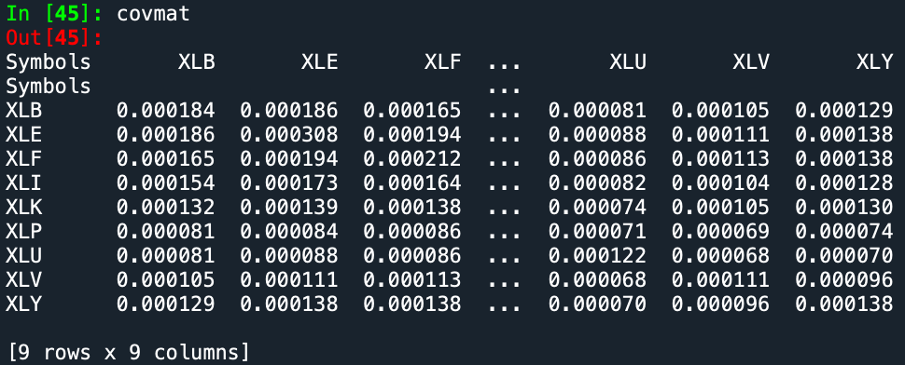

**(c)** ﻿The eigenvalues are:

[1.11985923e-03 1.23517089e-04 7.76360004e-05 4.59448344e-05

3.21449006e-05 2.89788708e-05 1.41972667e-05 1.88733718e-05

1.66908044e-05]

And the plot according to their large or small:

Obviously, all of them are positive, none of them are negative, although they’re all close to zero. Thus, I think all of them are statistically significant.

**(d)** Here’s one of my result of the random matrix:

电脑屏幕的照片上有文字

**(e)** About the random matrix (one of my many attempts):

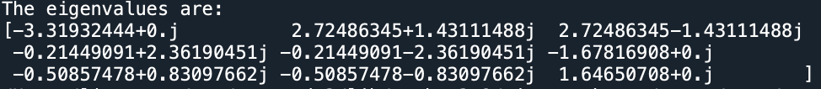

The plot:

Obviously, the eigenvalues of covariance matrix are positive. However, if we generate matrix randomly according to normal distribution, there could be negative eigenvalues.

**2. Portfolio Optimization:**

**(a)** here’s the annualized returns for each ETFs:

**(b)** according to the formula, the weights of the unconstrained mean-variance optimal portfolio:

**(c)** Here’s one attempt about these four sigma:

Sigma = 0.005, optimal: 90.38783

Sigma = 0.01, optimal: 133.106814

Sigma = 0.05, optimal: 216.118521

Sigma = 0.1, optimal: 750.15381

Sigma reflects the changes of expected returns. Obviously, when sigma become bigger, the weight of our portfolio becomes more unstable. While a smaller sigma leads to more stable weight.

**(d)(e)** set *δ* = 1, then we got the regularized covariance matrix:

By eigenvalue decomposition, we know the rank of this matrix is **9**.

**(f)** I tried delta 10 times (0.1,0.2,0.3,0.4,0.5,0.6,0.7,0.8,0.9,1.0), and here’re the result:

None of them are negative, they’re all positive and close to zero.

**(g)** First, repeat what I’ve done in 2.c (columns are sigma and raws are delta):

Here’re the **standard deviation** of each weight when delta becomes from 0.1 to 0.3, actually I’ve made lots of attempts, and we can see:

Compared with historical covariance matrix, the portfolio weights become more and more stable as delta increases.