**MF731 HomeWork 2 Part 1**

1. **VaR 1. VaR for a Portfolio of Microsoft, Apple and Google Stocks.**
2. The estimated mu and Sigma are shown below:

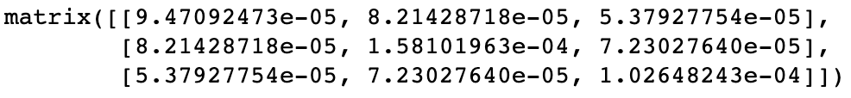

1. **(i)**the results for empirical distribution are shown below:

文本

**(ii)** the results for normal distribution using EWMA and standard eatimstors are shown below:

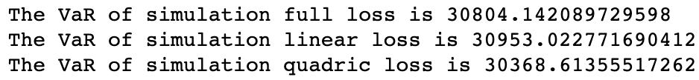

It seems that normal distribution using standard and empirical distribution results are about similar, but the normal distribution using EWMA results are different. From my perspective, that’s might because using moving average we decrease the mean and deviation from a big picture.

1. **VaR and Time Aggregation.**

The results are shown below: (for details, please see the code file)

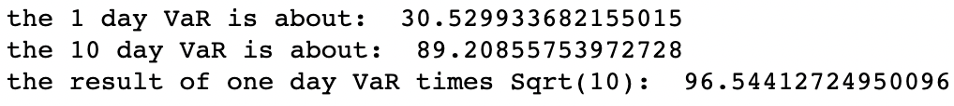

It’s really close the result that professor obtained.

**3.Backtesting VaR.**

I got exceedances for empirical distribution about 44 and for EWMA about 80(in class we got 79, I think its because I keep different decimal).

The Average is about 75.4 and the CI is about [58.81194118269656, 91.98805881730357].