**MF850**

**Problem Set 1**

**Problem1.1:(For the detail, See the code)**

1. The approximation to the price of European put is about: **1.347**
2. Here I plot the (Binomial_Euro_put – BS model Price) VS 1/n:

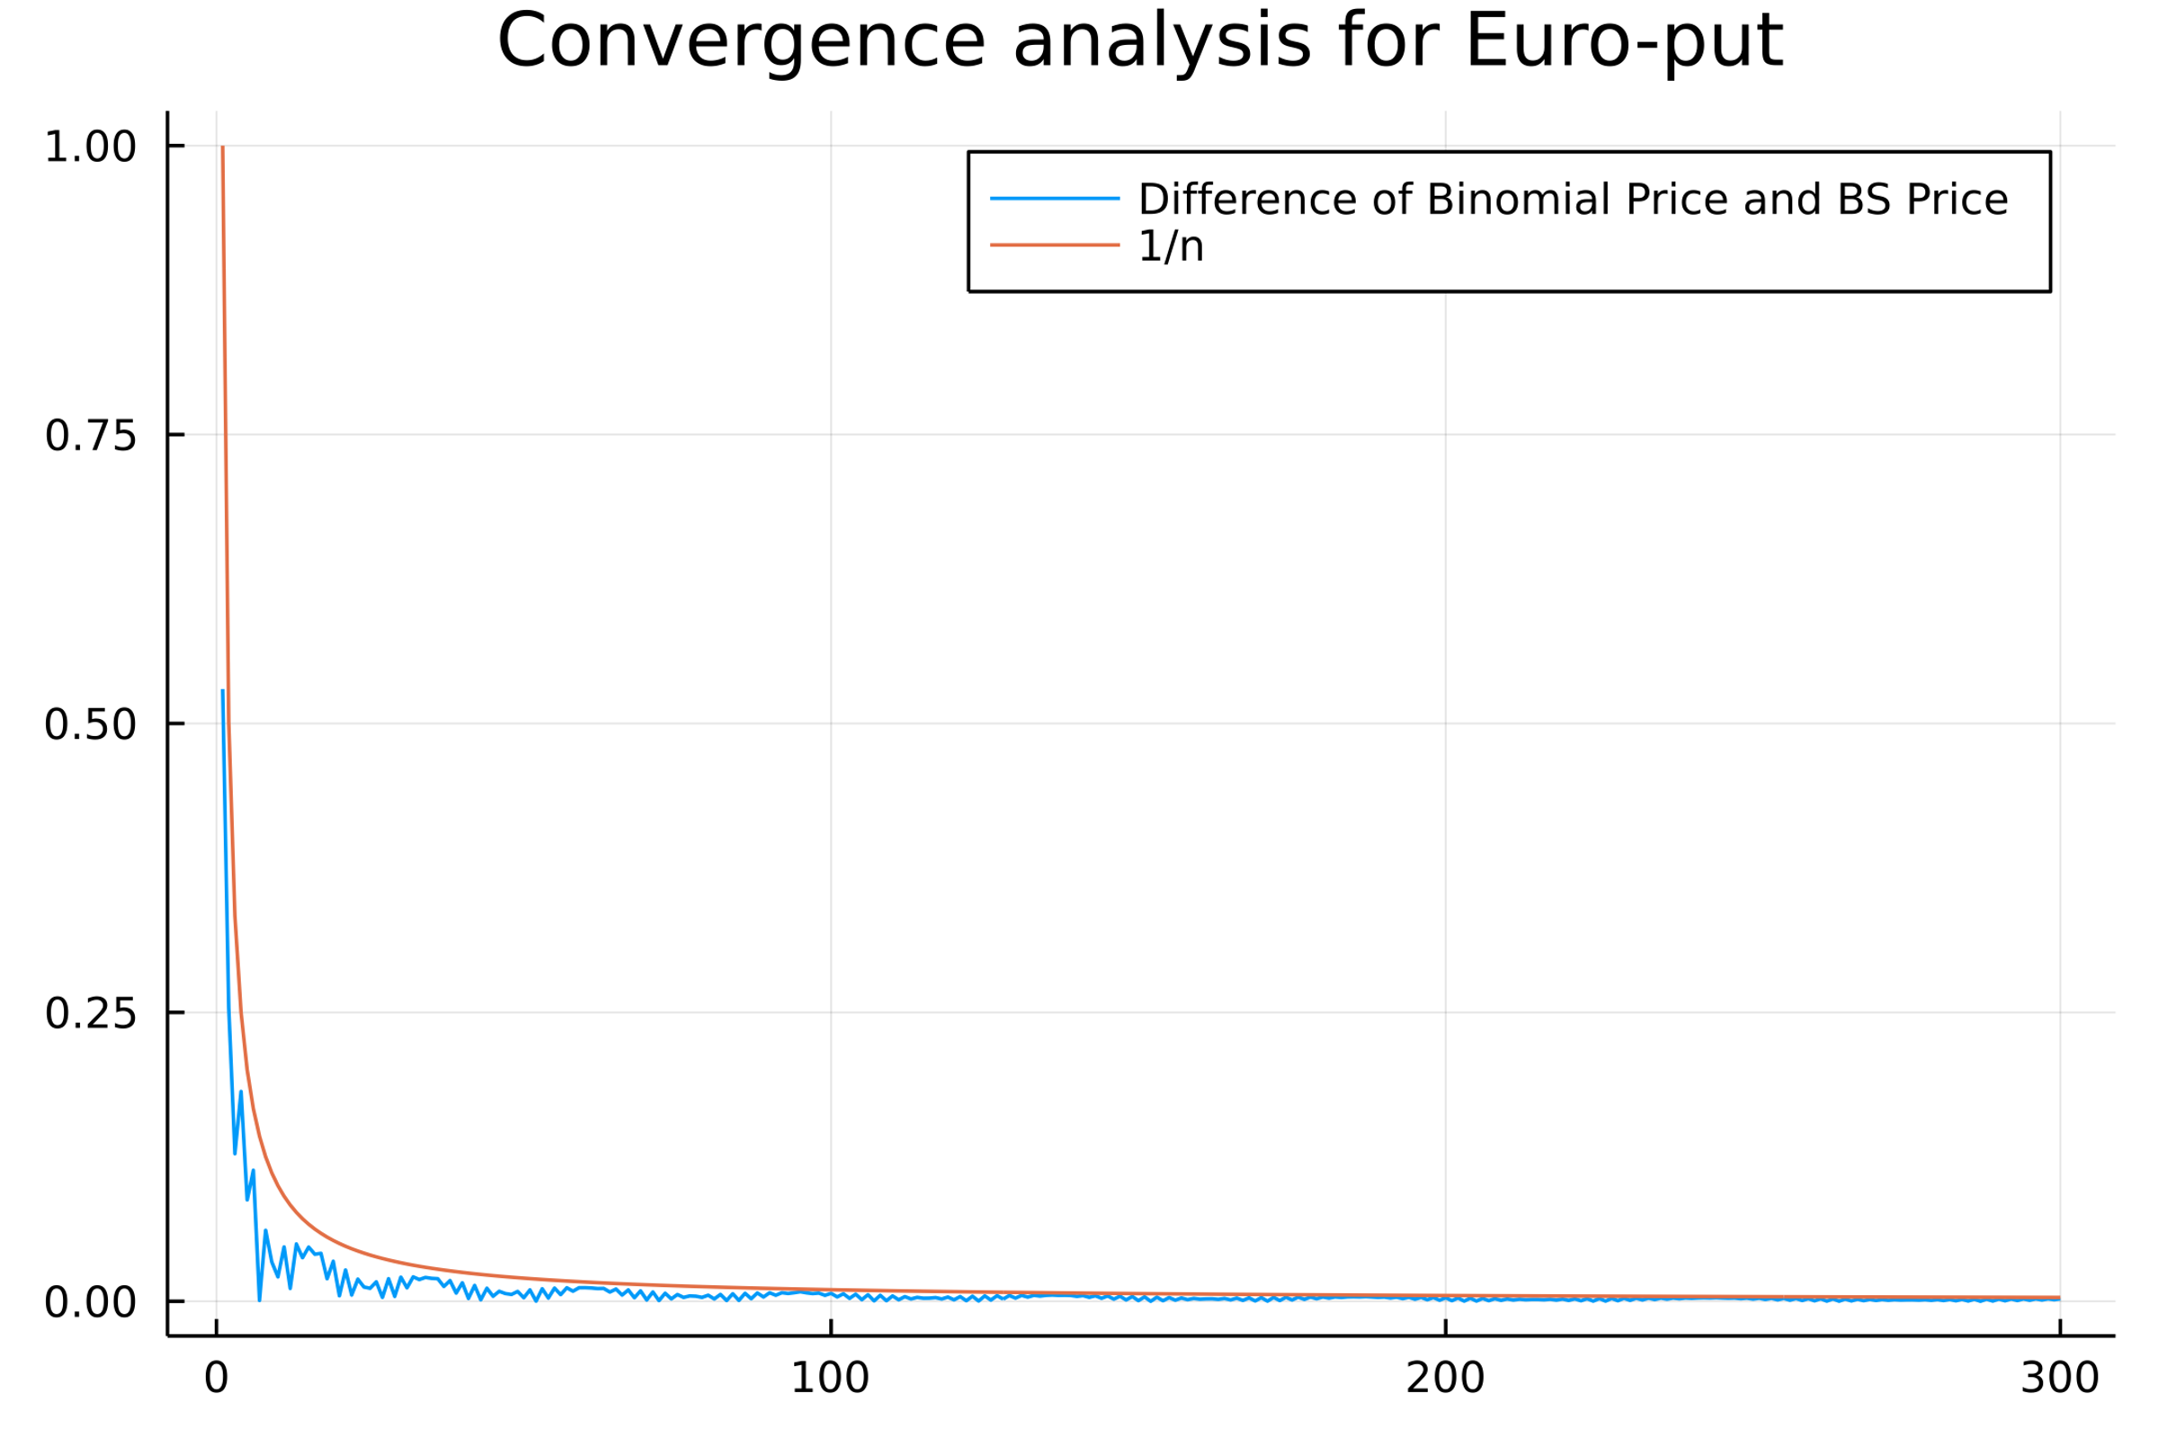

From the plot we can see that Binomial(n)-BS(n) converges to zero and it’s under the bound of the e(n) = 1/n.

we can see that:

$$\lim_{n→∞}{\frac{\frac{1}{n+1}}{\frac{1}{n^{q}}}}=\lim_{n→∞}{\frac{n^{q}}{n+1}}$$

We get the order of convergence for **q= 1**, so the convergence is linear. And the rate of the convergence obviously should be **1**.

1. We do the same things in American rules. The approximation of American put price is about: **1.4126**. And I also plot the same thing for American put options:

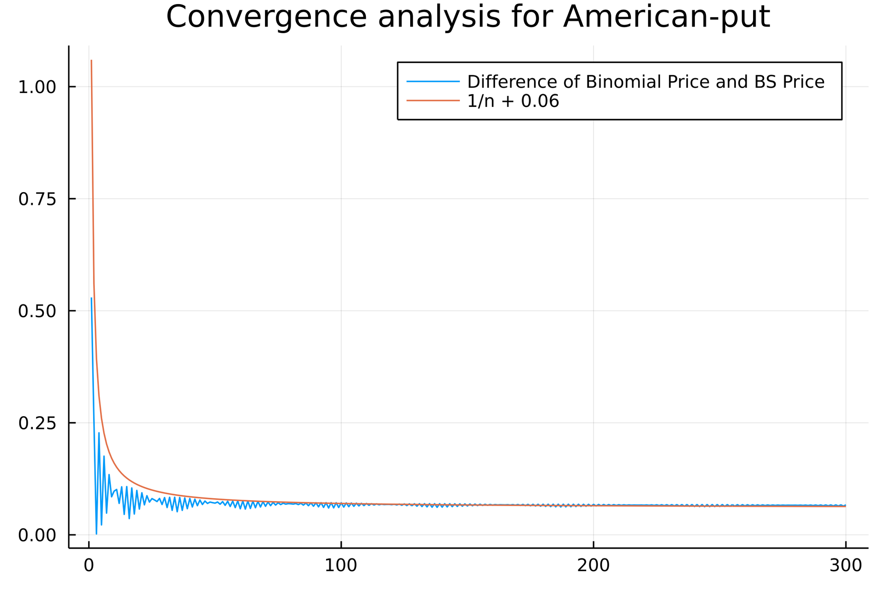

From the plot we can see the path of American put converges to around 0.06. This value is the premium with respect to the European option. But they converge in a very similar way. Therefore, we just use the e(n)=1/n+0.06 to describe its path. Because we just move the curve parallel. It should be also a linear convergence and the rate of convergence is **1**.