**MF850 Problem Set 3**

**Problem 3.1**

**(a)&(b)**The answer to the first two questions are shown below:

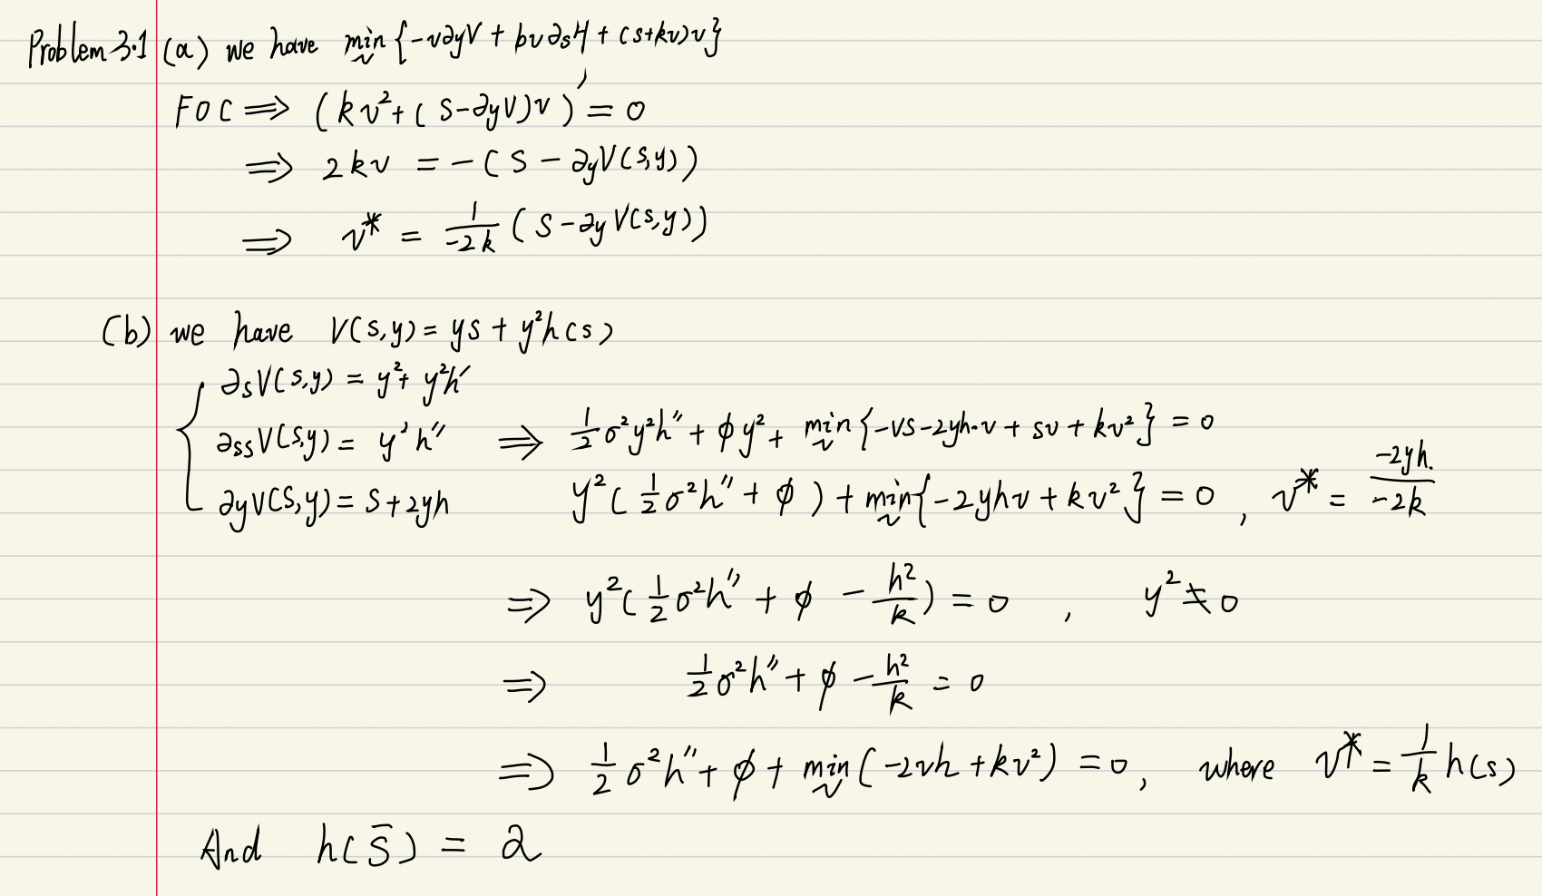

**(c)**The plot is shown below: (for the detail, please check the code file.)

