DermaBoss
Skin lesion classifier
Tested environment:
Python 3.11, Anaconda, Pytorch 2.10.0 + CUDA 13.0
A CUDA capable GPU is highly Recommended

- Introduction:
DermaBoss is a command line application designed to classify skin lesion images into one of eight diagnostic categories. It uses a fine-tuned Resnet 18 CNN Trained on the ISIC 2019 dataset.
Supported skin lesion class:
Class | Full name | Description
MEL | Melanoma | Malignant melanocytic tumour
NV | Melanocytic Nevi | Common benign mole
BCC | Basal Cell Carcinoma | Most common skin cancer
AK | Actinic Keratosis | Pre-cancerous rough skin patch
BKL | Benign Keratosis | Seborrhoeic keratosis / solar lentigo
DF | Dermatofibroma | Benign fibrous skin nodule
VASC | Vascular Lesion | Angiomas, angiokeratomas, etc.
SCC | Squamous Cell Carcinoma | Second most common skin cancer

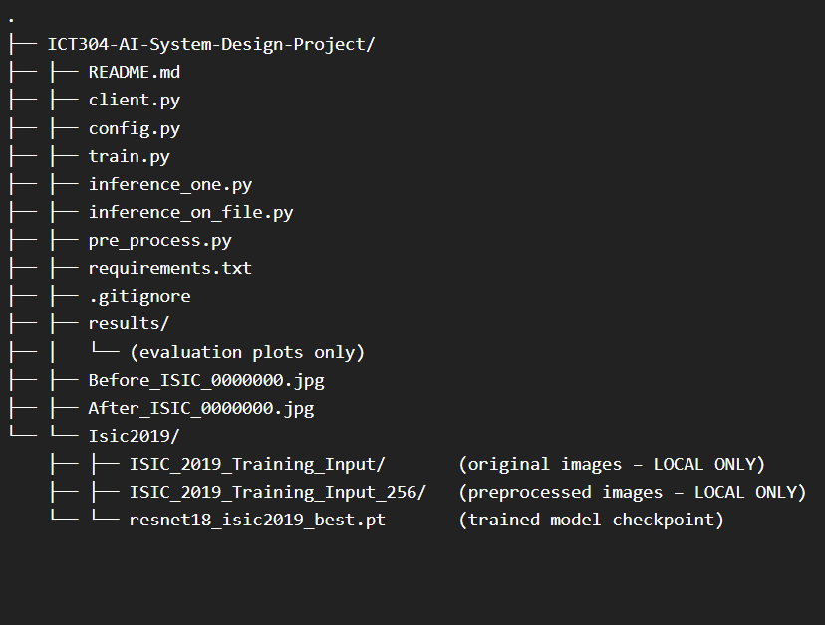
Project file structure:
- Prerequisites:
- Anaconda/miniconda Environment with Python 3.11
- CUDA capable GPU
- 22 GB free disk
- Internet access
2.1. Download and setup
Step 1:
- Setting up the Anaconda environment:
Conda create -n dermaboss python=3.11 -y
Conda activate dermaboss
Step 2:
- Cloning the github Repository
git clone https://github.com/karlnapod /ICT304-AI-System-Design-Project.git
cd ICT304-AI-System-Design-Project
Step 3:
- CUDA-capable gpu:
pip install torch torchvision --index-url https://download.pytorch.org/whl/cu130
- CPU only:
pip install torch torchvision --index-url https://download.pytorch.org/whl/cpu
- Install the remaining dependencies:
pip install -r requirements.txt
- Dataset download and setup
Run the client.py file the program will prompt you to enter the file path for the dataset base directory, if the dataset is not incomplete or missing, the program will give three options:
- Provide a different base directory path
- Download the data set automatically into the select directory
- Exit and handle the setup manually

- Running DermaBoss
- Assuming currently you are in the directory that has been cloned from Github run:
Python client.py
- You will asked for the dataset base directory:
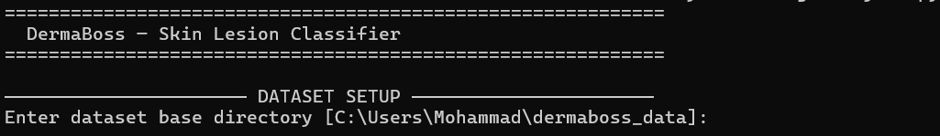
- If the dataset is not found:
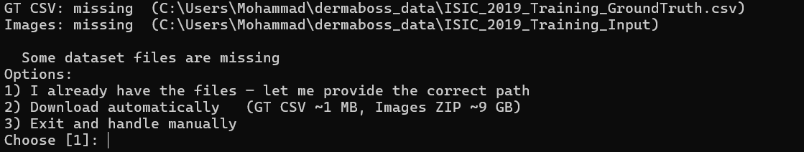
- You will be presented by a main menu:
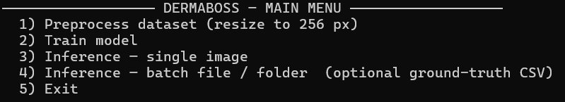
To be able to run options 2 and 4, first option 1 needs be run (if the split is missing or the images have not been resized preprocessing will be run automatically at the start upon entering the dataset based directory), but option 3 can be run.
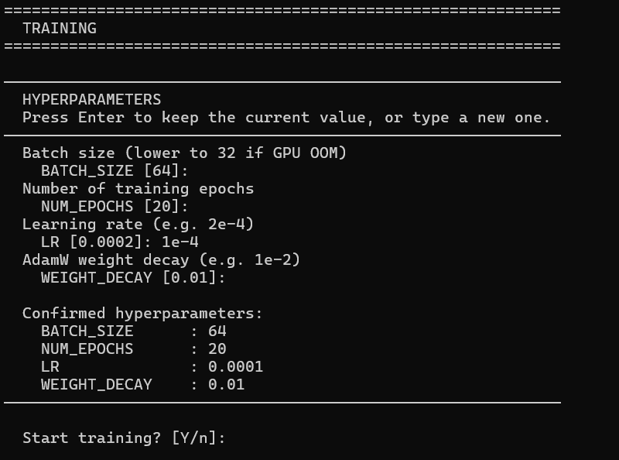
Option 2:
A set of four hyperparameters will be presented which can be edited or you can press enter to continue with the default.
When training is completed:
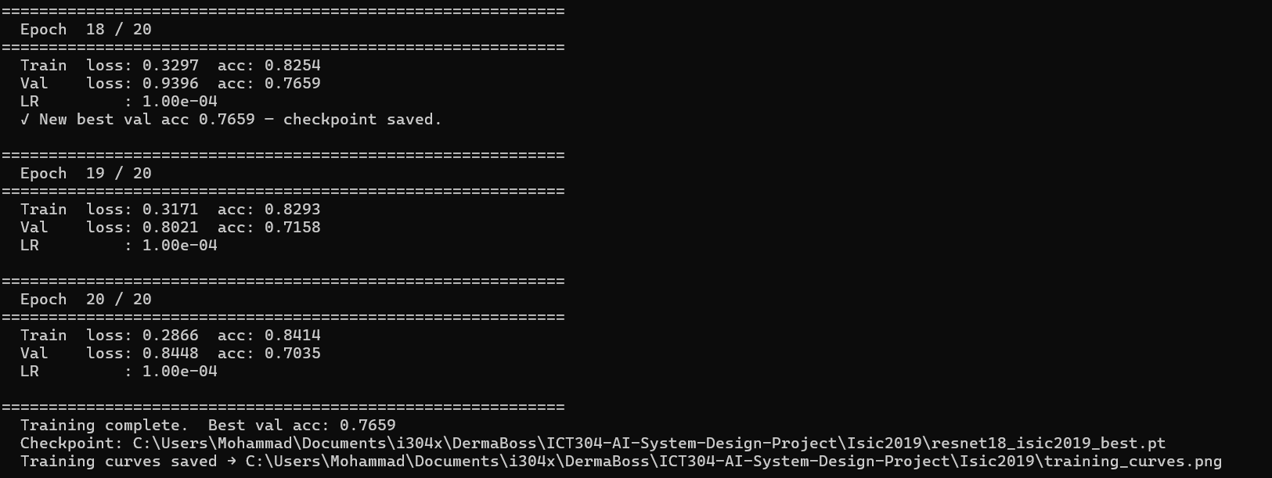
The best preforming model(checkpoint for the best saved weights) will and the validation accuracy will be presented.
Option 3:
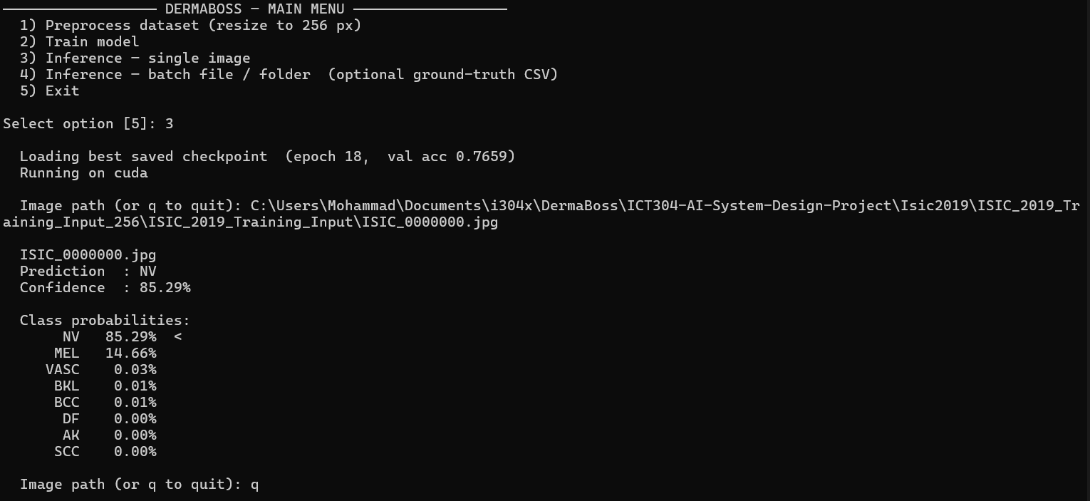
Upon selecting option three you will be prompted to give the file path to the image that intended for classification

Option 4:
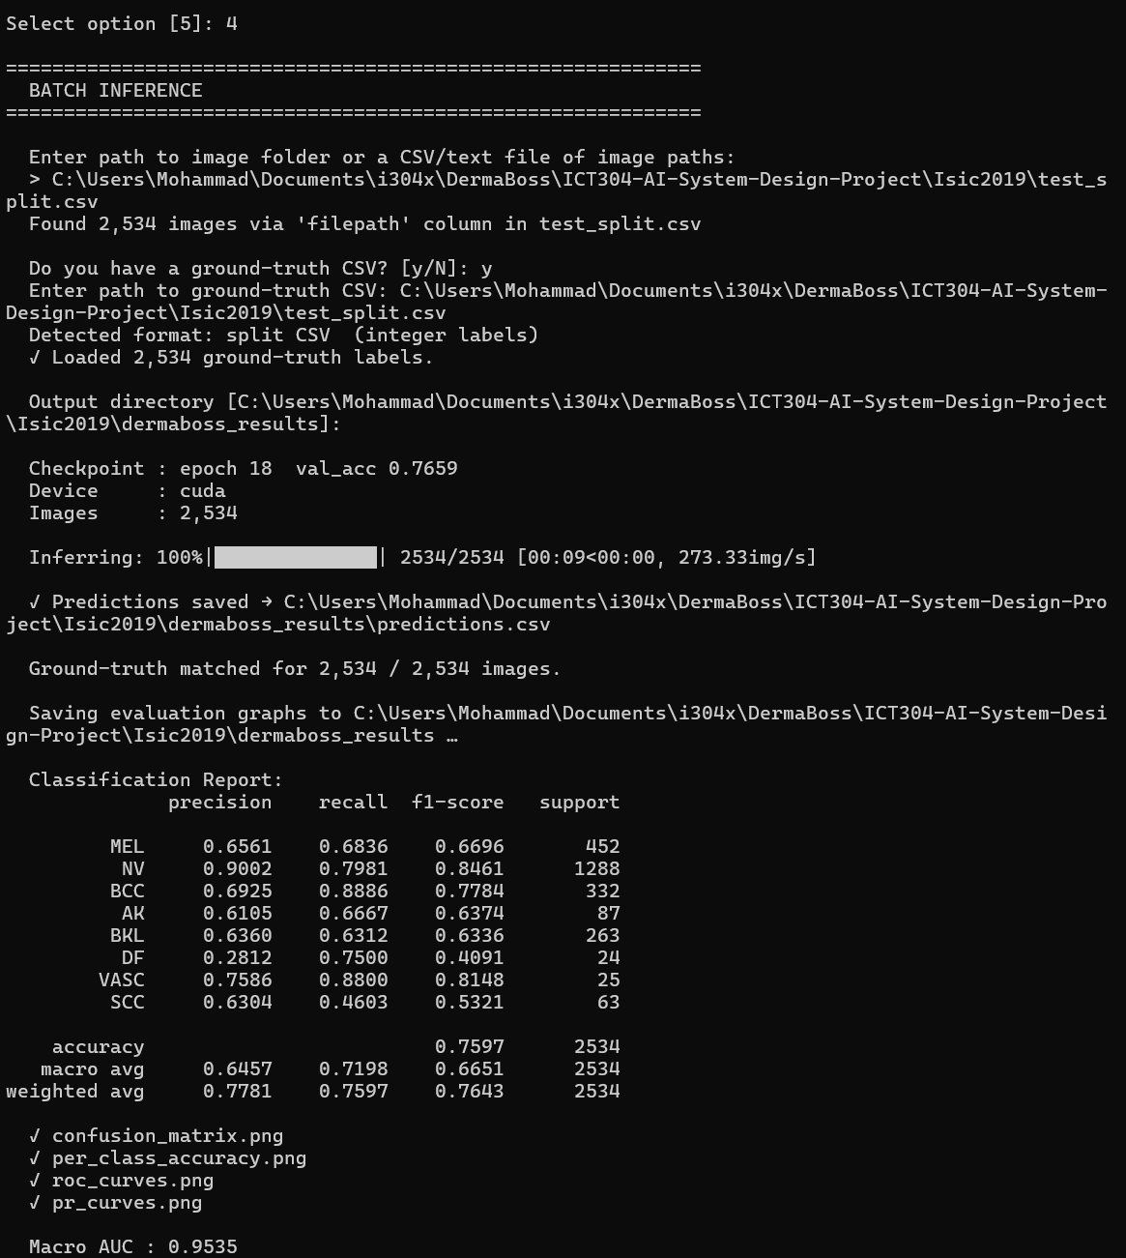
Option 4 could be used for evaluating the model and batch inference:
First you’ll be prompted to give CSV that the paths to the images
If you’re evaluating the model and have the truth labels as well in the CSV, Confirm that you have the truth labels And give the path to the CSV with the truth labels (It can be The same CSV file as the one used to store the paths to the images).

