**PAPER**

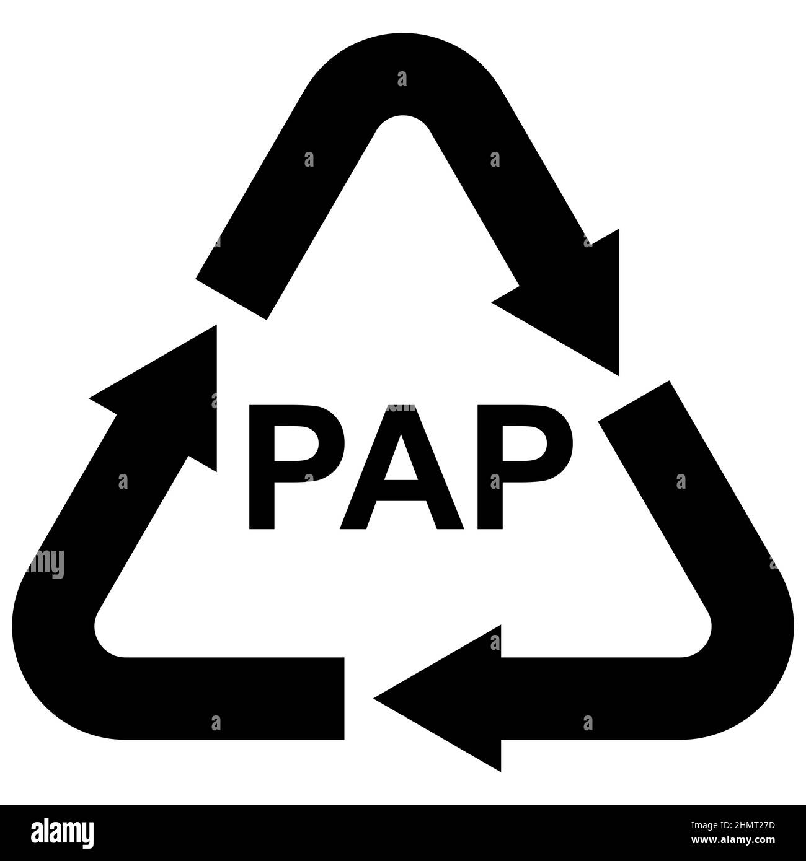

**PLASTIC**

