
NATIONAL UNIVERSITY OF SCIENCE AND TECHNOLOGY
Faculty of Applied Sciences · Department of Computer Science

Solution Book 2
SCS 1101, 2025 paper
SCS 1101 Introduction to Computer Science and Programming
Past-paper solutions with marks allocated, algorithms, textbook flowcharts, exam-ready code and a civil & water engineering lens
5 questions · 25 marks each · cover page not supplied (assume any 4 of 5)
Book 2 of 8 · Prepared October 2026

Index | Guide | Glance | Q1 | Q2 | Q3 | Q4 | Q5 | Refs | Links

Index — tap a tab or a line to jump
Every chapter starts with the coloured tab bar below; tap any tab to jump straight to that question. The page footer has a link back to this index. In Word, the Navigation Pane shows the same chapters.
Guide How to use this book
Glance At a glance
Q1 Question 1 [25]
▸ 1(a) Five ways computer viruses spread [10]
▸ 1(b) Program: ATM with deposit, withdraw and balance [15]
Q2 Question 2 [25]
▸ 2(a) Functions of computer components [2 each = 6]
▸ 2(b) The topology in Figure 1 [4]
▸ 2(c) Program: analyse 30 exam scores [15]
Q3 Question 3 [25]
▸ 3(a) Four types of errors, with examples [2 each = 8]
▸ 3(b) Local and global variables, with a program [7]
▸ 3(c) Compare and contrast traditional filing and cloud storage [10]
Q4 Question 4 [25]
▸ 4(a) Five benefits of using the internet [10]
▸ 4(b) Program: PAYE tax from salary [15]
Q5 Question 5 [25]
▸ 5(a) IaaS and PaaS, with examples [4 each = 8]
▸ 5(b) Five functions of an operating system [5]
▸ 5(c) Program: recursive Fibonacci series [12]
Refs Sources for this book
Links Source register

Index | Guide | Glance | Q1 | Q2 | Q3 | Q4 | Q5 | Refs | Links

How to use this book
This book is one of eight stand-alone solution books for NUST SCS 1101 past papers. It solves SCS 1101, 2025 paper question by question, with the marks the examiner allocates shown in square brackets, e.g. [2].

The six-block answer template
Every answer in this book (and in all eight books of the set) is built from the same six blocks, in the same order. Theory answers use blocks 1, 2, 5 and 6; programming answers use all six.
- Like you’re 3 — one or two sentences with a toy, a bath or a water tap.
- Model answer — the exam wording, with the mark for each point in brackets, e.g. [2]. Write it like this and you collect every mark.
- Algorithm + code — numbered pseudocode first, then C code that follows the H-D-I-P-O-R recipe.
- Flowchart or structure chart — textbook (ANSI) symbols. Programs built from functions also get a structure (hierarchy) chart.
- Engineering lens — the same idea in a civil and water engineering setting, using the profession’s vocabulary.
- Examiner’s tip — where students usually lose marks.
The H-D-I-P-O-R code recipe — “Happy Ducks In Ponds Only Relax”. Every exam program is these six steps, in this order:
/* H - Header: what the program does, and the libraries */
#include <stdio.h>
int main(void)
{
/* D - Declare: every variable, with a sensible type and a starting value */
/* I - Input: printf a prompt, then scanf with & */
/* P - Process: the if-ladder, loop or formula */
/* O - Output: printf the result with units and decimals */
/* R - Return: */ return 0;
}
The recipe is worth marks by itself: examiners give separate marks for headers, declarations, input, processing and output. A half-finished program laid out this way still scores; a clever one-liner without structure often does not.
Algorithm style used in every book:
Step 1: Start
Step 2: Read <inputs>
Step 3: <process, one action per step>
Step 4: Display <outputs>
Step 5: Stop
Flowchart symbols (ANSI):
Symbol | Shape | Use | Colour in this book
Terminator | Rounded box (stadium) | Start / Stop | Green
Input/Output | Parallelogram | Read or display | Blue
Process | Rectangle | Calculation or assignment | Amber
Decision | Diamond | Yes/no test, two exits | Red
Predefined process | Rectangle with double sides | Call to a function | Purple
Flow line | Arrow | Order of steps | Dark grey arrow
The smallest possible program, drawn with these symbols:
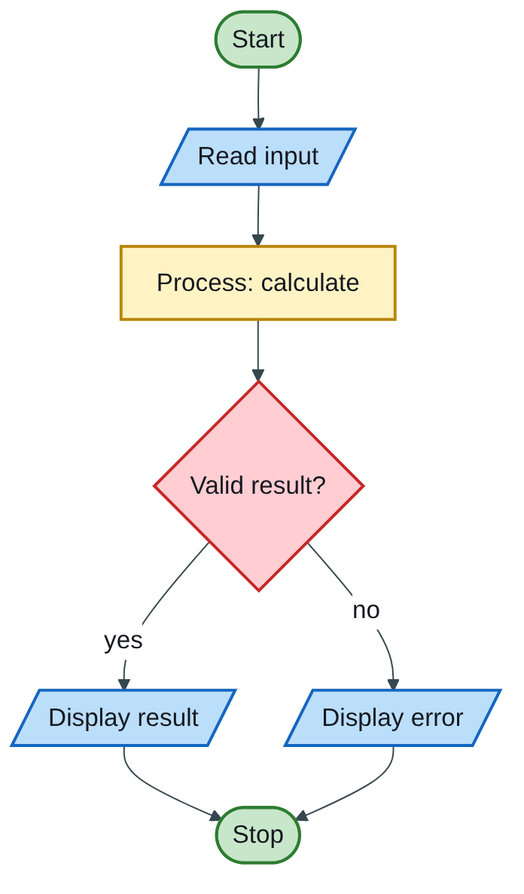
Figure 2.1 — Flowchart
The engineering lens. Programming questions get a civil and water engineering version where it fits, for example:
- tariff ladders become increasing block tariffs for water;
- array statistics become rainfall or concrete cube strength analysis;
- geometry programs become cross-section, wetted perimeter and hydraulic radius calculations.
Write the exam version in the exam; the engineering version is for understanding and for your later modules.

How the solutions were researched
Every fact a solution relies on is traced to a source in one of four tiers; each source has a short key (e.g. [MIT-2]) so answers can cite it without long links.
- Tier 1 — the course itself. The SCS 1101 outline and the past papers decide what to answer and how marks are split.
- Tier 2 — university teaching material. MIT OpenCourseWare and UCLA course pages for programming and algorithms; university histories for milestones.
- Tier 3 — standards and research. NIST for cloud definitions; peer-reviewed and arXiv papers, including Wits research on cloud adoption in South Africa.
- Tier 4 — standard textbook knowledge. Definitions every textbook agrees on (OS functions, topologies, printers) are written from the textbooks your outline lists, without a web citation.
A claim is only cited when a source was actually opened; anything from tier 4 stays general and uncited.

Index | Guide | Glance | Q1 | Q2 | Q3 | Q4 | Q5 | Refs | Links

At a glance
Five questions of about 25 marks each (page 1 with the instructions was not provided; the 2024 rule was “any 4, no calculators”). Three questions end in a 12–15 mark program, so prepare the ATM, exam-scores, PAYE and Fibonacci programs.
Question | What it tests | Marks split | Pick?
Q1 | How viruses spread; ATM menu program | 10 theory + 15 program | Yes
Q2 | ALU, address bus, register; star topology; 30 exam scores | 10 theory + 15 program | Yes
Q3 | Four error types; local vs global; filing vs cloud storage | 25 theory with a short program | Good
Q4 | Internet benefits; PAYE tax program | 10 theory + 15 program | Yes
Q5 | IaaS and PaaS; OS functions; recursive Fibonacci | 13 theory + 12 program | Yes

Index | Guide | Glance | Q1 | Q2 | Q3 | Q4 | Q5 | Refs | Links

Question 1 [25]

1(a) Five ways computer viruses spread [10]
Like you’re 3: a virus is a germ for computers. It jumps from one computer to another through anything they share: a USB stick, an email, a download, a network cable.
Name the route [1] and explain how infection happens [1], five times:
- Infected email attachments — opening a file (e.g. a fake invoice) runs the hidden virus code.
- Removable media — USB flash disks and external drives carry the virus between machines, often through autorun files.
- Downloads from untrusted sites — pirated software, cracked games and fake updates come bundled with malware.
- Malicious links and phishing — a click on a link in an SMS, WhatsApp or email message leads to a site that installs malware.
- Networks and file sharing — shared folders, peer-to-peer sharing and worms that exploit unpatched security holes spread across a LAN without anyone clicking.
- Infected documents (macros) — Word or Excel files with malicious macros run when editing is enabled.
Engineering lens: in a water utility, malware brought in on a contractor’s USB stick could reach the SCADA computers that run pumps and dosing. This is why control networks are separated from office networks (air-gapping or firewalls).

1(b) Program: ATM with deposit, withdraw and balance [15]
Like you’re 3: a piggy bank that starts with $500. You can put money in, take money out (but never more than is inside), or peek at how much is there, again and again until you say “bye”.
Algorithm:
Step 1: Start; balance = 500
Step 2: Display menu: 1 Deposit, 2 Withdraw, 3 Balance, 4 Exit
Step 3: Read choice
Step 4: If choice = 1: read amount; if amount > 0, balance = balance + amount
If choice = 2: read amount; if amount > balance, display "Insufficient funds"
else balance = balance - amount
If choice = 3: display balance
If choice = 4: display goodbye
Otherwise: display "Invalid option"
Step 5: If choice is not 4, go to Step 2
Step 6: Stop
Flowchart:
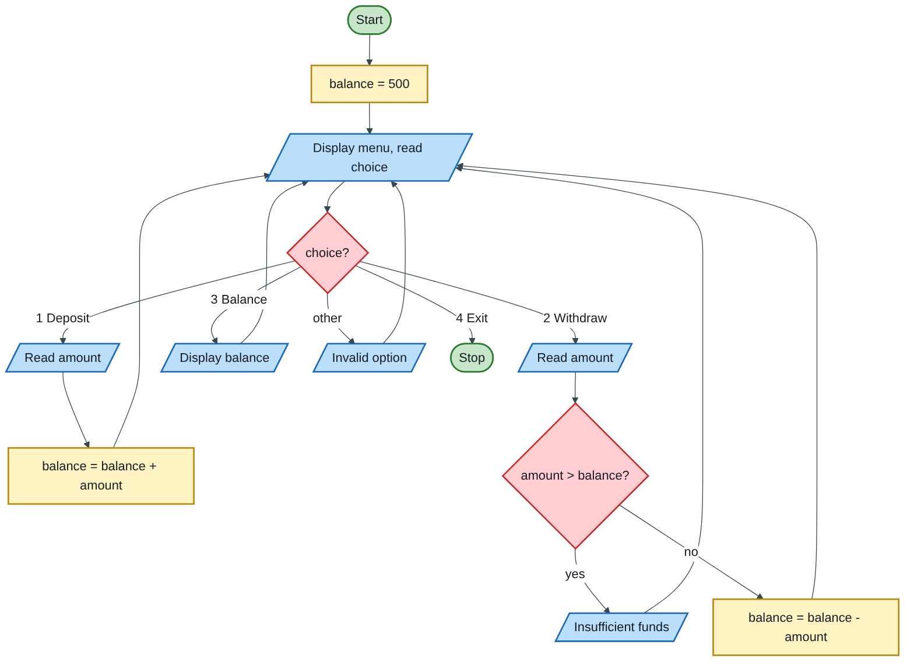
Figure 2.2 — Flowchart
Code (H-D-I-P-O-R) — the menu-loop pattern: do { menu; switch } while (not exit);
/* H: ATM simulation - deposit, withdraw, check balance; opening balance $500 */
#include <stdio.h>
int main(void)
{
double balance = 500.00, amount; /* D */
int choice;
do {
printf("\n====== ATM MENU ======\n");
printf("1. Deposit\n2. Withdraw\n3. Check balance\n4. Exit\n");
printf("Choose an option: ");
scanf("%d", &choice); /* I */
switch (choice) { /* P */
case 1: /* deposit */
printf("Amount to deposit: $");
scanf("%lf", &amount);
if (amount > 0) {
balance += amount;
printf("Deposited $%.2f\n", amount);
} else {
printf("Invalid amount\n");
}
break;
case 2: /* withdraw, no overdraft */
printf("Amount to withdraw: $");
scanf("%lf", &amount);
if (amount <= 0)
printf("Invalid amount\n");
else if (amount > balance)
printf("Insufficient funds. Balance is $%.2f\n", balance);
else {
balance -= amount;
printf("Please take your $%.2f\n", amount);
}
break;
case 3: /* O */
printf("Your balance is $%.2f\n", balance);
break;
case 4:
printf("Thank you for banking with us.\n");
break;
default:
printf("Invalid option, try again\n");
}
} while (choice != 4);
return 0; /* R */
}
Test run:
Action | Amount | Result | Balance after
Start | — | — | $500.00
Deposit | 200 | Accepted | $700.00
Withdraw | 1000 | Refused: insufficient funds | $700.00
Withdraw | 300 | Accepted | $400.00
Balance | — | Shows $400.00 | $400.00
Exit | — | Goodbye | —
Marking guide [15]: opening balance and declarations [2]; menu display [2]; loop that repeats until exit [3]; deposit [2]; withdrawal with the overdraft check [3]; balance enquiry [1]; invalid input handled [1]; formatted money output [1].
Engineering lens: this is the logic inside a prepaid water meter. Buying a token is a deposit of credit; consumption is a withdrawal; and when credit reaches zero the meter’s valve shuts off, the water version of “no overdraft”. Utilities use prepaid metering to cut non-revenue water from unpaid bills.
Examiner’s tip: check amount > balance before subtracting. Subtracting first and checking afterwards lets the balance go negative for a moment, which loses the overdraft mark.

Index | Guide | Glance | Q1 | Q2 | Q3 | Q4 | Q5 | Refs | Links

Question 2 [25]

2(a) Functions of computer components [2 each = 6]
Like you’re 3: the ALU is the calculator in the computer’s brain; the address bus is the road sign saying which drawer to open; registers are the tiny notepads the brain keeps in its hand.
Component | Model answer [1 function + 1 detail]
Arithmetic and Logic Unit (ALU) | The part of the CPU that performs arithmetic operations (+, −, ×, ÷) [1] and logical operations and comparisons (AND, OR, NOT, greater than, equal to) on data supplied by the registers [1].
Address bus | A set of parallel lines that carries the memory address of the location the CPU wants to read from or write to [1]. It is one-way (CPU → memory), and its width sets how much memory can be addressed: 32 lines address 2³² locations (4 GB) [1].
Register | A very small, very fast storage location inside the CPU [1] that holds the data, instruction or address currently being used, e.g. the program counter (address of the next instruction) and the accumulator (results) [1].

2(b) The topology in Figure 1 [4]
(i) Identify it [1]: a star topology: every device has its own link to a central hub.
(ii) Two advantages and one disadvantage [3]:
- Advantage: a fault in one cable or device affects only that device; the rest keep working [1].
- Advantage: easy to install, manage and expand; adding a device needs only one new cable to the hub, and faults are easy to isolate [1].
- Disadvantage: the hub is a single point of failure; if it fails, the whole network stops. It also uses more cable than a bus [1].
Engineering lens: star is also how a utility’s telemetry is usually laid out: each reservoir and pump-station outstation reports to one central control room (master station). If the master station fails, every site loses supervision, which is why control rooms have backup servers.

2(c) Program: analyse 30 exam scores [15]
Like you’re 3: 30 children each get a sticker with their score. We look for the biggest sticker, the smallest sticker, share all the points out equally (average), and count the stickers under 50.
Algorithm:
Step 1: Start
Step 2: For i = 0 to 29: read score[i] (reject values outside 0-100)
Step 3: highest = score[0], lowest = score[0], sum = 0, failed = 0
Step 4: For i = 0 to 29:
sum = sum + score[i]
if score[i] > highest: highest = score[i]
if score[i] < lowest: lowest = score[i]
if score[i] < 50: failed = failed + 1
Step 5: average = sum / 30
Step 6: Display highest, lowest, average, failed
Step 7: Stop
Flowchart (processing loop):
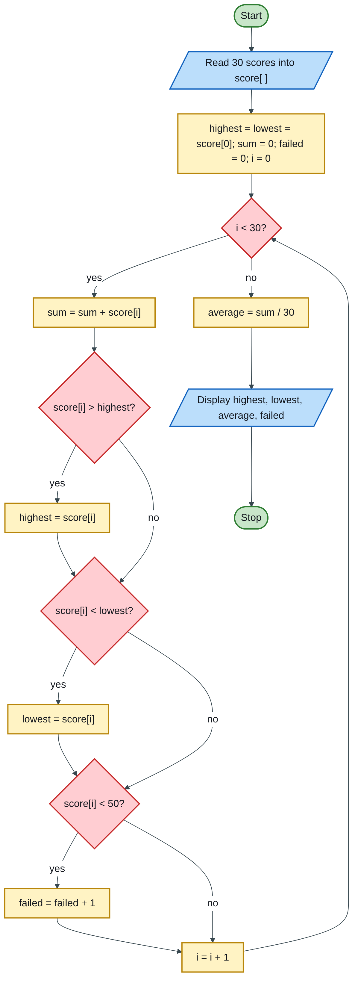
Figure 2.3 — Flowchart
Code (H-D-I-P-O-R):
/* H: analyse 30 exam scores - highest, lowest, average, number failed */
#include <stdio.h>
#define N 30
#define PASS 50
int main(void)
{
int score[N]; /* D */
int i, highest, lowest, failed = 0;
double sum = 0.0, average;
for (i = 0; i < N; i++) { /* I: read and validate */
do {
printf("Score for student %d (0-100): ", i + 1);
scanf("%d", &score[i]);
} while (score[i] < 0 || score[i] > 100);
}
highest = lowest = score[0]; /* P: start from the first score */
for (i = 0; i < N; i++) {
sum += score[i];
if (score[i] > highest) highest = score[i];
if (score[i] < lowest) lowest = score[i];
if (score[i] < PASS) failed++;
}
average = sum / N;
printf("\nHighest score : %d\n", highest); /* O */
printf("Lowest score : %d\n", lowest);
printf("Average score : %.2f\n", average);
printf("Failed (< 50) : %d student(s)\n", failed);
return 0; /* R */
}
Test (set N to 5 to check by hand): scores 45, 72, 50, 38, 90 give highest 90, lowest 38, average 295 / 5 = 59.00, failed 2 (45 and 38). Note that 50 is a pass, because the test is < 50.
Marking guide [15]: array and variables declared [2]; input loop into the array [3]; highest and lowest started from score[0] [2]; sum and average as a decimal [2]; correct max and min tests [3]; fail counter [2]; clear output [1].
Engineering lens: swap exam scores for 28-day concrete cube strengths (MPa) from a pour. The same program gives the maximum, minimum and mean strength, and the count below the specified characteristic strength is the number of non-compliant cubes, which the site engineer must investigate.
Examiner’s tip: never start highest = 0 and lowest = 0. With lowest = 0 no real score is ever smaller, so the lowest is always reported as 0. Start both at score[0].

Index | Guide | Glance | Q1 | Q2 | Q3 | Q4 | Q5 | Refs | Links

Question 3 [25]

3(a) Four types of errors, with examples [2 each = 8]
Like you’re 3: a syntax error is a spelling mistake; a run-time error is tripping over while running; a logic error is running very well, but to the wrong house; a semantic error is a sentence with good spelling that makes no sense (“the cup drank the milk”).
Error | Definition [1] | Example [1]
Syntax | Breaks the grammar rules of C; the compiler refuses to build the program. | printf("Hello") — missing ;
Run-time | The program compiles but crashes or misbehaves while running, usually because of bad data or resources. | q = v / t; when the user enters t = 0 (division by zero); opening a file that does not exist
Logical | The program runs to completion but gives a wrong answer, because the method is wrong. | avg = a + b / 2; instead of avg = (a + b) / 2;
Semantic | Grammatically correct but meaningless or invalid use of the language, e.g. wrong types or using something that has no value. | int x = "ten"; (text stored in an int); printf("%d", 2.5); (wrong format for a double)
Run-time errors are not just a beginner problem: MIT researchers showed that subtle C errors of this kind (undefined behaviour) occur in real systems and can become security holes (MIT-4).

3(b) Local and global variables, with a program [7]
Like you’re 3: a local variable is the toy in your own bedroom: only you can play with it, and it is packed away when you leave. A global variable is the TV in the lounge: everyone in the house can use it, all day.
- Local variable [2] — declared inside a function or block; visible only there; created when the function starts and destroyed when it ends; holds garbage unless initialised.
- Global variable [2] — declared outside all functions, usually at the top of the file; visible to every function below it; lives for the whole program run; starts at 0 automatically.
Program [3]:
#include <stdio.h>
int total = 0; /* GLOBAL: outside every function */
void addFlow(int q)
{
int doubled = q * 2; /* LOCAL to addFlow only */
total = total + doubled; /* a function may use the global */
}
int main(void)
{
int flow = 5; /* LOCAL to main only */
addFlow(flow); /* total becomes 10 */
addFlow(3); /* total becomes 16 */
printf("total = %d\n", total);
/* printf("%d", doubled); would NOT compile: doubled is local to addFlow */
return 0;
}
Output: total = 16.
Feature | Local | Global
Where declared | Inside a function | Outside all functions
Who can use it | Only that function | Every function in the file
Lifetime | While the function runs | The whole program
Starting value | Garbage unless set | 0
Good practice: prefer local variables and pass values as parameters; globals make programs harder to debug.

3(c) Compare and contrast traditional filing and cloud storage [10]
Like you’re 3: traditional filing is keeping your drawings in a box under your bed. Cloud storage is keeping them in a magic library you can open from any house, as long as the internet door is open.
Definitions [2]: a traditional filing system stores records as paper documents in folders and cabinets (or as separate files on one local computer), organised by a manual index. Cloud storage keeps digital files on a provider’s remote servers, reached over the internet (STD-1).
Similarities [3]:
- Both store and organise an organisation’s records for later retrieval.
- Both need a good naming or indexing scheme to find things.
- Both need access control and a policy on how long records are kept.
Differences [5]:
Point | Traditional filing | Cloud storage
Access | Only where the cabinet is, during office hours | Anywhere, any time, on any connected device
Search and retrieval | Slow, by hand | Seconds, using search
Space and cost | Needs office space, cabinets, paper | No physical space; monthly subscription
Backup and disaster risk | One copy; lost to fire, flood or termites | Automatic copies in several data centres
Sharing | Photocopy or carry the file | Share links; many people edit at once
Dependence | Works without power or internet | Needs internet and a trustworthy provider; raises data-privacy and data-location questions
South African research on choosing cloud providers found security and data sovereignty (where the data physically sits, and whose laws apply) among the key selection criteria (RES-1).
Engineering lens: a municipality’s as-built drawings of water mains were traditionally kept as paper sheets in a plan room. Modern projects keep drawings, models and site records in a common data environment (CDE), the cloud document system used in BIM, so the designer, contractor and client all work from the same latest revision.
Examiner’s tip: for 10 marks, give definitions, at least three similarities and five clear differences. A table of differences is the fastest way to collect marks.

Index | Guide | Glance | Q1 | Q2 | Q3 | Q4 | Q5 | Refs | Links

Question 4 [25]

4(a) Five benefits of using the internet [10]
Like you’re 3: the internet is a giant road connecting every house in the world, so letters, pictures, lessons and shopping can travel anywhere in seconds.
Name the benefit [1] and explain it with an example [1], five times:
- Fast, cheap communication — email, WhatsApp and video calls reach anyone worldwide in seconds at low cost.
- Access to information and research — search engines, e-journals and open courseware (e.g. MIT OpenCourseWare) put libraries of knowledge on your phone.
- E-learning — online courses, university portals and recorded lectures allow study from anywhere.
- E-commerce and online banking — buying, selling, paying bills and mobile money without travelling.
- Collaboration and cloud services — shared documents, cloud storage and remote work let teams in different towns work together.
- E-government and services — online tax returns, applications and booking.
Context line for an introduction: the internet grew from ARPANET, whose first message was sent from UCLA on 29 October 1969 (UCLA-1).
Engineering lens: the internet lets a utility read smart water meters remotely, publish rainfall and dam-level data daily, and let consultants share design models with the client the same day.

4(b) Program: PAYE tax from salary [15]
Like you’re 3: your salary is a pile of coins sorted into buckets. The first bucket ($100) pays no tax. Coins in the next bucket pay 20c of every dollar, the next 25c, then 30c, then 35c. Each coin only pays the rate of the bucket it sits in.
State your reading: PAYE is a progressive (marginal) tax, so each rate applies only to the part of the salary inside its band. The bands are taken as $0–100, $100–300, $300–1000, $1000–2000 and above $2000.
Full tax of each lower band (worked out once, used as constants):
Band | Width | Rate | Tax for the full band | Running total
0 – 100 | 100 | 0% | 0 | 0
100 – 300 | 200 | 20% | 40 | 40
300 – 1000 | 700 | 25% | 175 | 215
1000 – 2000 | 1000 | 30% | 300 | 515
above 2000 | — | 35% | — | —
Algorithm:
Step 1: Start
Step 2: Read salary
Step 3: If salary <= 100: tax = 0
Else if salary <= 300: tax = (salary - 100) x 0.20
Else if salary <= 1000: tax = 40 + (salary - 300) x 0.25
Else if salary <= 2000: tax = 215 + (salary - 1000) x 0.30
Else: tax = 515 + (salary - 2000) x 0.35
Step 4: net = salary - tax
Step 5: Display tax and net pay
Step 6: Stop
Flowchart:
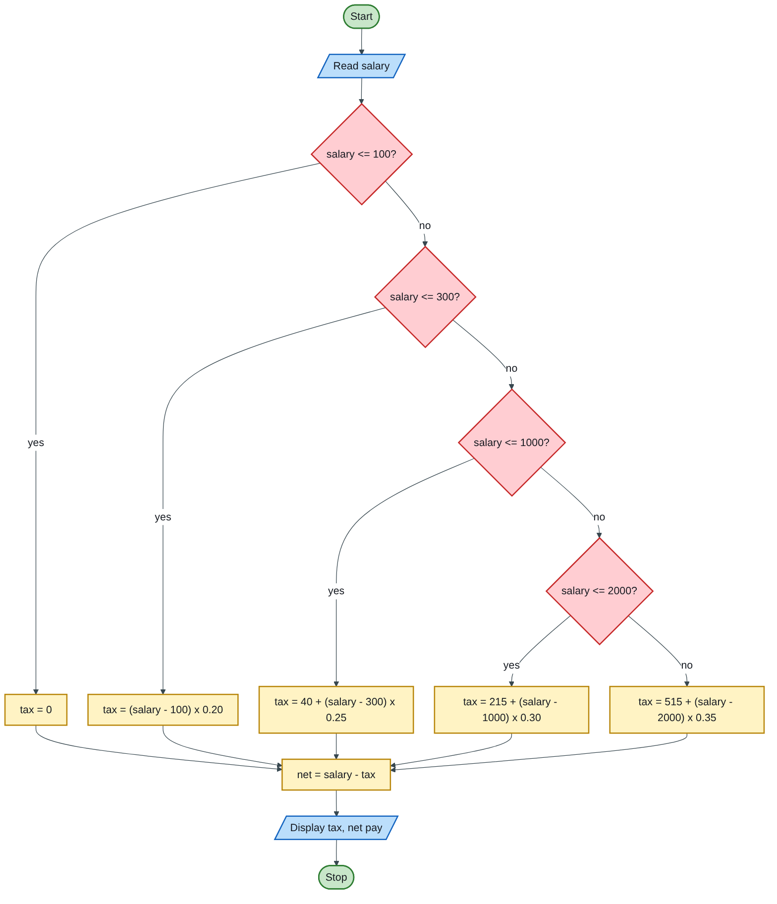
Figure 2.4 — Flowchart
Code (H-D-I-P-O-R):
/* H: PAYE tax using progressive bands 0%, 20%, 25%, 30%, 35% */
#include <stdio.h>
int main(void)
{
double salary, tax, net; /* D */
printf("Enter monthly salary ($): "); /* I */
scanf("%lf", &salary);
if (salary < 0) {
printf("Invalid salary\n");
return 1;
}
if (salary <= 100) /* P */
tax = 0.0;
else if (salary <= 300)
tax = (salary - 100) * 0.20;
else if (salary <= 1000)
tax = 40 + (salary - 300) * 0.25;
else if (salary <= 2000)
tax = 215 + (salary - 1000) * 0.30;
else
tax = 515 + (salary - 2000) * 0.35;
net = salary - tax;
printf("Salary : $%9.2f\n", salary); /* O */
printf("PAYE tax : $%9.2f\n", tax);
printf("Net pay : $%9.2f\n", net);
return 0; /* R */
}
Test table (one salary per band):
Salary | Working | PAYE
$80 | first band | $0.00
$250 | 150 × 0.20 | $30.00
$800 | 40 + 500 × 0.25 | $165.00
$1500 | 215 + 500 × 0.30 | $365.00
$3000 | 515 + 1000 × 0.35 | $865.00
If your lecturer means a flat rate (the whole salary taxed at its bracket’s rate), replace the ladder with rates only, e.g. else if (salary <= 2000) tax = salary * 0.30;. Then $1500 gives $450. Write one line saying which reading you used.
Marking guide [15]: declarations and input with prompt [3]; validation [1]; correct band ladder with five branches [6]; constants for the lower bands correct [2]; output of tax (and net pay) [2]; layout and comments [1].
Engineering lens: this “banded” calculation has the same shape as Book 1’s water increasing block tariff. Once you can write one, you can write any piecewise calculation: tariffs, tax, or design tables that change value at set limits.
Examiner’s tip: test the boundary values ($100, $300, $1000, $2000). A ladder written with < instead of <= puts the boundary salary in the wrong band.

Index | Guide | Glance | Q1 | Q2 | Q3 | Q4 | Q5 | Refs | Links

Question 5 [25]

5(a) IaaS and PaaS, with examples [4 each = 8]
Like you’re 3 (the pizza story): IaaS is renting a kitchen with an oven: you bring the dough and toppings and do the cooking. PaaS is a take-and-bake pizza: the base is made for you, you only add your toppings and bake. (SaaS would be ordering a ready pizza.)
Model | Definition [2] | Example [1] | Typical use [1]
IaaS — Infrastructure as a Service | The provider supplies basic computing resources (processing, storage, networks) as virtual machines; the customer installs and manages the operating system, software and data, but not the physical hardware (STD-1). | Amazon EC2, Microsoft Azure Virtual Machines, Google Compute Engine | Hosting a utility’s billing server without buying hardware; scaling up at month-end
PaaS — Platform as a Service | The provider supplies a ready platform (operating system, programming languages, database, tools) on which the customer builds and runs its own applications; the customer controls only the application and its data (STD-1). | Google App Engine, Microsoft Azure App Service, Heroku | Developers building and deploying a web app without managing servers
Who manages what:
Layer | On-premises | IaaS | PaaS | SaaS
Application and data | You | You | You | Provider
Operating system and runtime | You | You | Provider | Provider
Servers, storage, network | You | Provider | Provider | Provider

5(b) Five functions of an operating system [5]
Any five, 1 mark each: process management (scheduling programs on the CPU); memory management (allocating RAM); file management (organising and protecting files); device / I/O management (drivers for printers, disks, keyboards); security (user accounts, passwords, permissions); user interface (GUI or command line); error handling and logging.

5(c) Program: recursive Fibonacci series [12]
Like you’re 3: every new number is the last two numbers added together: 0, 1, 1, 2, 3, 5, 8… The function keeps asking two smaller copies of itself until it reaches 0 and 1, which it already knows.
Rule: fib(0) = 0; fib(1) = 1; fib(n) = fib(n − 1) + fib(n − 2).
Structure chart (how the program is built from modules):
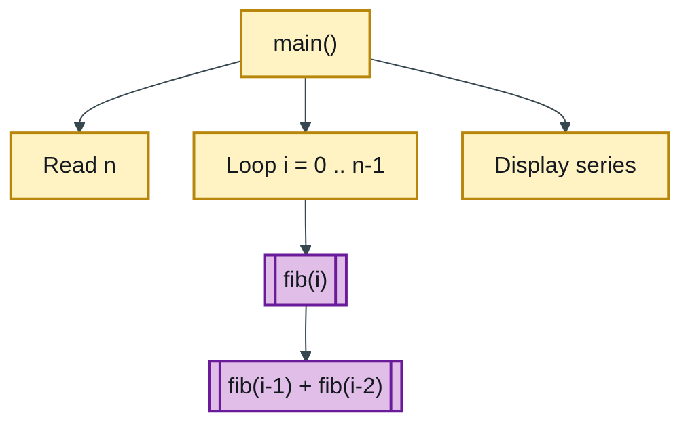
Figure 2.5 — Structure chart
Flowchart of main:
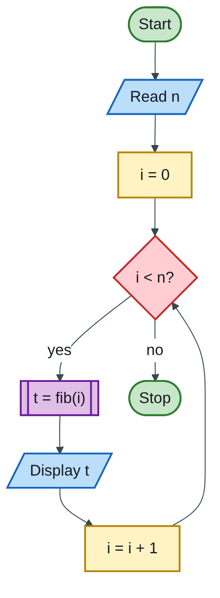
Figure 2.6 — Flowchart
Code (H-D-I-P-O-R):
/* H: Fibonacci series using a recursive function */
#include <stdio.h>
long fib(int n)
{
if (n == 0) return 0; /* base case */
if (n == 1) return 1; /* base case */
return fib(n - 1) + fib(n - 2); /* recursive case */
}
int main(void)
{
int n, i; /* D */
printf("Number of terms: "); /* I */
scanf("%d", &n);
if (n < 1) {
printf("Enter a positive number\n");
return 1;
}
printf("Fibonacci series:"); /* P + O */
for (i = 0; i < n; i++)
printf(" %ld", fib(i));
printf("\n");
return 0; /* R */
}
Test: n = 8 prints 0 1 1 2 3 5 8 13.
Marking guide [12]: header and function definition [2]; both base cases [2]; recursive return [3]; reading and validating n [2]; loop calling fib(i) and printing [2]; output layout [1].
Why it gets slow (one line for an extra mark): the naive recursive version recomputes the same values again and again and needs exponential time; MIT’s algorithms course fixes this by storing each answer once (memoization), giving about n steps (MIT-2).
Examiner’s tip: the paper says “calculate the Fibonacci series”, so print the series in a loop, not just one term.

Index | Guide | Glance | Q1 | Q2 | Q3 | Q4 | Q5 | Refs | Links

Sources for this book
- [STD-1] NIST SP 800-145 — IaaS, PaaS, cloud storage (3c, 5a).
- [RES-1] Bakasa & Pekane, arXiv:2108.09757 — security and data sovereignty in cloud selection (3c).
- [MIT-4] Wang et al., MIT CSAIL — run-time and undefined-behaviour errors (3a).
- [MIT-2] MIT 6.006 Lecture 19 — recursive vs memoized Fibonacci (5c).
- [UCLA-1] UCLA Samueli — first ARPANET message, 1969 (4a).
- Textbook knowledge (tier 4): viruses, CPU components, topologies, OS functions.

Index | Guide | Glance | Q1 | Q2 | Q3 | Q4 | Q5 | Refs | Links

Source register
The full register for the solution-book set. Sources marked ✓ are cited in this book; the rest (MIT, UCLA and Wits material used across the set) are further reading on the same topics.
Key | Source | Institution | Used for | In this book
NUST-1 | SCS 1101 course outline (uploaded) | NUST | Syllabus, assessment, C as the course language | ✓
MIT-1 | 6.087 Practical Programming in C | MIT | C syntax, pointers, structs, files, coding style | Further reading
MIT-2 | 6.006 Lecture 19: Dynamic Programming I (Fibonacci) | MIT | Why naive recursive Fibonacci is slow; memoization | ✓
MIT-3 | Whirlwind Computer, 1944–59 (IEEE Milestone) | MIT | Magnetic-core memory, real-time computing | Further reading
MIT-4 | Wang et al., Undefined Behavior: What Happened to My Code? | MIT CSAIL | Run-time and undefined-behaviour errors | ✓
UCLA-1 | First internet message, 29 Oct 1969 | UCLA Samueli | History of networks and the internet | ✓
UCLA-2 | Birthplace of the Internet (IEEE Milestone) | UCLA | ARPANET, packet switching, first node | Further reading
UCLA-3 | CS 31 Introduction to Computer Science I, syllabus | UCLA | Intro-programming scope; portability across compilers | Further reading
WITS-1 | Sithole (Wits) & Ruhode, Cloud Computing Adoption: Opportunities and Challenges for SMMEs in South Africa, arXiv:2108.10079 | Wits | Cloud benefits and barriers in Southern Africa | Further reading
WITS-2 | Leadership and the adoption of cloud computing for enterprises in Johannesburg (2022) | Wits | Drivers and barriers of cloud adoption | Further reading
STD-1 | NIST SP 800-145, The NIST Definition of Cloud Computing | NIST | SaaS, PaaS, IaaS; 5 characteristics; 4 deployment models | ✓
RES-1 | Bakasa & Pekane, Decision Criteria for Cloud Adoption by Large Enterprises in South Africa, arXiv:2108.09757 | UCT | Security and data sovereignty as selection criteria | ✓
RES-2 | Fu et al., Error Log Analysis in C Programming Language Courses (ICCE 2015) | Kyushu University | The errors novice C students actually make | Further reading

