
NATIONAL UNIVERSITY OF SCIENCE AND TECHNOLOGY
Faculty of Applied Sciences · Department of Computer Science

Solution Book 6
SCP 1101, August 2004 Supplementary
SCS 1101 Introduction to Computer Science and Programming
Past-paper solutions with marks allocated, algorithms, textbook flowcharts, exam-ready code and a civil & water engineering lens
Supplementary paper · 5 in total, at least 2 per section · page 1 (Section A) supplied
Book 6 of 8 · Prepared October 2026

Index | Guide | Glance | Q1 | Q2 | Q3 | Refs | Links

Index — tap a tab or a line to jump
Every chapter starts with the coloured tab bar below; tap any tab to jump straight to that question. The page footer has a link back to this index. In Word, the Navigation Pane shows the same chapters.
Guide How to use this book
Glance At a glance
Q1 Question 1 [20]
▸ Five printing devices: operation, impact or non-impact, quality and speed [4 each]
Q2 Question 2 [20]
▸ 2(i) Explain these terms [2 each = 10]
▸ 2(ii) Operating system: definition and five functions [10]
Q3 Question 3 [20]
▸ 3(i) Advantages of high-level languages over low-level languages [5]
▸ 3(ii) Compare first- and fourth-generation computers [15]
Refs Sources for this book
Links Source register

Index | Guide | Glance | Q1 | Q2 | Q3 | Refs | Links

How to use this book
This book is one of eight stand-alone solution books for NUST SCS 1101 past papers. It solves SCP 1101, August 2004 Supplementary question by question, with the marks the examiner allocates shown in square brackets, e.g. [2].

The six-block answer template
Every answer in this book (and in all eight books of the set) is built from the same six blocks, in the same order. Theory answers use blocks 1, 2, 5 and 6; programming answers use all six.
- Like you’re 3 — one or two sentences with a toy, a bath or a water tap.
- Model answer — the exam wording, with the mark for each point in brackets, e.g. [2]. Write it like this and you collect every mark.
- Algorithm + code — numbered pseudocode first, then C code that follows the H-D-I-P-O-R recipe.
- Flowchart or structure chart — textbook (ANSI) symbols. Programs built from functions also get a structure (hierarchy) chart.
- Engineering lens — the same idea in a civil and water engineering setting, using the profession’s vocabulary.
- Examiner’s tip — where students usually lose marks.
The H-D-I-P-O-R code recipe — “Happy Ducks In Ponds Only Relax”. Every exam program is these six steps, in this order:
/* H - Header: what the program does, and the libraries */
#include <stdio.h>
int main(void)
{
/* D - Declare: every variable, with a sensible type and a starting value */
/* I - Input: printf a prompt, then scanf with & */
/* P - Process: the if-ladder, loop or formula */
/* O - Output: printf the result with units and decimals */
/* R - Return: */ return 0;
}
The recipe is worth marks by itself: examiners give separate marks for headers, declarations, input, processing and output. A half-finished program laid out this way still scores; a clever one-liner without structure often does not.
Algorithm style used in every book:
Step 1: Start
Step 2: Read <inputs>
Step 3: <process, one action per step>
Step 4: Display <outputs>
Step 5: Stop
Flowchart symbols (ANSI):
Symbol | Shape | Use | Colour in this book
Terminator | Rounded box (stadium) | Start / Stop | Green
Input/Output | Parallelogram | Read or display | Blue
Process | Rectangle | Calculation or assignment | Amber
Decision | Diamond | Yes/no test, two exits | Red
Predefined process | Rectangle with double sides | Call to a function | Purple
Flow line | Arrow | Order of steps | Dark grey arrow
The smallest possible program, drawn with these symbols:
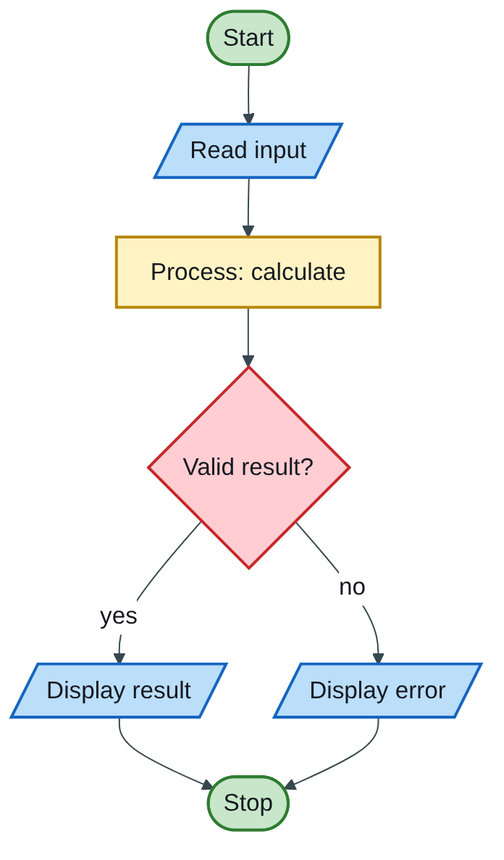
Figure 6.1 — Flowchart
The engineering lens. Programming questions get a civil and water engineering version where it fits, for example:
- tariff ladders become increasing block tariffs for water;
- array statistics become rainfall or concrete cube strength analysis;
- geometry programs become cross-section, wetted perimeter and hydraulic radius calculations.
Write the exam version in the exam; the engineering version is for understanding and for your later modules.

How the solutions were researched
Every fact a solution relies on is traced to a source in one of four tiers; each source has a short key (e.g. [MIT-2]) so answers can cite it without long links.
- Tier 1 — the course itself. The SCS 1101 outline and the past papers decide what to answer and how marks are split.
- Tier 2 — university teaching material. MIT OpenCourseWare and UCLA course pages for programming and algorithms; university histories for milestones.
- Tier 3 — standards and research. NIST for cloud definitions; peer-reviewed and arXiv papers, including Wits research on cloud adoption in South Africa.
- Tier 4 — standard textbook knowledge. Definitions every textbook agrees on (OS functions, topologies, printers) are written from the textbooks your outline lists, without a web citation.
A claim is only cited when a source was actually opened; anything from tier 4 stays general and uncited.

Index | Guide | Glance | Q1 | Q2 | Q3 | Refs | Links

At a glance
SCP 1101 Introduction to Computer Science, August 2004 supplementary. 3 hours, 20 marks per question; answer 5 questions in total, at least 2 from each section. Only page 1 (Section A, Q1–Q3) was provided, so this book solves those three; Section B (programming) is missing.
All three questions are theory, so marks come from complete, structured comparisons: use tables.
Question | What it tests | Marks
Q1 | Five printers: operation, impact or not, quality, speed | 20
Q2 | System software, EPROM, primary memory, register, virtual memory; OS functions | 10 + 10
Q3 | Advantages of high-level languages; 1st vs 4th generation | 5 + 15

Index | Guide | Glance | Q1 | Q2 | Q3 | Refs | Links

Question 1 [20]

Five printing devices: operation, impact or non-impact, quality and speed [4 each]
Like you’re 3: impact printers hit the paper through an inky ribbon, like a stamp; non-impact printers spray, melt or draw without hitting.
For each printer: how it works [2], impact or non-impact [1], quality and speed [1].
Printer | How it works | Impact? | Quality | Speed (approximate)
(a) Daisy wheel | A plastic or metal wheel has a fully formed character on each “petal”; the wheel spins to the right letter and a hammer strikes it against the ribbon and paper. | Impact | High (“letter quality”) text, but no graphics | Slow: tens of characters per second
(b) Dot matrix | A print head with 9 or 24 pins moves across the page; selected pins strike the ribbon, forming characters from dots. | Impact | Low to medium (draft or near-letter quality); can do carbon copies | Medium: hundreds of characters per second
(c) Inkjet | Tiny nozzles spray droplets of ink onto the paper, using heat (bubble jet) or piezo-electric crystals. | Non-impact | Good, including colour photos | Moderate: a few to about 20 pages per minute
(d) Laser | A laser beam draws the page as an electrostatic image on a drum; toner powder sticks to it, transfers to the paper and is fused by heat. | Non-impact | Very high, sharp text | Fast: a whole page at a time, tens of pages per minute
(e) Plotter | Pens (or inkjet heads) are moved over large paper under computer control to draw continuous lines. | Non-impact (pen or inkjet) | Very accurate line drawings on A1/A0 sheets | Slow per sheet, but precise
Engineering lens: civil engineers still print A1 and A0 construction drawings on large-format plotters (now mostly inkjet), while site offices keep a laser printer for reports and certificates.

Index | Guide | Glance | Q1 | Q2 | Q3 | Refs | Links

Question 2 [20]

2(i) Explain these terms [2 each = 10]
Like you’re 3: system software is the school’s caretaker; EPROM is a notebook you can wipe only with a special sun lamp; primary memory is your desk; a register is the scrap of paper in your hand; virtual memory is borrowing floor space when the desk is full.
Term | Explanation [1 + 1]
System software | Programs that run and manage the computer itself and support application software. Examples: operating systems, device drivers, utilities, compilers.
EPROM | Erasable Programmable Read-Only Memory: non-volatile memory that can be erased by ultraviolet light through a window on the chip and then reprogrammed. Used for firmware during development.
Primary memory | The main memory the CPU accesses directly (RAM, ROM and cache), holding the programs and data in use; fast but limited in size.
Register | A very small, very fast storage location inside the CPU that holds the current instruction, data or address, e.g. the program counter and accumulator.
Virtual memory | A technique where the OS uses part of the hard disk as an extension of RAM, swapping pages in and out, so programs larger than physical RAM can run (more slowly).

2(ii) Operating system: definition and five functions [10]
Definition [2]: the operating system is the system software that manages the computer’s hardware and software resources, provides services to programs, and acts as the interface between the user and the hardware. Examples: Windows, Linux.
Five functions [8]: process management (scheduling programs on the CPU); memory management (allocating RAM, virtual memory); file management (organising and protecting files); device management (drivers, spooling to printers); security (log-ins, permissions); user interface (GUI or command line). Name and explain any five.

Index | Guide | Glance | Q1 | Q2 | Q3 | Refs | Links

Question 3 [20]

3(i) Advantages of high-level languages over low-level languages [5]
Like you’re 3: a high-level language lets you talk to the computer in near-English (“add the tax to the price”), instead of in its own baby-talk of 0s and 1s.
Any five, 1 each:
- Easier to learn, read and write — English-like words and maths symbols (if, while, total = a + b).
- Faster to develop — one statement replaces many machine instructions.
- Portable — the same source code can be compiled for different CPUs; machine code is tied to one CPU family.
- Easier to debug and maintain — meaningful names, comments and structure; compilers report errors with line numbers.
- Problem-oriented — the programmer thinks about the engineering problem, not registers and memory addresses.
- Rich libraries — ready-made functions for maths, files and graphics.

3(ii) Compare first- and fourth-generation computers [15]
Like you’re 3: a first-generation computer was a room-sized giant made of hot glass tubes; a fourth-generation computer is a laptop or phone built around one tiny chip.
3 marks per heading: one fact for each generation plus the comparison.
Heading | 1st generation (about 1940–1956) | 4th generation (1971 onwards)
(a) Storage devices | Magnetic drums, mercury delay lines, early magnetic-core memory; punched cards and paper tape for bulk data | Semiconductor RAM in gigabytes; hard disks, SSDs, flash drives, optical discs, cloud storage
(b) Hardware components | Thousands of vacuum tubes; filled whole rooms; huge power use and heat | Microprocessor: VLSI chips with millions to billions of transistors; desktop, laptop and handheld size
(c) I/O devices | Punched-card readers, paper tape, switches, teleprinter printouts | Keyboard, mouse, touchscreen, scanner, high-resolution monitor, laser and inkjet printers
(d) Programming languages | Machine language (binary) and early assembly | High-level languages (C, C++, Java, Python), 4GLs such as SQL, and GUIs
(e) Efficiency | Slow (thousands of operations per second), unreliable (tubes burned out), very expensive | Billions of operations per second, very reliable, cheap and energy-efficient
A good first-generation example is MIT’s Whirlwind, a vacuum-tube machine that introduced reliable random-access magnetic-core memory (MIT-3); a typical fourth-generation example is any PC built around an Intel or AMD microprocessor.
Examiner’s tip: keep each comparison on the same line for both generations (a table does this); examiners can then tick the comparison, not just the facts.

Index | Guide | Glance | Q1 | Q2 | Q3 | Refs | Links

Sources for this book
- [MIT-3] Whirlwind Computer, 1944–59 (IEEE Milestone) — first-generation example (Q3).
- [NUST-1] SCS 1101 course outline.
- Textbook knowledge (tier 4): printer technology, memory types, virtual memory, OS functions, language levels and computer generations. Printer speeds are approximate ranges.

Index | Guide | Glance | Q1 | Q2 | Q3 | Refs | Links

Source register
The full register for the solution-book set. Sources marked ✓ are cited in this book; the rest (MIT, UCLA and Wits material used across the set) are further reading on the same topics.
Key | Source | Institution | Used for | In this book
NUST-1 | SCS 1101 course outline (uploaded) | NUST | Syllabus, assessment, C as the course language | ✓
MIT-1 | 6.087 Practical Programming in C | MIT | C syntax, pointers, structs, files, coding style | Further reading
MIT-2 | 6.006 Lecture 19: Dynamic Programming I (Fibonacci) | MIT | Why naive recursive Fibonacci is slow; memoization | Further reading
MIT-3 | Whirlwind Computer, 1944–59 (IEEE Milestone) | MIT | Magnetic-core memory, real-time computing | ✓
MIT-4 | Wang et al., Undefined Behavior: What Happened to My Code? | MIT CSAIL | Run-time and undefined-behaviour errors | Further reading
UCLA-1 | First internet message, 29 Oct 1969 | UCLA Samueli | History of networks and the internet | Further reading
UCLA-2 | Birthplace of the Internet (IEEE Milestone) | UCLA | ARPANET, packet switching, first node | Further reading
UCLA-3 | CS 31 Introduction to Computer Science I, syllabus | UCLA | Intro-programming scope; portability across compilers | Further reading
WITS-1 | Sithole (Wits) & Ruhode, Cloud Computing Adoption: Opportunities and Challenges for SMMEs in South Africa, arXiv:2108.10079 | Wits | Cloud benefits and barriers in Southern Africa | Further reading
WITS-2 | Leadership and the adoption of cloud computing for enterprises in Johannesburg (2022) | Wits | Drivers and barriers of cloud adoption | Further reading
STD-1 | NIST SP 800-145, The NIST Definition of Cloud Computing | NIST | SaaS, PaaS, IaaS; 5 characteristics; 4 deployment models | Further reading
RES-1 | Bakasa & Pekane, Decision Criteria for Cloud Adoption by Large Enterprises in South Africa, arXiv:2108.09757 | UCT | Security and data sovereignty as selection criteria | Further reading
RES-2 | Fu et al., Error Log Analysis in C Programming Language Courses (ICCE 2015) | Kyushu University | The errors novice C students actually make | Further reading

