
NATIONAL UNIVERSITY OF SCIENCE AND TECHNOLOGY
Faculty of Applied Sciences · Department of Computer Science

Solution Book 8
SCS 2107 Structured Programming, January 2013 (C++)
SCS 1101 Introduction to Computer Science and Programming
Past-paper solutions with marks allocated, algorithms, textbook flowcharts, exam-ready code and a civil & water engineering lens
Second-year Structured Programming paper, answered in C++ · any 4 of 6 · 25 marks each
Book 8 of 8 · Prepared October 2026

Index | Guide | Glance | Q1 | Q2 | Q3 | Q4 | Q5 | Q6 | Refs | Links

Index — tap a tab or a line to jump
Every chapter starts with the coloured tab bar below; tap any tab to jump straight to that question. The page footer has a link back to this index. In Word, the Navigation Pane shows the same chapters.
Guide How to use this book
Glance At a glance
Q1 Question 1 [25]
▸ 1(a) The structured programming constructs, with diagrams [12]
▸ 1(b) What is a structured walk-through? [3]
▸ 1(c) Advantages and disadvantages of structured walk-throughs [10]
Q2 Question 2 [25]
▸ 2(a)(i) What is an infinite loop, and how can it be useful? [5]
▸ 2(a)(ii) What is wrong with this loop? [5]
▸ 2(b) Convert the for loop into a while loop [7]
▸ 2(c) Simple calculator with a switch statement [8]
Q3 Question 3 [25]
▸ 3(a) Function print_pyramid(height) [14]
▸ 3(b) Recursive Fibonacci function [11]
Q4 Question 4 [25]
▸ 4(a) Explain [9]
▸ 4(b) Number of the last element of int test[5]; [2]
▸ 4(c) Output of the code in Figure 3 [5]
▸ 4(d) Function reverse(array, n) [9]
Q5 Question 5 [25]
▸ 5(a) Explain [3 each = 12]
▸ 5(b) Program: NUST mark sheet with a base class and a derived class [13]
Q6 Question 6 [25]
▸ Compare and contrast structured programming and object-oriented programming
Refs Sources for this book
Links Source register

Index | Guide | Glance | Q1 | Q2 | Q3 | Q4 | Q5 | Q6 | Refs | Links

How to use this book
This book is one of eight stand-alone solution books for NUST SCS 1101 past papers. It solves SCS 2107 Structured Programming, January 2013 (C++) question by question, with the marks the examiner allocates shown in square brackets, e.g. [2].

The six-block answer template
Every answer in this book (and in all eight books of the set) is built from the same six blocks, in the same order. Theory answers use blocks 1, 2, 5 and 6; programming answers use all six.
- Like you’re 3 — one or two sentences with a toy, a bath or a water tap.
- Model answer — the exam wording, with the mark for each point in brackets, e.g. [2]. Write it like this and you collect every mark.
- Algorithm + code — numbered pseudocode first, then C code that follows the H-D-I-P-O-R recipe.
- Flowchart or structure chart — textbook (ANSI) symbols. Programs built from functions also get a structure (hierarchy) chart.
- Engineering lens — the same idea in a civil and water engineering setting, using the profession’s vocabulary.
- Examiner’s tip — where students usually lose marks.
The H-D-I-P-O-R code recipe — “Happy Ducks In Ponds Only Relax”. Every exam program is these six steps, in this order:
/* H - Header: what the program does, and the libraries */
#include <stdio.h>
int main(void)
{
/* D - Declare: every variable, with a sensible type and a starting value */
/* I - Input: printf a prompt, then scanf with & */
/* P - Process: the if-ladder, loop or formula */
/* O - Output: printf the result with units and decimals */
/* R - Return: */ return 0;
}
The recipe is worth marks by itself: examiners give separate marks for headers, declarations, input, processing and output. A half-finished program laid out this way still scores; a clever one-liner without structure often does not.
Algorithm style used in every book:
Step 1: Start
Step 2: Read <inputs>
Step 3: <process, one action per step>
Step 4: Display <outputs>
Step 5: Stop
Flowchart symbols (ANSI):
Symbol | Shape | Use | Colour in this book
Terminator | Rounded box (stadium) | Start / Stop | Green
Input/Output | Parallelogram | Read or display | Blue
Process | Rectangle | Calculation or assignment | Amber
Decision | Diamond | Yes/no test, two exits | Red
Predefined process | Rectangle with double sides | Call to a function | Purple
Flow line | Arrow | Order of steps | Dark grey arrow
The smallest possible program, drawn with these symbols:
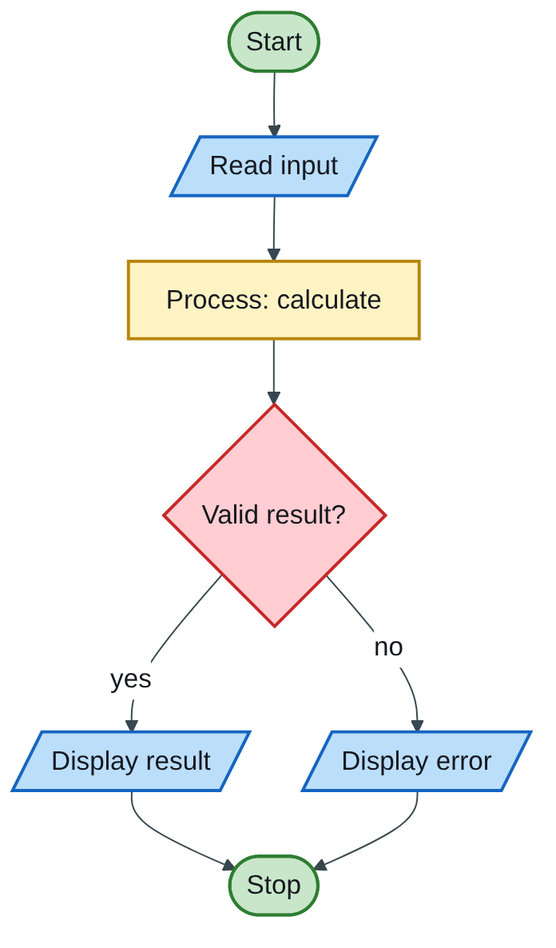
Figure 8.1 — Flowchart
The engineering lens. Programming questions get a civil and water engineering version where it fits, for example:
- tariff ladders become increasing block tariffs for water;
- array statistics become rainfall or concrete cube strength analysis;
- geometry programs become cross-section, wetted perimeter and hydraulic radius calculations.
Write the exam version in the exam; the engineering version is for understanding and for your later modules.

How the solutions were researched
Every fact a solution relies on is traced to a source in one of four tiers; each source has a short key (e.g. [MIT-2]) so answers can cite it without long links.
- Tier 1 — the course itself. The SCS 1101 outline and the past papers decide what to answer and how marks are split.
- Tier 2 — university teaching material. MIT OpenCourseWare and UCLA course pages for programming and algorithms; university histories for milestones.
- Tier 3 — standards and research. NIST for cloud definitions; peer-reviewed and arXiv papers, including Wits research on cloud adoption in South Africa.
- Tier 4 — standard textbook knowledge. Definitions every textbook agrees on (OS functions, topologies, printers) are written from the textbooks your outline lists, without a web citation.
A claim is only cited when a source was actually opened; anything from tier 4 stays general and uncited.

Index | Guide | Glance | Q1 | Q2 | Q3 | Q4 | Q5 | Q6 | Refs | Links

At a glance
SCS 2107 Structured Programming, January 2013. 3 hours, six questions, answer any four, 25 marks each, all code in C++. C++ is C plus classes: cin/cout replace scanf/printf, and the same H-D-I-P-O-R recipe applies.
Question | What it tests | Pick?
Q1 | Structured programming constructs with diagrams; structured walk-through | Yes, pure theory
Q2 | Infinite loops; loop bug; for → while; switch calculator | Yes, short code
Q3 | print_pyramid function; recursive Fibonacci | Yes
Q4 | Arrays explained; code output; reverse function | Yes
Q5 | Constructors, inline, virtual, inheritance; mark-sheet classes | If OOP is strong
Q6 | Structured programming vs OOP (25-mark essay) | Backup
C ↔ C++ quick map: #include <iostream> + using namespace std;; cout << x; prints; cin >> x; reads (no &); endl is a new line; string holds text; class bundles data and functions.

Index | Guide | Glance | Q1 | Q2 | Q3 | Q4 | Q5 | Q6 | Refs | Links

Question 1 [25]

1(a) The structured programming constructs, with diagrams [12]
Like you’re 3: every program is made from three Lego shapes only: straight road (sequence), fork in the road (selection) and roundabout (iteration).
For each construct: diagram [2], explanation [1], C++ snippet [1].
1. Sequence — statements execute one after another in the order written.
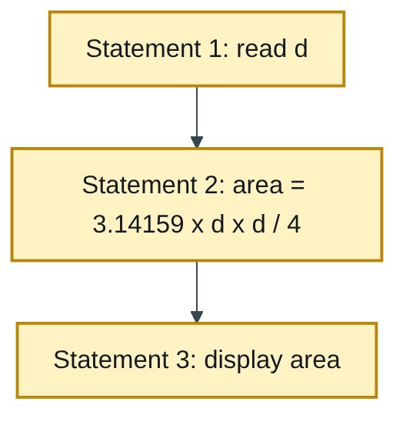
Figure 8.2 — Flowchart
cin >> d;
area = 3.14159 * d * d / 4;
cout << "Area = " << area << endl;
2. Selection (decision) — a condition decides which of two or more paths is taken (if, if-else, switch).
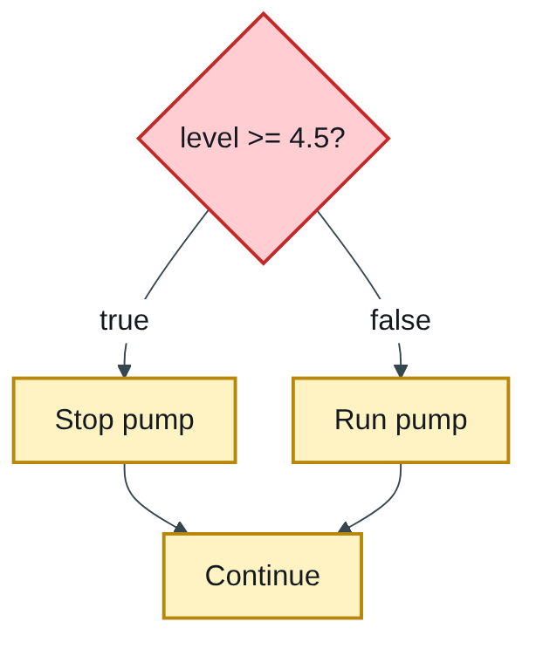
Figure 8.3 — Flowchart
if (level >= 4.5) cout << "Stop pump";
else cout << "Run pump";
3. Iteration (repetition) — a block repeats while a condition is true (while, do-while, for).
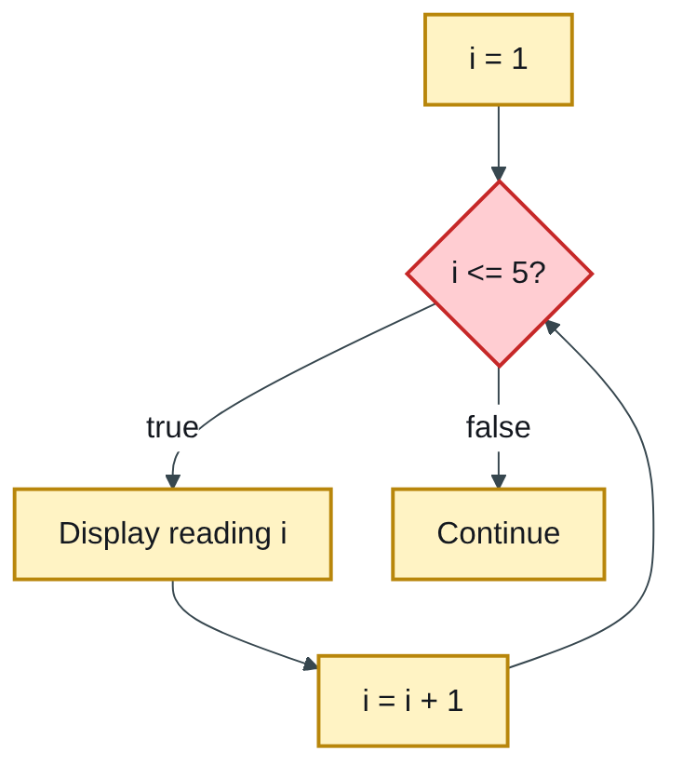
Figure 8.4 — Flowchart
for (int i = 1; i <= 5; i++)
cout << "Reading " << i << endl;
Each construct has one entry and one exit, so constructs can be nested inside each other without goto [this sentence earns the remaining marks for understanding].

1(b) What is a structured walk-through? [3]
Like you’re 3: before the school play, you act it out for your friends so they can spot mistakes before the real show.
A structured walk-through is a planned peer-review meeting in which the programmer leads a small team (reviewers, a moderator and a recorder) step by step through the design or code [1], explaining its logic so that errors, omissions and departures from standards are found early, before testing [1]. Problems are recorded for the author to fix; the code is not corrected in the meeting itself [1].

1(c) Advantages and disadvantages of structured walk-throughs [10]
Advantages (any five, 1 each) | Disadvantages (any five, 1 each)
Errors are found early, when they are cheapest to fix | Time-consuming for several people
Improves program quality and readability | Needs preparation: copies, agenda, reviewers’ study time
Enforces coding standards across the team | Can feel like personal criticism and cause tension
Spreads knowledge: others understand the code | Quality depends on the reviewers’ skill and attention
Trains junior programmers | May miss run-time and performance errors that only testing reveals
Shared ownership: the team, not one person, is responsible | Scheduling meetings delays the project
Engineering lens: engineering offices do the same thing as a design review: a checking engineer walks through calculations and drawings before they are issued for construction, because a mistake caught on paper costs far less than one found on site.

Index | Guide | Glance | Q1 | Q2 | Q3 | Q4 | Q5 | Q6 | Refs | Links

Question 2 [25]

2(a)(i) What is an infinite loop, and how can it be useful? [5]
Like you’re 3: a merry-go-round that never stops on its own; sometimes that is exactly what you want, as long as there is an off switch.
An infinite loop is a loop whose condition never becomes false, so it runs forever unless stopped from inside (e.g. break, return) or from outside [2]. Useful cases [3]:
- Servers and operating systems — wait forever for requests or events.
- Embedded and control systems — a pump controller or PLC reads sensors and updates outputs in an endless scan loop.
- Menus and games — repeat until the user chooses “exit”, which triggers break.
while (true) { // deliberate infinite loop
int choice = showMenu();
if (choice == 4) break; // the planned way out
handle(choice);
}

2(a)(ii) What is wrong with this loop? [5]
while (n <= 100)
sum += n*n;
Like you’re 3: the robot keeps adding blocks but never takes a step forward, so it stands in the same spot forever.
- n never changes inside the loop, so n <= 100 stays true: an infinite loop [2].
- Without braces, only the one statement belongs to the loop, so an increment added on the next line would sit outside it [1].
- sum and n must be initialised before the loop, or the result is garbage [1].
Corrected [1]:
int n = 1, sum = 0;
while (n <= 100) {
sum += n * n;
n++; // move towards the exit condition
}

2(b) Convert the for loop into a while loop [7]
for (int i = 1; i <= n; i++)
cout << i*i << " ";
Like you’re 3: a for loop is a lunchbox with three compartments (start; test; step). A while loop is the same food unpacked: start before, test at the top, step at the bottom.
int i = 1; // initialise (before the loop) [2]
while (i <= n) { // test (in the brackets) [2]
cout << i*i << " "; // body [1]
i++; // update (end of the body) [2]
}
For n = 5 both print 1 4 9 16 25.

2(c) Simple calculator with a switch statement [8]
Like you’re 3: you give the robot two numbers and a sign; it looks up the sign in its list and does that sum.
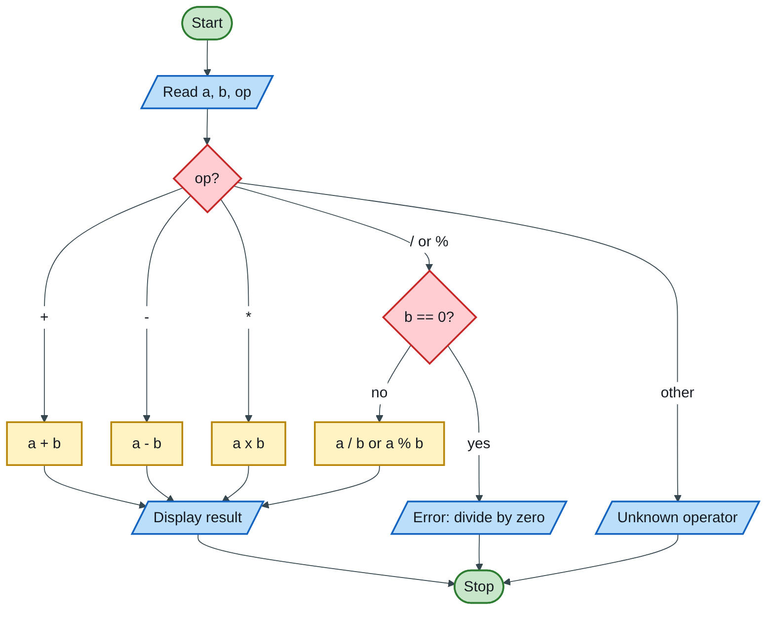
Figure 8.5 — Flowchart
// H: simple calculator - two integers and an operator, using switch
#include <iostream>
using namespace std;
int main()
{
int a, b; // D
char op;
cout << "Enter two integers and an operator (+ - * / %): "; // I
cin >> a >> b >> op;
switch (op) { // P + O
case '+': cout << a << " + " << b << " = " << a + b << endl; break;
case '-': cout << a << " - " << b << " = " << a - b << endl; break;
case '*': cout << a << " * " << b << " = " << a * b << endl; break;
case '/':
if (b != 0) cout << a << " / " << b << " = " << a / b << endl;
else cout << "Error: division by zero" << endl;
break;
case '%':
if (b != 0) cout << a << " % " << b << " = " << a % b << endl;
else cout << "Error: division by zero" << endl;
break;
default:
cout << "Unknown operator: " << op << endl;
}
return 0; // R
}
Test: 17 5 / → 17 / 5 = 3 (integer quotient); 17 5 % → 17 % 5 = 2; 4 0 / → error message.
Marking guide [8]: reading two integers and a character [2]; switch with all five cases and breaks [4]; division-by-zero check [1]; default case [1].

Index | Guide | Glance | Q1 | Q2 | Q3 | Q4 | Q5 | Q6 | Refs | Links

Question 3 [25]

3(a) Function print_pyramid(height) [14]
Like you’re 3: each row of the pyramid has 2 more stars than the row above. To make it look like a pyramid instead of a staircase, push each row in with some spaces: more spaces at the top, none at the bottom.
Pattern for height 6 (Figure 2.0): row r has 2r stars (2, 4, 6, …, 12) and height − r leading spaces.
Row r | Spaces (6 − r) | Stars (2r)
1 | 5 | 2
2 | 4 | 4
3 | 3 | 6
4 | 2 | 8
5 | 1 | 10
6 | 0 | 12
Flowchart:
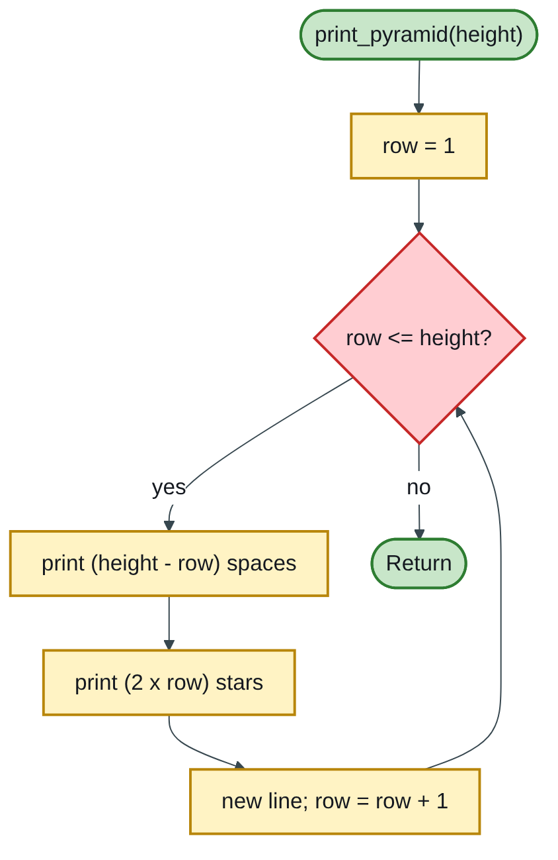
Figure 8.6 — Flowchart
Code:
// H: print a pyramid of '*' of the given height (row r has 2r stars)
#include <iostream>
using namespace std;
void print_pyramid(int height)
{
for (int row = 1; row <= height; row++) {
for (int s = 0; s < height - row; s++) // leading spaces centre the row
cout << ' ';
for (int k = 0; k < 2 * row; k++) // 2, 4, 6 ... stars
cout << '*';
cout << endl;
}
}
int main()
{
int h;
cout << "Height of pyramid: ";
cin >> h;
print_pyramid(h);
return 0;
}
Output for height 6:
**
****
******
********
**********
************
If the printed figure is meant to be left-aligned, simply delete the spaces loop.
Marking guide [14]: function header with an int height parameter and void return [2]; outer row loop [3]; spaces loop [3]; stars loop using 2 × row [4]; new line after each row [1]; call from main [1].

3(b) Recursive Fibonacci function [11]
Like you’re 3: each number is the two numbers before it added together: 0, 1, 1, 2, 3, 5, 8… The function asks two smaller copies of itself, until it reaches 0 or 1, which it already knows.
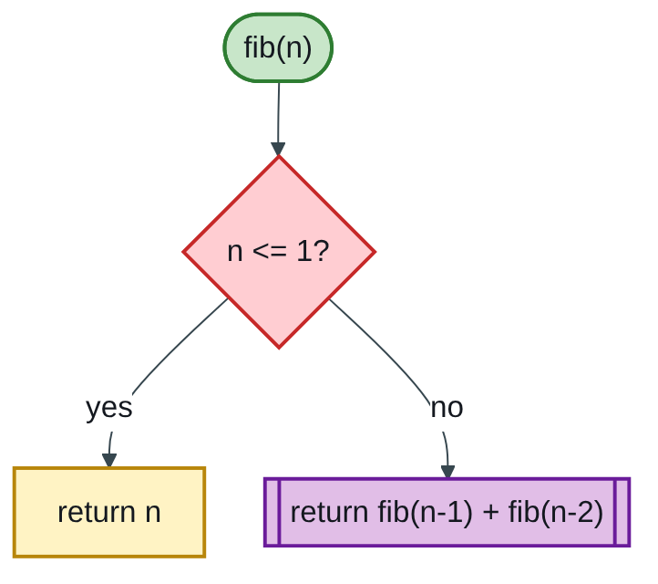
Figure 8.7 — Flowchart
// H: Fibonacci series using a recursive function
#include <iostream>
using namespace std;
long fib(int n)
{
if (n <= 1) // base cases: fib(0) = 0, fib(1) = 1
return n;
return fib(n - 1) + fib(n - 2); // recursive case
}
int main()
{
int terms;
cout << "How many terms? ";
cin >> terms;
for (int i = 0; i < terms; i++)
cout << fib(i) << " ";
cout << endl;
return 0;
}
Test: 10 terms → 0 1 1 2 3 5 8 13 21 34.
Marking guide [11]: function header [2]; base case [3]; recursive case [3]; main reading the number of terms and printing the series [2]; output [1].
One line for extra credit: naive recursion recomputes the same values and grows exponentially; storing each result once (memoization) makes it linear (MIT-2).

Index | Guide | Glance | Q1 | Q2 | Q3 | Q4 | Q5 | Q6 | Refs | Links

Question 4 [25]

4(a) Explain [9]
Like you’re 3: a simple variable is one egg cup; an array is an egg tray; a 2-D array is a tray with rows and columns; a 3-D array is a stack of trays.
(i) Array vs simple variable [3]: a simple variable holds one value under one name [1]; an array holds many values of the same type under one name, stored next to each other in memory and reached by an index starting at 0 [1]. Arrays let one loop process hundreds of values that would otherwise need hundreds of separate variables [1].
Declaration | Meaning | Elements
(ii) double a[5]; [2] | One-dimensional array of 5 doubles, a[0] to a[4] | 5
(iii) float b[3][5]; [2] | Two-dimensional array: 3 rows × 5 columns of floats, b[0][0] to b[2][4] | 15
(iv) int c[5][4][10]; [2] | Three-dimensional array: 5 × 4 × 10 ints, c[0][0][0] to c[4][3][9] | 200

4(b) Number of the last element of int test[5]; [2]
The last element is test[4]: indexes start at 0, so 5 elements are numbered 0 to 4 [2].

4(c) Output of the code in Figure 3 [5]
As printed, the first line reads include <iostream> without the #, so the program would not compile. Say so in one line [1], then give the output assuming #include <iostream> [4]:
Members of the array
Distance 1: 44.14
Distance 2: 720.52
Distance 3: 96.08
Distance 4: 468.78
Distance 5: 6.28
The loop runs i = 0 to 4 and prints i + 1, so the labels run 1 to 5 while the indexes run 0 to 4.

4(d) Function reverse(array, n) [9]
Like you’re 3: two children stand at the two ends of the row and swap their cards, then each takes one step inwards and swaps again, until they meet in the middle.
Step | i | j | Swap | Array afterwards
Start | — | — | — | 5.8, 2.6, 9.0, 3.4, 7.1
1 | 0 | 4 | 5.8 ↔ 7.1 | 7.1, 2.6, 9.0, 3.4, 5.8
2 | 1 | 3 | 2.6 ↔ 3.4 | 7.1, 3.4, 9.0, 2.6, 5.8
3 | 2 | 2 | stop (i is not < j) | 7.1, 3.4, 9.0, 2.6, 5.8
// reverses the first n values of a float array in place; returns nothing
void reverse(float a[], int n)
{
for (int i = 0, j = n - 1; i < j; i++, j--) {
float temp = a[i]; // three-step swap
a[i] = a[j];
a[j] = temp;
}
}
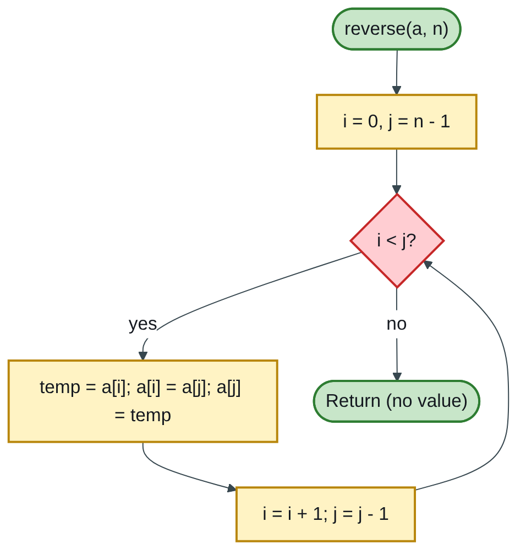
Figure 8.8 — Flowchart
The array is changed for the caller because C++ passes arrays by address.
Marking guide [9]: void function with an array and an int parameter [2]; loop moving i up and j down while i < j [4]; correct swap with a temporary variable [2]; no return value [1].
Engineering lens: surveyors reverse ordered lists all the time, e.g. turning a levelling run recorded from benchmark A to B into the B-to-A direction, or reversing chainages along a pipeline.

Index | Guide | Glance | Q1 | Q2 | Q3 | Q4 | Q5 | Q6 | Refs | Links

Question 5 [25]

5(a) Explain [3 each = 12]
Like you’re 3: a constructor is the factory that builds a toy; a non-public one means only the toy company may build it. An inline function is a tiny instruction copied straight into the story instead of saying “see page 50”. A virtual function is a button that does different things depending on which toy you press it on. Inheritance is a child toy getting its parent’s features.
(i) Non-public constructors — constructors declared private or protected [1]. A private constructor stops code outside the class from creating objects directly; objects are made only through a static member function, e.g. the Singleton pattern that allows exactly one object [1]. A protected constructor lets only derived classes build the object, so the base class is used purely as a parent [1].
class Logger {
private:
Logger() {} // nobody outside can call this
public:
static Logger& get() { static Logger one; return one; } // the only Logger
};
(ii) Inline function — the inline keyword asks the compiler to replace each call with the function’s body [1], removing call overhead for very small, frequently used functions [1]. Functions defined inside a class body are inline automatically; large functions should not be inline because they bloat the program [1].
inline double area(double d) { return 3.14159 * d * d / 4; }
(iii) Virtual functions — a member function declared virtual in a base class and overridden in derived classes [1]. When called through a base-class pointer or reference, the version for the actual object runs, decided at run time (dynamic binding): this is run-time polymorphism [1]. A pure virtual function (= 0) makes the class abstract [1].
class Section { public: virtual double area() const = 0; };
class Circle : public Section { double d; public: Circle(double x) : d(x) {}
double area() const override { return 3.14159 * d * d / 4; } };
// Section* s = new Circle(0.3); s->area(); calls Circle::area at run time
(iv) Types of inheritance [3]:
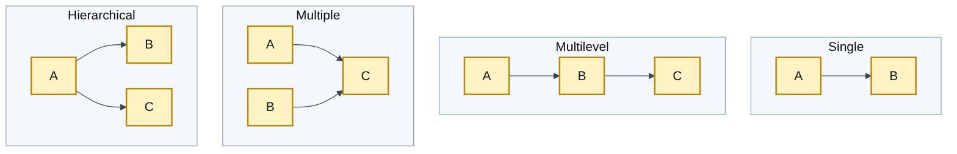
Figure 8.9 — Flowchart
Single (one parent, one child); multilevel (a chain A → B → C); multiple (one child, several parents); hierarchical (one parent, several children); hybrid (a mix). Access modes public, protected and private decide how inherited members can be used.

5(b) Program: NUST mark sheet with a base class and a derived class [13]
Like you’re 3: the parent card holds who the student is; the child card inherits that and adds which course they took and their marks.
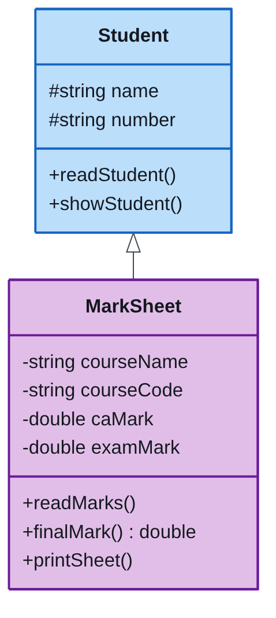
Figure 8.10 — Class diagram
// H: NUST examination mark sheet - base class Student, derived class MarkSheet
#include <iostream>
#include <string>
using namespace std;
class Student { // base class
protected:
string name, number;
public:
void readStudent() {
cout << "Student name: "; getline(cin, name);
cout << "Student number: "; getline(cin, number);
}
void showStudent() const {
cout << "Name : " << name << endl;
cout << "Number : " << number << endl;
}
};
class MarkSheet : public Student { // derived class
private:
string courseName, courseCode;
double caMark, examMark;
public:
void readMarks() {
cout << "Course name: "; getline(cin, courseName);
cout << "Course code: "; getline(cin, courseCode);
cout << "Continuous assessment mark (/100): "; cin >> caMark;
cout << "Exam mark (/100): "; cin >> examMark;
}
double finalMark() const { return 0.4 * caMark + 0.6 * examMark; }
void printSheet() const {
cout << "\n====== NUST EXAMINATION MARK SHEET ======\n";
showStudent(); // inherited function
cout << "Course : " << courseName << " (" << courseCode << ")" << endl;
cout << "CA : " << caMark << endl;
cout << "Exam : " << examMark << endl;
cout << "Final : " << finalMark() << endl;
}
};
int main()
{
MarkSheet sheet;
sheet.readStudent(); // from the base class
sheet.readMarks(); // from the derived class
sheet.printSheet();
return 0;
}
The 40% CA / 60% exam weighting follows the current SCS 1101 outline (NUST-1); the question gives no weighting, so state yours.
Test: CA 70, exam 60 → final = 0.4 × 70 + 0.6 × 60 = 28 + 36 = 64.
Marking guide [13]: base class with name, number and functions [3]; derived class using public inheritance with the four extra data members [4]; input functions [2]; formatted mark sheet output [2]; main creating the object and calling inherited and own functions [2].

Index | Guide | Glance | Q1 | Q2 | Q3 | Q4 | Q5 | Q6 | Refs | Links

Question 6 [25]

Compare and contrast structured programming and object-oriented programming
Like you’re 3: structured programming is a recipe: step 1, step 2, step 3, with the ingredients on the side. Object-oriented programming is a team of toy robots: each robot carries its own things and knows its own tricks, and you ask the robots to do jobs.
Plan for 25 marks: definitions [4] → similarities [5] → differences [12] → conclusion [4].
Definitions [4]:
- Structured (procedural) programming organises a program as a hierarchy of functions/procedures built only from sequence, selection and iteration, with data passed between functions. Examples: C, Pascal, FORTRAN.
- Object-oriented programming (OOP) organises a program as interacting objects, each bundling data (attributes) and the functions that act on it (methods), defined by classes. Examples: C++, Java, Python.
Similarities [5]:
- Both aim for programs that are easier to read, test and maintain than unstructured “spaghetti” code.
- Both use sequence, selection and iteration inside their functions or methods.
- Both break big problems into smaller modules (functions or classes).
- Both support reuse: function libraries or class libraries.
- Both can be written in C++, which supports both styles.
Differences [12]:
Point | Structured programming | Object-oriented programming
Basic unit | Function / procedure | Object (instance of a class)
Focus | Steps of the algorithm (how to do it) | Data and its behaviour (what things are)
Design approach | Top-down: break the task into sub-tasks | Bottom-up: identify the objects, then their interactions
Data and functions | Kept separate; data passed between functions or held globally | Bundled together inside objects (encapsulation)
Data security | Global data can be changed by any function | private members hide data (information hiding)
Reuse | Copy or call library functions | Inheritance: new classes extend existing ones
Flexibility | A change to a data structure affects every function using it | Polymorphism: one interface, many behaviours (virtual functions)
Best suited to | Small to medium, calculation-heavy programs; embedded code | Large, complex systems that change over time; GUIs; simulations
Overheads | Simple, fast, small memory use | More design effort; slightly more memory and run-time overhead
Conclusion [4]: neither is better in every case. Structured programming is ideal for clear, calculation-driven tasks (an SCS 1101 tariff or statistics program); OOP pays off as programs grow, because encapsulation, inheritance and polymorphism keep large systems modular and easy to extend. Modern practice combines them: OOP for the overall architecture, structured code inside each method.
Engineering lens: a structural-analysis program written in a structured style has functions such as readLoads(), solveStiffness() and printResults(). In an object-oriented style it has Beam, Column and Node classes, each knowing its own properties and how to compute its own stiffness. Adding a new member type then means adding one class, not editing every function: exactly the modular benefit of polymorphism.
Examiner’s tip: for a 25-mark essay, a table of 8–10 contrasts plus a short paragraph each for definitions, similarities and conclusion is the most efficient way to reach full marks.

Index | Guide | Glance | Q1 | Q2 | Q3 | Q4 | Q5 | Q6 | Refs | Links

Sources for this book
- [MIT-2] MIT 6.006 Lecture 19 — recursive vs memoized Fibonacci (Q3b).
- [UCLA-3] UCLA CS 31 syllabus — intro programming taught in C++ (context for this paper’s language).
- [NUST-1] SCS 1101 course outline — 40% CA / 60% exam weighting used in Q5b.
- Textbook knowledge (tier 4): structured constructs, walk-throughs, loops, arrays, C++ classes, constructors, inline and virtual functions, inheritance types, structured vs OOP.

Index | Guide | Glance | Q1 | Q2 | Q3 | Q4 | Q5 | Q6 | Refs | Links

Source register
The full register for the solution-book set. Sources marked ✓ are cited in this book; the rest (MIT, UCLA and Wits material used across the set) are further reading on the same topics.
Key | Source | Institution | Used for | In this book
NUST-1 | SCS 1101 course outline (uploaded) | NUST | Syllabus, assessment, C as the course language | ✓
MIT-1 | 6.087 Practical Programming in C | MIT | C syntax, pointers, structs, files, coding style | Further reading
MIT-2 | 6.006 Lecture 19: Dynamic Programming I (Fibonacci) | MIT | Why naive recursive Fibonacci is slow; memoization | ✓
MIT-3 | Whirlwind Computer, 1944–59 (IEEE Milestone) | MIT | Magnetic-core memory, real-time computing | Further reading
MIT-4 | Wang et al., Undefined Behavior: What Happened to My Code? | MIT CSAIL | Run-time and undefined-behaviour errors | Further reading
UCLA-1 | First internet message, 29 Oct 1969 | UCLA Samueli | History of networks and the internet | Further reading
UCLA-2 | Birthplace of the Internet (IEEE Milestone) | UCLA | ARPANET, packet switching, first node | Further reading
UCLA-3 | CS 31 Introduction to Computer Science I, syllabus | UCLA | Intro-programming scope; portability across compilers | ✓
WITS-1 | Sithole (Wits) & Ruhode, Cloud Computing Adoption: Opportunities and Challenges for SMMEs in South Africa, arXiv:2108.10079 | Wits | Cloud benefits and barriers in Southern Africa | Further reading
WITS-2 | Leadership and the adoption of cloud computing for enterprises in Johannesburg (2022) | Wits | Drivers and barriers of cloud adoption | Further reading
STD-1 | NIST SP 800-145, The NIST Definition of Cloud Computing | NIST | SaaS, PaaS, IaaS; 5 characteristics; 4 deployment models | Further reading
RES-1 | Bakasa & Pekane, Decision Criteria for Cloud Adoption by Large Enterprises in South Africa, arXiv:2108.09757 | UCT | Security and data sovereignty as selection criteria | Further reading
RES-2 | Fu et al., Error Log Analysis in C Programming Language Courses (ICCE 2015) | Kyushu University | The errors novice C students actually make | Further reading

