RESUBMISSION:

[LINK:](https://informaticsedu-my.sharepoint.com/:v:/g/personal/carlo_ruiz_informatics_edu_ph/EbGVUF0-ckZBhbzfXLlVV2MBofgSQVamWI0P_VThGATaCA?e=DvxrzF)

**<https://informaticsedu-my.sharepoint.com/:v:/g/personal/carlo_ruiz_informatics_edu_ph/EbGVUF0-ckZBhbzfXLlVV2MBofgSQVamWI0P_VThGATaCA?e=DvxrzF>**

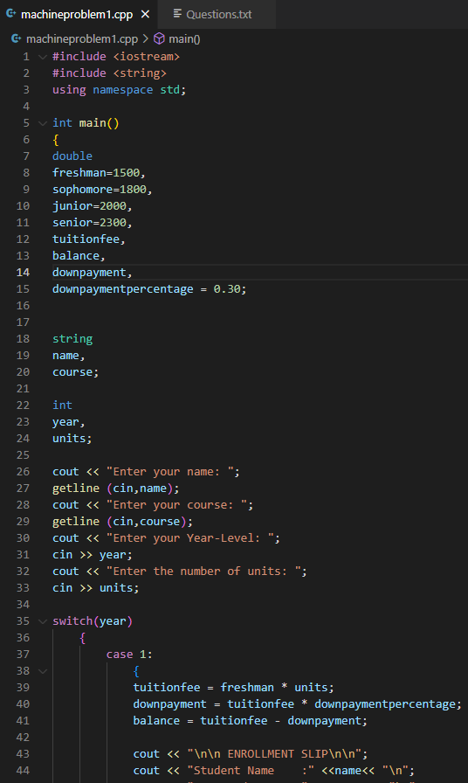

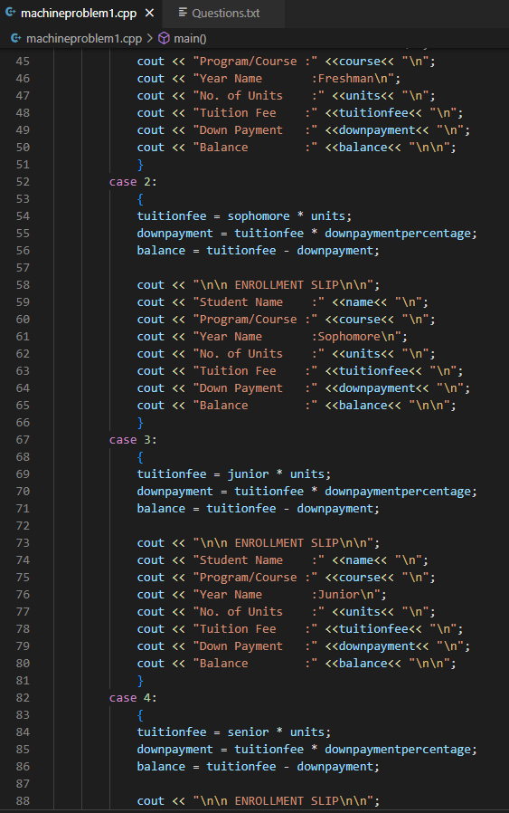

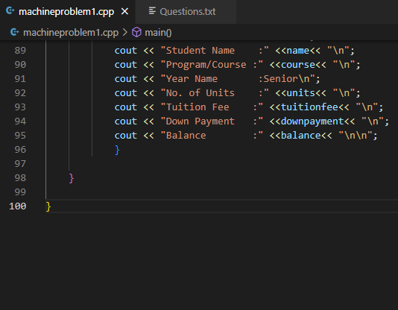

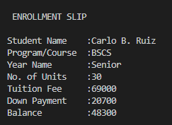

LINK:

https://informaticsedu-my.sharepoint.com/:v:/g/personal/carlo_ruiz_informatics_edu_ph/EbGVUF0-ckZBhbzfXLlVV2MBofgSQVamWI0P_VThGATaCA?e=DvxrzF