Question 1:

Write a program that displays “Hello” in one line, and “World” in another line using exactly two (2) COUT statements.

Question 2:

Write a program that displays “Hello” in one line, and “World” in another line using exactly ten (10) COUT statements. 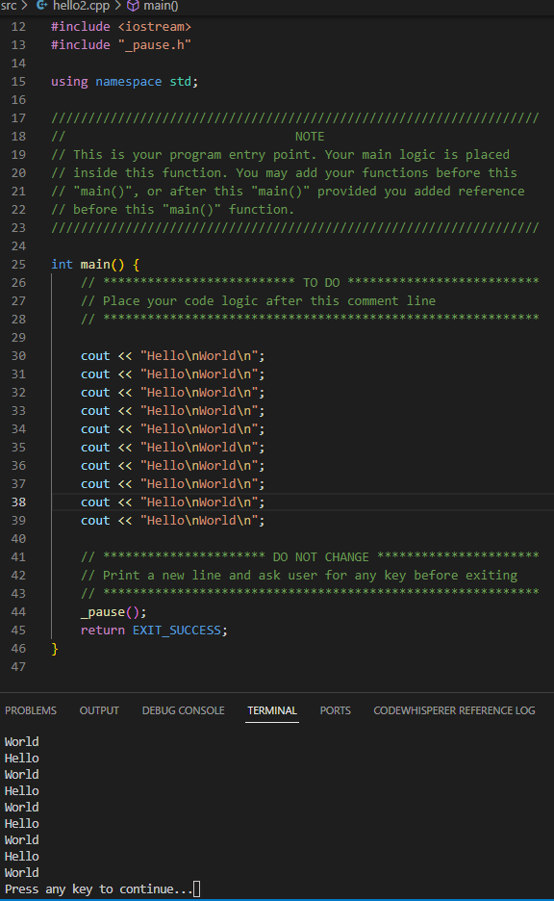

Question 3:

Write a program that displays “Hello” in one line, and “World” in another line using exactly one (1) for the “Hello” and exactly five (5) COUT statements for the “World”.

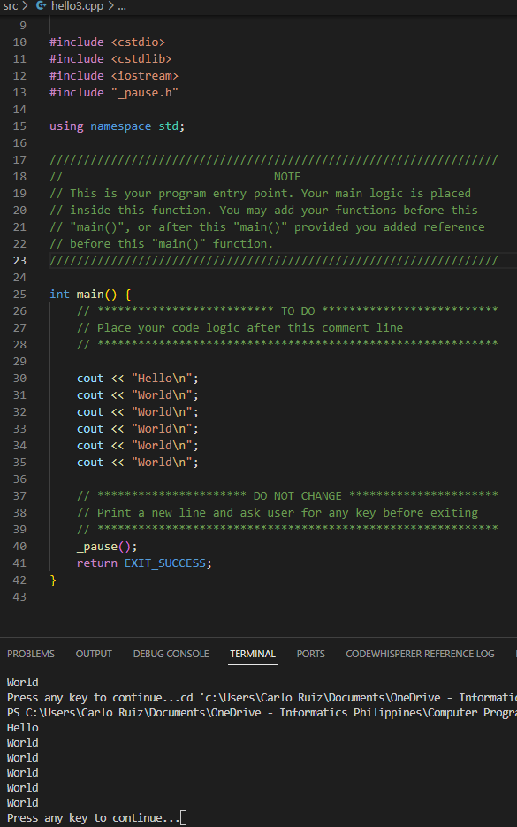

Question 4:

What can you conclude from this activity?

I can conclude that this activity is way more fun compared to the previous activities.