****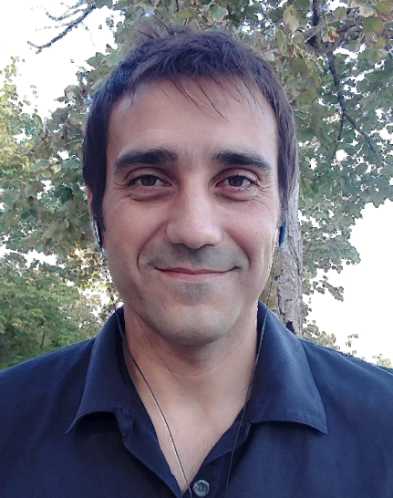

PROFESIONAL **SKILLS**

* Social responsibilities and ethics
* Transmission of values
* Teamwork
* Assertive communication

TECH & SOFTWARE **SKILLS**

* Computer basics and programming

HTML, CSS, PHP, JavaScript, MySQL

* CMS WordPress & Joomla
* WordPress plugin developer
* Analytical capacity
* Photo editor (GIMP)
* Node-RED
* Ubidots

**LANGUAGES**

* Catalan
* Spanish
* English B1 (2021 - 2022)
* English B2.1 (present)

**EXPERIENCE**

* **Front-End web developer**

Matic, Enginyeria Informàtica

July 2018 - August 2020

* **Web developer**

SubProf, SL

November 2017 - June de 2018

* **Web developer**

ICON, SL (internship)

October 2017

**EDUCATION**

* **Master’s Degree in Renewable Energies and Energy Sustainability**

UNIBA (online), Barcelona (2021 - 2022)

* **Web Development Professional Standards Certificate**

Adams Girona Academy, Girona (2017)

* **Bachelor Degree in Environmental Science**

Girona’s University, Girona (2012)

* **CFGS en Environmental Chemistry**

IES Mercè Rodoreda, L’Hospitalet del Llobregat (2006)

**CARLOS SEGARRA GONZÁLEZ**

Front-end web developer

I worked as a web developer in an online spearfishing shop, where I was able to manage the databases stock and the interaction with Google Merchant Centre and also, in an IT company performing website installation and its maintenance and custom support too (WordPress / Joomla).

Recently, I had been studied a Master’s Degree in Renewable Energies and Energy Sustainability. In the final project, I decided to develop a photovoltaic solar system monitoring to improve its efficiency through IoT.

I consider myself a proactive person, adaptable, open-minded, easy-going and hard-working.

CONTACT **DETAILS**

[jobscarlos27@gmail.com](mailto:jobscarlos27@gmail.com)

www.linkedin.com/in/carlossegarragonzalez

Visita el meu **perfil**