NIELIT (DOEACC) ‘O’ level Assignment





**KARIMGANJ COLLEGE COMPUTER CENTER**

**In Association with**

**Department of Computer Science & Application**

**KARIMGANJ COLLEGE, KARIMGANJ**

**Submitted By:**

**Name: Gaurav Kumar Roy**

# Starting of Web Developing project using HTML.

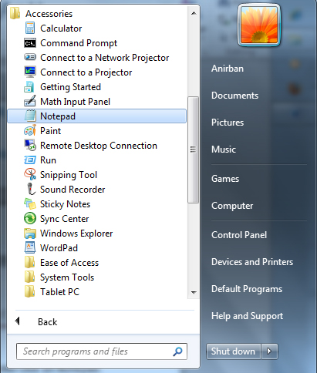From the Start menu, click on All Programs. Now from Accessories program folder click on Notepad.

Figure: 1.0

# Creating a Web Developing project using HTML code.

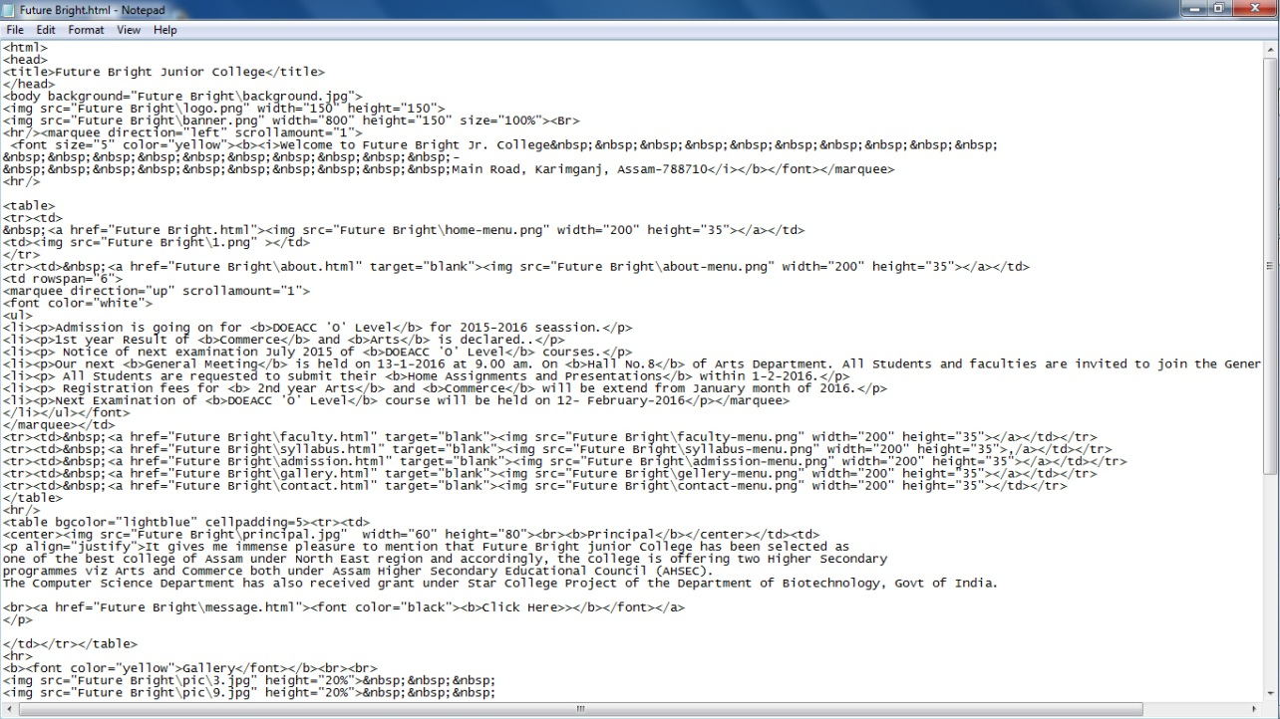Now, type the following code in Notepad and save it as Future Bright.html (shown in Fig.: 1.1).

Figure: 1.1

After saving the file, close the Notepad and double click on Future Bright.html file to open the file in HTML (Web page) format, which is look like the following figure (shown in Fig.: 1.2)

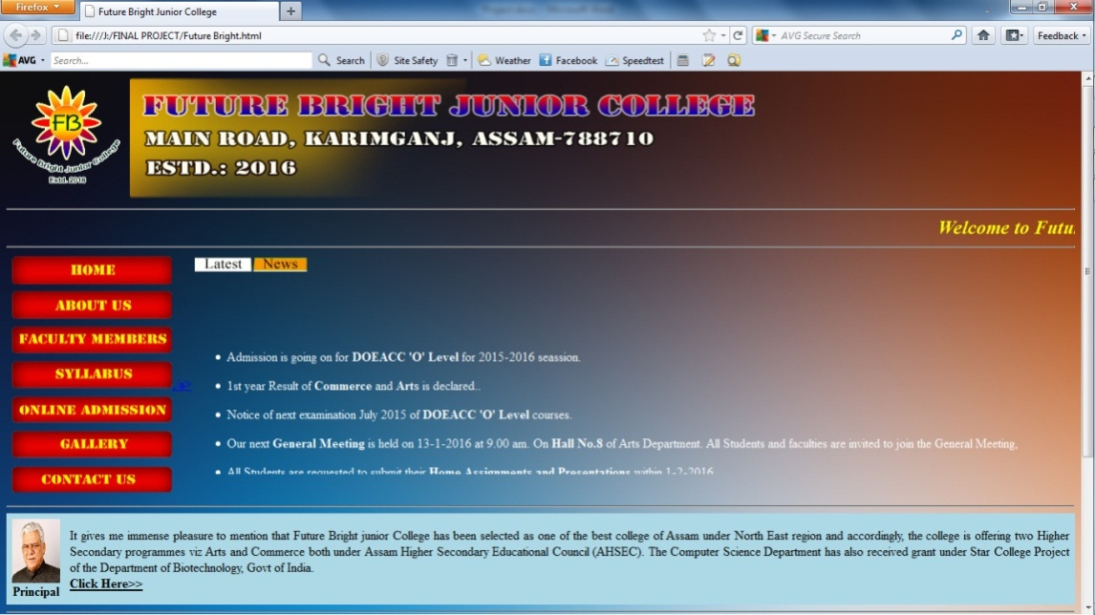Figure: 1.2

# Linking with multiple pages andcreating a frame using HTML.

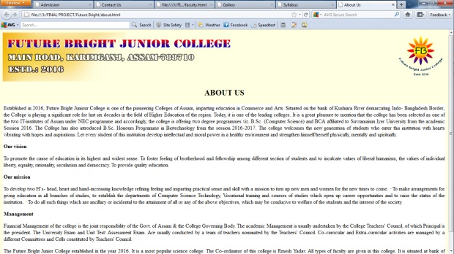Now, create six other HTML file in Notepad and save it as about.html (shown in Fig.: 1.3), faculty.html(shown in Fig.: 1.4, 1.5), syllabus.html(shown in Fig.: 1.6), admission.html(shown in Fig.: 1.6), gallery.html (shown in Fig.: 1.7)and contact.html(shown in Fig.: 1.8) respectively.

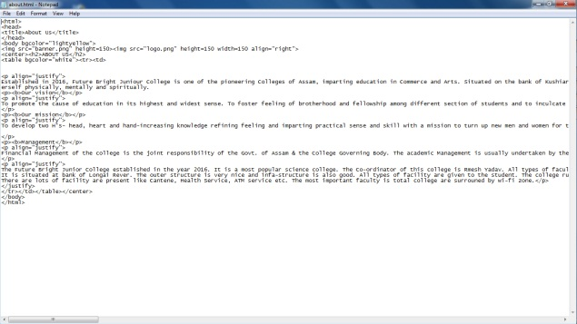

Figure: 1.3

Now, to create faculty.html using frame, we need to create webpages of various Department using proper HTML code. Such as,

* Department of Bengali
* Department of English
* Department of Commerce
* Department of Economics
* Department of History
* Department of Mathematics
* Department of Philosophy
* Department of Political Science
* Department of Statistics
* Department of Computer Science
* Department of NIELIT (DOEACC)
* Library Staff
* Office Staff
* Grade-IV

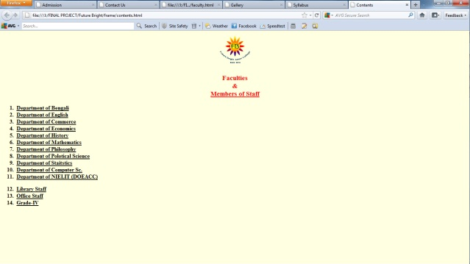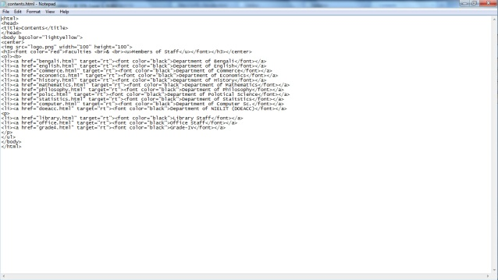Now, create other HTML page and named it as contents.html which is linked with above mentioned webpages. (Shown in Fig.: 1.4)

Figure: 1.4

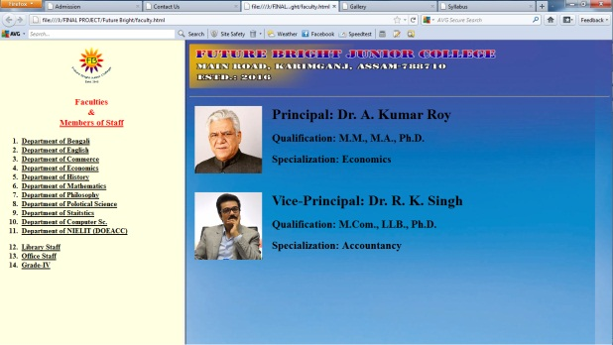Now, create another webpage using <frameset> tag which create a frame between these pages and save it as faculty.html

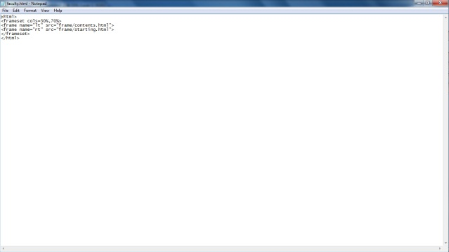

Figure: 1.5

The contents are shown in the left side of the frame and the results (webpages of various department) shown in the right side of the frame.

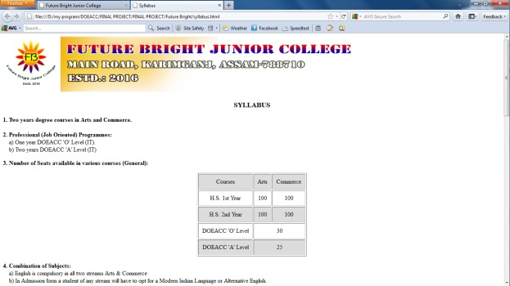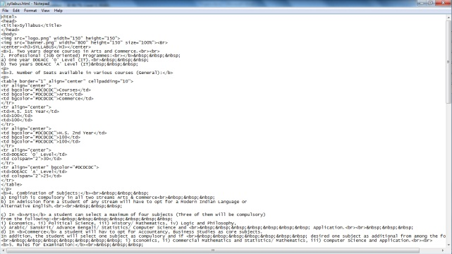Now, again we create another webpage of course syllabus using proper HTML tags and save it as syllabus.html (Shown in fig: 1.6)

Figure: 1.6

# Creation of HTML form.

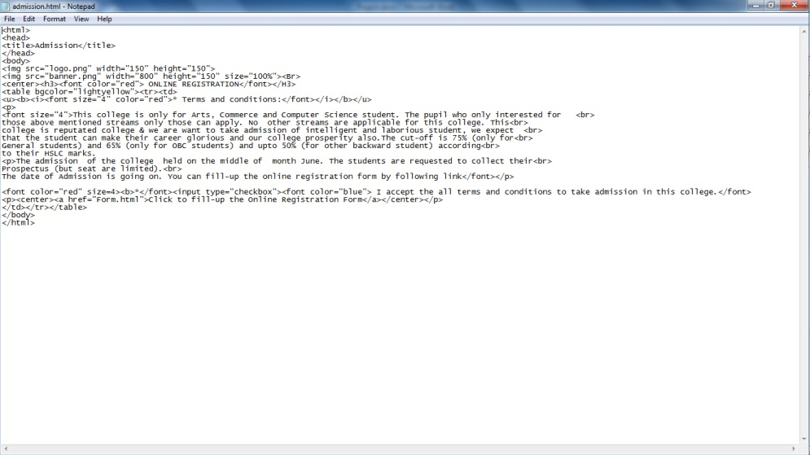Now, create two other webpage such as admission.html and form.html. Both are related to online admission process. First we create admission.html. Which is related to confirmation of ‘Terms and Condition’ of admission process. (Shown in fig.: 1.7)

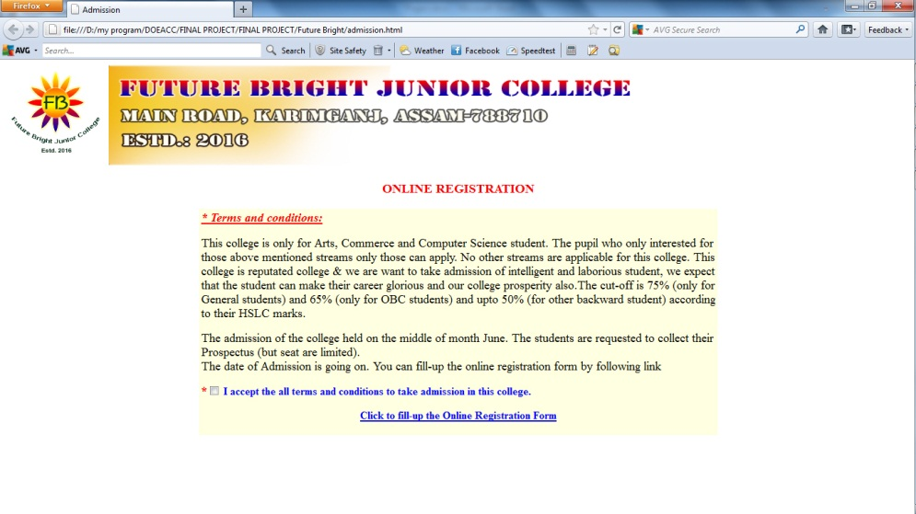

Figure: 1.8

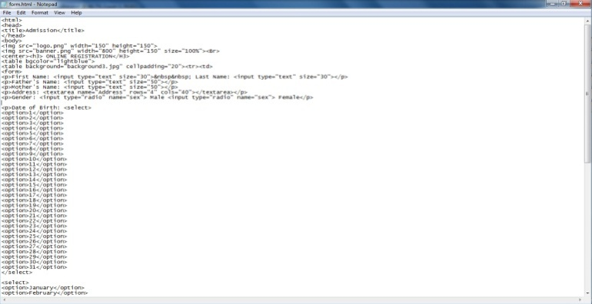After that we have to create another webpage of admission form which is created with proper HTML tag shown in the following: (Fig: 1.9)

Figure: 1.9

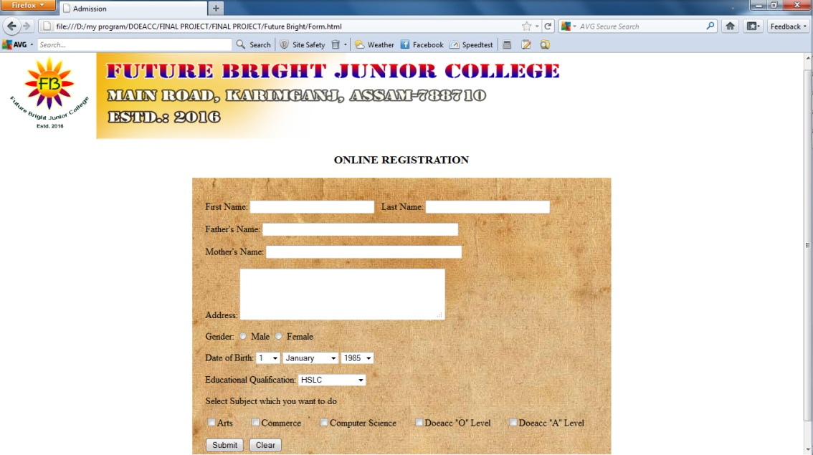Now, save it as form.html. After that closes the Notepad and opens it with HTML (webpage) format which is looked like the following figure (Fig.: 1.10)

Figure: 1.10

# Adding Images in HTML webpage.

Now to create gallery first we need to choose the images which we want to add in our webpages of gallery and save it in a separate folder which helps us to finding out the images easily which we want to add. Now, to add images to webpage we need to <img> tag in HTML and also mention the proper location/ path of the images which we want to add. For example, we want to add an image (named as a.png) which is located in folder named as ‘Picture’ in C:\ drive. We can add this by following tag:

<imgsrc=”C:\Picture\a.png>

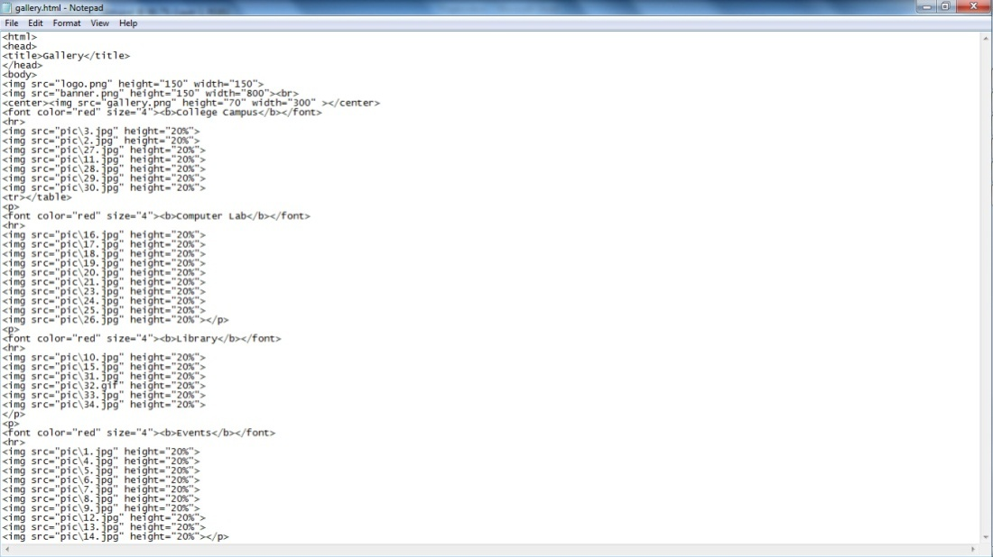In this process of using <img> tag we can add multiple images in a single webpage. (Shown in fig.: 1.11)

Figure: 1.11

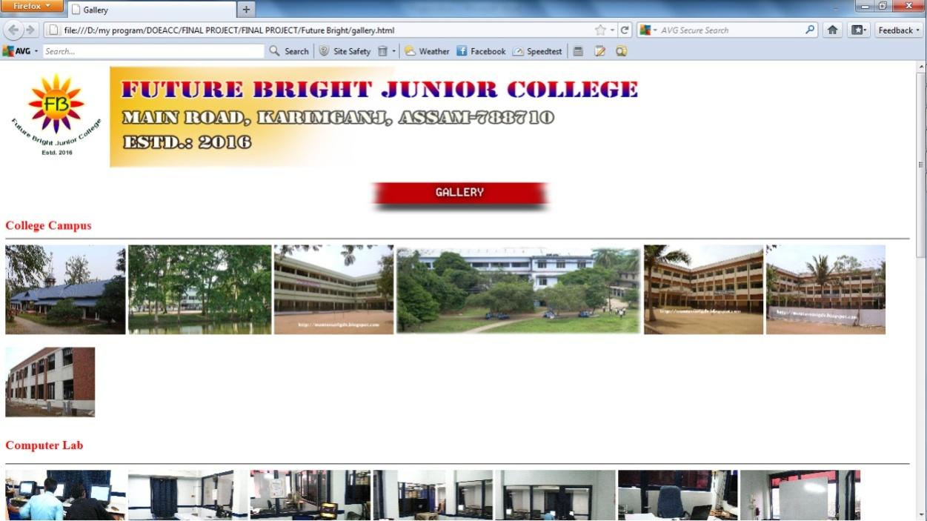Now, we need to save the document in HTML format and named as gallery.html and open it in HTML (webpage) format. (Shown in fig.: 1.12)

Figure: 1.12

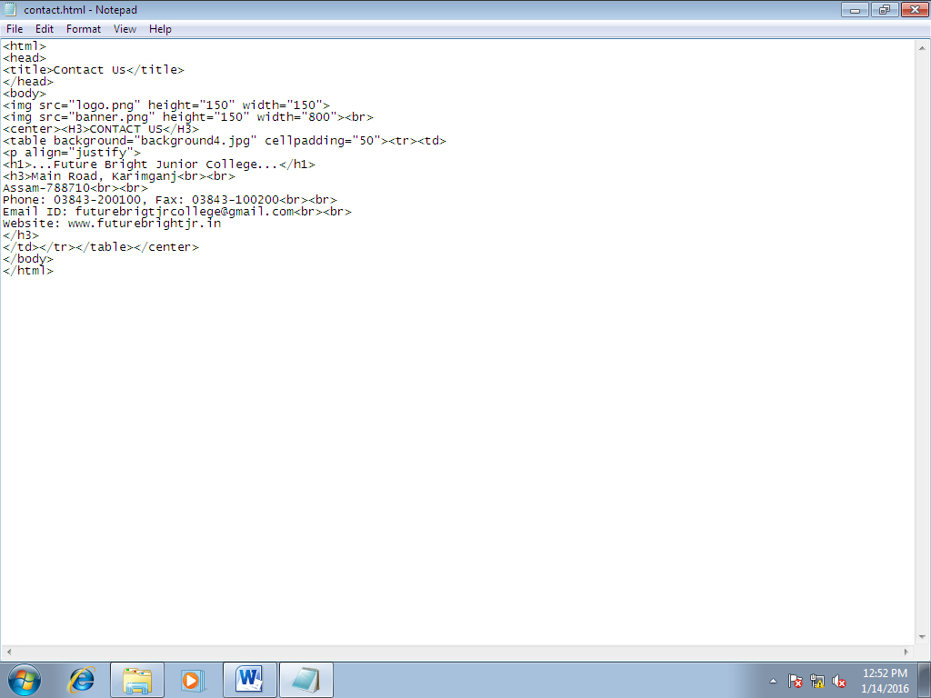Now, to create contact.html we need to enter proper HTML code shown in below and save it to the contact.html (fig.: 1.13)

Figure: 1.13

Now, after save the file open it in HTML (webpage format). (Shown in fig: 1.14)

Figure: 1.14

After that create link these pages (About with Future Bright.html webpage