Sqllocaldb commands to **create,** **start** a DB and get **info**

sqllocaldb c "SalesProcessDB"

sqllocaldb s 'SalesProcessDB'

sqllocaldb i 'SalesProcessDB'

I set the localdb file location to C:\SQL2022\ (conn string points to this in app)

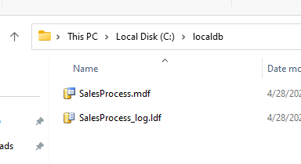

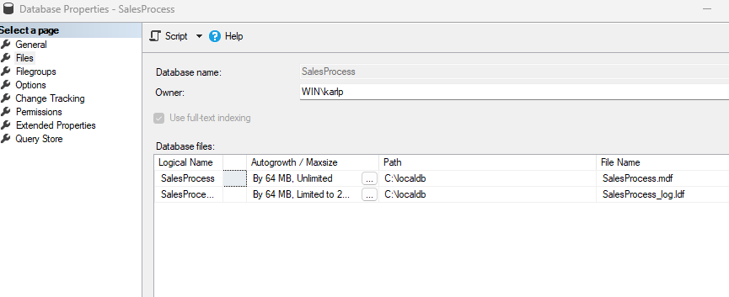

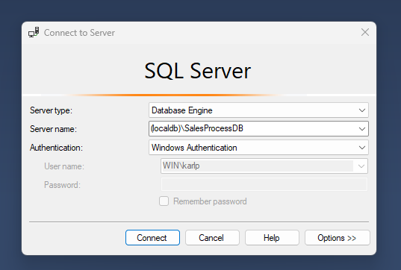

Data Source=.\\SQLEXPRESS;Initial Catalog=SalesProcess;Integrated Security=True;