Lab 8

Karl Roth

In this lab we demonstrated fundamental concepts of MongoDB. We learned how to access, insert, and delete entries in a database. We also wrote and ran a python script that imported Chicago twitter data into our MongoDB database.

!. Access MongoDB

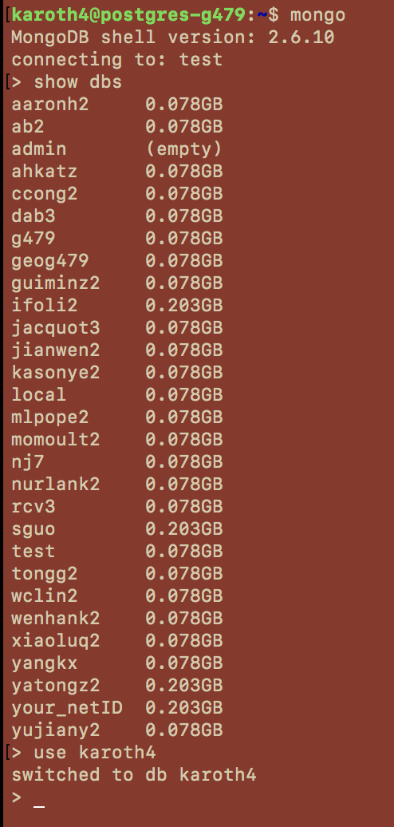

Fig 1: A list of all of the databases in our courses ROGER MongoDB

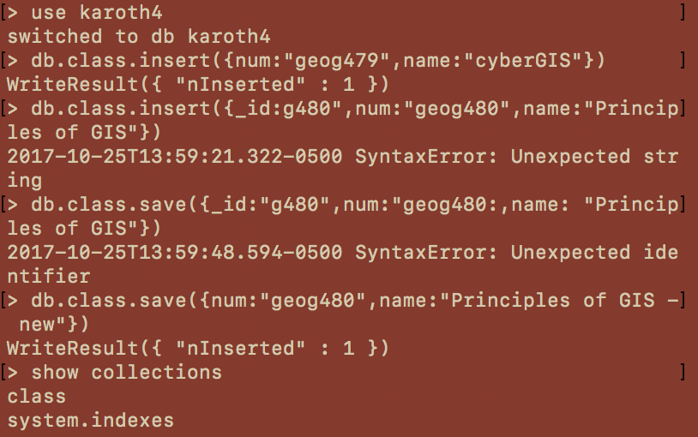

Fig 2: Demonstrating various insertions into a database called “class”, and saving the results

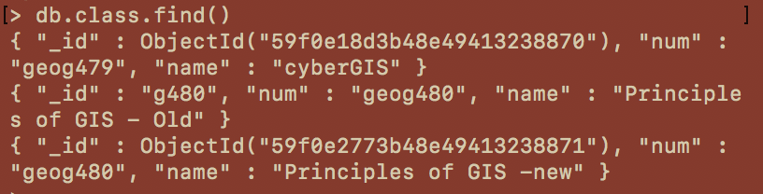

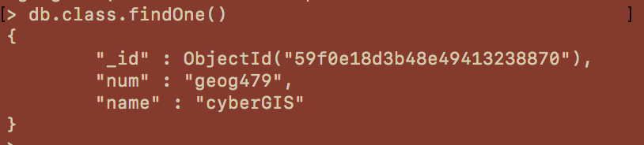

Fig 3: Listing the contents of our “class” database

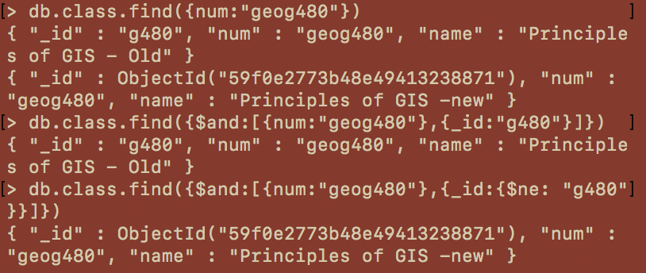

Fig 4: Querying all entries where “num is geog480”, “num is geog480 and id is g480”, and where “num is geog480 and id is not g480”

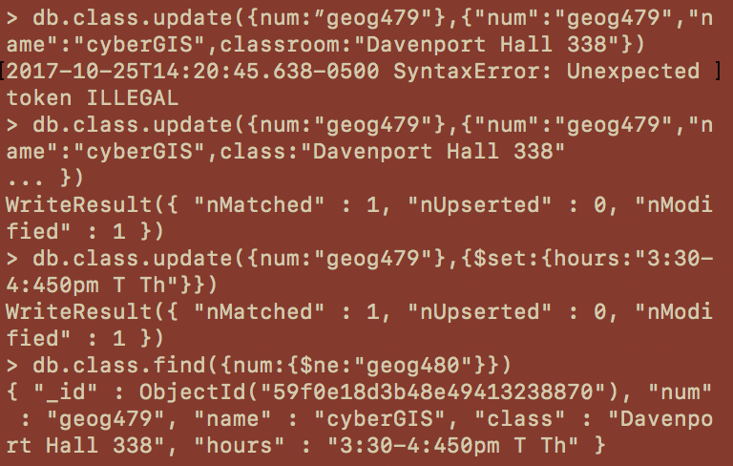

Fig 5: Modifying the entries and displaying the results

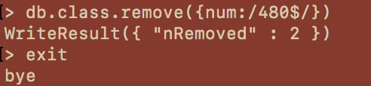

Fig 6: remove all entries with 480 in them, and then log out.

Chicago Twitter Data



Fig 7: Examine the structure of the data. [uid, lat, long, datetime, msg]

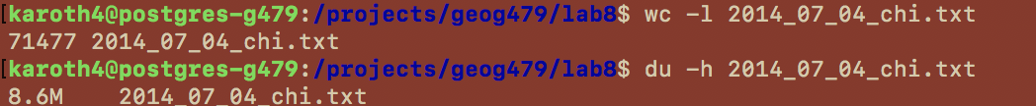

Fig 8: The text file contains 71,477 lines and is 8.6MB in size

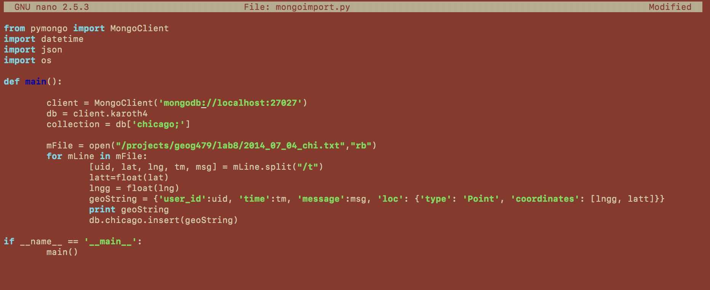

Fig 9: A python script written to import the Chicago twitter data into MongoDB.

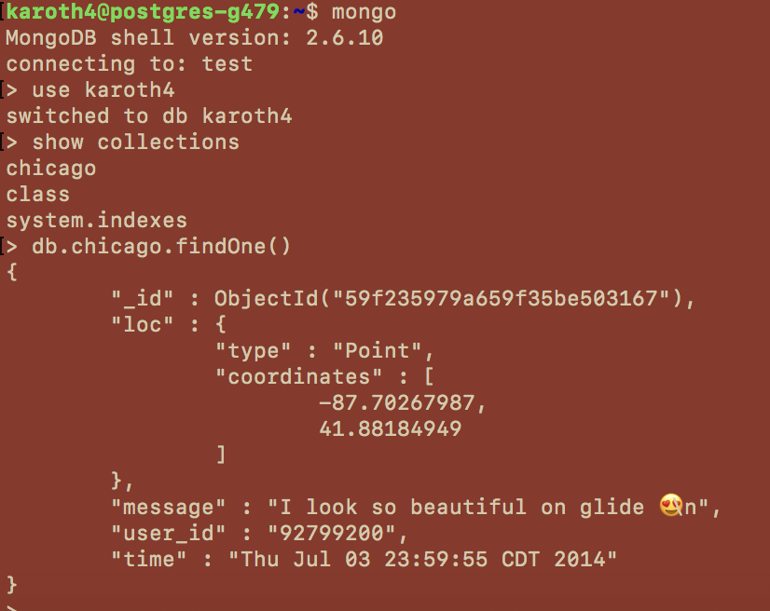

Fig 10: Logging into MongoDB to demonstrate that the data imported properly. Displaying the first tweet in the database.

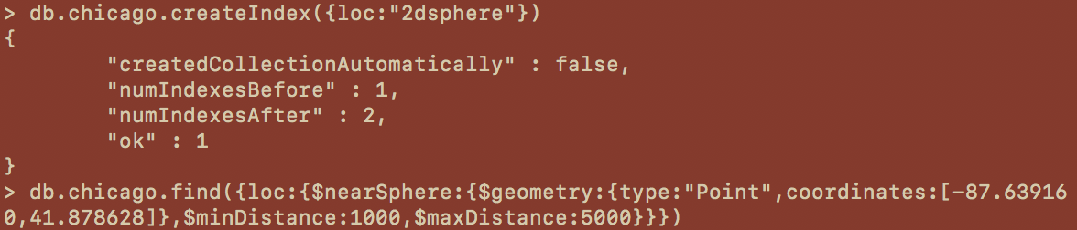

Fig 11: To perform spatial queries we must let MongoDB which field contains the location data, otherwise an error will be displayed. (I have not included the actual query results because they are too long).



Fig 12: Query of tweets within a specific region (i.e. “Polygon”) Again, query results not included in screen capture.

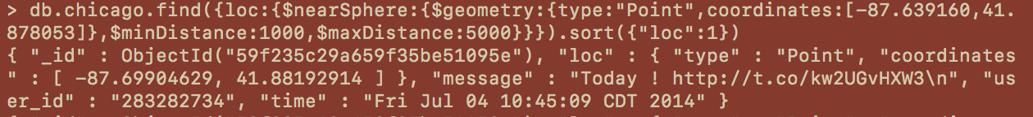

Fig 13: The query performed in figure 11, but sorted by distance. The first result was included in this screen capture