SKCC CCSG Publication Application
Developed by Karl J. Smalley from 2007 - present
Application is written in php which fetches publications form PubMed, stores them in a database and them re-renders them for a CCSG application with center members highlighted, program affiliations inserted and markings for intra/inter-programmatic publications. . It uses a postgreSQL database, but that can be modified to use MySQL or Oracle. It would require changes in the coding.
Originally this was developed over the years into several smaller tools that were used separately:
- php script to parse publications into database.
- java desktop application to assign Center Member Authors and their Associated Programs. There was also a java desktop application to maintain the Center Members and Program Affiliations under a few different program structure scenarios.
- A script which displayed parameter menu for selecting option that would affect how and what publications were displayed by the rendering script and the rendering script itself.
Upon hearing others might have an interest in the code (early in 2016), I very hastily (and I do mean very hastily here) converted the java parts to php and put an application menu around all the constituent php parts. I added an application users table and also some update routines for some of the tables I previously modified manually in pgAdmin.
I did actually use it for a few weeks before releasing it, however it is primarily code I never meant to share with anyone and quite often I dealt with issues as they appeared. So you may run into issues, I jsu thave not had to deal with yet. Also, and most importantly, it was not really any slower to do the work in the combined application over the tootlbox approach I had before.
I also (equally as hastily) wrote up this basic documentation.
Tables:
ccgs_users --- basic user table – There is an ADMIN user and NORMAL user. In the current configuration (which is easily modified), the ADMIN user can access the user table and the NORMAL user cannot. A login is required for all Main Menu Options except the Publication Display Menu. This has no authentication and can be accessed by anybody with its url directly. The same is true the rendering script (disppubs.php) and the journal summary script (journalsummary.php).
ccgspublications --- this is the main publication table. It contains all the publication data. The publication data is stored as fields/components. There is also a display text field which holds all the data as it will be displayed no matter what options are selected from the publication display menu (Authors in “Lastname Initial” format, Title of Article. Journal Abbreviated Name. Date of Publication. Volume(Issue): Page numbers). There is also a backup field for this field which is used when doing a publication update. Sometimes publications are removed from PubMed and you may want to look into missing publications after an update. In fact there is a field to alert you if a publication has been updated, so if you made any modifications (reducing an author listing from 100s to the FirstAuthor, . . . CenterMember1, . . . CenterMember2, … et. al.) The backup display text field will still have your modifications so you can re-apply them. For our particular center we also keep track of Drexel publications, LIMR publications and intra-consortium publications (we have a Consortium Cancer Center with Drexel University and the Lankenau Institute for Medical research). The application also captures the entire xml string from when the publication first stored and from the most recent update. If we decide there is something else in there that we may be interested in (MESH Terms or something) we do not have to go back to PubMed for every publication. We can just refer to the stored XML. It also contains 3 fields for member author listings. Each of these 3 fields represents a different program structure. The first is historical (members are associated with the program that they were ibn when the publication was published). The second is a proposed membership. In this case all publications after a certain date will be listed with the proposed program. The SKCC senior leadership though it made more sense to list publications with the members program at the site visit rather than listing them with another program. For example Dr. Smith is in Program 1 and has been there for a very long time. Due to proposed program changes by the Center in general or a shift in research interests by Dr. Smith, a couple of years before a renewal he is switched to Program 2 or even a new program which does not exist. So for history sake all of his publications before this change are still listed with Program 1. But for the Site Visit, it would make sense that hose evaluating program 2 to see all of Dr. Smith’s publications since he is in that program and it would be a bit confusing if the reviewers of Program 1 saw all of these older publications for Dr. Smith when he (at the time of the Site Visit) was not in Program 1. Also this most closely resembles what would be done if there were publications no system in place. In compiling the application one would collect each members CV and merge their publications with other members publications and use the program affiliations that were going to be used for the renewal. The third field allows for an alternate prosed structure (what if we had this program too or removed that program).This allows you to have 1 historical publication listing and 2 publication listings which are more in line with proposed program strictures. More options could be added, but there would be some code changes required for that. These 3 fields are key to whether a publication gets listed (will not if it is blank) and how member authors are displayed in the publication. They are also used for making intra-programmatic and inter-programmatic determinations for each publication (more about that later).
filters --- There are 2 types of filters (PRELOAD and ONRENDER). There is no module in the application for updating these (maybe in the next version). PRELOAD filters are filters applied to incoming publication authors. Replace Hajnóczky with Hajnoczky or replace Jiménez with Jimenez. ONRENDER filters are applied to the Display Text after all member/program modifications have been made. For instance we have a member named Jianke Zhang. He has a publication in which there are 2 authors named J Zhang. I modified the publication text and changed his J Zhang to JI Zhang (I also had to modify the member author fields for this one adding the extra I). In the publication rendering program, the script replaces all instances of ZHANG JI[ with ZHANG J[ (the [ makes sure I only catch members which will have the program affiliation in brackets right after their name and not some other author who actually has the last name initial combination of ZHANG JI ).
imp_fac_link – unfortunately many journals have multiple ISSNs. And I cannot be assured of selecting the ISSN which was listed with the Impact Factors when storing a new publication. This link table allows for multiple journal ISSNs in the publication table to link to one record in the impact factor table. When inserting a new publication, if an imp_fac_link record does not exist for the ISSN of that publication, a new link record is created as well as an impact factor record with an impact factor of -99. You will be alerted that this has happened. Depending on the journal you may or may not want to check and see if there was not a real record in the impact factor table with a different ISSN and then alter the link record accordingly and delete the artificial impact factor record. You may also want to periodically check the undefined (like those created above) impact factor records to make sure that you aren’t misrepresenting the impact factor of a publication’s journal.
imp_factors – I created this table originally from importing factors that I downloaded from citefactor.org. If you’d like to know how I did this please contact me directly karl.smalley@jefferson.edu.
members – This table contains the member records that are used when doing pubmed searches for new publications and suggesting author affiliation for publications in the publication update module. A member can be active or inactive. Inactive members will not be used in the bulk load module, nor will they be used on the author suggestion logic in the publication update script. There is a place for 2 pubmed search options. It is imperative that the first be LASTNAME FIRSTINITIAL(OPTIONAL MIDDLE INITIAL) {for example a member record for could be SMALLEY K or SMALLEY KJ). This field (besides being used to search pubmed for this member) is used for the author matching logic in the publication update script. The second pubmed string can be anything that makes it easier to locate publications for this author and not some other similarly named author. For instance to just retrieve my publications in PUBMED you could use this string “(Smalley KJ[Author]) Or (Smalley K[Author] Comerota AJ[Author]) and not Scarpa A[Author] and not Havens S[Author]” . Generally it is much more like this for Dr. Sato: ((sato t[Author] AND jefferson[Affiliation]) OR Takami Sato[Author - Full]). Since there are some members where “lastname initial” will just never work, you can also indicate that the bulk search should skip the first search string. We still need the first sting for the author matching in the publication update script. Lastly this is where the authors program affiliations are stored for all 3 program structure scenarios (historical – current, proposed structure 1, proposed structure 2). In many /most cases the first and second will be the same. DO NOT ENTER any data into this table until the PROGRAMS are set up
programs – This table contains the program records. Program records can be INACTIVE (but are retained to match program affiliations in historical publications). INACTIVE Programs will not be available on the “PROGRAM OPTIONS” for the publication menu and should NOT be included in any of the Program Structure Options. Each Program Record Contains a CODE (which should be unique) and a Full Program Name. There is also a sort number which controls how the Programs Are sorted in the Publication Display Menu, The Publication Rendering Module and the Member update module. This data should be entered first.
rejpubs – This table stores pubmed ids of previously rejected publications. Adding this was key to accelerating the curation process. Generally I run the bulk load back at least 3 months (just to make sure a new publication has been added to PubMed and the PubDate is a bit behind). Also, I used to do this more on a quarterly basis (art which time I would look back 6 months in pubmed). Now I am doing it weekly/bi-weekly and I am looking back 3 months. Originally, the most time-consuming task was looking through 10s or 100s of publications for one or 2 that were actually for that center member and not someone with the same initial and last name. The next round I would wade through a lot of the same publications that I had waded through the previous bulk-load cycle. Now I store all pubmed ids in a table if I’ve seen them for this author. If I accept the publication it goes into the publication table. If I reject it, it goes into the rejection table. The next time I search for this member, the application ignores any publications in the publication table or any in the rejection table (which also have the authors member id – a rejection for John Doe might accidentally knock out a publication for Jane Smith – although I’d like to think I‘d catch that -- for now I will have to reject a publication multiple times if it has authors that match multiple members).
systemconf – This table is actually a one row table (maybe it should be a file). At any rate, it contains the Center Name, Center Abbreviation (if there is one), whether it is a consortium cancer center (although to date I am not really using this setting anywhere – it could be used), and the text describing the 3 program structure scenarios. This is also the text that is displayed on publication menu for each program structure possibility. I‘ve left the data in this table so that you can see sort of how it works. The last field is the lastupdated field. Currently I am modifying this manually, although I think I will soon be adding code to the bulk update module that will update this automatically. I may also add a field for the reference for the Impact Factor which is currently hardwires into the publication rendering script.
Creation scripts for each of these tables is in the init.sql script. You will need or modify this if you are not using postgreSQL and if you want to use a different name for the application database (you can do this but just make sure to update the ccsgpubs-library script to match).

Scripts:
ccsgpubs-library.php – script where general application settings are created and login/session stuff takes place. Script requires a jeffldap.php script which is not in this bundle. Remove the “require_once” line and modify the authorize function as you need to in your environment.
index.php – Main login. THis script ncludes a header and footer as do all scripts except dispubs.php. The header and footer are too restraining for that script. Screenshoit below:
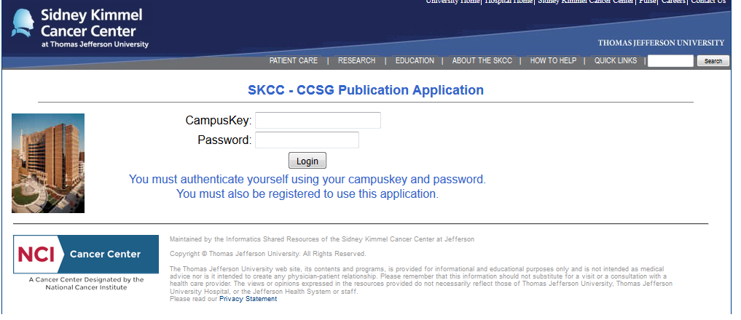
menu.php – main menu where authentication takes place and application options are listed. Below is a screenshot.
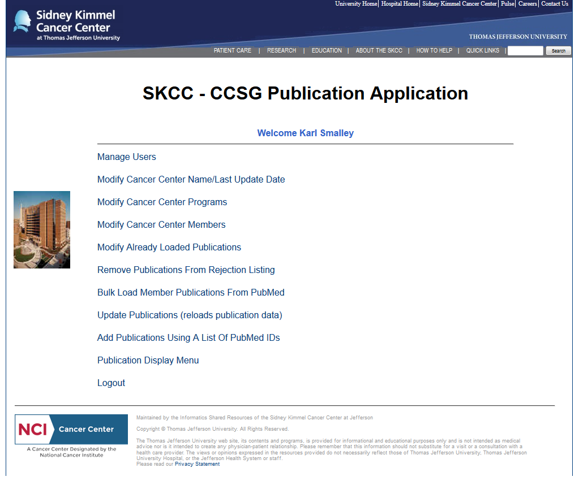
modusers.php – script which allows to modify/add application user records.

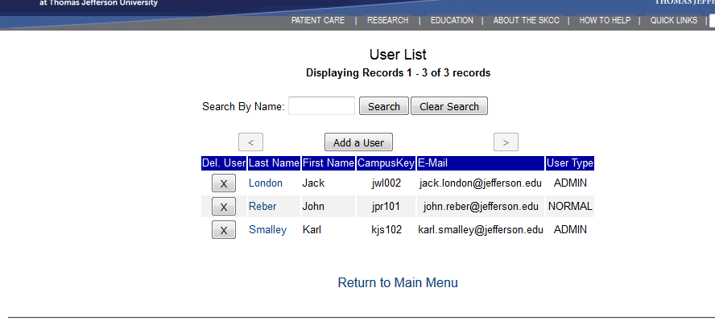
updusers.php - script for actually modyfing dat in application user record.
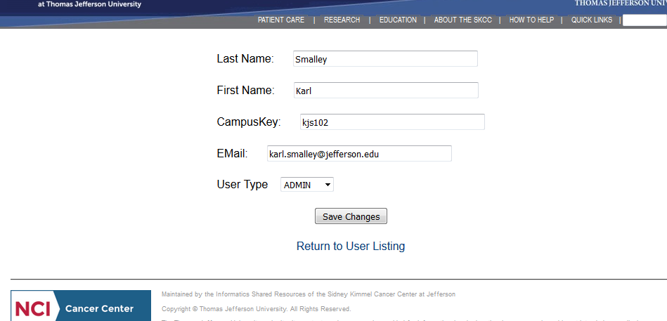

saveusers.php – script that records changes in new or existing user record.
modcentname.php – script for modifying data stored systemconf table, screen shot below:
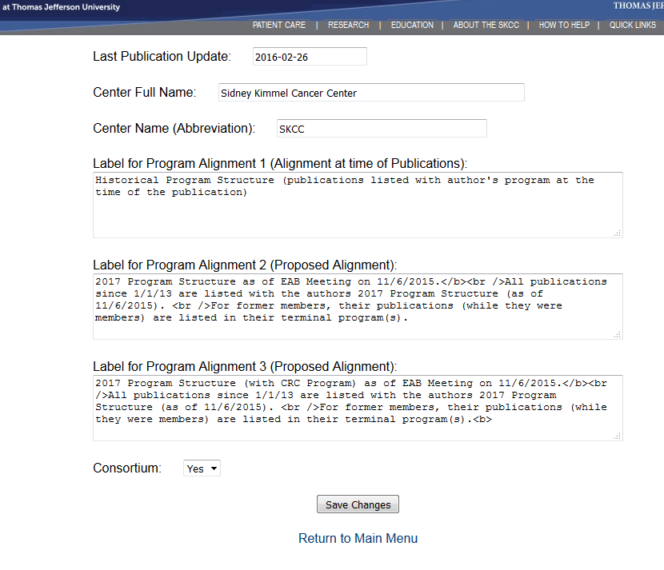
savecentname.php – script for storing changes to data stored systemconf table.
modprograms.php - script selecting programs to modify or initiating an addition of a program, screenshot below:
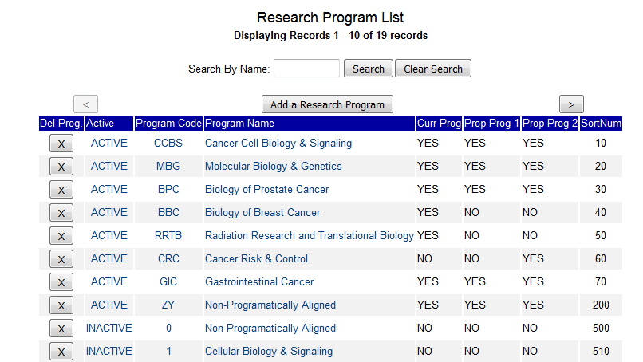

updprograms.php - script modifying new or existing records in the programs table, screenshot below:
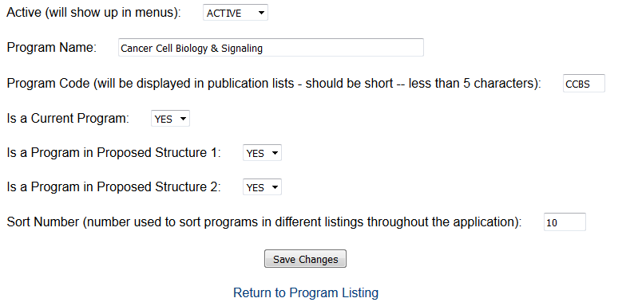
saveprograms.php – script for storing changes records in the programs table.
modmembers.php - script selecting members to modify or initiating an addition of a member, screenshot below:
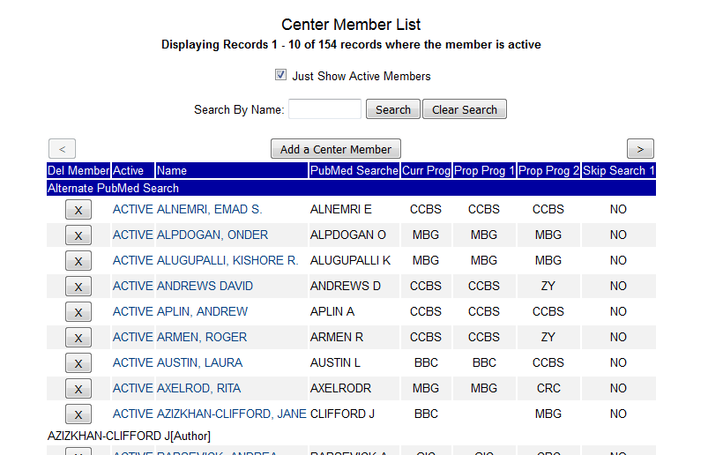
updmembers.php - script modifying new or existing records in the members table:
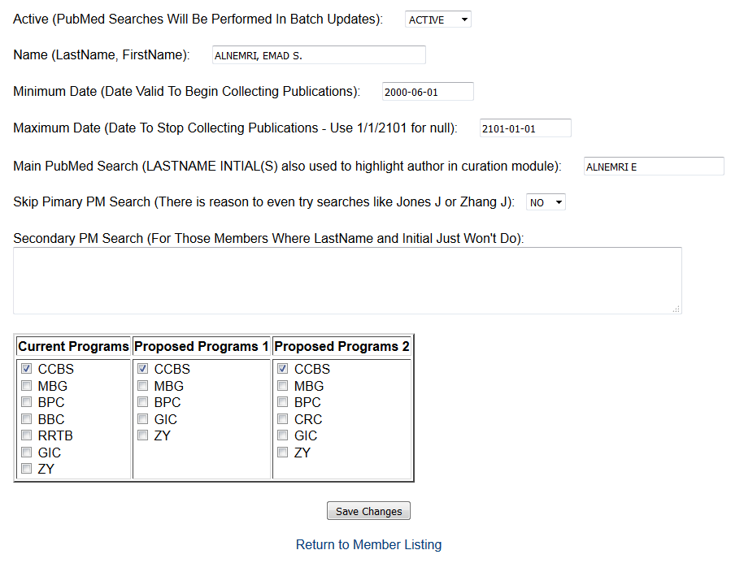
savemembers.php – script for storing changes records in the members table.
modpublications.php - script selecting members to modify or initiating an addition of a member, screenshot below:
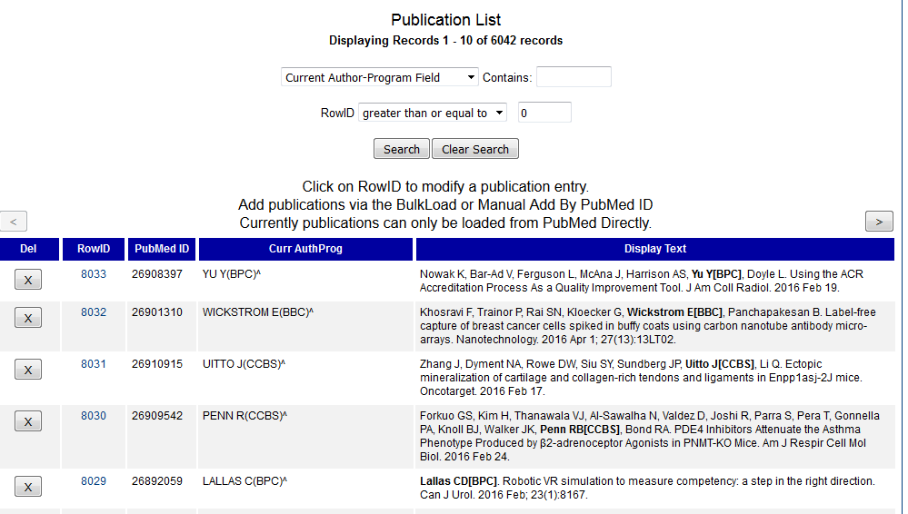
updpublicaitons.php - script modifying new or existing records in the publications table:
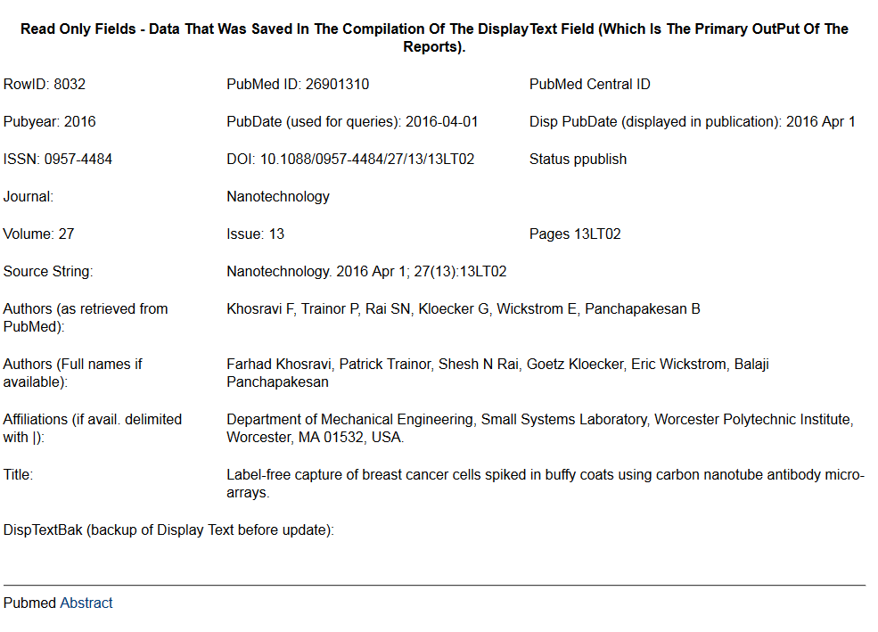
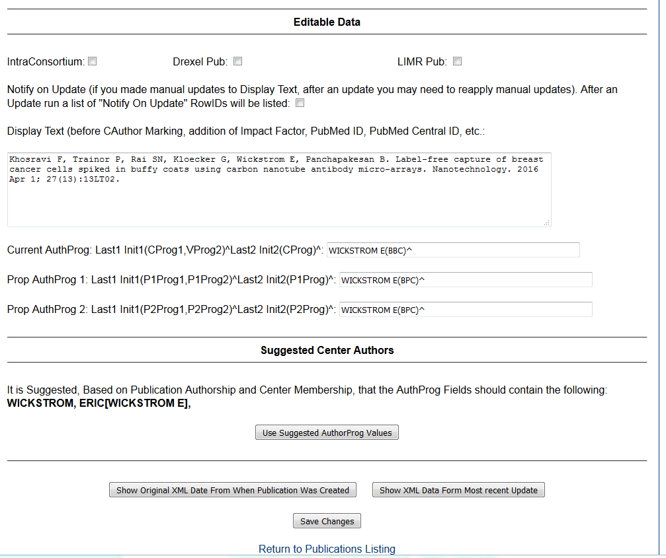
savepubliations.php – script for storing changes records in the publications table.
unreject.php - script for entering pubmedids that should be removed from rejpubs table.
restorepubs.php – script that removes records from rejpubs table.
findpubs.php – this script will go through the member table and search PubMed for new publications based on the pmsearch1 field (if not skipped) and the pmsearch2 field (if provided). Previously loaded publications and rejected publications will be omitted form the new publications count. If the new publication count is greater than 0 the link should be red. Although not showing up in the screen shot, all publication counts are links (even for 0 new pubs). Even if there are no new publications to review, you may want to review the rejected publications which will be disppayed. Below is a screenshot

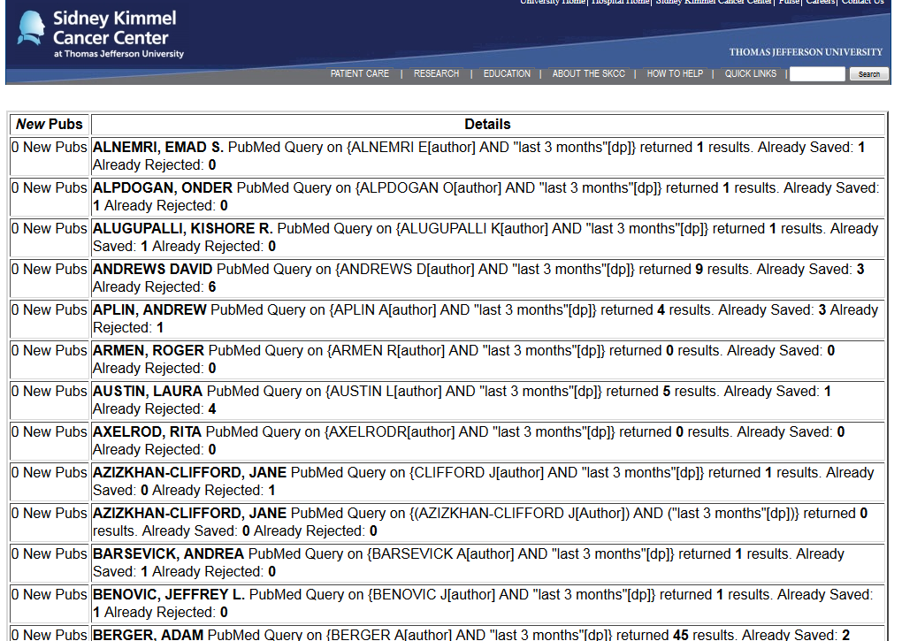

selectpubs. php script that displays information about publications that need to be reviewed for possible entry into the publication table (or alternatively the rejpubs table). You will also show all rejected publications during the time period, so that you might restore a publication that was inadvertently rejected, screenshot below.
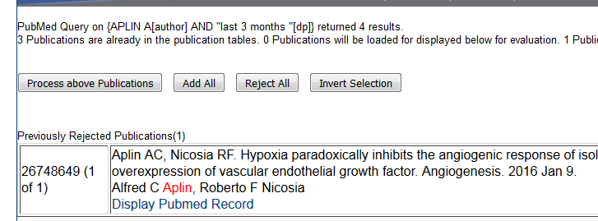
savewnewpubs. php script that stores new publications in the ccsgpublications table or the rejpubs table. If you are saving a publication to the ccsgpublciations table, you will be notified if the publicaiton ISSN do not match a previous imp_fac_link and imp_factor tables. New imp_fac_link and imp_factors records will be inserted to address this issue. The impact factor will be -99 (Unknown). You will be given the opportunity to modify any added publications and assign member authors and aligned programs.
pubreload.php – script that will update existing publication records by checking pubmed again. Usually done monthly/bi-month on any publication published in the last 6 months to catch page number updates or any other changes.
uidsbyhand.php – script that will allow you to type/copy a list of pubmed ids to be added to the ccsg_publciations table
savewnewpubsbyuids. php script that stores new publications in the ccsg_publications from uidsbyhand.php. Handles missing imp_fac_link records and offers the opportunity to modify newly added publications just like savewnewpubs. php
pubmenu.php - this is the menu for decide what publications show up in a report and how they might be displayed. There are a bunch of settings for the report in general. Below is a screenshot of the menu:
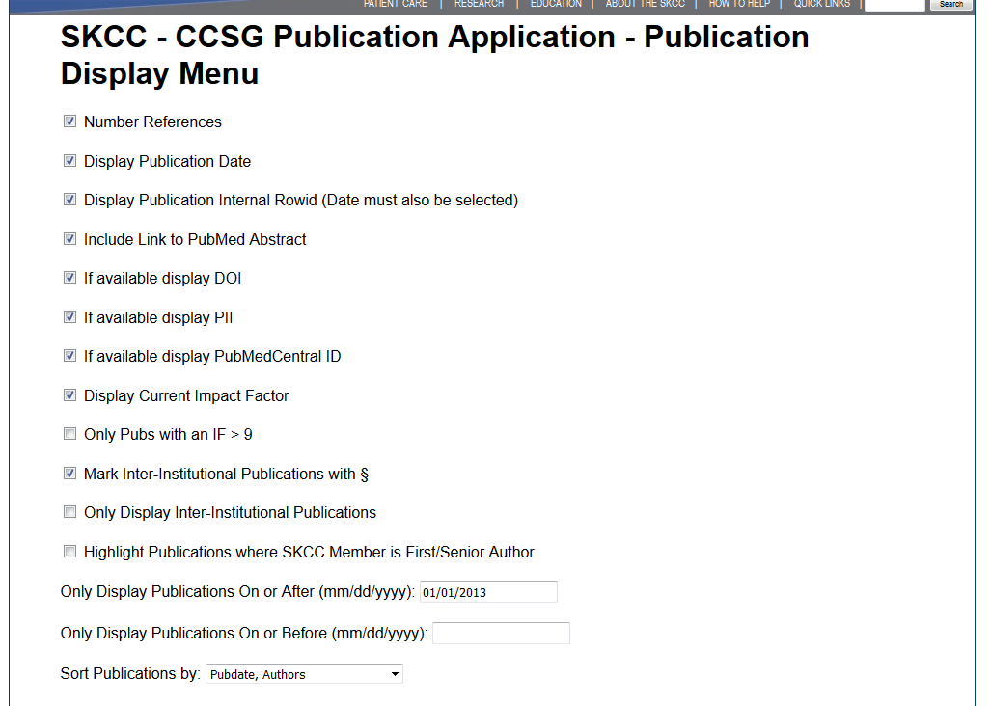
.
And then the user can choose any of the 3 different Program structure scenarios (current/historical, proposed 1 and proposed 2). Within those structures a user can see the whole center bibliography , a program bibliography or an author bibliography Below is a screenshot of the menu:

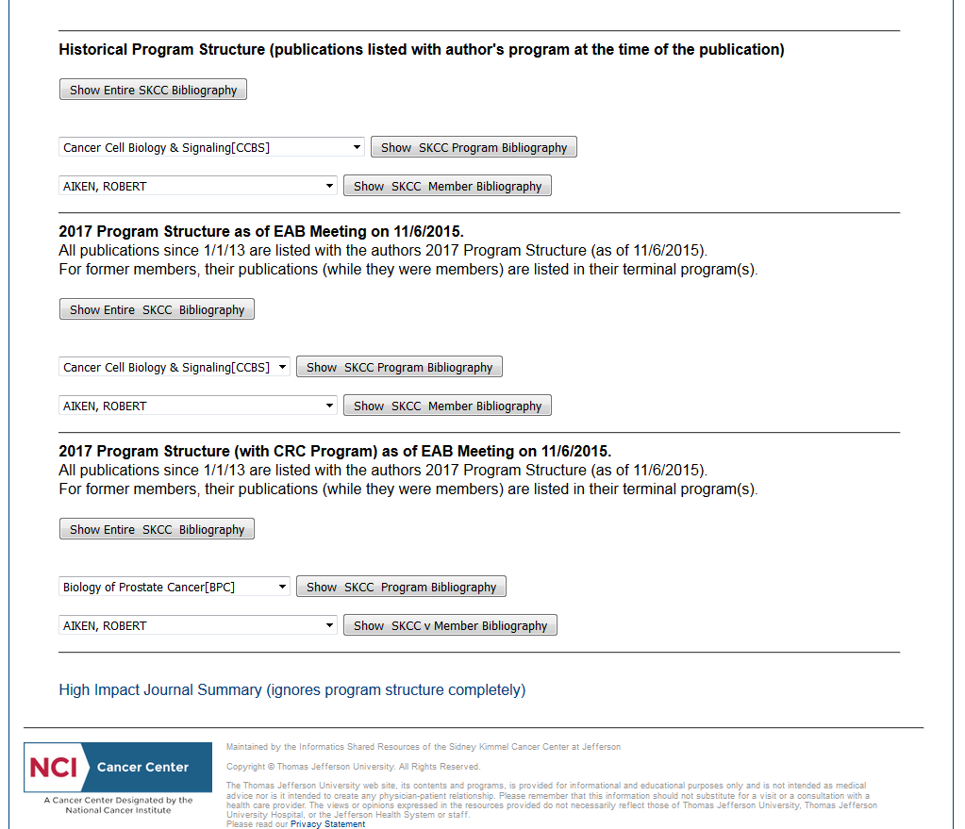

dispppubs.php – this is the main publication display routine. It does not require authentication or authorization and can be accessed out sided of the application directly by url. To that point parameters are sent to it by the publication display menu via GET so that the url can be shared.

Top portion of output:
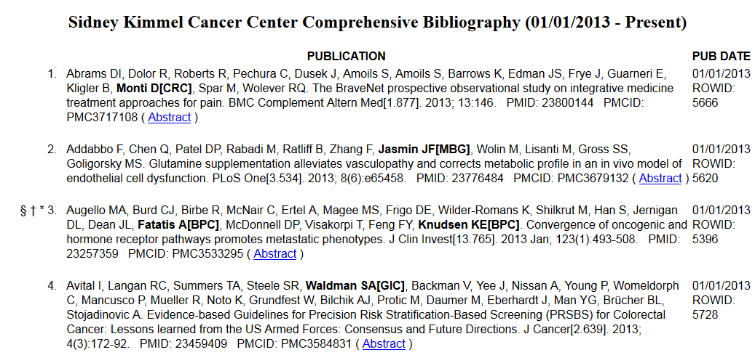

“Sidney Kimmel Cancer Center” is being loaded from systemconf table. It is a 2 or 3 column table. The first includes optional numbering and publication markings
+ - plus -- inter-programmatic publication (none in list above)
* - astericks - intra-programmatic publication
† - dagger – High-impact journal (IF > 10) {optional}
‡ - double-dagger – Reasonably High-impact journal (IF > 9 but < 10) {optional} (none in list
above)
§ - section – Intra-consortium publication {optional]

For author or center-wide listings, a publication is considered inter-programmatic(+) if there is more than one member-author, more than one center program is involved and no one center program contains all the member-authors for this publication. So if a publication has J DOE[1,2] and J SMITH[3] as authors it is inter-programmatic(+). However if it had J DOE[1,2] and S JOHNSON[2] it is not because all the author members are in program 2.
For author or center-wide listings, a publication is intra-programmatic(*) if any program has more than one member-author. So if a publication has J DOE[1,2] and J SMITH[3] as authors it is NOT intra-programmatic(*). However if it had J DOE[1,2] and S JOHNSON[2] it is intra-programmatic(*) more than one member author is in in program 2.
For author or center-wide listings, a publication with J DOE[1,2], J SMITH[3] and S JOHNSON[2] would be both intra-programmatic(*) and inter-programmatic(+).
For program listings, a publication is considered inter-programmatic if there is a member not from the currently selected program So if a publication has J DOE[1,2] and J SMITH[3] as authors it is inter-programmatic(+) in a listing for Programs 1, 2 or 3. If a publication t had J DOE[1,2] and S JOHNSON[2] as author members it would be inter-programmatic(+) in a Program 1 listing and intra-programmatic(*) in a Program 2 listing.
For program listings, a publication with J DOE[1,2], J SMITH[3] and S JOHNSON[2] as author members would be both inter-programmatic(+) in listings for Programs 1 and 3. It would be intra and inter-programmatic (+*) in listings for Program 2 (only inter- because of J SMITH[3]).
I’ve never really seen guidelines on this from NCI on intra/inter-programmatic publications – but the above system seems logical to me.
Marking an IF > 9 because several highly thought of Journals are in that range: PNAS, Cancer Research and Blood just to name a few.
The second column contains the publication text. All members emboldened (in program publication listings they may also be italicized) and include the program affiliation for this particular program structure {selected in publication display menu]. The PubMed ID and PubMedCentral IDs may also be displayed as they are above. The Journal Impact Factor (UK for unknown) may [optional] be displayed in brackets after the Journal Name. A link to the PubMed abstract can also be displayed if requested.
The whole third column is optional and can be omitted totally. If included, it will have the Publication Date and optionally the internal publication row id.

Depending on options selected the footer of the report looks like this (not form same report as above this is for the Biology of Prostate Cancer Program):
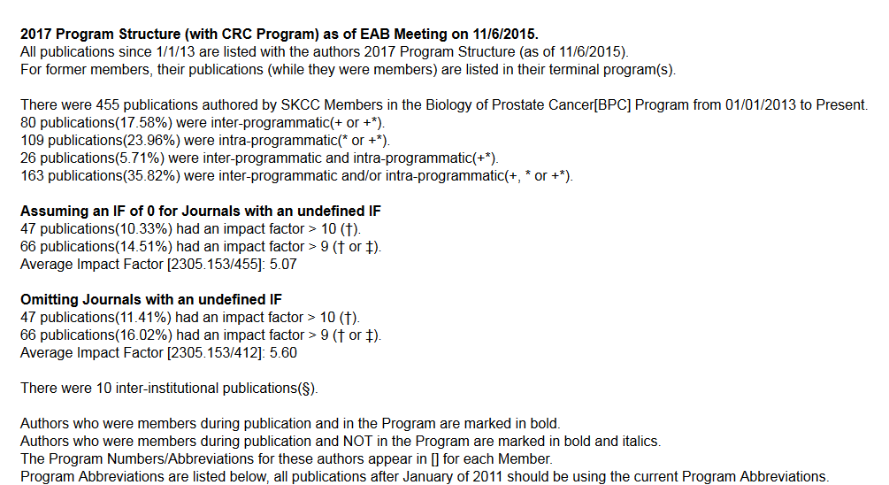

The label at top of footer (all 3 lines) comes from systemconf table and in this case is the second proposed structure.
The second block is the inter/intra –programmatic statistic calculations.
The third and fourth blocks are optional Impact Factor Statistics. The third counts publications in Journals without an IF as having an IF of 0 (I may be dropping this one). The fourth omits publications from Journals without an IF (this should be the valid measurement because usually only newer journals do not have IFs). The real measure is probably somewhere in between.
The final part of the footer is:
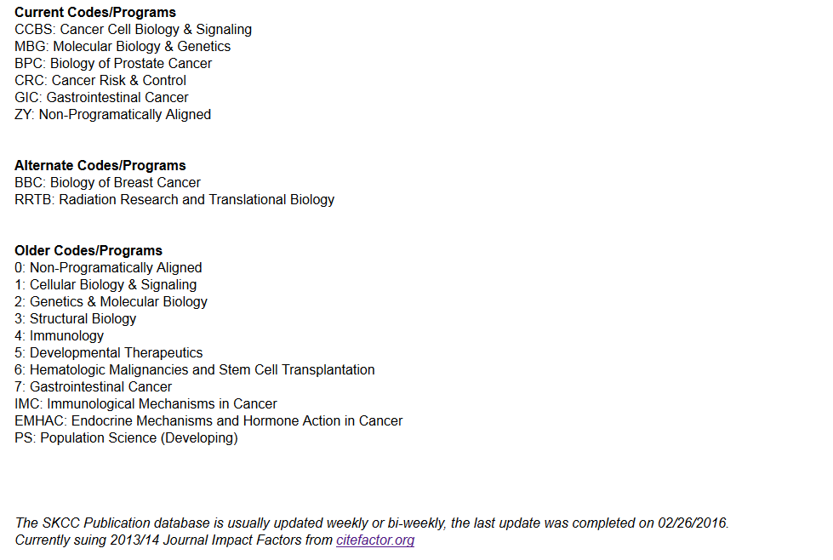
The active Program Codes associated with the currently selected program scenario are listed first. The alternate program codes and older codes (which theoretically should not show up except for a report that goes way back) are listed after the current codes.
There is a line which reads the last update date and center name abbreviation from the sytemconf table and reports it.
journalsummary.php – called form the bottom of the publication display menu. . It does not require authentication or authorization and can be accessed out sided of the application directly by url. To that point parameters are sent to it by the publication display menu via GET so that the url can be shared. Displays a count of publications stored for each journal by year. Journals are sorted by Impact Factor. This script also does not include the standard header and footer.
