Vidzemes University of Applied Sciences
Faculty of Engineering

mobile programming engineering 1
group G-02-2026

practical assignment #4
Link to repository: https://github.com/karluga/via-2026-android-pw4

Valmiera, 2026

CONTENT
1 How the CALC was made, what was used? 3
2 Core Components 4

File History:
Date: 21/10/2026
Authors: Kārlis & Andrejs
Changes: Full Documentation

Contacts and authors
Name, Surname | Department | Position | Contacts (e-mail)
Kārlis Ivars Braķis | Group #2 | Coordinator | karlisivars.brakis@va.lv
Andrejs Ņesterovičs | Group #2 | Developer | andrejs.nesterovics@va.lv

How the CALC was made, what was used?

Key Features & Requirements
1. Basic Arithmetic Operations ( + ) ( - ) ( * ) ( / )
2. Memory Operations
- MS (Memory Save): Saves the currently displayed number into memory while the application is running. A memory chip (M: <value>) appears on screen when memory contains a value.
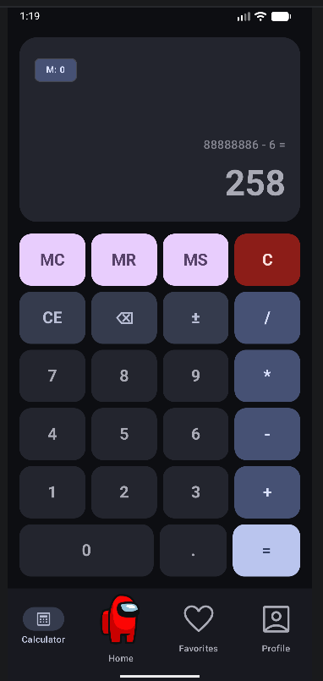
- MR (Memory Read): Retrieves the number saved in memory and inputs it into the current calculation display.
Figure 1. Calculator
- MC (Memory Clear): Clears the saved memory value (resets memory to null).
3. Utility & Navigation Controls
- C (Clear): Clears current input and expression history.
- CE (Clear Entry): Resets the current display input to "0".
- ⌫ Deletes the last entered character from the display.
- ± Toggles between positive and negative numbers.
- . (Decimal Point): Allows decimal fraction entries (prevents duplicate decimal points).
- = (Equals): Calculates and displays the result.

Core Components

1. State Definition (CalculatorUiState)
The state of the calculator is encapsulated in an immutable data class:
data class CalculatorUiState(
val display: String = "0",
val expression: String = "",
val memory: Double? = null,
val previousOperand: Double? = null,
val pendingOperation: String? = null,
val isNewInput: Boolean = true,
val isError: Boolean = false
)

2. ViewModel & Business Logic (CalculatorViewModel)
The CalculatorViewModel holds the CalculatorUiState in a StateFlow and exposes user actions to mutate state predictably.
Memory Operations Example (MS, MR, MC):
// Save current display to memory
fun onMemorySave() {
_uiState.update { state ->
val currentVal = state.display.toDoubleOrNull()
if (currentVal != null && !state.isError) {
state.copy(
memory = currentVal,
isNewInput = true
)
} else {
state
}
}
}
// Read saved value from memory onto display
fun onMemoryRead() {
_uiState.update { state ->
if (state.memory != null) {
state.copy(
display = formatResult(state.memory),
isNewInput = true,
isError = false
)
} else {
state
}
}
}
// Clear memory
fun onMemoryClear() {
_uiState.update { state ->
state.copy(memory = null)
}
}

Arithmetic Calculation & Precise Formatting:
To eliminate floating-point representation anomalies (such as 0.1 + 0.2 = 0.30000000000000004), calculation outputs are rounded and formatted cleanly using BigDecimal:
private fun performCalculation(num1: Double, num2: Double, op: String): Double? {
return when (op) {
"+" -> num1 + num2
"-" -> num1 - num2
"*" -> num1 * num2
"/" -> if (num2 == 0.0) null else num1 / num2
else -> null
}
}
companion object {
fun formatResult(value: Double): String {
if (value.isNaN() || value.isInfinite()) return "Error"
return try {
val bd = BigDecimal(value.toString())
.setScale(10, RoundingMode.HALF_UP)
.stripTrailingZeros()
bd.toPlainString()
} catch (_: Exception) {
value.toString()
}
}
}

Division by 0 is also handled in performCalculation

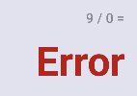
Figure 2. Error message after trying to divide by zero

3. Jetpack Compose UI (CalculatorScreen)
The user interface uses Material 3 components (Card, Button, AssistChip) in a responsive grid constructed with weighted rows:
@Composable
fun CalculatorScreen(
modifier: Modifier = Modifier,
viewModel: CalculatorViewModel = viewModel()
) {
val uiState by viewModel.uiState.collectAsState()
Column(
modifier = modifier
.fillMaxSize()
.padding(16.dp),
verticalArrangement = Arrangement.SpaceBetween
) {
// Display Section
Card(
modifier = Modifier.fillMaxWidth().weight(0.35f),
colors = CardDefaults.cardColors(containerColor = MaterialTheme.colorScheme.surfaceVariant),
shape = RoundedCornerShape(24.dp)
) {
Column(modifier = Modifier.fillMaxSize().padding(20.dp)) {
// Memory indicator chip
if (uiState.memory != null) {
AssistChip(
onClick = { viewModel.onMemoryRead() },
label = { Text("M: ${CalculatorViewModel.formatResult(uiState.memory!!)}") }
)
}
// Pending expression & main display
Text(text = uiState.expression, style = MaterialTheme.typography.titleMedium)
Text(text = uiState.display, style = MaterialTheme.typography.displayLarge)
}
}
// Calculator Keypad
Column(modifier = Modifier.fillMaxWidth().weight(0.65f)) {
// Memory Row: MC, MR, MS, C
Row(modifier = Modifier.weight(1f)) {
CalcButton("MC", Modifier.weight(1f)) { viewModel.onMemoryClear() }
CalcButton("MR", Modifier.weight(1f)) { viewModel.onMemoryRead() }
CalcButton("MS", Modifier.weight(1f)) { viewModel.onMemorySave() }
CalcButton("C", Modifier.weight(1f)) { viewModel.onClearClick() }
}
// Additional operation rows...
}
}
}

