HW1

Kungang Zhang

January 23, 2017

# Prob 1)

## Answer:

Joint density:

$$f(y;μ,σ^{2})∝\frac{1}{σ^{n}}exp\{−\frac{\sum_{i=1}^{n}{(}y_{i}−μ)^{2}}{2σ^{2}}\}$$

We already know that the MLE of $μ$ is that $\hat{μ}=\overline{y}$. Take derivatives w.r.t $σ$ and set it equal to $0$, we get

$$−n/σ^{n+1}+\sum_{i=1}^{n}{(}y_{i}−\overline{y})^{2}/σ^{n+3}=0$$

So we get

$$\hat{σ}=\sqrt{\frac{1}{n}\sum_{i=1}^{n}{(}y_{i}−\overline{y})^{2}}$$

# Prob 2)

rm(list = ls())  
setwd("/Users/kungangzhang/Documents/OneDrive/Northwestern/Study/Courses/MSiA-420-0/HW1")  
library(gdata)

## gdata: read.xls support for 'XLS' (Excel 97-2004) files ENABLED.

##

## gdata: read.xls support for 'XLSX' (Excel 2007+) files ENABLED.

##   
## Attaching package: 'gdata'

## The following object is masked from 'package:stats':  
##   
## nobs

## The following object is masked from 'package:utils':  
##   
## object.size

df <- read.xls("./HW1_data.xls", sheet = 1, header = TRUE)  
df <- df[, c("y", "x")]  
set.seed(111)

## (a)Linear model

## Answer: coef equals to 29.62201 13.44881

mod1<-lm(I(y^(-1))~I(x^(-1)),data = df)  
summary(mod1)

##   
## Call:  
## lm(formula = I(y^(-1)) ~ I(x^(-1)), data = df)  
##   
## Residuals:  
## Min 1Q Median 3Q Max   
## -0.056684 -0.004123 0.000694 0.002766 0.063565   
##   
## Coefficients:  
## Estimate Std. Error t value Pr(>|t|)   
## (Intercept) 0.033759 0.006684 5.051 0.000118 ***  
## I(x^(-1)) 0.454014 0.020061 22.632 1.41e-13 ***  
## ---  
## Signif. codes: 0 '***' 0.001 '**' 0.01 '*' 0.05 '.' 0.1 ' ' 1  
##   
## Residual standard error: 0.02175 on 16 degrees of freedom  
## Multiple R-squared: 0.9697, Adjusted R-squared: 0.9678   
## F-statistic: 512.2 on 1 and 16 DF, p-value: 1.411e-13

ga_mod1 <- c(1/mod1$coefficients[1],mod1$coefficients[2]/mod1$coefficients[1])  
ga_mod1

## (Intercept) I(x^(-1))   
## 29.62201 13.44881

## (b)Nonlinear model

## Answer: coef of nlm() equals to 28.13688 12.57428; coef of nls() equals to 28.13705 12.57445.

fn <- function(ga) {  
 yhat <- ga[1] * df$x/(ga[2] + df$x)  
 sum((df$y - yhat)^2)  
}  
out2 <- nlm(fn, p = ga_mod1, hessian = TRUE)  
summary(out2)

## Length Class Mode   
## minimum 1 -none- numeric  
## estimate 2 -none- numeric  
## gradient 2 -none- numeric  
## hessian 4 -none- numeric  
## code 1 -none- numeric  
## iterations 1 -none- numeric

out2$estimate

## [1] 28.13688 12.57428

Fitfun <- function(x, ga) ga[1] * x/(ga[2] + x)  
mod2 <- nls(y ~ Fitfun(x, ga), data = df, start = list(ga = ga_mod1))  
summary(mod2)

##   
## Formula: y ~ Fitfun(x, ga)  
##   
## Parameters:  
## Estimate Std. Error t value Pr(>|t|)   
## ga1 28.1370 0.7280 38.65 < 2e-16 ***  
## ga2 12.5745 0.7631 16.48 1.85e-11 ***  
## ---  
## Signif. codes: 0 '***' 0.001 '**' 0.01 '*' 0.05 '.' 0.1 ' ' 1  
##   
## Residual standard error: 0.5185 on 16 degrees of freedom  
##   
## Number of iterations to convergence: 4   
## Achieved convergence tolerance: 4.347e-07

mod2$m$getPars()

## ga1 ga2   
## 28.13705 12.57445

# Prob 3)

## (a)Observed Fisher information matrix and the covariance matrix of the estimated parameter using the Hessian produced by nlm(). Calculate the standar errors of the estimated parameters.

## Answer: SE for estimators are 0.7418084 0.7795476

#For Gaussian errors, the observed Fisher Information matrix equals to the Hessian(SSE)/2/MSE  
MSE <- out2$minimum/(length(df$y)-length(out2$estimate)) #estimate of the error variance  
InfoMat <- out2$hessian/2/MSE #observed information matrix  
CovTheta<-solve(InfoMat)  
SE<-sqrt(diag(CovTheta)) #standard errors of parameter estimates  
MSE

## [1] 0.2688919

CovTheta

## [,1] [,2]  
## [1,] 0.5502797 0.5430248  
## [2,] 0.5430248 0.6076944

SE

## [1] 0.7418084 0.7795476

## (b)Use vcov() applied to the output of nls() to calculate covariance and then standard errors.

## Answer: SE for estimators are 0.7279790 0.7630534. It is similar to what we get from part (a), but smaller.

## Question: How vcov() estimate the covariance of a model? Bootstrap?

cov_mod2<-vcov(mod2)  
SE_mod2 <- sqrt(diag(cov_mod2))  
SE_mod2

## ga1 ga2   
## 0.7279790 0.7630534

## (c)Use part (a) and confint.default() applied to the output of nls() to get CIs of gamma, respectively, and compare

## Answer: The 95% two-sided CI from part (a) is [26.76612 11.13378] (lower bound) and [29.50765 14.01479] (upper bound); the confint.default(mod2) gives [26.71024 11.07890] (lower bound) and [29.56386 14.07001] (upper bound)

## Question: From the help file, "confint is a generic function. The default method assumes asymptotic normality, and needs suitable coef and vcov methods to be available." But why the results are different? The difference in minimizer?

#The part (a) is asymmptotic results, assuming the normality  
#lower bound  
out2$estimate+qnorm(0.025,0,1)*SE

## [1] 26.68296 11.04640

#upper bound  
out2$estimate+qnorm(0.975,0,1)*SE

## [1] 29.59080 14.10217

confint.default(mod2)

## 2.5 % 97.5 %  
## ga1 26.71024 29.56386  
## ga2 11.07890 14.07001

# Prob 4)

## (a)Calculate and plot bootstrapped histograms of $\boldsymbol{\gamma}$, and calculate bootstrapped SE

## Answer:The histograms are the following plots. The SE of $\hat{γ_{0}}$ and $\hat{γ_{1}}$ are 0.7297492 0.7536710.

library(boot) #need to load the boot package  
fit<-function(Z,i,ga0,x_pred) {  
 #Z is the entire data set of replicates of boostrapping data  
 #i is for the i-th replicate  
 #theta0 is the starting point  
 #How to initialize during the bootstrapping?  
 Zboot<-Z[i,]  
 y<-Zboot[[1]];x<-Zboot[[2]];  
 fn <- function(ga) {yhat<-ga[1]*x/(ga[2]+x); sum((y-yhat)^2)}   
 out<-nlm(fn,p=ga0)  
 ga<-out$estimate #parameter estimates  
 y_pred<-ga[1]*x_pred/(ga[2]+x_pred)  
 c(ga,y_pred)}  
Probboot<-boot(df, fit, R=5000, ga0=ga_mod1,x_pred=27)#ga0 is just a constant parameters used in the fit function  
CovGa<-cov(Probboot$t[,1:2])#Probboot$t is just test-statistics of the parameters we are interested in (default is the last parameter of the function, here fit)  
SE<-sqrt(diag(CovGa))  
Probboot

##   
## ORDINARY NONPARAMETRIC BOOTSTRAP  
##   
##   
## Call:  
## boot(data = df, statistic = fit, R = 5000, ga0 = ga_mod1, x_pred = 27)  
##   
##   
## Bootstrap Statistics :  
## original bias std. error  
## t1* 28.13688 -0.09231511 0.7297492  
## t2* 12.57428 -0.05989065 0.7536710  
## t3* 19.19671 -0.03592575 0.2112369

CovGa

## [,1] [,2]  
## [1,] 0.5325339 0.5123663  
## [2,] 0.5123663 0.5680199

SE

## [1] 0.7297492 0.7536710

plot(Probboot,index=1) #index=i calculates results for ith parameter

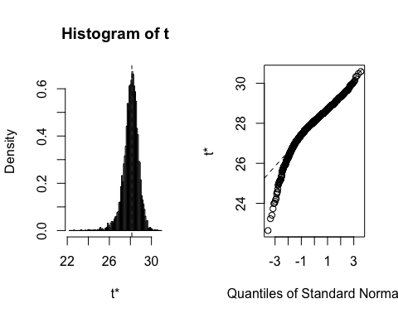

plot(Probboot,index=2) #index=i calculates results for ith parameter

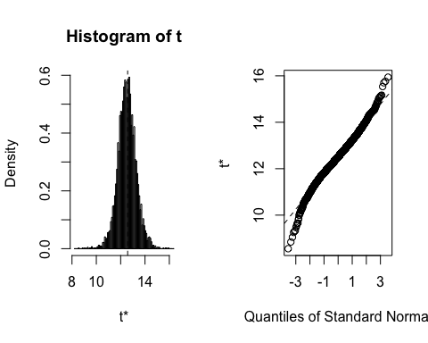

## (b)Calculate "crude" two-sided 95% CIs using normal app

## Answer: The crude: $γ_{0}$ (26.80, 29.66 ); $γ_{2}$ (11.16, 14.11 ).

boot.ci(Probboot,conf=c(.95),index=1,type=c("norm","basic"))#"norm" is the shifted (shifted by biase) CI; "basic" is the reflected CI (should also be shifted).

## BOOTSTRAP CONFIDENCE INTERVAL CALCULATIONS  
## Based on 5000 bootstrap replicates  
##   
## CALL :   
## boot.ci(boot.out = Probboot, conf = c(0.95), type = c("norm",   
## "basic"), index = 1)  
##   
## Intervals :   
## Level Normal Basic   
## 95% (26.80, 29.66 ) (26.97, 29.93 )   
## Calculations and Intervals on Original Scale

boot.ci(Probboot,conf=c(.95),index=2,type=c("norm","basic"))#"norm" is the shifted (shifted by biase) CI; "basic" is the reflected CI (should also be shifted).

## BOOTSTRAP CONFIDENCE INTERVAL CALCULATIONS  
## Based on 5000 bootstrap replicates  
##   
## CALL :   
## boot.ci(boot.out = Probboot, conf = c(0.95), type = c("norm",   
## "basic"), index = 2)  
##   
## Intervals :   
## Level Normal Basic   
## 95% (11.16, 14.11 ) (11.12, 14.14 )   
## Calculations and Intervals on Original Scale

## (c)Calculate reflected two-sided 95% CIs using normal app

## Answer: The reflected: $γ_{0}$ (26.97, 29.93 ); $γ_{0}$ (11.12, 14.14 ).

## (d)Do the CIs in part (c) agree with those in part (b)?

## Answer: Yes, they are pretty close, because the histograms are very close to normal.

# Prob 5)

## The CI's of predictable part and prediction interval. And compare them.

## Answer: The CI for predictable part: (18.91, 19.74); The PI: (18.14896 20.33852 ). The PI is wider. PI should be expected to contain the future response with roughly 95% chance, because the future response contains error and PI has counted for that.

#CI for predictable part:  
boot.ci(Probboot,conf=c(.95),index=3,type=c("norm","basic"))#"norm" is the shifted (shifted by biase) CI; "basic" is the reflected CI (should also be shifted).

## BOOTSTRAP CONFIDENCE INTERVAL CALCULATIONS  
## Based on 5000 bootstrap replicates  
##   
## CALL :   
## boot.ci(boot.out = Probboot, conf = c(0.95), type = c("norm",   
## "basic"), index = 3)  
##   
## Intervals :   
## Level Normal Basic   
## 95% (18.82, 19.65 ) (18.91, 19.74 )   
## Calculations and Intervals on Original Scale

#Prediction interval:  
e<-rnorm(nrow(Probboot$t), mean=0, sd=sqrt(MSE))   
Yboot<-Probboot$t[,3]-e#predicted response  
Yquant<-quantile(Yboot,prob=c(.025,.975))  
L<-2*Probboot$t0[3]-Yquant[2]  
U<-2*Probboot$t0[3]-Yquant[1]  
hist(Yboot,100)

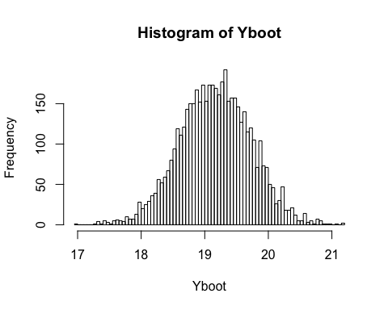

c(L,U) #more complex PI

## 97.5% 2.5%   
## 18.14896 20.33852

# Prob 6)

## Use AIC criterion to compare models from Prob 2)(b) and from Prob 6)

## Answer: The AIC for the two models are 1.628871 and 2.836148, so that AIC criterion suggests to take the first model.

n=nrow(df)  
FitFun1 <- function(x,ga) ga[1]*x/(ga[2]+x)  
out1<-nls(y~FitFun1(x,ga),data=df,start=list(ga=ga_mod1))  
summary(out1)

##   
## Formula: y ~ FitFun1(x, ga)  
##   
## Parameters:  
## Estimate Std. Error t value Pr(>|t|)   
## ga1 28.1370 0.7280 38.65 < 2e-16 ***  
## ga2 12.5745 0.7631 16.48 1.85e-11 ***  
## ---  
## Signif. codes: 0 '***' 0.001 '**' 0.01 '*' 0.05 '.' 0.1 ' ' 1  
##   
## Residual standard error: 0.5185 on 16 degrees of freedom  
##   
## Number of iterations to convergence: 4   
## Achieved convergence tolerance: 4.347e-07

AIC1<- -2*as.numeric(logLik(out1))/n+2*2/n  
AIC(out1)#The in-built AIC function has formula -logLik(out)+2*(p+1)

## [1] 31.31967

FitFun2 <- function(x,ga) ga[1]+ga[2]*sqrt(x)  
out2<-nls(y~FitFun2(x,ga),data=df,start=list(ga=ga_mod1))  
summary(out2)

##   
## Formula: y ~ FitFun2(x, ga)  
##   
## Parameters:  
## Estimate Std. Error t value Pr(>|t|)   
## ga1 -0.4566 0.5154 -0.886 0.389   
## ga2 3.7720 0.1401 26.918 9.41e-15 ***  
## ---  
## Signif. codes: 0 '***' 0.001 '**' 0.01 '*' 0.05 '.' 0.1 ' ' 1  
##   
## Residual standard error: 0.9483 on 16 degrees of freedom  
##   
## Number of iterations to convergence: 1   
## Achieved convergence tolerance: 3.418e-07

AIC2<- -2*as.numeric(logLik(out2))/n+2*2/n  
AIC(out2)#The in-built AIC function has formula -logLik(out)+2*(p+1)

## [1] 53.05066

# Prob 7)

## Use n-fold CV to compare models from Prob 2)(b) and from Prob 6)

## Answer: Basically I used different forms and R-functions to do the CV. The first two MSEs are based on nlm() for the two models; the third MSE is based on lm() for the second model; the last two MSEs are based on nls() for the two model. Those MSEs corresponding to the same model are slightly different probably because the minimizers are different. The MSE vector is $[0.29430331.11065381.11065520.29430151.1106553]$ (the first and the fourth corresponds to the model from Prob 2)(b)). So CV suggests we should use the model from Prob 2)(b).

#R commands for creating indices of partition for K-fold CV  
CVInd <- function(n,K) {   
 #n is sample size; K is number of parts; returns K-length list of indices for each part  
 m<-floor(n/K) #approximate size of each part  
 r<-n-m*K   
 I<-sample(n,n) #random reordering of the indices  
 Ind<-list() #will be list of indices for all K parts  
 length(Ind)<-K  
 for (k in 1:K) {  
 if (k <= r) kpart <- ((m+1)*(k-1)+1):((m+1)*k)   
 else kpart<-((m+1)*r+m*(k-r-1)+1):((m+1)*r+m*(k-r))  
 Ind[[k]] <- I[kpart] #indices for kth part of data  
 }  
 Ind  
}  
  
#Shell for running multiple random replicates of CV  
Nrep<-1 #number of replicates of CV  
n=nrow(df)  
K<-n #K-fold CV on each replicate  
n.models = 5 #number of different models to fit and compare  
y<-df$y  
x<-df$x  
yhat=matrix(0,n,n.models)  
MSE_cv<-matrix(0,Nrep,n.models)  
for (j in 1:Nrep) {  
 Ind<-CVInd(n,K)  
 for (k in 1:K) {#All models use exactly the samle CV partition  
 y_temp = y[-Ind[[k]]]  
 x_temp = x[-Ind[[k]]]  
   
 fn1 <- function(ga) {yhat_temp<-ga[1]*x_temp/(ga[2]+x_temp); sum((y_temp-yhat_temp)^2)}#the first model to compare  
 out<-nlm(fn1,p=ga_mod1,hessian=TRUE)  
 ga_temp<-out$estimate #parameter estimates  
 yhat[Ind[[k]],1]<-ga_temp[1]*x[Ind[[k]]]/(ga_temp[2]+x[Ind[[k]]])#The prediction part doesn't include random error  
 fn2 <- function(ga) {yhat_temp<-ga[1]+ga[2]*sqrt(x_temp); sum((y_temp-yhat_temp)^2)}#the second model to compare   
 out<-nlm(fn2,p=ga_mod1,hessian=TRUE)  
 ga_temp<-out$estimate #parameter estimates  
 yhat[Ind[[k]],2]<-ga_temp[1]+ga_temp[2]*sqrt(x[Ind[[k]]])#The prediction part doesn't include random error  
 out<-lm(y~I(x^(.5)),df[-Ind[[k]],]) #the second model to compare, just using different function to calculate, because it can be looked as a linear model. Should be the same as previous.  
 yhat[Ind[[k]],3]<-as.numeric(predict(out,df[Ind[[k]],]))  
 #Using nls() function to redo the CV for model 1 and model 2  
 out<-nls(y~FitFun1(x,ga),data=df[-Ind[[k]],],start=list(ga=ga_mod1))  
 yhat[Ind[[k]],4]<-as.numeric(predict(out,df[Ind[[k]],]))  
 out<-nls(y~FitFun2(x,ga),data=df[-Ind[[k]],],start=list(ga=ga_mod1))  
 yhat[Ind[[k]],5]<-as.numeric(predict(out,df[Ind[[k]],]))  
 } #end of k loop  
 MSE_cv[j,]=apply(yhat,2,function(x) sum((y-x)^2))/n  
} #end of j loop  
MSE_cv

## [,1] [,2] [,3] [,4] [,5]  
## [1,] 0.2943033 1.110654 1.110655 0.2943015 1.110655

MSEAve_cv<- apply(MSE_cv,2,mean); MSEAve_cv #averaged mean square CV error

## [1] 0.2943033 1.1106538 1.1106552 0.2943015 1.1106553

MSEsd_cv <- apply(MSE_cv,2,sd); MSEsd_cv #SD of mean square CV error

## [1] NA NA NA NA NA

r2<-1-MSEAve_cv/var(y); r2 #CV r^2

## [1] 0.9924874 0.9716485 0.9716484 0.9924874 0.9716484

# Prob 8)

## Use residual plots to determine which models we used to compare in Prob 6) and 7) is better.

## Answer: Obvious, the residual of model from Prob 6) is not independent of x, while the residual of model from Prob 2)(b) is more independent of x. So it suggests that the model from Prob 2) is better and it is consistent with the conclusions from Prob 6) and Prob 7).

#Residual plot for the model from Prob 2)(b) (nls() model with the entire dataset, out1)  
plot(df$x,resid(out1),ylab="Residuals", xlab="x", main="Enzyme kinetics-model from Prob 2)(b)")  
abline(0, 0)

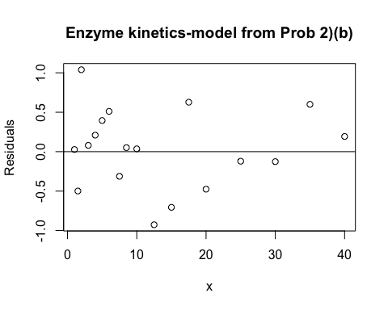

#Residual plot for the model from Prob 6 (nls() model with the entire dataset, out2)  
plot(df$x,resid(out2),ylab="Residuals", xlab="x", main="Enzyme kinetics-model from Prob 6)")  
abline(0, 0)

