Scrn_1

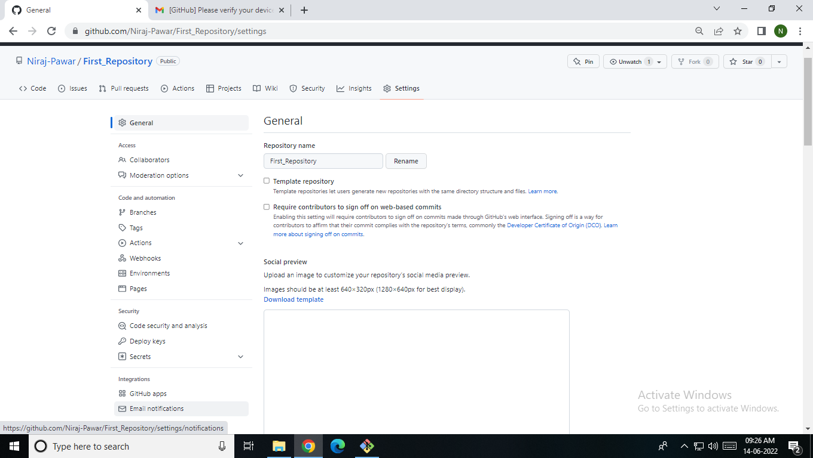

Scrn_2

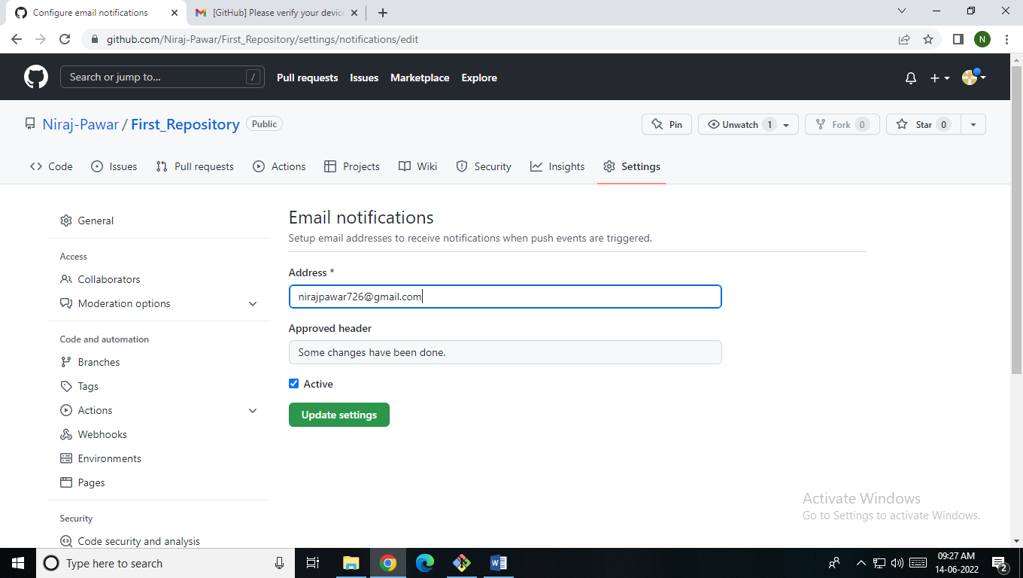

Scrn_3

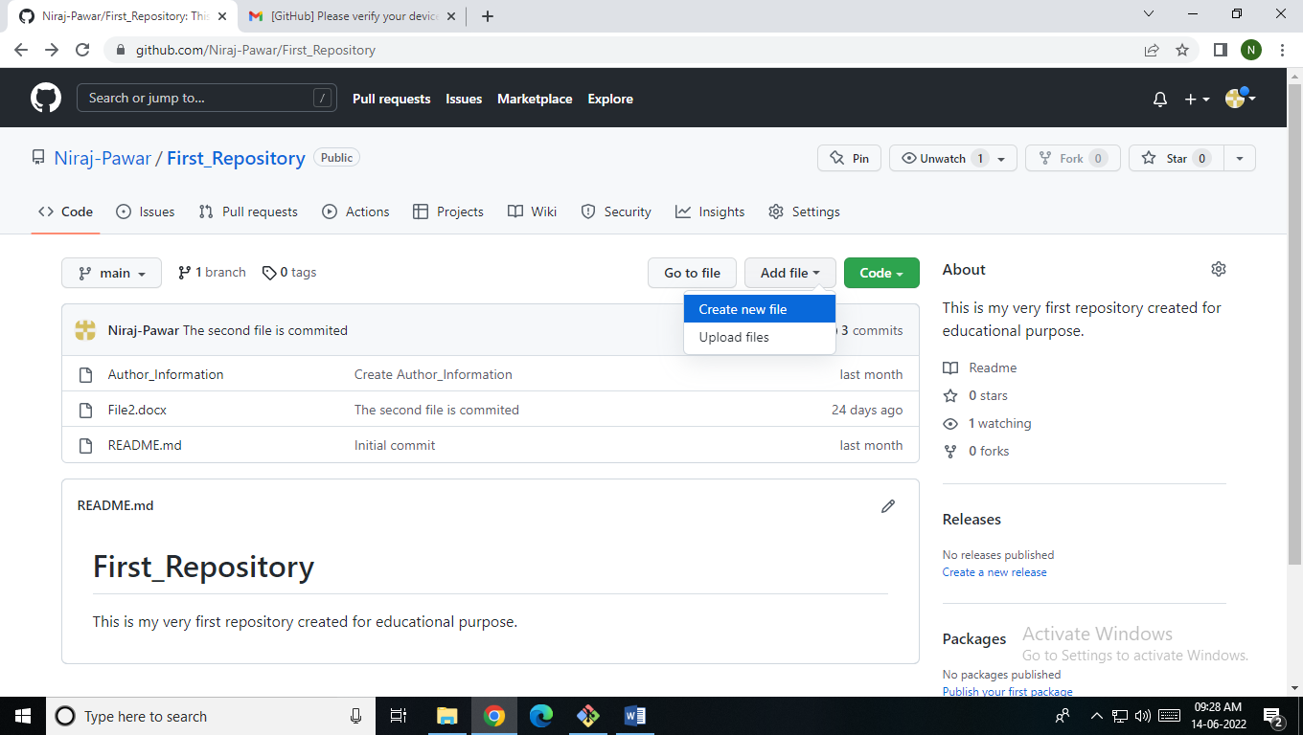

Scrn_4

comp@comp235 MINGW32 ~

$ git clone https://github.com/Niraj-Pawar/First_Repository.git

Cloning into 'First_Repository'...

remote: Enumerating objects: 9, done.

remote: Counting objects: 100% (9/9), done.

remote: Compressing objects: 100% (8/8), done.

remote: Total 9 (delta 0), reused 3 (delta 0), pack-reused 0

Receiving objects: 100% (9/9), 10.05 KiB | 2.01 MiB/s, done.

Scrn_5

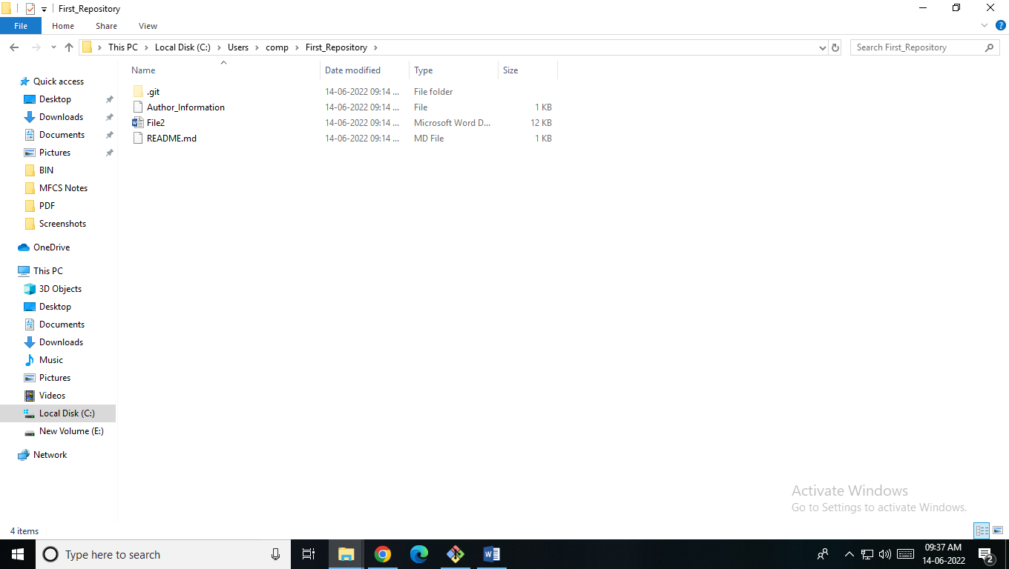

Scrn_6

  
scrn 7

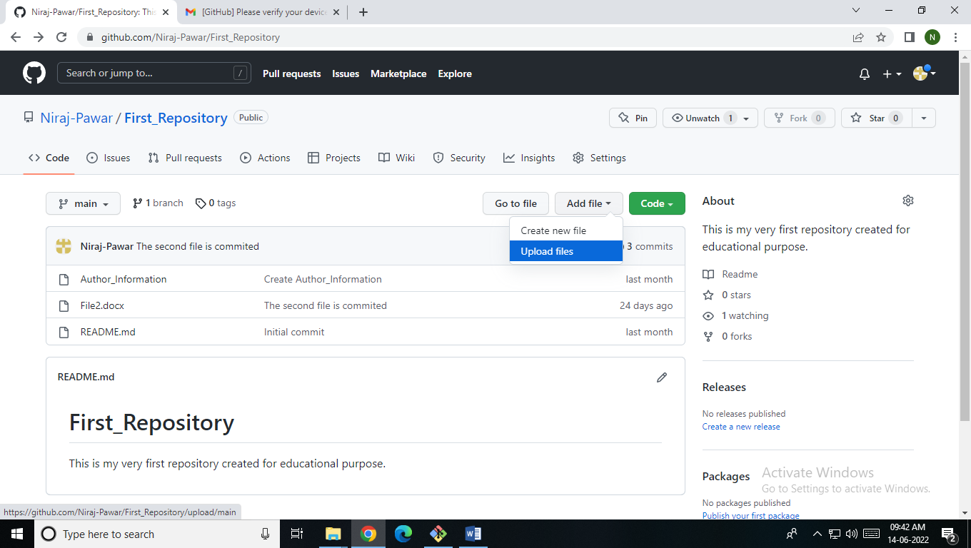

scrn_8

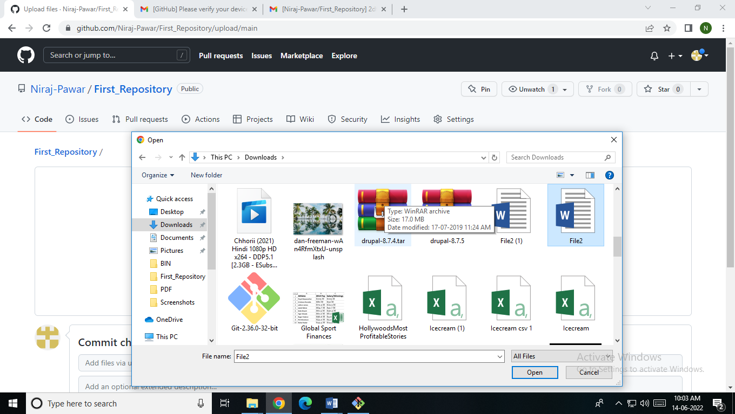

Scrn_9

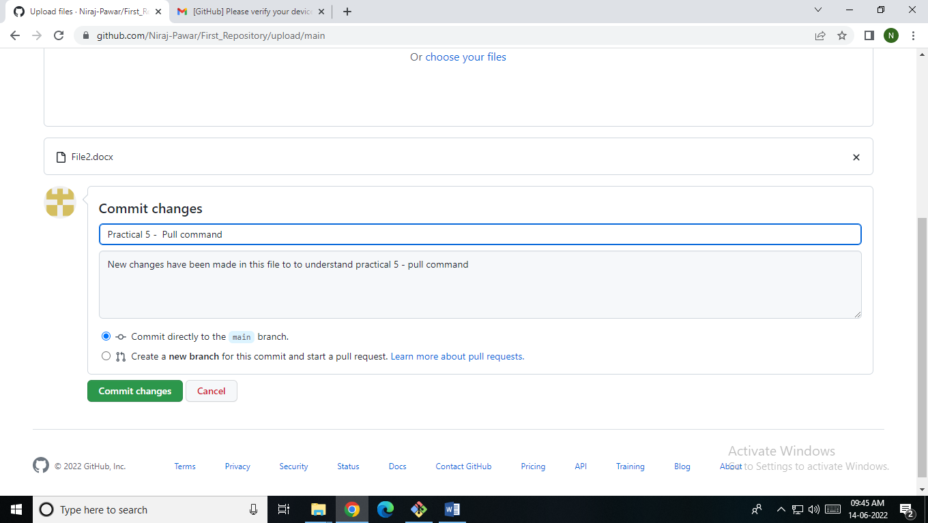

Scrn_10

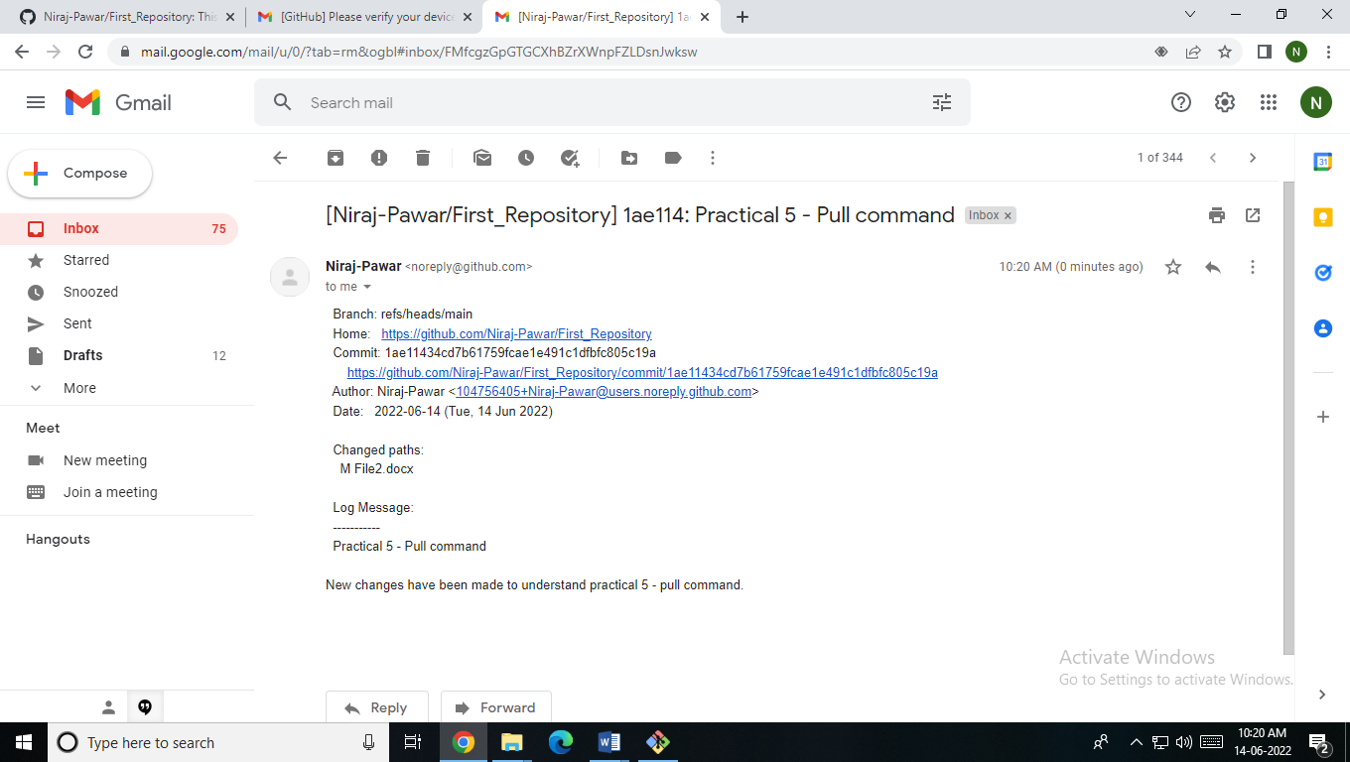

Scrn_11

comp@comp235 MINGW32 ~

$ cd First_Repository

comp@comp235 MINGW32 ~/First_Repository (main)

$ git init

Reinitialized existing Git repository in C:/Users/comp/First_Repository/.git/

Scrn_12

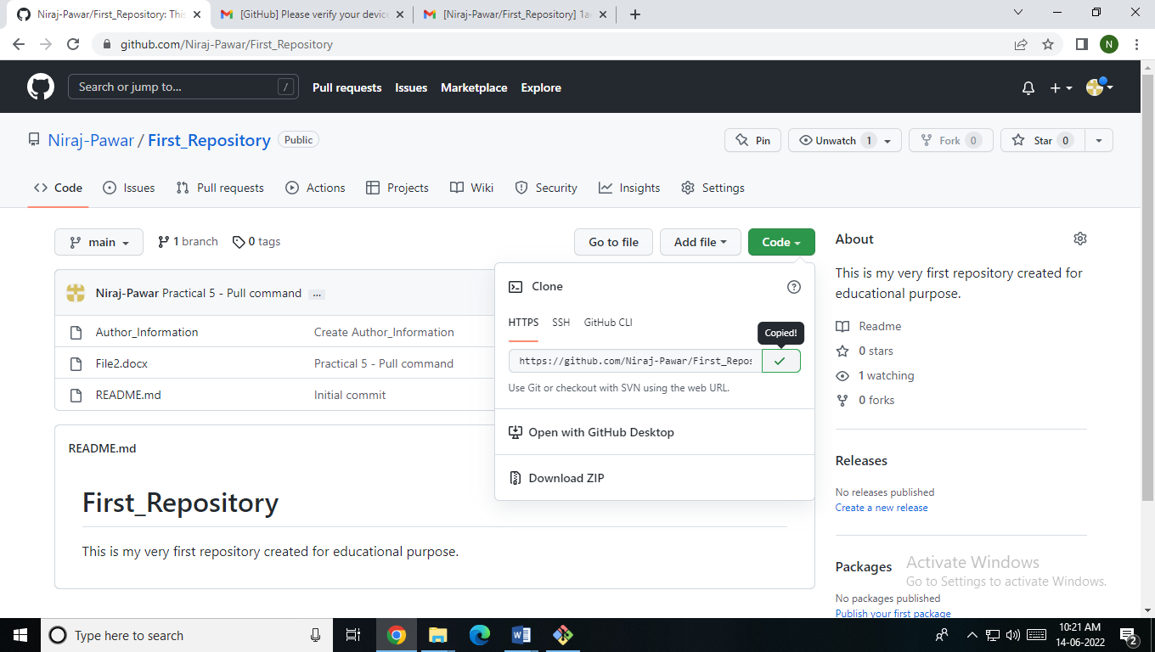

Scrn 13

comp@comp235 MINGW32 ~/First_Repository (main)

$ git pull https://github.com/Niraj-Pawar/First_Repository.git

remote: Enumerating objects: 1, done.

remote: Counting objects: 100% (1/1), done.

remote: Total 1 (delta 0), reused 0 (delta 0), pack-reused 0

Unpacking objects: 100% (1/1), 621 bytes | 88.00 KiB/s, done.

From https://github.com/Niraj-Pawar/First_Repository

* branch HEAD -> FETCH_HEAD

Updating e8831e7..2df0b9c

Fast-forward

comp@comp235 MINGW32 ~/First_Repository (main)

$ git pull https://github.com/Niraj-Pawar/First_Repository.git

remote: Enumerating objects: 5, done.

remote: Counting objects: 100% (5/5), done.

remote: Compressing objects: 100% (3/3), done.

remote: Total 3 (delta 0), reused 0 (delta 0), pack-reused 0

Unpacking objects: 100% (3/3), 10.37 KiB | 442.00 KiB/s, done.

From https://github.com/Niraj-Pawar/First_Repository

* branch HEAD -> FETCH_HEAD

Updating 2df0b9c..1ae1143

Fast-forward

File2.docx | Bin 11274 -> 12648 bytes

1 file changed, 0 insertions(+), 0 deletions(-)

Scrn_14

