**WHERE**

-- SELECT * FROM BOOKS

-- WHERE BOOK_GENRE = 'Drama'

δ

BOOK_GENRE=‘Drama’ (BOOKS)

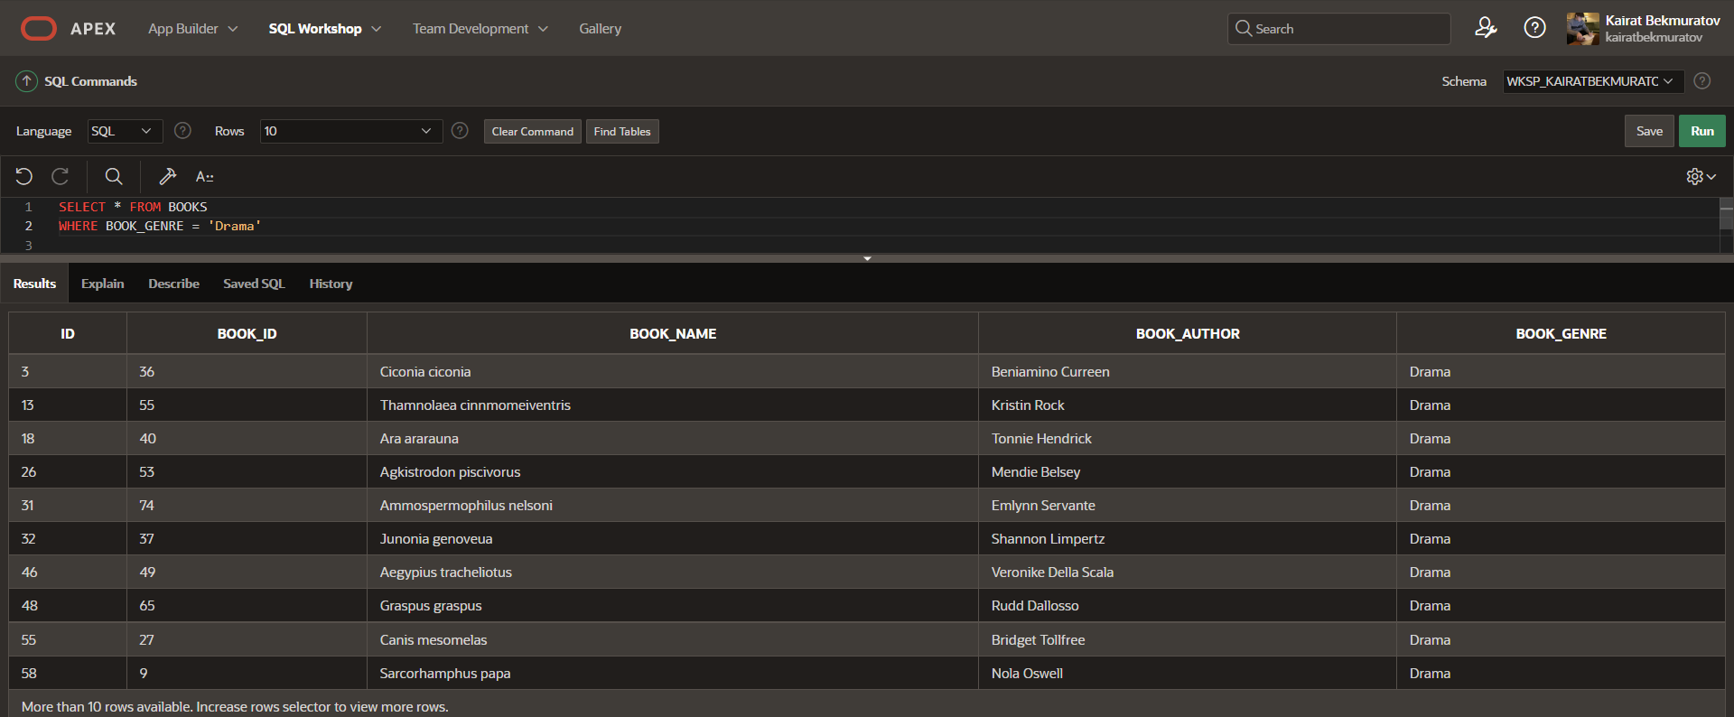

**HAVING**

-- SELECT COUNT(DEPARTMENT_ID)

-- FROM DEPARTMENT

-- HAVING COUNT(DEPARTMENT_ID) > 5;

π COUNT (department_id)

σ COUNT (department_id) > 5

γ COUNT (department_id) (department)

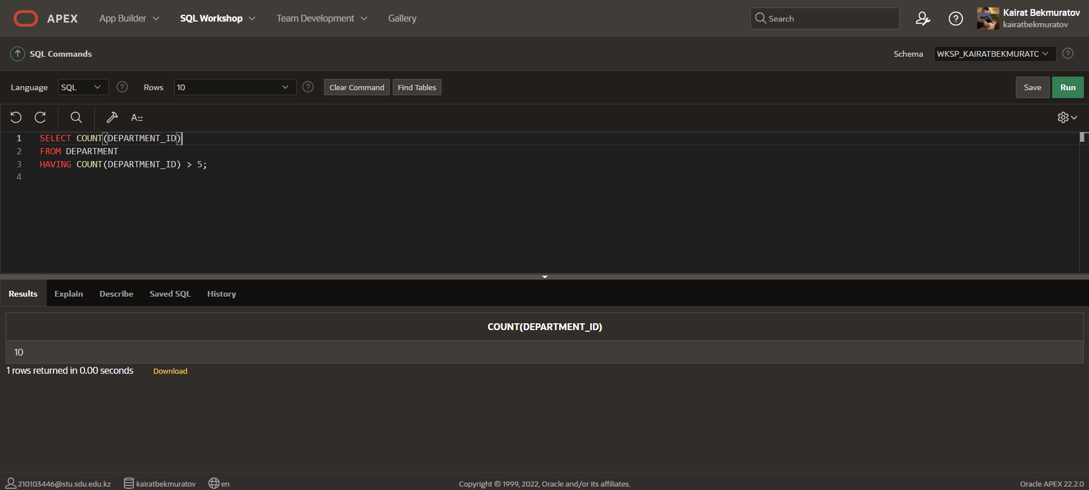

**GROUP BY**

-- SELECT COUNT(CREDITS), COURSE_NAME

-- FROM COURSE

-- GROUP BY COURSE_NAME

γ course_name, COUNT (credits) (course)

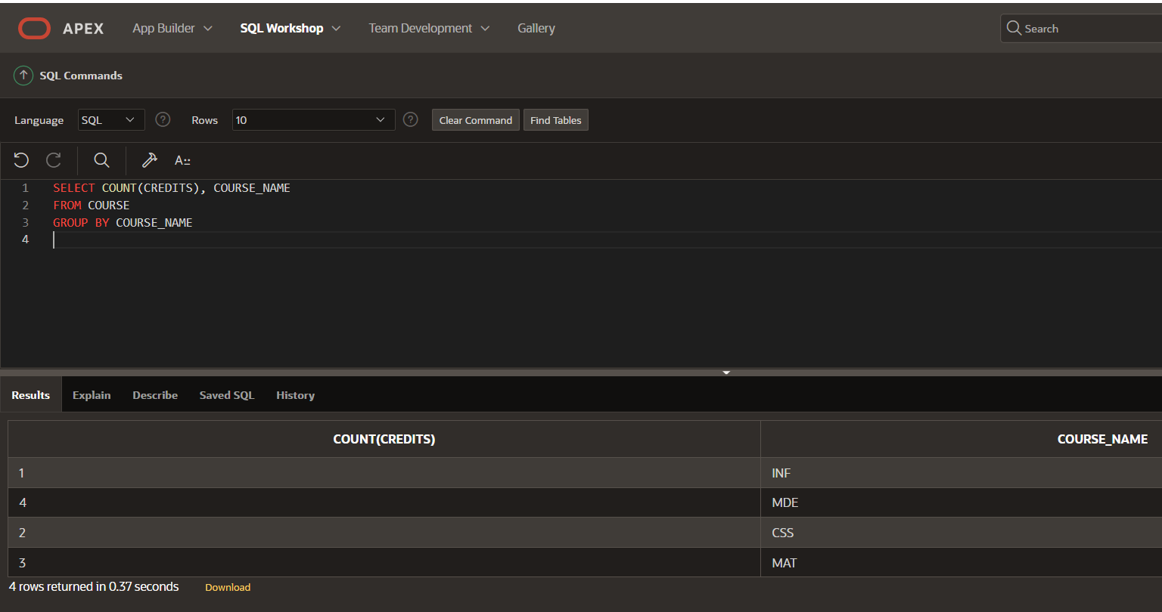

**AND**

-- SELECT * FROM COURSE

-- WHERE CREDITS ='5' AND COURSE_NAME='MAT'

σ credits = "5" AND course_name = "MAT" (course)

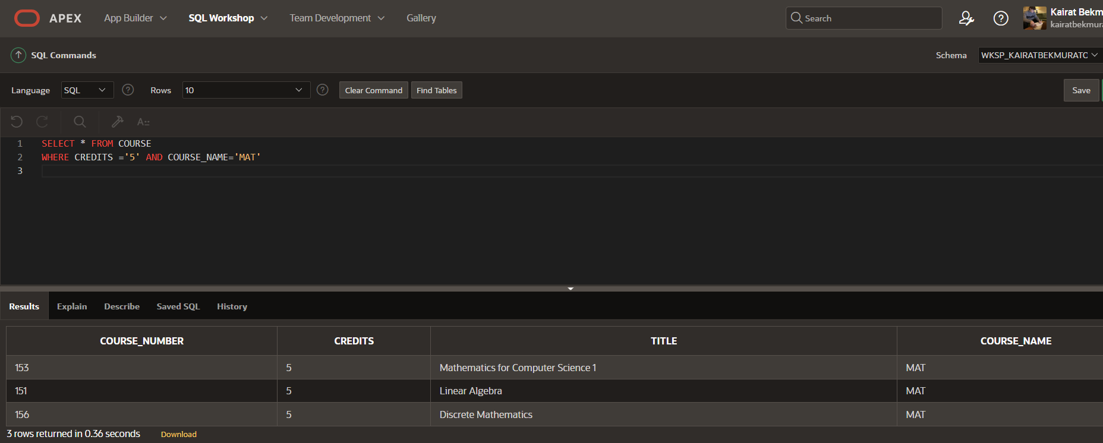

**OR**

-- SELECT * FROM PROFESSOR

-- WHERE P_FIRST_NAME = 'Kellen' OR P_ID = '20'

σ p_first_name = "Kellen" OR p_id = "20" (professor)

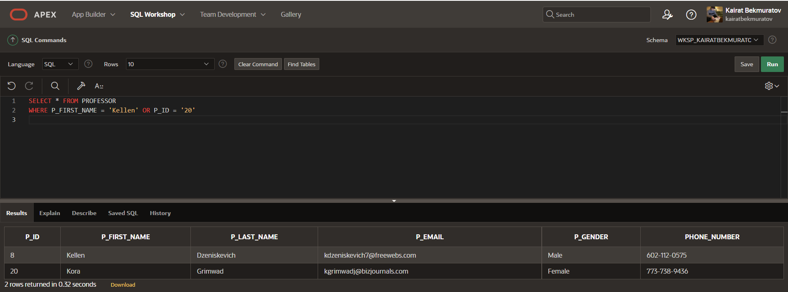

**NOT**

-- SELECT * FROM FACULTY

-- WHERE NOT DEPARTMENT = 'Economy'

σ NOT (department = "Economy") (faculty)

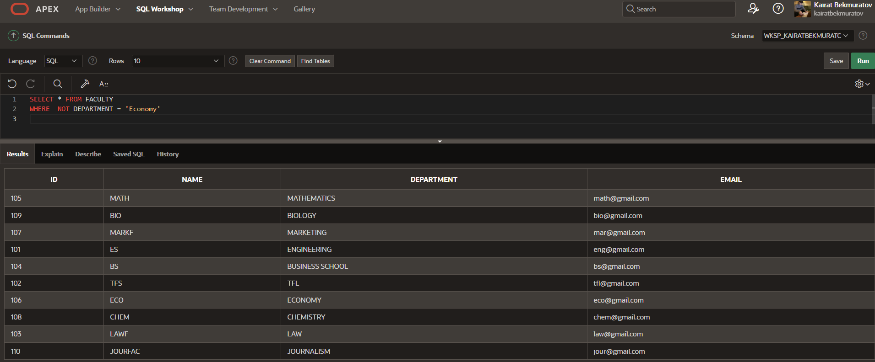

**COUNT**

-- SELECT COUNT(GPA)

-- FROM STUDENT

π COUNT (gpa)

γ COUNT (gpa) (student)

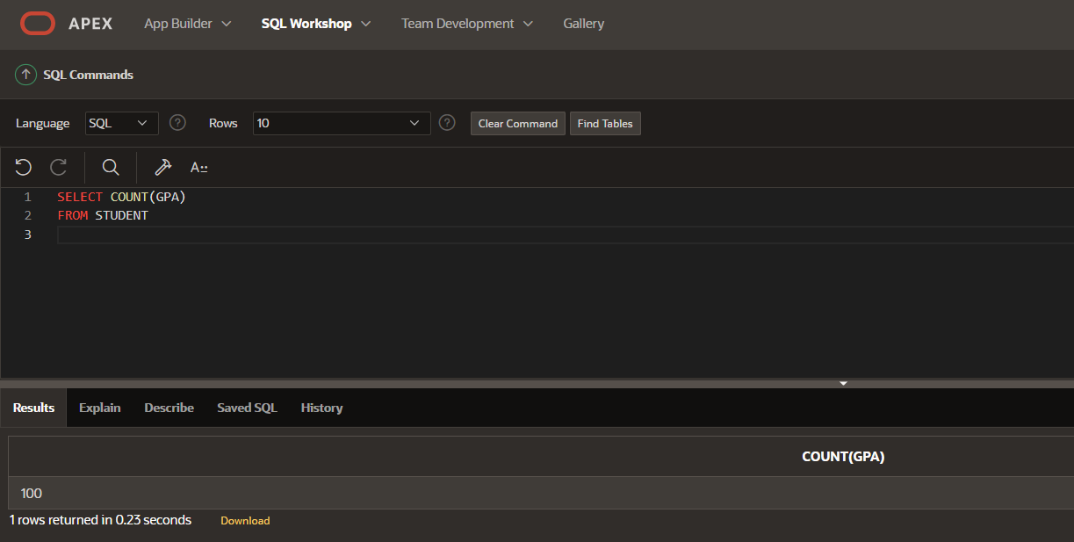

**AVG**

-- SELECT AVG(GPA)

-- FROM STUDENT

π AVG (gpa)

γ AVG (gpa) (student)

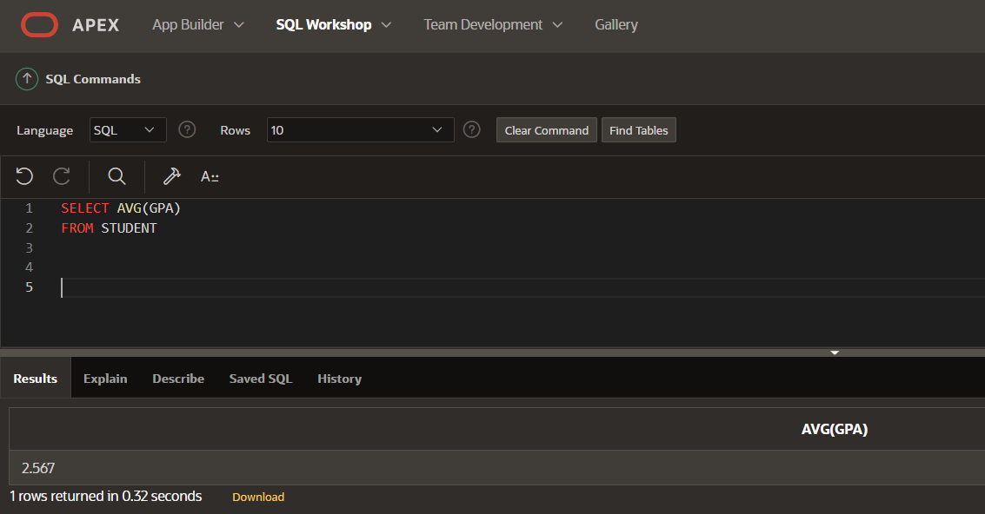

**SUM**

-- SELECT SUM(GPA)

-- FROM STUDENT

π SUM (gpa)

γ SUM (gpa) (student)

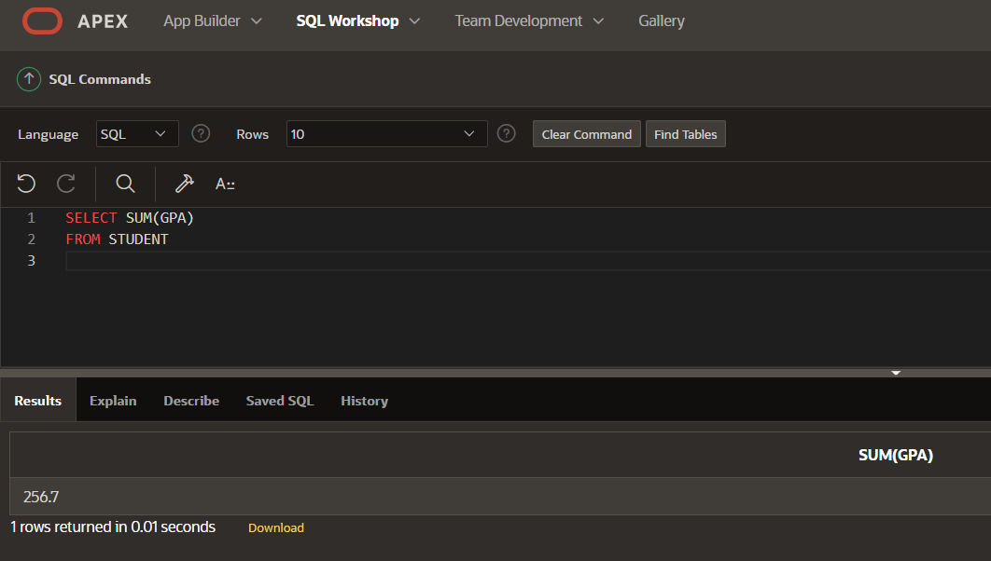

**AS(ALIASES)**

-- SELECT DEPARTMENT_NAME AS DEPARTMENT_ID

-- FROM DEPARTMENT;

π department_name → department_id (department)

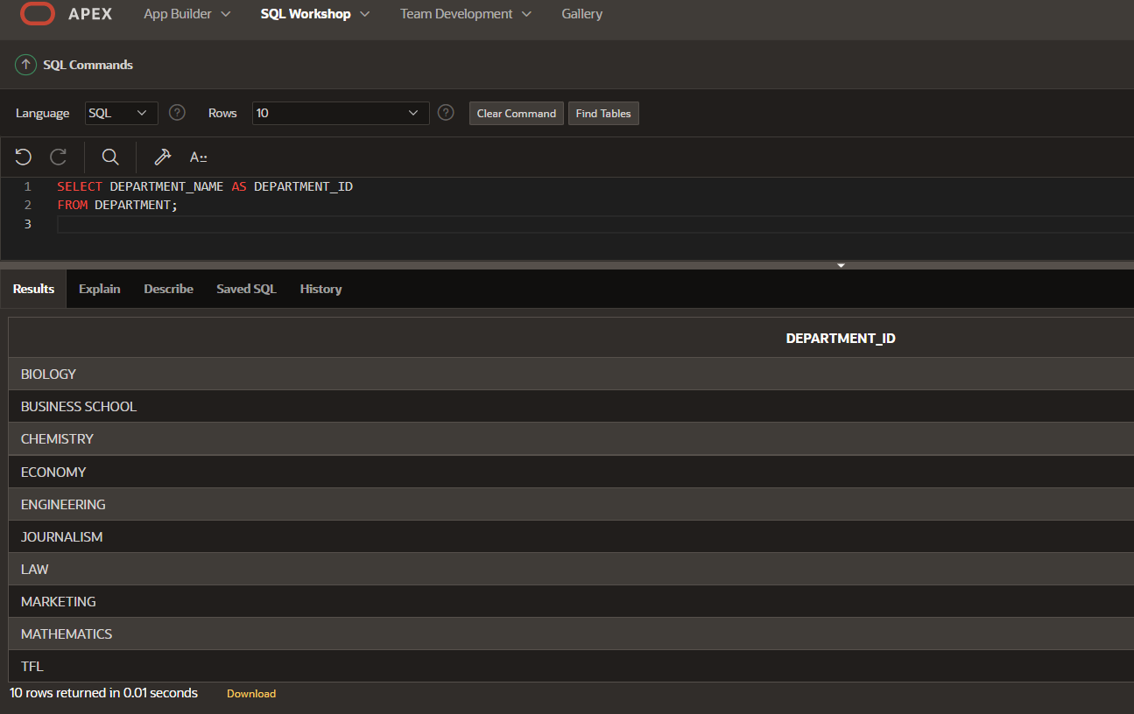

**FULL JOIN**

-- SELECT DEPARTMENT_NAME

-- FROM DEPARTMENT

-- FULL OUTER JOIN FACULTY

-- ON DEPARTMENT.DEPARTMENT_NAME = FACULTY.DEPARTMENT

π department_name ((department) ⋈o department.department_name = faculty.department (faculty))

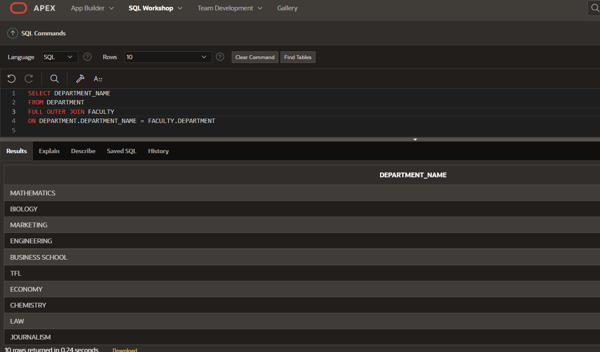

**ORDER BY**

SELECT FIRST_NAME,LAST_NAME,GPA, FACULTY FROM Student

ORDER BY FIRST_NAME ASC, GPA DESC, FACULTY ASC

τ first_name, gpa↓, faculty

(Student)

π first_name, last_name, gpa, faculty

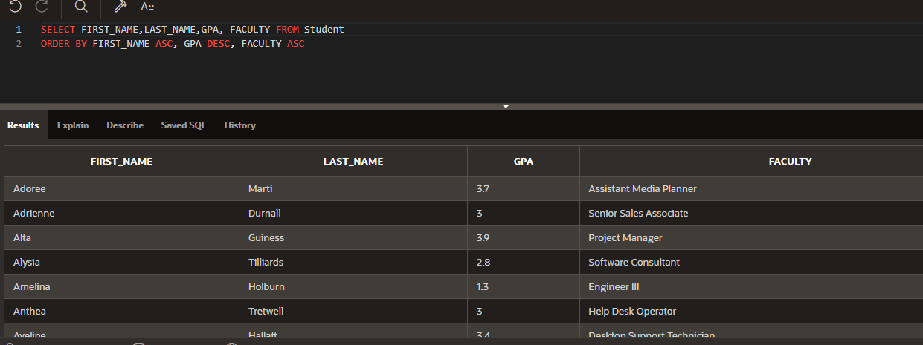

**LIKE**

SELECT * FROM PROFESSOR

WHERE P_FIRST_NAME LIKE '_a%' AND P_LAST_NAME LIKE '_a%'

ORDER BY Phone_Number ASC;

τ phone_number

(professor)

σ p_first_name LIKE "_a%" AND p_last_name LIKE "_a%"

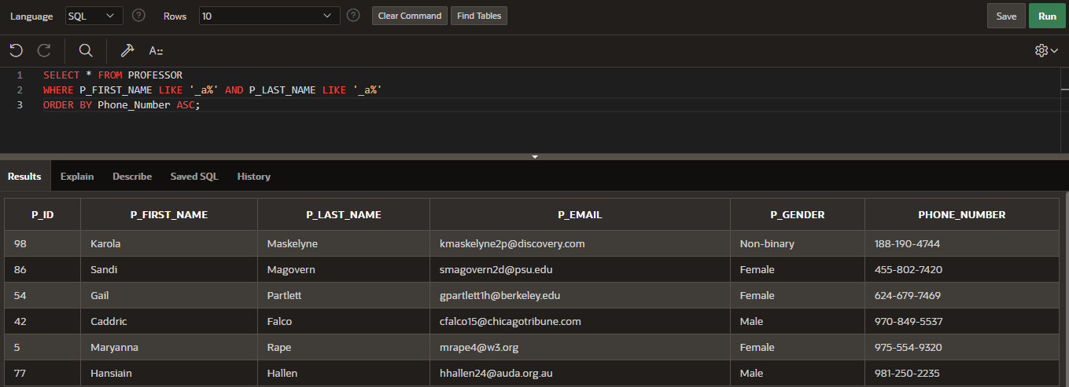

**IN**

SELECT FIRST_NAME, LAST_NAME from Hostel

WHERE AGE IN ('20', '21', '22') AND FIRST_NAME LIKE '%a'

ORDER BY ADDRESS ASC

τ address

π first_name, last_name

(hostel)

σ age = "20" OR age = "21" OR age = "22" AND first_name LIKE "%a"

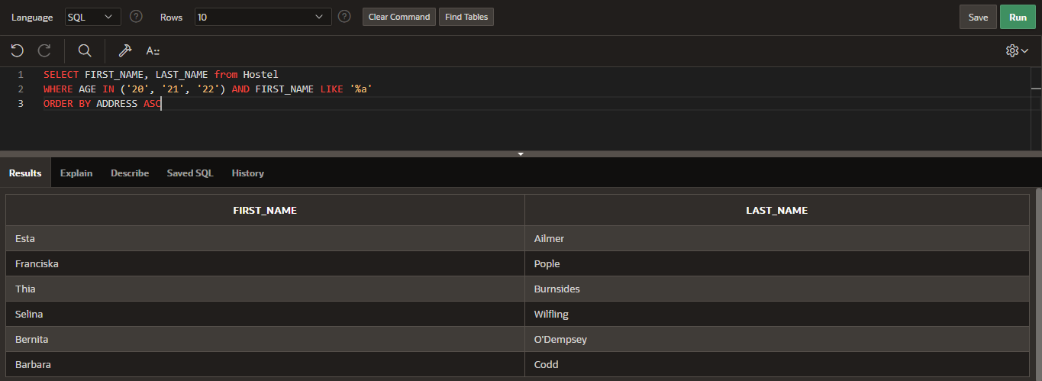

**INNER JOIN**

SELECT OFFICE_NAME, EXAMS.ROOM, EXAM_CODE

FROM OFFICE

INNER JOIN EXAMS ON NUMBER_ = EXAMS.ROOM

WHERE EXAM_CODE IN '57-nx'

π office_name, exams . room, exam_code

σ exam_code = "57-nx" ((office) ⋈ number_ = exams . room (exams))

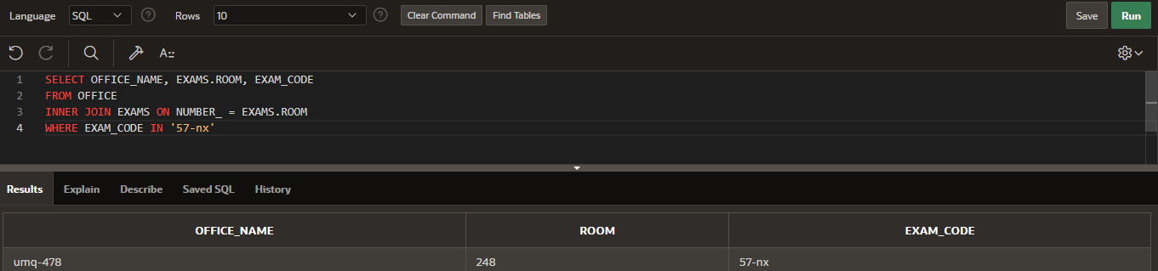

**LEFT JOIN**

SELECT * FROM CUSTOMER

LEFT JOIN Orders

ON CUSTOMER_ID = ORDER_ID

ORDER BY ORDER_ID

τ order_id ((customer) ⟕ customers_id = order_id (orders))

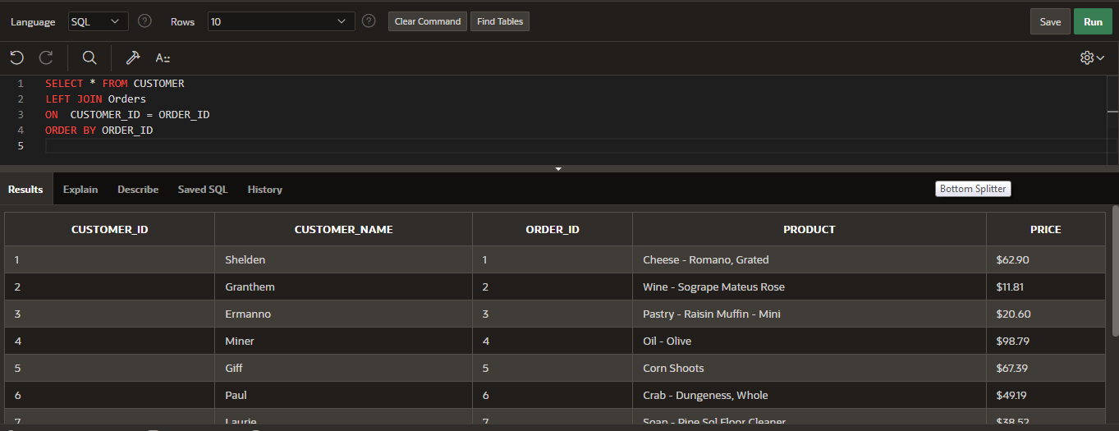

**RIGHT JOIN**

SELECT * FROM ORDERS  
RIGHT JOIN CUSTOMER  
ON CUSTOMER_ID = ORDER_ID

(orders) ⟖ customer_id = order_id (customer)

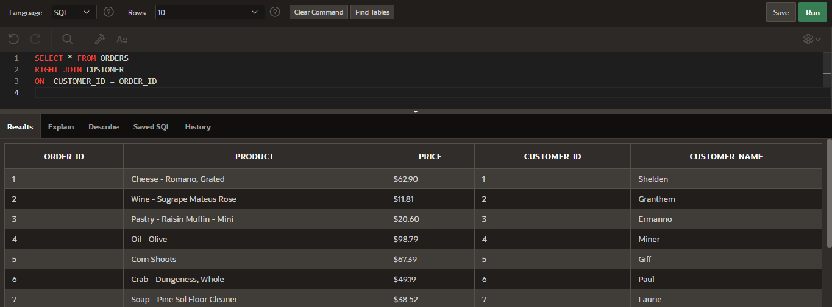

**SELECT**

SELECT * FROM STUDENT, PROFESSOR

π (student × professor)

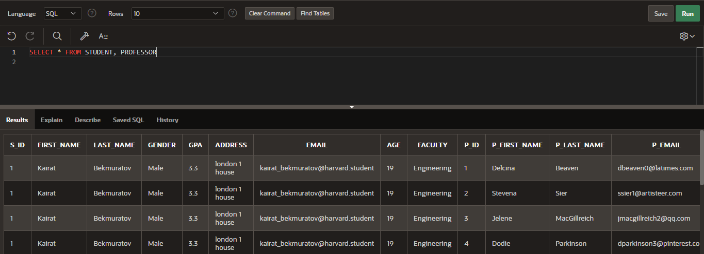

**DISTINCT**

SELECT DISTINCT GPA ,FIRST_NAME FROM STUDENT  
WHERE STUDENT.AGE=19

δ

π gpa, first_name

σ student.age = 19 (student)

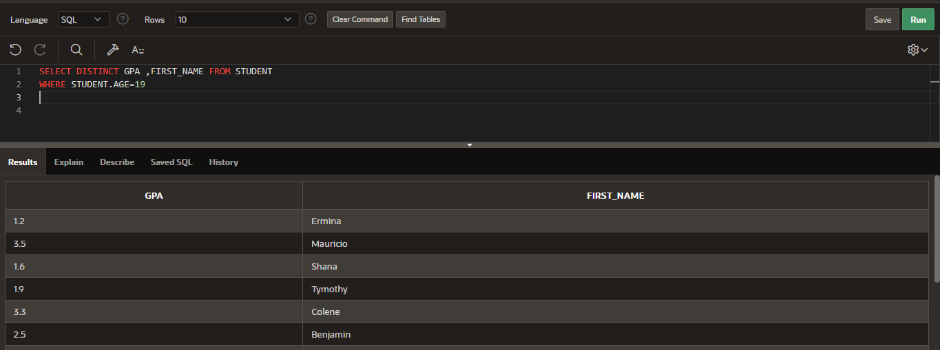

**UNION**

SELECT First_name, Last_name

FROM Student

Where First_name like 'a%'

UNION

SELECT P_first_name, P_last_name

FROM Professor

π first_name, last_name

σ first_name LIKE "a%" student ∪

π p_first_name, p_last_name (professor)

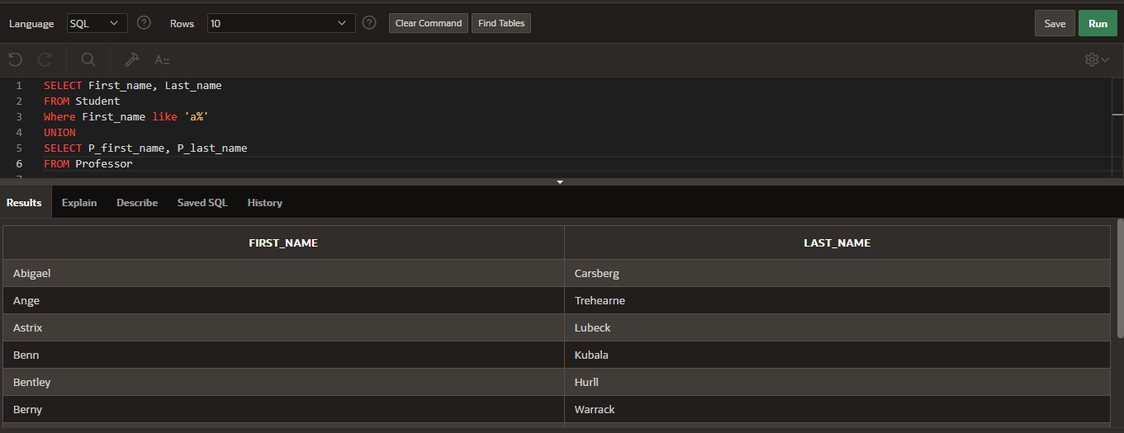

**MAX, MIN**

SELECT MAX(CAPACITY), MIN(CAPACITY) FROM SPORT_HALL

π MAX (capacity), MIN (capacity)

γ MAX (capacity), MIN (capacity) (sport_hall)

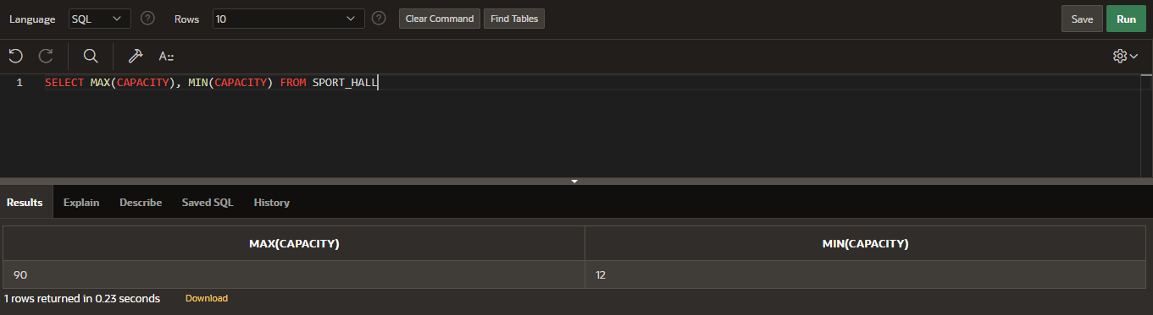

**TRIGGER 1**

create or replace trigger "FORKITCHEN"  
AFTER  
insert or update on "KITCHEN"  
for each row   
declare  
pragma autonomous_transaction;  
begin  
if :new.product_name = 'Dr.Pepper' then   
insert into kitchen(id,product_code,product_quantity,product_price,product_name,product_type)   
values(:[new.id](http://new.id/),:new.product_code,:new.product_quantity,:new.product_price-10;'Dr.Pepper',:new.product_type);  
update kitchen  
set product_price = :new.product_price/2 where product_name = 'Pepsi';  
commit;  
end if;  
end;