DATA MODEL / ERD
CampusPulse
Entities, relationships, and the v1/v2 schema seam

Prepared by Karma Groups
Prepared for CampusPulse — Ezeocha Obioma
Document owner Engineering
Version 1.0
Status Draft for review
Companion docs CampusPulse PRD v1.0 · Technical Architecture v1.0

1. Overview

1.1 Purpose
Events, tickets, tiers, organizers, attendees, payments, payouts, check-ins, and stories together are meaningfully more complex than a single-sided listings app's schema. This document maps every entity and relationship before anyone writes a migration — the goal is that the v1 build never requires a destructive schema change to support v2.

1.2 Modeling principle carried from the Technical Architecture doc
Free RSVPs and paid tickets are not two different concepts — they're the same underlying row with an optional payment attached. A single tickets entity (called "RSVP" in v1 product copy, since no payment flow exists yet) carries the seam so v2 attaches to it rather than replacing it.

2. Entity-Relationship Diagram
Grouped by role, not by build order: v1 core (the entities every event passes through), v1 supporting (social/discovery layer), and the v2 payment seam (schema present now, unpopulated until paid ticketing ships).
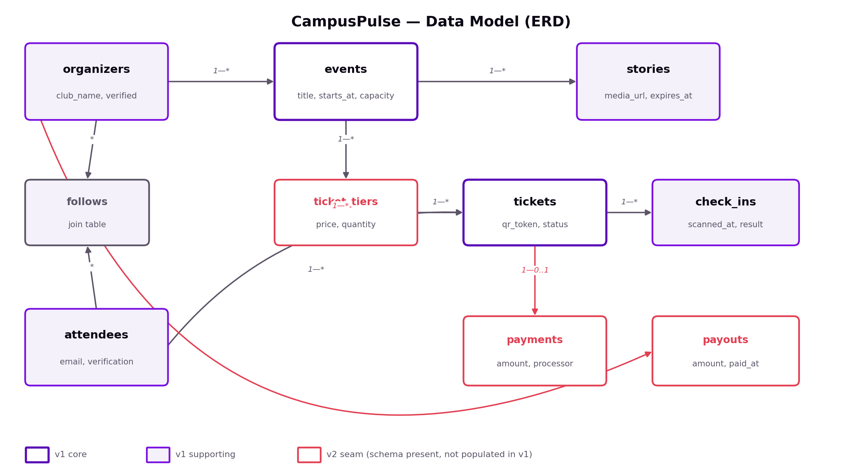

3. Entity Definitions
v1 core and v1 supporting entities are fully populated in v1. v2 seam entities exist in the schema now — created empty, not queried by any v1 code path — so v2 attaches rather than migrates.

3.1 organizers
A club, faculty association, or hall committee account. Publishes events.
Field | Type | Constraints | Notes
id | uuid | PK
owner_user_id | uuid | FK → users, not null | The individual student account that administers this organizer profile. Multi-admin (PRD §3.2, v2) extends this to many-to-many later.
club_name | text | not null
verified_status | enum | not null, default 'pending' | pending / verified / rejected — gates publishing per PRD §3.2.
created_at | timestamptz | not null, default now()

3.2 events
The durable record for a single event.
Field | Type | Constraints | Notes
id | uuid | PK
organizer_id | uuid | FK → organizers, not null
title | text | not null
description | text
cover_image_url | text |  | Points to object storage per Technical Architecture §3.
location | text | not null | Free-text for v1 — no campus-building lookup table needed at single-campus scale.
starts_at | timestamptz | not null
ends_at | timestamptz
capacity | integer |  | Null = unlimited. Drives the "Full" RSVP state (PRD §4.1).
status | enum | not null, default 'draft' | draft / published / cancelled. Cancellation cascades a notification to all ticket holders (PRD §4.2).
created_at | timestamptz | not null, default now()

3.3 stories
24-hour ephemeral content attached to an event.
Field | Type | Constraints | Notes
id | uuid | PK
event_id | uuid | FK → events, not null
media_url | text | not null
posted_at | timestamptz | not null, default now()
expires_at | timestamptz | not null | = posted_at + 24h, set at insert time.
- Feed query filters expires_at > now() — no application-level delete job needed for v1 visibility. A daily cron hard-deletes expired rows to keep the table small (Technical Architecture §4.1).

3.4 attendees
A student account, distinct from the underlying users table so verification state has a clear home.
Field | Type | Constraints | Notes
id | uuid | PK
user_id | uuid | FK → users, not null, unique
email | text | not null, unique
verification_status | enum | not null, default 'unverified' | domain_verified (@stu.ui.edu.ng) / manual_pending / manual_approved — PRD §3.1.
created_at | timestamptz | not null, default now()

3.5 follows
Join table between attendees and organizers — drives feed prioritization.
Field | Type | Constraints | Notes
attendee_id | uuid | FK → attendees, part of composite PK
organizer_id | uuid | FK → organizers, part of composite PK
followed_at | timestamptz | not null, default now()

3.6 ticket_tiers
v2 seam — pricing tiers for an event. Present in schema for v1, unused.
Field | Type | Constraints | Notes
id | uuid | PK
event_id | uuid | FK → events, not null
name | text | not null, default 'General' | In v1, every event gets exactly one implicit tier created automatically at publish time, so tickets always has a tier_id to point to.
price | integer | not null, default 0 | Minor currency units (kobo). 0 for every v1 event — no paid-ticketing UI exists to set otherwise.
currency | text | not null, default 'NGN'
quantity_available | integer |  | Null = unlimited; otherwise mirrors events.capacity in v1.
quantity_sold | integer | not null, default 0
This is the clearest example of the v1/v2 seam: rather than skip this table and add it later, v1 auto-creates one free tier per event so the tickets table has a consistent parent to reference. Paid ticketing in v2 is then "allow organizers to add more tiers with a nonzero price," not a schema change.

3.7 tickets
One row per (event, attendee) — called "RSVP" in v1 product copy. The unified entity for free RSVPs and future paid tickets.
Field | Type | Constraints | Notes
id | uuid | PK
event_id | uuid | FK → events, not null
attendee_id | uuid | FK → attendees, not null
tier_id | uuid | FK → ticket_tiers, not null | Always the auto-created free tier in v1.
qr_token | text | not null, unique | Signed HMAC token per Technical Architecture §5.1 — not a random ID, so it validates offline.
payment_id | uuid | FK → payments, nullable | Null for every v1 ticket (free). Populated in v2 for paid tiers.
status | enum | not null, default 'confirmed' | confirmed / checked_in / cancelled.
created_at | timestamptz | not null, default now()
- Unique constraint on (event_id, attendee_id) — this is what prevents duplicate RSVPs at the database level, not just in application logic.

3.8 check_ins
One row per scan attempt — deliberately not a single field on tickets, so duplicate scans are logged, not just rejected.
Field | Type | Constraints | Notes
id | uuid | PK
ticket_id | uuid | FK → tickets, not null
scanned_by | uuid | FK → users (organizer staff), not null
scanned_at | timestamptz | not null | Set on-device at scan time, not at sync time — order matters for "first scan wins" logic.
result | enum | not null | accepted / duplicate / invalid — set once the server reconciles synced scans (Technical Architecture §5.2).
synced_at | timestamptz |  | Null until the scanning device successfully syncs this record to the server.
This table is what makes the offline-tolerant duplicate-scan design in the Technical Architecture doc (§5.2) actually implementable: every scan is recorded, and "who actually gets in" is resolved by scanned_at ordering once the server has all the records, not decided unilaterally by whichever device scanned first.

3.9 payments
v2 seam — not written to by any v1 code path.
Field | Type | Constraints | Notes
id | uuid | PK
ticket_id | uuid | FK → tickets, not null, unique
processor | text | not null, default 'paystack' | Technical Architecture §6.1.
amount | integer | not null | Minor currency units.
currency | text | not null, default 'NGN'
status | enum | not null | pending / success / failed / refunded.
processor_reference | text |  | Paystack transaction reference, for reconciliation.
created_at | timestamptz | not null, default now()

3.10 payouts
v2 seam — organizer revenue disbursement. No relationship to any v1 entity, so this table can be deferred entirely rather than pre-created.
Field | Type | Constraints | Notes
id | uuid | PK
organizer_id | uuid | FK → organizers, not null
amount | integer | not null | Gross ticket revenue minus platform fee for the period.
status | enum | not null | scheduled / processing / paid / failed.
period_start / period_end | timestamptz | not null | The payout's revenue window.
processor_reference | text |  | Paystack sub-account settlement reference.
paid_at | timestamptz
- Unlike ticket_tiers and payments, this table has zero v1 seam requirement — nothing in v1 needs to reference it, so it's simply created when v2 build starts (Technical Architecture §6.2).

4. Relationship Summary
From | Cardinality | To | Notes
organizers | 1—* | events | An organizer publishes many events.
events | 1—* | stories | Ephemeral, event-scoped content.
events | 1—* | ticket_tiers | Exactly one auto-created tier per event in v1.
ticket_tiers | 1—* | tickets
attendees | 1—* | tickets | One ticket per (event, attendee) — enforced by a unique constraint, not just app logic.
tickets | 1—* | check_ins | Every scan attempt logged, not just the final outcome.
tickets | 1—0..1 | payments | Null in v1 for every ticket. v2 seam.
organizers | 1—* | payouts | v2 seam — no v1 dependency.
attendees | *—* | organizers | Via follows — drives feed prioritization.

5. Indexes & Constraints
The handful that matter for the NFR targets already committed to in the PRD (§5) and Technical Architecture doc (§8) — not an exhaustive index list.
- tickets: unique (event_id, attendee_id) — the database-level guarantee against duplicate RSVPs, referenced in §3.7.
- tickets: unique index on qr_token — the scanner's offline signature check still needs a fast server-side lookup path for the post-event reconciliation pass (Technical Architecture §5.2).
- events: composite index on (status, starts_at) — the feed's core query ("published events, soonest first") per Technical Architecture §4.2.
- stories: index on (event_id, expires_at) — supports the expires_at > now() feed filter without a full table scan as story volume grows.
- follows: composite PK on (attendee_id, organizer_id) doubles as the index needed for "does this attendee follow this organizer" feed-ranking lookups.
- check_ins: index on (ticket_id, scanned_at) — supports the "first scan wins" reconciliation ordering described in Technical Architecture §5.2 and §3.8 above.

6. v1 → v2 Migration Notes
The test this table is meant to pass: every v2 change below is additive (new rows, new nullable-field values) — none require rewriting or backfilling existing v1 data.
Entity | v1 state | What v2 changes
ticket_tiers | One free (price = 0) tier auto-created per event; no UI to add more. | Organizer UI to add priced tiers to an existing event. Existing free tier rows are untouched.
tickets | payment_id always null. | Paid-ticket creation populates payment_id. Free tickets keep working exactly as before — no code path removed.
payments | Table exists, zero rows. | Populated on first paid checkout. No dependency on any v1 data.
payouts | Table does not need to exist yet. | Created at v2 build start. No v1 entity references it, so there's nothing to migrate.
events / organizers / attendees / stories / follows / check_ins | Fully populated, no seam fields. | Unchanged by v2 — payments and payouts attach around the edges, not through these tables.

End of document.

