TECHNICAL ARCHITECTURE DOCUMENT
CampusPulse
System design for the v1 (MVP) build

Prepared by Karma Groups
Prepared for CampusPulse — Ezeocha Obioma
Document owner Engineering
Version 1.0 — v1 (MVP) Scope
Status Draft for review
Companion doc CampusPulse PRD v1.0

1. Overview

1.1 Purpose
This document translates the v1 scope decisions in the PRD into a concrete system design: what gets built, what technology it's built with, and — just as important — what gets deliberately deferred without painting the team into a corner for v2.

1.2 Architecture principles
- Design for degraded connectivity, not offline-first. Campus WiFi is unreliable at high-density venues (PRD §5.4); the check-in scanner must fail gracefully, not require full offline capability in v1.
- Keep v1 infrastructure boring. Managed services over self-hosted wherever possible — a small team should spend its time on the product, not on operating databases.
- Leave seams for v2 without building v2. Paid ticketing and multi-campus are explicitly out of v1 scope (PRD §1.3), but the data model must not require a destructive migration to add them.
- Fan-out on read, not on write. The feed is a query, not a precomputed, pushed artifact — appropriate for single-campus scale (PRD §5.1), and simpler to reason about and debug.

2. System Architecture
Two mobile clients (attendee, organizer) talk to a single API backend, which is the only service with direct access to the datastore. Third-party services are called from the backend, never from the client — this keeps the Paystack integration point (v2) and push credentials off-device.
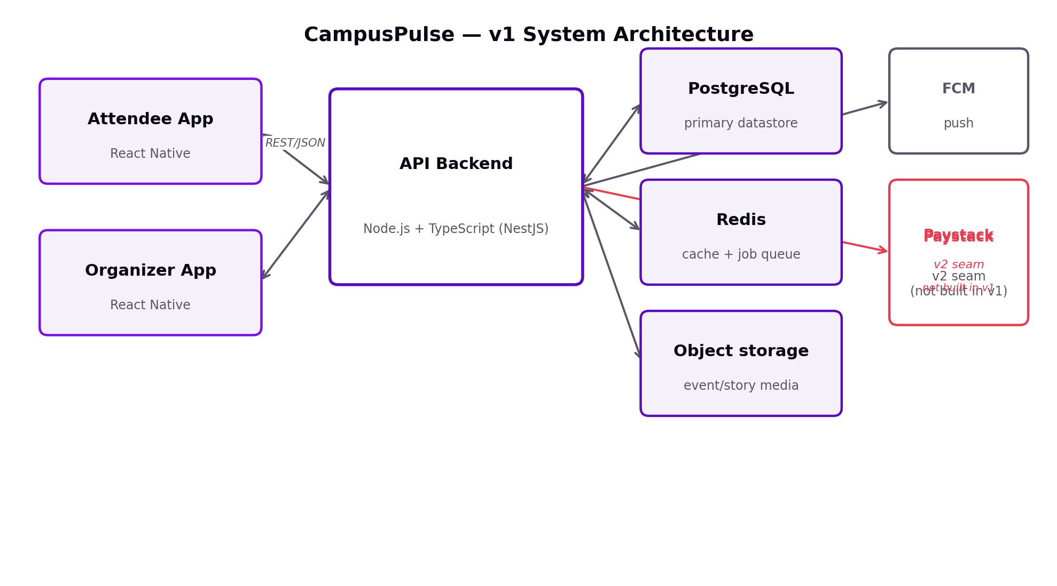
The Paystack box is drawn in the diagram deliberately, even though it is not built in v1 — it exists to show engineering where the seam is, not to imply work in progress.

3. Stack Decision
Proposed, not prescribed by prior constraint — recommended for this team size, this timeline, and this user base.
Layer | Choice | Why
Mobile | React Native (TypeScript) | Single codebase for both attendee and organizer apps across iOS and Android. Matches the mid-range-Android-first target in PRD §5.4, and has the deepest available talent pool for a Lagos/Ibadan-based team to hire against.
Backend | Node.js + TypeScript (NestJS) | Modular structure suits the two-persona split (attendee module, organizer module) without duplicating a whole service. Mature Paystack SDK support when v2 arrives. Consistent language across mobile and backend simplifies hiring and code review.
Database | PostgreSQL (managed) | Relational integrity matters once RSVPs, capacity limits, and — later — payouts are all consistency-sensitive. JSONB columns give the flexibility the story/feed model needs without a second database.
Cache / queue | Redis | Feed query caching, RSVP-burst rate limiting (PRD §5.1: 200 RSVPs/min sustained), and a background job queue (e.g. BullMQ) for story-expiry cleanup and notification fan-out.
Object storage | S3-compatible (AWS S3) | Event cover images and story media. Pairs with a CDN for the aggressive media compression called for in PRD §5.4.
Push notifications | Firebase Cloud Messaging | Free at this scale, cross-platform, the default pairing for a React Native app.
Hosting | AWS, af-south-1 (Cape Town) | Nearest AWS region to Nigeria — meaningfully lower latency than routing through US or EU regions. Managed RDS (Postgres) and ElastiCache (Redis) remove day-to-day database operations from a small team's plate. Scales via autoscaling groups for event-night traffic spikes without a re-architecture.

4. Feed & Story Data Model
A single events table is the wrong shape for this product. Stories are ephemeral and event-attached but not events themselves, and the feed is a ranked view across two entity types plus a follow graph — structurally closer to a social app's schema than a listings app's.

4.1 Core entities
Entity | Key fields | Notes
events | id, organizer_id, title, description, location, starts_at, capacity, status | The durable record. status covers draft / published / cancelled — cancellation must cascade a notification per PRD §4.2.
stories | id, event_id, media_url, posted_at, expires_at | expires_at = posted_at + 24h. No delete job needed for v1 — the feed query filters expires_at > now(), with a daily cron for actual row cleanup.
organizers | id, club_name, verified_status, owner_user_id | verified_status gates publishing per PRD §3.2 — unverified accounts see a "pending" state, not a silent block.
attendees | id, user_id, email, verification_status | verification_status: domain-verified (@stu.ui.edu.ng) or manual-upload-pending, per PRD §3.1.
rsvps | id, event_id, attendee_id, qr_token, status, checked_in_at | status: confirmed / checked_in / cancelled. One row per (event, attendee) — the unique constraint that prevents duplicate RSVPs.
follows | attendee_id, organizer_id, followed_at | Drives feed prioritization — followed organizers' events/stories rank first.

4.2 Feed query approach
Fan-out-on-read: the feed is computed at request time — followed-organizer content first, then recency- and proximity-ranked events for the rest — rather than precomputed and pushed to a per-user feed table.
- Appropriate for v1 scale (500–5,000 concurrent users per PRD §5.1) — an indexed query against events + stories + follows is fast enough without a dedicated ranking service.
- Deliberately avoids fan-out-on-write (a real social-app pattern) because it adds write-amplification complexity this launch doesn't need yet — revisit only if feed load times (PRD §5.2 target: <2.5s cold start) start to slip under real load.

5. QR Ticket Generation & Validation
The design goal here is set by PRD §5.4 and §7.2: campus WiFi is unreliable exactly where the scanner needs to work best. A server-lookup-only approach (validate every scan against a live database call) would build the fragility the PRD already flagged as a risk — so v1 uses signed tokens as the primary check.

5.1 Token design
- On RSVP confirmation, the backend issues a signed token (HMAC-SHA256) containing event_id, attendee_id, and issued_at, and stores it on the rsvps row as qr_token.
- The organizer's scanner app validates the signature locally — no network call required to confirm the token is authentic. This is what makes check-in work even with zero connectivity at the door.

5.2 Duplicate-scan handling
Signature validation alone can't prevent two door staff from both accepting the same screenshotted token before either device syncs. v1's approach: accept locally, reconcile centrally.
- Scanner validates the token signature offline and marks it checked-in in a local on-device cache immediately — the line keeps moving.
- The device syncs checked-in tokens to the server as connectivity allows (background retry, not blocking).
- The server is the source of truth for "first checked-in wins" — any duplicate scan that synced later is flagged to the organizer post-event in the dashboard (PRD §4.2 step 7), not blocked in real time at the door.
This is a deliberate trade: v1 accepts a small, after-the-fact-visible risk of double check-in from a shared screenshot in exchange for a scanner that never blocks a line waiting on a network call. It directly extends the PRD's own stance on QR screenshot sharing (§5.5, §7.1) — reduce, don't pretend to eliminate.

6. Payment Architecture — v2 Seam
Paid ticketing is explicitly out of v1 scope (PRD §1.3, §3.2). This section is deliberately forward-looking: it documents the decision and the schema seam needed so v2 doesn't require a destructive migration — it does not describe work being built now.

6.1 Processor decision
Paystack over Flutterwave for this launch. The deciding factor is split-payment/sub-account support — the mechanism by which ticket revenue can route directly to an individual organizer's payout account minus a platform fee, which is exactly the payout model PRD §3.2 describes. Flutterwave's comparative strength (multi-currency, pan-African reach) isn't relevant to a single Nigerian university in v1 or v2.

6.2 Schema seam for v2
To avoid a painful retrofit later, v1's schema should include (but not populate or expose) the following, so "free RSVP" and "paid ticket" aren't structurally different concepts that require a data migration to reconcile:
- A nullable price_tiers relationship on events, unused in v1 — every v1 event effectively has one implicit free tier.
- A nullable payment_reference field on rsvps, so a future paid "ticket" is still the same underlying row type as a free RSVP, not a parallel table.
- An organizer_payout_accounts table can be deferred entirely — no seam needed since it has no relationship to any v1 entity.

6.3 Compliance flag
Not an engineering decision, but one the architecture doc should surface rather than let surface for the first time during v2 planning: routing money to organizers on the platform's behalf likely touches Nigerian Data Protection Act (NDPA) requirements for the financial data involved, and potentially CBN guidance depending on how payouts are structured (direct sub-account settlement vs. platform-held-and-forwarded funds). This belongs on the legal/compliance checklist already flagged as a needed deliverable, timed for v2 planning, not v1 launch.

7. Security & Privacy
- Student verification data (email, ID upload per PRD §3.1) is stored with standard access controls and encryption at rest — no payment data exists in v1's scope, which keeps the compliance surface meaningfully smaller than v2 will be.
- The HMAC signing key for QR tokens is a backend secret, never shipped to any client, including the organizer scanner app — the scanner verifies signatures via a backend-provided verification routine, not by holding the key itself.
- Standard API security practices apply: rate limiting on RSVP and auth endpoints (leaning on the same Redis layer used for feed caching), HTTPS everywhere, no secrets in mobile app bundles.

8. Scaling Against the PRD's NFRs
Sanity-checking that the proposed stack actually meets the non-functional targets the PRD already committed to (§5) — not aspirational, the specific numbers.
PRD target (§5) | Value | How the stack meets it
Peak concurrent users | 3,000–5,000 | AWS autoscaling groups behind the API layer; RDS Postgres sized for a single-campus read-heavy load with read replicas as a known, not yet needed, next step.
RSVP burst handling | 200/min sustained | Redis-backed rate limiting and queueing absorb write bursts without hammering Postgres directly on every request.
Check-in scanner uptime | 99.9% during live events | Offline-tolerant signed-token validation (§5.1) means the scanner's core function doesn't depend on API uptime at all during the check-in window itself.
Feed cold load | < 2.5 sec | Indexed Postgres query plus Redis caching for the common "what's live now" query shape.

9. Open Technical Questions
- QR signing key rotation policy — how often, and what happens to already-issued-but-unused tokens when the key rotates?
- Manual ID-upload review (PRD §3.1, "v1 — limited") — does this need a lightweight internal admin tool, or is it handled outside the product entirely for v1?
- Push notification volume caps (flagged in PRD §7.3) — needs a technical ceiling, not just a product policy, to avoid FCM throttling at scale.
- CDN choice for media delivery — CloudFront is the default AWS pairing, but worth confirming against actual Ibadan-network performance before committing.

End of document.

