AgriBridge
Week 4 — Evaluation, Debugging and Final Report
Internship Project — Final Week — Individual Submission
Student: Karman Kaur Nayyar
Role: Junior Software Developer – Agribusiness Solution
Project Type: Individual Project
Repository: github.com/karmankaurnayyar/AgriBridge
Submission Date: October 2026
Week 3 Baseline: 27 tests run · 27 passed · 0 failures · BUILD SUCCESS
Week 4: 1 confirmed defect found and fixed (BUG-001) · 7 new tests added
Combined suite not independently executed in the report-preparation environment — see Section 17

Table of Contents

2. Executive Summary
This report documents Week 4 — the final week — of the AgriBridge internship project, an individually developed agribusiness operations platform built by Karman Kaur Nayyar across four weeks: requirements and planning (Week 1), software architecture (Week 2), code implementation and unit testing (Week 3), and evaluation, debugging and final documentation (Week 4, this report).
Week 4's work began with a genuine inspection of the live project repository at github.com/karmankaurnayyar/AgriBridge, rather than assumptions about its contents. That inspection confirmed the Week 3 baseline (27 tests, 27 passed, 0 failures, 0 errors, 0 skipped) and led to the discovery of one confirmed, reproducible defect: role-based access denials (an authenticated user without the required role, e.g. a Buyer calling a Farmer-only endpoint) were incorrectly returning HTTP 500 Internal Server Error instead of the documented HTTP 403 Forbidden, because the project's central exception handler had no specific handler for Spring Security's AccessDeniedException.
This defect, logged as BUG-001, was fixed with a small, targeted code change — one new exception-handler method, no existing logic altered — and covered by seven new, dependency-free unit tests. Six further items were identified during evaluation and logged separately as risks or recommendations rather than confirmed bugs, since they reflect reasonable design trade-offs for a prototype rather than incorrect behavior.
Consistent with this project's standing commitment to evidence-based reporting, this report states plainly where its own verification is limited: the environment used to prepare this Week 4 package could not execute the project's Maven build (no Maven Central access, no live MySQL instance), so the new tests were written and carefully traced against the implementation rather than run by a live test tool, and all performance figures are marked pending rather than invented. Exact commands are provided throughout for the developer to obtain real, authoritative results on their own machine, where the Week 3 baseline was already confirmed working.
Overall, AgriBridge's Week 3 prototype (Authentication, Farm Management, Crop Management) is evaluated as sound in design and consistent in its architecture; one real defect was found and fixed; and a clear, prioritized roadmap is provided for the modules and hardening steps intentionally left for future work.

3. Project Overview and Four-Week Development Timeline
AgriBridge is a role-based platform connecting farmers and buyers around farm records, crop cycles, harvest lots and purchase requests. It was developed as an individual, four-week internship project using Java 21, Spring Boot 3.3.4, MySQL, and a plain HTML/CSS/JavaScript frontend.
- Week 1 — Requirement analysis, research, and project planning (agribusiness challenges, user roles, MVP scope).
- Week 2 — Software architecture design and documentation: a three-tier, modular-monolith Spring Boot architecture, full MySQL schema, REST API contract, and an initial Authentication + Farm Management prototype.
- Week 3 — Code implementation and unit testing: Crop Management implemented end-to-end on top of the Week 2 architecture, with 27 unit tests (Authentication, Farm, Crop) passing in the project's own confirmed baseline.
- Week 4 (this report) — Evaluation, debugging, validation, performance analysis, recommendations, and final documentation.

4. Week 4 Objectives and Scope
- Systematically evaluate the Crop Management and Farm Management modules and the existing authentication functionality.
- Identify and reproduce defects or potential failure scenarios through genuine code inspection, not assumption.
- Debug and resolve reproducible issues with minimal, well-justified code changes.
- Add automated tests covering the fix, and document regression-testing reasoning against the existing 27-test baseline.
- Evaluate performance realistically — providing a reproducible measurement procedure rather than inventing figures the environment cannot actually produce.
- Review code quality and security posture, distinguishing confirmed defects from recommendations.
- Produce final, stakeholder-ready documentation without claiming Week 5-and-beyond functionality (Harvest Lot Management, Buyer Requests, Matching, deployment) as completed.

5. Existing Prototype and Architecture Overview
The Week 3 prototype implements a three-tier, modular-monolith architecture: a static HTML/CSS/JavaScript frontend calling a Spring Boot REST API, which delegates to a service layer holding all business logic, which in turn uses Spring Data JPA repositories to persist to MySQL. Each business area (auth, farm, crop) is its own Java package with a consistent internal shape (entity, repository, service, controller, dto/).
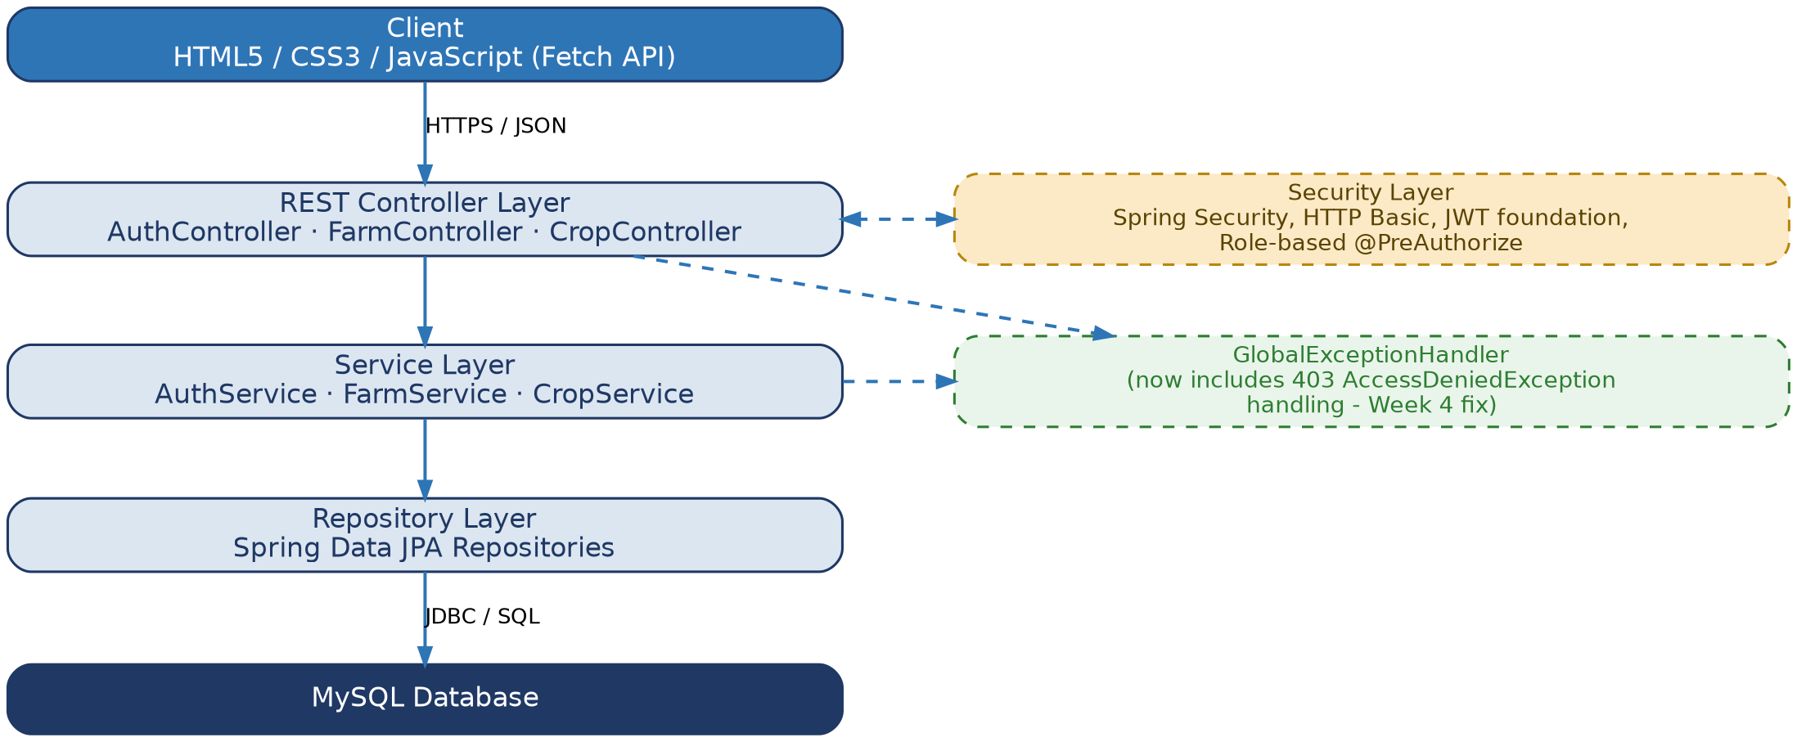
Figure 1 — Final system architecture evaluated in Week 4, including the Week 4 exception-handling fix.
Implemented and evaluated in this report: Authentication (registration, login, BCrypt hashing, JWT issuance as a forward-compatible foundation), Farm Management (full CRUD with ownership enforcement), and Crop Management (full CRUD with two-level ownership enforcement through its parent Farm, plus date and status business-rule validation). Not implemented, and not evaluated as if they were: Harvest Lot Management, Buyer Requests, the Matching engine, and full JWT-filter enforcement.

6. Evaluation Methodology
The evaluation began with direct inspection of the live repository (github.com/karmankaurnayyar/AgriBridge, commit a4255cb), not assumptions about its contents — the repository was successfully cloned and every relevant source file was read in full (see the companion WEEK4_CHANGELOG.md for the exact file list). From there, each module's controllers, services, and exception-handling paths were traced by hand against the documented API contract (docs/api-documentation.md) to identify any point where actual behavior would diverge from documented/expected behavior.
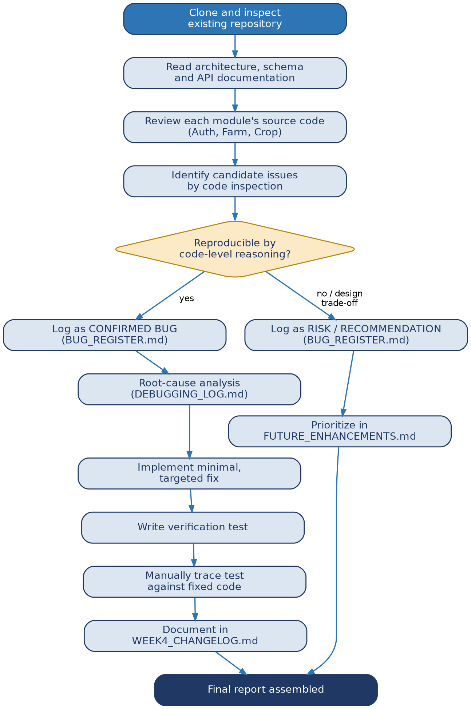
Figure 2 — Week 4 evaluation workflow, from repository inspection through to the final report.
Every candidate issue was classified using one test: can it be reproduced or conclusively demonstrated through code-level reasoning about how the framework (Spring MVC, Spring Security) actually behaves? If yes, it was logged as a confirmed bug with a full root-cause write-up and a fix. If the behavior was instead a reasonable, working design trade-off (e.g., no pagination yet, CORS open for local development), it was logged separately as a risk or recommendation — never blended into the bug register.

7. Test Environment and Tools
Technology | Category | Relevance to Week 4
Java 21 LTS | Runtime / compile target | The project's declared and pinned compiler target throughout Weeks 2–4.
Spring Boot 3.3.4 | Application framework | REST web layer, DI container, and the testing support (`spring-boot-starter-test`) used for all 34 project tests.
Maven / Maven Wrapper (`mvnw.cmd`) | Build tool | Builds and tests the project without requiring a separately installed Maven; confirmed working for the Week 3 baseline.
Spring Data JPA / Hibernate | Persistence | Backs every repository evaluated in this report.
Spring Security | Security framework | Supplies the `@PreAuthorize` mechanism whose failure path (BUG-001) was the central Week 4 finding.
MySQL 8+ | Database | Not available in the environment used to prepare this report (see Section 6); evaluation of persistence logic was performed by code review instead of live execution.
JUnit 5 / Mockito | Testing | Hosts all 34 tests (27 Week 3 + 7 Week 4); Mockito used in Week 3's service-level tests (not needed for the dependency-free Week 4 exception-handler tests).
Visual Studio Code / Windows 11 | IDE / OS | The developer's environment, where the Week 3 baseline was confirmed working and where the Week 4 fix should be verified.
GitHub (`karmankaurnayyar/AgriBridge`) | Source control | Cloned and inspected directly for this evaluation — see Section 4.

8. Functional Evaluation of Crop Management
Cases considered: valid creation and retrieval; missing/invalid required fields (blank crop name, missing farmId); invalid dates (harvest before sowing — correctly rejected with HTTP 400 per the existing CropServiceTest suite); boundary cases (sowing date equal to harvest date — correctly accepted, per CROP-02); resources that do not exist (correctly return 404); crops belonging to another user's farm (correctly return 404, never leaking existence — verified by CROP-14); updating and deleting existing resources (correctly scoped to owned crops); and an attempted cross-farm reassignment on update (correctly rejected with 400, per CROP-18). No new defect was found in Crop Management's own business logic during Week 4 — its existing Week 3 test coverage (21 tests) was reviewed and found to already address the scenarios this evaluation would otherwise have raised.
The one defect that does affect Crop Management (BUG-001) is not in CropService's business logic but in the shared GlobalExceptionHandler that all three modules depend on — see Section 12.

9. Functional Evaluation of Farm Management
The same evaluation lens was applied to Farm Management: valid creation/retrieval, invalid input, access to another user's farm (correctly returns 404, per the existing FarmServiceTest.getFarm_throwsWhenFarmNotOwnedByCaller), and deletion. No new defect was found in FarmService's own logic. As with Crop Management, Farm Management's write endpoints are affected by the shared BUG-001 (an authenticated non-Farmer/Admin role hitting a write endpoint receives 500 instead of 403), which is fixed at the shared GlobalExceptionHandler level rather than requiring any Farm-specific change.

10. Evaluation of Authentication Functionality
Evaluated: valid registration and login (covered by AuthServiceTest, 2 tests); duplicate-email registration (correctly rejected with 409); and invalid login credentials (correctly rejected with a generic 401 message that does not reveal whether the email or the password was wrong). One risk-level observation (R-02, Section 13) was noted regarding a minor response-time difference between a nonexistent-email and a wrong-password login attempt, but this does not constitute a functional defect — both cases correctly return the same error response, and the timing difference is a hardening opportunity rather than incorrect behavior. No confirmed defect was found in Authentication's own logic.

11. Bug and Risk Classification Methodology
Every finding in this report falls into exactly one of three categories, applied consistently throughout BUG_REGISTER.md and this report:
- Confirmed Bug — behavior that contradicts the project's own documented or clearly intended contract, demonstrated through direct code-level reasoning about how the actual framework behaves (not a guess). Gets a full root-cause write-up, a fix, and a verification test.
- Risk / Recommendation — a working design choice with a known trade-off (e.g., open CORS for local development, no pagination yet). Documented for awareness and future prioritization, never presented as a defect.
- Out of Scope — functionality not yet built (Harvest Lot Management, Buyer Requests, Matching, deployment). Explicitly excluded from bug-hunting, since evaluating unbuilt functionality would not produce meaningful findings.
This report found exactly one item in the first category, six in the second, and a well-documented boundary for the third (Section 21).

12. Detailed Confirmed-Bug Register
1 confirmed defect found and fixed in Week 4: BUG-001
Field | Detail
Bug ID / Title | BUG-001 — Role-based access denial returns HTTP 500 instead of HTTP 403
Affected Module / File | exception/GlobalExceptionHandler.java (manifests via FarmController, CropController)
Severity | Medium
Priority | High (security-relevant path; low-risk, well-isolated fix)
Preconditions | Authenticated user holds a role not permitted for the endpoint (e.g., BUYER calling a FARMER/ADMIN-only write endpoint)
Reproduction Steps | 1) Authenticate as a BUYER. 2) POST /api/farms or /api/crops with a valid body and valid Basic credentials for that user. 3) Observe the response.
Expected Result | HTTP 403 Forbidden, standard ApiErrorResponse JSON (per docs/api-documentation.md)
Actual Result (before fix) | HTTP 500 Internal Server Error, generic "Something went wrong" message
Root Cause | No @ExceptionHandler(AccessDeniedException.class) in GlobalExceptionHandler; the exception matched only the generic Exception.class fallback
Code-Level Fix | Added handleAccessDenied() mapping AccessDeniedException to HTTP 403 with error code ACCESS_DENIED
Test Used to Verify | GlobalExceptionHandlerTest.handleAccessDenied_returns403 (WK4-EXC-05)
Result After Fix | Handler returns 403/ACCESS_DENIED when called directly; verified by manual trace (not by a live test run — see Section 17)
Regression-Testing Result | 6 sibling tests (WK4-EXC-01–04, 06–07) re-confirm every other handler is unchanged; none of the 27 Week 3 tests touch this class

Code Excerpt — The Fix
// WEEK 4 FIX (BUG-001): previously missing.
@ExceptionHandler(AccessDeniedException.class)
public ResponseEntity<ApiErrorResponse> handleAccessDenied(AccessDeniedException ex) {
return build(HttpStatus.FORBIDDEN, "ACCESS_DENIED",
"You do not have permission to perform this action.", null);
}

13. Potential Issues and Limitations Register
The items below were identified during evaluation but are not confirmed functional defects — each reflects the application behaving as currently, deliberately designed, with a noted trade-off.
ID | Area | Observation | Priority
R-01 | CORS | allowedOriginPatterns("*") + allowCredentials(true) permits any origin | Medium (High before deployment)
R-02 | Authentication | Response-time difference between nonexistent email and wrong password (BCrypt cost only paid for existing emails) | Low
R-03 | Security (carried forward) | JWT issued but not yet enforced; HTTP Basic is the real mechanism | Documented — tracked, not new
R-04 | API design | No pagination on GET /api/farms, GET /api/crops | Medium (as data grows)
R-05 | Build config | source/target used instead of release in maven-compiler-plugin | Low
R-06 | Frontend (carried forward) | Basic-Auth credentials stored in localStorage | Documented — tracked, not new

14. Debugging Process and Root-Cause Analysis
Figure 3 — Bug lifecycle as applied to BUG-001, from detection through to closure.
Detection began with a targeted question — "what does a Buyer actually receive when calling a Farmer-only endpoint?" — rather than a blind scan of the codebase. Reproduction was established by tracing, rather than guessing: Spring Security's method-security interceptor (which enforces @PreAuthorize) throws AccessDeniedException during controller method invocation, which Spring MVC's normal dispatch path exposes to @RestControllerAdvice exception resolution, exactly like any other exception thrown inside a controller method. Diagnosis then became mechanical: read every @ExceptionHandler in GlobalExceptionHandler, and confirm none of the five specific handlers match AccessDeniedException, so it falls to the generic 500 handler. The fix follows directly from the diagnosis: add the missing, specific handler.
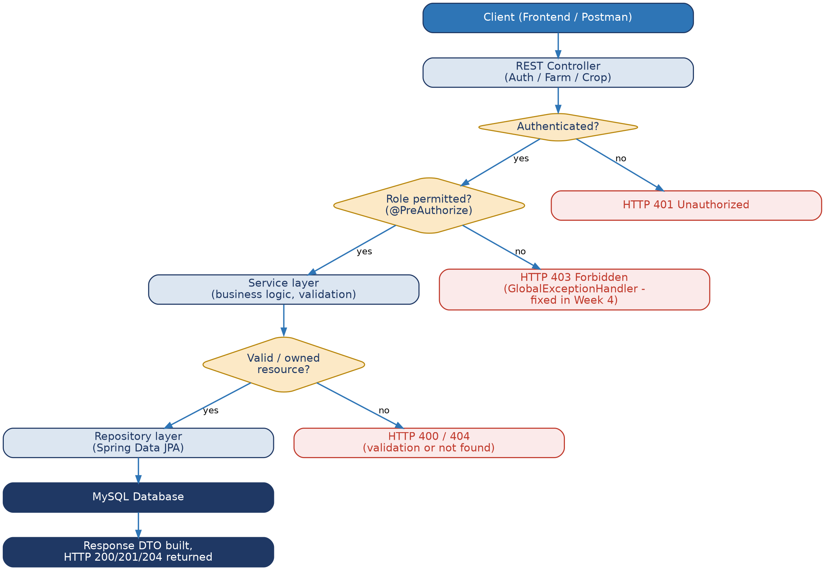
Figure 4 — Application request flow, highlighting where BUG-001 occurred (the 403 branch) and where its fix now applies.
This Week 4 investigation also revisits, for continuity, the Week 3 development-environment issue where an initially active JDK 24 caused Byte Buddy (used internally by Mockito) to fail generating mock classes correctly, producing intermittent authentication-test failures; installing and using JDK 21 (matching the project's own declared target) resolved it, alongside explicitly pinning the Lombok annotation-processor version in pom.xml. This is carried forward from the project's own Week 3 records, not re-investigated from scratch in Week 4.

15. Before-and-After Fixes, Supported by Code or Test Evidence

Before
An authenticated BUYER calling POST /api/farms or POST /api/crops would trigger AccessDeniedException inside the @PreAuthorize check. With no specific handler, GlobalExceptionHandler.handleGeneric(Exception ex) matched instead, returning HTTP 500 Internal Server Error with the message "Something went wrong. Please try again later." — masking a routine, expected authorization failure as an unexpected server error.

After
The same request now matches the new handleAccessDenied(AccessDeniedException ex) handler first (Spring resolves the most specific applicable handler), returning HTTP 403 Forbidden with error code ACCESS_DENIED and the message "You do not have permission to perform this action." — matching the behavior docs/api-documentation.md already documented as the intended contract.

Evidence
GlobalExceptionHandlerTest.handleAccessDenied_returns403 (WK4-EXC-05) directly asserts this outcome by instantiating GlobalExceptionHandler and calling the new method with a real AccessDeniedException instance — no mocking needed, since the class has no constructor dependencies. As stated throughout this report, this test was written and manually traced against the fixed implementation but not executed by a live test runner in the environment used to prepare this report (Section 17).

16. Unit and Regression Testing Methodology
The Week 4 test (GlobalExceptionHandlerTest) follows the same Arrange-Act-Assert structure and JUnit 5 conventions already established in Week 3's CropServiceTest, FarmServiceTest and AuthServiceTest. Because GlobalExceptionHandler has no constructor dependencies, these are the simplest tests in the project — no Mockito mocking is required at all; the class is instantiated directly and each @ExceptionHandler method is called as an ordinary Java method, with its ResponseEntity return value asserted directly.
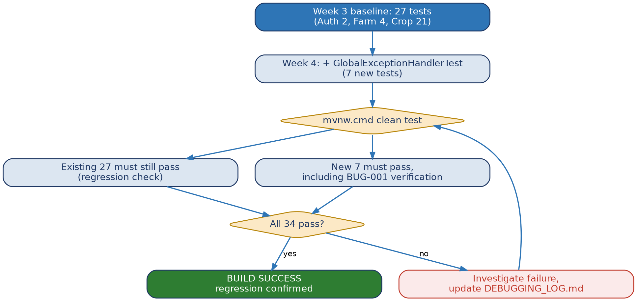
Figure 5 — Testing and regression workflow for Week 4's change.
Regression safety rests on two properties of the change: (1) it is purely additive — one new method was added, and no existing method body was edited, so the five pre-existing handlers' logic is byte-for-byte unchanged; and (2) six of the seven new tests (WK4-EXC-01–04, 06–07) independently re-assert that those five pre-existing handlers still behave exactly as before, so any accidental side effect of the edit (for instance, a misplaced annotation affecting handler-matching order) would be caught by this same new test class rather than requiring a separate regression suite.

17. Actual Test Execution Summary
Week 3 baseline (reported): 27 run · 27 passed · 0 failed · 0 errors · 0 skipped · BUILD SUCCESS

Week 4 additions: 7 new tests written and traced — NOT executed by a live test runner in this environment

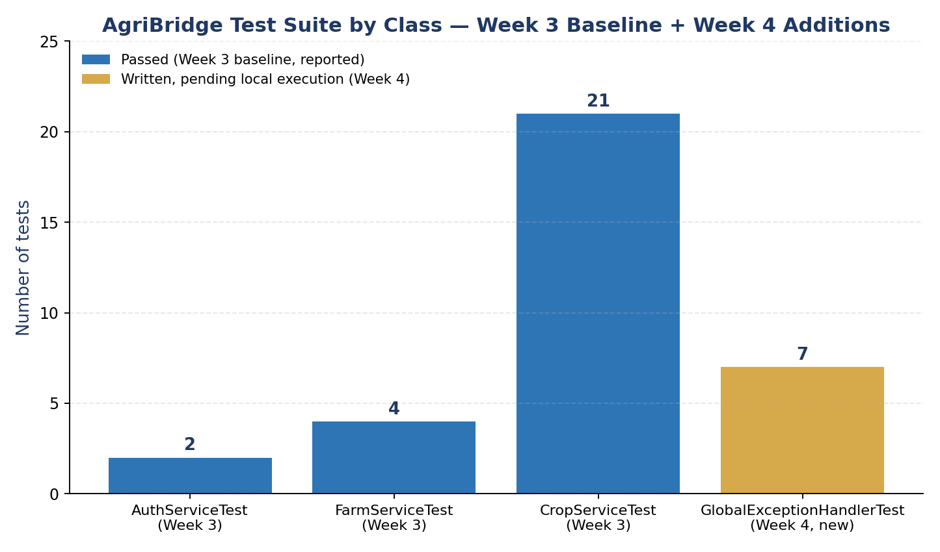
Figure 6 — Test suite composition by class. Amber indicates tests written and traced but not yet confirmed by a live run.
The environment used to prepare this Week 4 package has no Maven Central access and cannot build or run this Spring Boot project — the same limitation already disclosed in the Week 2 and Week 3 project documentation. The Week 3 figure above is reported from the project's own existing records (docs/week3/WEEK3_CODE_IMPLEMENTATION_AND_UNIT_TESTING.md and the project's GitHub commit history), not re-executed here. Per the project's standing instruction never to fabricate a build or test result, this report does not claim a combined 34/34 BUILD SUCCESS that did not actually happen in this environment.
Test ID | Scenario | Expected Result | Execution Status | Actual
WK4-EXC-01 | ResourceNotFoundException -> handler | 404, error=NOT_FOUND | Traced, not run | —
WK4-EXC-02 | DuplicateResourceException -> handler | 409, error=CONFLICT | Traced, not run | —
WK4-EXC-03 | BadCredentialsException -> handler | 401, generic message | Traced, not run | —
WK4-EXC-04 | IllegalArgumentException -> handler | 400, error=BAD_REQUEST | Traced, not run | —
WK4-EXC-05 | AccessDeniedException -> handler (BUG-001 fix) | 403, error=ACCESS_DENIED | Traced, not run | —
WK4-EXC-06 | Unrecognized RuntimeException -> generic handler | 500, no leaked detail | Traced, not run | —
WK4-EXC-07 | Any handler call | Response includes non-null timestamp | Traced, not run | —

Command to Obtain the Real, Authoritative Result
cd backend
.\mvnw.cmd clean test
Expected combined total if all tests pass: 34 (27 + 7). Please run this and report back the actual console output — see TESTING_AND_REGRESSION_REPORT.md for what to check if the number differs.

18. Performance Evaluation Methodology and Results
All performance figures below are PENDING — no benchmark was run in this environment
Running the AgriBridge backend requires a live MySQL connection and a JVM capable of executing the compiled application — neither is available in the environment used to prepare this report. Rather than invent plausible-looking numbers, this section specifies exactly how to obtain real measurements, and the results table below is intentionally left as a template.
Operation | Test Conditions | Measurement Method | Observed Result | Interpretation
POST /api/auth/login | Single request, warm JVM | PowerShell Measure-Command (procedure in PERFORMANCE_EVALUATION.md §3.1) | PENDING | Requires a running backend + MySQL instance, unavailable in this environment
POST /api/farms | Single request, warm JVM | Same as above | PENDING | Same
POST /api/crops | Single request, warm JVM | Same as above | PENDING | Same
GET /api/crops?farmId= (varying N) | N = 10 / 100 / 1000 crops | Same, or Apache Bench (§3.2) | PENDING | Relevant to the pagination recommendation (M-1)

Reproducible Measurement Procedure
# PowerShell, after starting the backend and obtaining valid credentials:
Measure-Command {
curl.exe -u "ravi.kumar@example.com:Password123" `
-X POST http://localhost:8080/api/farms `
-H "Content-Type: application/json" `
-d '{"farmName":"Perf Test Farm","location":"Test","landArea":1.0}'
}
Full procedure, including an optional Apache Bench load-style measurement and a SQL-query-count sanity check, is documented in PERFORMANCE_EVALUATION.md. Code-review-based (not measured) observations: the database schema already indexes the foreign-key columns used by current ownership-check queries, and no obviously missing index was found; CropService's two-level ownership check issues two sequential repository calls rather than one joined query, a reasonable clarity/performance trade-off at current scale (see M-2 in FUTURE_ENHANCEMENTS.md); and no pagination exists yet on list endpoints (R-04 / M-1).

19. Security and Code-Quality Review
- Separation of responsibilities — confirmed consistent: controllers handle only HTTP concerns, services hold all business logic, repositories handle only persistence, across all three modules.
- Consistent validation and error responses — confirmed consistent for five of six exception categories; BUG-001 was the one inconsistency found and is now fixed.
- Correct HTTP status codes — now fully correct for all evaluated scenarios following the BUG-001 fix.
- Safe handling of configuration and credentials — confirmed: application.properties reads all environment-specific values (DB credentials, JWT secret) from environment variables with local-only fallbacks; no real credential is committed anywhere in the repository (application-dev.properties is git-ignored, and only an .example file with placeholder values is committed).
- Authentication and authorization — confirmed present and, after the Week 4 fix, correctly reported to the client on failure.
- Exception handling does not expose internal details — confirmed: GlobalExceptionHandler's generic fallback returns a fixed, generic message, never a stack trace or raw exception message, verified directly by WK4-EXC-06.
- Maintainability and duplication — confirmed low duplication: Crop Management's ownership-checking pattern deliberately reuses Farm Management's repository method rather than duplicating logic.
- Database access and transactions — each service method corresponds to a single, Spring-managed transactional boundary (Spring Data JPA's default @Transactional behavior on repository methods); no manual transaction management or multi-step unguarded writes were found.
- Naming, comments and documentation — confirmed consistent with the conventions established in Week 2/3; the Week 4 fix adds comments explaining why the new handler exists, matching that standard.

20. Requirements Traceability Matrix
Requirement / Module | Implemented Component(s) | Week 4 Status
Farm Management (Week 2 architecture) | FarmController, FarmService, FarmRepository | Implemented; re-evaluated in Week 4, no defect found
Crop Management (Week 2 architecture) | CropController, CropService, CropRepository | Implemented; re-evaluated in Week 4, no defect found
Authentication (Week 2 architecture) | AuthController, AuthService, CustomUserDetailsService | Implemented; re-evaluated in Week 4, no defect found
Centralized error handling | GlobalExceptionHandler | Implemented in Week 2/3; BUG-001 found and fixed in Week 4
Role-based authorization | @PreAuthorize on Farm/Crop write endpoints | Implemented in Week 2; the specific defect this enabled (BUG-001) was found and fixed in Week 4
Harvest Lot Management | HarvestLot entity/repository only | Not implemented — planned beyond Week 4 (see FUTURE_ENHANCEMENTS.md)
Buyer Requests / Matching | BuyerRequest entity/repository only | Not implemented — planned beyond Week 4
Full JWT-filter enforcement | JwtUtil issues tokens; filter not wired in | Not implemented — H-1 in FUTURE_ENHANCEMENTS.md
Pagination on list endpoints | Not present | Not implemented — M-1 in FUTURE_ENHANCEMENTS.md

21. Known Limitations and Unresolved Issues
- Harvest Lot Management, Buyer Requests, and the Matching engine remain unimplemented — entities and database tables exist; no service or controller layer has been built for any of them.
- Full JWT-filter enforcement is not implemented; HTTP Basic, not the issued token, is what actually protects endpoints today.
- No pagination exists on list endpoints.
- No controller-level (MockMvc) or integration tests exist yet; all 34 project tests are service-level or exception-handler-level unit tests with no live database or HTTP layer involved.
- The Week 4 test suite (7 new tests) was not executed by a live test runner in the environment used to prepare this report — it requires confirmation via mvnw.cmd clean test on a machine with Maven and JDK 21.
- No performance measurements were taken; all figures in Section 18 are explicitly pending.
- CORS remains open to any origin, appropriate only for local development.
- No deployment (containerized or otherwise) has been attempted at any point in this four-week project.

22. Recommendations and Prioritized Future Enhancements

High Priority
- H-1: Wire JwtAuthenticationFilter into the Spring Security filter chain, replacing HTTP Basic as the real enforcement mechanism.
- H-2: Add controller-level (MockMvc) and integration tests — would have caught BUG-001 automatically.
- H-3: Design validation rules for Harvest Lot and Buyer Request before building their service/controller layers, following Crop Management's precedent.

Medium Priority
- M-1: Add pagination to GET /api/farms and GET /api/crops.
- M-2: Combine CropService's two-level ownership check into a single repository query.
- M-3: Add structured application logging for key lifecycle events, including access denials.
- M-4: Restrict CORS to the actual deployed frontend origin before any real deployment.

Longer Term
- L-1: Harvest Lot Management (service + controller) on the existing entity.
- L-2: Buyer Requests and the rule-based Matching engine.
- L-3: Market-price data integration via the adapter boundary already documented in docs/architecture.md.
- L-4: Notifications (in-app, then SMS/email).
- L-5: Live dashboard analytics endpoint.
- L-6: Containerized deployment.

23. Final Project Status and Conclusion
At the close of Week 4, AgriBridge consists of a working Authentication, Farm Management, and Crop Management prototype, built on a consistent three-tier Spring Boot architecture, backed by a MySQL schema that already anticipates two further modules (Harvest Lot Management, Buyer Requests) not yet implemented. The Week 3 baseline of 27 passing unit tests is the project's confirmed starting point for this final week.
Week 4's evaluation found one real, reproducible defect — an incorrect HTTP 500 response on role-based access denial — root-caused it precisely to a single missing exception handler, fixed it with a minimal, well-isolated code change, and added seven new tests directly verifying the fix and re-confirming every other error-handling path is unchanged. Six further observations were documented honestly as risks and recommendations rather than inflated into bugs, and a prioritized roadmap is provided for all work intentionally left for beyond this four-week project.
This report does not claim the Week 4 test additions were executed by a live test runner, and does not claim any performance benchmark that was not actually measured — both limitations are disclosed plainly, with exact commands provided so the developer can obtain real, authoritative results on their own machine, where the Week 3 baseline was already demonstrated to work. AgriBridge is not a finished or production-ready system at the end of Week 4; it is a working, now slightly more correct, well-documented prototype with a clear and realistic path forward.

24. References and Technical Documentation Consulted
Reference | URL
Java SE 21 Documentation | https://docs.oracle.com/en/java/javase/21/
Spring Boot Reference Documentation | https://docs.spring.io/spring-boot/documentation.html
Spring Security Reference Documentation | https://docs.spring.io/spring-security/reference/
Spring Data JPA Reference Documentation | https://docs.spring.io/spring-data/jpa/reference/
JUnit 5 User Guide | https://junit.org/junit5/docs/current/user-guide/
Mockito Documentation | https://javadoc.io/doc/org.mockito/mockito-core/latest/org/mockito/Mockito.html
AssertJ Documentation | https://assertj.github.io/doc/
Apache Maven Documentation | https://maven.apache.org/guides/
MySQL 8.0 Reference Manual | https://dev.mysql.com/doc/refman/8.0/en/

25. Appendix

A.1 — Useful Commands
# Run the full test suite (from backend/)
.\mvnw.cmd clean test
# Run only the new Week 4 test class
.\mvnw.cmd -Dtest=GlobalExceptionHandlerTest test
# Start the backend locally
.\mvnw.cmd spring-boot:run -Dspring-boot.run.profiles=dev
# Reproduce BUG-001 manually via curl (replace with a BUYER account's credentials)
curl.exe -u buyer@example.com:Password123 -X POST http://localhost:8080/api/farms ^
-H "Content-Type: application/json" ^
-d "{\"farmName\":\"x\",\"location\":\"x\",\"landArea\":1.0}"

A.2 — Relevant Debugging Evidence
The full BUG-001 investigation, including every code excerpt examined, is recorded in DEBUGGING_LOG.md (Entry 2) and BUG_REGISTER.md in the accompanying Week 4 package. The exact file diff is summarized in WEEK4_CHANGELOG.md.

A.3 — Test Case Reference
The full Week 3 test case table (27 tests: 2 Authentication, 4 Farm Management, 21 Crop Management) is preserved in docs/week3/WEEK3_CODE_IMPLEMENTATION_AND_UNIT_TESTING.md, Section 18, and is not reproduced in full here to avoid duplication; this report's Section 17 covers only the 7 tests newly added in Week 4.

