No Bull Investing
FINS3645 FinTech Project, Part B
Student: z5520481
Systematic Multi-Asset Funds with Finance-Adjusted News Sentiment

Executive Summary
No Bull Investing is a prototype investment product that offers a financially literate retail investor a menu of systematically managed, multi-asset funds and the analytics to choose between them. It spans twelve funds, formed from three asset families (equity-only across 50 US large-cap stocks, crypto-only across 10 major cryptocurrencies, and a combined 60-asset family) and four construction methods (Equal Weight, Minimum Variance, Maximum Sharpe and Risk Parity). Every fund is evaluated with a walk-forward, out-of-sample (OOS) backtest that forms weights only from data available before each monthly rebalance, so the product reports realised OOS performance rather than an in-sample fit.
The results carry a consistent message: added complexity did not reliably add value. Equity Equal Weight returned 12.64% a year at a Sharpe ratio of 0.819 and beat all three optimised equity funds on risk-adjusted performance. In the combined family, Maximum Sharpe produced the strongest terminal growth (24.01% CAGR) but concentrated up to 64.2% in a single asset, whereas Combined Risk Parity delivered a more balanced 13.97% CAGR with a materially shallower drawdown. Crypto produced substantially more extreme return, volatility and drawdown outcomes, and Crypto Maximum Sharpe is the cautionary result: it optimised historical Sharpe yet lost money out of sample (CAGR of -4.10%, drawdown of -89.5%).
The project's primary innovation is Finance-Adjusted VADER, a conservative 32-term directional finance lexicon added to standard VADER, none of whose terms VADER already recognises. It cut the headline neutral rate from 48.85% to 45.96%, a reduction of 2.88 percentage points, rescuing 4,257 previously neutral headlines, and it shifted about 39% of sector-day index values. Folded into an equity overlay, it improved on the Standard VADER tilt but still did not beat plain Equal Weight. That negative portfolio result is retained honestly: richer finance-language coverage changed the measured sentiment signal and improved the portfolio overlay relative to Standard VADER without producing decisive outperformance. The locally tested Streamlit prototype reads only precomputed results and supports the full investor journey of comparing funds, reading fact sheets, building an allocation, and inspecting sentiment analytics.

1. Product and Model Design

1.1 Product Proposition and Target Investor
No Bull Investing is built for a financially literate retail investor who wants systematic, evidence-based diversification but does not have the tools or the time to build optimised portfolios themselves. The investor's decision problem is not stock selection but fund selection: which systematically managed fund, or blend of funds, matches their appetite for risk. The product answers that by packaging each combination of asset family and construction method as a prototype fund with its own fact sheet. The prototype allows investors to allocate across the fund menu, with a potential commercial model based on a management fee charged on invested assets. Its value therefore rests on honest, out-of-sample evidence rather than flattering in-sample curves.
Three asset families give the investor a clear risk ladder. The equity family holds 50 US large-cap stocks across ten sectors. The crypto family holds ten major cryptocurrencies and provides a substantially higher-risk alternative to the equity-only funds. The combined family merges the two into a 60-asset universe, and each family is built with all four methods. This twelve-fund structure enables direct comparison across both asset families and portfolio-construction methods, rather than relying on the performance of a single strategy.

1.2 Walk-Forward Out-of-Sample Methodology
All twelve funds share one locked backtest design so that differences in performance reflect the method, not the test. On the first trading day of each eligible month, the model estimates weights from a rolling window of the most recent 252 return observations, drawn strictly from dates before the rebalance date, with an explicit look-ahead check in the code. Weights are long-only, bounded in [0, 1] and sum to one, with a zero risk-free rate and zero transaction costs stated as modelling choices. Target weights are applied only at monthly rebalances and holdings drift naturally between them.
Annualisation follows each family's trading calendar. Equity and combined funds annualise with 252 periods a year; crypto funds, which trade every day, annualise with 365. For the combined fund, crypto returns are first calculated on their native 365-day calendar and then aligned to the equity trading calendar, so weekend-only crypto observations are excluded from combined-fund returns, which use 252-day annualisation. The Equity and Combined OOS periods begin on 4 January 2021 with 36 monthly rebalances, while the Crypto OOS period begins on 1 October 2020 with 39 rebalances, because crypto's continuous calendar clears the 252-observation window sooner. One limitation is built into this choice: a 252-observation window is about one calendar year for equities but only about eight months for crypto. The window was fixed at a constant observation count for estimation stability and cross-family comparability, at the cost of giving crypto a shorter calendar-time history. This is a methodological trade-off, not a coding error, and should be read alongside the crypto results below.

1.3 Portfolio Construction Methods
Equal Weight allocates capital evenly across the available assets and serves as the transparent benchmark against which the optimisers are judged. Minimum Variance solves a long-only quadratic program (SLSQP) for the lowest-variance weights, with a small covariance ridge and a scaling step for numerical stability. Maximum Sharpe applies the mean-variance framework (Markowitz, 1952) to maximise expected return per unit of portfolio volatility, solving a long-only program and annualising the expected-return and covariance inputs with the family-specific factor; it can become highly concentrated because it is sensitive to expected-return estimates. Risk Parity uses a numerical objective that equalises each asset's contribution to portfolio variance (Maillard, Roncalli and Teïletche, 2010) and produced materially more diversified weights than Maximum Sharpe in this sample.

2. Out-of-Sample Fund Results
Table 1 reports the OOS performance of all twelve funds. Two conventions must be read together to interpret it correctly. The annualised return column is the compound annual growth rate (CAGR) implied by the realised growth of one dollar. The Sharpe ratio, by contrast, is the annualised arithmetic mean of daily returns divided by annualised volatility, with a zero risk-free rate. Because one figure compounds realised growth and the other linearly scales an arithmetic mean, the two are not the same quantity, and in a very volatile series a positive Sharpe can sit beside a negative CAGR.
Table 1. Out-of-sample performance across the twelve walk-forward funds. (source: results/tables/performance_metrics.csv. Equity and combined funds: 4 Jan 2021 to 29 Dec 2023, annualised at 252; crypto: 1 Oct 2020 to 31 Dec 2023, annualised at 365. Risk-free rate and transaction costs set to zero.)
Fund | CAGR | Ann. volatility | Sharpe | Max drawdown | Growth of $1
Equity Equal Weight | 12.64% | 16.12% | 0.819 | -20.25% | 1.427
Equity Minimum Variance | 5.43% | 12.73% | 0.479 | -15.25% | 1.171
Equity Maximum Sharpe | 9.15% | 18.17% | 0.573 | -25.65% | 1.299
Equity Risk Parity | 9.91% | 14.53% | 0.723 | -18.49% | 1.326
Crypto Equal Weight | 61.86% | 82.21% | 1.001 | -81.57% | 4.788
Crypto Minimum Variance | 88.48% | 66.77% | 1.283 | -71.28% | 7.855
Crypto Maximum Sharpe | -4.10% | 77.94% | 0.338 | -89.47% | 0.873
Crypto Risk Parity | 67.99% | 80.07% | 1.052 | -79.54% | 5.403
Combined Equal Weight | 15.14% | 21.60% | 0.761 | -27.87% | 1.524
Combined Maximum Sharpe | 24.01% | 25.15% | 0.981 | -25.82% | 1.902
Combined Minimum Variance | 5.41% | 12.75% | 0.477 | -15.41% | 1.171
Combined Risk Parity | 13.97% | 16.20% | 0.888 | -19.47% | 1.478

2.1 Performance Across the Twelve Funds
The clearest theme is that optimisation did not reliably beat simple diversification. In the equity family, Equal Weight returned 12.64% a year at a Sharpe of 0.819, ahead of Risk Parity (9.91%, 0.723), Maximum Sharpe (9.15%, 0.573) and Minimum Variance (5.43%, 0.479) on both growth and risk-adjusted return. The result is consistent with estimation error reducing the out-of-sample benefit of optimisation. Maximum Sharpe is particularly sensitive to expected-return estimates, while Minimum Variance and Risk Parity depend more heavily on covariance and risk estimates. When these inputs are noisy, theoretically attractive portfolios can fail to outperform a simple diversified benchmark out of sample. For a retail product this supports keeping Equal Weight as a genuine core option rather than assuming complexity creates value.
The combined family tells a subtler story. Combined Maximum Sharpe produced the strongest terminal growth of any non-crypto fund (24.01% CAGR, a Sharpe of 0.981, one dollar growing to 1.90, Figure 1), while Combined Risk Parity returned a lower but steadier 13.97% (Sharpe 0.888, one dollar to 1.48). Combined Equal Weight returned 15.14% with 21.60% volatility, making it more volatile than Combined Risk Parity and Minimum Variance but less volatile than Combined Maximum Sharpe.
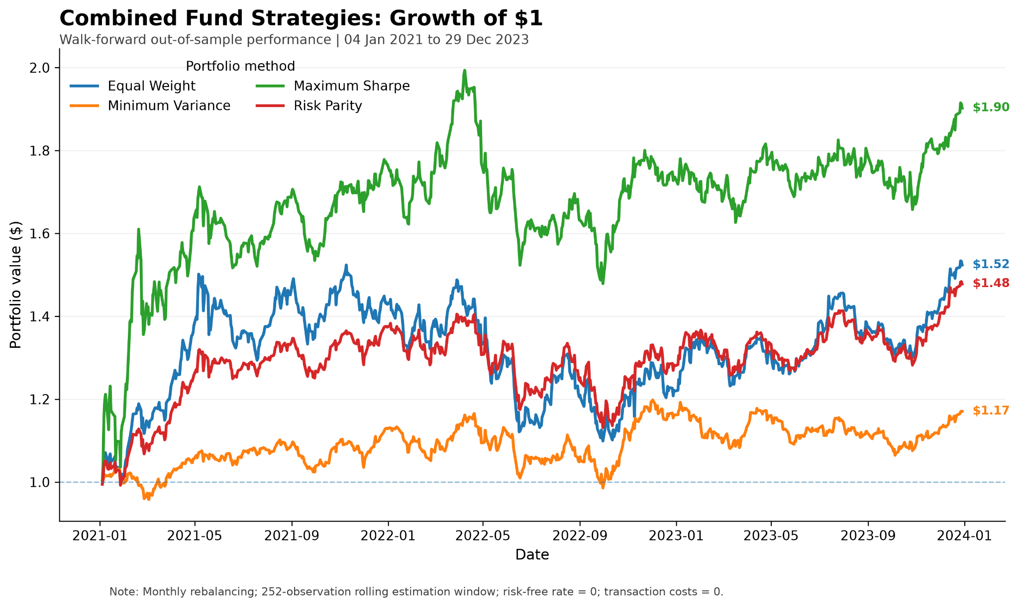
Figure 1. Combined fund strategies: growth of $1, 4 January 2021 to 29 December 2023. (source: results/figures/combined_growth_of_1.png. Monthly rebalancing, 252-observation window, risk-free rate and transaction costs zero.)
Minimum Variance delivered its intended low-volatility profile out of sample in both non-crypto families, and the trade-off was clear. Combined Minimum Variance returned 5.41% at 12.75% volatility with a -15.41% maximum drawdown, while Equity Minimum Variance returned 5.43% at 12.73% volatility with a -15.25% drawdown. These were among the lowest-risk realised profiles in the non-crypto group, but their growth was materially below Equal Weight. The results therefore show that reducing portfolio volatility came at a substantial opportunity cost over this sample.

2.2 Diversification Versus Optimisation
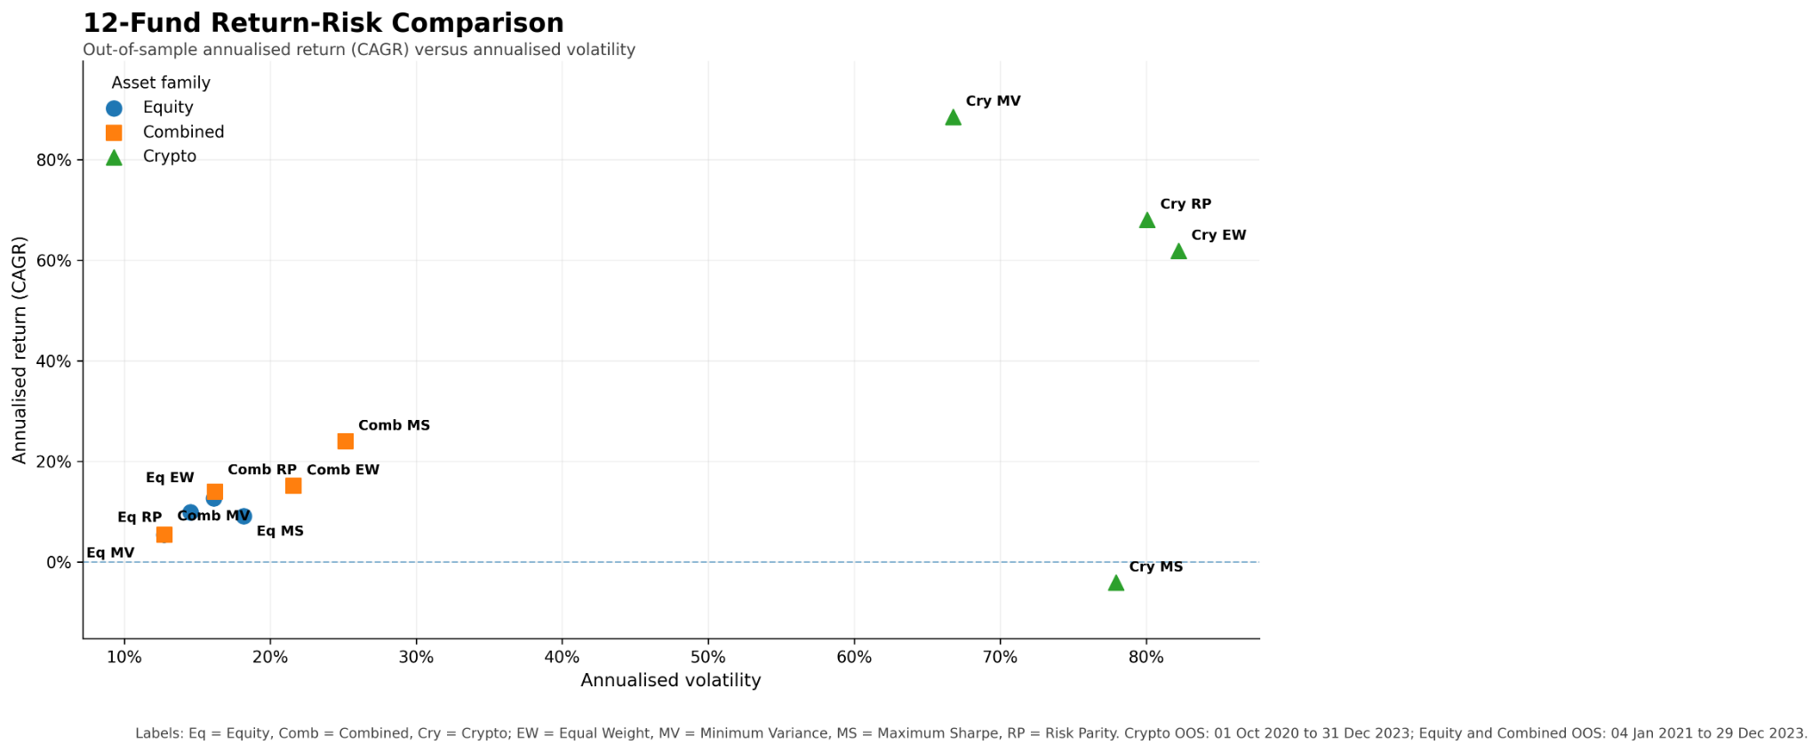
Figure 2. Return-risk comparison across the twelve walk-forward funds. (source: results/figures/fund_return_risk_comparison.png. Crypto OOS: 1 October 2020 to 31 December 2023; Equity and Combined OOS: 4 January 2021 to 29 December 2023.)
Figure 2 places all twelve funds on a return-versus-risk plane and makes the family structure visible at a glance. Crypto occupies its own region in the top-right, with annualised volatilities between roughly 67% and 82% and returns ranging from spectacular to negative, while the equity and combined funds cluster in the lower-left at far lower risk. Crypto Minimum Variance appears strongest on headline metrics, but the result came with extreme realised risk: its maximum drawdown reached -71.28%, and the portfolio also became highly concentrated, including one rebalance with an allocation close to 100% Bitcoin. It cannot be considered low-risk merely because its summary Sharpe ratio is high.
The starkest illustration of the CAGR-versus-Sharpe distinction is Crypto Maximum Sharpe, which posts a positive Sharpe of 0.338 yet a CAGR of -4.10%, turning one dollar into 0.87. At each rebalance it was constructed to maximise estimated Sharpe using the preceding estimation window, yet the realised OOS path produced a -4.10% CAGR. Very high volatility and the resulting volatility drag help explain why the arithmetic mean annualised in the Sharpe ratio remains positive while the compounded path that determines CAGR does not. This outcome is consistent with expected-return estimation error and optimiser instability, and it is the clearest sign in the line-up that a portfolio tuned to maximise historical Sharpe can fail badly when its estimates do not hold.

2.3 Concentration, Drawdown and Portfolio Stability
Combined Maximum Sharpe's strong terminal growth came with concentration and instability that a fact sheet must disclose. Figure 3 plots its target weights over time for the five assets with the highest average weight (MRK at 13.7%, PSA at 12.2%, GE at 10.4%, ABBV at 8.3% and NVDA at 6.2%), and it shows the portfolio rotating aggressively between a small subset of names rather than holding a stable, diversified book; the remaining assets are omitted only for readability. The largest single-asset target weight the fund ever held was 64.2% in MRK on 3 January 2023. Appendix Figure A1 summarises this across methods: Combined Maximum Sharpe frequently ran 40% to 65% in one asset, with a latest rebalance of 45.3% in a single name, against 18.5% for Minimum Variance, 3.8% for Risk Parity and 1.7% for Equal Weight.
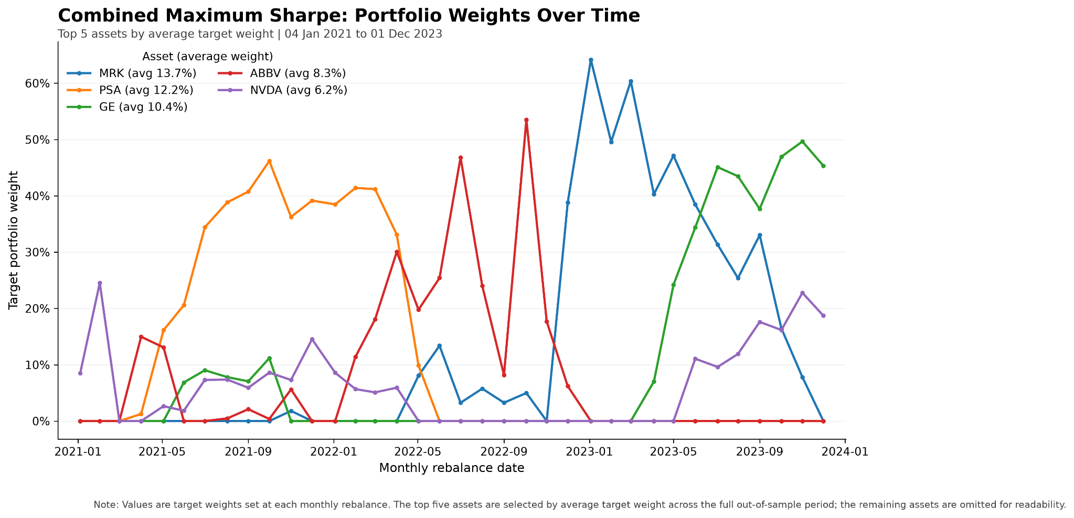
Figure 3. Combined Maximum Sharpe target weights over time (top five assets by average weight), 4 January 2021 to 1 December 2023. (source: results/figures/combined_max_sharpe_weights_over_time.png. Remaining assets omitted for readability.)
This reframes the growth ranking. Combined Maximum Sharpe's 24.01% CAGR was accompanied by highly concentrated weights, making the realised outcome more sensitive to the stability of the expected-return estimates, and its drawdown of -25.82% (Figure 4) is deeper than Risk Parity's -19.47% despite Risk Parity carrying a fraction of the single-name exposure. For a retail investor prioritising diversification, Risk Parity or Equal Weight therefore provides a more defensible core allocation than a strategy whose weights repeatedly became concentrated in a handful of assets.
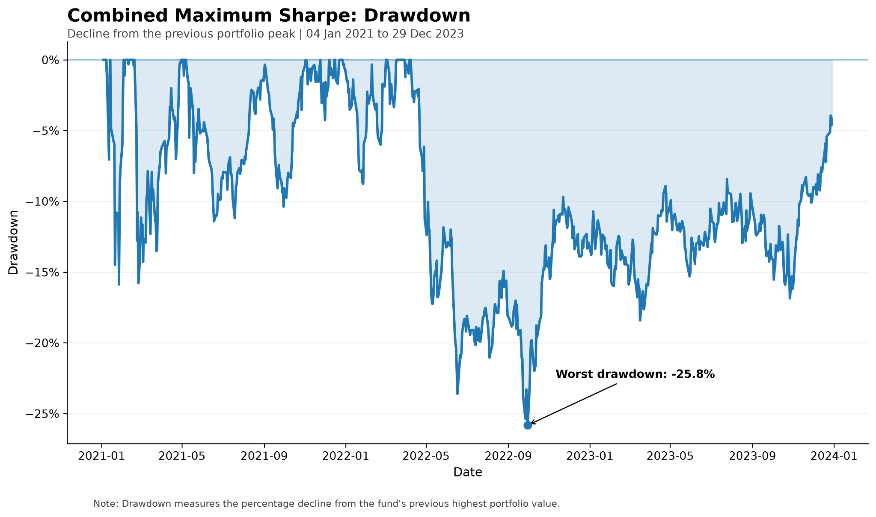
Figure 4. Combined Maximum Sharpe drawdown, 4 January 2021 to 29 December 2023. (source: results/figures/combined_max_sharpe_drawdown.png. Drawdown is the percentage decline from the fund's previous peak; worst drawdown -25.8%.)

3. News Sentiment Index and Validation

3.1 Standard VADER Baseline
The sentiment analytics begin with standard VADER (Hutto and Gilbert, 2014) applied to the 146,830 equity headlines mapped to trading days. VADER is a rule-based model tuned for social media, and on this corpus it scored 48.85% of all mapped headlines as exactly neutral (a compound score of zero). Some of these neutral classifications appear to reflect finance-specific vocabulary gaps: headlines with clear financial direction whose key term VADER's general-purpose lexicon does not recognise. The raw headline text is preserved before scoring, since VADER relies on casing, punctuation and intensifiers. This neutral rate is the baseline the innovation in Section 4 is designed to reduce.

3.2 Sector Sentiment Index Construction
The sector index converts headline scores into a daily signal for each of the ten equity sectors. Multiple headlines for the same ticker on the same trading day are averaged first. A full trading-day-by-ticker panel is then constructed so that every ticker-day is explicit, and the five tickers within a sector are equal-weighted into a sector score. Each value carries diagnostics including a headline count and a coverage share. The panel holds 10,060 sector-day observations across ten sectors from 2 January 2020 to 29 December 2023.

3.3 Coverage and the No-News Rule
Ticker-days with no headline are treated as neutral, a score of zero, a deliberate choice with a clear meaning and a clear cost. A zero means "no new measured news signal", not "the market judges this company to be neutral". Because average coverage is about 75.5% rather than 100%, zero-filled ticker-days mechanically attenuate the measured sector-index magnitude relative to an index calculated only from tickers with observed news. To prevent look-ahead, the usable signal is lagged by one trading day, so a decision on day t uses only sentiment from day t-1 or earlier. The panel has no missing current-sentiment values and exactly ten missing lagged values, one at the first observation of each sector, which is the expected consequence of a one-day lag. Every backtest that consumes sentiment reads the lagged column, so the fusion strategies never see contemporaneous information.

3.4 Event-Based Validation
The index was face-validated against a genuine market-stress episode, the COVID sell-off window of 15 February to 31 March 2020. Within that window the most negative cross-sector day was 12 March 2020 (Figure 5). On that day, standard VADER's cross-sector daily mean fell to -0.028 with five of ten sectors negative, and the Finance-Adjusted index fell further to -0.036 with seven of ten sectors negative; both ranked second-lowest in the full 1,006-day sample, on 88% coverage. The index therefore produced a strongly negative reading during a recognised market-stress episode, while the Finance-Adjusted version produced a more broadly negative signal across sectors. This is event validation, a check that the index behaves sensibly, not a test of forecasting power or evidence that the index predicts returns.
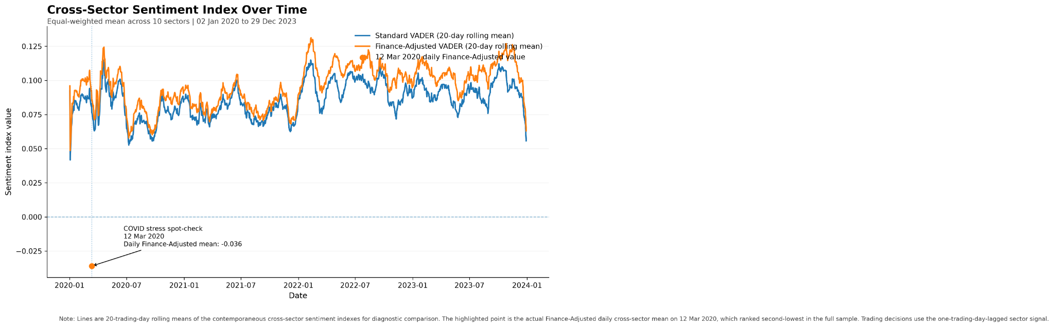
Figure 5. Cross-sector Standard and Finance-Adjusted VADER sentiment, 2 January 2020 to 29 December 2023. (source: results/figures/sector_sentiment_time_series.png. Lines are 20-trading-day rolling means of the contemporaneous indices; the marked point is the 12 March 2020 daily value. Trading uses the one-day-lagged signal.)

4. Innovation: Finance-Adjusted VADER

4.1 Motivation
Part A identified finance-specific vocabulary gaps as one contributor to the large number of neutral classifications produced by Standard VADER. The Part B innovation therefore targets this measurable language-coverage problem directly. Two related statistics must be kept distinct. The Part A finding that about 46.9% of headlines contained no recognised VADER sentiment vocabulary is a vocabulary-coverage measure. The Part B baseline that 48.85% of headlines score a compound of exactly zero is a scored-output measure. They describe related but different quantities, and the Part B neutral-rate measure provides the baseline outcome used to evaluate the Finance-Adjusted lexicon.

4.2 Finance Lexicon Design
The innovation is a conservative 32-term finance lexicon, all 32 of which are absent from standard VADER, added to a second VADER instance so the two models can be scored side by side on the same text. The design is deliberately restrained. Ambiguous or context-dependent words such as "buy", "sell", "higher", "dividend" and "guidance" were excluded because their direction depends on context, and words VADER already recognises, such as "miss", were dropped to avoid overwriting existing scores. What remains is a set of clearly directional terms (positive: beat, outperform, bullish, rally, surge, upgrade, buyback; negative: downgrade, underperform, bearish, plunge, selloff, downturn, default, bankruptcy) scaled by severity, with bankruptcy at -3.0 the strongest. The baseline lexicon is left untouched and raw text preserved, so any measured change comes only from the added finance terms.

4.3 Headline-Level and Sector-Level Results
At the headline level the effect is real but selective. The neutral rate fell from 48.85% to 45.96%, a reduction of 2.88 percentage points (a percentage-point reduction, not a 2.88% relative change), which rescued 4,257 previously neutral headlines. Those rescues are 2.90% of all headlines and about 5.9% of the headlines VADER had scored neutral. Only 8,846 headlines, 6.02% of the corpus, contain any custom finance term at all. The reading that follows is deliberately modest: about 94% of headlines contain no finance term and are unaffected, so Finance-Adjusted VADER is a targeted correction to a specific language gap, not a broad transformation of all sentiment classification. Table 2 demonstrates the mechanism using verified examples from the project corpus. Each headline was exactly neutral under Standard VADER but became directional once one or more finance-specific terms were recognised.
Table 2. Verified headline rescues from the project news corpus. Each headline received a Standard VADER compound score of exactly 0.000 and became directional after the Finance-Adjusted lexicon recognised the listed finance terms. Raw headline text is retained as supplied, including original spelling. Five verified examples across five different sectors are shown; the complete reproducible eight-example sample is stored in results/tables/rescued_headline_examples.csv.
Headline | Sector | Standard | Finance-Adjusted | Matched finance terms
AMD Continues March Higher As Mizuho Joins Bullish Peers With Upgrade | Tech | 0.000 | +0.751 | bullish, upgrade
Halliburton (HAL) Q1 Earnings Beat as Both Units Outperform | Energy | 0.000 | +0.735 | beat, outperform
Disney downgraded to Underperform from In-Line at Imperial Capital | Consumer | 0.000 | -0.751 | downgraded, underperform
Caterpillar shares are trading lower after analysts at Bank of America downgraded the company's stock from Neutral to Underperform. | Industrials | 0.000 | -0.751 | downgraded, underperform
Dow shares are trading lower after analysts at Bank of America downgraded their rating of the stock from Buy to Underperform. | Materials | 0.000 | -0.751 | downgraded, underperform

The observed use of the 32-term lexicon was concentrated in a smaller subset of terms. Beat appeared in 2,085 headlines, followed by rally (1,065), beats (879), rebound (680) and surge (504). Because a headline can contain more than one finance term, these counts are non-exclusive. The result shows that although 32 terms were implemented, their empirical exposure within the corpus was uneven.
The correction reaches every sector. All ten show a lower neutral rate under the finance lexicon, with the largest reductions in Healthcare (about 3.50 pp), Materials (3.41 pp), Real Estate (3.37 pp) and Technology (3.28 pp), and finance-term coverage ranging from about 4.6% in Communications to 6.9% in Technology and Financials. Part A had suggested finance-language gaps might matter most in drier-news sectors, and the Part B pattern partly supports that expectation: Materials and Real Estate do show large reductions, but Technology and Healthcare respond just as strongly, so the result is a partial rather than a clean confirmation.
The aggregation step is where a 6% headline footprint becomes materially larger. Across the 10,060 sector-days, 3,918 (38.95%) have a different index value under the finance lexicon, with a mean absolute change of about 0.014 and extremes of +0.282 and -0.286. This must be read carefully: changing 39% of sector-day index values is not the same as changing 39% of trading decisions, and certainly not 39% of decisions becoming more profitable. Because a change to even one ticker-day sentiment value can alter the equal-weighted sector average, headline-level adjustments propagate into a larger share of sector-day index observations than the raw 6.02% headline coverage suggests.

4.4 Sentiment Fusion
The fusion test folds the sector signal into the Equity Equal Weight fund and measures the before-versus-after effect (Table 3, Figure 6). It is run on Equity Equal Weight rather than on an optimised fund, so the result isolates the sentiment signal from optimiser noise. At each monthly rebalance the base equal weight of each stock is multiplied by one plus the one-day-lagged sentiment of the stock's sector, and the tilted weights are renormalised. The tilt strength was fixed at 1.0 before any results were seen and was not tuned afterward. That discipline is deliberate: selecting the tilt strength after observing out-of-sample performance would effectively overfit the evaluation period and make any apparent improvement less credible as evidence of generalisation.
Table 3. Sentiment fusion, before versus after, on the Equity Equal Weight base fund. (source: results/tables/fusion_comparison.csv, 4 Jan 2021 to 29 Dec 2023, annualised at 252, one-day-lagged sentiment, tilt strength 1.0.)
Strategy | CAGR | Ann. volatility | Sharpe | Max drawdown | Growth of $1
Baseline Equal Weight | 12.64% | 16.12% | 0.819 | -20.25% | 1.427
Standard VADER Tilt | 12.02% | 16.09% | 0.786 | -20.58% | 1.404
Finance-Adjusted VADER Tilt | 12.17% | 16.07% | 0.795 | -20.42% | 1.409

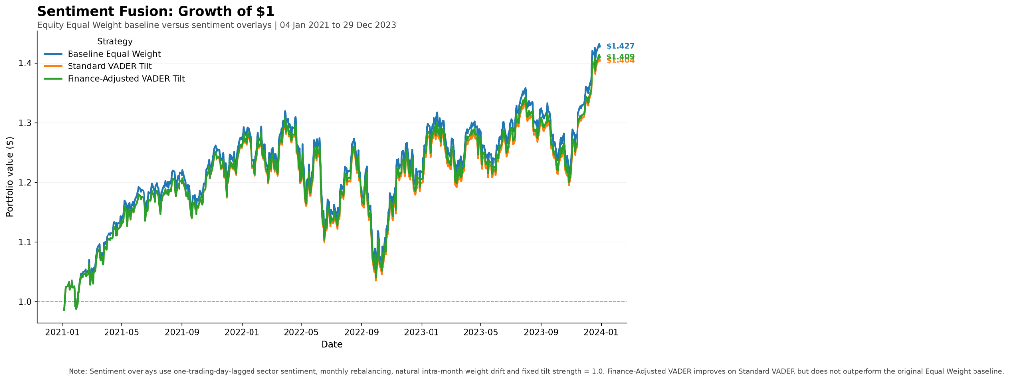
Figure 6. Equity Equal Weight baseline versus Standard and Finance-Adjusted sentiment overlays, 4 January 2021 to 29 December 2023. (source: results/figures/fusion_growth_comparison.png. One-day-lagged sector sentiment, monthly rebalancing, tilt strength 1.0.)

4.5 Interpretation of the Negative Portfolio Result
The honest result, in Table 3, is that the sentiment overlay did not beat the base fund. The Standard VADER tilt underperformed the untilted Equal Weight baseline on return, Sharpe and terminal wealth. The Finance-Adjusted tilt improved on the Standard tilt on every metric, with a higher return, higher Sharpe, slightly lower volatility, a shallower drawdown and higher terminal wealth, but it still finished below the baseline.
The improvement over Standard VADER is nevertheless economically small: CAGR rises by only about 0.14 percentage points, from 12.02% to 12.17%, while Sharpe increases from 0.786 to 0.795. The nearly overlapping growth paths in Figure 6 reinforce that the lexicon refinement improved the overlay only marginally at portfolio level.
The fusion result separates improved sentiment measurement from economic investment value. Finance-Adjusted VADER improved the overlay relative to Standard VADER, but the added signal was not sufficient to outperform Equal Weight. A plausible contributing mechanism is that sector sentiment values are small in magnitude, so a multiplier of one plus sentiment only modestly perturbs equal weights, though this is offered as an inference rather than a measured cause. The broader finding is the valuable one for a data product: better natural-language coverage does not automatically create an economically powerful investment signal, and a naive overlay can underperform a simple benchmark.

5. Streamlit Product and Investor Journey
The No Bull Investing prototype turns these analytical outputs into a decision tool for the target investor, and its architecture is shaped by that goal. It reads only precomputed artifacts (the fund returns, weights, sector index and performance tables written by the build scripts) and never reruns a backtest or scores VADER on load, which is designed to keep computational requirements low and make deployment on basic cloud hardware feasible. The interface is organised as four tabs that follow the investor's journey from comparison to allocation.
The Compare Funds tab presents all twelve funds with family filtering, headline cards for the highest-CAGR, highest-Sharpe and lowest-volatility funds, a return-versus-risk plot and the metrics table, plus a short note on why CAGR and Sharpe can disagree, which guards against chasing the highest headline return. The Fund Fact Sheet tab shows any fund's CAGR, volatility, Sharpe, maximum drawdown, growth of one dollar, latest target holdings and a concentration warning. That warning is an original, investor-oriented feature: it flags when the fund's latest available backtest target weight is highly concentrated. For example, Combined Maximum Sharpe's final rebalance allocated about 45% to its largest position, compared with about 3.8% for Combined Risk Parity. This connects the Section 2.3 finding to the point of decision.
The Build an Allocation tab lets the investor choose up to four funds, assign percentages that must sum to 100%, and see the blended portfolio's CAGR, volatility, Sharpe, maximum drawdown and growth of one dollar over the common out-of-sample period. The blend is genuinely computed from the precomputed fund returns and lets the initial allocation drift naturally rather than resetting daily, consistent with the fund backtests, so the resulting metrics are calculated dynamically from the precomputed fund-return series rather than displayed as fixed examples. The Sentiment Analytics tab surfaces the headline count, the two neutral rates and their difference, finance-term coverage, a sector selector with both time series, a news-coverage chart and plain-language notes on the no-news rule and the one-day lag, positioning sentiment as supplementary context rather than a return engine. The application is a prototype decision-support interface, not a licensed real-money product, and it does not execute trades.

6. Critical Reflection, Limitations and Recommendations

6.1 What Worked
Three things worked well. First, simple diversification proved robust: Equal Weight beat the optimised equity funds out of sample, and Risk Parity produced materially less concentrated allocations than Maximum Sharpe in the reported comparisons. Second, the Finance-Adjusted VADER lexicon measurably improved text coverage, cutting the neutral rate across all ten sectors and improving the overlay relative to standard VADER. Third, the analytics translated into features an investor can act on: the event validation behaved sensibly during the COVID shock, and the concentration warning turned an abstract risk into a fact-sheet flag at the point of decision.

6.2 What Did Not and Key Limitations
Several limitations bound the results. Optimisation instability is the clearest: Maximum Sharpe became concentrated and estimation-sensitive, and Crypto Maximum Sharpe failed outright out of sample, which highlights expected-return estimation as a major source of fragility in the Maximum Sharpe approach. Second, the 252-observation window is roughly a year for equities but only about eight months for crypto, so the families are not estimated over the same calendar horizon. The Combined funds are also evaluated on the equity trading calendar, meaning weekend-only crypto movements are excluded from the mixed-asset return series; the Combined results therefore do not represent continuous seven-day crypto exposure. Third, transaction costs are set to zero. Trading costs would reduce net performance where portfolio rebalancing requires larger transactions, but turnover was not measured in this build, so the size of that effect cannot be quantified here. Fourth, the sentiment signal rests on headlines only, not full article text, and is a noisy proxy. Fifth, the no-news-equals-zero rule attenuates index magnitude at about 75.5% average coverage. Sixth, the finance lexicon reaches only about 6% of headlines, so it is a targeted correction rather than a general-purpose sentiment engine. The Finance-Adjusted lexicon is also evaluated primarily through coverage, face-valid headline examples and aggregate event behaviour rather than against a human-labelled sentiment benchmark. A rescued neutral headline is therefore evidence of increased finance-language sensitivity, not definitive proof that the revised score is objectively correct. Finally, the 2020 to 2023 sample contains unusual regimes (the COVID crash, a strong recovery and an inflation shock) that may not generalise, and the framework is long-only. The OOS evaluation horizon is also relatively short, at approximately three years for the Equity and Combined families. No confidence intervals or statistical significance tests are reported for differences in CAGR or Sharpe, so the observed rankings should be treated as sample-specific evidence rather than proof of persistent superiority.

6.3 Three Concrete Recommendations
First, the product team should position Equal Weight and Combined Risk Parity as core options, but for different reasons. Equal Weight offers maximum transparency and very low concentration without relying on estimated optimal weights, while Combined Risk Parity delivered the stronger risk-balanced profile, with 16.20% volatility, a -19.47% maximum drawdown and a latest largest target position of about 3.8%. Higher-concentration strategies such as Maximum Sharpe should instead be clearly identified as specialist options. This structure reduces the risk that retail investors select funds solely on headline CAGR without understanding the different sources of portfolio risk.
Second, if Maximum Sharpe is offered commercially, the risk team should add concentration and implementation controls before any live deployment, such as a maximum single-asset weight cap, turnover monitoring, an explicit transaction-cost model and stronger robustness testing of the expected-return inputs. None of these controls exists in the current prototype; they are a next-stage requirement. The 64% single-asset weight, the zero-cost assumption and the OOS failure of Crypto Maximum Sharpe collectively motivate stronger controls around concentration, parameter robustness and implementation costs.
Third, the analytics team should use Finance-Adjusted sentiment as a secondary, contextual overlay and a transparency feature, not as a standalone return engine. The evidence is that the lexicon improved finance-language coverage and improved the Standard VADER tilt but did not beat Equal Weight, so it should be surfaced to give investors context on the news environment and used only in conservative overlays subject to further predictive validation before they drive allocations. This addresses the temptation to over-trust a plausible-looking signal that the backtest does not support.

Conclusion
No Bull Investing set out to build a data-driven investment product from raw market and news data through to a working app, and the project's central lesson is that complexity and richer data do not automatically improve investment outcomes. Simple diversification proved robust, with Equal Weight beating the optimised equity funds and Risk Parity producing materially less concentrated allocations in the reported comparisons. Optimisation created both opportunity and risk: Combined Maximum Sharpe produced the strongest non-crypto growth through concentrated, unstable positions, and Crypto Maximum Sharpe optimised historical Sharpe only to fail out of sample. Finance-Adjusted VADER expanded finance-specific language coverage and improved the Standard VADER overlay, yet still could not beat the simple baseline. Taken together, the findings support positioning No Bull Investing as a transparent decision-support prototype rather than as a system that promises predictive superiority. Its strongest contribution is the combination of reproducible out-of-sample evidence, explicit concentration and risk disclosure, and sentiment analytics whose limitations are shown alongside their potential value.

References
Hutto, C.J. and Gilbert, E. (2014) 'VADER: A parsimonious rule-based model for sentiment analysis of social media text', Proceedings of the Eighth International AAAI Conference on Weblogs and Social Media (ICWSM-14), Ann Arbor, MI, pp. 216-225.
Maillard, S., Roncalli, T. and Teïletche, J. (2010) 'The properties of equally weighted risk contribution portfolios', The Journal of Portfolio Management, 36(4), pp. 60-70.
Markowitz, H. (1952) 'Portfolio selection', The Journal of Finance, 7(1), pp. 77-91.
FINS3645 (2026) Project data bundle: equity prices, crypto prices and news headlines, University of New South Wales, accessed via the course data-access helper.

Appendix
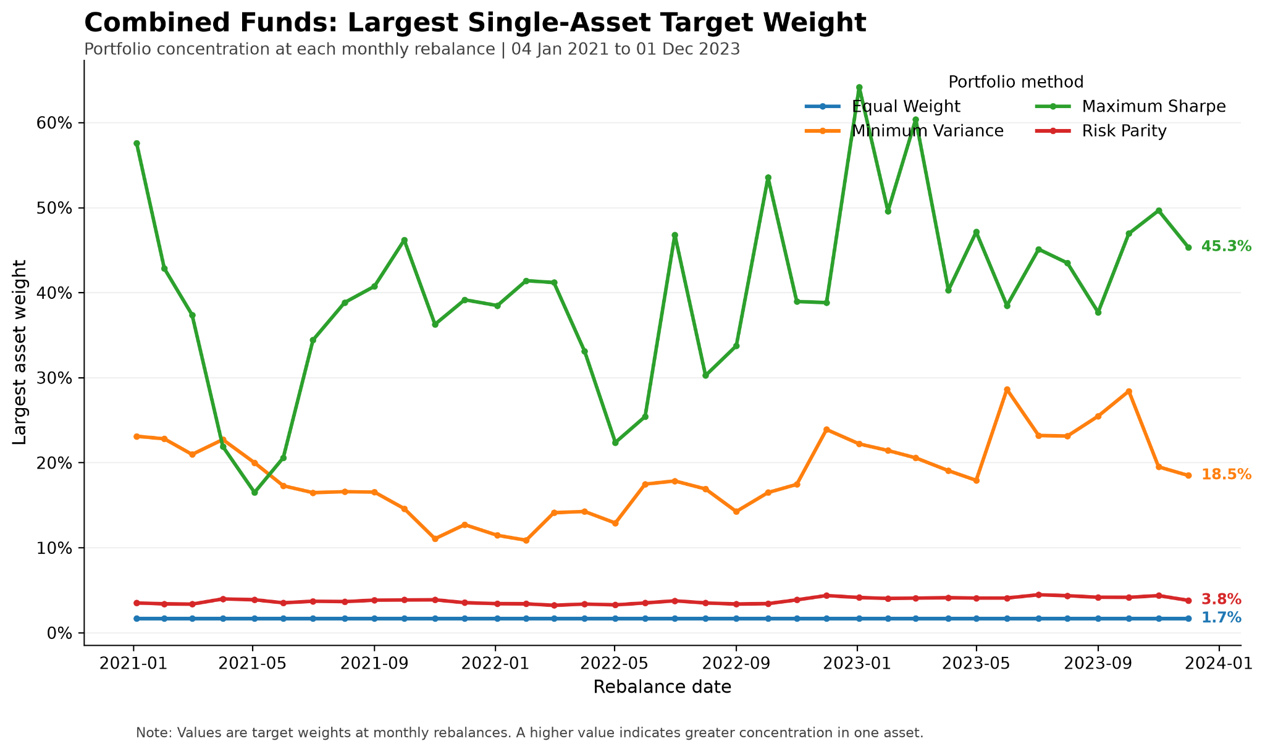
Figure A1. Combined funds: largest single-asset target weight at each rebalance, 4 Jan 2021 to 1 Dec 2023. (source: results/figures/combined_weight_concentration.png. Referenced and interpreted in Section 2.3.)
Supporting tables produced by the build pipeline and referenced in the narrative: results/tables/sentiment_model_comparison.csv (sector-level baseline and Finance-Adjusted neutral rates and finance-term coverage, discussed in Section 4.3) and results/tables/sentiment_event_validation.csv (the 12 March 2020 event validation, discussed in Section 3.4). Finance-term frequency counts across the corpus can be regenerated with scripts/extract_rescued_examples.py.

