# Installation Guideline

***Solution: Clinic Reporting System - BI Solution***

***Owner:*** *Karla Rivas*

***Date:*** *March 2017*

## Change Log

|  |  |  |
| --- | --- | --- |
| **Who** | **When** | **What** |
|  |  |  |
|  |  |  |
|  |  |  |

# 

**Installation Guideline** **1**

Change Log 1

1. Introduction 1

1.1 Summary 1

2. Installation 1

2.1 Installation of ETL Support tables and Scripts 1

2.2 Installation of views and support stored procedures for the patients and visits integrations 2

3. Running the Process 2

4. Additional Considerations 3

## 1. Introduction

### 1.1 Summary

This document aims to provide a guideline about how to install and run the Clinic Reporting Solution

## 

## 2. Installation

### 2.1 Installation of ETL Support tables and Scripts

|  |  |  |
| --- | --- | --- |
| Step | Script | Description |
| 1 | \Scripts\Create Datawarehouse\DWClinicReportData.sql | Creates the DWClinicReportData |
| 2 | Scripts\Create ETL\1_dwclinicreport_etl_drop_fks_procedure.sql | Create the stored procedure used to drop foreign keys |
| 3 | Scripts\Create ETL\2_dwclinicreport_etl_truncate_table_procedure.sql | Create the stored procedure used to truncate tables |
| 4 | Scripts\Create ETL\3_dwclinicreport_etl_build_dim_staging_tables.sql | Create dimension views |
| 5 | Scripts\Create ETL\4_dwclinicreport_etl_load_dimensions_procedures.sql | Create stored procedures used to load all dimensions |
| 6 | Scripts\Create ETL\5_dwclinicreport_etl_load_dimdate_procedure.sql | Creates the stored procedure used to build the date dimension |
| 7 | Scripts\Create ETL\6_dwclinicreport_etl_build_fact_staging_tables.sql | Create fact views |
| 8 | Scripts\Create ETL\7_dwclinicreport_etl_load_facts_procedures.sql | Creates the stored procedures used to load the fact tables |
| 9 | Scripts\Create ETL\8_dwclinicreport_etl_create_fks_procedure.sql | Creates the stored procedure used to re-create the foreign keys |

### 2.2 Installation of views and support stored procedures for the patients and visits integrations

|  |  |  |
| --- | --- | --- |
| Step | Script | Description |
| 1 | \Scripts\Create Integration Support Files\1_clinicdataintegration_create_staging_table_procedures.sql | Creates staging tables |
| 2 | Scripts\Create Integration Support Files\2_clinicdataintegration_load_new_patients_procedure.sql | Create stored procedure used to load new patients data |
| 3 | Scripts\Scripts\Create Integration Support Files\3_clinicdataintegration_load_new_visits_procedure.sql | Create the stored procedure used to load new visit records |

## 3. Running the Process

The Process can be run by selecting the MainDataFlow Package:

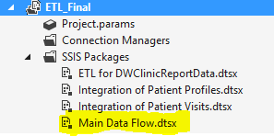

It will execute all the packages in the following order:

## 

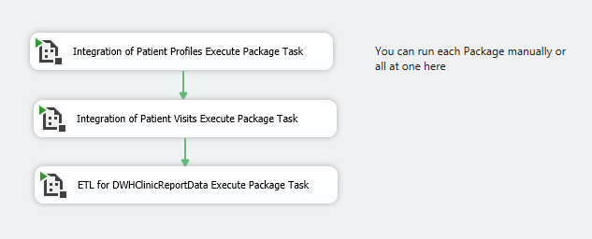

The ETL process can be manually run by executing the dwclinicreport_etl_execute_script.sql script located inside the Scripts folders

## 4. Additional Considerations

In order to run properly, please take in consideration the following specifications:

* Clinic data should be placed in the following location C:\ClinicDailyData

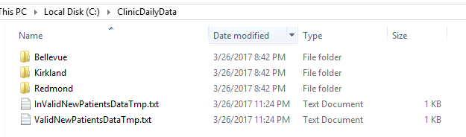

* SSIS Package must be placed in the following location: C:\_ETLSolutions\UW_ETL_Final\ETL_Final

