Data Exploration

Data Set Overview

The table below lists each of the files available for analysis with a short description of what is found in each one.

|  |  |  |
| --- | --- | --- |
| **File Name** | **Description** | **Fields** |
| Ad-clicks.csv | A line is added to this file when a player clicks on an advertisement in the Flamingo app. | timestamp: when the click occurred.  txId: a unique id (within ad­clicks.log) for the clickuserSessionid: the id of the user session for the user who made the click  teamid: the current team id of the user who made the click  userid: the user id of the user who made the click  adId: the id of the ad clicked on  adCategory: the category/type of ad clicked on |
| Buy-clicks.csv | A line is added to this file when a player makes an in­app purchase in the Flamingo app. | timestamp: when the purchase was made.txId: a unique id (within buy­clicks.log) for the purchase  userSessionId: the id of the user session for the user who made the purchase  team: the current team id of the user who made the purchase  userId: the user id of the user who made the purchase  buyId: the id of the item purchased  price: the price of the item purchased |
| users.csv | file contains a line for each user playing the game | timestamp: when user first played the game.userId: the user id assigned to the user.  nick: the nickname chosen by the user.  twitter: the twitter handle of the user.  dob: the date of birth of the user.  country: the two­letter country code where the user lives |
| team.csv | file contains a line for each team terminated in the game | teamId: the id of the team  name: the name of the teamteamCreationTime: the timestamp when the team was created  teamEndTime: the timestamp when the last member left the team  strength: a measure of team strength, roughly corresponding to the success of a team  currentLevel: the current level of the team |
| Team-assignments.csv | line is added to this file each time a user joins a team. A user can be in at most a single team at a  time. | timestamp: when the user joined the team.  team: the id of the teamuserId: the id of the user  assignmentId: a unique id for this assignment |
| Level-events.csv | A line is added to this file each time a team starts or finishes a level in the game | timestamp: when the event occurred.  eventId: a unique id for the event  teamId: the id of the team  teamLevel: the level started or completedeventType: the type of event, either start or end |
| User-session.csv | Each line in this file describes a user session, which denotes when a user starts and stops playing  the game. Additionally, when a team goes to the next level in the game, the session is ended for  each user in the team and a new one started. | timestamp: a timestamp denoting when the event occurred.  userSessionId: a unique id for the session.  userId: the current user's ID.teamId: the current user's team.  assignmentId: the team assignment id for the user to the team.  sessionType: whether the event is the start or end of a session.  teamLevel: the level of the team during this session.  platformType: the type of platform of the user during this session. |
| Game-clicks.csv | A line is added to this file each time a user performs a click in the game | timestamp: when the click occurred.  clickId: a unique id for the click.userId: the id of the user performing the click.  userSessionId: the id of the session of the user when the click is performed.  isHit: denotes if the click was on a flamingo (value is 1) or missed the flamingo (value is 0)  teamId: the id of the team of the user  teamLevel: the current level of the team of the user |

Aggregation

|  |  |
| --- | --- |
| Amount spent buying items  source="buy-clicks.csv" | stats sum(price) | 21407 |
| Number of unique items available to be purchased | 6 |

A histogram showing how many times each item is purchased:

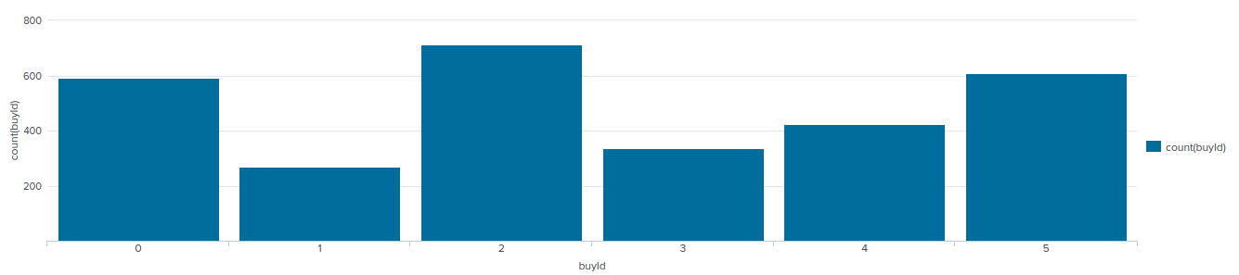A histogram showing how much money was made from each item:

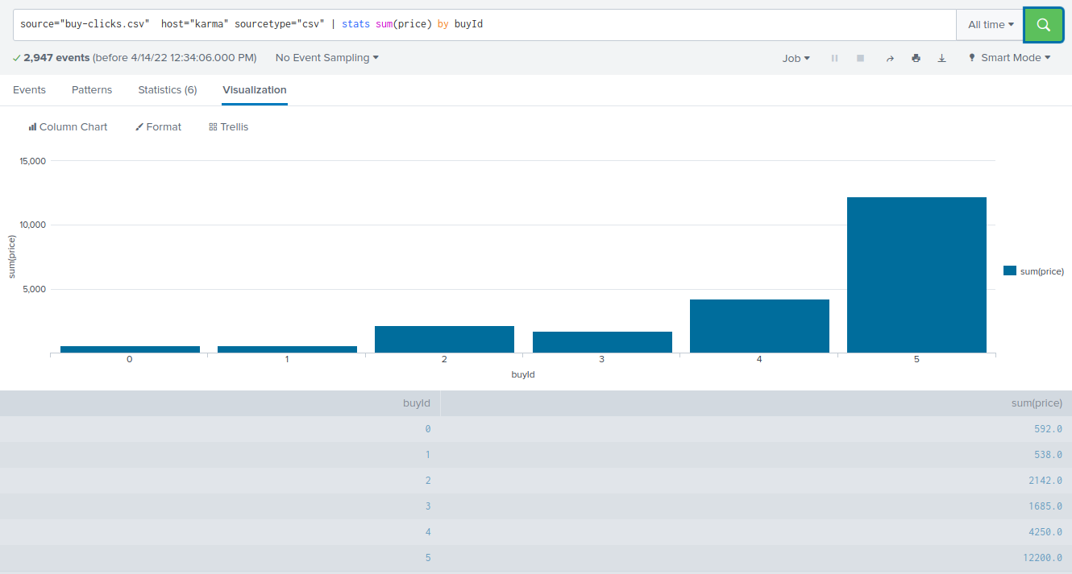

Filtering

A histogram showing total amount of money spent by the top ten users (ranked by how much money they spent).

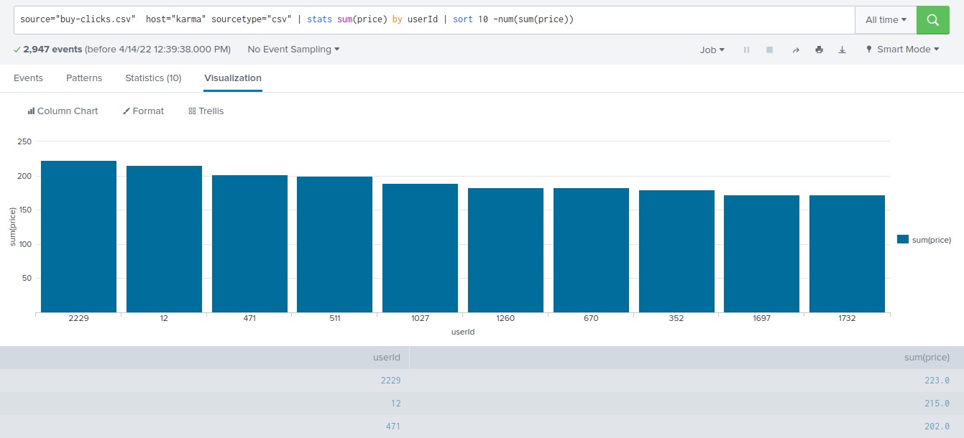

The following table shows the user id, platform, and hit-ratio percentage for the top three buying users:

|  |  |  |  |
| --- | --- | --- | --- |
| **Rank** | **User Id** | **Platform** | **Hit-Ratio (%)** |
| 1 | 2229 | iphone | 61/465=13% |
| 2 | 12 | iphone | 92/612=15% |
| 3 | 471 | iphone | 76/448=17% |