Report

Topics: Sparsity (PCA and Compressive Sensing)

Assigned: Wednesday May 23

Due: Sunday June 10 by midnight

# Part I: PCA

**1. (a) d0 = 6 are the dominant singular values. After 6 the values are extremely low and effectively do not contribute a lot to the ddataset.**

When we run a comparison for the standard deviation values. We see that when considering the 6 dominant values there is a minor error in

Reduced this Matrix from = (2000 × 100) to = (2000, 6)

* SD-inp: 1.2395057807174528
* SD-out: 1.235722754594632
* SD-Err: 0.09679696927444671

6 dominant singular values from Matrix (2000 × 100) : [282.76080712 266.71486558 242.47285716 229.01120717 161.32588682 133.6358575 5.38798619]

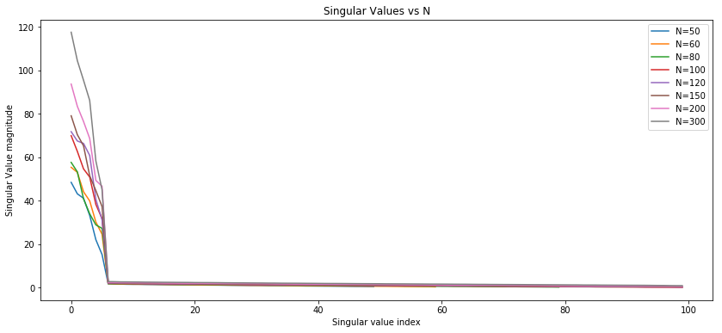

**1. (b) Performed PCA and implemented KMeans for the dominant d0 components. We can see the probabilities of various components based on the cluster center plot.**

K= 2

comp= 1 -> Prob=0.00 -> Prob=1.00

comp= 2 -> Prob=0.80 -> Prob=0.20

comp= 3 -> Prob=0.00 -> Prob=1.00

K= 3

comp= 1 -> Prob=0.00 -> Prob=1.00 -> Prob=0.00

comp= 2 -> Prob=0.30 -> Prob=0.00 -> Prob=0.70

comp= 3 -> Prob=0.49 -> Prob=0.51 -> Prob=0.00

K=4

comp= 1 -> Prob=0.00 -> Prob=0.00 -> Prob=0.00 -> Prob=1.00

comp= 2 -> Prob=0.51 -> Prob=0.45 -> Prob=0.04 -> Prob=0.00

comp= 3 -> Prob=0.00 -> Prob=0.00 -> Prob=0.56 -> Prob=0.44

K=5

comp= 1 -> Prob=0.00 -> Prob=0.50 -> Prob=0.13 -> Prob=0.00 -> Prob=0.37

comp= 2 -> Prob=0.30 -> Prob=0.00 -> Prob=0.00 -> Prob=0.70 -> Prob=0.00

comp= 3 -> Prob=0.46 -> Prob=0.00 -> Prob=0.54 -> Prob=0.00 -> Prob=0.00

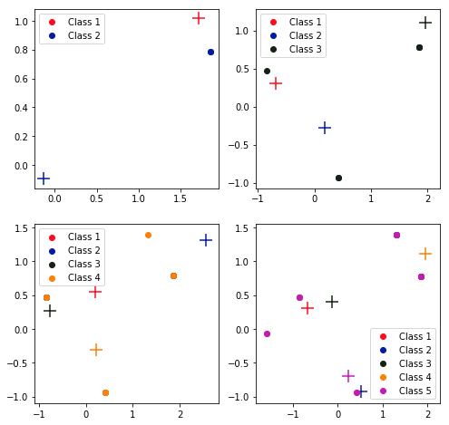

**Observing the Cluster Centers**

**2. Insights into how the cluster centers found by K-means relate to the d0-dimensional projections of the vectors {uj} in the model**

The mean of data points from component 1 is the projection of u1 into m = 6 dimension, and the mean data points from component u2 is the projection of 2 × u4 to the m = 6 dimension, and for the data points from component three, it is the projection of (2)u6 to the m = 6 dimension. Thus, for every cluster, the centers found by K-means is the weighted average of the means of each component in lower dimension, based on how many points of that component are in the cluster.

# Part II: Random Projections & Compressed Sensing

**3. Generated the dataset with the following variable shapes & values**

N = 2000,

M = 20,

Y_xp : (2000, 20),

Labels: (2000, 3),

Phi : (20, 100),

B : (100, 7)

**4. Find a sparse reconstruction of s based on y using Lasso. The minimum M is 11**

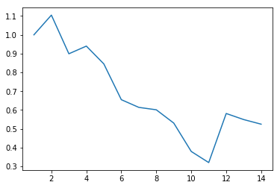

**MSE vs M values**

**5. normalized MSE over many draws, with reconstruction performance.**

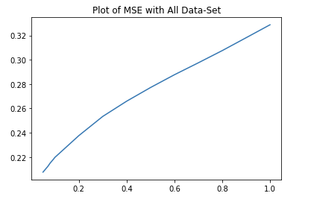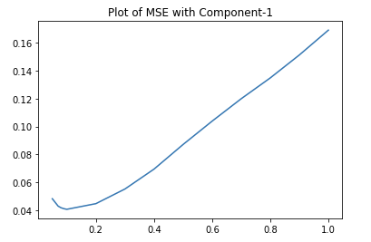

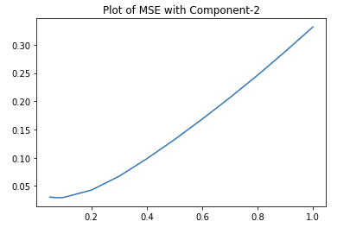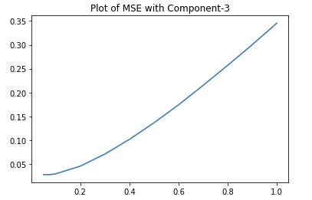

Fig: We can see the mean square error increases as the lambda value increase from 0 to 1

There was another case in which it did not perform any good irrespective of the lambda value and the plot of that is available in the code logs.

**6. Down projected the data to 6 dimensions with m =11**

The projected distance are mentioned below in both the spaces. We can see that it did maintain some consistency across the values however not accurate.

projected_dist_matrix

[[ 0. 37.45 56.36 73.45 23.64 46.82]

[ 37.45 0. 66.91 66.55 34.91 87.55]

[ 56.36 66.91 0. 131.27 59.64 114.45]

[ 73.45 66.55 131.27 0. 70.18 67.18]

[ 23.64 34.91 59.64 70.18 0. 43.18]

[ 46.82 87.55 114.45 67.18 43.18 0. ]]

dist_matrix

[[ 0. 2. 2. 7. 3. 4.]

[ 2. 0. 2. 3. 3. 2.]

[ 2. 2. 0. 7. 3. 4.]

[ 7. 3. 7. 0. 10. 7.]

[ 3. 3. 3. 10. 0. 7.]

[ 4. 2. 4. 7. 7. 0.]]

**7. K-means algorithm post-projection**

**Dataset Dimension: (2000, 11)**

K= 2

comp= 1 -> Prob=0.69 -> Prob=0.31

comp= 2 -> Prob=0.63 -> Prob=0.37

comp= 3 -> Prob=0.27 -> Prob=0.73

K= 3

comp= 1 -> Prob=0.00 -> Prob=0.31 -> Prob=0.69

comp= 2 -> Prob=0.43 -> Prob=0.02 -> Prob=0.55

comp= 3 -> Prob=0.08 -> Prob=0.66 -> Prob=0.26

K= 4

comp= 1 -> Prob=0.23 -> Prob=0.03 -> Prob=0.00 -> Prob=0.74

comp= 2 -> Prob=0.01 -> Prob=0.30 -> Prob=0.39 -> Prob=0.30

comp= 3 -> Prob=0.57 -> Prob=0.01 -> Prob=0.06 -> Prob=0.36

K= 5

comp= 1 -> Prob=0.00 -> Prob=0.00 -> Prob=0.47 -> Prob=0.43 -> Prob=0.10

comp= 2 -> Prob=0.25 -> Prob=0.37 -> Prob=0.28 -> Prob=0.10 -> Prob=0.00

comp= 3 -> Prob=0.01 -> Prob=0.05 -> Prob=0.13 -> Prob=0.41 -> Prob=0.40

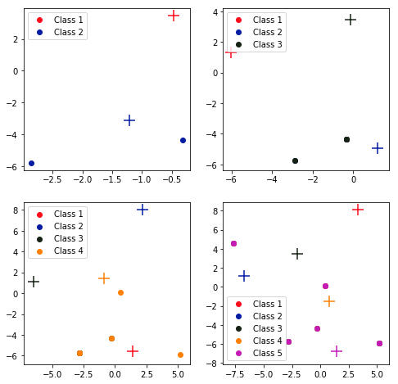

**Observing the Cluster Centers**

**8. geometric insight. cluster centers found by K-means relate to the m=11 dimensional projections of the vectors**

K-means seeks to represent all n data vectors via small number of cluster centroids so K-means can be seen as a highly-sparse PCA.

The mean of data points from component 1 is the projection of u1 into m = 11 dimension, and the mean data points from component u2 is the projection of 2 × u4 to the m = 11 dimension, and for the data points from component three, it is the projection of (2)u6 to the m = 11 dimension. Thus, for every cluster, the centers found by K-means is the weighted average of the means of each component in lower dimension, based on how many points of that component are in the cluster.