GPU Configuration Guide

Step 1: Install Ubuntu system dependencies

Let’s get our Ubuntu OS up to date:

$ sudo apt-get update
$ sudo apt-get upgrade

Then, let’s install some necessary development tools, image/video I/O, GUI operations and various other packages:

$ sudo apt-get install build-essential cmake git unzip pkg-config
$ sudo apt-get install libjpeg-dev libtiff5-dev libjasper-dev libpng12-dev
$ sudo apt-get install libavcodec-dev libavformat-dev libswscale-dev libv4l-dev
$ sudo apt-get install libxvidcore-dev libx264-dev
$ sudo apt-get install libgtk-3-dev
$ sudo apt-get install libhdf5-serial-dev graphviz
$ sudo apt-get install libopenblas-dev libatlas-base-dev gfortran
$ sudo apt-get install python-tk python3-tk python-imaging-tk

Next, let’s install both Python 2.7 and Python 3 header files:
$ sudo apt-get install python2.7-dev python3-dev

We also need to prepare our system to swap out the default drivers with NVIDIA CUDA drivers:
$ sudo apt-get install linux-image-generic linux-image-extra-virtual
$ sudo apt-get install linux-source linux-headers-generic

Step 2: Install nvidia drivers

Lets start by finding the nvidia graphic card type in product of the displayed result:

$ sudo lshw -C display
*-display
description: VGA compatible controller
product: G73 [GeForce 7600 GT]
vendor: nVidia Corporation
physical id: 0
bus info: pci@0000:01:00.0
version: a1
width: 64 bits
clock: 33MHz
capabilities: pm msi pciexpress vga_controller bus_master cap_list rom
configuration: driver=nvidia latency=0
resources: irq:16 memory:fd000000-fdffffff memory:c0000000-cfffffff memory:fc000000-fcffffff ioport:8c00(size=128) memory:fe7e0000-fe7fffff

Now, First disable the Nouveau kernel driver by creating a new file:
$ sudo nano /etc/modprobe.d/blacklist-nouveau.conf

Feel free to use your favorite terminal text editor such as vim or emacs instead of nano .
Add the following lines and then save and exit:

blacklist nouveau
blacklist lbm-nouveau
options nouveau modeset=0
alias nouveau off
alias lbm-nouveau off

Your session should look like the following (if you are using nano):

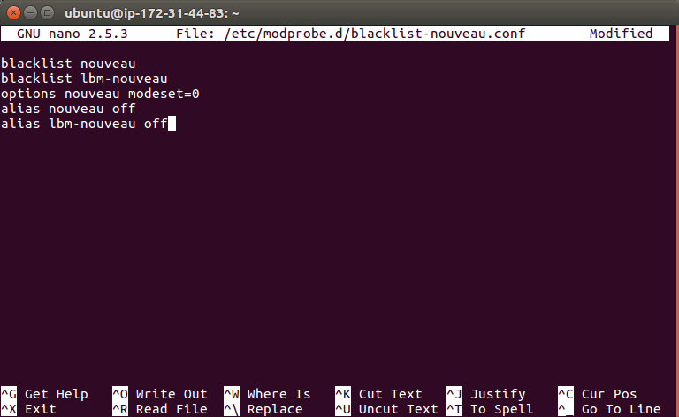

Next let’s update the initial RAM filesystem and reboot the machine:

$ echo options nouveau modeset=0 | sudo tee -a /etc/modprobe.d/nouveau-kms.conf
$ sudo update-initramfs -u
$ sudo reboot

You will lose your SSH connection at the reboot step, so wait patiently and then reconnect before moving on.

Download Driver
Next you will need to download the NVIDIA driver from the following site: https://www.nvidia.in/Download/index.aspx?lang=en-in

Fill in the required information as shown in the example below for Grid K520 graphic card:

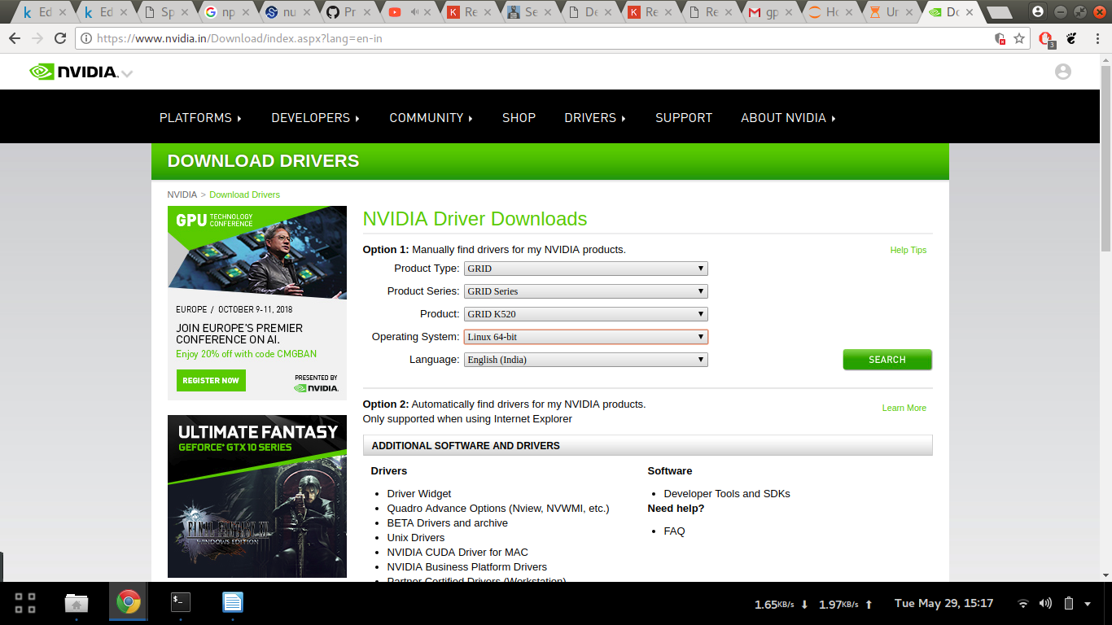

Simply copy the download link from the download button and run wget <link> on the terminal for downloading the file on the gpu.

Now, run the file with the command:
$ sudo ./<file_name>
$ modprobe nvidia

The installation can be checked by typing the command:
$ nvidia-smi

If no error pops up, the installations is successful, and the screen will have a display like this:

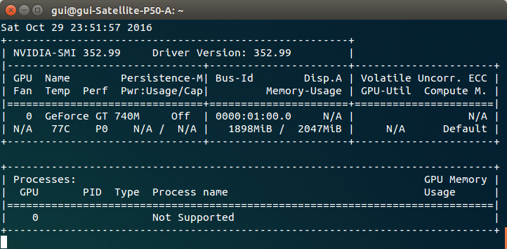

Step 3: Install CUDA Toolkit

The CUDA Toolkit installation step requires attention to detail for it to go smoothly.

You will want to download the CUDA Toolkit v8.0 via the NVIDIA CUDA Toolkit website:
https://developer.nvidia.com/cuda-80-ga2-download-archive

Once you’re on the download page, select
Linux=>x86_64=>Ubuntu=>16.04=>runfile(local).

Here is a screenshot of the download page:

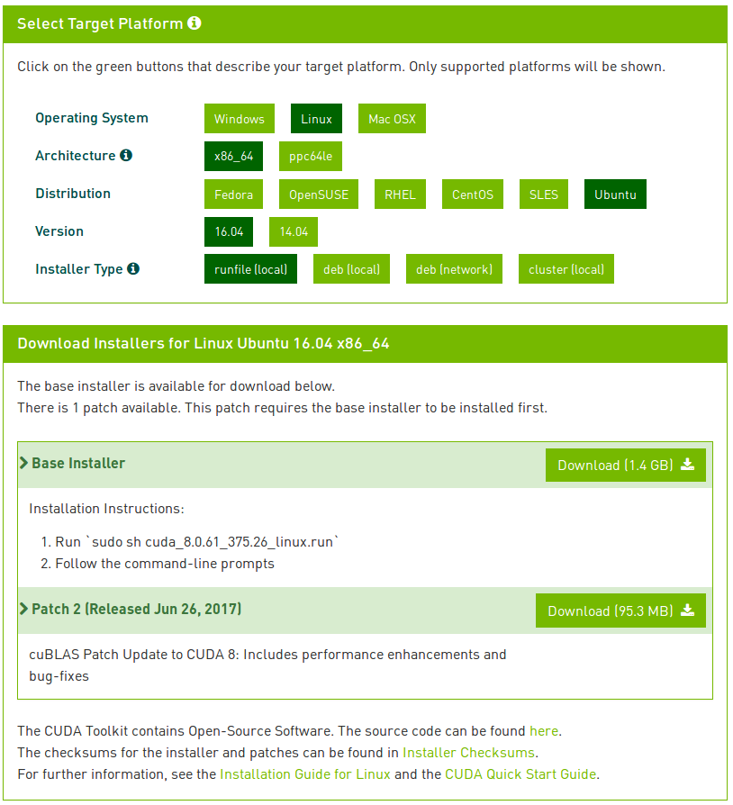
Figure 2: The CUDA Toolkit download page.

From there, download the-run file which should have the filename cuda_8.0.61_375.26_linux-run or similar. To do this, simply right-click to copy the download link and use wget on your remote GPU box:

$ wget https://developer.nvidia.com/compute/cuda/9.0/Prod2/local_installers/cuda_8.0.61_375.26_linux-run

From there, unpack the -run file (simply replace the <FILE NAME> with the downloaded file’s name):

$ chmod +x <FILE NAME>
$ mkdir installers
$ sudo ./<FILE NAME> -extract=`pwd`/installers

Of the three files in the extracted folder, we will ignore the NVIDIA kernel driver named something similar to NVIDIA-Linux-x86_64-375.26.run as we have already installed it in the 2nd step.

Install the CUDA Toolkit and examples

$ cd installers
$ sudo ./<file name>

Example:
$ sudo ./cuda-linux64-rel-9.0.61-21551265.run
$ sudo ./cuda-samples-linux-9.0.61-21551265.run

Now that the NVIDIA CUDA driver and tools are installed, you need to update your~/.bashrc file to include CUDA Toolkit (I suggest using terminal text editors such as vim, emacs, or nano):
$ export PATH=/usr/local/cuda-9.0/bin:$PATH
$ export LD_LIBRARY_PATH=/usr/local/cuda-9.0/lib64/

(Make sure the paths are set properly as it might create issues later. Pay special attention is you have installed a different CUDA version before)

Now, reload your ~/.bashrc (source ~/.bashrc) and then test the CUDA Toolkit installation by compiling the deviceQuery example program and running it:

$ source ~/.bashrc
$ cd /usr/local/cuda-9.0/samples/1_Utilities/deviceQuery
$ sudo make
$ ./deviceQuery

If the output shows Result=PASS, the cuda installation was successful.
If you do not see this result, I suggest you repeat the Step and examine the output of each and every command carefully to ensure there wasn’t an error during the install. Also check the path you exported to the bashrc file.

Step 4: Download and Install CuDNN

(Version 7.0.5 with CUDA 9.0 is suggested by the official tensorflow website)

In order to download cuDNN, ensure you are registered for the NVIDIA Developer Program.
- Go to: NVIDIA cuDNN home page.
- Click Download.
- Complete the short survey and click Submit.
- Accept the Terms and Conditions. A list of available download versions of cuDNN displays.
- Select the cuDNN version you want to install. A list of available resources displays.

Downloading and installing the debian file

- From the list of files, you would need to download all three .deb files for your ubuntu and CUDA version. As you need to login for the downloads, you can’t download the files directly to your GPU. Instead you would need to download the files to your pc and then transfer them to the GPU by running the scp command (from a new terminal window) which would look something like this:
$ sudo scp -i Deep-learning_large.pem /local/path/to/the/file/to/copy ubuntu@ec2-34-204-45-114.compute1.amazonaws.com:~/path/to/the/file/to/copy

- Navigate to your directory in your GPU containing cuDNN Debian file.
- Install the runtime library, for example:(use filename of the files you have downloaded)
$ sudo dpkg -i libcudnn7_7.0.3.11-1+cuda9.0_amd64.deb
- Install the developer library, for example:
$ sudo dpkg -i libcudnn7-dev_7.0.3.11-1+cuda9.0_amd64.deb
- Install the code samples and the cuDNN Library User Guide, for example:
$ sudo dpkg -i libcudnn7-doc_7.0.3.11-1+cuda9.0_amd64.deb
To verify that cuDNN is installed and is running properly, compile the mnistCUDNN sample located in the /usr/src/cudnn_samples_v7directory in the debian file.

Verifying the installation

- Copy the cuDNN sample to a writable path.
$cp -r /usr/src/cudnn_samples_v7/ $HOME
- Go to the writable path.
$ cd $HOME/cudnn_samples_v7/mnistCUDNN
- Compile the mnistCUDNN sample.
$make clean && make
- Run the mnistCUDNN sample.
$ ./mnistCUDNN
If cuDNN is properly installed and running on your Linux system, you will see a message similar to the following:
Test passed!
- If the test doesnt pass, test the exported paths in the ~/.bashrc file and verify if the version of cuda is correct, as it might still point to an older cuda version that had been uninstalled.
- If test fails, run(to link files): $ sudo ldconfig /usr/local/cuda/lib64

Step 5: Installing TensorFlow from Sources

Start the process of building TensorFlow by cloning a TensorFlow repository.
To clone the latest TensorFlow repository, issue the following command:
$ git clone https://github.com/tensorflow/tensorflow
The preceding git clonecommand creates a subdirectory named tensorflow. After cloning, you may optionally build a specific branch (such as a release branch) by invoking the following commands:
$ cd tensorflow
Prepare environment for Linux
Before building TensorFlow on Linux, install the following build tools on your system:
- bazel
- TensorFlow Python dependencies
- NVIDIA packages to support TensorFlow for GPU.

Install Bazel
If bazel is not installed on your system, install it now by following these directions.

Install TensorFlow Python dependencies
To install TensorFlow, you must install the following packages:
- numpy, which is a numerical processing package that TensorFlow requires.
- dev, which enables adding extensions to Python.
- pip, which enables you to install and manage certain Python packages.
- wheel, which enables you to manage Python compressed packages in the wheel (.whl) format.
To install these packages for Python 2.7, issue the following command:(don’t execute this for python 3.n)
$ sudo apt-get install python-numpy python-dev python-pip python-wheel
To install these packages for Python 3.n, issue the following command:
$ sudo apt-get install python3-numpy python3-dev python3-pip python3-wheel
CUPTI ships with the CUDA Toolkit, but you also need to append its path to the LD_LIBRARY_PATHenvironment variable:
$ export LD_LIBRARY_PATH=$LD_LIBRARY_PATH:/usr/local/cuda/extras/CUPTI/lib64
Configure the installation
The root of the source tree(i.e. in the tensorflow folder) contains a bash script named configure. When run, This script asks you to identify the pathname of all relevant TensorFlow dependencies and specify other build configuration options such as compiler flags. You must run this script prior to creating the pip package and installing TensorFlow.
If you wish to build TensorFlow with GPU, configure will ask you to specify the version numbers of CUDA and cuDNN. If several versions of CUDA or cuDNN are installed on your system, explicitly select the desired version instead of relying on the default.
One of the questions that configure will ask is as follows:
Please specify optimization flags to use during compilation when bazel option "--config=opt" is specified [Default is -march=native]
This question refers to a later phase in which you'll use bazel to build the pip package. We recommend accepting the default (-march=native), which will optimize the generated code for your local machine's CPU type. However, if you are building TensorFlow on one CPU type but will run TensorFlow on a different CPU type, then consider specifying a more specific optimization flag as described in the gcc documentation.
Here is an example execution of the configure script. Note that your own input will likely differ from our sample input:
$ cd tensorflow # cd to the top-level directory created
$ ./configure
NOTE: read and follow the instructions below:
Following the below bold steps, you will be able to install the tensorflow. You can also install the tensorflow with the different supports, but doing so might give some errors in the later steps.
Please specify the location of python. [Default is /usr/bin/python]: /usr/bin/python2.7 (enter preffered version’s path)(python3.5 is to be used in this case)
Found possible Python library paths:
/usr/local/lib/python2.7/dist-packages
/usr/lib/python2.7/dist-packages
Please input the desired Python library path to use. Default is [/usr/lib/python2.7/dist-packages]
Using python library path: /usr/local/lib/python2.7/dist-packages
Please specify optimization flags to use during compilation when bazel option "--config=opt" is specified [Default is -march=native]:
Do you wish to use jemalloc as the malloc implementation? [Y/n] Y
jemalloc enabled
Do you wish to build TensorFlow with Google Cloud Platform support? [y/N] N
No Google Cloud Platform support will be enabled for TensorFlow
Do you wish to build TensorFlow with Hadoop File System support? [y/N] N
No Hadoop File System support will be enabled for TensorFlow
Do you wish to build TensorFlow with the XLA just-in-time compiler (experimental)? [y/N] N
No XLA support will be enabled for TensorFlow
Do you wish to build TensorFlow with VERBS support? [y/N] N
No VERBS support will be enabled for TensorFlow
Do you wish to build TensorFlow with OpenCL support? [y/N] N
No OpenCL support will be enabled for TensorFlow
Do you wish to build TensorFlow with CUDA support? [y/N] Y
CUDA support will be enabled for TensorFlow
Do you want to use clang as CUDA compiler? [y/N] N
nvcc will be used as CUDA compiler
Please specify the CUDA SDK version you want to use, e.g. 7.0. [Leave empty to default to CUDA 9.0]:
Please specify the location where CUDA 9.0 toolkit is installed. Refer to README.md for more details. [Default is /usr/local/cuda]:
Please specify which gcc should be used by nvcc as the host compiler. [Default is /usr/bin/gcc]:
Please specify the cuDNN version you want to use. [Leave empty to default to cuDNN 7.0]:
Please specify the location where cuDNN 7 library is installed. Refer to README.md for more details. [Default is /usr/local/cuda]:
Please specify a list of comma-separated CUDA compute capabilities you want to build with.
You can find the compute capability of your device at: https://developer.nvidia.com/cuda-gpus.
Please note that each additional compute capability significantly increases your build time and binary size.
Do you wish to build TensorFlow with MPI support? [y/N] N
MPI support will not be enabled for TensorFlow
Configuration finished

If you told configure to build for GPU support, then configure will create a canonical set of symbolic links to the CUDA libraries on your system. Therefore, every time you change the CUDA library paths, you must rerun the configure script before re-invoking the bazel build command.
Note the following:
- Although it is possible to build both CUDA and non-CUDA configs under the same source tree, we recommend running bazel clean when switching between these two configurations in the same source tree.
- If you don't run the configure script before running the bazel build command, the bazel build command will fail.
To build a pip package for TensorFlow with GPU support, invoke the following command:
$ bazel build --config=opt --config=cuda //tensorflow/tools/pip_package:build_pip_package
(If you get any error, you might want to run the configure file again with proper inputs to avoid the errors)
NOTE on gcc 5 or later: the binary pip packages available on the TensorFlow website are built with gcc 4, which uses the older ABI. To make your build compatible with the older ABI, you need to add –cxxopt="-D_GLIBCXX_USE_CXX11_ABI=0" to your bazel build command. ABI compatibility allows custom ops built against the TensorFlow pip package to continue to work against your built package.
Tip: By default, building TensorFlow from sources consumes a lot of RAM. If RAM is an issue on your system, you may limit RAM usage by specifying --local_resources 2048,.5,1.0 while invoking bazel. (Probably not required)
The bazel build command builds a script named build_pip_package. Running this script as follows will build a .whl file within the /tmp/tensorflow_pkg directory:
$ bazel-bin/tensorflow/tools/pip_package/build_pip_package /tmp/tensorflow_pkg
Install the pip package
Invoke pip install to install that pip package. The filename of the .whl file depends on your platform. For example, the following command will install the pip package for TensorFlow 1.8.0 on Linux:
$ sudo pip install /tmp/tensorflow_pkg/tensorflow-1.8.0-py2-none-any.whl
Validate your TensorFlow installation by doing the following:
Start a terminal.
Change directory (cd) to any directory on your system other than the tensorflowsubdirectory from which you invoked the configure command.
Invoke python:
$ python
Enter the following short program inside the python interactive shell:
# Python
$ import tensorflow as tf
$ tf.__version__

