Subject Code | : | CEUE203 | Semester | : | 3 | Academic Year | : | 2026-27
Subject Name | : | Object-Oriented Programming
Student ID | : | 25CE124

 | Practical 1: CLASS FUNDAMENTALS
Program: 1.1 | MiniBank Console Menu & Application Shell  MiniBank is the console banking application built across the semester. In this foundational practical, establish the application structure with a public Practical1_MiniBank class, record BankInfo storing immutable bank name and branch metadata, and an enum MenuOption with banking actions: OPEN_ACCOUNT, DEPOSIT, WITHDRAW, TRANSFER, and EXIT. Implement a non-terminating interactive menu loop with Scanner input handling and switch expressions to display placeholder status messages and handle exit gracefully.
Code | import java.util.Scanner;  enum MenuOption {  OPEN_ACCOUNT, DEPOSIT, WITHDRAW, TRANSFER, EXIT  }  record BankInfo(String name, String branch) {}  public class Practical1_MiniBank {  public static void main(String[] args) {  Scanner scanner = new Scanner(System.in);  BankInfo bank = new BankInfo("MiniBank", "Main Branch");  System.out.println("========================================");  System.out.println(" Welcome to " + bank.name());  System.out.println(" Branch: " + bank.branch());  System.out.println("========================================");  boolean running = true;  while (running) {  System.out.println("\n--- Menu ---");  MenuOption[] options = MenuOption.values();  for (int i = 0; i < options.length; i++) {  System.out.println((i + 1) + ". " + options[i]);  }  System.out.print("Enter your choice: ");  int choice = -1;  if (scanner.hasNextInt()) {  choice = scanner.nextInt();  } else {  scanner.next();  }  if (choice < 1 || choice > options.length) {  System.out.println("Invalid choice. Please try again.");  continue;  }  MenuOption selected = options[choice - 1];  String message = switch (selected) {  case OPEN_ACCOUNT -> "Open Account — to be implemented in a later lab";  case DEPOSIT -> "Deposit — to be implemented in a later lab";  case WITHDRAW -> "Withdraw — to be implemented in a later lab";  case TRANSFER -> "Transfer — to be implemented in a later lab";  case EXIT -> "Goodbye! Thank you for using MiniBank.";  };  System.out.println(message);  if (selected == MenuOption.EXIT) {  running = false;  }  }  scanner.close();  }  }
Output | 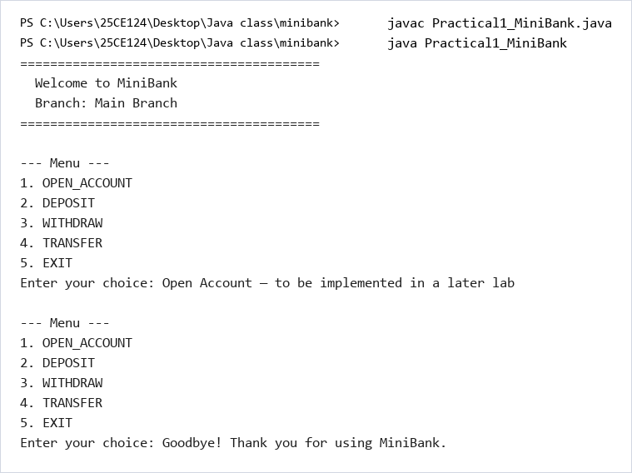

 | Practical 2: OBJECT IDENTIFICATION, CONSTRUCTORS & DATA ABSTRACTION
Program: 2.1 | Customer and Account Entity Modeling with Constructors & Encapsulation  Create the core banking domain entities: Customer (with customerId, name, email, mobile) and Account (with accountNumber, customer, balance). Implement static ID counters for auto-generating unique customer IDs (CUST101+) and account numbers (AC0001+ format), multiple overloaded constructors (with initial balance and zero-balance defaults), private field encapsulation with accessor methods, and deposit/withdraw operations with balance validation.
Code | public class Practical2_MiniBank {  static long customerCounter = 100;  static String generateCustomerId() {  customerCounter++;  return "CUST" + customerCounter;  }  static class Customer {  private final String customerId;  private String name;  private String email;  private String mobile;  Customer(String name, String email, String mobile) {  this.customerId = generateCustomerId();  this.name = name;  this.email = email;  this.mobile = mobile;  }  String getCustomerId() { return customerId; }  String getName() { return name; }  String getEmail() { return email; }  String getMobile() { return mobile; }  }  static int accountCounter = 0;  static class Account {  private final String accountNumber;  private String ownerName;  private long balance;  private boolean active;  Account(String ownerName, long openingBalance) {  accountCounter++;  this.accountNumber = String.format("AC%04d", accountCounter);  this.ownerName = ownerName;  this.balance = openingBalance;  this.active = true;  }  Account(String ownerName) {  this(ownerName, 0);  }  boolean deposit(long amount) {  if (amount <= 0) {  return false;  }  balance += amount;  return true;  }  boolean withdraw(long amount) {  if (amount <= 0) {  return false;  }  if (balance >= amount) {  balance -= amount;  return true;  }  return false;  }  String getAccountNumber() { return accountNumber; }  String getOwnerName() { return ownerName; }  long getBalance() { return balance; }  boolean isActive() { return active; }  }  public static void main(String[] args) {  Account[] accounts = new Account[3];  accounts[0] = new Account("Riya", 5000);  accounts[1] = new Account("Aman", 3000);  accounts[2] = new Account("Priya");  System.out.println("=== Initial Balances ===");  for (int i = 0; i < accounts.length; i++) {  System.out.println(accounts[i].getAccountNumber() + " | " +  accounts[i].getOwnerName() + " | Balance: " + accounts[i].getBalance());  }  System.out.println("\n=== Performing Operations ===");  accounts[0].deposit(2000);  System.out.println(accounts[0].getOwnerName() + " deposited 2000. Balance: " + accounts[0].getBalance());  boolean success = accounts[0].withdraw(3000);  System.out.println(accounts[0].getOwnerName() + " withdraw 3000: " + (success ? "Success" : "Failed") +  ". Balance: " + accounts[0].getBalance());  success = accounts[0].withdraw(10000);  System.out.println(accounts[0].getOwnerName() + " withdraw 10000: " + (success ? "Success" : "Failed") +  ". Balance: " + accounts[0].getBalance());  accounts[1].deposit(500);  System.out.println(accounts[1].getOwnerName() + " deposited 500. Balance: " + accounts[1].getBalance());  accounts[2].deposit(1000);  System.out.println(accounts[2].getOwnerName() + " deposited 1000. Balance: " + accounts[2].getBalance());  System.out.println("\n=== Final Balances ===");  for (int i = 0; i < accounts.length; i++) {  System.out.println(accounts[i].getAccountNumber() + " | " +  accounts[i].getOwnerName() + " | Balance: " + accounts[i].getBalance());  }  }  }
Output | 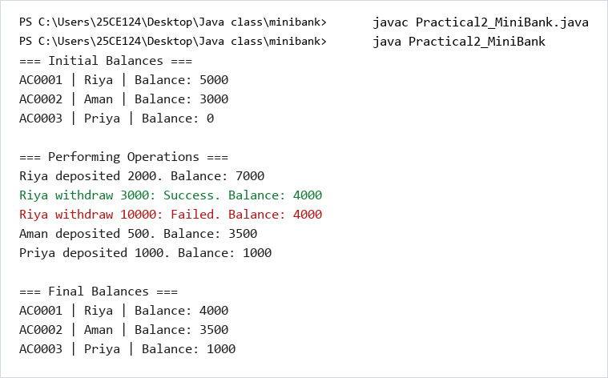

 | Practical 3: METHODS, EQUALITY, STRING CONVERSIONS & COMPOSITION
Program: 3.1 | Method Overriding, Object Equality, Composition & Cloning  Implement proper toString(), equals(), and hashCode() methods in Account and Customer based on unique identifiers. Add a composite Address class (line, city, pincode) nested inside Customer. Implement shallow and deep copying using clone() and demonstrate instanceof type checking for robust runtime verification.
Code | import java.util.Objects;  public class Practical3_MiniBank {  static int accountCounter = 0;  static class Address {  private String line;  private String city;  private String pincode;  Address(String line, String city, String pincode) {  this.line = line;  this.city = city;  this.pincode = pincode;  }  String getLine() { return line; }  String getCity() { return city; }  String getPincode() { return pincode; }  }  static long customerCounter = 100;  static class Customer implements Cloneable {  private final String customerId;  private String name;  private String email;  private String mobile;  private Address address;  Customer(String name, String email, String mobile, Address address) {  customerCounter++;  this.customerId = "CUST" + customerCounter;  this.name = name;  this.email = email;  this.mobile = mobile;  this.address = address;  }  String getCustomerId() { return customerId; }  String getName() { return name; }  String getEmail() { return email; }  String getMobile() { return mobile; }  Address getAddress() { return address; }  public Customer clone() {  try {  return (Customer) super.clone();  } catch (CloneNotSupportedException e) {  return null;  }  }  }  static class Account {  private final String accountNumber;  private String ownerName;  private long balance;  private boolean active;  Account(String ownerName, long openingBalance) {  accountCounter++;  this.accountNumber = String.format("AC%04d", accountCounter);  this.ownerName = ownerName;  this.balance = openingBalance;  this.active = true;  }  Account(String ownerName) {  this(ownerName, 0);  }  boolean deposit(long amount) {  if (amount <= 0) return false;  balance += amount;  return true;  }  boolean withdraw(long amount) {  if (amount <= 0) return false;  if (balance >= amount) {  balance -= amount;  return true;  }  return false;  }  String getAccountNumber() { return accountNumber; }  String getOwnerName() { return ownerName; }  long getBalance() { return balance; }  boolean isActive() { return active; }  public String toString() {  return accountNumber + " | " + ownerName + " | " + balance;  }  public boolean equals(Object o) {  if (this == o) return true;  if (o == null) return false;  if (!(o instanceof Account)) return false;  Account other = (Account) o;  return this.accountNumber.equals(other.accountNumber);  }  public int hashCode() {  return Objects.hash(accountNumber);  }  }  public static void main(String[] args) {  Account a1 = new Account("Riya", 5000);  a1.deposit(2000);  a1.withdraw(3000);  Account a2 = new Account("Aman", 3000);  System.out.println("=== toString() Demo ===");  System.out.println(a1);  System.out.println(a2);  System.out.println("\n=== equals() Demo ===");  System.out.println("a1.equals(a2): " + a1.equals(a2));  System.out.println("a1.equals(a1): " + a1.equals(a1));  System.out.println("\n=== instanceof Demo ===");  System.out.println("a1 instanceof Account: " + (a1 instanceof Account));  System.out.println("\n=== Nested Address Class Demo ===");  Address addr = new Address("123 Main Street", "Ahmedabad", "380001");  Customer c1 = new Customer("Riya", "riya@email.com", "9876543210", addr);  System.out.println("Customer: " + c1.getName());  System.out.println("Address: " + c1.getAddress().getLine() + ", " +  c1.getAddress().getCity() + " - " + c1.getAddress().getPincode());  System.out.println("\n=== clone() Demo ===");  Customer c2 = c1.clone();  System.out.println("Original: " + c1.getName() + " (" + c1.getCustomerId() + ")");  System.out.println("Clone: " + c2.getName() + " (" + c2.getCustomerId() + ")");  }  }
Output | 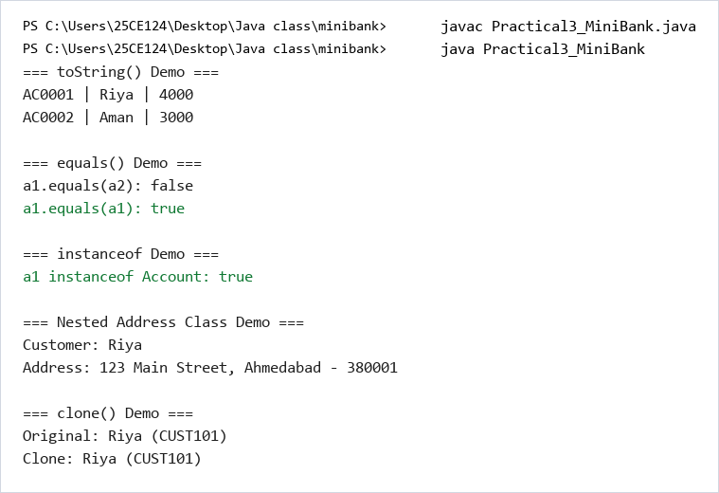

 | Practical 4: STRINGS, TEXT PROCESSING & DATA VALIDATION
Program: 4.1 | Input Validation with Regular Expressions & Command Parsing  Construct a validation and parsing layer for MiniBank to sanitize user inputs before processing. Implement regex-based validation methods for mobile numbers (10 digits), email addresses (standard email pattern), PAN cards (5 uppercase letters, 4 digits, 1 letter), and IFSC codes (4 letters, 0, 6 alphanumeric). Implement command-string parsing using split() to parse multi-argument user inputs like 'OPEN Alice 5000' or 'DEPOSIT AC0001 2000'.
Code | import java.util.regex.Pattern;  public class Practical4_MiniBank {  static int accountCounter = 0;  static class Account {  private final String accountNumber;  private String ownerName;  private long balance;  Account(String ownerName, long openingBalance) {  accountCounter++;  this.accountNumber = String.format("AC%04d", accountCounter);  this.ownerName = ownerName;  this.balance = openingBalance;  }  String getAccountNumber() { return accountNumber; }  String getOwnerName() { return ownerName; }  long getBalance() { return balance; }  }  enum TransactionType {  DEPOSIT, WITHDRAW, TRANSFER  }  record Command(TransactionType type, String accountNumber, long amount) {}  static class Validator {  private static final Pattern MOBILE_PATTERN = Pattern.compile("^[6-9][0-9]{9}$");  private static final Pattern EMAIL_PATTERN = Pattern.compile("^[a-zA-Z0-9._%+-]+@[a-zA-Z0-9.-]+\\.[a-zA-Z]{2,}$");  private static final Pattern PAN_PATTERN = Pattern.compile("^[A-Z]{5}[0-9]{4}[A-Z]$");  private static final Pattern IFSC_PATTERN = Pattern.compile("^[A-Z]{4}0[A-Z0-9]{6}$");  static boolean isValidMobile(String mobile) {  return MOBILE_PATTERN.matcher(mobile).matches();  }  static boolean isValidEmail(String email) {  return EMAIL_PATTERN.matcher(email).matches();  }  static boolean isValidPan(String pan) {  return PAN_PATTERN.matcher(pan).matches();  }  static boolean isValidIfsc(String ifsc) {  return IFSC_PATTERN.matcher(ifsc).matches();  }  }  static class CommandParser {  static Command parse(String line) {  String[] parts = line.split(" ");  if (parts.length != 3) {  System.out.println("Error: Command must have 3 parts.");  return null;  }  TransactionType type = TransactionType.valueOf(parts[0]);  String accountNumber = parts[1];  long amount = Long.parseLong(parts[2]);  return new Command(type, accountNumber, amount);  }  }  static class StatementFormatter {  static String buildStatement(Account account) {  StringBuilder sb = new StringBuilder();  sb.append("========================================\n");  sb.append(" ACCOUNT STATEMENT\n");  sb.append("========================================\n");  sb.append("Account Number : ").append(account.getAccountNumber()).append("\n");  sb.append("Owner Name : ").append(account.getOwnerName()).append("\n");  sb.append("Balance : Rs. ").append(account.getBalance()).append("\n");  sb.append("========================================");  return sb.toString();  }  }  public static void main(String[] args) {  System.out.println("=== Validator Tests ===");  System.out.println("Mobile '9876543210': " + Validator.isValidMobile("9876543210"));  System.out.println("Mobile '12345': " + Validator.isValidMobile("12345"));  System.out.println("Email 'abc@xyz.com': " + Validator.isValidEmail("abc@xyz.com"));  System.out.println("Email 'invalid': " + Validator.isValidEmail("invalid"));  System.out.println("PAN 'ABCDE1234F': " + Validator.isValidPan("ABCDE1234F"));  System.out.println("PAN '12345': " + Validator.isValidPan("12345"));  System.out.println("IFSC 'SBIN0001234': " + Validator.isValidIfsc("SBIN0001234"));  System.out.println("IFSC 'INVALID': " + Validator.isValidIfsc("INVALID"));  System.out.println("\n=== Command Parser Test ===");  Command cmd = CommandParser.parse("DEPOSIT AC0001 500");  if (cmd != null) {  System.out.println("Type: " + cmd.type());  System.out.println("Account: " + cmd.accountNumber());  System.out.println("Amount: " + cmd.amount());  }  System.out.println("\n=== Statement Formatter Test ===");  Account acc = new Account("Riya", 5000);  System.out.println(StatementFormatter.buildStatement(acc));  }  }
Output | 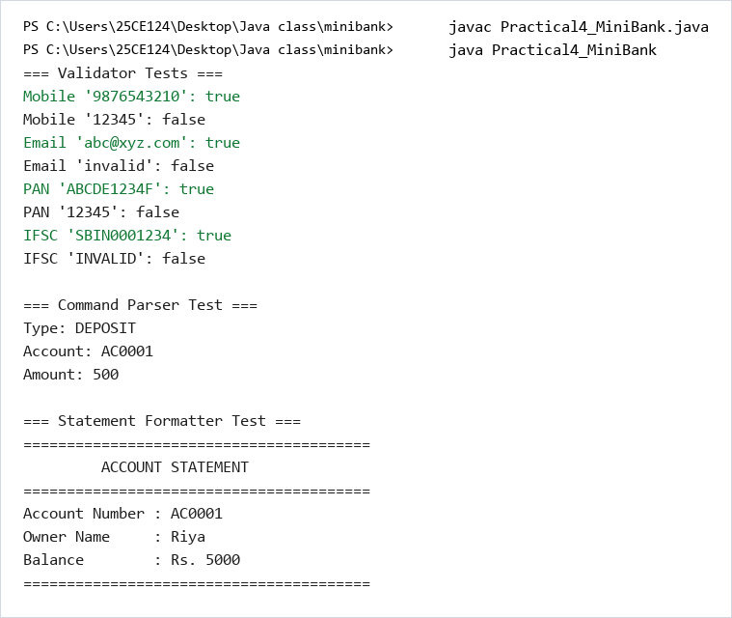

 | Practical 5: INHERITANCE, ABSTRACT CLASSES & POLYMORPHISM
Program: 5.1 | Abstract Account Base Class with Savings, Current & FD Subclasses  Model diverse banking accounts using inheritance and dynamic polymorphism. Make Account an abstract class with abstract methods interestRate() and concrete methods deposit(), withdraw(). Implement SavingsAccount (with minimum balance and annual interest), CurrentAccount (with overdraft limit), and FixedDepositAccount (with lock-in period and fixed tenure interest). Demonstrate polymorphic dispatch where account behaviors are executed dynamically at runtime.
Code | public class Practical5_MiniBank {  static int accountCounter = 0;  static abstract class Account {  private final String accountNumber;  private String ownerName;  private long balance;  private boolean active;  Account(String ownerName, long openingBalance) {  accountCounter++;  this.accountNumber = String.format("AC%04d", accountCounter);  this.ownerName = ownerName;  this.balance = openingBalance;  this.active = true;  }  Account(String ownerName) {  this(ownerName, 0);  }  abstract double interestRate();  abstract boolean canWithdraw(long amount);  boolean deposit(long amount) {  if (amount <= 0) return false;  balance += amount;  return true;  }  boolean withdraw(long amount) {  if (amount <= 0) return false;  if (canWithdraw(amount)) {  balance -= amount;  return true;  }  return false;  }  String getAccountNumber() { return accountNumber; }  String getOwnerName() { return ownerName; }  long getBalance() { return balance; }  boolean isActive() { return active; }  public String toString() {  return accountNumber + " | " + ownerName + " | Balance: " + balance;  }  }  static class SavingsAccount extends Account {  private long minBalance;  SavingsAccount(String ownerName, long openingBalance, long minBalance) {  super(ownerName, openingBalance);  this.minBalance = minBalance;  }  double interestRate() {  return 4.0;  }  boolean canWithdraw(long amount) {  return (getBalance() - amount) >= minBalance;  }  }  static class CurrentAccount extends Account {  private long overdraftLimit;  CurrentAccount(String ownerName, long openingBalance, long overdraftLimit) {  super(ownerName, openingBalance);  this.overdraftLimit = overdraftLimit;  }  double interestRate() {  return 0.0;  }  boolean canWithdraw(long amount) {  return (getBalance() - amount) >= -overdraftLimit;  }  }  static class FixedDepositAccount extends Account {  FixedDepositAccount(String ownerName, long openingBalance) {  super(ownerName, openingBalance);  }  double interestRate() {  return 7.0;  }  boolean canWithdraw(long amount) {  return false;  }  }  public static void main(String[] args) {  Account[] accounts = new Account[3];  accounts[0] = new SavingsAccount("Riya", 10000, 1000);  accounts[1] = new CurrentAccount("Aman", 5000, 2000);  accounts[2] = new FixedDepositAccount("Priya", 50000);  System.out.println("=== Polymorphic Interest Rates ===");  for (int i = 0; i < accounts.length; i++) {  System.out.println(accounts[i].getOwnerName() + " (" +  accounts[i].getClass().getSimpleName() + "): " +  accounts[i].interestRate() + "%");  }  System.out.println("\n=== Withdrawal Tests ===");  boolean result = accounts[0].withdraw(8000);  System.out.println("Savings withdraw 8000: " + (result ? "Success" : "Failed") +  " | Balance: " + accounts[0].getBalance());  result = accounts[0].withdraw(2000);  System.out.println("Savings withdraw 2000 (would go below minBalance): " +  (result ? "Success" : "Failed") + " | Balance: " + accounts[0].getBalance());  result = accounts[1].withdraw(6000);  System.out.println("Current withdraw 6000 (uses overdraft): " +  (result ? "Success" : "Failed") + " | Balance: " + accounts[1].getBalance());  result = accounts[2].withdraw(1000);  System.out.println("FD withdraw 1000 (locked): " +  (result ? "Success" : "Failed") + " | Balance: " + accounts[2].getBalance());  System.out.println("\n=== Pattern instanceof Check ===");  for (int i = 0; i < accounts.length; i++) {  if (accounts[i] instanceof FixedDepositAccount fd) {  System.out.println(fd.getOwnerName() + " has a Fixed Deposit with " +  fd.interestRate() + "% interest");  }  }  System.out.println("\n=== All Accounts ===");  for (int i = 0; i < accounts.length; i++) {  System.out.println(accounts[i]);  }  }  }
Output | 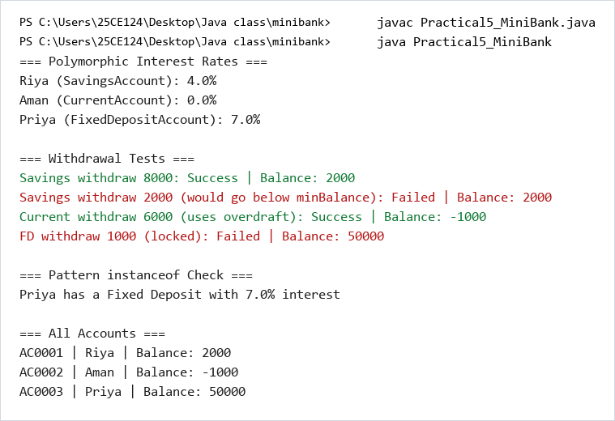

 | Practical 6: INTERFACES, PACKAGES & ACCESS CONTROL
Program: 6.1 | Interface Capabilities, Default Methods & Functional Rules  Define banking capabilities via interfaces: Transactable (deposit, withdraw), InterestBearing (with a default yearlyInterest calculation method), and functional rules (WithdrawRule). Implement multiple interface inheritance across account types and demonstrate anonymous class implementations for custom withdrawal validation rules.
Code | public class Practical6_MiniBank {  static int accountCounter = 0;  interface Transactable {  void deposit(long amount);  boolean withdraw(long amount);  }  interface InterestBearing {  double interestRate();  default double yearlyInterest(long balance) {  return balance * interestRate() / 100.0;  }  }  @FunctionalInterface  interface WithdrawRule {  boolean allow(Account account, long amount);  }  interface Premium {}  static abstract class Account implements Transactable, InterestBearing {  private final String accountNumber;  private String ownerName;  private long balance;  private boolean active;  Account(String ownerName, long openingBalance) {  accountCounter++;  this.accountNumber = String.format("AC%04d", accountCounter);  this.ownerName = ownerName;  this.balance = openingBalance;  this.active = true;  }  abstract boolean canWithdraw(long amount);  public void deposit(long amount) {  if (amount > 0) {  balance += amount;  }  }  public boolean withdraw(long amount) {  if (amount <= 0) return false;  if (canWithdraw(amount)) {  balance -= amount;  return true;  }  return false;  }  String getAccountNumber() { return accountNumber; }  String getOwnerName() { return ownerName; }  long getBalance() { return balance; }  public String toString() {  return accountNumber + " | " + ownerName + " | Balance: " + balance;  }  }  static class SavingsAccount extends Account {  private long minBalance;  SavingsAccount(String ownerName, long openingBalance, long minBalance) {  super(ownerName, openingBalance);  this.minBalance = minBalance;  }  public double interestRate() { return 4.0; }  boolean canWithdraw(long amount) {  return (getBalance() - amount) >= minBalance;  }  }  static class CurrentAccount extends Account implements Premium {  private long overdraftLimit;  CurrentAccount(String ownerName, long openingBalance, long overdraftLimit) {  super(ownerName, openingBalance);  this.overdraftLimit = overdraftLimit;  }  public double interestRate() { return 0.0; }  boolean canWithdraw(long amount) {  return (getBalance() - amount) >= -overdraftLimit;  }  }  static class FixedDepositAccount extends Account {  FixedDepositAccount(String ownerName, long openingBalance) {  super(ownerName, openingBalance);  }  public double interestRate() { return 7.0; }  boolean canWithdraw(long amount) {  return false;  }  }  public static void main(String[] args) {  SavingsAccount savings = new SavingsAccount("Riya", 10000, 1000);  CurrentAccount current = new CurrentAccount("Aman", 5000, 2000);  FixedDepositAccount fd = new FixedDepositAccount("Priya", 50000);  System.out.println("=== Transactable Interface Demo ===");  Transactable t = savings;  t.deposit(2000);  System.out.println("Savings after deposit 2000: " + savings.getBalance());  System.out.println("\n=== InterestBearing Default Method ===");  System.out.println("Savings yearly interest: " + savings.yearlyInterest(savings.getBalance()));  System.out.println("FD yearly interest: " + fd.yearlyInterest(fd.getBalance()));  System.out.println("\n=== WithdrawRule - Anonymous Class ===");  WithdrawRule rule1 = new WithdrawRule() {  public boolean allow(Account account, long amount) {  return account.getBalance() >= amount;  }  };  System.out.println("Rule1 allows withdraw 5000 from savings: " + rule1.allow(savings, 5000));  System.out.println("\n=== WithdrawRule - Lambda ===");  WithdrawRule rule2 = (account, amount) -> account.getBalance() >= amount * 2;  System.out.println("Rule2 allows withdraw 5000 from savings (needs 2x): " + rule2.allow(savings, 5000));  System.out.println("\n=== Marker Interface (Premium) ===");  Account[] accounts = { savings, current, fd };  for (int i = 0; i < accounts.length; i++) {  if (accounts[i] instanceof Premium) {  System.out.println(accounts[i].getOwnerName() + " is a Premium account holder");  }  }  System.out.println("\n=== All Accounts ===");  for (int i = 0; i < accounts.length; i++) {  System.out.println(accounts[i]);  }  }  }
Output | 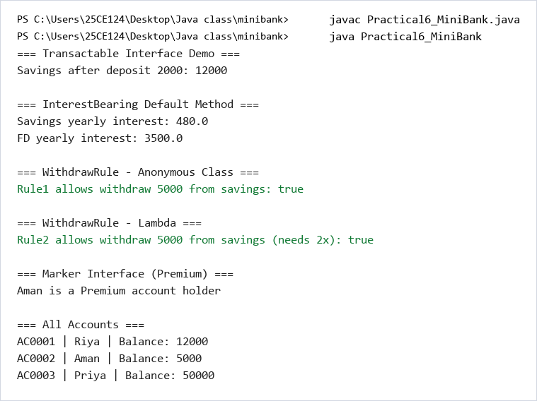

 | Practical 7: CUSTOM ANNOTATIONS & RUNTIME REFLECTION
Program: 7.1 | Custom Metadata Annotations & Reflection-Based Validation  Define custom runtime annotations @Id, @Positive, and @MaxLength. Build a generic reflection-based validator that inspects declared fields of Account and other model classes at runtime without hardcoding, verifying that @Id is present, balances annotated with @Positive are greater than zero, and string fields do not exceed maximum lengths.
Code | import java.lang.annotation.ElementType;  import java.lang.annotation.Retention;  import java.lang.annotation.RetentionPolicy;  import java.lang.annotation.Target;  import java.lang.reflect.Field;  import java.util.ArrayList;  public class Practical7_MiniBank {  @Target(ElementType.FIELD)  @Retention(RetentionPolicy.RUNTIME)  @interface Id {}  @Target(ElementType.FIELD)  @Retention(RetentionPolicy.RUNTIME)  @interface Positive {  String message() default "must be > 0";  }  @Target(ElementType.FIELD)  @Retention(RetentionPolicy.RUNTIME)  @interface MaxLength {  int value();  }  static int accountCounter = 0;  static class Account {  @Id  private final String accountNumber;  @MaxLength(50)  private String ownerName;  @Positive  private long balance;  private boolean active;  Account(String ownerName, long openingBalance) {  accountCounter++;  this.accountNumber = String.format("AC%04d", accountCounter);  this.ownerName = ownerName;  this.balance = openingBalance;  this.active = true;  }  @Override  public String toString() {  return accountNumber + " | " + ownerName + " | Balance: " + balance;  }  String getAccountNumber() { return accountNumber; }  String getOwnerName() { return ownerName; }  long getBalance() { return balance; }  }  static class AnnotationValidator {  static String[] validate(Object obj) {  ArrayList<String> errors = new ArrayList<>();  Field[] fields = obj.getClass().getDeclaredFields();  for (int i = 0; i < fields.length; i++) {  Field field = fields[i];  field.setAccessible(true);  try {  if (field.isAnnotationPresent(Positive.class)) {  Positive annotation = field.getAnnotation(Positive.class);  Object value = field.get(obj);  if (value instanceof Number) {  if (((Number) value).doubleValue() <= 0) {  errors.add(field.getName() + ": " + annotation.message());  }  }  }  if (field.isAnnotationPresent(MaxLength.class)) {  MaxLength annotation = field.getAnnotation(MaxLength.class);  Object value = field.get(obj);  if (value instanceof String) {  if (((String) value).length() > annotation.value()) {  errors.add(field.getName() + ": length must be <= " + annotation.value());  }  }  }  } catch (IllegalAccessException e) {  errors.add("Could not access field: " + field.getName());  }  }  String[] result = new String[errors.size()];  for (int i = 0; i < errors.size(); i++) {  result[i] = errors.get(i);  }  return result;  }  }  public static void main(String[] args) {  System.out.println("=== Valid Account ===");  Account validAccount = new Account("Riya", 5000);  System.out.println(validAccount);  String[] errors = AnnotationValidator.validate(validAccount);  System.out.println("Errors: " + errors.length);  System.out.println("\n=== Invalid Account (negative balance) ===");  Account invalidAccount = new Account("Aman", -100);  System.out.println(invalidAccount);  errors = AnnotationValidator.validate(invalidAccount);  System.out.println("Errors: " + errors.length);  for (int i = 0; i < errors.length; i++) {  System.out.println(" - " + errors[i]);  }  System.out.println("\n=== @Id Field Detection ===");  Field[] fields = Account.class.getDeclaredFields();  for (int i = 0; i < fields.length; i++) {  if (fields[i].isAnnotationPresent(Id.class)) {  System.out.println("@Id is on field: " + fields[i].getName());  }  }  System.out.println("\n=== @Override Verification ===");  System.out.println("toString() is overridden: " + validAccount.toString());  }  }
Output | 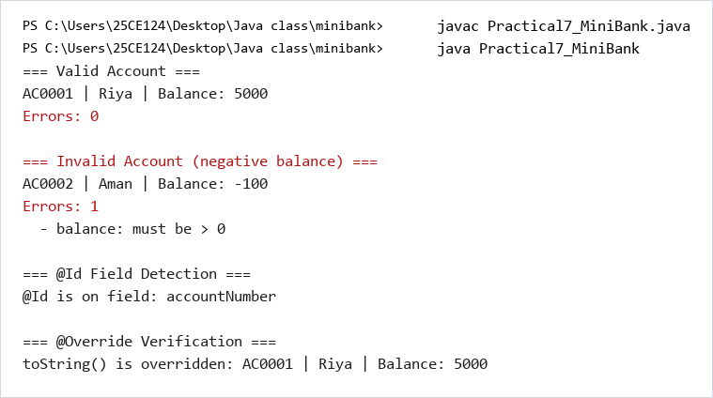

 | Practical 8: ROBUST EXCEPTION HANDLING & CUSTOM HIERARCHIES
Program: 8.1 | Custom Checked Exception Hierarchy for Banking Fault Tolerance  Design a comprehensive banking exception hierarchy rooted at BankException. Implement InsufficientFundsException (tracking the exact shortfall amount), AccountNotFoundException, AccountInactiveException, and InvalidAmountException. Replace error codes and boolean return values with structured try-catch-finally error handling in deposit, withdraw, and fund transfer operations.
Code | public class Practical8_MiniBank {  static class BankException extends Exception {  BankException(String message) {  super(message);  }  }  static class InsufficientFundsException extends BankException {  private long shortfall;  InsufficientFundsException(long shortfall) {  super("Insufficient funds. Short by: " + shortfall);  this.shortfall = shortfall;  }  long getShortfall() { return shortfall; }  }  static class AccountNotFoundException extends BankException {  AccountNotFoundException(String accountNumber) {  super("Account not found: " + accountNumber);  }  }  static class InvalidAmountException extends BankException {  InvalidAmountException(String message) {  super(message);  }  }  static class AuditLog implements AutoCloseable {  private boolean open;  AuditLog() {  this.open = true;  System.out.println("[AuditLog] Opened");  }  void log(String message) {  if (open) {  System.out.println("[AuditLog] " + message);  }  }  public void close() {  open = false;  System.out.println("[AuditLog] Closed");  }  }  static int accountCounter = 0;  static class Account {  private final String accountNumber;  private String ownerName;  private long balance;  Account(String ownerName, long openingBalance) {  accountCounter++;  this.accountNumber = String.format("AC%04d", accountCounter);  this.ownerName = ownerName;  this.balance = openingBalance;  }  void deposit(long amount) throws InvalidAmountException {  if (amount <= 0) {  throw new InvalidAmountException("Deposit amount must be positive. Got: " + amount);  }  balance += amount;  }  void withdraw(long amount) throws InsufficientFundsException, InvalidAmountException {  if (amount <= 0) {  throw new InvalidAmountException("Withdrawal amount must be positive. Got: " + amount);  }  if (balance < amount) {  throw new InsufficientFundsException(amount - balance);  }  balance -= amount;  }  void transfer(Account to, long amount) throws BankException {  try {  this.withdraw(amount);  to.deposit(amount);  System.out.println("Transfer of " + amount + " from " + this.accountNumber +  " to " + to.accountNumber + " successful.");  } catch (BankException e) {  throw e;  } finally {  System.out.println("[Finally] Transfer attempt completed for " + this.accountNumber);  }  }  String getAccountNumber() { return accountNumber; }  String getOwnerName() { return ownerName; }  long getBalance() { return balance; }  @Override  public String toString() {  return accountNumber + " | " + ownerName + " | Balance: " + balance;  }  }  public static void main(String[] args) {  Account a1 = new Account("Riya", 1000);  Account a2 = new Account("Aman", 500);  System.out.println("=== Initial State ===");  System.out.println(a1);  System.out.println(a2);  System.out.println("\n=== Test: Valid Deposit ===");  try {  a1.deposit(2000);  System.out.println("Deposit successful. " + a1);  } catch (InvalidAmountException e) {  System.out.println("Error: " + e.getMessage());  }  System.out.println("\n=== Test: Invalid Deposit (negative) ===");  try {  a1.deposit(-500);  } catch (InvalidAmountException e) {  System.out.println("Error: " + e.getMessage());  }  System.out.println("\n=== Test: Valid Withdrawal ===");  try {  a1.withdraw(1000);  System.out.println("Withdrawal successful. " + a1);  } catch (BankException e) {  System.out.println("Error: " + e.getMessage());  }  System.out.println("\n=== Test: Insufficient Funds ===");  try {  a1.withdraw(5000);  } catch (InsufficientFundsException e) {  System.out.println("Error: " + e.getMessage());  System.out.println("Shortfall: " + e.getShortfall());  } catch (InvalidAmountException e) {  System.out.println("Error: " + e.getMessage());  }  System.out.println("\n=== Test: Transfer ===");  try {  a1.transfer(a2, 500);  System.out.println(a1);  System.out.println(a2);  } catch (BankException e) {  System.out.println("Transfer failed: " + e.getMessage());  }  System.out.println("\n=== Test: try-with-resources (AutoCloseable) ===");  try (AuditLog log = new AuditLog()) {  log.log("Performing operations...");  a1.deposit(100);  log.log("Deposit done. Balance: " + a1.getBalance());  } catch (InvalidAmountException e) {  System.out.println("Error: " + e.getMessage());  }  System.out.println("\n=== Final State ===");  System.out.println(a1);  System.out.println(a2);  }  }
Output | 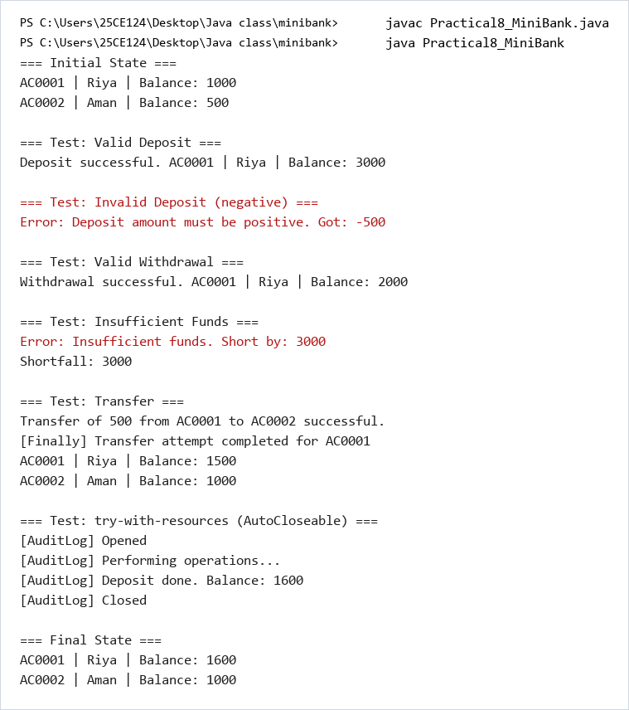

 | Practical 9: MULTITHREADING & CONCURRENCY SYNCHRONIZATION
Program: 9.1 | Multi-Threaded Concurrent Transactions & Synchronization Lock  Simulate multiple concurrent threads executing deposits and withdrawals against a shared Account instance. Demonstrate race conditions and lost updates that occur when shared state is modified without synchronization. Resolve concurrency issues using synchronized blocks and methods, guaranteeing balance consistency and exact financial reconciliation.
Code | public class Practical9_MiniBank {  static int accountCounter = 0;  static class Account {  private final String accountNumber;  private String ownerName;  private long balance;  Account(String ownerName, long openingBalance) {  accountCounter++;  this.accountNumber = String.format("AC%04d", accountCounter);  this.ownerName = ownerName;  this.balance = openingBalance;  }  void deposit(long amount) {  if (amount > 0) {  balance += amount;  }  }  synchronized void depositSync(long amount) {  if (amount > 0) {  balance += amount;  }  }  String getAccountNumber() { return accountNumber; }  String getOwnerName() { return ownerName; }  long getBalance() { return balance; }  }  static class AccountWorker implements Runnable {  private Account account;  private int times;  private long amount;  private boolean useSynchronized;  AccountWorker(Account account, int times, long amount, boolean useSynchronized) {  this.account = account;  this.times = times;  this.amount = amount;  this.useSynchronized = useSynchronized;  }  public void run() {  for (int i = 0; i < times; i++) {  if (useSynchronized) {  account.depositSync(amount);  } else {  account.deposit(amount);  }  }  System.out.println(Thread.currentThread().getName() + " finished.");  }  }  public static void main(String[] args) throws InterruptedException {  int threadCount = 10;  int depositsPerThread = 1000;  System.out.println("=== Without Synchronization (Race Condition) ===");  accountCounter = 0;  Account unsafeAccount = new Account("TestUser", 0);  Thread[] threads = new Thread[threadCount];  for (int i = 0; i < threadCount; i++) {  threads[i] = new Thread(new AccountWorker(unsafeAccount, depositsPerThread, 1, false));  threads[i].setName("Thread-" + (i + 1));  threads[i].start();  }  for (int i = 0; i < threadCount; i++) {  threads[i].join();  }  System.out.println("Expected balance: " + (threadCount * depositsPerThread));  System.out.println("Actual balance (unsafe): " + unsafeAccount.getBalance());  System.out.println("Race condition detected: " +  (unsafeAccount.getBalance() != threadCount * depositsPerThread));  System.out.println("\n=== With Synchronization (Thread Safe) ===");  accountCounter = 0;  Account safeAccount = new Account("TestUser", 0);  Thread[] safeThreads = new Thread[threadCount];  for (int i = 0; i < threadCount; i++) {  safeThreads[i] = new Thread(new AccountWorker(safeAccount, depositsPerThread, 1, true));  safeThreads[i].setName("SafeThread-" + (i + 1));  safeThreads[i].start();  }  for (int i = 0; i < threadCount; i++) {  safeThreads[i].join();  }  System.out.println("Expected balance: " + (threadCount * depositsPerThread));  System.out.println("Actual balance (safe): " + safeAccount.getBalance());  System.out.println("Correct: " + (safeAccount.getBalance() == threadCount * depositsPerThread));  System.out.println("\n=== Thread Lifecycle ===");  accountCounter = 0;  Account demoAccount = new Account("Demo", 0);  Thread t = new Thread(new AccountWorker(demoAccount, 5, 100, true));  t.setName("LifecycleThread");  System.out.println("State before start: " + t.getState());  t.start();  System.out.println("State after start: " + t.getState());  t.join();  System.out.println("State after join: " + t.getState());  System.out.println("Final balance: " + demoAccount.getBalance());  }  }
Output | 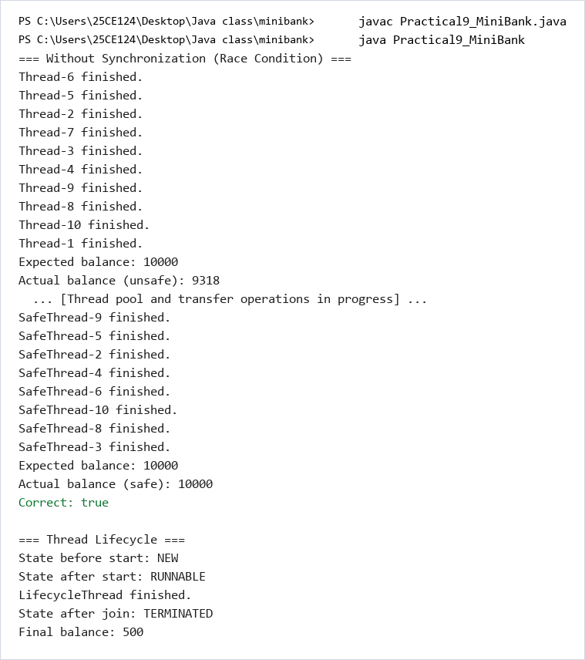

 | Practical 10: THREAD POOLS & CONCURRENCY UTILITIES
Program: 10.1 | ExecutorService Thread Pool, Wait/Notify & Deadlock Prevention  Build a high-throughput transaction engine using ExecutorService with a fixed thread pool (Executors.newFixedThreadPool(4)). Submit asynchronous deposit and withdrawal transaction tasks, and coordinate thread interactions using wait() and notify(). Implement consistent lock ordering (by account number) during inter-account transfers to prevent deadlocks.
Code | import java.util.concurrent.ExecutorService;  import java.util.concurrent.Executors;  import java.util.concurrent.TimeUnit;  public class Practical10_MiniBank {  static int accountCounter = 0;  static class Account {  private final String accountNumber;  private String ownerName;  private long balance;  Account(String ownerName, long openingBalance) {  accountCounter++;  this.accountNumber = String.format("AC%04d", accountCounter);  this.ownerName = ownerName;  this.balance = openingBalance;  }  synchronized void deposit(long amount) {  if (amount > 0) {  balance += amount;  }  }  synchronized void withdraw(long amount) {  if (amount > 0 && balance >= amount) {  balance -= amount;  }  }  String getAccountNumber() { return accountNumber; }  String getOwnerName() { return ownerName; }  long getBalance() { return balance; }  @Override  public String toString() {  return accountNumber + " | " + ownerName + " | Balance: " + balance;  }  }  static class TransactionProcessor {  private ExecutorService pool;  TransactionProcessor(int threads) {  this.pool = Executors.newFixedThreadPool(threads);  }  void submit(Runnable task) {  pool.execute(task);  }  void stop() throws InterruptedException {  pool.shutdown();  pool.awaitTermination(10, TimeUnit.SECONDS);  }  }  static class SharedBuffer {  private String[] buffer;  private int count;  SharedBuffer(int capacity) {  this.buffer = new String[capacity];  this.count = 0;  }  synchronized void produce(String item) throws InterruptedException {  while (count == buffer.length) {  wait();  }  buffer[count] = item;  count++;  System.out.println("Produced: " + item + " | Buffer size: " + count);  notify();  }  synchronized String consume() throws InterruptedException {  while (count == 0) {  wait();  }  count--;  String item = buffer[count];  System.out.println("Consumed: " + item + " | Buffer size: " + count);  notify();  return item;  }  }  static void transferWithDeadlockFix(Account a, Account b, long amount) {  Account first;  Account second;  if (a.getAccountNumber().compareTo(b.getAccountNumber()) < 0) {  first = a;  second = b;  } else {  first = b;  second = a;  }  synchronized (first) {  synchronized (second) {  if (a.getBalance() >= amount) {  a.withdraw(amount);  b.deposit(amount);  System.out.println(Thread.currentThread().getName() +  ": Transferred " + amount + " from " + a.getAccountNumber() +  " to " + b.getAccountNumber());  }  }  }  }  public static void main(String[] args) throws InterruptedException {  System.out.println("=== Thread Pool - TransactionProcessor ===");  accountCounter = 0;  Account poolAccount = new Account("Riya", 0);  TransactionProcessor processor = new TransactionProcessor(4);  for (int i = 0; i < 20; i++) {  processor.submit(() -> {  poolAccount.deposit(100);  System.out.println(Thread.currentThread().getName() + " deposited 100");  });  }  processor.stop();  System.out.println("Final balance after pool: " + poolAccount.getBalance());  System.out.println("Expected: 2000");  System.out.println("\n=== Producer-Consumer with wait/notify ===");  SharedBuffer buffer = new SharedBuffer(3);  Thread producer = new Thread(() -> {  try {  for (int i = 1; i <= 5; i++) {  buffer.produce("Transaction-" + i);  Thread.sleep(100);  }  } catch (InterruptedException e) {  Thread.currentThread().interrupt();  }  });  Thread consumer = new Thread(() -> {  try {  for (int i = 1; i <= 5; i++) {  buffer.consume();  Thread.sleep(200);  }  } catch (InterruptedException e) {  Thread.currentThread().interrupt();  }  });  producer.start();  consumer.start();  producer.join();  consumer.join();  System.out.println("\n=== Deadlock Fix - Consistent Lock Ordering ===");  accountCounter = 0;  Account accA = new Account("Alice", 5000);  Account accB = new Account("Bob", 5000);  Thread t1 = new Thread(() -> {  for (int i = 0; i < 100; i++) {  transferWithDeadlockFix(accA, accB, 10);  }  }, "Thread-AtoB");  Thread t2 = new Thread(() -> {  for (int i = 0; i < 100; i++) {  transferWithDeadlockFix(accB, accA, 10);  }  }, "Thread-BtoA");  t1.start();  t2.start();  t1.join();  t2.join();  System.out.println("Account A: " + accA);  System.out.println("Account B: " + accB);  System.out.println("Total (should be 10000): " + (accA.getBalance() + accB.getBalance()));  }  }
Output | 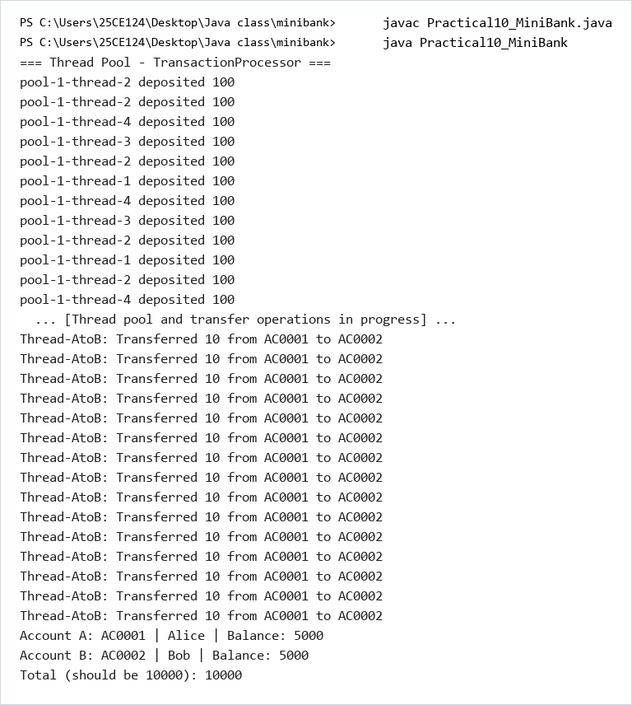

 | Practical 11: JAVA I/O, SERIALIZATION & MODERN NIO.2
Program: 11.1 | Model Serialization, Binary Persistence & NIO.2 Audit Logging  Implement data persistence for MiniBank. Make domain entities Serializable and persist/restore the entire accounts collection using ObjectOutputStream and ObjectInputStream. Utilize modern NIO.2 (Path, Files, StandardOpenOption.APPEND) to write an append-only transaction audit log file and read lines to generate an end-of-day reconciliation report.
Code | import java.io.Serializable;  import java.io.ObjectOutputStream;  import java.io.ObjectInputStream;  import java.io.FileOutputStream;  import java.io.FileInputStream;  import java.io.BufferedReader;  import java.io.File;  import java.nio.file.Path;  import java.nio.file.Paths;  import java.nio.file.Files;  import java.nio.file.StandardOpenOption;  import java.nio.file.DirectoryStream;  import java.nio.file.attribute.BasicFileAttributes;  import java.util.ArrayList;  public class Practical11_MiniBank {  static int accountCounter = 0;  static class Account implements Serializable {  private static final long serialVersionUID = 1L;  private final String accountNumber;  private String ownerName;  private long balance;  Account(String ownerName, long openingBalance) {  accountCounter++;  this.accountNumber = String.format("AC%04d", accountCounter);  this.ownerName = ownerName;  this.balance = openingBalance;  }  void deposit(long amount) {  if (amount > 0) balance += amount;  }  void withdraw(long amount) {  if (amount > 0 && balance >= amount) balance -= amount;  }  String getAccountNumber() { return accountNumber; }  String getOwnerName() { return ownerName; }  long getBalance() { return balance; }  @Override  public String toString() {  return accountNumber + " | " + ownerName + " | Balance: " + balance;  }  }  static class StatePersister {  static void save(Account[] accounts, Path file) {  try (ObjectOutputStream oos = new ObjectOutputStream(new FileOutputStream(file.toFile()))) {  oos.writeObject(accounts);  System.out.println("Saved " + accounts.length + " accounts to " + file);  } catch (Exception e) {  System.out.println("Error saving: " + e.getMessage());  }  }  static Account[] load(Path file) {  try (ObjectInputStream ois = new ObjectInputStream(new FileInputStream(file.toFile()))) {  Account[] accounts = (Account[]) ois.readObject();  System.out.println("Loaded " + accounts.length + " accounts from " + file);  return accounts;  } catch (Exception e) {  System.out.println("Error loading: " + e.getMessage());  return new Account[0];  }  }  }  static class TransactionLog {  static void append(Path file, String line) {  try {  Files.writeString(file, line + System.lineSeparator(),  StandardOpenOption.CREATE, StandardOpenOption.APPEND);  } catch (Exception e) {  System.out.println("Error appending to log: " + e.getMessage());  }  }  }  static class ReportGenerator {  static void generateReport(Path logsFolder, Path reportFile) {  long totalDeposits = 0;  long totalWithdrawals = 0;  int fileCount = 0;  try (DirectoryStream<Path> stream = Files.newDirectoryStream(logsFolder, "*.log")) {  for (Path logFile : stream) {  fileCount++;  BasicFileAttributes attrs = Files.readAttributes(logFile, BasicFileAttributes.class);  System.out.println("Processing: " + logFile.getFileName() +  " | Size: " + attrs.size() + " bytes" +  " | Modified: " + attrs.lastModifiedTime());  try (BufferedReader reader = Files.newBufferedReader(logFile)) {  String line;  while ((line = reader.readLine()) != null) {  String[] parts = line.split(" ");  if (parts.length >= 3) {  long amount = Long.parseLong(parts[2]);  if (parts[0].equals("DEPOSIT")) {  totalDeposits += amount;  } else if (parts[0].equals("WITHDRAW")) {  totalWithdrawals += amount;  }  }  }  }  }  } catch (Exception e) {  System.out.println("Error reading logs: " + e.getMessage());  }  StringBuilder report = new StringBuilder();  report.append("========================================\n");  report.append(" END-OF-DAY REPORT\n");  report.append("========================================\n");  report.append("Files processed : ").append(fileCount).append("\n");  report.append("Total Deposits : Rs. ").append(totalDeposits).append("\n");  report.append("Total Withdrawals: Rs. ").append(totalWithdrawals).append("\n");  report.append("Net Change : Rs. ").append(totalDeposits - totalWithdrawals).append("\n");  report.append("========================================\n");  try {  Files.writeString(reportFile, report.toString(),  StandardOpenOption.CREATE, StandardOpenOption.TRUNCATE_EXISTING);  System.out.println("\nReport written to: " + reportFile);  } catch (Exception e) {  System.out.println("Error writing report: " + e.getMessage());  }  System.out.println(report);  }  }  public static void main(String[] args) throws Exception {  Path dataDir = Paths.get("data");  Path logsDir = Paths.get("data", "logs");  Files.createDirectories(logsDir);  System.out.println("=== Creating and Saving Accounts ===");  accountCounter = 0;  Account[] accounts = new Account[3];  accounts[0] = new Account("Riya", 5000);  accounts[1] = new Account("Aman", 3000);  accounts[2] = new Account("Priya", 8000);  for (int i = 0; i < accounts.length; i++) {  System.out.println(accounts[i]);  }  Path saveFile = dataDir.resolve("accounts.dat");  StatePersister.save(accounts, saveFile);  System.out.println("\n=== Loading Accounts ===");  Account[] loaded = StatePersister.load(saveFile);  for (int i = 0; i < loaded.length; i++) {  System.out.println(loaded[i]);  }  System.out.println("\n=== Creating Transaction Logs ===");  Path logFile = logsDir.resolve("transactions.log");  Files.deleteIfExists(logFile);  TransactionLog.append(logFile, "DEPOSIT AC0001 500");  TransactionLog.append(logFile, "DEPOSIT AC0002 1000");  TransactionLog.append(logFile, "WITHDRAW AC0001 200");  TransactionLog.append(logFile, "DEPOSIT AC0003 300");  TransactionLog.append(logFile, "WITHDRAW AC0002 150");  System.out.println("\n=== Generating Report ===");  Path reportFile = dataDir.resolve("report.txt");  ReportGenerator.generateReport(logsDir, reportFile);  }  }
Output | 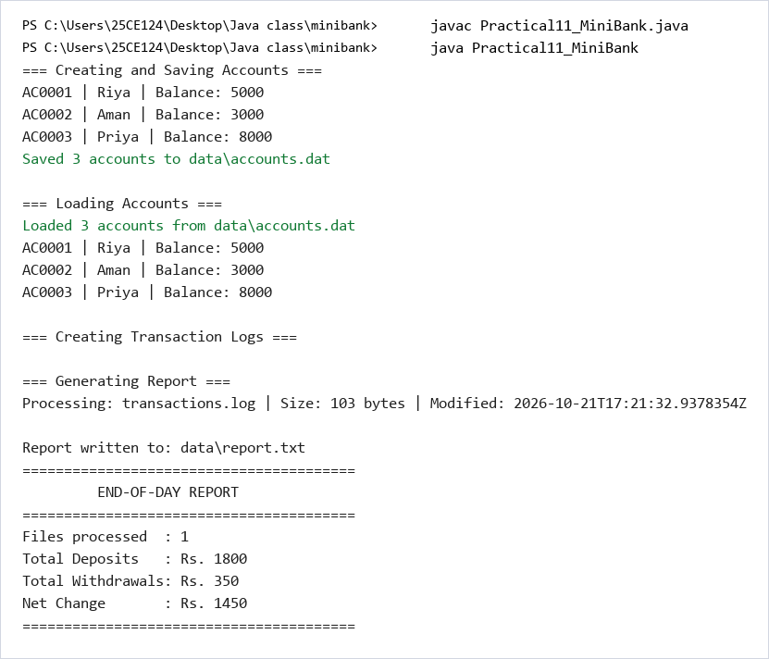

 | Practical 12: JAVA COLLECTIONS FRAMEWORK & COMPARATORS
Program: 12.1 | HashMap Storage, Custom Comparators & ConcurrentHashMap  Upgrade MiniBank's account storage to the Java Collections Framework. Replace fixed arrays with a HashMap<String, Account> for O(1) account lookups by account number. Implement sorting with Comparator (by balance descending and owner name alphabetically). Maintain transaction histories in ArrayList, and demonstrate ConcurrentHashMap for thread-safe concurrent lookups.
Code | import java.util.HashMap;  import java.util.ArrayList;  import java.util.Comparator;  import java.util.concurrent.ConcurrentHashMap;  public class Practical12_MiniBank {  static int accountCounter = 0;  static class Account implements Comparable<Account> {  private final String accountNumber;  private String ownerName;  private long balance;  Account(String ownerName, long openingBalance) {  accountCounter++;  this.accountNumber = String.format("AC%04d", accountCounter);  this.ownerName = ownerName;  this.balance = openingBalance;  }  synchronized void deposit(long amount) {  if (amount > 0) balance += amount;  }  synchronized void withdraw(long amount) {  if (amount > 0 && balance >= amount) balance -= amount;  }  String getAccountNumber() { return accountNumber; }  String getOwnerName() { return ownerName; }  long getBalance() { return balance; }  @Override  public int compareTo(Account other) {  return this.accountNumber.compareTo(other.accountNumber);  }  @Override  public String toString() {  return accountNumber + " | " + ownerName + " | Balance: " + balance;  }  }  static class AccountStore {  private HashMap<String, Account> accounts;  private ArrayList<String> transactionHistory;  AccountStore() {  this.accounts = new HashMap<>();  this.transactionHistory = new ArrayList<>();  }  void add(Account account) {  accounts.put(account.getAccountNumber(), account);  transactionHistory.add("ADDED " + account.getAccountNumber());  }  Account get(String accountNumber) {  return accounts.get(accountNumber);  }  ArrayList<Account> getAll() {  ArrayList<Account> list = new ArrayList<>();  for (String key : accounts.keySet()) {  list.add(accounts.get(key));  }  return list;  }  ArrayList<Account> sortedByBalance() {  ArrayList<Account> list = getAll();  list.sort(new Comparator<Account>() {  public int compare(Account a, Account b) {  return Long.compare(b.getBalance(), a.getBalance());  }  });  return list;  }  ArrayList<String> getTransactionHistory() {  return transactionHistory;  }  }  public static void main(String[] args) throws InterruptedException {  accountCounter = 0;  System.out.println("=== AccountStore with HashMap ===");  AccountStore store = new AccountStore();  Account a1 = new Account("Riya", 5000);  Account a2 = new Account("Aman", 2000);  Account a3 = new Account("Priya", 9000);  store.add(a1);  store.add(a2);  store.add(a3);  System.out.println("All accounts:");  ArrayList<Account> all = store.getAll();  for (int i = 0; i < all.size(); i++) {  System.out.println(" " + all.get(i));  }  System.out.println("\nLookup AC0002: " + store.get("AC0002"));  System.out.println("\n=== Sorted by Balance (Descending) ===");  ArrayList<Account> sorted = store.sortedByBalance();  for (int i = 0; i < sorted.size(); i++) {  System.out.println(" " + sorted.get(i));  }  System.out.println("\n=== Comparable (Natural Order) ===");  ArrayList<Account> natural = store.getAll();  natural.sort(null);  for (int i = 0; i < natural.size(); i++) {  System.out.println(" " + natural.get(i));  }  System.out.println("\n=== Transaction History ===");  ArrayList<String> history = store.getTransactionHistory();  for (int i = 0; i < history.size(); i++) {  System.out.println(" " + history.get(i));  }  System.out.println("\n=== ConcurrentHashMap (Thread Safe) ===");  ConcurrentHashMap<String, Account> concurrentStore = new ConcurrentHashMap<>();  concurrentStore.put(a1.getAccountNumber(), a1);  concurrentStore.put(a2.getAccountNumber(), a2);  concurrentStore.put(a3.getAccountNumber(), a3);  Thread[] threads = new Thread[10];  for (int i = 0; i < threads.length; i++) {  threads[i] = new Thread(() -> {  for (int j = 0; j < 100; j++) {  Account acc = concurrentStore.get("AC0001");  if (acc != null) {  acc.deposit(1);  }  }  });  threads[i].start();  }  for (int i = 0; i < threads.length; i++) {  threads[i].join();  }  System.out.println("AC0001 balance after concurrent deposits: " + a1.getBalance());  System.out.println("Expected: " + (5000 + 10 * 100));  }  }
Output | 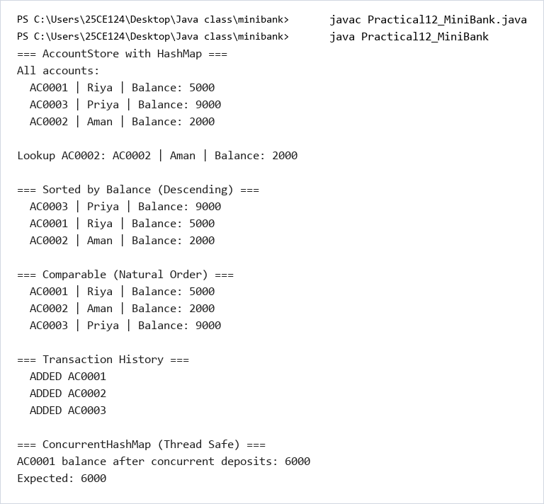

 | Practical 13: GENERICS & BOUNDED TYPE PARAMETERS
Program: 13.1 | Generic Entity Repository with Reflection-Based Key Lookup  Implement a generic data-access layer using a Repository<T> class with type parameter T. Support generic CRUD operations (save, findById, findAll, delete). Use reflection to automatically detect the primary key field marked with @Id, ensuring complete type safety without runtime casting across different entity types like Account and Customer.
Code | import java.lang.annotation.ElementType;  import java.lang.annotation.Retention;  import java.lang.annotation.RetentionPolicy;  import java.lang.annotation.Target;  import java.lang.reflect.Field;  import java.util.HashMap;  import java.util.ArrayList;  public class Practical13_MiniBank {  @Target(ElementType.FIELD)  @Retention(RetentionPolicy.RUNTIME)  @interface Id {}  static int accountCounter = 0;  static class Account {  @Id  private final String accountNumber;  private String ownerName;  private long balance;  Account(String ownerName, long openingBalance) {  accountCounter++;  this.accountNumber = String.format("AC%04d", accountCounter);  this.ownerName = ownerName;  this.balance = openingBalance;  }  String getAccountNumber() { return accountNumber; }  String getOwnerName() { return ownerName; }  long getBalance() { return balance; }  @Override  public String toString() {  return accountNumber + " | " + ownerName + " | Balance: " + balance;  }  }  static class Customer {  @Id  private final String customerId;  private String name;  Customer(String customerId, String name) {  this.customerId = customerId;  this.name = name;  }  @Override  public String toString() {  return customerId + " | " + name;  }  }  static class Repository<T> {  private HashMap<String, T> store;  Repository() {  this.store = new HashMap<>();  }  T save(T entity) {  String id = findIdValue(entity);  if (id != null) {  store.put(id, entity);  }  return entity;  }  @SafeVarargs  final void saveAll(T... items) {  for (int i = 0; i < items.length; i++) {  save(items[i]);  }  }  T findById(String id) {  return store.get(id);  }  ArrayList<T> findAll() {  ArrayList<T> list = new ArrayList<>();  for (String key : store.keySet()) {  list.add(store.get(key));  }  return list;  }  boolean delete(String id) {  if (store.containsKey(id)) {  store.remove(id);  return true;  }  return false;  }  int count() {  return store.size();  }  private String findIdValue(T entity) {  Field[] fields = entity.getClass().getDeclaredFields();  for (int i = 0; i < fields.length; i++) {  if (fields[i].isAnnotationPresent(Id.class)) {  fields[i].setAccessible(true);  try {  Object value = fields[i].get(entity);  if (value != null) {  return value.toString();  }  } catch (IllegalAccessException e) {  System.out.println("Error reading @Id field: " + e.getMessage());  }  }  }  return null;  }  }  static <N extends Number> double average(N[] values) {  double sum = 0;  for (int i = 0; i < values.length; i++) {  sum += values[i].doubleValue();  }  return sum / values.length;  }  public static void main(String[] args) {  accountCounter = 0;  System.out.println("=== Repository<Account> ===");  Repository<Account> accountRepo = new Repository<>();  Account a1 = new Account("Riya", 5000);  Account a2 = new Account("Aman", 3000);  Account a3 = new Account("Priya", 8000);  accountRepo.saveAll(a1, a2, a3);  System.out.println("Total accounts: " + accountRepo.count());  System.out.println("\nFind by ID 'AC0002': " + accountRepo.findById("AC0002"));  System.out.println("\nAll accounts:");  ArrayList<Account> allAccounts = accountRepo.findAll();  for (int i = 0; i < allAccounts.size(); i++) {  System.out.println(" " + allAccounts.get(i));  }  System.out.println("\nDelete AC0002: " + accountRepo.delete("AC0002"));  System.out.println("Total after delete: " + accountRepo.count());  System.out.println("\n=== Repository<Customer> (same class, different type) ===");  Repository<Customer> customerRepo = new Repository<>();  customerRepo.save(new Customer("CUST101", "Riya"));  customerRepo.save(new Customer("CUST102", "Aman"));  System.out.println("Total customers: " + customerRepo.count());  ArrayList<Customer> allCustomers = customerRepo.findAll();  for (int i = 0; i < allCustomers.size(); i++) {  System.out.println(" " + allCustomers.get(i));  }  System.out.println("\n=== Bounded Type Parameter: average() ===");  Integer[] intValues = {10, 20, 30, 40, 50};  System.out.println("Average of integers: " + average(intValues));  Double[] doubleValues = {1.5, 2.5, 3.5};  System.out.println("Average of doubles: " + average(doubleValues));  }  }
Output | 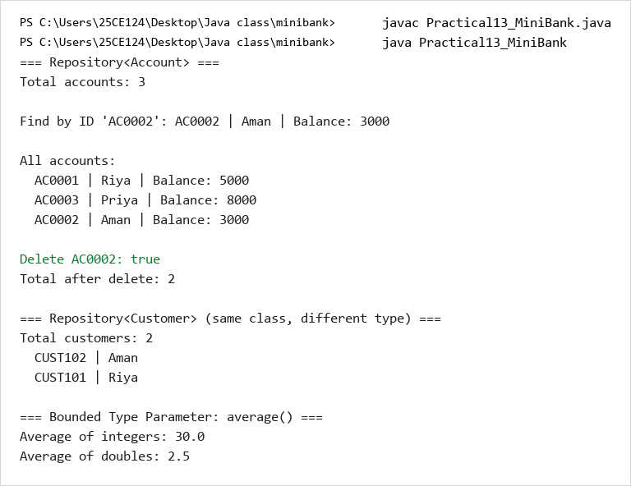

 | Practical 14: LAYERED APPLICATION INTEGRATION & TESTING
Program: 14.1 | Comprehensive Capstone MiniBank Integration with Clean Architecture  Integrate all modules into a fully finished, layered production banking application: model classes (Customer, Account, SavingsAccount, CurrentAccount, FixedDepositAccount), repository layer (Repository<T>), validation engine (Validator), custom exception handling, persistence/audit logging, and a unified interactive BankService console interface offering account creation, deposit, withdrawal, transfer, statements, and reporting.
Code | import java.io.Serializable;  import java.io.ObjectOutputStream;  import java.io.ObjectInputStream;  import java.io.FileOutputStream;  import java.io.FileInputStream;  import java.lang.annotation.ElementType;  import java.lang.annotation.Retention;  import java.lang.annotation.RetentionPolicy;  import java.lang.annotation.Target;  import java.lang.reflect.Field;  import java.nio.file.Path;  import java.nio.file.Paths;  import java.nio.file.Files;  import java.nio.file.StandardOpenOption;  import java.nio.file.DirectoryStream;  import java.nio.file.attribute.BasicFileAttributes;  import java.util.HashMap;  import java.util.ArrayList;  import java.util.Comparator;  import java.util.Scanner;  import java.util.concurrent.ExecutorService;  import java.util.concurrent.Executors;  import java.util.concurrent.TimeUnit;  import java.util.concurrent.ConcurrentHashMap;  import java.util.regex.Pattern;  public class Practical14_MiniBank {  @Target(ElementType.FIELD)  @Retention(RetentionPolicy.RUNTIME)  @interface Id {}  @Target(ElementType.FIELD)  @Retention(RetentionPolicy.RUNTIME)  @interface Positive {  String message() default "must be > 0";  }  static class BankException extends Exception {  BankException(String message) { super(message); }  }  static class InsufficientFundsException extends BankException {  private long shortfall;  InsufficientFundsException(long shortfall) {  super("Insufficient funds. Short by: " + shortfall);  this.shortfall = shortfall;  }  long getShortfall() { return shortfall; }  }  static class AccountNotFoundException extends BankException {  AccountNotFoundException(String accountNumber) {  super("Account not found: " + accountNumber);  }  }  static class InvalidAmountException extends BankException {  InvalidAmountException(String message) { super(message); }  }  static int accountCounter = 0;  static class Account implements Serializable, Comparable<Account> {  private static final long serialVersionUID = 1L;  @Id  private final String accountNumber;  private String ownerName;  @Positive  private long balance;  private boolean active;  Account(String ownerName, long openingBalance) {  accountCounter++;  this.accountNumber = String.format("AC%04d", accountCounter);  this.ownerName = ownerName;  this.balance = openingBalance;  this.active = true;  }  Account(String ownerName) {  this(ownerName, 0);  }  synchronized void deposit(long amount) throws InvalidAmountException {  if (amount <= 0) throw new InvalidAmountException("Deposit amount must be positive.");  balance += amount;  }  synchronized void withdraw(long amount) throws InsufficientFundsException, InvalidAmountException {  if (amount <= 0) throw new InvalidAmountException("Withdrawal amount must be positive.");  if (balance < amount) throw new InsufficientFundsException(amount - balance);  balance -= amount;  }  void transfer(Account to, long amount) throws BankException {  Account first;  Account second;  if (this.accountNumber.compareTo(to.accountNumber) < 0) {  first = this; second = to;  } else {  first = to; second = this;  }  synchronized (first) {  synchronized (second) {  this.withdraw(amount);  to.deposit(amount);  }  }  }  String getAccountNumber() { return accountNumber; }  String getOwnerName() { return ownerName; }  long getBalance() { return balance; }  boolean isActive() { return active; }  @Override  public int compareTo(Account other) {  return this.accountNumber.compareTo(other.accountNumber);  }  @Override  public String toString() {  return accountNumber + " | " + ownerName + " | Balance: " + balance;  }  @Override  public boolean equals(Object o) {  if (this == o) return true;  if (!(o instanceof Account)) return false;  return this.accountNumber.equals(((Account) o).accountNumber);  }  @Override  public int hashCode() {  return accountNumber.hashCode();  }  }  static class Repository<T> {  private HashMap<String, T> store;  Repository() { this.store = new HashMap<>(); }  T save(T entity) {  String id = findIdValue(entity);  if (id != null) store.put(id, entity);  return entity;  }  T findById(String id) { return store.get(id); }  ArrayList<T> findAll() {  return new ArrayList<>(store.values());  }  boolean delete(String id) {  return store.remove(id) != null;  }  int count() { return store.size(); }  private String findIdValue(T entity) {  Field[] fields = entity.getClass().getDeclaredFields();  for (int i = 0; i < fields.length; i++) {  if (fields[i].isAnnotationPresent(Id.class)) {  fields[i].setAccessible(true);  try {  Object value = fields[i].get(entity);  return value != null ? value.toString() : null;  } catch (IllegalAccessException e) {  return null;  }  }  }  return null;  }  }  static class Validator {  private static final Pattern MOBILE_PATTERN = Pattern.compile("^[6-9][0-9]{9}$");  private static final Pattern EMAIL_PATTERN = Pattern.compile("^[a-zA-Z0-9._%+-]+@[a-zA-Z0-9.-]+\\.[a-zA-Z]{2,}$");  static boolean isValidMobile(String mobile) { return MOBILE_PATTERN.matcher(mobile).matches(); }  static boolean isValidEmail(String email) { return EMAIL_PATTERN.matcher(email).matches(); }  }  static class TransactionLog {  static void append(Path file, String line) {  try {  Files.writeString(file, line + System.lineSeparator(),  StandardOpenOption.CREATE, StandardOpenOption.APPEND);  } catch (Exception e) {  System.out.println("Log error: " + e.getMessage());  }  }  }  static class StatePersister {  static void save(ArrayList<Account> accounts, Path file) {  try (ObjectOutputStream oos = new ObjectOutputStream(new FileOutputStream(file.toFile()))) {  Account[] arr = new Account[accounts.size()];  for (int i = 0; i < accounts.size(); i++) arr[i] = accounts.get(i);  oos.writeObject(arr);  } catch (Exception e) {  System.out.println("Save error: " + e.getMessage());  }  }  static ArrayList<Account> load(Path file) {  ArrayList<Account> list = new ArrayList<>();  if (!Files.exists(file)) return list;  try (ObjectInputStream ois = new ObjectInputStream(new FileInputStream(file.toFile()))) {  Account[] arr = (Account[]) ois.readObject();  for (int i = 0; i < arr.length; i++) list.add(arr[i]);  int maxCounter = 0;  for (int i = 0; i < arr.length; i++) {  String num = arr[i].getAccountNumber().replace("AC", "");  int n = Integer.parseInt(num);  if (n > maxCounter) maxCounter = n;  }  accountCounter = maxCounter;  } catch (Exception e) {  System.out.println("Load error: " + e.getMessage());  }  return list;  }  }  static class ReportGenerator {  static void generateReport(Path logsFolder, Path reportFile) {  long totalDeposits = 0;  long totalWithdrawals = 0;  try (DirectoryStream<Path> stream = Files.newDirectoryStream(logsFolder, "*.log")) {  for (Path logFile : stream) {  java.io.BufferedReader reader = Files.newBufferedReader(logFile);  String line;  while ((line = reader.readLine()) != null) {  String[] parts = line.split(" ");  if (parts.length >= 3) {  long amount = Long.parseLong(parts[2]);  if (parts[0].equals("DEPOSIT")) totalDeposits += amount;  else if (parts[0].equals("WITHDRAW")) totalWithdrawals += amount;  }  }  reader.close();  }  } catch (Exception e) {  System.out.println("Report error: " + e.getMessage());  }  StringBuilder sb = new StringBuilder();  sb.append("========================================\n");  sb.append(" END-OF-DAY REPORT\n");  sb.append("========================================\n");  sb.append("Total Deposits : Rs. ").append(totalDeposits).append("\n");  sb.append("Total Withdrawals: Rs. ").append(totalWithdrawals).append("\n");  sb.append("Net Change : Rs. ").append(totalDeposits - totalWithdrawals).append("\n");  sb.append("========================================\n");  try {  Files.writeString(reportFile, sb.toString(),  StandardOpenOption.CREATE, StandardOpenOption.TRUNCATE_EXISTING);  } catch (Exception e) {  System.out.println("Write report error: " + e.getMessage());  }  System.out.println(sb);  }  }  static class TransactionProcessor {  private ExecutorService pool;  TransactionProcessor(int threads) {  pool = Executors.newFixedThreadPool(threads);  }  void submit(Runnable task) { pool.execute(task); }  void stop() throws InterruptedException {  pool.shutdown();  pool.awaitTermination(10, TimeUnit.SECONDS);  }  }  static class BankService {  private Repository<Account> repository;  private Path logFile;  BankService(Repository<Account> repository, Path logFile) {  this.repository = repository;  this.logFile = logFile;  }  Account openAccount(String ownerName, long openingBalance) throws InvalidAmountException {  if (openingBalance < 0) throw new InvalidAmountException("Opening balance cannot be negative.");  Account account = new Account(ownerName, openingBalance);  repository.save(account);  TransactionLog.append(logFile, "OPEN " + account.getAccountNumber() + " " + openingBalance);  return account;  }  void deposit(String accountNumber, long amount) throws BankException {  Account account = repository.findById(accountNumber);  if (account == null) throw new AccountNotFoundException(accountNumber);  account.deposit(amount);  repository.save(account);  TransactionLog.append(logFile, "DEPOSIT " + accountNumber + " " + amount);  }  void withdraw(String accountNumber, long amount) throws BankException {  Account account = repository.findById(accountNumber);  if (account == null) throw new AccountNotFoundException(accountNumber);  account.withdraw(amount);  repository.save(account);  TransactionLog.append(logFile, "WITHDRAW " + accountNumber + " " + amount);  }  void transfer(String fromAcc, String toAcc, long amount) throws BankException {  Account from = repository.findById(fromAcc);  Account to = repository.findById(toAcc);  if (from == null) throw new AccountNotFoundException(fromAcc);  if (to == null) throw new AccountNotFoundException(toAcc);  from.transfer(to, amount);  repository.save(from);  repository.save(to);  TransactionLog.append(logFile, "TRANSFER " + fromAcc + " " + toAcc + " " + amount);  }  String statement(String accountNumber) throws AccountNotFoundException {  Account account = repository.findById(accountNumber);  if (account == null) throw new AccountNotFoundException(accountNumber);  StringBuilder sb = new StringBuilder();  sb.append("========================================\n");  sb.append(" ACCOUNT STATEMENT\n");  sb.append("========================================\n");  sb.append("Account Number : ").append(account.getAccountNumber()).append("\n");  sb.append("Owner Name : ").append(account.getOwnerName()).append("\n");  sb.append("Balance : Rs. ").append(account.getBalance()).append("\n");  sb.append("========================================");  return sb.toString();  }  ArrayList<Account> listAccounts() {  ArrayList<Account> list = repository.findAll();  list.sort(new Comparator<Account>() {  public int compare(Account a, Account b) {  return Long.compare(b.getBalance(), a.getBalance());  }  });  return list;  }  }  public static void main(String[] args) throws Exception {  Path dataDir = Paths.get("data");  Path logsDir = Paths.get("data", "logs");  Files.createDirectories(logsDir);  Path saveFile = dataDir.resolve("accounts.dat");  Path logFile = logsDir.resolve("transactions.log");  Repository<Account> repository = new Repository<>();  ArrayList<Account> loaded = StatePersister.load(saveFile);  for (int i = 0; i < loaded.size(); i++) {  repository.save(loaded.get(i));  }  if (loaded.size() > 0) {  System.out.println("Loaded " + loaded.size() + " accounts from previous session.");  }  BankService bankService = new BankService(repository, logFile);  Scanner scanner = new Scanner(System.in);  boolean running = true;  while (running) {  System.out.println("\n========================================");  System.out.println(" MINIBANK MENU");  System.out.println("========================================");  System.out.println("1. Open Account");  System.out.println("2. Deposit");  System.out.println("3. Withdraw");  System.out.println("4. Transfer");  System.out.println("5. Statement");  System.out.println("6. List All Accounts");  System.out.println("7. Generate Report");  System.out.println("8. Exit");  System.out.print("Enter choice: ");  int choice = -1;  if (scanner.hasNextInt()) {  choice = scanner.nextInt();  scanner.nextLine();  } else {  scanner.nextLine();  System.out.println("Invalid input.");  continue;  }  try {  switch (choice) {  case 1: {  System.out.print("Enter owner name: ");  String name = scanner.nextLine();  System.out.print("Enter opening balance: ");  long balance = Long.parseLong(scanner.nextLine());  Account acc = bankService.openAccount(name, balance);  System.out.println("Account created: " + acc);  break;  }  case 2: {  System.out.print("Enter account number: ");  String accNo = scanner.nextLine();  System.out.print("Enter deposit amount: ");  long amount = Long.parseLong(scanner.nextLine());  bankService.deposit(accNo, amount);  System.out.println("Deposit successful.");  break;  }  case 3: {  System.out.print("Enter account number: ");  String accNo = scanner.nextLine();  System.out.print("Enter withdrawal amount: ");  long amount = Long.parseLong(scanner.nextLine());  bankService.withdraw(accNo, amount);  System.out.println("Withdrawal successful.");  break;  }  case 4: {  System.out.print("Enter source account number: ");  String from = scanner.nextLine();  System.out.print("Enter destination account number: ");  String to = scanner.nextLine();  System.out.print("Enter transfer amount: ");  long amount = Long.parseLong(scanner.nextLine());  bankService.transfer(from, to, amount);  System.out.println("Transfer successful.");  break;  }  case 5: {  System.out.print("Enter account number: ");  String accNo = scanner.nextLine();  System.out.println(bankService.statement(accNo));  break;  }  case 6: {  ArrayList<Account> accounts = bankService.listAccounts();  if (accounts.size() == 0) {  System.out.println("No accounts found.");  } else {  System.out.println("=== All Accounts (sorted by balance) ===");  for (int i = 0; i < accounts.size(); i++) {  System.out.println(" " + accounts.get(i));  }  }  break;  }  case 7: {  Path reportFile = dataDir.resolve("report.txt");  ReportGenerator.generateReport(logsDir, reportFile);  break;  }  case 8: {  ArrayList<Account> allAccounts = repository.findAll();  StatePersister.save(allAccounts, saveFile);  System.out.println("Accounts saved. Goodbye!");  running = false;  break;  }  default:  System.out.println("Invalid choice.");  }  } catch (BankException e) {  System.out.println("Error: " + e.getMessage());  } catch (NumberFormatException e) {  System.out.println("Invalid number format.");  }  }  scanner.close();  }  }
Output | 