ABS WATERFALL AI
Executive Overview

Same rigor. Half the effort.
Full auditability.

February 2026 • Confidential

The Transformation
Today, building a payment model for a single ABS deal requires two analysts to build two independent Excel models, cross-check results, and manually trace every formula back to a 300+ page legal document. This process takes days per deal.
ABS Waterfall AI replaces one of those two analysts with an AI system that reads the legal documents, understands the payment waterfall, and generates a validated Python payment model — automatically, in minutes, with every formula traced to its source paragraph.
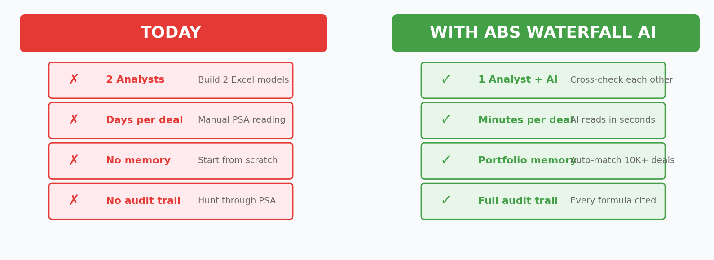

Pain Points Solved
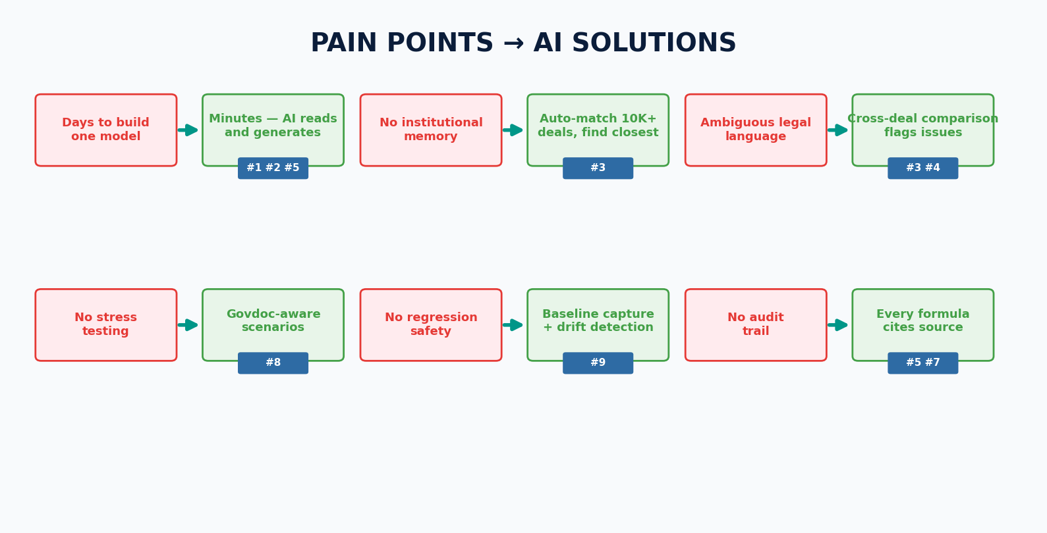

The 13-Agent Ecosystem
ABS Waterfall AI is not one tool — it's an ecosystem of 13 specialized AI agents, each purpose-built for a specific part of the deal lifecycle.
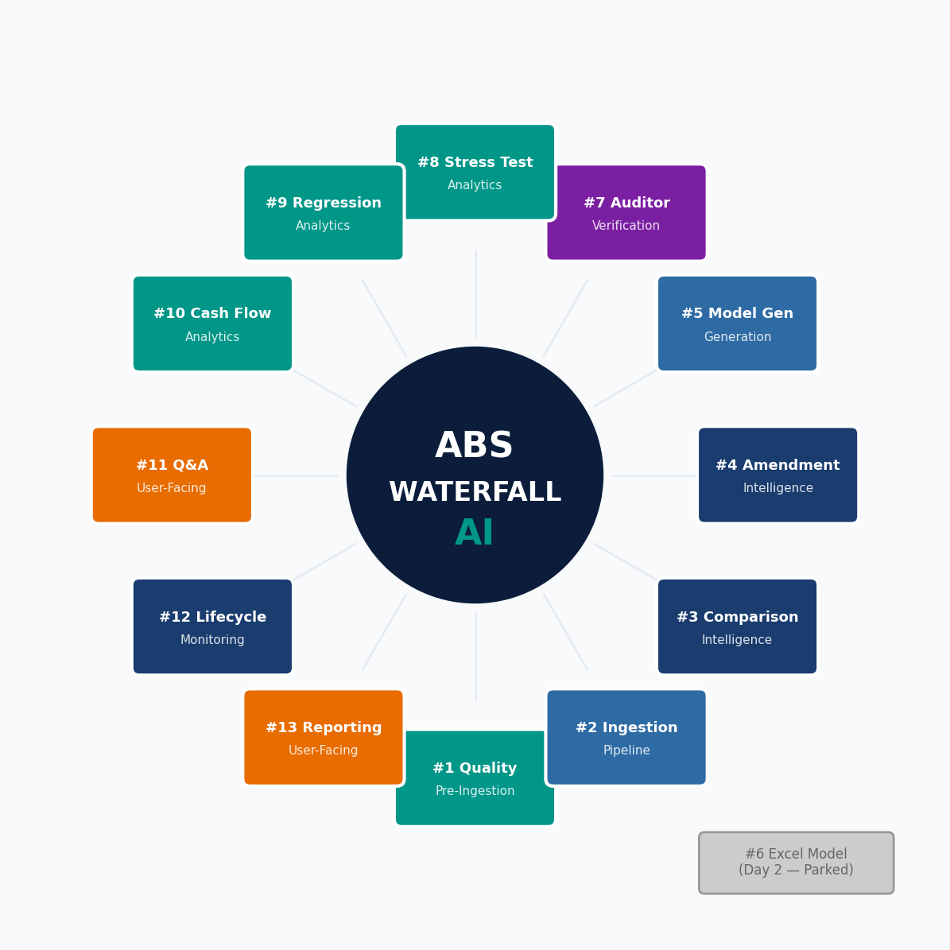

# | Agent | What It Does (One Line) | Why It Matters
1 | Document Quality | Checks doc integrity + blocks duplicates | Prevents garbage in, garbage out
2 | Ingestion Pipeline | Transforms PSA → structured knowledge | Foundation for everything else
3 | Comparison | Finds the closest deal in 10K+ portfolio | Institutional memory at scale
4 | Amendment | Tracks versioned changes + cascade impact | 20-30 year deal lifecycle
5 | Model Creation | Generates a payment model with citations | The core AI analyst
6 | Excel Model | Excel version of Python model (Day 2) | Industry lingua franca
7 | Auditor | Independent formula verification | Checker ≠ Builder
8 | Stress Testing | Govdoc-aware boundary scenarios | Which triggers fire, and when
9 | Regression | Baseline capture + drift detection | Safety net for changes
10 | Cash Flow + Tax | Multi-month projections, OID/8-K | Investment + tax decisions
11 | Q&A / Research | Natural language deals with questions | "What is the OC target?"
12 | Lifecycle Monitor | Trigger tracking + stepdown alerts | Automated surveillance
13 | Investor Reporting | Payment model output reports | Regulatory reporting

Agents Mirror Business processes (broadly)
Each AI agent maps to a real business function. This isn't a black box — it's your automated operating model.
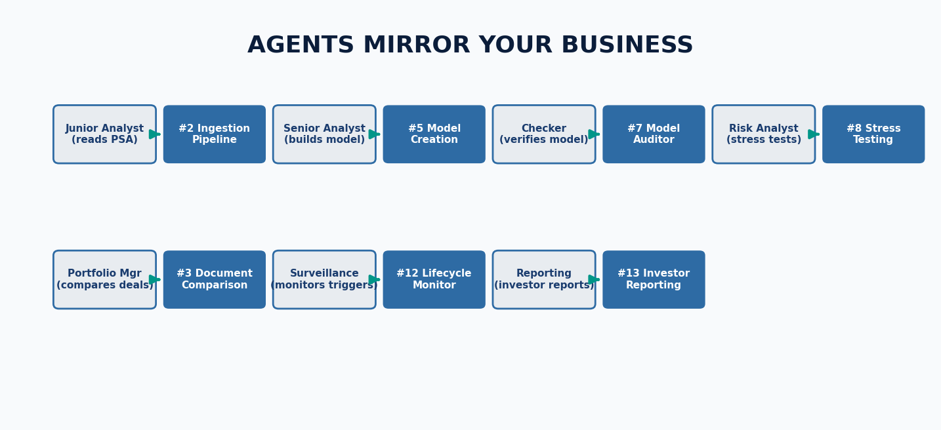

Cost Analysis
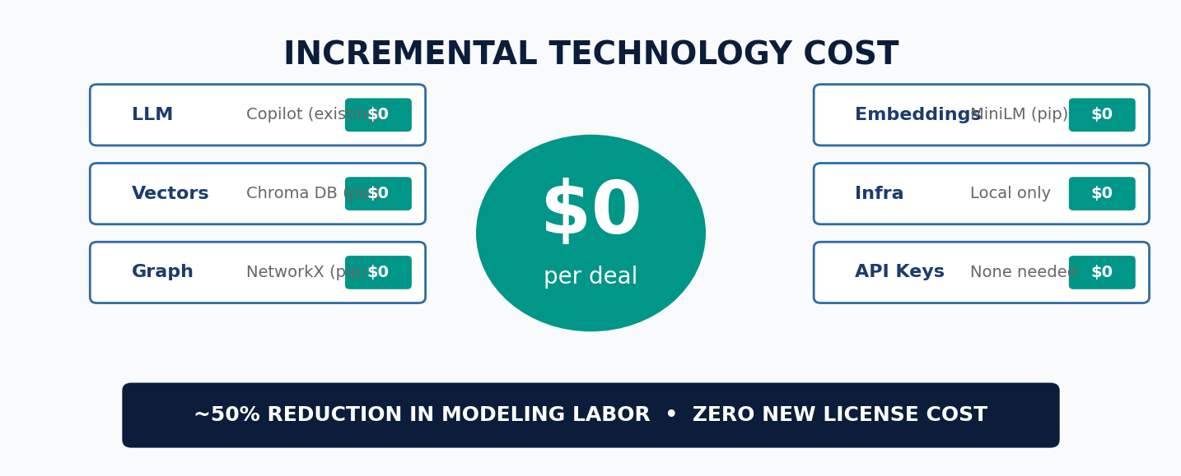

Category | Current | With ABS Waterfall AI | Impact
LLM / API | N/A | $0 (Copilot subscription) | No new cost
Infrastructure | N/A | $0 (all local, pip) | No new cost
Embeddings | N/A | $0 (open-source) | No new cost
Vector DB | N/A | $0 (Chroma DB) | No new cost
Graph DB | N/A | $0 (NetworkX) | No new cost
Analyst Time | 2 analysts × N days | 1 analyst + AI | ~50% reduction
Error Detection | Manual cross-check | Automated validation | Faster, fewer misses

Risk Mitigation
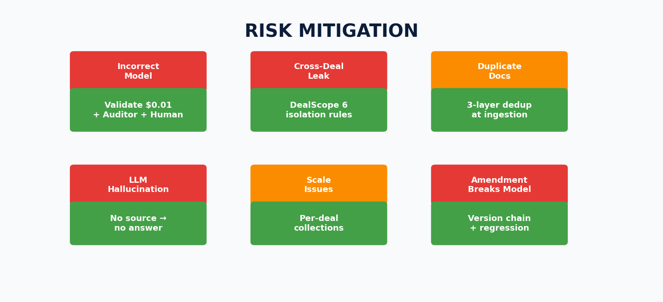

Roadmap to Value
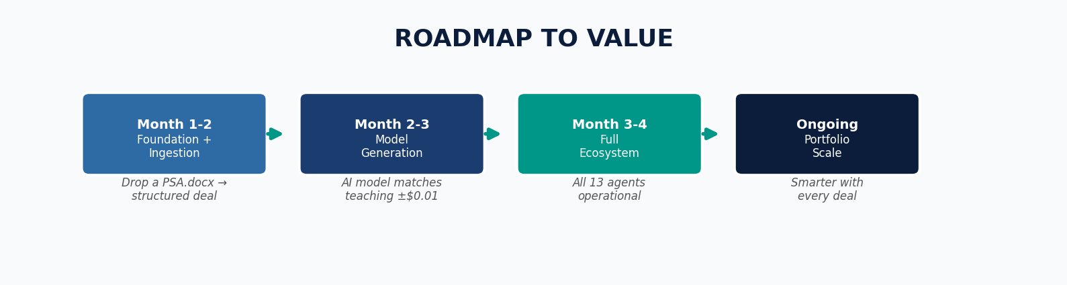

Phase | Timeline | Milestone | User Impact
Foundation | Month 1-2 | Ingestion pipeline operational | Drop a PSA.docx → fully structured deal
Generation | Month 2-3 | Model generation working | AI model matches teaching within $0.01
Full Ecosystem | Month 3-4 | All 13 agents live | Comparison, stress, Q&A, reporting all active
Scale | Ongoing | Portfolio intelligence grows | Every new deal makes the system smarter

Key Technology Decisions
Decision 1: Zero API Cost
All LLM tasks run through our existing GitHub Copilot subscription. Every model generation, Q&A query, and comparison costs $0 in API fees.

Decision 2: Local-Only Stack
Every component — Chroma DB, NetworkX, sentence-transformers — is pip-installable and runs locally—no cloud, no Docker, no external databases. Data never leaves the workstation.

Decision 3: Deal Isolation by Construction
With 10,000+ deals, cross-contamination is prevented structurally via the DealScope enforcer: separate vector collections, path enforcement, and LLM context boundaries.

Decision 4: Regex-First Splitting
Documents split using regex (handles 90%+ of formats for free) with Copilot Chat LLM fallback (also $0) for edge cases—speed + coverage.

Decision 5: Teaching Model Evolution
The first deal in a series gets a manual teaching model. Subsequent deals inherit from the validated predecessor — turning days of work into minutes.

ABS Waterfall AI
13 agents. Zero incremental cost.
Every formula is traced to its legal source.
Your operating model is automated.

