ABS WATERFALL AI
System Architecture

February 2026 • Confidential

1. System Overview
ABS Waterfall AI is a 13-agent ecosystem that transforms raw legal deal documents (Pooling & Servicing Agreements, Indentures, Prospectus Supplements) into validated Python payment models. The system ingests, structures, compares, generates, validates, and monitors Asset-Backed Securities deals across a portfolio of 10,000+ deals spanning 500+ issuers and 36 years (1990–2026).
Current state: Two humans independently build two Excel payment models, cross-check, and pay investors. Future state: One human builds an Excel model, the AI builds a Python model, and they cross-check — cutting modeling effort by 50% while adding programmatic auditability, stress testing, and portfolio-wide intelligence.

Technology Stack
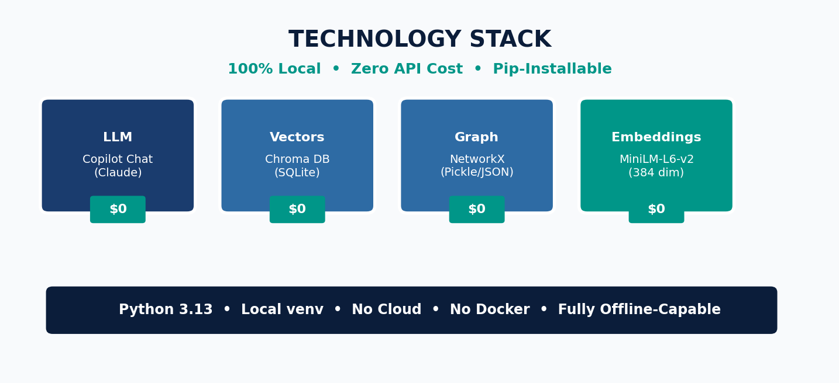

Design Principles
Deal-first mental model — Users think in deals, not pipelines. Every operation starts with a deal ID.
Deal isolation by construction — Every file path, vector query, and graph traversal is scoped to one deal via the DealScope enforcer.
Skills over monoliths — Pure-function skills are testable without LLM. Agents compose skills via a tool registry.
Parallel, not phased — All 13 agents share a common Foundation layer. Adding agent #13 is no harder than adding agent #2.
No source, no answer — Every generated value must cite its governing document section. Hallucination is structurally prevented.

2. Pipeline Architecture
The system operates as a two-phase pipeline: an Ingestion Pipeline (Stages 1–5) that transforms raw documents into structured knowledge, followed by a Generation Pipeline (Stages 6–9) that produces validated payment models.
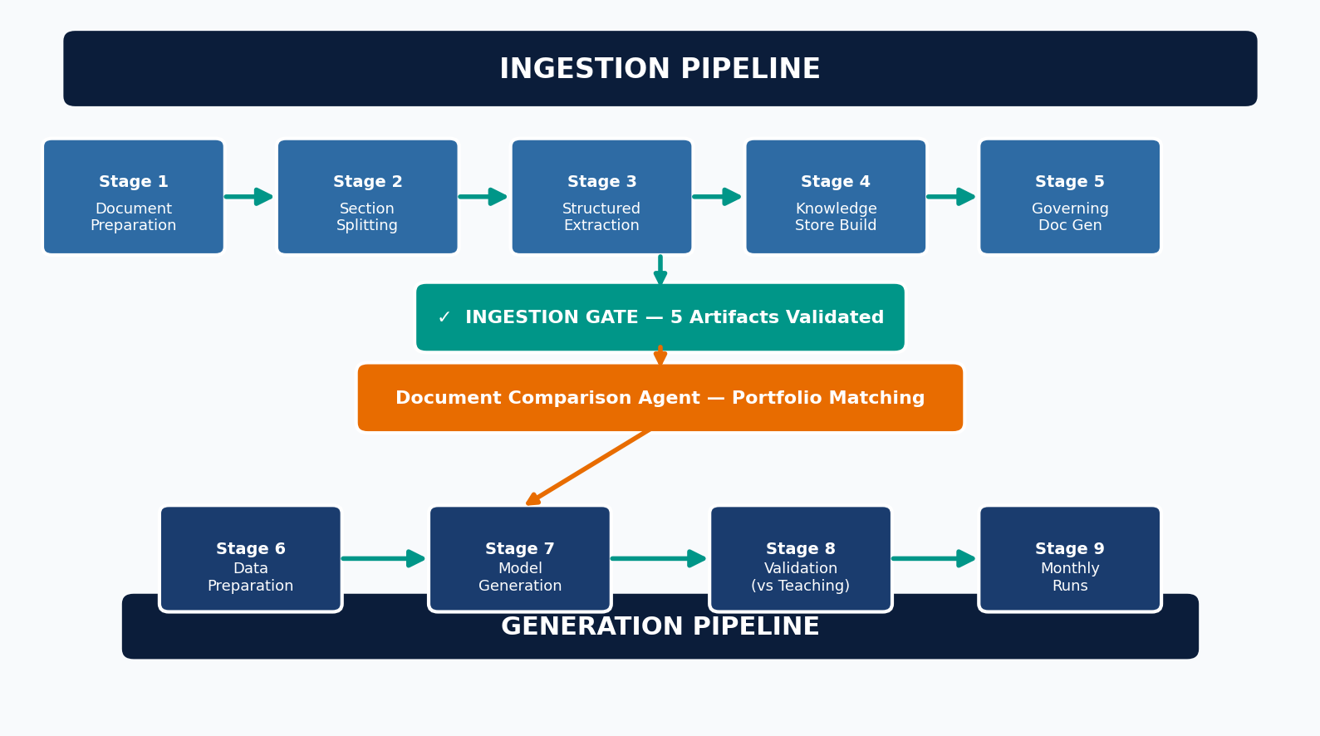

Stage Details
Stage | Input | Process | Output | LLM?
1. Doc Prep | PSA.docx / PDF | python-docx / pdfplumber extraction | full.md + full.txt + metadata.json | No
2. Section Split | full.md | Regex patterns + LLM fallback | Named section .md files | Fallback
3. Extraction | sections/*.md | 6 parsers (regex-based) | JSON extractions + CSVs | No
4. Knowledge Store | sections + JSONs | Chunk→embed→Chroma + NetworkX graph | chroma.sqlite3 + deal_graph.pickle | No
5. Governing Docs | sections + JSONs | Claude generates enhanced markdown | governing_docs/*.md | Yes
6. Data Prep | CSVs | Schema validation + auto-fill | Validated CSV files | No
7. Model Gen | Gov docs + CSVs | Claude generates payment_model.py | payment_model.py | Yes
8. Validation | Model + teaching | Run + compare per-class ($0.01) | VALIDATION_NOTES.md | No
9. Monthly Run | Model + inputs | Execute model, collect outputs | runs/month_N/output.csv | No

Ingestion Gate — Five Required Artifacts
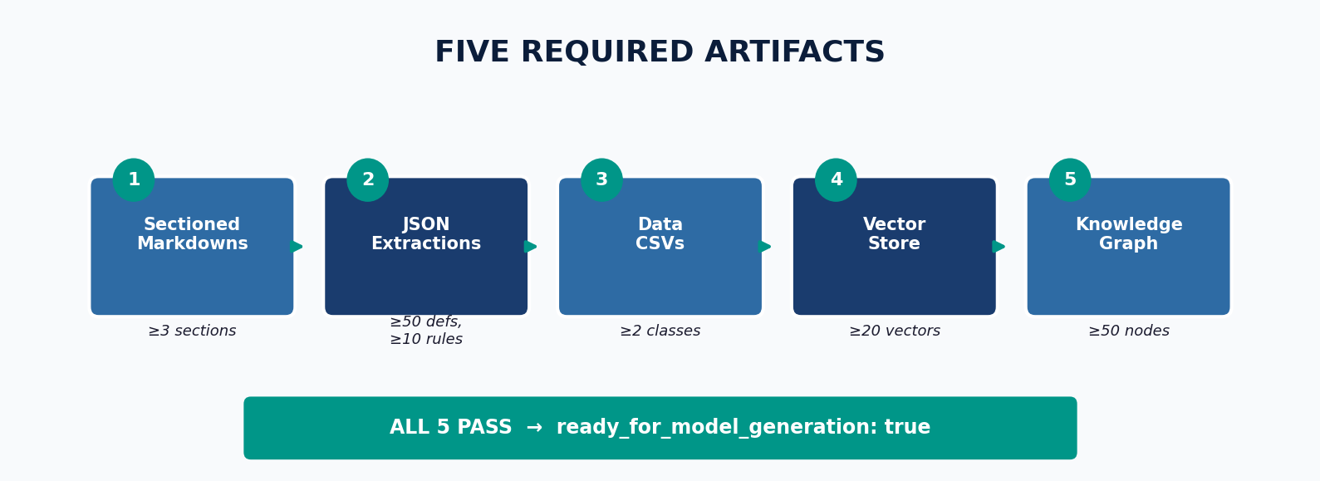

3. Agent Ecosystem
Each agent is a tool-using LLM with a system prompt that defines its role, a tool allowlist, and a DealScope injection that constrains all access. The 13 agents span six lifecycle phases.
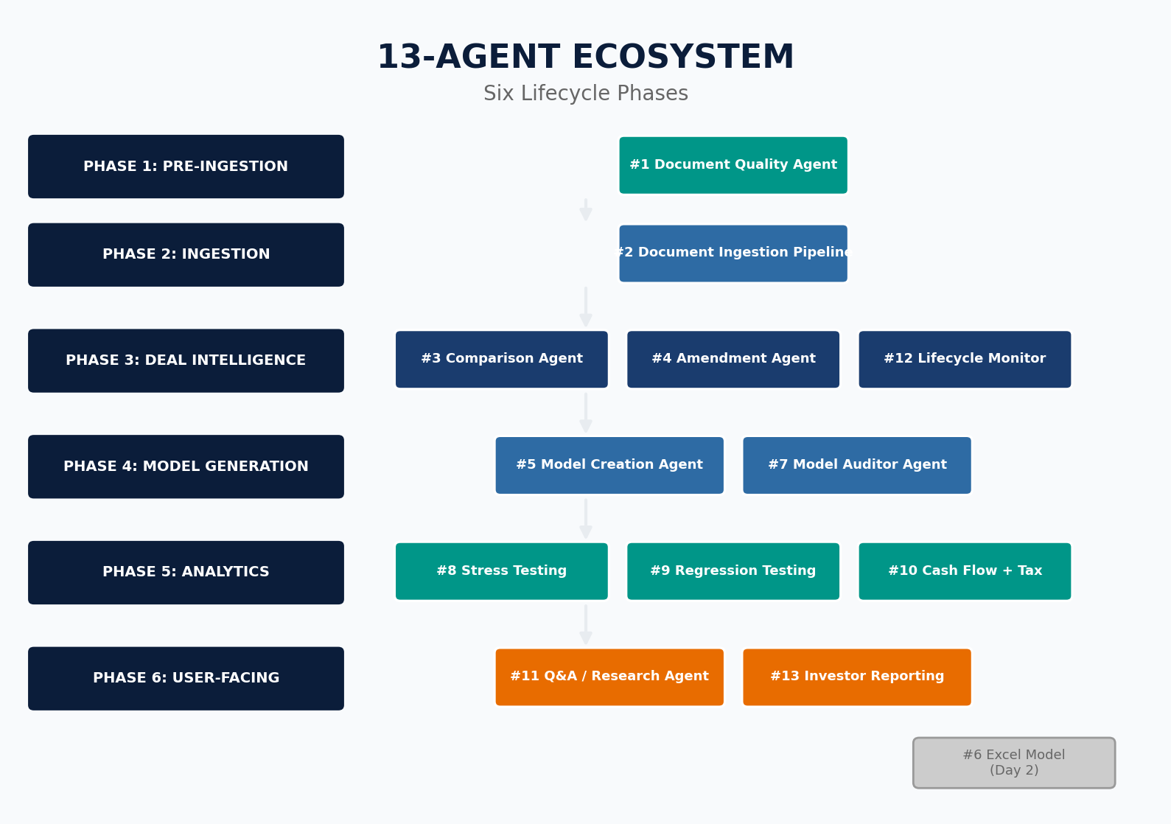

Agent Summary
# | Agent | Phase | Key Capability | Scope
1 | Document Quality | Pre-Ingestion | Type detection, duplicate prevention (3-layer) | Deal
2 | Ingestion Pipeline | Ingestion | Orchestrates Stages 1-5, produces 5 artifacts | Deal
3 | Document Comparison | Intelligence | Cross-portfolio matching, delta reports, and teaching model selection | Portfolio (R/O)
4 | Deal Amendment | Intelligence | Version chains, cascade detection, re-extraction | Deal
5 | Model Creation | Generation | Claude generates payment_model.py with citations | Deal
6 | Excel Model | Day 2 | openpyxl template generation (PARKED) | Deal
7 | Model Auditor | Generation | Independent formula/constant audit vs governing docs | Deal
8 | Stress Testing | Analytics | Govdoc-aware boundary scenarios, trigger analysis | Deal
9 | Regression Testing | Analytics | Baseline capture, drift detection after changes | Deal
10 | Cash Flow + Tax | Analytics | Multi-month projections, OID/8-K/10-K output | Deal
11 | Q&A / Research | User-Facing | RAG retrieval with citations, no-hallucination policy | Deal
12 | Lifecycle Monitor | Intelligence | Trigger tracking, stepdown alerts, maturity monitoring | Deal
13 | Investor Reporting | User-Facing | Payment model output reports (Excel/PDF) | Deal

4. Deal Isolation Architecture
With 10,000+ deals, cross-contamination is inevitable if not prevented by design. The DealScope enforcer applies six rules to every operation — file reads, vector queries, graph traversals, and LLM context.
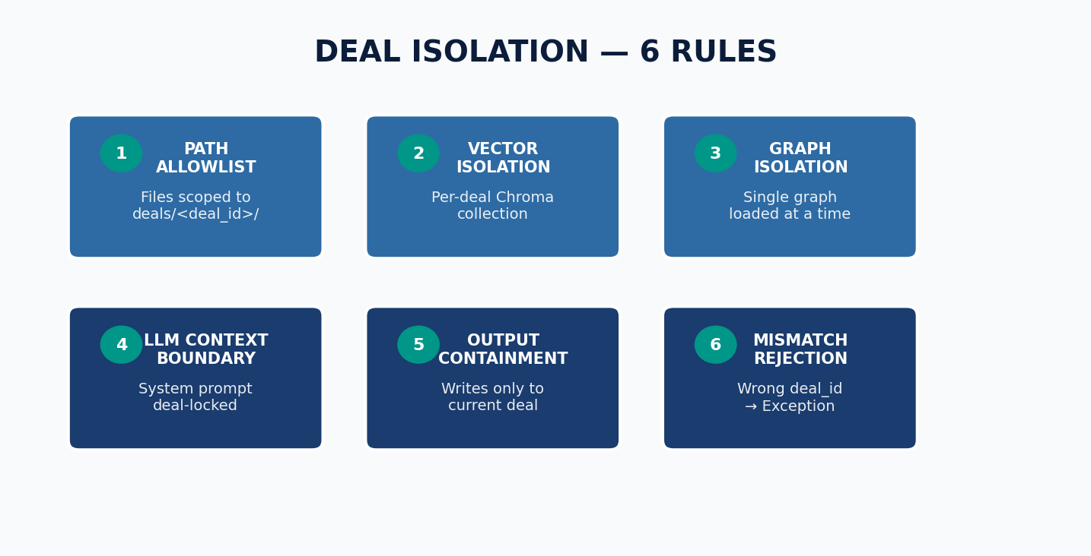

Exception: The Document Comparison Agent (#3) has read-only cross-deal access. It can read extractions and models from other deals, but cannot write to any deal folder other than the active one.

5. Skill Layer
Skills are pure Python functions that are testable without an LLM. They form the computational backbone that agents compose via the tool registry. 13 skills total — 2 reused as-is, 2 extended, 9 new.
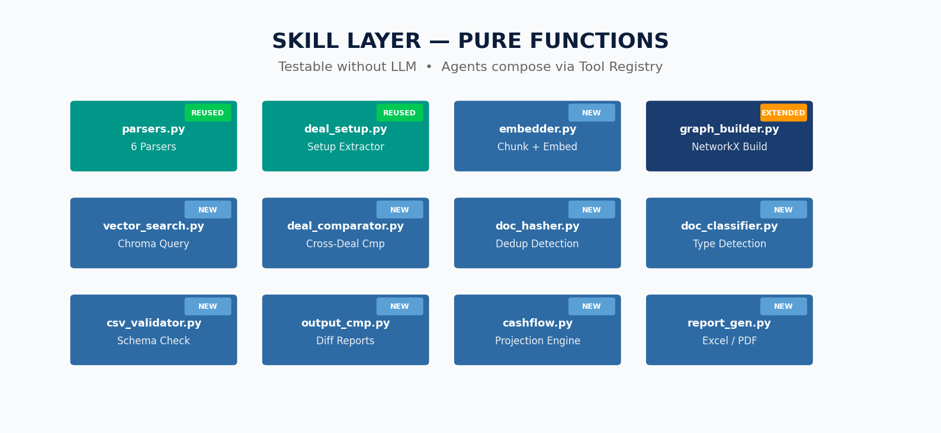

6. Data Architecture

Deal Folder Structure
Each deal is a self-contained folder under deals/<deal_id>/ with a standardized structure that supports multiple source documents, versioned amendments, and all pipeline artifacts.
Folder / File | Contents
deal_manifest.json | Deal metadata, payment source of truth, document registry
documents/<type>/ | Source documents: source.docx, full.md, metadata.json, sections/, extractions/
data/ | deal_setup.csv, classes_setup.csv, month_N/ (inputs + teaching output)
vectorstore/ | Combined Chroma DB from ALL documents (per-deal collection)
graph/ | Combined NetworkX graph from ALL documents (pickle + JSON)
governing_docs/ | Enhanced markdown generated from the payment source of truth ONLY
models/ | payment_model.py + VALIDATION_NOTES.md
runs/month_N/ | output.csv + run_metadata.json per month
comparison/ | closest_match, delta_report, language_flags, teaching_recommendation
amendments/ | v1_original/, v2_amended/, active/ (version chain)
ingestion_manifest.json | Artifact inventory + readiness status

Graph Schema
Node Type | Description | Key Attributes
Deal | One per deal | deal_id, name, issuer
Section | Document sections | section_type, source_document
Term | Defined terms | term, definition, value, category
Rule | Waterfall rules | rule_id, priority, rule_type, pays_to
Account | Named accounts | account_name, purpose, flow_rules
Class | Certificate classes | class_name, group, balance, margin
Trigger | Trigger events | trigger_name, condition, effect
Fee | Service fees | fee_name, rate, recipient

Embedding Strategy
Content | Chunking | Scope
Section markdowns | ~1000 chars at sentence boundaries | All documents
Definition entries | Term name + definition text | All documents
Waterfall rules | Rule text + priority + dependencies | All documents
Raw CSVs | NOT embedded (structured data) | N/A

7. Testing Strategy
Layer | Scope | Approach
Unit | Skills (parsers, embedders, comparators) | Known input → expected output. HE2 fixture.
Integration | Pipeline stages (converter → splitter → extractor → store → gen) | Stage N output feeds Stage N+1. Assert artifact quality.
Agent | Each of 13 agents | Agent makes correct tool calls, produces correct outputs, and respects deal scope.
End-to-End | Full pipeline + cross-deal isolation | HE2 DOCX → validated model within $0.01. No leakage.

Exit Criteria (15 Gates)
# | Criterion
1 | HE2 ingests end-to-end from DOCX
2 | Duplicate document rejected on re-ingestion
3 | Document type correctly detected for PSA
4 | Payment model generates within $0.01 of teaching
5 | Model auditor validates all formulas cite sources
6 | Q&A answers 10 test questions with citations
7 | Cross-deal isolation holds (HE1 + HE2)
8 | Comparison agent finds HE1 as closest to HE2
9 | Amendment creates a version chain without corruption
10 | Cash flow projection runs 12 months
11 | Stress test triggers at expected thresholds
12 | Regression detects model drift
13 | Investor report generated in Excel
14 | Lifecycle monitor alerts on trigger breach
15 | CLI --help works for all subcommands

