Akal college of Engineering and technology

Major project Report

Accident information system with gps and gsm



|  |  |
| --- | --- |
| Submitted By:  Karmveer kaur  BS18BTET003 | Submitted to:  Er. Abhilasha sharma  Assistant Professor |

**Contents**

Introduction

Design principle

Circuit description

1. Power supply
2. Piezo sensor
3. Alcohol sensor
4. Arduino (Atmega328p microcontroller)
5. Bluetooth module (hc-05)
6. GPS module
7. Motor driver
8. Buzzer driver

Conclusion

**Introduction**

The Rapid growth of technology and infrastructure has made our lives easier. The advent of technology has also increased the traffic hazards and the road accidents take place frequently which causes huge loss of life and property because of the poor emergency facilities. Our project will provide an optimum solution to this draw back. According to this project when a vehicle meets with an accident, immediately Vibration sensor will detect the signal and sends it to the controller. Microcontroller sends the alert message through the Bluetooth module including the location to police control room or a rescue team. So the police can immediately trace the location through the GPS MODEM, after receiving the information. Then after conforming the location necessary action will be taken. If the person meets with a small accident or if there is no serious threat to anyone`s life, then the alert message can be terminated by the driver by a switch provided in order to avoid wasting the valuable time of the medical rescue team.

GSM is used as a media which is used to control and monitor the Vehicle load from anywhere by sending a message. It has its own deterministic character. Thereby, here GSM is used to monitor and control the DC motor, Stepper motor, Temperature sensor and Solid State Relay by sending a message through GSM modem. Hence no need to waste time by manual operation and transportation. Hence it is considered as highly efficient communication through the mobile which will be useful in industrial controls, automobiles, and appliances which would be controlled from anywhere else. It is also highly economic and less expensive; hence GSM is preferred most for this mode of controlling.

Drunk driving is one of the major reasons behind road accidents worldwide. In all of the road accident cases worldwide drivers have been observed to have excess alcohol content in their blood. So we here design a smart alcohol detector and accident information system using arduino coupled with gsm and gps for location transmission. The system allows for automatic sensing of alcohol in breathes, we also use a motor to demonstrate as a vehicle. We further use a GPS module with GSM to send an SMS message to the concerned person in case alcohol is detected or accident detected and stop the vehicle motor.

**Working**

In this project, Arduino is used for controlling whole the process with a GPS Receiver and GSM module (here we used hc-05 module). GPS Receiver is used for detecting coordinates of the vehicle, GSM module is used for sending the alert SMS with the coordinates and the link to Google Map. And an optional 16x2 LCD is also used for displaying status messages or coordinates. We have used GPS Module and Bluetooth hc-05 module. A motor is connected to arduino through a motor driver. An alcohol and Piezo sensor is used to detect both alcohol presence and accident. When we are ready with our hardware after programming, we can install it in our vehicle and power it up. Now whenever there is an accident, the car gets vibrated and sends a value to the controller. These values read by Arduino and if any change occurs then Arduino reads coordinates by extracting $GPGGA String from GPS module data (GPS working explained above) and send SMS to the predefined number to the police or ambulance or family member with the location coordinates of accident place. The message contains a Latitude and longitude value. If we put that value on Google map, that location can be easily tracked. Same happens when it detected alcohol by the alcohol sensor.

**Block diagram**

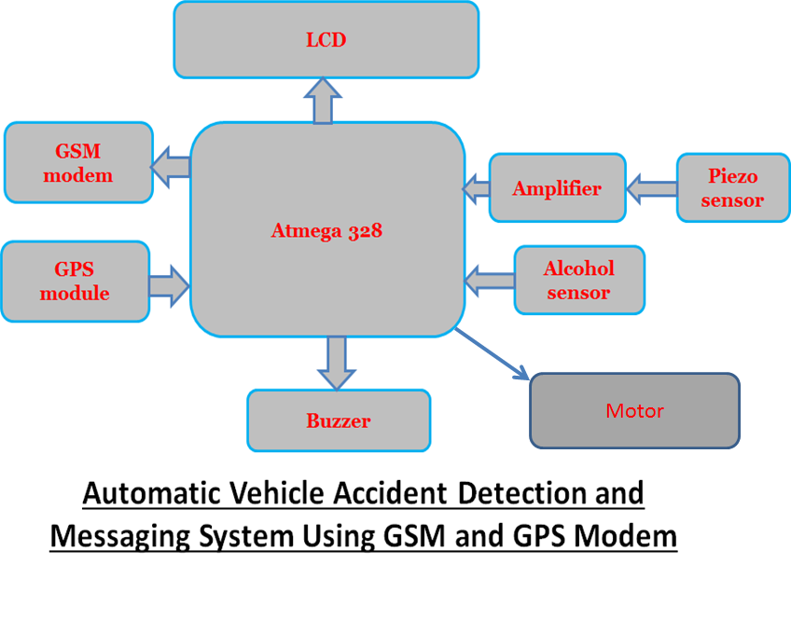

**Circuit description**

**Power supply**

In this project the power supply required is very much precession and also requires different level of power supply. Basically the power supply used for the transmitter and receiver is arranged from a battery. Along with the battery the power supply requirement are +12Volt and +5Volt

**Description**

The power supply designed for catering a fixed demand connected in this project. The basic requirement for designing a power supply is as follows,

1. The different voltage levels required for operating the devices. Here +5Volt required for operating microcontroller. And +12Volt required for drivers etc.
2. The current requirement of each device or load must be added to estimate the final capacity of the power supply.

The power supply always specified with one or multiple voltage outputs along with a current capacity. As it is estimate the requirement of power is approximately as follows,

Out Put Voltage = +5Volt, +12Volt

Capacity = 1000mA

The power supply is basically consisting of three sections as follows,

1. Step down section
2. Rectifier Section
3. Regulator section

**Design principle:**

There are two methods for designing power supply, the average value method and peak value method. In case of small power supply peak value method is quit economical, for a particular value of DC output the in put AC requirement is appreciably less. In this method the Dc out put is approximately equal to Vm. The rectifier output is approximately charged to Vcc due to charging of the capacitor. The capacitance provides the backup during the discharge period. So, the value of the capacitor is calculated

**Circuit connection: -** In this we are using Transformer (0-12) vac, 1Amp, IC 7805 & 7812, diodes IN 4007,LED & resistors.

Here 230V, 50 Hz ac signal is given as input to the primary of the transformer and the secondary of the transformer is given to the bridge rectification diode. The o/p of the diode is given as i/p to the IC regulator (7805 &7812) through capacitor (1000mf/35v). The o/p of the IC regulator is given to the LED through resistors.

**Circuit Explanations: -** When ac signal is given to the primary of the transformer, due to the magnetic effect of the coil magnetic flux is induced in the coil(primary) and transfer to the secondary coil of the transformer due to the transformer action.” Transformer is an electromechanical static device which transformer electrical energy from one coil to another without changing its frequency”. Here the diodes are connected in a bridge fashion. The secondary coil of the transformer is given to the bridge circuit for rectification purposes.

During the +ve cycle of the ac signal the diodes D2 & D4 conduct due to the forward bias of the diodes and diodes D1 & D3 does not conduct due to the reversed bias of the diodes. Similarly during the –ve cycle of the ac signal the diodes D1 & D3 conduct due to the forward bias of the diodes and the diodes D2 & D4 does not conduct due to reversed bias of the diodes. The output of the bridge rectifier is not a power dc along with rippled ac is also present. To overcome this effect, a capacitor is connected to the o/p of the diodes (D2 & D3). Which removes the unwanted ac signal and thus a pure dc is obtained. Here we need a fixed voltage, that’s for we are using IC regulators (7805 & 7812).”Voltage regulation is a circuit that supplies a constant voltage regardless of changes in load current.” This IC’s are designed as fixed voltage regulators and with adequate heat sinking can deliver output current in excess of 1A. The o/p of the bridge rectifier is given as input to the IC regulator through capacitor with respect to GND and thus a fixed o/p is obtained. The o/p of the IC regulator (7805 & 7812) is given to the LED for indication purpose through resistor. Due to the forward bias of the LED, the LED glows ON state, and the o/p are obtained from the pin no-3.



**0-12 V**

**Piezo-sensor and inverting amplifier**

We have taken a vibration sensor which is nothing but a **piezoelectric sensor** which detects the vibration occurs due to accident. **PIEZOELECTRIC SENSOR** is nothing but a transducer which converts mechanical vibration or mechanical stress into an electrical signal and that signal is very weak, for that we need an amplifier to amplify the weak signal. That weak signal is given as input to the **2-stage inverting** amplifier in which it amplifies the weak signal.

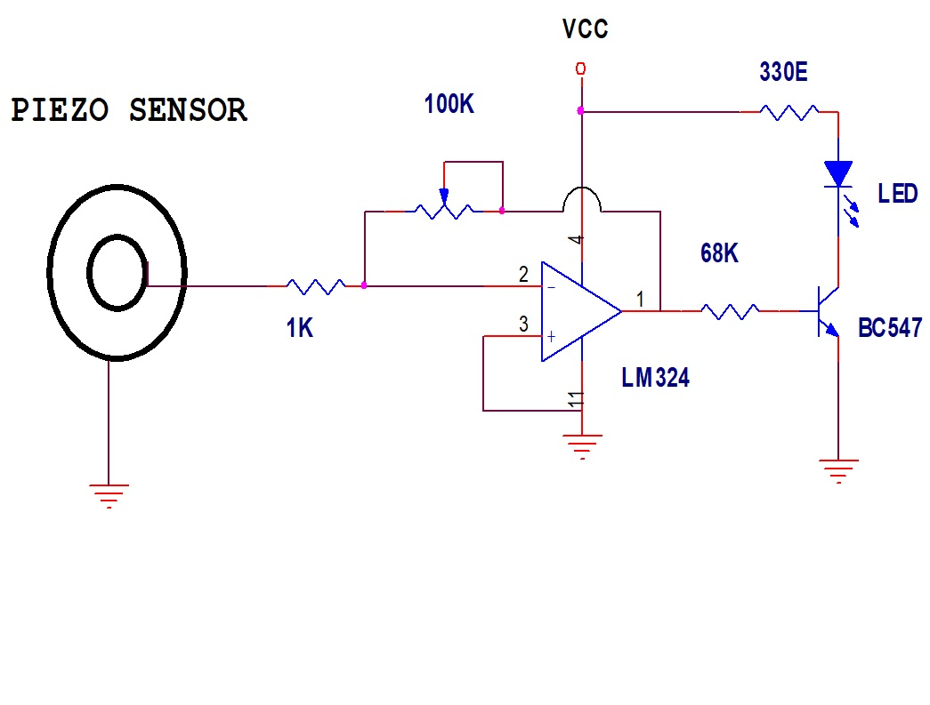

**NOT GATE**

**INTRODUCTION:**

The application of the transistors is not limited solely to the amplification of the signals. Through proper design transistors can be used as switches for computers and control applications.

The network of figure-01 (a) can be employed as an inverter in computer logic circuitry. Note that the output voltage Vc is opposite to the applied to the base or input terminal. In addition note the absence of dc supply connected to the base circuit. The only dc source is connected to the collector or output side, and for computer applications is typically equal to the magnitude of the “high” side of the applied signal – in this case 5V.

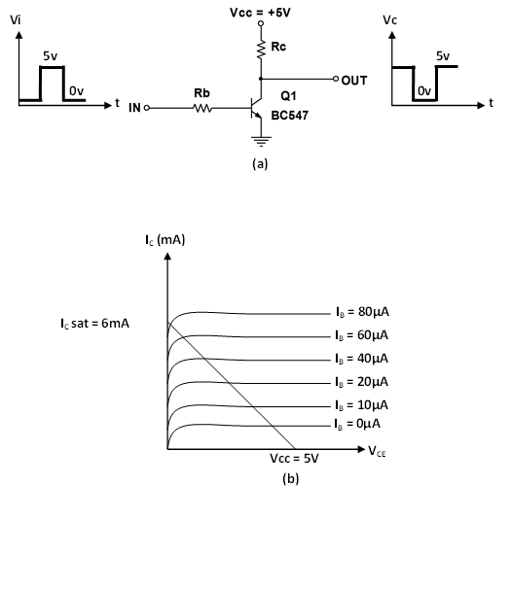

**OPERATION:**

Proper design for the inversion process requires that the operating points switch from cut-off to saturation along the load line depicted in above figure (b). For our proposes we will assume that IC = ICEO = 0mA, when IB = 0µA (an excellent approximation in light of improving construction techniques), as shown in above figure (b). In addition, we will assume that VCE = VCE sat = 0V.

When Vi = 5v, the transistor will be “ON” and design must insured that the network is heavily saturated by a level of IB greater than that associated if the IB curve appearing near the saturation level. In the above figure (b), this requires that IB > 50µA.

The saturation level for the collector current for the circuit is defined by,

IC = VCC - VCE / RC

= 5V – 0.2V / 10K

= 480µA

The level of IB in the active region just before saturation results can be approximated by the following equation,

IB min ≈ IC sat / βdc

=480µA / 300

=1.6µA

For the saturation level we must therefore insure that the following condition is satisfied:

IB max > IC sat / βdc

For the network of the above figure (b), when Vi = 5v the resulting level of IB is

Assume

IB = 100µA

5v - RB IB – 0.7v = 0

RB (max) = 4.3 / 100µA = 43kΩ

RB (min) = 4.3 / IB(max) = 1kΩ

Certainly any level of IB greater than 16µA will pass through a Q- point on the load line that is very close to the vertical axis.

**Alcohol sensor**

MQ-3 gas sensor has high sensitivity to Alcohol, and has good resistance to disturb of gasoline, smoke and vapors. The sensor could be used to detect alcohol with different concentration; it is with low cost and suitable for different application. Also it has Long life and low cost and simple drive circuit.

Working

**In this section the ALCOHOL sensor is used as one of the element of the voltage divider network. The voltage across the sensor varies as the as its resistance of the LPG sensor increases with increase of GAS intensity. The output of the voltage divider network is feed to a comparator designed using Op-Amp. The comparator input from the voltage divider network is compared with a reference voltage correspond to the voltage of set GAS intensity and gives a logic output. The output of the comparator is connected to a microcontroller to alert the driver.** We have connected a led indicator ckt at the o/p of the comparator to indicate the high low condition of comparator.

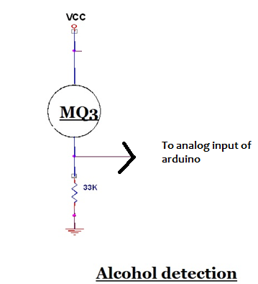

**Arduino UNO (Atmega328)**

The Arduino UNO is an open-source microcontroller board based on the Microchip ATmega328P microcontroller and developed by Arduino.cc.The board is equipped with sets of digital and analog input/output (I/O) pins that may be interfaced to various expansion boards (shields) and other circuits. The board has 14 Digital pins, 6 Analog pins, and programmable with the Arduino IDE (Integrated Development Environment) via a type B USB cable. It can be powered by a USB cable or by an external 9 volt battery, though it accepts voltages between 7 and 20 volts. It is also similar to the Arduino Nano and Leonardo. Hardware reference design is distributed under a Creative Commons Attribution Share-Alike 2.5 license and is available on the Arduino website. Layout and production files for some versions of the hardware are also available. "Uno" means one in Italian and was chosen to mark the release of Arduino Software (IDE) 1.0. The Uno board and version 1.0 of Arduino Software (IDE) were the reference versions of Arduino, now evolved to newer releases. The Uno board is the first in a series of USB Arduino boards, and the reference model for the Arduino platform. The ATmega328 on the Arduino Uno comes preprogrammed with a boot loader that allows uploading new code to it without the use of an external hardware programmer. It communicates using the original STK500 protocol. The Uno also differs from all preceding boards in that it does not use the FTDI USB-to-serial driver chip. Instead, it uses the Atmega16U2 (Atmega8U2 up to version R2) programmed as a USB-to-serial converter.

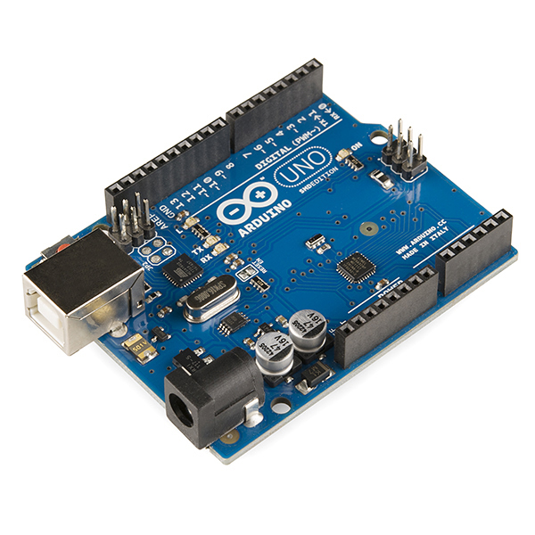

**Background**

The Arduino project started at the Interaction Design Institute Ivrea (IDII) in Ivrea, Italy. At that time, the students used a BASIC Stamp microcontroller at a cost of $100, a considerable expense for many students. In 2003 Hernando Barragán created the development platform Wiring as a Master's thesis project at IDII, under the supervision of Massimo Banzi and Casey Reas, who are known for work on the Processing language. The project goal was to create simple, low-cost tools for creating digital projects by non-engineers. The Wiring platform consisted of a printed circuit board (PCB) with an ATmega168 microcontroller, an IDE based on Processing and library functions to easily program the microcontroller. In 2003, Massimo Banzi, with David Mellis, another IDII student, and David Cuartielles, added support for the cheaper ATmega8 microcontroller to Wiring. But instead of continuing the work on Wiring, they forked the project and renamed it Arduino. Early arduino boards used the FTDI USB-to-serial driver chip and an ATmega168. The Uno differed from all preceding boards by featuring the ATmega328P microcontroller and an ATmega16U2 (Atmega8U2 up to version R2) programmed as a USB-to-serial converter.

**Technical specifications**

Microcontroller : Microchip ATmega328P

Operating Voltage: 5 Volt

Input Voltage: 7 to 20 Volts

Digital I/O Pins: 14 (of which 6 provide PWM output)

Analog Input Pins: 6

DC Current per I/O Pin: 20 mA

DC Current for 3.3V Pin: 50 mA

Flash Memory: 32 KB of which 0.5 KB used by bootloader

SRAM: 2 KB

EEPROM: 1 KB

Clock Speed: 16 MHz

Length: 68.6 mm

Width: 53.4 mm

Weight: 25 g

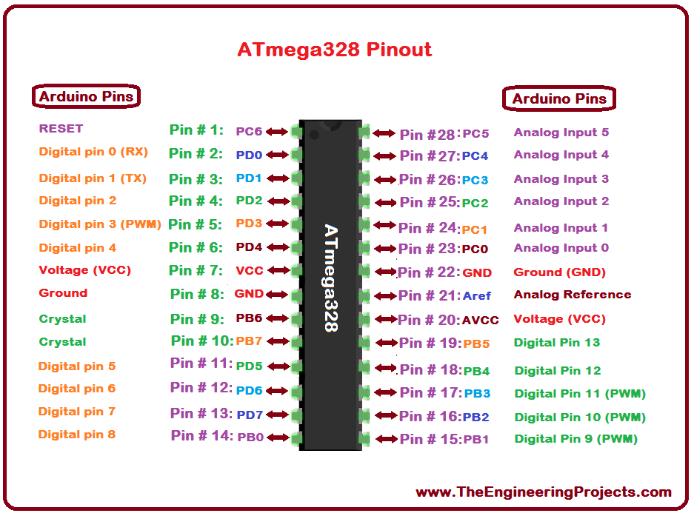

**General Pin functions**

**LED**: There is a built-in LED driven by digital pin 13. When the pin is HIGH value, the LED is on, when the pin is LOW, it's off.

**VIN**: The input voltage to the Arduino/Genuino board when it's using an external power source (as opposed to 5 volts from the USB connection or other regulated power source). You can supply voltage through this pin, or, if supplying voltage via the power jack, access it through this pin.

**5V**: This pin outputs a regulated 5V from the regulator on the board. The board can be supplied with power either from the DC power jack (7 - 20V), the USB connector (5V), or the VIN pin of the board (7-20V). Supplying voltage via the 5V or 3.3V pins bypasses the regulator, and can damage the board.

**3V3**: A 3.3 volt supply generated by the on-board regulator. Maximum current draw is 50 mA.

**GND**: Ground pins.

**IOREF**: This pin on the Arduino/Genuino board provides the voltage reference with which the microcontroller operates. A properly configured shield can read the IOREF pin voltage and select the appropriate power source or enable voltage translators on the outputs to work with the 5V or 3.3V.

**Reset**: Typically used to add a reset button to shields which block the one on the board.

**Special Pin Functions**

Each of the 14 digital pins and 6 Analog pins on the Uno can be used as an input or output, using pin Mode(),digital Write(), and digital Read () functions. They operate at 5 volts. Each pin can provide or receive 20 mA as recommended operating condition and has an internal pull-up resistor (disconnected by default) of 20-50k ohm. A maximum of 40mA is the value that must not be exceeded on any I/O pin to avoid permanent damage to the microcontroller. The Uno has 6 analog inputs, labeled A0 through A5, each of which provide 10 bits of resolution (i.e. 1024 different values). By default they measure from ground to 5 volts, though is it possible to change the upper end of their range using the AREF pin and the analog Reference() function.

In addition, some pins have specialized functions:

**Serial**: pins 0 (RX) and 1 (TX). Used to receive (RX) and transmit (TX) TTL serial data. These pins are connected to the corresponding pins of the ATmega8U2 USB-to-TTL Serial chip.

**External Interrupts**: pins 2 and 3. These pins can be configured to trigger an interrupt on a low value, a rising or falling edge, or a change in value.

**PWM**(**P**ulse **W**idth **M**odulation) 3, 5, 6, 9, 10, and 11 Can provide 8-bit PWM output with the analog Write() function.

**SPI**(**S**erial **P**eripheral **I**nterface): 10 (SS), 11 (MOSI), 12 (MISO), 13 (SCK). These pins support SPI communication using the SPI library.

**TWI**(**T**wo **W**ire **I**nterface): A4 or SDA pin and A5 or SCL pin. Support TWI communication using the Wire library.

**AREF**(**A**nalog **Reference**): Reference voltage for the analog inputs.

The Arduino/Genuino Uno has a number of facilities for communicating with a computer, another Arduino/Genuino board, or other microcontrollers. The ATmega328 provides UART TTL (5V) serial communication, which is available on digital pins 0 (RX) and 1 (TX). An ATmega16U2 on the board channels this serial communication over USB and appears as a virtual com port to software on the computer. The 16U2 firmware uses the standard USB COM drivers, and no external driver is needed. However, on Windows, a .inf file is required. The Arduino Software (IDE) includes a serial monitor which allows simple textual data to be sent to and from the board. The RX and TX LEDs on the board will flash when data is being transmitted via the USB-to-serial chip and USB connection to the computer (but not for serial communication on pins 0 and 1). A SoftwareSerial library allows serial communication on any of the Uno's digital pins.

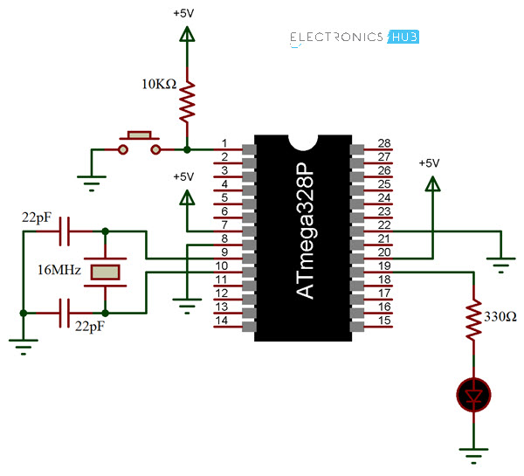

**Automatic (Software) Reset**

Rather than requiring a physical press of the reset button before an upload, the Arduino/Genuino Uno board is designed in a way that allows it to be reset by software running on a connected computer. One of the hardware flow control lines (DTR) of the ATmega8U2/16U2 is connected to the reset line of the ATmega328 via a 100 nanofarad capacitor. When this line is asserted (taken low), the reset line drops long enough to reset the chip.

This setup has other implications. When the Uno is connected to either a computer running Mac OS X or Linux, it resets each time a connection is made to it from software (via USB). For the following half-second or so, the bootloader is running on the Uno. While it is programmed to ignore malformed data (i.e. anything besides an upload of new code), it will intercept the first few bytes of data sent to the board after a connection is opened.

**LCD INTERFACE**

LCD panel consists of two patterned glass panels in which crystal is filled under vacuum. The thickness of glass varies according to end use. Most of the LCD modules have glass thickness in the range of 0.70 to 1.1mm

Normally these liquid crystal molecules are placed between glass plates to form a spiral staircase to twist the twist the light. Light entering the top plate twist 900 before entering the bottom plate. Hence the LCDs are also called as optical switches. These LCD cannot display any information directly. These act as an interface between electronics and electronics circuit to give a visual output.

Technology: - The liquid crystal display (LCD), as the name suggests is a technology based on the use of liquid crystal. It is a transparent material but after applying voltage it becomes opaque. This property is the fundamental operating principle of LCDs.

An LCD consists of two-glass panel with a cavity in between. The panels are sealed together. The inner surface of glass is coated with transparent material to form characters or symbols for display. The most common type of liquid crystal used is ‘nematis’. In this type of crystal the long rod type molecules are arranged in parallel. It changes the optical characteristics with change in direction by applying voltage to it.

There are two common type of LCDs which use this material. They are :

1. TN (Twisted nematic):-The twisted nematic field effect mode arranges the liquid crystal molecules by controlling their movement Witt electric voltage soaks twist them by 900 in the direction for their thickness. It controls the light passing through the polarized placed on the two plates of the LCD by controlling the movements of the liquid crystal molecules. Almost all the medium and small type segment LCD are these types. Hence this type is most common type used.

2. STN (Super twisted nematic) While the TN mode arranges the liquid crystal molecule by twisting them by 900 the STN effect mode arranges them by giving a still larger twist and provides a display by refringence effect of the liquid crystal. The LCD structure in STN mode is same as that in TN mode. But as it has a different arrangement of liquid crystal, and by bi-refringence effect of liquid crystal. The LCD structure in STN mode is same as that in TN mode but as it has a different arrangement of liquid crystal and bi-refringence effect there is a colour in display and also a background colour. In STN mode, a wide viewing angle is obtained. The STN mode also offers a high contrast display compare to the TN mode. This mode is widely used in large size full dot-matrix LCD modules. For colours it has multiple modes depending on the combination of the polarized and retardation film.

Energy consumption: - LCD normally requires very little energy to operate typically 5A to 25A at five volts (per square inch) for a display. In addition, auxiliary lighting will require supplementary energy. ALL LCD require a pure AC drive voltage. Inadvertent DC voltage, such as DC component in an AC signal, can significantly reduce the life of LCDs and must be limited to 50mv DC.

Direct drive: - Direct drive, static or simplex drive, means that each segment of the LCD has an independent connection to the driver. Direct drive LCD has the highest contrast over the widest temperature ranges. They are widely used in outdoor application. Direct drives typically requires drive frequency between 30HZ and 60HZ frequency. Frequency below 30HZ will flicker the display. While frequency above 60HZ will excessive current draw in the circuit. This is very important for battery mode operation. If voltage frequency across the limit then LCD ’Off’ segments can be come in adherently energized. This partial activation of segment is known as cross talk or ghosting.

LCD is available in a verity of model having one to four rows of 8 to 20 characters each. A display with two rows of 16 characters is used for this example project. Almost all aspects of the design can be used with other model of LCD, since the internal structure of the various LCD models are almost same, differencing only in the number of driver chips used. The display module is powered from a 5 V supply.

Connecting an LCD to a micro controller is very simple, requiring either bit or an 8-bit bus. A 4-bit interface saves I/O pins but requires that the command and data be split into 4-bit pieces, which are sent one after the other. Thus the saving in I/O lines comes at the price of more complicated software. To simplify understanding of the software the example uses a 8-bit interface. Three control lines are required in addition to the data line.

The voltage at the V0 pin adjusts the contrast of the display. Normally this voltage is provided by an adjustable voltage divider. The control line E (Enable) enables or disables the display. When the display is enabling it monitors the value of the other two control lines and interprets the data lines accordingly. When the display is disabled it ignores the status of the other two control lines and places its data line drivers in a high impedance state (tri-state). The data bus can then be used for other purpose. The control line R/W (Read /Write) determines weather data is read from or written to the LCD. Finally, the RS (Register select) line distinguishes between commands and display characters.

**LCD Controller device characteristics**

The HD44780 contains 80 bytes of internal RAM called Data display RAM (DDR) that is used for presentation of characters in the LCD. The size of the DDR is independent of the LCD configuration (number of rows and character). For an LCD having two rows of characters, the leftmost character in the first row is assigned to address 0 of the DDR. Each following character position in the first display row is assigned to the next following address in turn until the 40th character location reached, which is assigned to DDR address 27 hex. The character locations in the second row of the display are assigned to DDR address 40 hex through 67 hex. If for example a character is to be written to the third position from the left in the second row of the display, it must be written to DDR, so that for example with a display, it must be written to DDR location 42hex.If the LCD module displays fewer than 40 characters per row, then these are mapped into a ‘window’ within the DDR, so that for example with a display of 16 characters per line only 16 of the 40 available DDR locations per line can be displayed at one time. The HD44780 supports commands to move this window to the left or to the right to allow various regions of the DDR to be displayed.

In additions to the DDR the HD44780 has a character genator ROM (CGROM) and a character-generator RAM (CGRAM).The CG ROM contains the dot-matrix patterns for the standard(fixed)character set,whilethe CGRAM allows the user to program additional character. Either eight4 X 7-point or four 5 X 10-point characters may be stored on the CGRAM.

**THE PRINCIPLES OF LCD TECHNOLOGY**

In this section, we will explain everything ranging from the properties of liquid crystal molecules to the basic principle of display technology by using TN type liquid crystals as an example.

The parallel arrangement of liquid crystal molecules along grooves

When coming into contact with grooved surface in a fixed direction, liquid crystal molecules line up parallelly along the grooves.

Natural state

When liquid crystals are sandwiched between upper and lower plates, they line-up with grooves pointing in directions 'a' and 'b,' respectively

The molecules along the upper plate point in direction 'a' and those along the lower plate in direction 'b,' thus forcing the liquid crystals into a twisted structural arrangement./ (figure shows a 90-degree twist) (TN type liquid crystal)

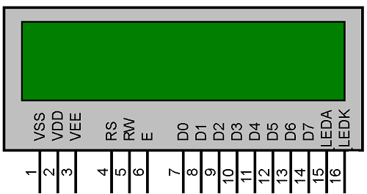

Light travels through the spacing of the molecular arrangement

The light also "twists" as it passes through the twisted liquid crystals

Light passes through liquid crystals, following the direction in which the molecules are arranged. When the molecule arrangement is twisted 90 degrees as shown in the figure, the light also twists 90 degrees as it passes through the liquid crystals. Light bends 90 degrees as it follows the twist of the molecules

Molecules rearrange themselves when voltage is applied

When voltage is applied to the liquid crystal structure, the twisted light passes straight through.

The molecules in liquid crystals are easily rearranged by applying voltage or another external force. When voltage is applied, molecules rearrange themselves vertically (along with the electric field) and light passes straight through along the arrangement of molecules.

Blocking light with two polarizing filters

When voltage is applied to a combination of two polarizing filters and twisted liquid crystal, it becomes a LCD display. Light passes when two polarizing filters are arranged with polarizing axes as shown above, left. Light is blocked when two polarizing filters are arranged with polarizing axes as shown above, right.

TN type LCDs

A combination of polarizing filters and twisted liquid crystal creates a liquid crystal display. When two polarizing filters are arranged along perpendicular polarizing axes, light entering from above is re-directed 90 degrees along the helix arrangement of the liquid crystal molecules so that it passes through the lower When voltage is applied, the liquid crystal molecules straighten out of their helix pattern and stop redirecting the angle of the light, thereby preventing light from passing through the lower filter. This figure depicts the principle behind typical twisted nematic (TN) liquid crystal displays. In a TN type LCD, liquid crystals in which the molecules form a 90-degree twisted helix, are sandwiched between two polarizing filters. When no voltage is applied, light passes; when voltage is applied, light is blocked and the screen appears black.

**HC-05 Bluetooth module**

HC-05 module is an easy to use Bluetooth SPP (Serial Port Protocol) module, designed for transparent wireless serial connection setup. Serial port Bluetooth module is fully qualified Bluetooth V2.0+EDR (Enhanced Data Rate) 3Mbps Modulation with complete 2.4GHz radio transceiver and baseband. It uses CSR Blue core 04-External single chip Bluetooth system with CMOS technology and with AFH(Adaptive Frequency Hopping Feature). It has the footprint as small as 12.7mmx27mm. Hope it will simplify your overall design/development cycle.

**Specifications**

**Hardware features**

* Typical -80dBm sensitivity
* Up to +4dBm RF transmit power
* Low Power 1.8V Operation ,1.8 to 3.6V I/O
* PIO control
* UART interface with programmable baud rate
* With integrated antenna
* With edge connector

**Software features**

* Default Baud rate: 38400, Data bits:8, Stop bit:1,Parity:No parity, Data control: has. Supported baud rate: 9600,19200,38400,57600, 115200,230400,460800.
* Given a rising pulse in PIO0, device will be disconnected.
* Status instruction port PIO1: low-disconnected, high-connected;
* PIO10 and PIO11 can be connected to red and blue led separately. When master and slave are paired, red and blue led blinks 1time/2s in interval, while disconnected only blue led blinks 2times/s.
* Auto-connect to the last device on power as default.
* Permit pairing device to connect as default.
* Auto-pairing PINCODE:”0000” as default
* Auto-reconnect in 30 min when disconnected as a result of beyond the range of connection.

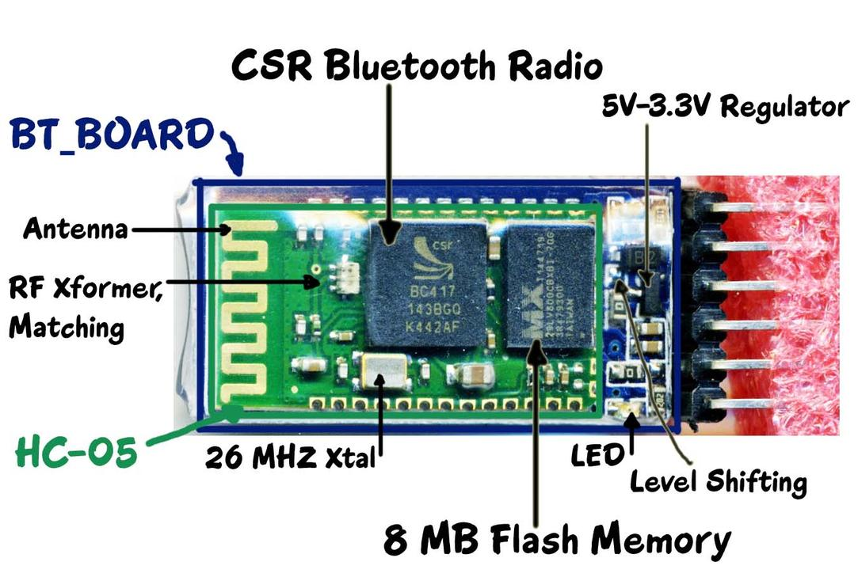 **HC-05 Bluetooth module**

HC-05 module is an easy to use Bluetooth SPP (Serial Port Protocol) module, designed for transparent wireless serial connection setup. Serial port Bluetooth module is fully qualified Bluetooth V2.0+EDR (Enhanced Data Rate) 3Mbps Modulation with complete 2.4GHz radio transceiver and baseband. It uses CSR Blue core 04-External single chip Bluetooth system with CMOS technology and with AFH(Adaptive Frequency Hopping Feature). It has the footprint as small as 12.7mmx27mm. Hope it will simplify your overall design/development cycle.

**Specifications**

**Hardware features**

* Typical -80dBm sensitivity
* Up to +4dBm RF transmit power
* Low Power 1.8V Operation ,1.8 to 3.6V I/O
* PIO control
* UART interface with programmable baud rate
* With integrated antenna
* With edge connector

**Software features**

* Default Baud rate: 38400, Data bits:8, Stop bit:1,Parity:No parity, Data control: has. Supported baud rate: 9600,19200,38400,57600, 115200,230400,460800.
* Given a rising pulse in PIO0, device will be disconnected.
* Status instruction port PIO1: low-disconnected, high-connected;
* PIO10 and PIO11 can be connected to red and blue led separately. When master and slave are paired, red and blue led blinks 1time/2s in interval, while disconnected only blue led blinks 2times/s.
* Auto-connect to the last device on power as default.
* Permit pairing device to connect as default.
* Auto-pairing PINCODE:”0000” as default
* Auto-reconnect in 30 min when disconnected as a result of beyond the range of connection.



**GPS module**

**The Basics of GPS**

You have probably used or benefitted from a GPS receiver. They are found in most smartphones, many new automobiles, and they are used to track commerce all over the globe. These tiny devices can instantaneously give your exact position and time, almost anywhere on the planet, for free! All you need is a GPS receiver, and receivers are getting less expensive and smaller every day.

**A common GPS receiver or GPS module.**

Don’t take these tiny, inexpensive modules for granted. There are decades of engineering that went in to giving you accurate position anytime, anywhere. Dozens of GPS satellites, all containing extremely accurate atomic clocks, have been launched since the late 70’s, and launches continue to this day. The satellites continuously send data down to earth over dedicated RF frequencies. Our pocket-sized GPS receivers have tiny processors and antennas that directly receive the data sent by the satellites and compute your position and time on the fly. Simply amazing.

Suggested Reading

There are some concepts that this tutorial builds upon and that you may need to know or prepare before starting:

Logic Levels

Connector Basics

Binary (used in the configuration section)

Serial Communication

Serial Terminal Basics

Suggesting Viewing

How Does GPS Work

GPS receivers use a constellation of satellites and ground stations to compute position and time almost anywhere on earth.

Notice the moving point on the globe and the number of visible satellites.

At any given time, there are at least 24 active satellites orbiting over 12,000 miles above earth. The positions of the satellites are constructed in a way that the sky above your location will always contain at most 12 satellites. The primary purpose of the 12 visible satellites is to transmit information back to earth over radio frequency (ranging from 1.1 to 1.5 GHz). With this information and some math, a ground based receiver or GPS module can calculate its position and time.

How does a GPS receiver calculate its position and time?

The data sent down to earth from each satellite contains a few different pieces of information that allows your GPS receiver to accurately calculate its position and time. An important piece of equipment on each GPS satellite is an extremely accurate atomic clock. The time on the atomic clock is sent down to earth along with the satellite’s orbital position and arrival times at different points in the sky. In other words, the GPS module receives a timestamp from each of the visible satellites, along with data on where in the sky each one is located (among other pieces of data). From this information, the GPS receiver now knows the distance to each satellite in view. **If the GPS receiver’s antenna can see at least 4 satellites, it can accurately calculate its position and time.** This is also called a lock or a fix.

Did you catch all of that? If not or if you want more, check out a much more detailed explanation, in volume 1 of GPS Fundamentals by Dan Doberstein. Volume 1 has been released for free, but you must support the author to read volume 2.

An artist’s rendition of the control segment.

There is another piece of the global positioning system we haven’t talked about. Along with satellites and GPS receivers, there are ground based stations that can communicate with the satellite network and some GPS receivers. This system is formally called the control segment and increases the accuracy of your GPS receiver. Common systems that use the control segment to improve accuracy are WAAS and DGPS. WAAS is common on most GPS receivers and improves accuracy to about 5 meters. DGPS requires a specific type of GPS receiver and gets centimeter accuracy. DGPS units are also expensive and tend to be larger because they require an additional antenna.

**GPS Accuracy**

GPS Accuracy depends on a number of variables, most notably signal to noise ratio (noisy reception), satellite position, weather and obstructions such as buildings and mountains. These factors can create errors in your perceived location. Signal noise usually creates an error from around one to ten meters. Mountains, buildings and other things that might obstruct the path between the receiver and the satellite can cause three times as much error as signal noise. A GPS receiver must be able to get a lock on 4 satellites to be able to solve for a position. The first lock it gets allows the receiver to obtain the almanac information and thus what other satellites it should listen for. Although it is possible to get a position from less than 4 satellites, the margin of error of this position can be rather large. Your most accurate read of your location comes when you have a clear view of a clear sky away from any obstructions and under more than four satellites. To combat these errors, a couple of different assistants have been created.

Assisted GPS

One of these ancillaries is Assisted GPS or AGPS. This method uses wireless (ground-based) networks to help relay between the satellite and the receiver when the GPS signal is weak or not able to be picked up. There are two ways AGPS can help out. The first is to provide the receiver with the proper almanac data and the precise time. The second utilizes the higher computing power and good satellite signal of the ground base to interpret the broken or fragmented information the receiver is receiving to provide a more accurate position reading to the receiver. AGPS is mostly accomplished by GPS receivers mounted on cellular towers. When communicating with these receivers, the GPS can acquire a lock on the satellite more quickly as well as receive more accurate information. This method is what is used for GPS in mobile phones and why they’re sometimes more accurate than the GPS receivers on their own. But AGPS is present in more devices than just cellphones; it’s even available in cameras and some vehicles. It’s most beneficial in cities where the GPS signal may have a difficult time making it through the dense maze of the buildings.

Differential GPS

**(Image Courtesy of ASMA)**

Another method is Differential GPS or DGPS. DGPS also uses ground or fixed GPS stations to determine the location, but differs in that it finds the difference between both the satellite and the ground location reading. These ground stations may be up to 200 nautical miles from the receiver, and it is important to note that accuracy deteriorates the further you are from the ground station. DGPS is accomplished by a ground station broadcasting a signal which dictates the error between the actual pseudorange and the measured pseudorange. This value is calculated by multiplying the speed of light by the time it takes the signal to travel from the satellite to the receiver. As an example, one form of DGPS is Wide Area Augmentation System or WAAS.

GPS receiver module gives output in standard (National Marine Electronics Association) NMEA string format. It provides output serially on Tx pin with default 9600 Baud rate.

This NMEA string output from GPS receiver contains different parameters separated by commas like longitude, latitude, altitude, time etc. Each string starts with ‘$’ and ends with carriage return/line feed sequence.

**E.g.**

$GPGGA,184237.000,1829.9639,N,07347.6174,E,1,05,2.1,607.1,M,-64.7,M,,0000\*7D

$GPGSA,A,3,15,25,18,26,12,,,,,,,,5.3,2.1,4.8\*36

$GPGSV,3,1,11,15,47,133,46,25,44,226,45,18,37,238,45,26,34,087,40\*72

$GPGSV,3,2,11,12,27,184,45,24,02,164,26,29,58,349,,05,26,034,\*7F

$GPGSV,3,3,11,21,25,303,,02,11,071,,22,01,228,\*40

$GPRMC,184237.000,A,1829.9639,N,07347.6174,E,0.05,180.19,230514,,,A\*64

**Pin Description**

**GPS Receiver Module**

**VCC:** Power Supply 3.3 – 6 V

**GND:**Ground

**TX:**Transmit data serially which gives information about location, time etc.

**RX:**Receive Data serially. It is required when we want to configure GPS module.

Check GPS module

Before Interfacing GPS module with PIC18F4550 microcontroller, we can check the output of GPS module. From that string, we can extract information like longitude, latitude, time which is helpful to find location and timing information.

To do this, connect this GPS module to the PC via USB to Serial converter or DB9 connector. Also, it is necessary to keep antenna of GPS module on proper location.

Now open any serial terminal e.g. Realterm, Hyper terminal, Putty etc. on PC/laptop.

Open the PORT with 9600 baud rate.

The terminal will show data coming from GPS receiver module.

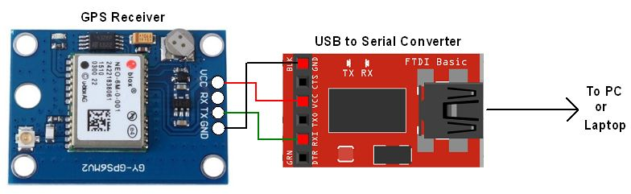

**Motor Driver**

The D.C. Motor used in this project operates at 12 volt and carries approximately 400mA of current. The motor driver is designed to inter face the motor with micro controller. The micro controller output is +5volt and can maximum give a current of 5mA. The driver stage changes the current and voltage level suitably to drive the motor. The driver stage not only drives the motor but also helps to control the direction of rotation. As the output current (Ic) is large the driver section requires a Darlington pair to switch the load. The Darlington pair I.C. TIP 122 is used here for designing. There are four ICs used here but two of those switched for one direction and other two will be switched for opposite direction rotation of the D.C. motor. The design principle of the driver section is as follows.

The motor takes approximately 400mA at 12 volt D.C., The power transistors can have amplification factor maximum 60 to 70 as per this assumption the base current required to switch on the transistor is approximately

Ib= (Ic/beta) =400mA/60 =6.7 mA

This current is too high to supply as a base current, more over the Microcontroller can not supply that much current to drive the transistor so, a darling ton pair is required to limit the base current with in 100 micro amp. To 2 mA.

**DC MOTOR**

The motor being dissected here is a simple PMDC electric motor that is typically find applications in robotics and control systems also used for techo generator in the industries.

|  |
| --- |
|  |

This is a small motor, about as big around as a coin. From the outside the body of the motor is shown in the picture along with its axle and two battery leads. If the motor is connected to the battery then , the axle will spin. If the leads are reversed then, it will spin in the opposite direction. Here are two other views of the same motor. (Note the two slots in the side of the steel can in the second shot -- their purpose will become more evident in a moment.)

|  |
| --- |
|  |

e nylon end cap is held in place by two tabs that are part of the steel can. By bending the tabs back, end cap can be free and removed. Inside the end cap are the motor's brushes. These brushes transfer power from the battery to the commutator as the motor spins:

|  |
| --- |
| C:\Documents and Settings\zenith\My Documents\PMDC\pmdc1_files\motor4.jpg |

The axle holds the armature and the commutator. The armature is a set of electromagnets in this case three. The armature in this motor is a set of thin metal plates stacked together, with thin copper wire coiled around each of the three poles of the armature. The two ends of each wire (one wire for each pole) are soldered onto a terminal, and then each of the three terminals is wired to one plate of the commutator. The figures below make it easy to see the armature, terminals and commutator:

|  |
| --- |
| C:\Documents and Settings\zenith\My Documents\PMDC\pmdc2_files\motor7a.jpg |

|  |
| --- |
|  |

The final piece of any DC electric motor is the field magnet. The field magnet in this motor is formed by the can itself plus two curved permanent magnets:

|  |
| --- |
| C:\Documents and Settings\zenith\My Documents\PMDC\pmdc2_files\motor8.jpg |

|  |
| --- |
|  |

One end of each magnet rests against a slot cut into the can, and then the retaining clip presses against the other ends of both magnets.

An electromagnet is the basis of an electric motor. You can understand how things work in the motor by imagining the following scenario. Say that you created a simple electromagnet by wrapping 100 loops of wire around a nail and connecting it to a [battery](http://electronics.howstuffworks.com/battery.htm). The nail would become a magnet and have a north and south pole while the battery is connected.

Now say that you take your nail electromagnet, run an axle through the middle of it and suspend it in the middle of a horseshoe magnet as shown in the figure below. If you were to attach a battery to the electromagnet so that the north end of the nail appeared as shown, the basic law of magnetism tells you what would happen: The north end of the electromagnet would be repelled from the north end of the horseshoe magnet and attracted to the south end of the horseshoe magnet. The south end of the electromagnet would be repelled in a similar way. The nail would move about half a turn and then stop in the position shown.

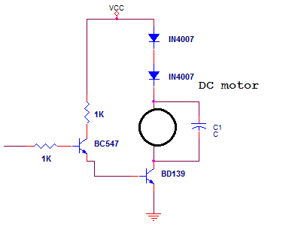

**Buzzer driver**

This section interfaces one audible piezo electric buzzer with the controller. The controller activates the buzzer whenever there is any fault appears in any of the channel.

**PIEZO ELECRTIC BUZZER:**

It is a device that converts electrical signal to an audible signal (sound signal).The Microcontroller cannot drive directly to the buzzer, because the Microcontroller cannot give sufficient current to drive the buzzer for that we need a driver transistor (BC547), which will give sufficient current to the buzzer.Whenever a signal received to the base of the transistor through a base resistance (1.5k) is high, the transistor comes to saturation condition i.e. ON condition thus the buzzer comes to on condition with a audible sound. Similarly, whenever the signal is not received to the base of the transistor, thus the transistor is in cut-off state i.e. is in OFF state thus the buzzer does not gets activated.



**Future expansion**

A wireless webcam can be added in this for capturing the images which will help in providing driver`s assistance. This can also be bettered by locking all the brakes automatically in case of accident. Mostly in accidents, it becomes serious as the drivers lose control and fail to stop the vehicle. In such cases, the vibration sensor will be triggered because of the vibrations received and also processed by the processor. The processor has to be linked to the devices which can lock the brakes when triggered. With this improvement, we can stop the vehicle and can weaken the impact of the accident. This system can also be utilized in fleet management, food services, traffic violation cases, rental vehicle services etc.

**Conclusion**

Our idea is used to detect accident and automate emergency assistance services. As a result, system is sending SMS to the nearest Emergency assistance service provider from accident location. The high demand of automobiles has also increased the traffic hazards and the road accidents. Life of the people is under high risk. This is because of the lack of best emergency facilities available in our country. An automatic alarm device for vehicle accidents. This design is a system which can detect accidents in significantly less time and sends the basic information. This alert message is sent to the rescue team in a short time, which will help in saving the valuable lives. A Switch is also provided in order to terminate the sending of a message in rare case where there is no casualty, this can save the precious time of the medical rescue team. When the accident occurs the alert message is sent automatically to the rescue team and to the police station and the message is sent through the GSM module.